Critical Analysis & Design

Becky Davies (2104215)

260 per section
350 introduction & conclusion

Table of Contents
Introduction 3
Product selection 4
Initial review 5
UX design principles 6
UX analysis 7
Recommendations for improvement 8
Conclusion 9
References 9

Introduction

UX Design which stands for user experience design is the process of designing the experience that users will have when interacting with the company or software. The importance of thinking about the UX design when designing a product/software is that this is the process where you will discover how to navigate the application, this process will also help to see what improvements should be implemented to make sure that the audience will have an easy time when navigating the product/software.
User experience is how people feel when using a product or software, this is where a UX designer comes in. UX designer is someone who analyses and investigates how people feel about or interact with the software offered; the designer uses the information gathered to adapt or implement improvements of the software. UX is important as it helps ensure users have the best possible experience when using a software/programme.
This assignment aims to research the importance of UX design and how it can affect how people use the software/ product. This research will discuss the information gathered from reviewing two different applications. The 2 applications selected are mobile games the first one is Dead by Daylight mobile, the second application is Tetris. Two mobile games have been selected as they would allow users to compare both applications from a similar user perspective. Additionally, both applications have some form of UX design, each with pros and cons.
Primary research will be conducted through initial reviews of the game's user navigation experience before getting to the main portion of the application, which would be the game itself. This research will be important as it will help to give a first impression of the game.
The secondary research will include reviews of the games and how other people have felt when using the game, such as whether navigation has been difficult or whether they found navigating the application relatively easy. Moreover, including research on the pros and cons of both applications, this will allow comparing the significant UX design and the differences between both applications.

Product selection

The applications that were chosen was Dead by Daylight Mobile and Tetris, these were chosen as they are both mobile applications and that it will allow to make the analysis based on similar comparisons of the applications.
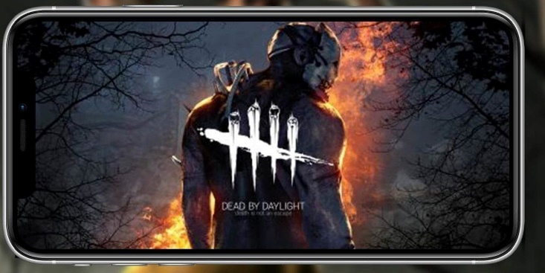[1]
Dead by daylight is a 4v1 multiplayer horror game with one player taking on the role of killer whilst the other 4 players are the survivors trying to escape the killer and to avoid being caught. The killer plays in first person whilst the survivors play in third person, which can lead to them having an advantage and having more situational awareness. Dead by Daylight Mobile was developed by Behaviour Interactive.
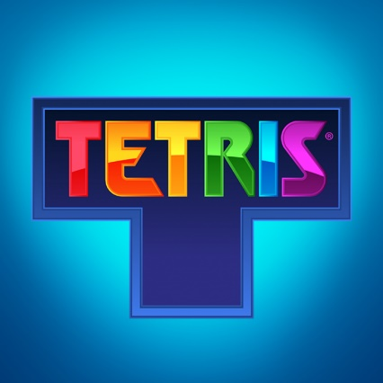 [2]
Tetris is a puzzle game. The mobile game was published by Takács Victor József. Tetris is a block puzzle game where the player has to move blocks of different sizes of different colours to make them fit together and destroy the blocks below to make more room for more blocks to increase your score. It’s very similar to a jigsaw puzzle; however, you use blocks rather than jigsaw pieces.
Overall, both games are quite different to each other; however, since they are both mobile games, it allows for a more even comparison rather than comparing a mobile game to a PC game.

Initial review

Based on initial appearances of dead by daylight the menu layout is very busy and crowded and the system buttons aren’t very clear or accessible as it’s very easy to miss click and to press a different button due to the sizing on some buttons, it was also quite difficult to navigate the menu due to this.
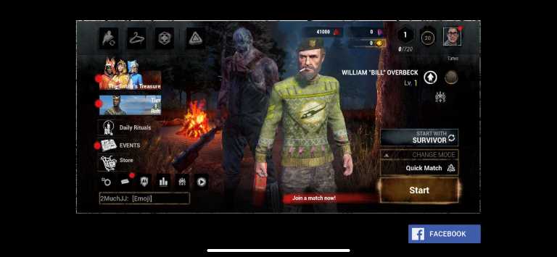
When opening the game it is very difficult to find out where the options button is as it isn’t made clear as to where the settings are. There also really isn’t any way to find what buttons are before clicking them as they aren’t made very clear.
The game was updated on 23/11/2023 (This update included some new characters for the game)
Initial reaction on opening Tetris is the simple menu layout and how clear the buttons are in the system menu, and how simple it was to navigate the menu due to the simple and clean layout.
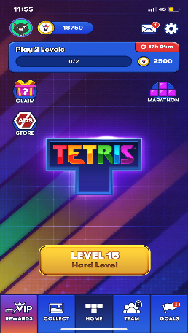
Overall both games had very different menu layouts due to being different games, however the Tetris menu was much more easier to navigate compared to the dead by daylight menu, there was also a lot less issues with selecting the different buttons and being able to continue the game.

UX design principles
the-basics-of-ux-design (uwtsd.ac.uk)
Usability is a crucial part of UX design; usability is important because if users are not able to complete their goals in a satisfactory manner, they are more likely to seek alternative solutions to complete their goals efficiently users are more likely to seek alternative solutions to achieve their goals efficiently if they cannot complete their goals sufficiently.
Another fundamental aspect of UX design is accessibility. Accessibility is when you provide an experience which can be accessed by people with disability or with people who struggle with using software for different reasons, such as colour-blind, which can be countered by being allowed access to a colour-blind filter so that using the software would be easier.
Consistency is another fundamental principle of UX design, creating a user-friendly interface by creating a consistent visual language and interaction to help users navigate the application and understand how to interact with the software, which is very important for UX design.
Ensuring a product is useful is critical when it comes to UX design because if the product isn’t practical, there is no point in bringing it to the market. However, it is essential to acknowledge that ‘useful’ can mean different things, such as bringing an aesthetic appeal. For example, a computer game can be useful. For example, a person can use a game as a well-being tool, making the game a useful tool.
Another factor to look into in user-centred design is an approach that makes sure that user needs are the centre point of the design, and it focuses on the user's needs throughout the design process to make sure that it is as accessible as possible.

UX analysis

When it came to dead by daylight mobile visual design, it wasn’t very appealing due to the fact that the menu was busy and chaotic and it was difficult to figure out where things were before even getting into the main gameplay. The main issue with the menu is how difficult it was to find the options button (lower left of the screen we have the option to click an arrow which will then give us the option to get into setting). The first thing to note was that it didn’t include a accessibility menu at all, and only includes settings to do with the graphics, audio, language and so on.
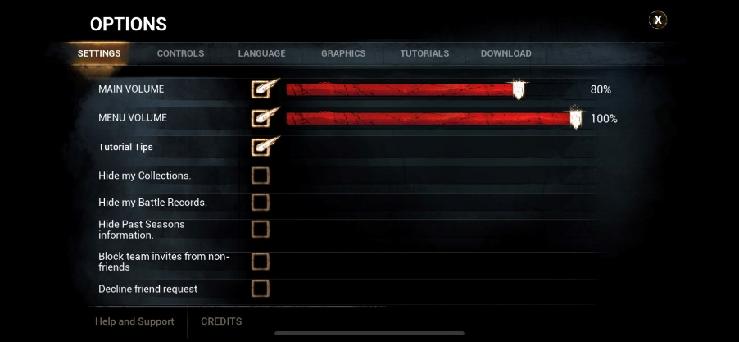
Another thing to take into account is the loading times of the game, these loading times can vary however it can take almost 5 minutes to only open the game due to the amount of patch downloads that have to be done when you open the application, however it can take longer if there are new characters being added so that the game has to update those as well.
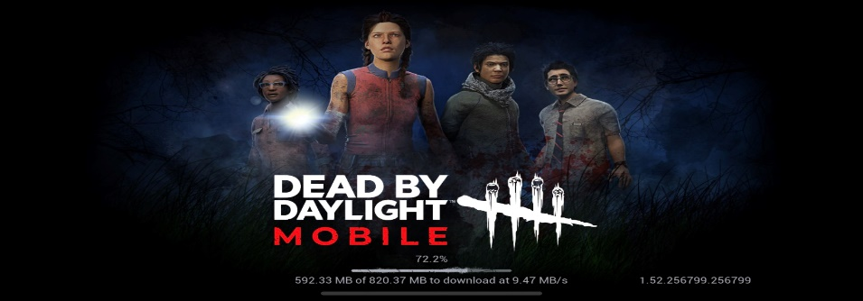
There is also quite a lot of lagging when playing this game, due to it being an online mobile game only, you don’t have the option to play offline and you can struggle to play the game if you are not playing with good internet.
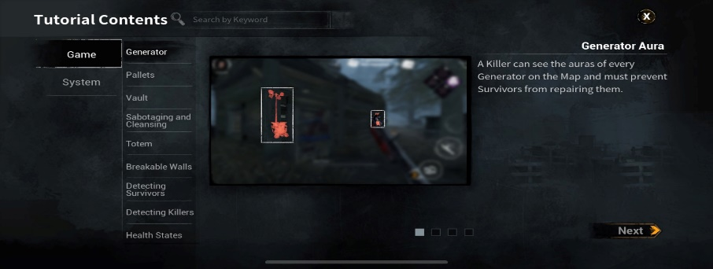
However there is quite a few tutorial options for when you start playing the game so that you are able to understand how to play before getting into an online game.
However when it comes to Tetris there are a lot less intricacies that go into the layout of the game. The menu is kept very simple and its clear as to where the important buttons are such as the options button and the play button.
Like the settings for dead by daylight mobile, Tetris also doesn’t include an accessibility menu and mostly focuses on audio and gameplay, however its much easier to access the settings menu in Tetris than it is to access the settings menu in dead by daylight.
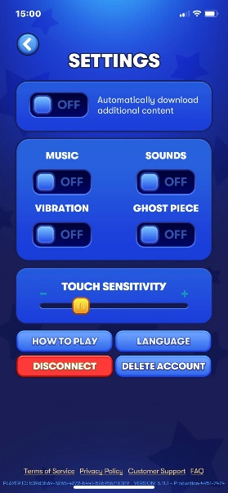
When it comes to loading times in Tetris there is little to no loading time other than when you first open the game which seems to take less than a minute to load up and the gameplay is very simple due to it being tetris, however if there was an issue with loading a game there is an offline option where you can without internet so that you don’t have to wait for any loading times and how you can still play this game even without internet.

Recommendations for improvement

For Dead by Daylight I would recommend making the menu layout more clean and less busy, by maybe include more drop down menu’s so that things could be grouped togather rather than having a separate button for everything. Another I would recommend is trying to sread out the new updates as it can take a while to open the game due to the update and for this to happen more frequently and regularly can put people off from wanting to open the game as it would be frequently giving more updates and asking for more storage space which can be difficult to deal with. It would also be an idea to have more accessibility options within the game such as colour blind options or way to change the touch sensitivity as it can be to sensitive when it comes to use the touch screen sometimes.
When it comes to Tetris it would be fun to have different gameplay rather than just the classic Tetris, rather than having to score a certain amount of points each round or destroying a certain amount of lines, it could include one which requires completing the challenge within a certain time, it would also be ideal for them to include an accessibility menu as well. As well as more gameplay options for when playing offline as it could repetitive for when having to play offline mostly rather than being able to play on internet.

Conclusion

Overall all both games have some negative and positive aspects in their game whilst there can be some things that can be improved on in order to make the games more enjoyable and playable. Whilst researching these games it has been made clear how it’s important that the games don’t get to repetitive where people are less likely to want to play the games again as they can get to boring. Another thing that has come to attention is that lacking an accessibility menu can limit the amount of people that can play the game as there is no option to edit or change certain settings within the game, such as having a colour blind option to make the games easier to see, especially in games like dead by daylight mobile where you can struggle to see some noise notifications due to them blending in the environments, but having an accessibility menu can increase the amount of people that can play the games.

References

Dead by Daylight Mobile is Already A Huge Hit (gamerant.com)
[1] A. J. P. Jr., “Dead by Daylight Mobile is already a huge hit,” Game Rant, https://gamerant.com/dead-daylight-mobile-1-million-downloads/ [accessed Dec. 19, 2023].
Tetris (iOS) | Tetris
[2] “Tetris (IOS),” Tetris, https://tetris.com/product/118/tetris-mobile [accessed Dec. 17, 2023].

