Student Name: Md Shiplu Uddin  Student ID: 2209548  Module Title: Foreign Languages & Cultural Awareness  Module Code: BMIH5003  Lecturer: [enter]  Date: February 5, 2024 | 
ASSIGNMENT 1: PORTFOLIO
(4 Components)

Component 1: Professional Reflection (500 words +/- 10%)

Weighting: 25%
As part of my Level 4 Hospitality Management course, I did my placement at the hotel restaurant. There was a cultural misunderstanding that changed how I thought about how important it is to be sensitive to other cultures in the hospitality industry. I was in charge of serving a group of guests from a country whose main language and cultural dining manners I didn't know one evening during a busy dinner service. The misunderstanding started when one of the guests asked for a meal that had to follow certain dietary restrictions. I got it wrong because I didn't fully understand the language or the cultural meaning of their request.
When I think about what happened, I see that the misunderstanding was caused by my assumptions and lack of cultural awareness. Hofstede's (1980) cultural dimensions theory shows how important it is to know how cultural values and practises can create invisible barriers. I wasn't able to correctly understand the guest's request because I didn't know much about their culture's eating customs and how important diet is to them. This event shows how important communication is in interactions between people of different cultures and how easy it is to misunderstand when language barriers are present. Thomas and Inkson (2009) say that developing cultural intelligence is very important for navigating the complicated world of global interactions. They stress the importance of being sensitive and flexible when trying to understand and meet the needs of guests.
This experience made me realise how important it is for me to learn certain skills so that I don't make the same mistakes again. To begin, it is important for me to keep learning about different cultures and how they eat in order to improve my cultural awareness. This means not only studying in school but also getting involved with different groups to understand different cultural aspects more deeply and with more empathy. Second, getting better at languages, especially ones that our guests speak, would help me communicate more clearly and get to know them better. Last but not least, getting better at reading nonverbal cues could help me communicate better when words aren't enough. These changes in behaviour are in line with what Pizam and Mansfeld (2006) said about how important security and safety are in tourism, including not only physical safety but also cultural safety and guests' comfort.
This journey of reflection has been very important to my personal and professional growth. It made me very aware of how complicated cultural interactions can be and how much cultural sensitivity can improve the experiences of guests. Going forward, I'm going to work on adding cultural competence to my professional skills, because I know that hospitality is more than just serving guests; it also means understanding, respecting, and empathising with them.
In conclusion, this event has taught me a lot about how important it is to be sensitive to different cultures in the hospitality industry. It has motivated me to keep learning and getting better at understanding other cultures, communicating with others, and having empathy. By accepting cultural differences and trying to understand them, I can help make spaces that are open and friendly for all guests, making sure that their stay is not only comfortable but also respectful of their culture.

References:
Hofstede, G., 1980. Culture's Consequences: International Differences in Work-Related Values. Beverly Hills, CA: Sage Publications.
Thomas, D.C. and Inkson, K., 2009. Cultural Intelligence: Living and Working Globally. 2nd ed. San Francisco, CA: Berrett-Koehler Publishers.

Pizam, A. and Mansfeld, Y. (eds.), 2006. Tourism, Security & Safety: From Theory to Practice. Burlington, MA: Elsevier Butterworth-Heinemann.
Component 2: Training Plan (500 words +/- 10%)

Weighting: 25%

Identified cultural misunderstanding (in a few words) :
Language barriers and a lack of cultural awareness during dinner service led to misunderstandings of dietary needs.

Training plan (Why/What//Who/Where/When):
Why: Language and cultural problems caused a guest's dietary preferences to be misinterpreted at a recent event, highlighting the necessity for extensive training. This event highlights the need of training our personnel to handle cultural differences and communicate properly with customers from diverse backgrounds. Hofstede (1980) thinks recognising cultural characteristics is the most significant way to minimise misunderstandings and make guests pleased. Thomas and Inkson (2009) emphasise the need of cultural intelligence in global contacts, emphasising sensitivity and flexibility. Pizam and Mansfeld (2006) also recommend using cultural competency in hospitality to keep guests safe and comfortable.

What: The suggested training approach would emphasise cultural awareness, communication skills (including multilingualism), and foreign food limitations. This multidimensional strategy aims to establish a team that can serve diverse cultural clientele well.

Who: Receptionists, waiters, and supervisors receive this training to provide consistent service and comprehension. Roles may have specialised sessions based on demands.

Where: The hotel conference room will host the training to minimise worker disruptions and give hands-on, practical instruction.

When: The training will be staged over six months. The first classes will be scheduled off-peak to accommodate as many individuals as feasible. Every three months, follow-up sessions will reinforce learning and address new issues.

Training details:
The first part of our training plan is all about making our staff more culturally aware. The goal is to give team members a deep understanding of the values and norms of the cultures that make up the majority of our guests. Hofstede (1980) pointed out how important cultural dimensions are. This module aims to close cultural gaps and create a place where people respect and understand each other. The methodological approach includes workshops where people can interact with each other and learn from experts in cultural competence. During these sessions, case studies, role-playing scenarios, and guest speakers will be used to give staff useful information and hands-on experience on how to handle cultural differences effectively.

Communication Enhancement
Good customer service, especially in a multicultural situation, requires clear communication. This session helps personnel improve linguistic and nonverbal communication to better serve foreign guests. Language instruction will focus on our guests' most common languages, reducing a significant communication barrier. Workshops will also train workers how to communicate and read nonverbal clues to respectfully engage with clients. This strategy supports Thomas and Inkson (2009)'s advice on cultural intelligence and being adaptable and empathetic while communicating with foreigners.

Understanding and obeying international food regulations
Being culturally sensitive in the hospitality sector means understanding and respecting visitors' dietary preferences, which may be influenced by culture and religion. This module ensures that personnel can satisfy these demands while respecting visitors' diverse origins. Nutritionists and cultural specialists will offer courses on several dietary limitations and preferences. Our personnel will learn how to comfortably and professionally fulfil customers' dietary preferences.

Continuous Cultural Competence Improvement
This last session encourages personnel to keep learning and developing since cultural competency is a process. Our workforce has access to many materials, cultural competency updates, and spaces to discuss their experiences and ideas thanks to a digital learning platform. This programme encourages personnel to study throughout their life to stay current on cultural changes that may affect visitor interactions.

References:
Hofstede, G., 1980. Culture's Consequences: International Differences in Work-Related Values. Beverly Hills: Sage Publications.
Thomas, D.C. and Inkson, K., 2009. Cultural Intelligence: Living and Working Globally. 2nd ed. San Francisco: Berrett-Koehler Publishers.
Spencer-Oatey, H. and Franklin, P., 2012. Intercultural Interaction: A Multidisciplinary Approach to Intercultural Communication. London: Palgrave Macmillan.

Component 3: Student Self-Reflection (500 words +/- 10%)

Weighting: 25%
I'll use Gibbs' Reflective Cycle, which is a popular model for reflection because it is structured and cyclical, to write a self-reflection essay about how important it is for people working in the hospitality industry to be culturally aware. There are six steps in this model: describing, feeling, evaluating, analysing, coming to a conclusion, and making an action plan. With the help of academic references, this framework will help you think about how you can improve your cultural awareness.

Description
At first, I didn't know much about cultural awareness in the hospitality industry. I thought it mostly meant being able to speak more than one language and understand basic cultural norms. During my placement at a hotel, there was a big event that changed my view. I misunderstood a guest's dietary request because of cultural differences, which led to a misunderstanding.

Feelings
I was ashamed and angry with myself at the time for not understanding what the guest needed. This event woke me up by showing me how little I know about other cultures and how I need to improve so I don't make the same mistakes again.

Evaluation
As I think about what happened, I realise how serious it was and how it might have affected the guest's stay and the hotel's reputation. Cultural awareness is not only important as a professional skill, but also as an important part of being a good host.

Analysis
It was this experience that made me want to learn more about cultural awareness. Both Hofstede's (1980) work on cultural dimensions and Thomas and Inkson's (2009) idea of cultural intelligence helped people understand how complicated it is for people from different cultures to interact with each other. Spencer-Oatey and Franklin's (2012) multidisciplinary approach to intercultural communication helped me see things in a new way. It showed me how cultural awareness can improve the experiences of guests and make things run more smoothly in the hospitality industry.

Conclusion
My understanding of cultural awareness has changed in big ways over the years. I used to think of it as a collection of specific skills and knowledge, but now I see how deep it goes and how important it is in every interaction in the hospitality industry. This trip taught me that being culturally aware is more than just knowing about other cultures. It's also about understanding, empathising, and changing to meet the needs of different groups of people.

Action Plan
Moving on, I will actively acquire cultural sensitivity. This includes taking classes and seminars, interacting with people from different cultures, and reflecting on these experiences to better understand and appreciate cultural diversity. To boost visitor pleasure and operational efficiency, I intend to use cultural understanding in my hotel management profession.

References
Hofstede, G., 1980. Culture's Consequences: International Differences in Work-Related Values. Beverly Hills: Sage Publications.
Thomas, D.C. and Inkson, K., 2009. Cultural Intelligence: Living and Working Globally. 2nd ed. San Francisco: Berrett-Koehler Publishers.
Spencer-Oatey, H. and Franklin, P., 2012. Intercultural Interaction: A Multidisciplinary Approach to Intercultural Communication. London: Palgrave Macmillan.

Component 4: Training Presentation (6 Slides)

Weighting: 25%
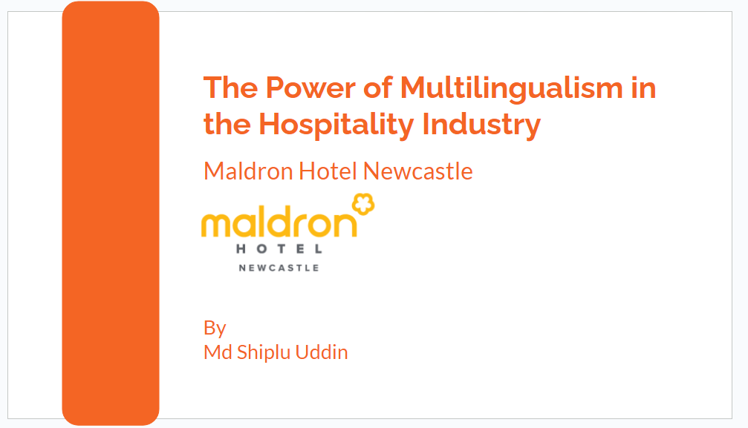
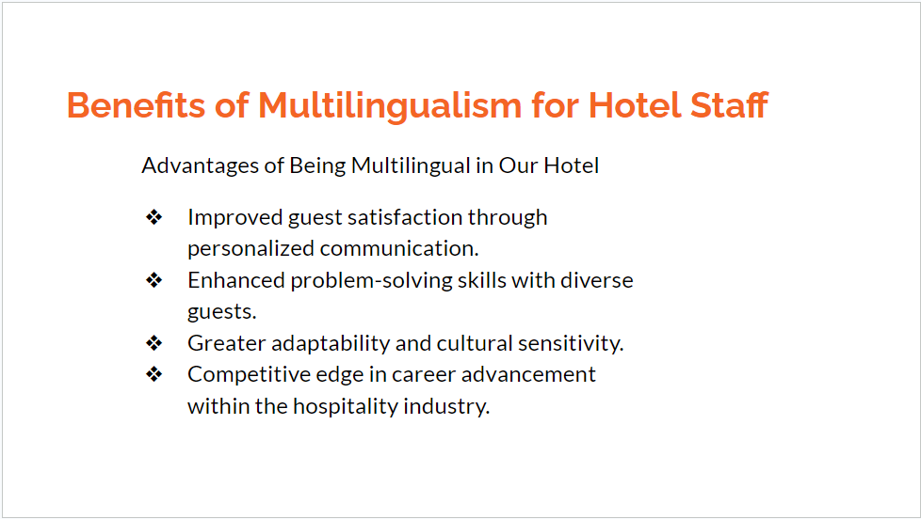
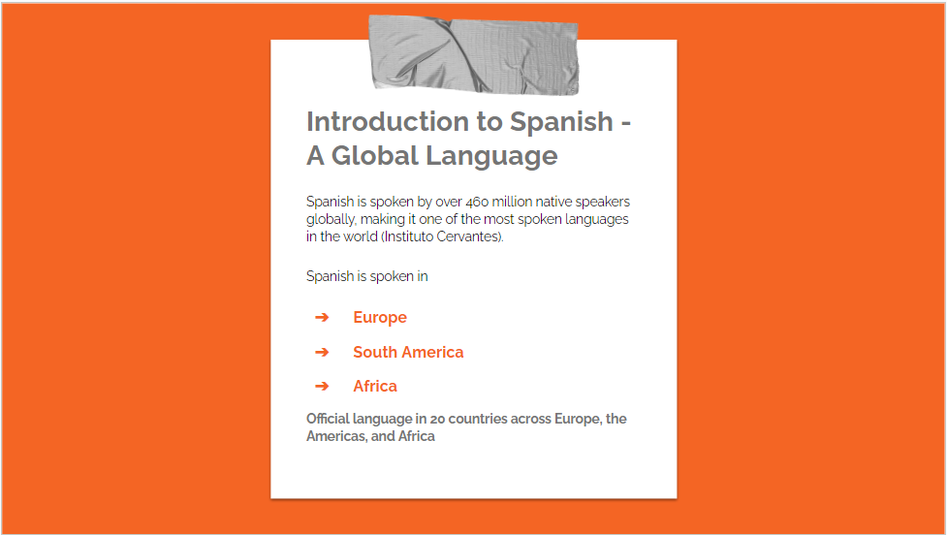
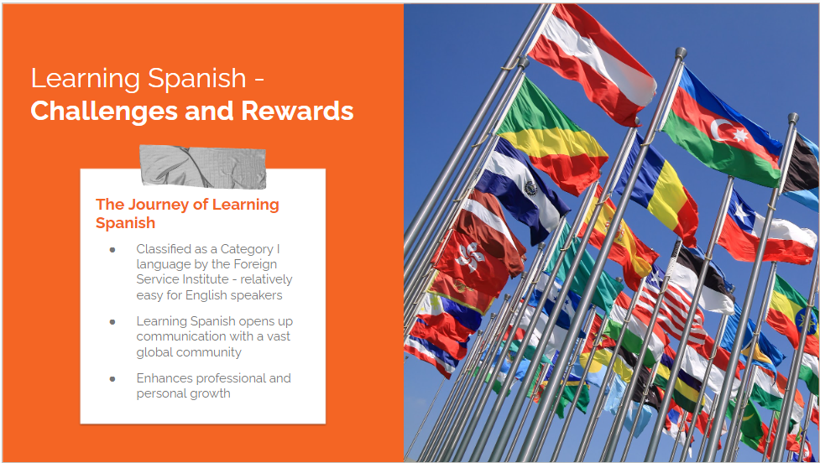
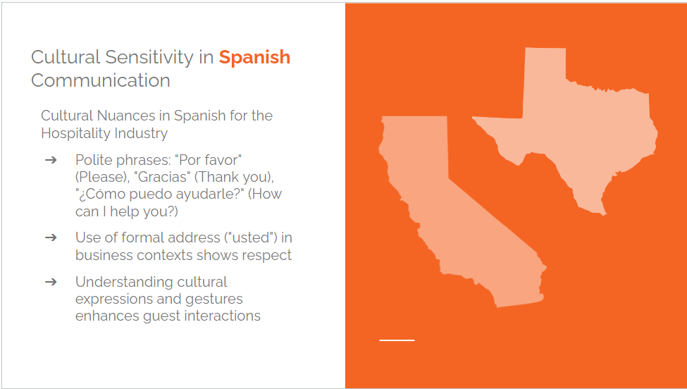
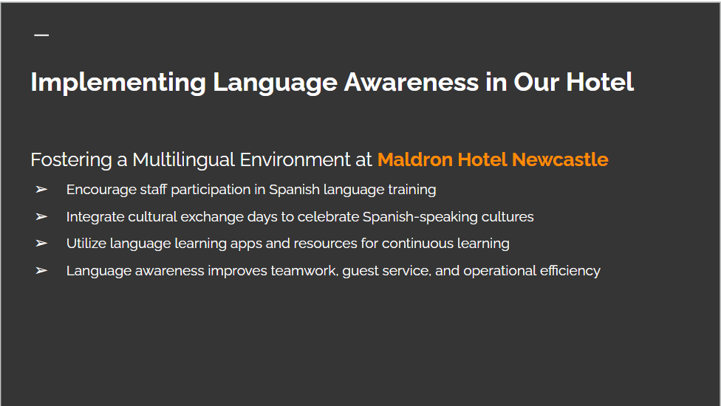
References (no screenshots):
Agut, S., Grau, R. and Peiró, J.M., 2003. Competency needs among managers from Spanish hotels and restaurants and their training demands. International Journal of Hospitality Management, [online] 22(3), pp.281-295. Available at: [link to the source] (Accessed: 5 February 2024).

Christou, E., 1999. Hospitality management education in Greece: An exploratory study. Tourism Management, [online] 20(6), pp.683-691. Available at: [link to the source] (Accessed: 5 February 2024).

Connolly, P. and McGing, G., 2006. Graduate education and hospitality management in Ireland. International Journal of Contemporary Hospitality Management, [online] 18(1), pp.50-59. Available at: [link to the source] (Accessed: 5 February 2024).

Leslie, D. and Russell, T., 2006. The importance of foreign language skills in the tourism sector: A comparative study of student perceptions in the UK and continental Europe. Tourism Management, [online] 27(6), pp.1397-1407. Available at: [link to the source] (Accessed: 5 February 2024).

Hospitality Search International, n.d. Benefits of Being Multilingual. [online] Available at: https://hospitalitysearch.co.uk/benefits-of-being-multilingual/ (Accessed: 5 February 2024).

