Assignment Title: Hotel Handbook

Student Name: Apurba Das
Student ID- 2107164
Lecturer Name: Rodrigo Fernandes Aguilera
Module Name: Foreign Languages and Cultural Awareness
Module code: BMIH5003

Executive Summary
One of the rapidly growing industries is the hospitality industry. And its growth has made the sector very competitive. That’s why personnel working in this industry need intellectual competency that can help them treat guests from multicultural diversity effectively and appropriately. Intellectual competencies of the employees of the hotel businesses ensure that they provide the best services to multicultural consumers by understanding the differences in their norms and values.

This report examines the differences between the culture of UAE and the UK. The chosen hotel for the study is Premier Inn. This study used Hofstede’s Cultural Dimension framework to compare these two cultures. It has explained how hotel management in the UK and UAE can offer better services by understanding cultural differences, sensitivity, and norms. And lastly, It has provided a summary sheet of Do’s and Don’t of both cultures for the employees of the hotel to help them perform better with the guideline. The study finds that the two mentioned countries have huge differences in their culture and running a business in the hospitality industry it is important to understand the differences in these cultures. It finds that the businesses that are successful in the hospitality industry are the ones that adapt to cultural differences and serve consumers by fulfilling their cultural needs.

Contents
Executive Summary 2
Introduction 4
Country A 4
Country B 5
Critical Analysis 7
Handbook 8
Conclusion 9
References 10
Appendices 12

Introduction
Intellectual competency in the hospitality sector is defined as the ability to engage effectively with people from diverse backgrounds and the ability to adapt to various cultures (Urbanek, 2017). It helps employees in the hospitality industry to be efficient and effective by understanding the value of each culture of the consumers. The cultural variation between the UK and UAE is examined in this study using Hofstede's Cultural Dimension Framework. It looks on how the UK hotel staff can maintain France's cultural differences and sensitivity. In order to understand the Do’s and Don'ts of each culture, it also offers a summary sheet of cultural competencies. The tools used in this study are Hofstede’s Cultural Dimension Framework and statistical analysis.

Country A
In this report, country A is the UK. The chosen hotel for this report is Premier Inn. This research will analyse the UK culture with Hofstede’s Cultural Dimension framework to have a better understanding of the culture of the UK.
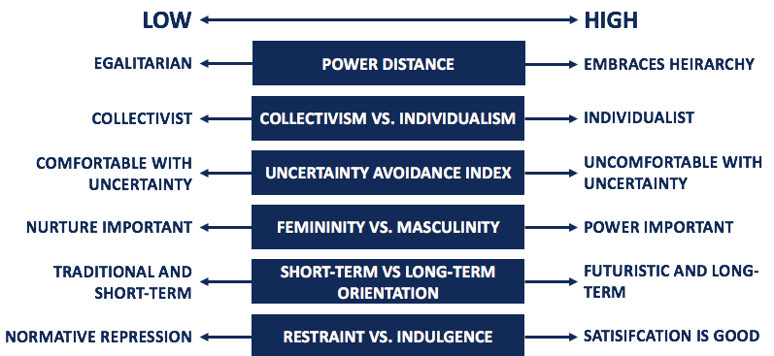
Figure: Hofstede’s cultural dimension framework Source: (Chi, 2020)
Power distance- The UK culture has a low power distance. The UK people believe that there shouldn’t be any power distance and all people must be treated fairly. That’s why the hotel staff of the UK may serve all their guests equally.
Individualism- The UK people are highly individualist. It makes the hotel employees concentrate on their specific task and feels accountable for them alone. They do not see the need to establish a long-term relationship with the visitors.
Masculine- The UK culture is a masculine one thus employees feel intense competition among each other and they want success in their individual character.
Uncertainty Avoidance- UK’s uncertainty avoidance score is low which means that people do not follow strict guidelines. Thus, hotel employees are flexible in their services (The Guardian, 2014).
Long-term/short-term orientation- The UK culture has a balance between long-term and short-term orientation. That means employees have both short and long-term goals to satisfy their consumers.
Indulgence- The score of indulgence in the UK culture is high. It shows the expectation level of the UK people for leisure is very high to satisfy them hotel services should provide them best leisure experience.
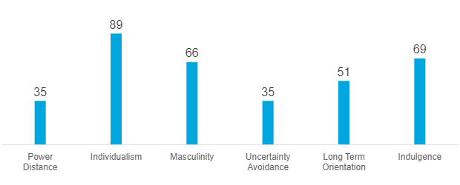
Figure: UK’s culture analysis Source: (Fan, 2021)

Country B
In this research, country B is UAE. Hofstede’s cultural dimension framework is used to analyse the culture of the country.
Power distance- UAE has a big power distance and socioeconomic position is highly valued there, and people are treated accordingly. Different classes are treated differently in hotels. So, the guests in the hotel expect differently due to their status (Hofstede Insights, 2017).
Collectivism- UAE is a collectivist society. People of this culture love traveling in a group and they expect equal treatment to all the members of the group when they stay in a hotel.
Masculine- UAE’s culture is a masculine one. It is driven by the success of individuals. They believe in competition and achievement. Thus, they like to be valued when they are staying in a hotel.
Uncertainty Avoidance- Uncertainty avoidance is very high in this culture. They have a rigid code of beliefs and they don’t like unorthodox ideas or beliefs. So, the hotel management shouldn’t include entertainments that UAE people aren’t familiar with.
Long-term/short-term orientation- It is a short-term-oriented country. These people show respect for their tradition and they focus on the instant result so the hotel management should keep that in mind while serving them (Walker, 2017).
Indulgence- The culture of UAE is restrained. Thus, they don’t enjoy leisure time much. Their stay in hotels may be due to professional reasons so they want professional services.
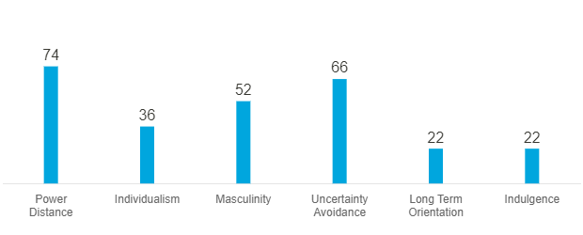
Figure: UAE’s culture analysis Source: (Lundberg and Vassilios Ziakas, 2019)

Critical Analysis
It is clear from the research on the cultural characteristics of UAE and the UK that the cultures of these two nations are very different from one another. In comparison to the UK, UAE has a relatively wide power gap. As a result, when guests are treated particularly according to their social level, it is appreciated. So Premier Inn Hotel needs to prioritize serving guests according to their social status so they feel appreciated.
The UK is an individualist country and UAE is a collectivist country. So, when serving UAE’s guest Premier Inn hotel needs to focus on treating all the members of the guest group equally and with care (Smith and László Puczkó, Gospodarski Svetovalec, 2014).
UAE people are more aware of their cultural, social, and traditional customs. Therefore, the hotel management must pay great attention to and show respect for the customs and traditions of its guests.
UAE’s culture is also very intolerant to new ideas and they have an emotional need for rules (Ruhet Genc, 2014). Thus, hotel employees should always be professional and efficient while serving them to delight them.
They live more hurriedly and less leisurely lives. Therefore, the hotel may need to provide its staff with the proper hospitality training to ensure that guests receive effective services while their stay in the hotel.

Handbook
A guideline for hotel employees of both countries is given below to serve better:
Etiquettes |  | Do’s and Don’ts
Greetings | UK | - Offer a firm handshake  - Use last names to address guests  - Avoid staring
Greetings | UAE | - Say, As-salam Alaykum to greet the guests  - Avoid shaking hands with women
Nonverbal-communication | UK | - Use thank you and please often  - Avoid speaking too casual English (Savage, 2021)
Nonverbal-communication | UAE | - Stand close while having a conversation  - Avoid enthusiastic greetings, touching women
Attire | UK | - Be neat and tidy  - Smart casuals are allowed
Attire | UAE | - Wear formal clothes, women should dress modestly  - Avoid wearing clothes that are tight and fitted
Dining | UK | - Put your cutlery down between bites  - Avoid talking with a mouth full
Dining | UAE | - Use the right hand to serve and eat.  - Avoid using the left hand (Goodall and Ashworth, 2014)
Others | UK | - Apologizeze to show your concern  - Avoid talking overly loud
Others | UAE | - Avoid showing public intimacy  - Be modest

Conclusion
This study has reported the comparison between the cultures of UAE and the UK. This report helps to understand how vastly different cultures are from to another. What is accepted and appreciated in one country can be refused by another. Thus, it is important in the hospitality industry to understand the culture of the guests to serve them better and ensure consumer satisfaction. Knowing cultural sensitivity, norms, and values allow a business to perform better and gain acceptance from consumers.

References
Chi, R. (2020). Economic principles for the hospitality industry. London ; Abingdon England ; New York: Routledge.
Fan, Q. (2021). An Analysis of Hofstede’s 5 Cultural Dimensions Functioning in Ren Zhengfei’s Intercultural Communication With BBC Reporter. [online] www.atlantis-press.com. doi:10.2991/assehr.k.210121.027.
Goodall, B. and Ashworth, G.J. (2014). Marketing in the tourism industry : the promotion of destination regions. London: Routledge.
Hofstede Insights (2017). France - Hofstede Insights. [online] Hofstede Insights. Available at: https://www.hofstede-insights.com/country/france/.
Lundberg, C. and Vassilios Ziakas (2019). The Routledge handbook of popular culture and tourism. Abingdon, Oxon ; New York, Ny: Routledge, An Imprint Of The Taylor & Francis Group.
Premier Inn (2021). Premier Inn Home. [online] Premier Inn. Available at: https://www.premierinn.com/gb/en/home.html.
Ruhet Genc (2014). International Hotel and Restaurant Management. CreateSpace.
Savage, M. (2021). Is cultural knowledge more important than language skills? [online] www.bbc.com. Available at: https://www.bbc.com/worklife/article/20180518-is-cultural-knowledge-more-important-than-language-skills.
Smith, M.K. and László Puczkó, Gospodarski Svetovalec (2014). Health, tourism and hospitality : spas, wellness and medical travel. London ; New York: Routledge.
The Guardian (2014). A very British struggle: a guide to saying hello. [online] the Guardian. Available at: https://www.theguardian.com/society/2014/jun/08/greeting-etiquette-guide-brits-learn-say-hello.
Urbanek, G. (2017). The Identification of a Company’s Competitive and Market Competency Gaps. Kidmore End: Academic Conferences International Limited.
Walker, J.R. (2017). Introduction to hospitality management. Boston: Pearson.
Weaver, D.B. and Lawton, L. (2014). Tourism management. 5th ed. Milton, Qld.: Wiley.

Appendices
Figure: Hofstede’s cultural dimension framework
Figure: UK’s culture analysis
Figure: UAE’s culture analysis

