

International Meetings Management for the Hotel Industry
Student name: Sebastian Garbaty
Student ID Number: 2211131
Module code: BMIH6007
Lecturer: Kathryn Flynn

Presentation

Event theme- Winter

Event title- “Winter Wonderland: Feasibility Study for a Seasonal MICE Event in the Hospitality Sector”

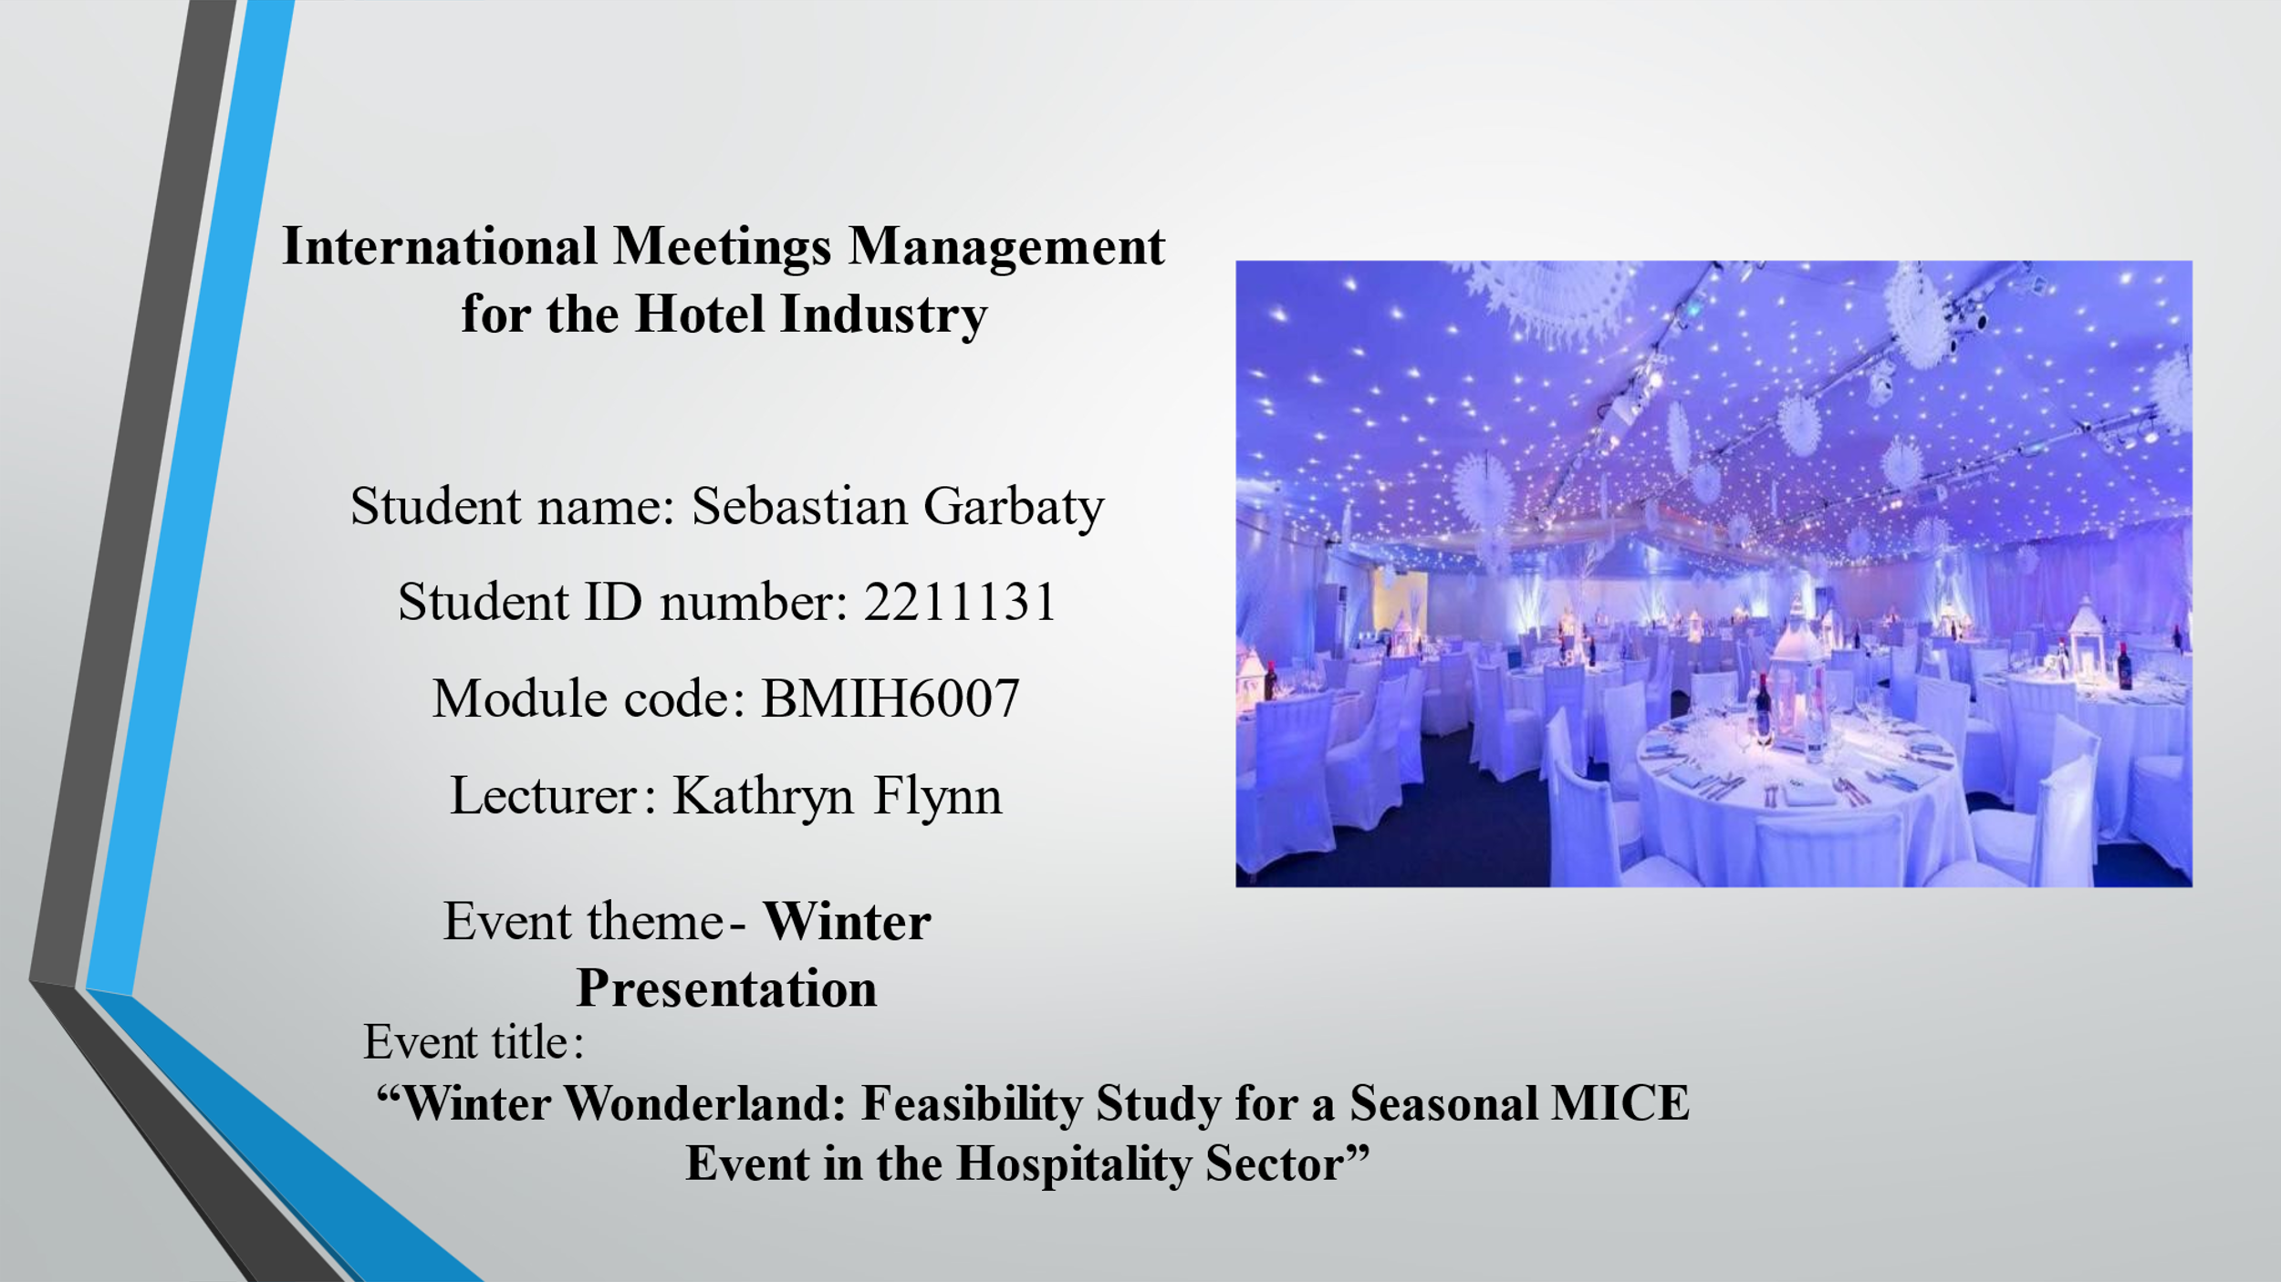

Table of Contents
Introduction 3
Event planning 4
Market factors 6
Operational factors 8
Financial Factors 10
SWOT analysis 11
PESTLE analysis 12
Strategic pre-planning for arranging 13
Conclusion 14
References 15
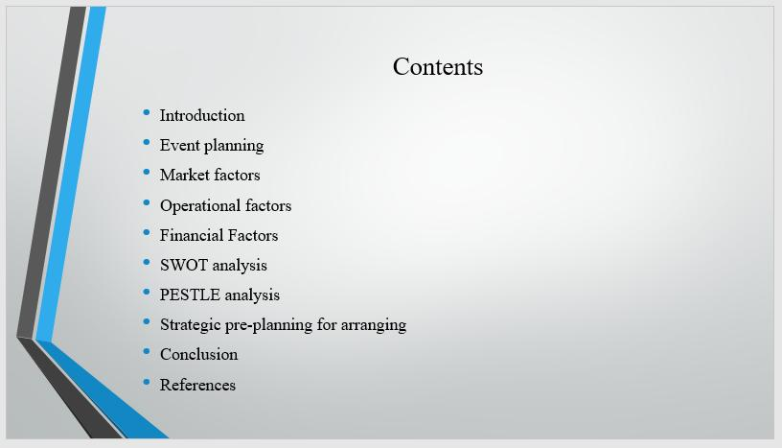

Introduction
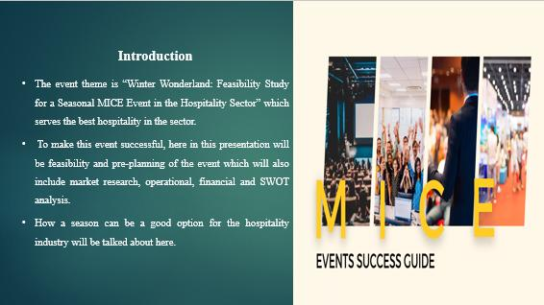
The event theme is “Winter Wonderland: Feasibility Study for a Seasonal MICE Event in the Hospitality Sector” which serves the best hospitality in the sector. To make this event successful, here in this presentation will be feasibility and pre-planning of the event which will also include market research, operational, financial and SWOT analysis. How a season can be a good option for the hospitality industry will be talked about here.

Event planning
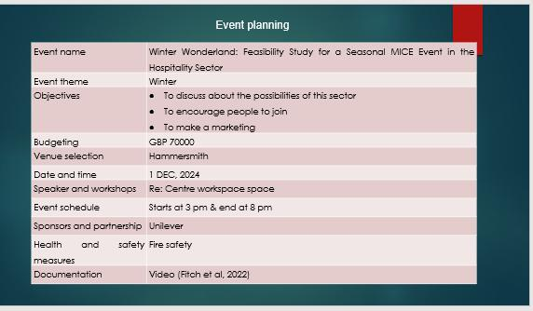
Event name | Winter Wonderland: Feasibility Study for a Seasonal MICE Event in the Hospitality Sector
Event theme | Winter
Objectives | - To discuss about the possibilities of this sector  - To encourage people to join  - To make a marketing
Budgeting | GBP 70000
Venue selection | Hammersmith
Date and time | 1 DEC, 2024
Speaker and workshops | Re: Centre workspace space
Event schedule | Starts at 3 pm & end at 8 pm
Sponsors and partnership | Unilever
Health and safety measures | Fire safety
Documentation | Video (Fitch et al, 2022)

Market factors
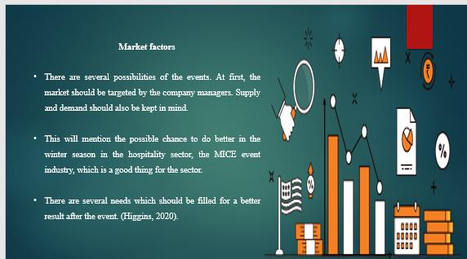
There are several possibilities of the events. At first, the market should be targeted by the company managers. Supply and demand should also be kept in mind. This will mention the possible chance to do better in the winter season in the hospitality sector, the MICE event industry, which is a good thing for the sector. Since this event is centred on that aspect of hospitality, more people will be joining and enjoying it, which is good for the MICE hospitality business. There are several needs which should be filled for a better result after the event. The main theme will be how winter can be a good season for travelling in the country and abroad. How one can use the best of this season. How people enjoy their winter will be one of the most attractive themes of this event which is a good thing for the event and the MICE industry of the hospitality sector (Higgins, 2020).
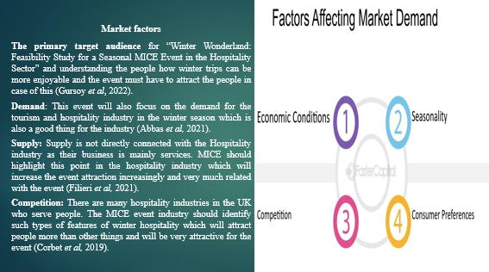
The primary target audience for “Winter Wonderland: Feasibility Study for a Seasonal MICE Event in the Hospitality Sector” and understanding the people how winter trips can be more enjoyable and the event must have to attract the people in case of this. The event must satisfy the people who will participate in the event (Gursoy et al, 2022).
Demand: This event will also focus on the demand for the tourism and hospitality industry in the winter season which is also a good thing for the industry. This demand will be increased if people join and enjoy this event as this event is focused on that area of hospitality which is a good thing for the MICE industry of hospitality (Abbas et al, 2021).
Supply: Supply is not directly connected with the Hospitality industry as their business is mainly services. MICE should highlight this point in the hospitality industry which will increase the event attraction increasingly and very much related with the event. So, the hospitality industry should not be concerned with the supply as they are noticing that supply is not directly connected with this industry (Filieri et al, 2021).
Competition: There are many hospitality industries in the UK who serve people. The MICE event industry should identify such types of features of winter hospitality which will attract people more than other things and will be very attractive for the event. How competition can be more advantageous for the tourist will be also discussed in the event (Corbet et al, 2019).

Operational factors
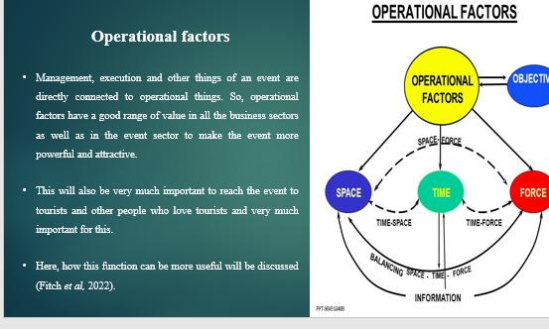
Management, execution and other things of an event are directly connected to operational things. So, operational factors have a good range of value in all the business sectors as well as in the event sector to make the event more powerful and attractive. In the hotel sector, MICE ought to draw attention to this issue, which is closely tied to the event and will raise event interest. This event will also highlight the winter demand for the tourist and hospitality sectors, which is advantageous for those sectors as well. This will also be very much important to reach the event to tourists and other people who love tourists and very much important for this. Here, how this function can be more useful will be discussed (Fitch et al, 2022).
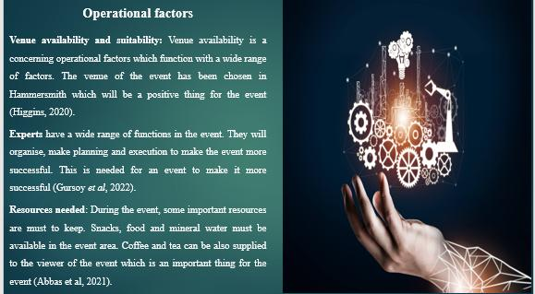
Venue availability and suitability: Venue availability is a concerning operational factors which function with a wide range of factors. The venue of the event has been chosen in Hammersmith which will be a positive thing for the event. This venue is also suitable for the event and with the theme which is very much important and suitable. In Hammersmith, there are many tourists which will be very much beneficial to make the event more successful (Higgins, 2020).
Experts have a wide range of functions in the event. They will organise, make planning and execution to make the event more successful. This is needed for an event to make it more successful. The presentation of the event should be very interesting, which is another important thing for the event (Gursoy et al, 2022).
Resources needed: During the event, some important resources are must to keep. Snacks, food and mineral water must be available in the event area. Coffee and tea can be also supplied to the viewer of the event which is an important thing for the event. Good lighting and projector setup is a must. Sound system should also be good. If these resources are found inside the event, the event will be successful (Abbas et al, 2021).

Financial Factors
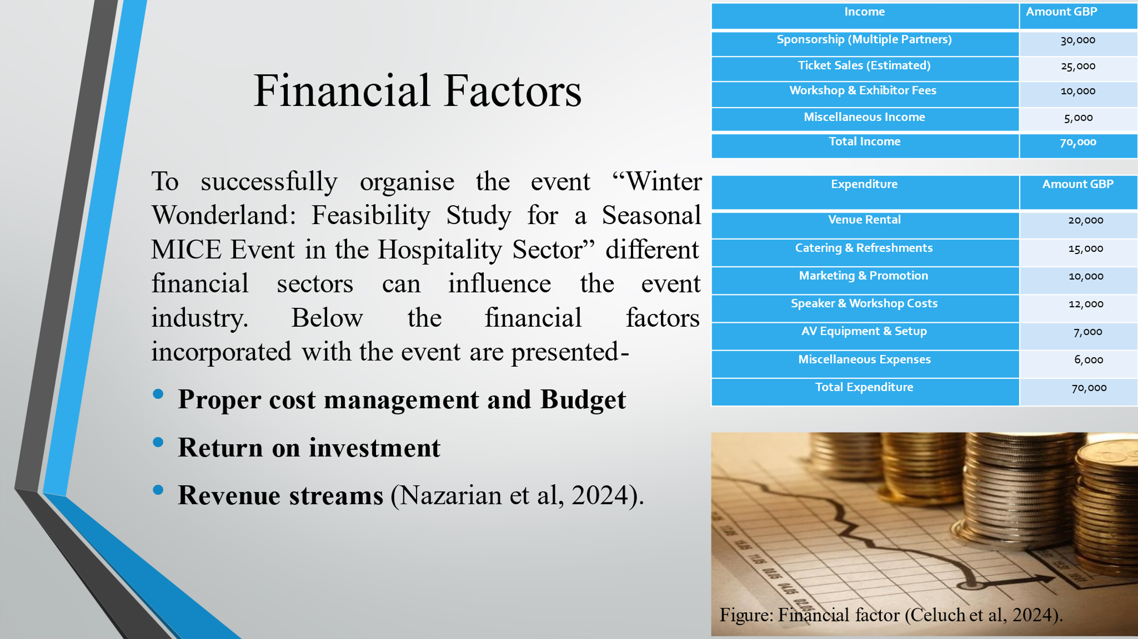
To successfully organise the event “Winter Wonderland: Feasibility Study for a Seasonal MICE Event in the Hospitality Sector” different financial sectors can influence the event industry. Below the financial factors incorporated with the event are presented-
Proper cost management and Budget: The event industry has to manage the costs carefully to successfully organise the “Winter Wonderland: Feasibility Study for a Seasonal MICE Event in the Hospitality Sector” because the success of the event largely depends on this. The event organising team will focus on the local area to rent the venue for it’s to reduce rental costs. Also, the organisers will give priority to local designers for decorating the event focusing on the winter theme. To manage costs the event organiser will also make a budget for catering, accommodation, marketing and other services of the organisation (Celuch et al, 2024).
Return on investment: The MICE Event industry has to invest a huge amount for the winter-themed “Winter Wonderland” event so it is crucial to ensure positive return on investment from the event to make the event successful. The event organiser will mainly focus on the satisfaction of guests attending the event and try to create business opportunities to increase earning opportunities. The Mice event will look for sponsors and stakeholder support to create opportunities for financial outcomes (Li et al, 2024).
Revenue streams
Revenue streams refer to the ways a business organisation or an event can earn profit from the idea. The event “Winter Wonderland” will earn the most from the registration fees where different organisations register for the winter-themed event. The event also looks to earn revenue from its partnership with different local organisations and getting sponsorships. It will also offer tickets for guests to earn profit and to increase interest among guests the event organisers will offer discounts (Nazarian et al, 2024).

SWOT analysis
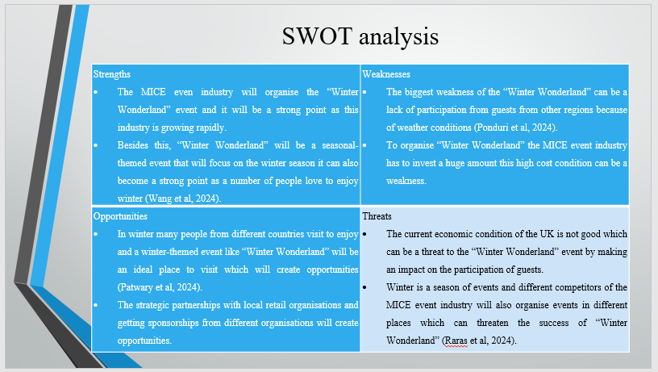
Strengths  - The MICE even industry will organise the “Winter Wonderland” event and it will be a strong point as this industry is growing rapidly.  - Besides this, “Winter Wonderland” will be a seasonal-themed event that will focus on the winter season it can also become a strong point as a number of people love to enjoy winter (Wang et al, 2024). | Weaknesses  - The biggest weakness of the “Winter Wonderland” can be a lack of participation from guests from other regions because of weather conditions (Ponduri et al, 2024).  - To organise “Winter Wonderland” the MICE event industry has to invest a huge amount this high cost condition can be a weakness.
Opportunities  - In winter many people from different countries visit to enjoy and a winter-themed event like “Winter Wonderland” will be an ideal place to visit which will create opportunities (Patwary et al, 2024).  - The strategic partnerships with local retail organisations and getting sponsorships from different organisations will create opportunities. | Threats  - The current economic condition of the UK is not good which can be a threat to the “Winter Wonderland” event by making an impact on the participation of guests.  - Winter is a season of events and different competitors of the MICE event industry will also organise events in different places which can threaten the success of “Winter Wonderland” (Raras et al, 2024).

PESTLE analysis
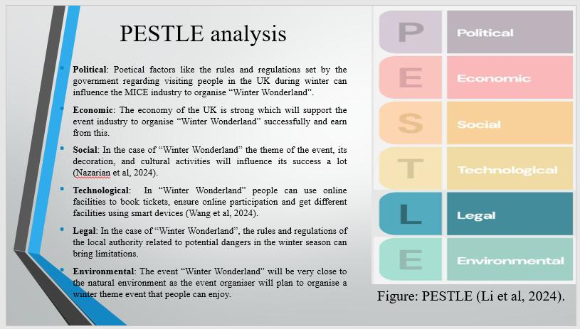
Political: Poetical factors like the rules and regulations set by the government regarding visiting people in the UK during winter can influence the MICE industry to organise “Winter Wonderland”. Also, issues like BREXIT will also influence the event by creating participation issues (Celuch et al, 2024).
Economic: The economy of the UK is strong which will support the event industry to organise “Winter Wonderland” successfully and earn from this. However, different current issues like COVID-19, inflation, and geo-political issues hamper the economy a lot which can increase challenges for the MICE event industry to organise the event (Li et al, 2024).
Social: Social factors are related to the wants, requirements, preferences, values and other things of individuals which often influence the success of an event. In the case of “Winter Wonderland” the theme of the event, its decoration, and cultural activities will influence its success a lot (Nazarian et al, 2024).
Technological: The MICE event industry will ensure the proper application of technologies in its events to enhance the experience for the guests. In “Winter Wonderland” people can use online facilities to book tickets, ensure online participation and get different facilities using smart devices (Wang et al, 2024).
Legal: Legal factors of an event are related to the laws and legislation of the place which make a direct impact on the success of the event. In the case of “Winter Wonderland”, the rules and regulations of the local authority related to potential dangers in the winter season can bring limitations. Besides this, changes in employment laws in seasonal themed events, privacy of employees and guests etc. can influence the MICE Event industry to organise “Winter Wonderland” (Ponduri et al, 2024).
Environmental: The event “Winter Wonderland” will be very close to the natural environment as the event organiser will plan to organise a winter theme event that people can enjoy. The arrangement of the event, the waste management system in the event, transportation system used in the event can influence the environment where the MICE Event industry has to focus (Patwary et al, 2024).

Strategic pre-planning for arranging
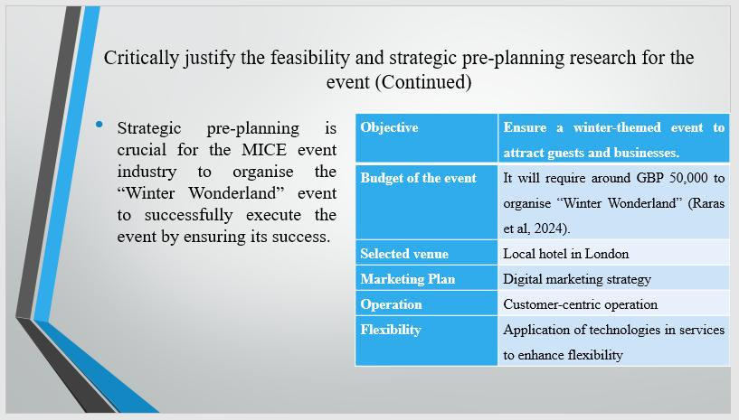
Strategic pre-planning is crucial for the MICE event industry to organise the “Winter Wonderland” event to successfully execute the event by ensuring its success. The event organising team will identify the right place and time to start the event so that it can offer a suitable place where people can enjoy the winter-themed event most with the fear of extreme weather change. Therefore, since supply is not directly related to this industry, the hotel sector should not be concerned about it. The event organising team will ensure the right resources, proper budgeting, marketing strategy, flexibility and proper event operation to reach the objectives. Below the plan for “Winter Wonderland” is presented-
Objective | Ensure a winter-themed event to attract guests and businesses.
Budget of the event | It will require around GBP 50,000 to organise “Winter Wonderland” (Raras et al, 2024).
Selected venue | Local hotel in London
Marketing Plan | Digital marketing strategy
Operation | Customer-centric operation
Flexibility | Application of technologies in services to enhance flexibility

Conclusion
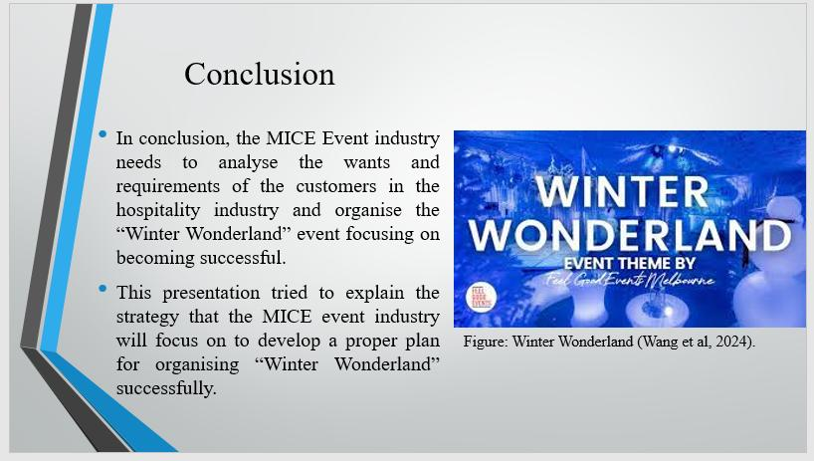
In conclusion, the MICE Event industry needs to analyse the wants and requirements of the customers in the hospitality industry and organise the “Winter Wonderland” event focusing on becoming successful. This presentation tried to explain the strategy that the MICE event industry will focus on to develop a proper plan for organising “Winter Wonderland” successfully. Supply has no direct relationship to the hospitality sector because their primary business is providing services.

References
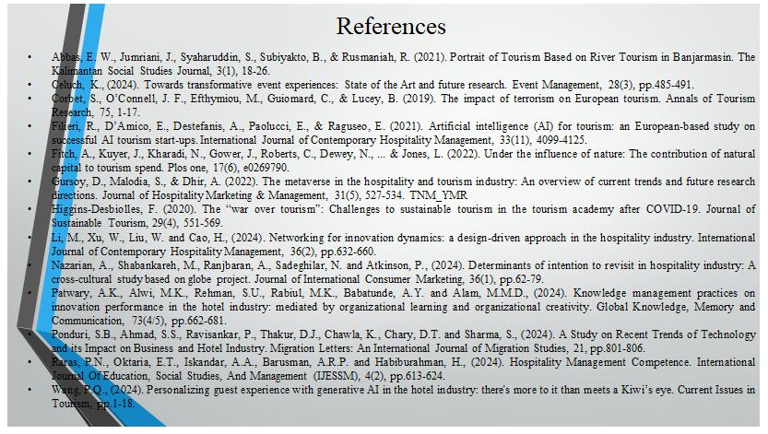
Abbas, E. W., Jumriani, J., Syaharuddin, S., Subiyakto, B., & Rusmaniah, R. (2021). Portrait of Tourism Based on River Tourism in Banjarmasin. The Kalimantan Social Studies Journal, 3(1), 18-26.
Celuch, K., (2024). Towards transformative event experiences: State of the Art and future research. Event Management, 28(3), pp.485-491.
Corbet, S., O’Connell, J. F., Efthymiou, M., Guiomard, C., & Lucey, B. (2019). The impact of terrorism on European tourism. Annals of Tourism Research, 75, 1-17.
Filieri, R., D’Amico, E., Destefanis, A., Paolucci, E., & Raguseo, E. (2021). Artificial intelligence (AI) for tourism: an European-based study on successful AI tourism start-ups. International Journal of Contemporary Hospitality Management, 33(11), 4099-4125.
Fitch, A., Kuyer, J., Kharadi, N., Gower, J., Roberts, C., Dewey, N., ... & Jones, L. (2022). Under the influence of nature: The contribution of natural capital to tourism spend. Plos one, 17(6), e0269790.
Fox, D. et al. (2014) Doing events research: from theory to practice. Routledge: Oxford
Further Meredith, J. (2022) Project management: a managerial approach
Getz, D. and Page, S. (2019) Event studies: theory, research and policy for planned events. 3rd Edition Routledge: Oxford
Gursoy, D., Malodia, S., & Dhir, A. (2022). The metaverse in the hospitality and tourism industry: An overview of current trends and future research directions. Journal of Hospitality Marketing & Management, 31(5), 527-534.
Higgins-Desbiolles, F. (2020). The “war over tourism”: Challenges to sustainable tourism in the tourism academy after COVID-19. Journal of Sustainable Tourism, 29(4), 551-569.
Li, M., Xu, W., Liu, W. and Cao, H., (2024). Networking for innovation dynamics: a design-driven approach in the hospitality industry. International Journal of Contemporary Hospitality Management, 36(2), pp.632-660. TNM_YMR
Nazarian, A., Shabankareh, M., Ranjbaran, A., Sadeghilar, N. and Atkinson, P., (2024). Determinants of intention to revisit in hospitality industry: A cross-cultural study based on globe project. Journal of International Consumer Marketing, 36(1), pp.62-79.
Ponduri, S.B., Ahmad, S.S., Ravisankar, P., Thakur, D.J., Chawla, K., Chary, D.T. and Sharma, S., (2024). A Study on Recent Trends of Technology and its Impact on Business and Hotel Industry. Migration Letters: An International Journal of Migration Studies, 21, pp.801-806.
Raras, P.N., Oktaria, E.T., Iskandar, A.A., Barusman, A.R.P. and Habiburahman, H., (2024). Hospitality Management Competence. International Journal Of Education, Social Studies, And Management (IJESSM), 4(2), pp.613-624.
Wang, P.Q., (2024). Personalizing guest experience with generative AI in the hotel industry: there's more to it than meets a Kiwi’s eye. Current Issues in Tourism, pp.1-18.

