Location Theory: How beneficial can it be with renewable energy?

- Introduction

Renewable energy is becoming an important factor for many countries as the growing concern of climate change and the amount of carbon being released by fossil fuels. This means that the use of renewable energy will be needed as it will lower the amount of carbon being released. This will mean that more areas will be needed to allocate these renewable resource sites. Location theory is a way in which that can help find the best areas for sites to be constructed. Location theory hasn’t been fully used for renewable energy resources, but the concept of location theory would be used as it can use logical decisions such as tidal not being in the middle of a lake or on the land. In this study the aim is to change the way location theory is thought about and to create a ranking system with the main factors of location choices in renewable energy.

1.1 Location Theory
Location theory was an idea theorised by German Theorist, Alfred Weber. Alfred Weber was trying to find new ways in finding locations for industrial sites during the 1800s. He thought that looking at multiple different angles of a location and determining which would provide the best economic benefit (Nolen, J. 2009). The main factors which were looked at were: Transport links; seeing the distance from the location to docking areas or train links. The labour costs for the people working within the area as it was believed that people working within big cities would be ‘cheaper’ than near the countryside (Capello, R 2011). The last area in which he looked into was the agglomeration economy, this looks at the output of the area and how the area is able to benefit from the area compared to others. Location theory has evolved into three main areas which are focused upon. The cost minimisation of the location, the maximum benefit and revenue and the maximum of the profit from the location. Although, it has evolved into looking into three different components, the main push is still for the most profitable location and money being the most important (Thisse, JF. 2008).

1.2 Renewable Energy
Furthermore, with renewable energy the cost of building upon the location would be important the output of the electricity or energy would be more important, especially with the carbon zero and zero emission targets across the world. Also, with in different renewable energy resources some of the prioritises will change as some may have more production at one location but will cost more for every ton of energy created. This shows that having a system to look at what could cause risk to the renewable energy would create a more sustainable location (Chapman, 2009). This was seen in Turkey where the government despite an increase in demand decided to change some of the fossil fuel energy and swap it for newly built wind farms. This was heavily invested in by Turkey, and they hoped that by 2023 30% of Turkey would be renewable. However, after the first few years they learnt that the wind speeds were not as high as they thought which mean the wind farms were not producing sufficient energy (Talinli et al., 2011). This shows that having a plan on what the location would be like would reduce the risk of having failed renewable resources. This method is used for a multitude of different business and could be used for more beneficial placements of renewable energy resources. This theory could help support the environment and cause there to be a more positive look on where renewable energy could be located in different areas. Looking into different priorities of the location of renewable energy resources. This could change from looking and the easiest location to build on and looking more into the production of the area and how close to communities and disruption. Many of the observations are undertaken and consultations are created for renewable energy but as seen by some examples, Barry biomass, they are not fully undertaken when choosing locations or which renewable technique. However, within location theory the main aim to produce the biggest profit within the company or factory but with renewable energy the main priority would change to most productive and least risk in failure for the location. This would take all the major factors into consideration and would be able to clearly express how the renewable energy would be able to affect them and could show what would be affected such as some of the fields or roads nearby.

1.3 Choosing Area and Renewable Energy Resource
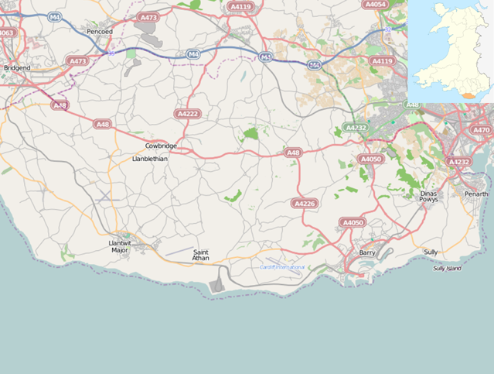
Some renewable energy resources are location based anyway which can make it easier to minimise the locations for construction. However, each of the main 7 renewable resources would be possible to be used with location theory. In order to focus on one particular renewable energy resource. An area in which would be chosen for the research to be undertaken would need to be chosen first. The area in which this research will be looked into is South Wales, mainly Vale of Glamorgan. This is due to the targets set being to increase the amount of renewable energy being used. Vale of Glamorgan has a target of becoming net zero by 2030, the Vale of Glamorgan up to 2026 is projected to have over 20% of electricity being from renewable resources. Also, as it is in Wales, it is local so in order to get to areas, it is very useful and accessible and local knowledge of areas which are more reasonable for renewable energy than others. Vale of Glamorgan are pursuing multiple different ways to increase renewable energy usage, these have included over 100 energy saving projects across council buildings, converting all street lights to LED and fitting heat pumps in different areas to reduce gas consumption (Local development play). Across the Vale of Glamorgan tehre are lots of plans to with reducing carbon emissions which indicates that areas across the Vale of Glamorgan would need renewable energy to be located nearby. In the Vale of Glamorgan tehre are some renewable resources which are unable to be located such as a natural geothermal system and hydroelectric as there are more productive types of renewable resource. Nuclear energy is able to be put up in many different places, however the UK are looking to close almost all of the nuclear power plants by 2030. This means that trying to find a location for a nuclear power plant wouldn’t be very beneficial for the Vale of Glamorgan as the UK seem to be shifting away from
Figure 1: Map showing the Vale of Glamorgan
nuclear energy. Also, lots of people do believe that nuclear power isn’t a renewable energy due to the amount of toxic waste which is produced. The next renewable energy which could be used within the Vale of Glamorgan is tidal energy. The has a lot of potential across the Vale of Glamorgan, however with the Vale of Glamorgan having multiple communities along the coast this could cause a large risk. This was seen when an offshore wind farm was being planned just off Porthcawl and lots of protests and consultations were to stop the construction of the wind farm. This shows that anything along the coast could cause a problem for constructions of different renewable resources. Another renewable energy which was disbanded was the biomass facility in Barry. This was constructed after 10 years of consultations and planning application but was met with a massive backlash from local communities. This is another reason why location theory could have been more beneficial as it could have shown that the public interference would have been a major risk for the development of the site. Solar energy is a big resource within the Vale of Glamorgan with multiple fields in use solely for solar farms. This shows that the Vale of Glamorgan has found good locations to locate these areas. However tehre is one renewable energy which is not utilised within the main land areas of the Vale of Glamorgan, this is wind energy. Wind energy is used throughout Wales but there is only one turbine in the Vale of Glamorgan. Wind energy and solar energy are two of the lowest prices for the cost per MWh, so they also support location theory with highest profitable outcomes (Bhutada, 2022). The Vale of Glamorgan as previously stated has a large community which can help evolve the way location theory is thought about as it shows the angle of people within the location. This helps location theory change from purely profit and revenue and look more at less risk and more beneficial for the environment and local areas.

- Aims and Objectives

The aims of the research are to look into the applicability and usage of location theory within renewable energy. The aim is to find how the use of location theory is able to be applied and why it can be important in the decision making. Also, looking into the different ways in which location theory is adapted to find which areas of location theory should be more prioritised. Within location theory, it is not fully understood across all brackets of industries as it was mainly used within industrial fields. Therefore, another aim is to find and understand the viability of location theory with renewable resources. This is through links between the industrial field and renewable resource construction and looking into the different ways that renewable energy can be utilised efficiently. The last aim is looking into the contribution to location theory and how it can be applied in different fields as well as with other renewable energy resources. This is to get a deeper understanding of location theory and gain reliability and validity on how location theory can work. This can help provide evidence that the change of location theory can support other environmental issues. This links to an objective where location theory would be able to support different industries into finding locations for business parks and buildings.

- Literature Review

The literature on location theory with linking with renewable energy is quite limited as there hasn’t been a massive study on whether it would be able to work or not. This implies that a lot of the literature about eh two topics will not have massively overlapping factors. Renewable energy is an important way in which the world is trying to tackle the amount of carbon being emitted into the atmosphere. This means that creating more ways and more areas for renewable energy to exist and produce energy is a significant factor to contribute to reducing carbon emissions (Shahzad, 2015). Furthermore, one of the main positive of renewable energy is that it is limitless if utilised to its maximum potential can provide a large benefit for the environment. However, one of the main problems with renewable energy is where to locate the energy resources. Some of the renewable energy resources have to be located in certain areas such as geothermal, tidal and hydroelectric as they all create electric using nature in certain areas. This is where location theory can become very advantageous for learning how to pinpoint locations for renewable energy. There was a study in Portugal which looked into knowledge of renewable energy resources. This was done by (Pinto et al., 2021) and looked at a random selection of around 1700 people they found and gave them a simple questionnaire about renewable energy. The questions were about whether they know what the renewable energy source was, what are the main environmental problems in Portugal and do you see any renewable energy on a daily basis. The results were quite surprising as the majority of people knew all of the renewable energy sources. Only 27% see the renewable energy in function. However, most of the people found it as a nice scenic view as it showed that the environment was benefitting off the use of these resources.
Over the last 10 years, the energy demand has almost doubled across the globe which provides a greater strain on scientists to create more ways to create energy. This makes it harder to create more renewable energy sites within the time frame due to the demand constantly increasing. Norway is one country which has thought about long-term energy demand and how that will affect hem in the future. In (Rosenberg. E 2013), it was found that in Norway they have found relatively cheap was of using the natural state of the country to obtain renewable energy production. They also found ways to implement technology and policies in order to reduce the projection of the energy demand. This shows that many ways are used in order to reduce the carbon emissions. However, it doesn’t fully show how renewable energy is going to help. There isn’t much previous work that can link location theory to renewable energy. However a lot of the recent papers which mention location have included transport costs, this was mentioned in both McCann (1998) and McQuaid (2004). These papers mention the factors of transport links between firms or factories, this indicates that location theory is still looked at in terms of profitable margins. The 1998 paper suggests that the location theory based upon transport costs are very little in terms of being a significant factor (McQuaid, 2004).
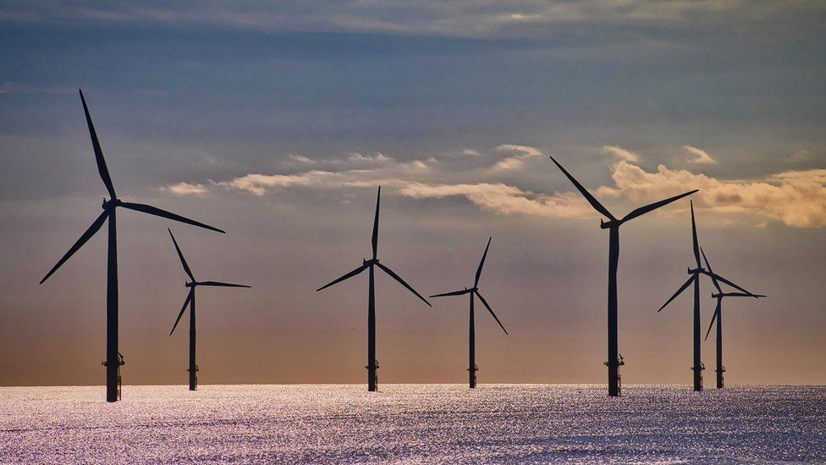
Location theory overall can help with tough decision making as it can easily compare multiple different areas clearly (Gorter & Nijkamp, 2001). However as time has evolved location theory has been developed into many different ways but it has formed into something known as the Weber problem. This links more with the transport links and choosing the more profitable location rather than the more reasonable location. The link between the transport routes is that the distances are different, and the longer route could be cheaper than the shorter route and determining the best profitable route (Nickel & Albandoz, 2005). The Weber problem was solved during the 1960s by the Weiszfeld algorithm which looked at the Euclidean distance facility location. This is the simple and direct line in which the distance can be measured between the two points. The would therefore find the median cost and a straight-line distance to find most cost-effective way of transportation (Lotfi et al., 2021). This shows that the development of location theory was evolving and becoming useful in the present day.
Figure 2: Offshore Wind Farm

- Methodology

4.1 Collecting Data
In order to find the best way to look at locations for renewable energy interviews and questionnaires will be very important. These would give knowledge in how different companies and aspects of jobs see how renewable energy can be located. Some of the main interviews will be focused upon wind farm experts in the field. Hopefully through these interactions a new understanding of how locations are thought about with wind farms. As well as whether the focus in economy is the best or reduction of risk can be a better view for future plans. The questions mainly focussing towards the wind farm experts will be mainly to do with what wind farms will need in order to be provided a potential placement rather than looking purely at the production of the area. This would hopefully help look at the comparisons with other areas and see which would be a more beneficial area for looking at placements of wind turbines. Renewable energy companies would also help in looking into these main factors as it can provide addition information on different angles on why the companies believe somewhere would be more helpful. Comparing these answers would give a clear understanding on what each of the different factors people believe would more important and should be prioritised. Also, with other renewable energy companies looking into ways in which they could have located the renewable energy somewhere else could provide a separate view, which shows that even without some of the factors it can still be a better location over other locations (Local development plan). Local councils within South Wales, Vale of Glamorgan and Cardiff, will also be contacted as they can show the support of governmental views on how renewable energy can be easily incorporated into different areas. The main council which will be in contact are Vale of Glamorgan as they are striving to become zero carbon by 2030 which could be benefitted trough using location theory. Also, in the Vale of Glamorgan tehre are plans to try and create more wind farms and location theory could help to pinpoint the exact locations needed across the county or to fully support areas which are being managed to have wind turbines in the future (Achieving our vision 2021). Within looking into location theory the best way to understand how it can be helpful is to provide multiple different views and put them together to find different options for each location. However one of the main problems is that location theory has never fully been understood and applied to different trades and researches. This insinuates that there are not many people who can fully understand how location theory would be able to practice the theory for benefits which are not purely for economical gain.

4.2 Presentation of Data

Area | Price of Land | Distance to National Grid | Weather  (Wind Speeds) | Conflict with communities | Amount of power generated | Land Topography | Wildlife endangerment | Visual Impacts

As shown above this would be how the table for each of the areas would be labelled and displayed. Each of the areas would by ranked out of 50 to give a clear comparisons between each of the areas. This would show the difference in whether the areas which have a higher price would create more power or whether the higher the price of land the less conflict with communities. Therefore using the table can eliminate different areas which have a low benefit for the production of the wind farm.
This would also be used to rank through 1-9 through the interviews and questionnaires in order to determine the difference in views on what would be the most important factor for the choosing of location. Using the difference between the ranking system can be put up with the different areas and show what areas of the Vale of Glamorgan can be utilised to the full potential for wind farms. The data collected within these tables will be portrayed in graphs and correlations to clearly show the different aspects within the Vale of Glamorgan. The graphs and correlations will hopefully be able to eliminate any anomalies in data and fully understand how the location theory can help renewable energy sites.
- Results
The results of the study could end up being a mix of all the different factors. This is due to the different views on each of the areas from environmentalists to construction companies. The difference in knowledge of the area can be a large range which could be a positive as it can give an understanding of the whole population. Overall, the study should show that location theory is able to help with placements of renewable energy as it factors in all the risks and can show which factors need more priority and which factors can support the other factors. Also, using the observations of the data and being able to go to the areas which have potential for wind turbines can provide a more realistic view on how the wind farms would be able to be constructed. One of the more obvious factors which should be important is the amount of power being created. However with the ranking systems it might be that the area which creates less power could be more beneficial as it is has a lower risk over having protests or opposition of the site. This was seen with the biomass in Barry where the production of the biomass facility would have been very beneficial but due to the constant protests and backlash through online consultations the facility was decommissioned. Therefore, if there were factors which provided a different angle on the approach it could have been located somewhere different and could be used for renewable energy today.

- Evaluation
Useful examples of how location theory could be useful in the future is through the amount of open areas which are located throughout South Wales. Vale of Glamorgan is seen to be full of little villages which suggests that there is lots of different areas in which can be exploited in order to create different renewable energy sites throughout the county. Also, in terms of looking at different ways to elevate location theory it could be used to find new housing areas as population is increasing so more houses are being constructed. Also, there are a lot of solar farm fields near Barry which could have an influence on whether more renewable energy sites could be created nearby.
Hopefully, this research also encourages the Vale of Glamorgan to pursue in wind energy if there are multiple areas in which it would be sustainable to create their own energy. This would be very beneficial for the Vale of Glamorgan as it would eliminate the transport of energy through the counties from the Valleys. This could also help to combine the decisions which are made between renewable companies and the experts in that renewable resource.
There are some limitations with this study. A lot of these limitations stem from location theory not being fully understood by a lot of people within the renewable energy field. This reduces the amount of reliability of the study as there may be areas where parts of the results could be assumed or thought about without major evidence. This is also seen through a lot of the methodology is through opinions of people within different companies which could show a bias. However, one of the main ways location theory is undertaken is through people’s perspective of how things are able to benefit the economy. Another limitation is that the majority of the data will be collected through interviews and questionnaires through companies and individuals within renewable energy. This relies heavily on replies from the people who are sent these interviews or questionnaires. This could reduce the amount of data and cause the whole research to become less reliable. As spoken about earlier location theory can be applied in many different ways to help with the environment. These could include different renewable resources or looking at different locations to see if they are able to become SSSIs or national parks. These would need different groups but would still have some of the same principles as they would need to prioritise different things to understand the environment.

- Conclusion
Overall, this research would be beneficial for environmental work in many different ways. Also this research hopes to show that location theory is still able to evolve and adapt to modern day problems. Therefore, location theory would be able to develop into most aspects of the environment which can be an important way to help tackle climate change especially with increasing weather events. Whereas, in this research study location theory can solidify the location of where renewable energy can be most beneficial to surrounding areas and the most sustainable energy production. However, some companies may feel that the most sustainable production isn’t as important as the maximum power output which could cause issues when choosing areas but the risk and danger of decommissioning the renewable energy site could sway opinions (Olabi, 2013).

- Gantt Chart

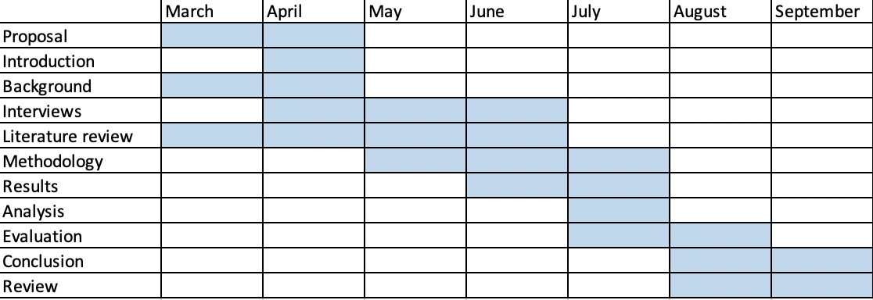
This is the Gantt chart which hopefully shows when each of the main components of research study will be completed by in order to maintain progress through the 6-7 months of which the study will be completed. These deadlines could change depending on the speed of some replies needed for methodology and whether new literature comes out about location theory.

- Reference:
- Achieving our vision (2021) Home. Available at: https://www.valeofglamorgan.gov.uk/en/our_council/achieving_our_vision/Achieving-our-Vision.aspx.
- Bhutada, G. (2022) What are the five major types of renewable energy?, Visual Capitalist. Available at: https://www.visualcapitalist.com/what-are-the-five-major-types-of-renewable-energy/.
- Bolter, K. (2020) Agglomeration economies: A literature review - W. E. upjohn institute ..., UpJohn Institute. Available at: https://research.upjohn.org/cgi/viewcontent.cgi?article=1256&context=reports
- Capello, R (2011). Location, Regional Growth and Local Development Theories, Journal: Aestimum, DOI:10.13128
- Chapman, K. (2009) “Industrial location,” International Encyclopedia of Human Geography, pp. 396–401. Available at: https://doi.org/10.1016/b978-008044910-4.00174-7.
- “Editorial Board” (2020) Geoforum, 111, pp. 155–164. Available at: https://doi.org/10.1016/s0016-7185(20)30089-0.
- Fischer, K. (2011) “Central places: The theories of von thünen, Christaller, and Lösch,” International Series in Operations Research & Management Science, pp. 471–505. Available at: https://doi.org/10.1007/978-1-4419-7572-0_20.
- Gorter, C. and Nijkamp, P. (2001) “Location theory,” International Encyclopedia of the Social & Behavioral Sciences, pp. 9013–9019. Available at: https://doi.org/10.1016/b0-08-043076-7/02490-6.
- Local development plan - renewable energy report - vale of glamorgan (no date) Dulas Resolutions. Available at: https://www.valeofglamorgan.gov.uk/Documents/Living/Planning/Policy/LDP/LDP_Renewable_Energy_Study.pdf.
- Lotfi, R., Mardani, N. and Weber, G.W. (2021) “Robust Bi‐level programming for Renewable Energy Location,” International Journal of Energy Research, 45(5), pp. 7521–7534. Available at: https://doi.org/10.1002/er.6332.
- McCann, P. (1998) The Economics of Industrial Location: A Logistics-Costs Approach, Springer, Berlin
- McQuaid, R. (2004) Department for Transport - The Importance of transport in business ..., Dspace. Available at: https://dspace.stir.ac.uk/bitstream/1893/17048/1/Dft-transport%2004%20%20web.pdf
- Nickel, S. and Albandoz, J.P. (2005) Location theory: A unified approach. Berlin, Heidelberg: 9201.
- Nolen, J. (2009) Location theory, Encyclopædia Britannica. Encyclopædia Britannica, inc. Available at: https://www.britannica.com/topic/location-theory (Accessed: March 26, 2023).
- Olabi, A.G. (2013) “State of the art on renewable and Sustainable Energy,” Energy, 61, pp. 2–5. Available at: https://doi.org/10.1016/j.energy.2013.10.013.
- Pinto, L.M., Sousa, S. and Valente, M. (2021) “Explaining the social acceptance of renewables through location-related factors: An application to the Portuguese case,” International Journal of Environmental Research and Public Health, 18(2), p. 806. Available at: https://doi.org/10.3390/ijerph18020806.
- Rosenberg, E., Lind, A. and Espegren, K.A. (2013) “The impact of future energy demand on renewable energy production – case of Norway,” Energy, 61, pp. 419–431. Available at: https://doi.org/10.1016/j.energy.2013.08.044.
- Shahzad, U. (2015) “The Need For Renewable Energy Sources.”
- Stevens, L. and Shearmur, R.G. (2020) “The end of location theory? some implications of micro-work, work trajectories and gig- work for conceptualizing the urban space economy,” Geoforum, 111, pp. 155–164. Available at: https://doi.org/10.1016/j.geoforum.2020.02.010.
- Thisse, JF. (2008). Location Theory. In: The New Palgrave Dictionary of Economics. Palgrave Macmillan, London. https://doi.org/10.1057/978-1-349-95121-5_2185-1
- Talinli, İ. et al. (2011) A holistic approach for wind farm site selection by using FAHP, IntechOpen. IntechOpen. Available at: https://www.intechopen.com/chapters/17126.

