Contents
1 Cardiff Business School, Postgraduate Teaching Centre (PTC): Schedule of Major Plant Equipment. 4
1.1 Boilers. 4
1.2 Boilers & CHP Unit Flues. 4
1.3 Combined Heat and Power (CHP). 4
1.4 Pressurisation Unit: Heating System / Chilled Water Pressurisation Unit. 4
1.5 Chiller. 4
1.6 Pumps. 4
1.6.1 Chilled Water Pump. 4
1.6.2 Underfloor Heating Pump. 4
1.7 Cold Water Booster. 4
1.8 Air Handling Units (AHU). 5
1.9 Heat Pumps. 5
1.10 Water Heaters. 5
1.11 Pressure Differential Control Valves & Combination Valves. 5
2 Organising Maintenance of the Building Engineering Services; Cardiff Business School, Postgraduate Teaching Centre (PTC). 5
2.1 The Organisation: Cardiff University. 5
2.1.1 Considerations of Implementing a Maintenance Strategy at the PTC. 5
3 Organising Maintenance of the Building Engineering Services. 6
3.1 Adopting the Principles of International Organisational Standards (ISO) 31000 & 55001. 6
3.2 Operations and Maintenance Manuals (O&M’s). 6
4 Creating a Maintenance Schedule. 6
4.1 Planned Maintenance. 8
4.1.1 Limitations Affecting Planned Maintenance. 9
4.1.2 Involvement of all users of the facility. 9
5 Maintenance: In-house or Outsourced? 9
5.1 In-house Maintenance. 10
5.2 Outsourced Maintenance. 10
6 Maintenance Strategy Conclusion 10
7 CARBS. PTC Building: Planning an Energy Audit. 11
7.1 Standards for Energy Audits. 11
7.2 Undertaking an Energy Audit. 11
8 Assessing the PTC. 12
8.1 The PTC Building. 12
8.1.1 Operational Hours. 13
8.2 Preliminary Audit Information. 13
8.3 How the PTC uses Energy. 13
8.4 Meter Usage. 13
8.4.1 Anomalies of Sub Meter Readings: (Figure 7). 16
8.4.1.1 Meter Name - SMB1. 16
8.4.1.2 Meter Names - SMB2 & DB External. 16
8.4.1.3 Meter Name - ‘Unknown’. 16
8.4.2 Sub Meter Anomalies, Combined Usage (SMB1, SMB2, DB External & Unknown). 16
8.5 Housekeeping to Improve Energy Efficiency. 17
8.5.1 Plant Equipment. 17
8.5.2 Involving PTC users in Energy Efficiency Efforts – Education & Collaboration. 17
8.5.3 Involving PTC Users in Energy Efficiency Efforts – Communication. 18
8.5.4 Operational Hours. An Opportunity to Save Energy? 18
9 Investment Grade Recommendations. 18
9.1 A Heating Alternative? 19
9.1.1 Hybrid Variable Refrigerant Flow (HVRF). 19
9.1.2 Estimated Costs of Installing a HVRF. 20
9.1.3 HVRF Efficiency. 20
9.1.4 Maintenance Savings & Improving Carbon Efficiencies with a HVRF System. 21
9.2 Future Energy Costs. 21
9.3 Renewable Energy Sources: Opportunities to Power a HVRF system? 21
9.3.1 Advances in Solar Technology to Assist a HVRF? 22
10 References. 22
11 Appendices 24
11.1 DEC. CARBS Postgraduate Teaching Centre 24
11.2 Items of Plant Equipment, including Pictures and Schematics. 25

Figure 1 Maintenance requirements for boilers, as specified by the CARBS O&M's. 7
Figure 2 NHS Estates; rankings for physical condition of each sub element (Source: NHS Estates). 7
Figure 3 Risk Matrix. 8
Figure 4 Overview of planned and unplanned maintenance (Source: Cibse Guide F). 8
Figure 5 Indicative annual services maintenance costs, for selected premises (based on first quarter 2012) (information provided by and reproduced by kind permission of BCIS) (Source: Cibse Guide F). 9
Figure 6 Process chart for an energy audit and the implementation of its recommendations. Source: Lewry (2013). 11
Figure 7 Sub meters and Monthly meter readings at the PTC 14
Figure 8 Meter Usage at PTC, illustrating total CHP meter use. 15
Figure 9 CHP meter energy use, compared to all other meters. 15
Figure 10 Energy Uses. CHP / Meters with anomalies of data and all other meters 16
Figure 11 HVRF Schematic. Source: Mitsubishi Electric 19
Figure 12 A risk management map. Source: Lewry, 2015. 20
Figure 13 Estimated HVRF vs VRF costs. Source: Mitsubishi Electric. 20
Figure 14 Years of fossil fuel reserves left. Source: BP statistical review of world energy 2016. (https://ourworldindata.org/how-long-before-we-run-out-of-fossil-fuels). 21
Figure 15 Electricity generation from solar, measured in terawatt-hours (TWh) per year. Source: Our World in Data based on BP Statistical Review into World Energy & Ember. 21

Abbreviations.
AHU Air Handling Unit
AM Asset Management
BCIS Building Cost Information Service
CARBS Cardiff Business School
CHP Combined Heat and Power
Cibse The Chartered Institution of Building Services Engineers
DEC Display Energy Certificate
HVRF Hybrid Variable Refrigerant Flow
ISO International Standardisation Organisation
Kw Kilowatt
Kwh Kilowatt Hours
O&M's Operational and Maintenance Manuals
PPM Planned Preventative Maintenance
PTC Postgraduate Teaching Centre
RM Risk Management
UK United Kingdom
VRF Variable Refrigerant Flow

Cardiff Business School, Postgraduate Teaching Centre (PTC): Schedule of Major Plant Equipment.
Whitehead Building Services provided an Operations and Maintenance manual (O&M’s) for the PTC, listing all plant equipment. Appendix 11.2 illustrates these plant items, together with pictures, and schematics.

Boilers.
Three, 200kW, gas fired boilers provide a maximum load of 600Kw. Combustion air is drawn into the closed air box, through the air inlet, and mixed with gas to produce the precise required combustion (Rehma, 2021). They are suitable to use with heating technologies using low grade heat such as heat pumps or underfloor circuits.

Boilers & CHP Unit Flues.
A piece of pipework which moves gases and hot air, to be safely dispersed.

Combined Heat and Power (CHP).
An energy efficient technology generating electricity by capturing wasted heat, providing useful thermal energy. It can be used for space heating, cooling, or providing domestic hot water to other parts of the building and improving efficiency by reducing fuel use.

Pressurisation Unit: Heating System / Chilled Water Pressurisation Unit.
Pressurisation units are used for heating hot or cold-water services, allowing for optimal pressure flows, using one or two pumps to maintain pressure flow. The pressure is controlled and detects when pressure is lost.

Chiller.
The chiller produces chilled water, by extracting heat from water and getting rid of it. The simplest approach is combining the heat rejection system and chiller into a single unit called a packaged chiller, incorporating fans to draw fresh air through the unit to carry heat away (De Saulles, 2002).

Pumps.
There are several plant items requiring pumps to support their function.

Chilled Water Pump.
Chilled water pumps are used to circulate water through primary or secondary pipe circuits. The pumps are sized individually and should be large enough to compensate for the total water pressure loss but supply sufficient water to the unit.

Underfloor Heating Pump.
A typical system heats the floor using an electric system or hydronic system, where water is pumped to designated areas.

Cold Water Booster.
Used to boost water pressure to multiple areas, particularly high-rise buildings.

Air Handling Units (AHU).
The AHU has a separate supply, an extractor fan, heat exchanger, air filter, heating coil and possibly a cooling coil with a ductwork system supplying and extracting air from around the building. The heating coil can be used as the main source of heat for the building. The volume of air can be controlled, saving energy in cold weather, as portions of warm extracted air are re-circulated back into the supply, cutting down on the fresh air to be heated. Similarly, in warm weather it can be used for night-time cooling (De Saulles, 2002).

Heat Pumps.
Heat pumps are used to extract heat from one place, upgrade it to a higher temperature and move it to another place. They circulate refrigerant liquids between two heat exchangers with a compressor pump.

Water Heaters.
Used to maximise water heating capacity, giving instant delivery of hot water. The heating technology was not established, but could be from several fuel sources, including renewables.

Pressure Differential Control Valves & Combination Valves.
Valves are used to absorb unwanted head pressure and limit differential pressures across pipework circuits.

Organising Maintenance of the Building Engineering Services; Cardiff Business School, Postgraduate Teaching Centre (PTC).

The Organisation: Cardiff University.
Cardiff University are an accredited organisation for Investors in People and ISO 14001: Energy Management Systems (Cardiff University, 2021), and aim to be a carbon neutral University by 2030 (Cardiff University, 2019).
Though these objectives are clearly defined, maintenance strategies for the PTC are unplanned, which can lead to maintenance faults, energy wastage and losses. This suggests such targets are ambitious, and support for maintenance services from senior management is limited, yet the consequences significantly impact organisational objectives.

Considerations of Implementing a Maintenance Strategy at the PTC.
The Chartered Institution of Building Services Engineers (Cibse) suggest maintenance strategies should start at the design stage of any building, by appointing a maintenance advisor, to advise on budgets and operational capabilities of the conceptual plant (Cibse Guide F, 2012, p.201). This suggests, assessing design options at the planning stage is critical to meeting organisational objectives, budgets and resources and ensuring engineering services are not over specified, which impact on upfront capital costs, plant performance, energy performance and planned maintenance schedules.
Yet, deciding whether to implement in-house or out-sourced maintenance for building and energy services, many primary factors must be considered, which cannot be generally applied across the estate, but through an understanding of each building.
Organisational objectives, budgets, staff resources and legislation are examples of such considerations, but regularly reviewing maintenance strategies should always consider its main drivers: Cost, legislation, and reputational risk.

Organising Maintenance of the Building Engineering Services.

Adopting the Principles of International Organisational Standards (ISO) 31000 & 55001.
When considering maintenance strategies for the PTC, an understanding of the principles of ISO 31000: Risk Management (RM) (ISO, 2018) and ISO 55001: Asset Management (AM) (ISO,2014) is suggested. ISO 31000 and 55001 require top-down leadership, continued involvement from those within the organisation and continually reviewing processes to ensure their success.
ISO 31000:2018, defines risk as ‘the effect of uncertainty on objectives’, and highlights risk as positive and negative. Each item of plant is an asset, which presents risks, and therefore, inclusion of plant within an AM register is essential, and a critical process to planning maintenance schedules of engineering services.

Operations and Maintenance Manuals (O&M’s).
The O&M’s provide clear maintenance guidelines for equipment and services, and a clear statement, outlining.
Only a regular and organised scheme of maintenance work, planned to cover all details of the installation, within given maintenance periods, can ensure continued satisfactory operation with a minimum liability to supply due to equipment faults.
(Whitehead Building Services, 2014)
It was established the existing plant is out of warranty. Whether this was due to a lack of a planned maintenance program, or whether the installer was only offering lower warranty terms, was inconclusive.

Creating a Maintenance Schedule.
The O&M’s outline maintenance frequencies, legislative requirements and whether qualified engineers are required as part of maintenance measures. It is suggested, where the PTC is concerned, an asset and maintenance register be established, detailing these requirements, which responds to legislation, and allows condition of plant equipment to be assessed.
This allows an opportunity to assess current conditions and develop a maintenance plan across the PTC. As an example, Figure 1 illustrates advice set out in the O&M’s, for boilers.
Figure 1 Maintenance requirements for boilers, as specified by the CARBS O&M's.
Additionally, a condition report, allows for regular monitoring of plant equipment. Methods outlined in the Davies report, into ‘Underused and Surplus Property within the NHS’ (Davies, 1993), and categories adopted by the NHS Estates, outlined in their 2004 report, ‘a risk-based method for establishing and managing backlog’ (NHS Estates, 2004), illustrated in figure 2, could also be implemented.
A | As new and can be expected to perform adequately to its full normal life
B | Sound, operationally safe and exhibits only minor deterioration
B (c) | Currently as B but will fall below B within 5 years
C | Operational but major repair or replacement is currently needed to bring up to condition B
D | Operationally unsound and in imminent danger of breakdown
X | Supplementary data added to C or D to indicate that it is impossible to improve without replacement

Figure 2 NHS Estates; rankings for physical condition of each sub element (Source: NHS Estates).
Where elements are below condition ‘B’, it is suggested they should be risk assessed, to ascertain whether the sub element needs to be addressed urgently. Figure 3 demonstrates how risk ratings can produce differing risk scores for these sub elements. If consequence risks are classified as ‘extreme risks’, it is recommended they’re effectively managed, or, addressed as an urgent priority.

Severity x Likelihood = Risk Rating
 | Likelihood
Severity | 1  Rare | 2  Unlikely | 3  Possible | 4  Likely | 5  Almost Certain
5 Catastrophic | 5 | 10 | 15 | 20 | 25
4 Major | 4 | 8 | 12 | 16 | 20
3 Moderate | 3 | 6 | 9 | 12 | 15
2 Minor | 2 | 4 | 6 | 8 | 10
1 Negligible | 1 | 2 | 3 | 4 | 5
 | 15-25 | Extreme risk
 | 8-12 | High risk
 | 4-6 | Moderate risk
 | 1-3 | Low risk

Figure 3 Risk Matrix.

Planned Maintenance.
Once created, the schedule should be reviewed, and a program of planned maintenance undertaken. Cibse, guide F, suggest this is based on ‘time’ or ‘condition’ of plant and whether maintenance is preventative, or corrective (Figure 4), which is assisted by the maintenance schedule. However, much depends on available staff resources, budgets, and perhaps more importantly: how the facility is viewed by senior management.

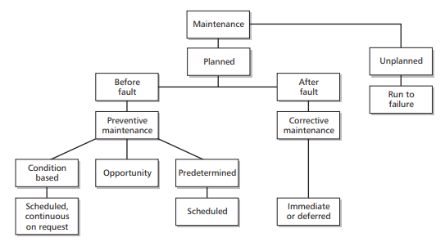
Figure 4 Overview of planned and unplanned maintenance (Source: Cibse Guide F).

Limitations Affecting Planned Maintenance.
There are 180 buildings across the University estate, presenting challenges and opportunities, especially when considering staff resources. Yet, significance of maintenance budgets, as far as engineering services are concerned, is highlighted by the complexities of how property and maintenance services are viewed by senior management.
Research by Roulac found property must be recognised as a means by which an enterprise connects both with its resource inputs (employees and suppliers) and its customers, in which the physical environment has an extraordinary role in its marketing function (Roulac, 2001). This is particularly important where the University is concerned, as the customer is a critical part of the process to meeting its objectives and suggests the reputational risk of a building which fails to deal with engineering maintenance issues in a timely manner can have a negative effect on the organisation.
A program of Planned Preventative Maintenance (PPM) is suggested, with budgets based on recommendations by the BCIS, summarised in figure 5. Cibse Guide F sets out, and allows for indicative budgets to be set, based on building usage.
Building Type | Estimated Maintenance cost (£/100 M²)
Offices
- General | 2000
- Air conditioned | 2200
- Non-Air-conditioned | 1650
- University | 1800
- Administration building | 1550

Figure 5 Indicative annual services maintenance costs, for selected premises (based on first quarter 2012) (information provided by and reproduced by kind permission of BCIS) (Source: Cibse Guide F).
These figures relate to 2012, and are for illustrative purposes only, and not exhaustive. Further consideration to how the building is utilised, along with occupancy hours and rates, allows accurate and appropriate maintenance budgets to be set.

Involvement of all users of the facility.
People are at the heart of all processes, particularly RM and AM, which are important aspects of maintenance management. Users of the facility must feel part of maintenance process and encouraged to report maintenance issues (Moss, 2006). Communication from top management to users is recommended, highlighting the important role they play in ensuring ‘their’ facility is well maintained. Such communication can be developed to consider energy saving initiatives.

Maintenance: In-house or Outsourced?
There are advantages and disadvantages when considering whether to undertake maintenance in-house, or to outsource. The arguments for undertaking in-house maintenance can be retaining control and familiarity of staff to the facility and its expectations. The arguments for outsourcing are equally as strong, such as flexibility, efficiency, and expertise of outsourcing partners.
Such considerations are essential, but the needs of the facility are the most important concern, and therefore an approach to a hybrid of in-house and outsourcing is suggested.

In-house Maintenance.
The O&M’s recommend regular maintenance, and the schedule outlines maintenance frequencies to plant equipment and each sub element of equipment.
PPM should be undertaken by university staff, rather than requiring more costly qualified service engineers. It is critical PPM is supported by management to ensure plant is functioning reliably, efficiently, and effectively, whilst protecting and enhancing the asset value of the plant and building, ensuring the health, safety, and comfort (Cibse Guide F, 2012, p.201), of those using the PTC.

Outsourced Maintenance.
Advantages of out-sourcing are access to skilled resources, familiarity with plant and current legislation. In the event of plant breakdown, it is safe to assume in-house staff are potentially quicker to react, but outside contractors may have the necessary tools and skills to repair plant quicker, thus reducing downtime within the facility. Skilled labour should undertake necessary servicing required by specialist engineers, complying with relevant legislation, and undertaken as part of a PPM agreement.
Nevertheless, employing external contractors should require tight specifications and service level agreements, prior to tendering for external contractors. Cibse set out advice in their Guide M document, ‘Maintenance Engineering and Management’, covering contract documents, conditions, specifications, tender procedures, and monitoring of the ongoing contract (Cibse Guide F, 2012, p.202). Risks exist when out-sourcing maintenance contracts, and it is suggested ‘cost, plus profit margin’ maintenance contracts be explored, which can alleviate budgetary concerns with certainty of fixed prices for servicing and parts, with known hours worked to repair plant.

Maintenance Strategy Conclusion
Roulac suggested, property must be recognised as a means by which an enterprise connects with its resource inputs and its customers. Therefore, with reputational risks to the University, adopting a PPM maintenance strategy is essential to meeting University objectives.
An equipment asset and maintenance register (figure 1), could be designed to include maintenance plans, provide basic condition reports (figure 2) and assessing risk (figure 3). Updating this following each service visit, can ensure corrective action is taken to failing equipment, or which is showing signs of failure, leading to more efficient plant, and providing opportunities to repair plant rather than replace.
Leadership is essential and adopting the principles of ISO 31000 and ISO 55001 allows management to review maintenance processes, whilst providing communication opportunities to involve those using the facility, who can contribute to its efficiency through encouragement to report maintenance issues.
A hybrid of in-house and outsourcing maintenance is recommended. In house maintenance can be implemented with immediate effect, but further consideration and reference to Cibse Guide M, should be taken, to guarantee the right maintenance contract and conditions are sought, prior to awarding an outsourced maintenance contract.

CARBS. PTC Building: Planning an Energy Audit.
By 2050, 80 % of current buildings in the UK are already built, accounting for 50% of energy usage (UK Green Building Council, 2021). Much of this provides an indoor environment, satisfying occupiers within, in the form of heating or cooling space, ventilating areas, supplying occupiers with electric lighting, hot water or electricity for equipment within.
Energy consumption is the greatest source of greenhouse gas emissions, contributing to 73% worldwide (Ge and Friedrich, 2020), and The Paris Agreement sought to address this though its landmark, multi-national legally binding agreement. Yet, for many businesses and organisations, the key reasons to reduce energy use is to save costs, comply with legislation or reduce risk.

Standards for Energy Audits.
ISO 50001: Energy Management Systems, refers to audits as energy reviews, yet an energy audit is more associated with BS EN 16247.
The systematic Inspection and analysis of energy use and energy consumption of a site, building, system, or organisation with the objective of identifying energy flows and the potential for energy efficiency improvements and reporting them.
(European Standard BS EN 16247 p5, 3.1)

Undertaking an Energy Audit.
Energy audits can be undertaken by outsourcing, or if resources are available by experienced in house members of staff. Audits require considerable amounts of sub metering over a period of a year or more, with further consideration given to plant, how the building was constructed, its size, and different energy resources used. Gathering this information helps develop a process, which permits energy audits to be undertaken, and allows recommendations to be implemented. This process is illustrated by Lewry (2013), set out in Figure 6.
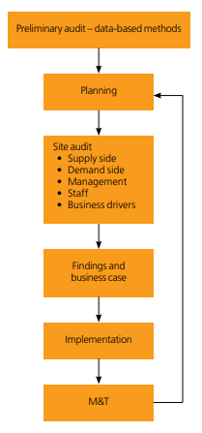
Figure 6 Process chart for an energy audit and the implementation of its recommendations. Source: Lewry (2013).
When considering what an energy audit should cover, Lewry recommends a survey, covering several aspects, yet the depth of such a survey depends on the level of anticipated savings and available investment in time and resources (Lewry, 2012), and must be measurable or managing them becomes difficult.
- Building and/or process
- Pattern of use
- Energy supply
- Process equipment
- Building services
- Lighting
- Distribution networks
- Metering and performance
- Management and facilities
- Staff issues
- Maintenance and upgrades
- Opportunities for improvements

Assessing the PTC.

The PTC Building.
A 5142.45 sq. meter, 3 storey building whose main entrance is located on the North-East elevation. The South-West elevation has a stairwell and toilet facilities, with a ‘bri soleil’ over the rear lobby entrance. Behind the North elevation is a lecture theatre, stairwell, and AHU plant room. The South elevation has a curtain walling, behind which is a void and glazed façade, with occupied office space, which is pictured below (Wood, 2021).
North-east elevation | South-west elevation
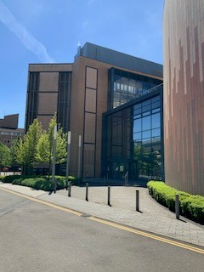 | 
South-west elevation | South elevation
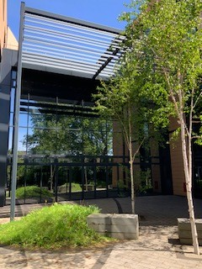 | 

Operational Hours.
It was advised:
- Weekdays, 8am – 6pm (some days 8pm)
- Weekends 9am-4pm on a Saturday and 10am - 2pm, Sundays.
- Patterns of occupation could not be ascertained.

Preliminary Audit Information.
Lewry (2013) suggests important information must be gathered, prior to starting an audit, such as reviewing previous audits, historical surveys, and other energy-related organisational projects. Moss (2006), advises surveying those staff using the building is an essential requirement, to measure comfort levels, which may show false energy consumption. The site visit was unable to determine this.
The O&M’s provided critical information about plant serving the PTC. It is 7 years since completion, suggesting plant equipment should be at an optimum. Yet, the lack of maintenance could suggest it is not performing at its peak, and such ‘housekeeping maintenance’ is suggested to improve performance.

How the PTC uses Energy.
Understanding how the building uses energy, asset ratings and operational ratings are required. The visit could not determine the asset rating, but the 2020 DEC indicated an operational rating of C, compared to ‘B’, in 2019 (Appendix 11.1), offering an opportunity to investigate further.

Meter Usage.
There are several sub meters at the PTC, and annual usage is illustrated in figure 7. The meters in green showed a relatively stable use. Sub meters highlighted in yellow, orange, and red suggest discrepancies in monthly meter readings, requiring further investigation. The CHP is the biggest energy user, emphasised in figure 8, with figure 9 giving further comparison of the CHP against all other combined plant.

Figure 7 Sub meters and Monthly meter readings at the PTC

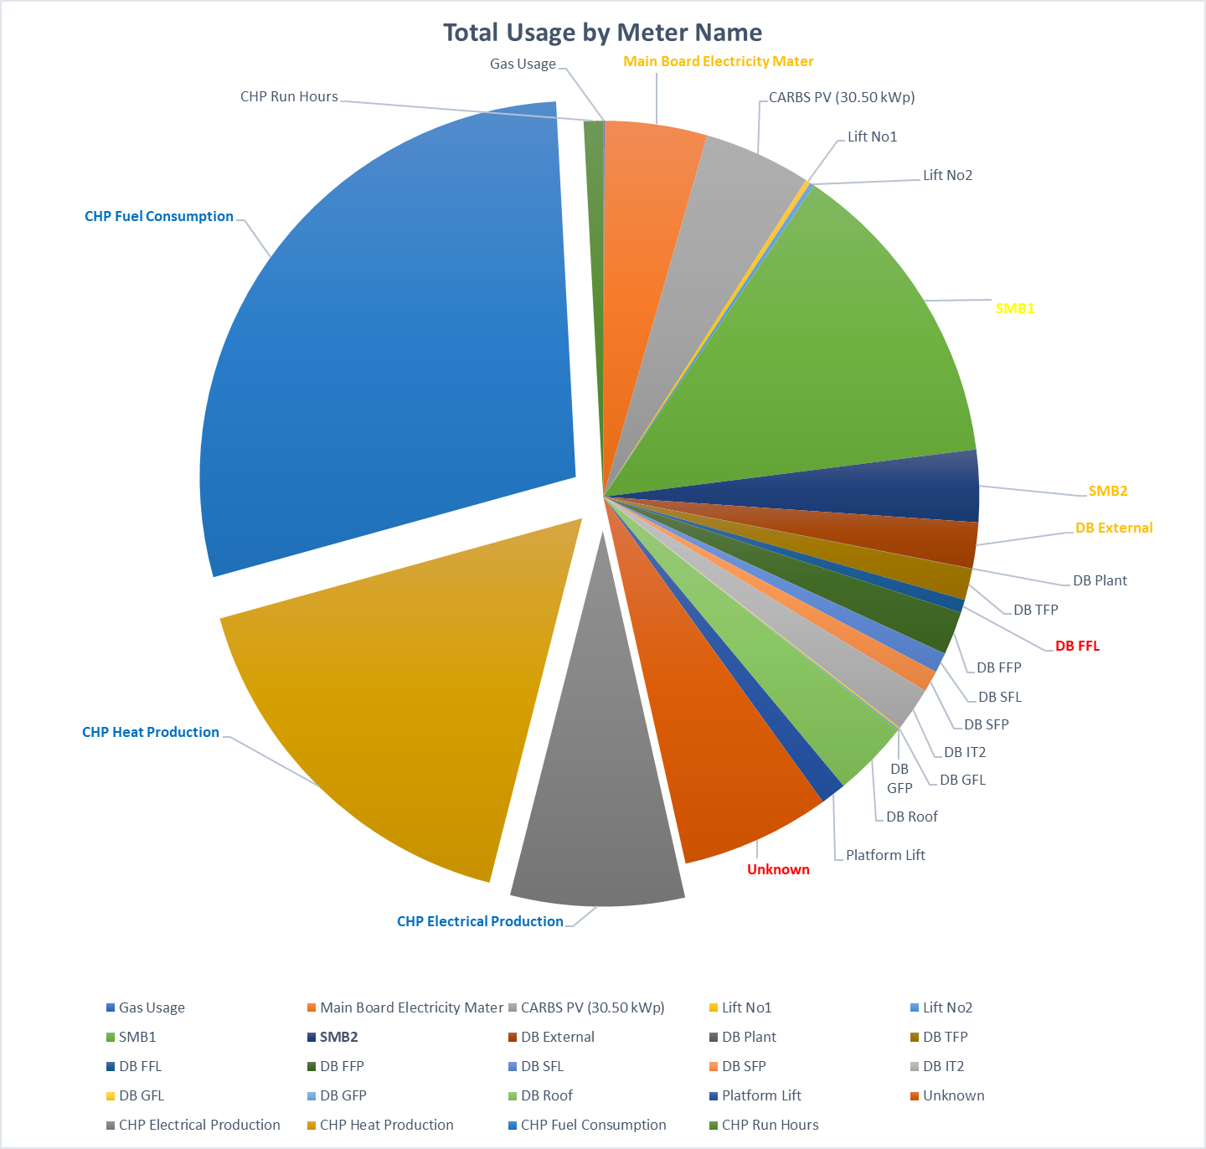
Figure 8 Meter Usage at PTC, illustrating total CHP meter use.
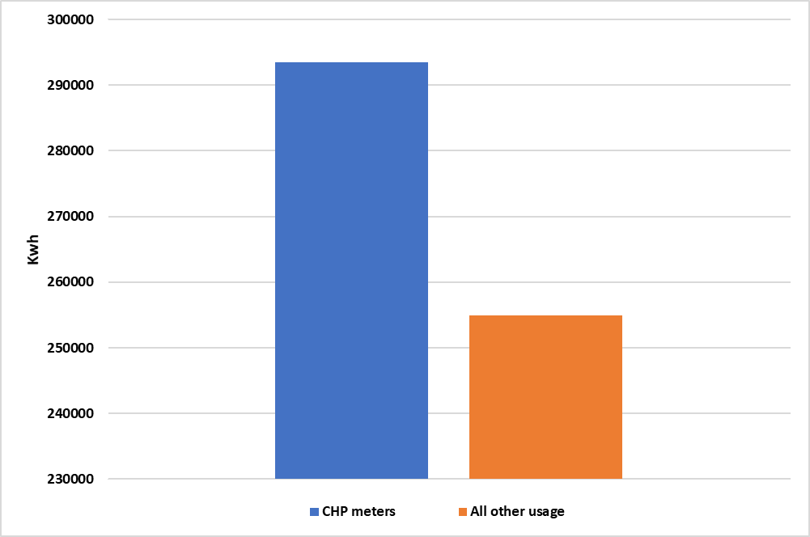
Figure 9 CHP meter energy use, compared to all other meters.

Anomalies of Sub Meter Readings: (Figure 7).
Understanding what sub meter related to what plant and area proved difficult, given the abbreviations of meter names. Analysis of annual consumption of each sub meter highlighted several sub meters with data anomalies, providing an opportunity to assess the plant or equipment these meters serve.

Meter Name - SMB1.
SMB1 accounts for 13.5% of energy use, illustrated in figure 7, yet readings each month are quite random. Considering its position as a major energy user, its recommended this sub meter be investigated to determine why readings vary.

Meter Names - SMB2 & DB External.
Accounting for 5% of energy use, both meters have provided anomalies in monthly readings. SMB2 has above average usage in February, March, October, and November. DB External has anomalies in meter readings taken for January, October, November, and December. It may be safe to assume seasonal changes play a role, but a better understanding of usage can help determine if anything is untoward.

Meter Name - ‘Unknown’.
The ‘Unknown’ meter accounts for 6.42% of energy use. Knowing what this meter is monitoring is critical and further investigation is suggested.

Sub Meter Anomalies, Combined Usage (SMB1, SMB2, DB External & Unknown).
Figure 10 illustrates these sub meters account for 26% of energy use, demonstrating the need for a greater understanding of their readings and the sources they are reading, for recommendations to be made.
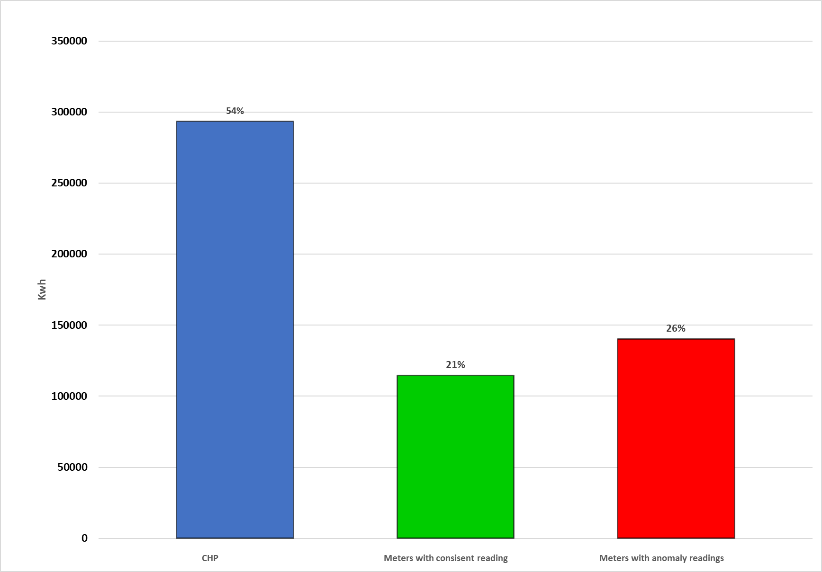
Figure 10 Energy Uses. CHP / Meters with anomalies of data and all other meters

Housekeeping to Improve Energy Efficiency.

Plant Equipment.
Point 6 concluded with the suggestion to implement a program of PPM. The importance of this is highlighted by Moss who suggested annual energy consumption can be reduced through a maintenance schedule, checking thermostat settings, time scheduling of plant and zones and perhaps the most important point, encouragement of occupants to view energy consumption as a daily habit (Moss, 2006).

Involving PTC users in Energy Efficiency Efforts – Education & Collaboration.
Information gathered indicated students are encouraged to undertake ‘black out days’, but there’s no incentivisation of staff or students to participate in anything other than ‘token’ efforts. People are part of all processes, and encouragement, collaboration, and education of users of the PTC can help reduce energy consumption, which is an absolute requirement of energy conservation initiatives (Moss, 2006).
The site visit indicated several areas, where simple adjustments could be made and which are photographed (Wood, 2021). Some examples are highlighted, but which are not exhaustive.
- Tv on Standby. | - Personal 4-gang socket being used.
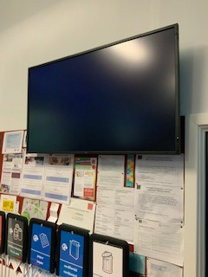 | 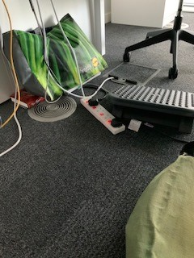
- Bags blocking the adjacent floor vent | - Personal fan under a desk.
` | 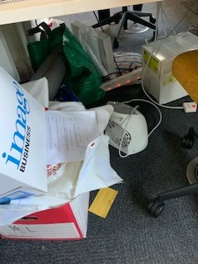
- Sofa’s blocking floor vents. | - Radiators being blocked by benches.
 | 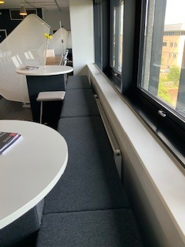
- Pictures 1 & 2. Immediate impacts of energy use, through minor housekeeping changes, such as turning off equipment can be made.
- Pictures 3 & 4 demonstrates the actions of one user affects conditions of others. Blocked floor vents could lead to users bringing in personal heating fans, which maybe in continual use.
- Pictures 5 & 6, Illustrate a lack of understanding of the heating system, with floor vents and radiators covered. This may be unnoticed in summer, but in colder months could lead to complaints about inside temperatures.
Telephones on permanently.  - Each phone is continually running a 5w.  - This equates to 120w a day.  - 43,800w (43.8Kwh) a year.  - At a price of 0.1507p per Kwh, this would equate to £6.60 per year per phone.  (https://powercompare.co.uk/electricity-prices/) | 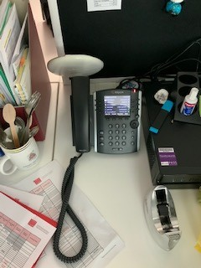

With circa 4000 similar phones across the University Estate, its estimated £26,400 is spent keeping phones on 24/7, which presents an opportunity for quick savings.

Involving PTC Users in Energy Efficiency Efforts – Communication.
Communication is a two-way process. Staff must be encouraged to participate in energy saving measures, through a process allowing them to highlight issues affecting energy usage. For example, one W/C was accessed during the visit where a continual flow of water was witnessed. Across an estate, leakages could see significant wastage and costs. Therefore, maintenance communication measures should be adopted, encouraged, and rewarded.

Operational Hours. An Opportunity to Save Energy?
The opening hours and usage are noted in 8.1.1. Operating plant equipment to facilitate 4 hours on a Sunday is an inefficient use of the facility, and its suggested the facility closes on Sundays.
Monitoring user numbers on Saturdays could demonstrate the need to only use one floor, reducing heating costs, or, to even close the facility due do minimal use.
Though housekeeping and maintenance demonstrate small but immediate savings, recognising investment in plant could provide opportunities for bigger cost savings and better energy efficiencies.

Investment Grade Recommendations.
Cost, legislation, and risk are drivers for energy audits. Current targets to be carbon neutral by 2030, coupled with diminishing fossil fuel reserves, suggest the CHP unit, may provide an opportunity for investment grade recommendations.
Figure 7 highlights an increase in CHP meter readings from March, suggesting CHP became the main source of heating at the PTC, offering a perspective that greater gas consumption was a factor in the Operational rating change of the DEC.
Figure 9 demonstrated the CHP as the primary energy user. By way of an example, Novembers total gas usage was 19672 Kwh, heat production 11567Kwh and electric production 5172Kwh, suggesting CHP is using more energy than it is producing to heat the building. The electric production of 5172Kwh suggests the efficiency of the CHP is 85%. The bolier specification, advises the Broag boilers optimal efficiency is 95.2% (Rehma, 2021), and maybe a more efficient alternative?
Yet, the drive to be a carbon zero university by 2030 suggests other heating alternatives should be considered, but which could also reduce energy usage and maintenance costs.

A Heating Alternative?

Hybrid Variable Refrigerant Flow (HVRF).
Mitsubishi Electric have developed a hybrid VRF (Variable Refrigerant Flow), a patented, world first technology (Mitsubishi, 2021). HVRF looks to replace chiller systems, which are high maintenance items, with 4 pipes running around the building and requiring a boiler and VRF to carry refrigerant around the building. HVRF allows the heating requirements of one area to offset the cooling requirements of another, which can assist in the reducing of energy costs, but also reducing the impact of refrigerants being used, contributing to university objectives.

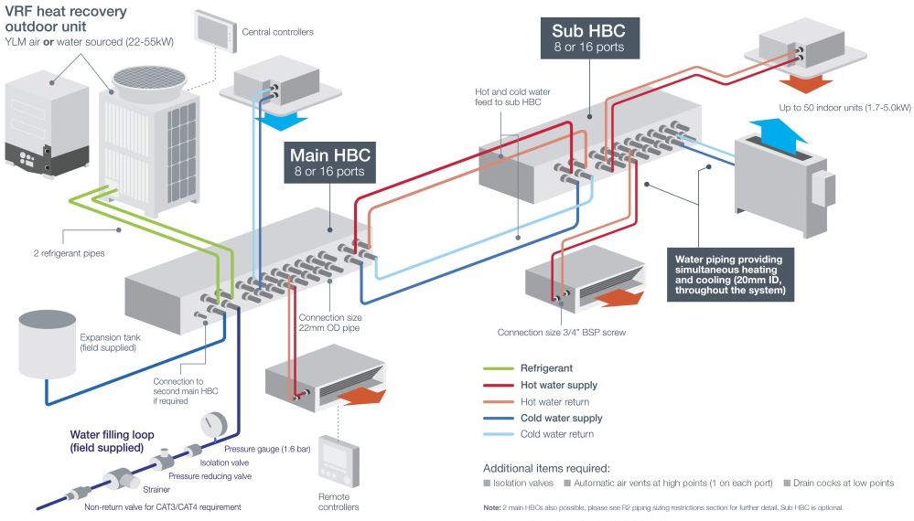
Figure 11 HVRF Schematic. Source: Mitsubishi Electric
Changing a heating system involves significant capital investment, but the ‘do-nothing’ scenario, cannot be taken, especially considering Government legislation, the Universities carbon management plan, and potential rises in energy prices. Lewry suggests these capital risks should be categorised using a risk map, demonstrated in Figure 12.
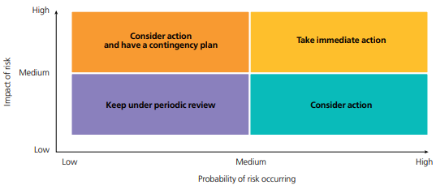
Figure 12 A risk management map. Source: Lewry, 2015.

Estimated Costs of Installing a HVRF.
The existing boilers provide capacity loads of 600kW. Figure 13 is a 450kW system and priced at £600,000. Though capital costs must be considered, the HVRF is a modular system which can be gradually fitted, and costs managed.
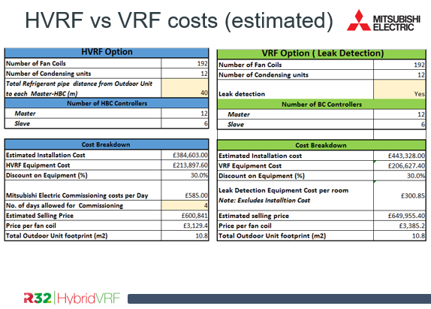
Figure 13 Estimated HVRF vs VRF costs. Source: Mitsubishi Electric.

HVRF Efficiency.
The HVRF efficiency provides for a minimum 5:1 or as high as 7:1. The boiler efficiency is 95.2%, suggesting its maximum capacity is 571Kwh. The PTC load capacity requirements could not be determined, but the lack of maintenance may already be diminishing this capacity.

Maintenance Savings & Improving Carbon Efficiencies with a HVRF System.
The O&M’s indicate the need for regular maintenance of chillers, boilers and their components, the cost of which could be recovered. Changes in refrigerant allows for the removal of internal leak detection devices, improving carbon efficiencies: a key University objective.

Future Energy Costs.
Predicting energy prices is difficult. UK Government’s commitment to renewable energy sources and targets to reduce emissions to net zero by 2050, suggest energy prices will rise, especially where fossil fuels are concerned. This suggestion gains further strength when it was reported in 2016, only 52.8 years supply of natural gas remained: Figure 14.
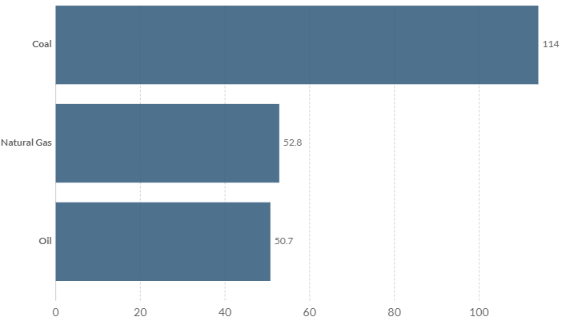
Figure 14 Years of fossil fuel reserves left. Source: BP statistical review of world energy 2016. (https://ourworldindata.org/how-long-before-we-run-out-of-fossil-fuels).
Mitsubishis HVRF is a modular system, allowing for a phased move from a gas energy heat source, to one, perhaps powered by renewables in the long term.

Renewable Energy Sources: Opportunities to Power a HVRF system?
Figure 15 illustrates the last 10 years supply of electricity from solar. It is expected $1.2 trillion will be invested on an annual basis, 5 times more than fossil fuels (Burston, 2016), largely driven by Governments and Banks who have reduced fossil fuel funding, and pension funds who have switched to investing in renewable energy sources,
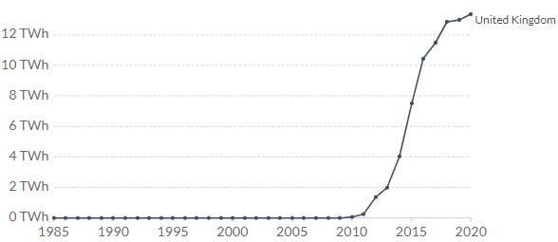
Figure 15 Electricity generation from solar, measured in terawatt-hours (TWh) per year. Source: Our World in Data based on BP Statistical Review into World Energy & Ember.
The PTC uses solar power, so space maybe limited. Therefore, new solar technologies maybe required to assist a HVRF system.

Advances in Solar Technology to Assist a HVRF?
Technology has advanced in recent years, largely due to investment, increased supply chains, and reducing prices. The images in section 8.1 illustrate opportunities for energy investment, which could improve the PTC energy supplies.
Developments in products such as a ‘peel and stick model’, such as Flextron by BipVco (BipVco, 2021), could see the South-west elevation overclad with 370W wall mounted solar panels, or applied to the bri soleil or roof vents.
These decisions need comprehensive cost/return exercises, but consideration should include how batteries such as the Tesla Powerwall will develop. Though maximum storage capacities for such batteries are 20Kwh (Solar Guide, 2021), given the investment in this sector over the last 10 years, it is reasonable to expect storage capacities to increase and supply costs to decrease, and which must be considered as a future alternative, and which could possibly harness solar gains to power a HVRF system in the future.

References.
BipVco (2021), BipVco Products. Available at: https://bipvco.com/products/ (Accessed 8 June, 2021).
Burston, J. (2016) Five Predictions for Energy in 2030. Available at: https://www.weforum.org/agenda/2016/11/5-predictions-for-energy-in-2030/ (Accessed 8 June, 2016).
Cardiff University (2019) Cardiff University declares climate emergency. Available at: https://www.cardiff.ac.uk/news/view/1730638-cardiff-university-declares-climate-emergency (Accessed 1 June, 2021).
Cardiff University (2021) Our Quality Standards. Available at: https://www.cardiff.ac.uk/about/facts-and-figures/quality-marks (Accessed 1 June, 2021).
Cibse (2021) About Display Energy Certificates (DEC). Available at: https://www.cibsecertification.co.uk/About-us/About-Energy-Certificates/Display-Energy-Certificates#:~:text=A%20display%20energy%20certificate%20%28DEC%29%20is%20required%20annually,and%20are%20therefore%20frequently%20visited%20by%20those%20people. Accessed (5 June, 2021).
Cibse Guide F. (2012) Energy efficiency in Buildings. The Chartered Institution of Building Services Engineers London.
Davies, C (1983) Underused and Surplus Property within the NHS. Available at: https://archive.org/details/op1277186-1001/mode/2up (Accessed 31 May, 2021).
De Saulles, T. 2002, The illustrated guide to mechanical building services, Bracknell : BSRIA, Bracknell.
European Standard (2012). Energy Audits – Part 1. General Requirements. Available at: http://www.comunidadism.es/wp-content/uploads/downloads/2012/11/JW001_23294_vot1e.pdf (Accessed 5 June, 2021).
Ge and Friedrich, 2020. 4 Charts Explain Greenhouse Gas Emissions by Countries and Sectors. [online] World Resources Institute. Available at: <https://www.wri.org/blog/2020/02/greenhouse-gas-emissions-by-country-sector> [Accessed 3 June, 2021].
Hall, F. and Greeno, R. (2013) Building services handbook, 7th ed. Oxford : Elsevier Butterworth-Heinemann, Oxford.
ISO (2014) ISO 55001:2014 Asset management — Management Systems - Requirements. Available at: https://www.iso.org/standard/55089.html (Accessed 1 June, 2021).
ISO (2018) ISO 31000:2018 Risk management — Guidelines Available at: https://www.iso.org/obp/ui/#iso:std:iso:31000:ed-2:v1:en (Accessed 1 June, 2021).
Lewry, A (2012) Energy Management in the Built Environment. A Review of Best Practice. Bracknell, Berkshire, IHS BRE Press
Lewry, A (2013) Energy Surveys and Audits. A guide to best practice. Garston, Watford IHS BRE Press
Mitsubishi (2021) City Multi HVRF Available at: https://les.mitsubishielectric.co.uk/products/air-conditioning/city-multi-hvrf (Accessed 7 June, 2021).
Moss, K. (2006), Energy management in buildings, 2nd ed. edn, London : Routledge, London.
NHS (2004) NHS Estates: A risk-based method for establishing and managing backlog. Available at: https://assets.publishing.service.gov.uk/government/uploads/system/uploads/attachment_data/file/148143/Backlog_costing.pdf (Accessed 2 June, 2021).
Rehma (2021) GAS 210 ECO PRO Product Details. Available at: https://mediacdn.remeha.co.uk/-/media/themes/remehauk/documents/current/specification-guides/gas-210-eco-pro-specification-guide.pdf?v=1&d=20190627T093225Z (Accessed 7 June, 2021).
Roulac, Stephen (2001). ‘Corporate Property Strategy is Integral to Corporate Business Strategy’. Journal of Real Estate Research. Vol 22. 129-152.
Solar Guide (2021). Solar Battery Storage: The Best Solar Batteries [2021] Available at: https://www.solarguide.co.uk/solar-batteries#/ (Accessed 5 June, 2021).
UK Green Building Council (2021) Climate Change. Available at: https://www.ukgbc.org/climate-change/#:~:text=Newly%20constructed%20buildings%20are%20more%20energy%20efficient%2C%20but,back%20dramatically%2C%20and%20insulation%20installation%20rates%20have%20stalled. (Accessed 5 June, 2021).
Whitehead Building Services (2014) Operations & Maintenance Manual, CARBS building, Cardiff University Business School. Unpublished.
Wood (2021) External Pictures of Cardiff Business School, Postgraduate Teaching Centre Private Pictures, Swansea (May 27, 2021).

Appendices

DEC. CARBS Postgraduate Teaching Centre
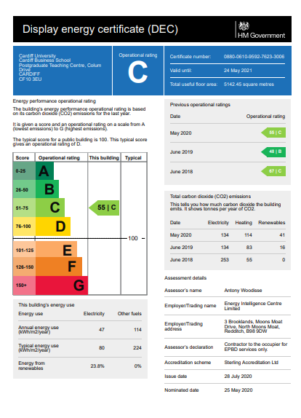

Items of Plant Equipment, including Pictures and Schematics.
1.1 BOILERS

Manufacturer: Broag Ltd
Model: Gas210 Pro 6 Section. Output: 200 kW each

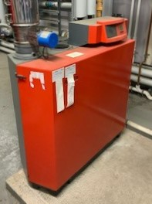
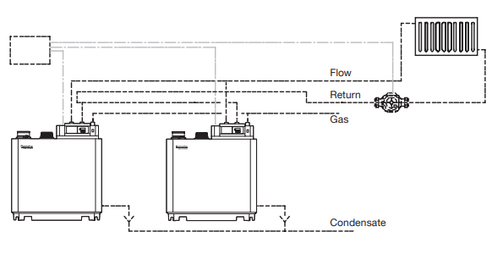
Image Source; https://www.remeha.co.uk/product-documents/current-literature

1.2 BOILER & CHP UNIT FLUES

Supplier/Installer: A1 Flues
NOTE – The model details were not contained within the O&M
The flue for the Broag Gas210 Pro 6, is detailed below, with a common header arrangement:
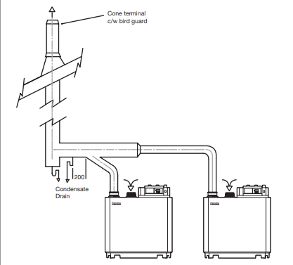

Image Source - https://www.remeha.co.uk/product-documents/current-literature

1.3 CHP UNIT

Manufacturer: SAV Systems
Model: Load Tracker XRG1 9G with Q40. Storage Vessel: 1000 Litres
Serial No: 11 14 00 0012

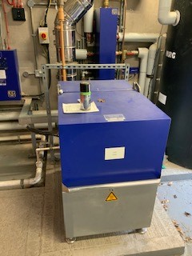


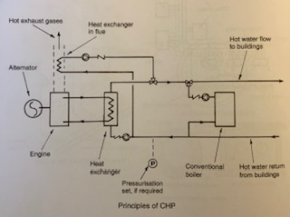

Image Source: Building Services Handbook, 7th Edition. Fred Hall & Roger Greeno
1.4 PRESSURISATION UNITS

2.4.1 Heating System
Supplier: BSS Ltd
Type: PHT F150
Serial No: B/0214/12506
Expansion Vessel Size: 800 Litre

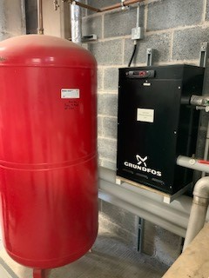
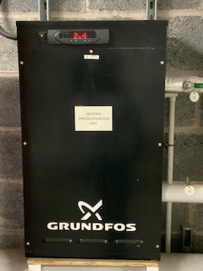
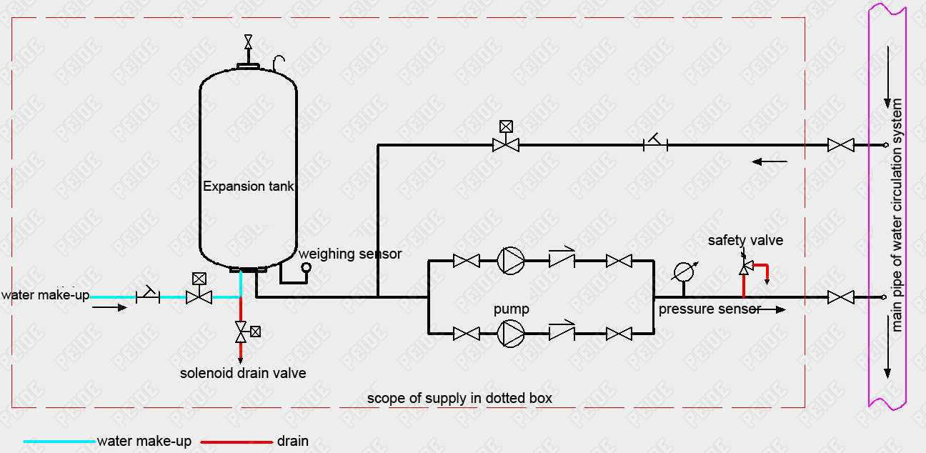

Image Source: https://www.hvacaqua.com/products/pump-controlled-pressurisation-system/

1.4 PRESSURISATION UNITS

Chilled Water System
Type: PHT F150
Serial No: A/0214/12506
Expansion Vessel Size: 300 Litre

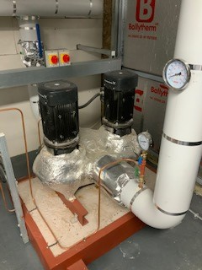

See Chillers schematic (2.5).
At point 6 the pump is located. The pump should be large enough to compensate for the total water pressure loss and supply sufficient water to the unit.

1.5 CHILLER

Manufacturer: Klima-Therm Ltd
Model: TMA 1B400A EC TUBOCOR
Duty: 400 Kw
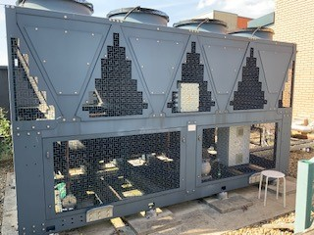
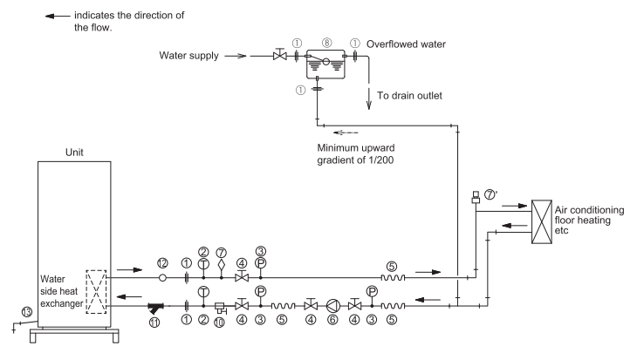
Image Source: Mitsubishi Electric

1.6 PUMPS
Manufacturer: Grundfos Pumps Ltd
1.6.1 Chilled Water Pump.
Points 2.4 & 2.5 show the images and schematic. The pump location, is point 6 on the schematic drawing.

1.6.2 Underfloor Heating

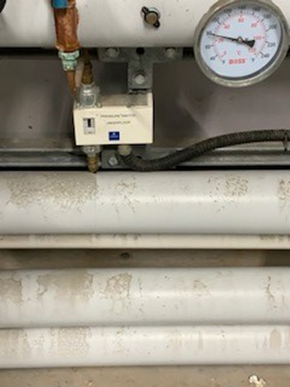
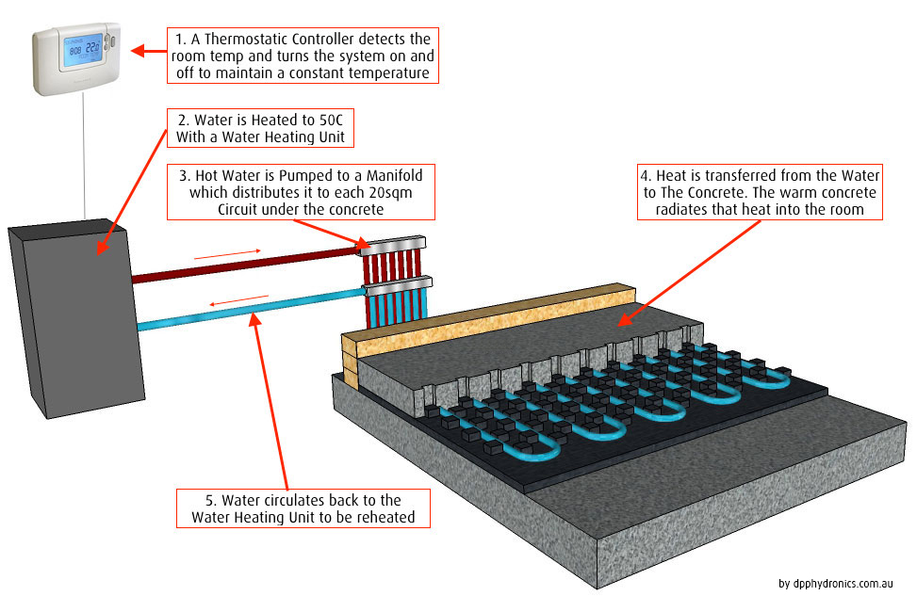

Image Source: https://dpphydronics.com.au/underfloor-heating/in-screed/
1.7 COLD WATER BOOSTER
Manufacturer: Grundfos Pumps Ltd Model: Hydro Gti
Serial No: 7556

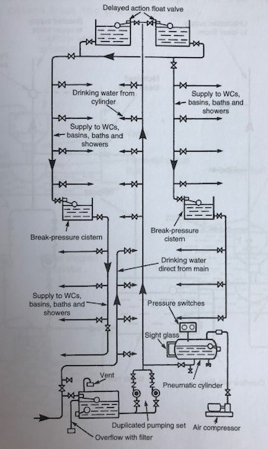
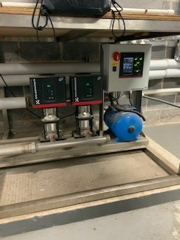
Image Source: Building Services Handbook, 7th Edition. Fred Hall & Roger Greeno

1.8 AIR HANDLING UNITS
Manufacturer: Thermal Technology Ltd
AHU11; WEGER ECONOMIC 66/66 0.26 @ 135 0.26 @ 143
There were 11 AHU’s in total with differing specifications.
The picture below relates to AHU 11.
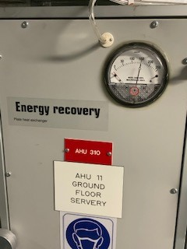
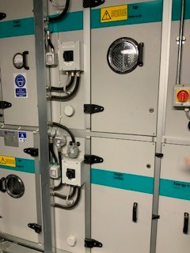
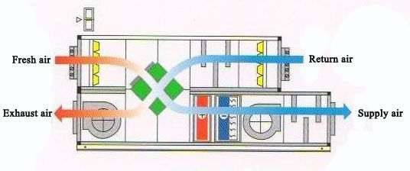

Image Source: https://methodstatementhq.com/sequence-of-operation-for-variable-volume-type-fresh-air-handling-units-fahus-with-enthalpy-wheel-heat-recovery-system.html

1.9 HEAT PUMPS
Supplier/Installer: Cool Solutions Ltd
PKA RP100KAL: PUHZ-P100HA4 9.4 Total/7.05 Sensible
Manufacturer: Mitsubishi Electric
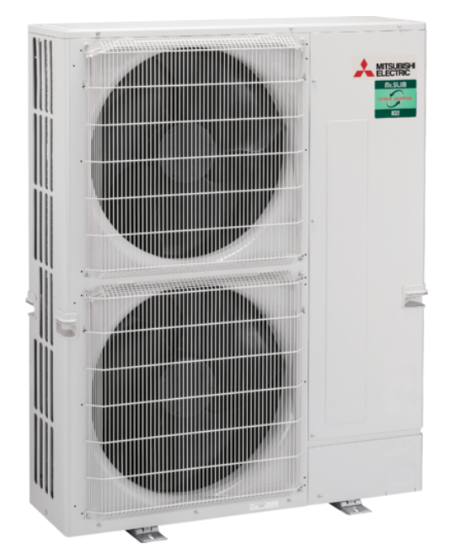
Image Source: Mitsubishi Electric
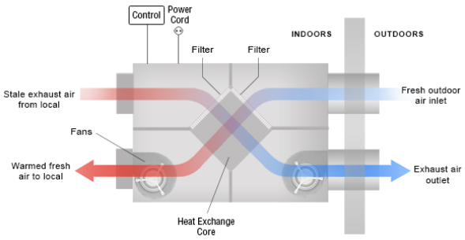
Image Source: https://www.airtecnics.com/technology/heat-recovery-overview

2.10 WATER HEATERS

Supplier: BSS Ltd
Manufacturer: Zip Heaters (UK) Ltd

No Picture was taken on the site visit. Below is an example picture and schematic of a gad fired water storage heater.
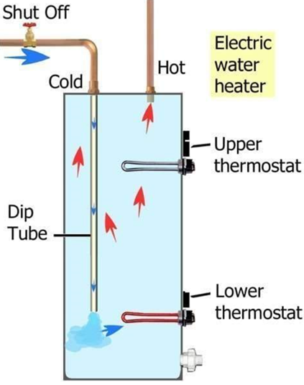
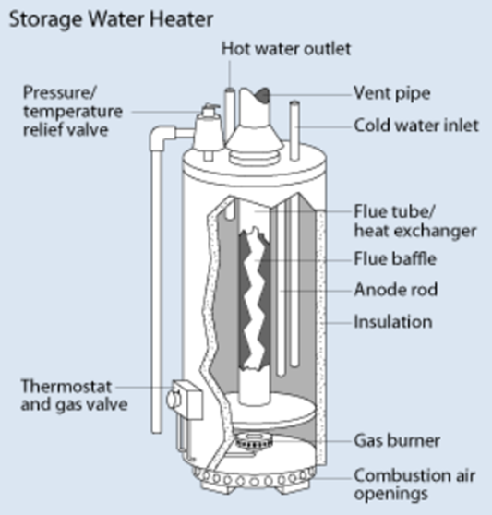
Image Source: http://www.eere.energy.gov/basics/buildings/water_heaters_conventional.html
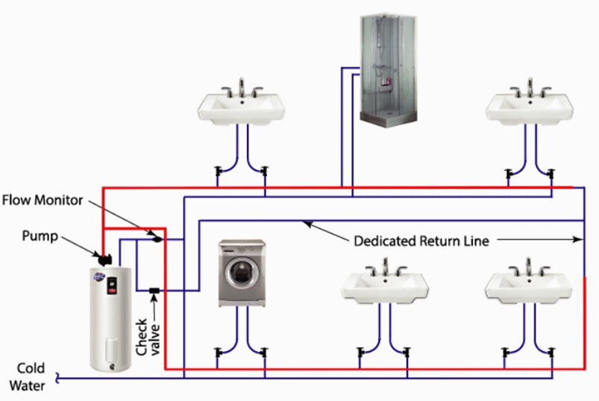
Image Source : https://kenmorewaterheater.blogspot.com/2020/01/water-heater-pipe-diagram.html
1.11 PRESSURE DIFFERENTIAL CONTROL VALVES & COMBINATION VALVES
Manufacturer: Samson Controls (London) Ltd
No Pictures were taken on the site visit. Below are pictures and schematic examples of a pressurisation control valve.
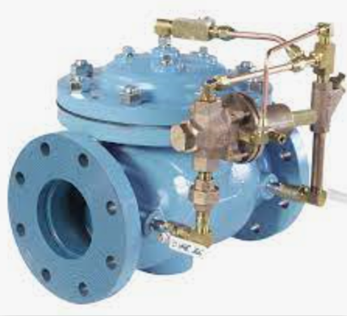
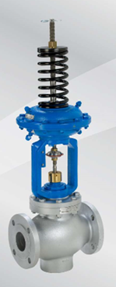
Image Source : https://www.controlvalves.com/product/model-110-differential-pressure-control-valve/
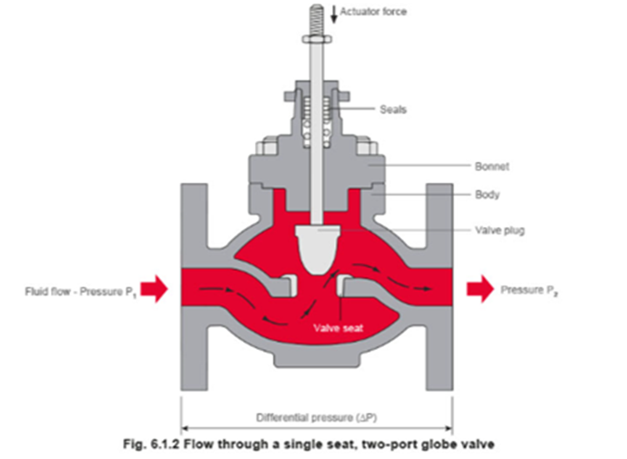
Image Source : https://www.spiraxsarco.com/learn-about-steam/control-hardware-electric-pneumatic-actuation/control-valves
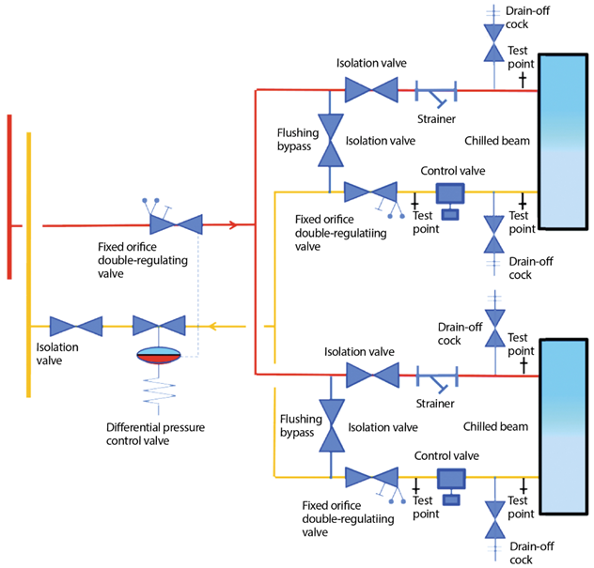

Image Source : https://www.cibsejournal.com/cpd/modules/2019-01-vvs/

