2/16/2026
University of Wales Trinity Saint David
London campus
E-Portfolio Link: https://smoustayine.wixsite.com/portfolio-avenue

LDE Assignment 1

Module Name: Learning In the Digital Era
Module Code: ACCA 4025

Student Name: Serigne Moustayine Fall
Student ID:2515322
Group: 2

Lecturer’s Name: Koushik Modak

Table of Contents
Introduction 2
Main Body 2
Task 1: Essential Academic and Employment Skills for the future career Path 2
Task 1 (a): Report on Essential Academic and Employment Skills 2
Task 1 (b): Evaluation of Task 1 (a) based on Similarity report 2
Task 2: Collaborative Mind Map and Individual Poster 2
Mind Map (Collaborative) 2
Poster (Individual) 2
Task 3: Virtual Collaboration and RefWorks 2
Report on Virtual Collaboration 2
Step-by-step process of using RefWorks with visuals 2
Task 4: E-Portfolio Creation and Evaluation 2
Task 4 (a): E-Portfolio Creation 2
Task 4 (b): Illustrative Review of E-Portfolio tool Selection 2
Conclusion 2
References 2
Task 1 References: 2
Task 3 References: 2

Introduction
Essential academic and employment skills are transferable abilities—such as communication, problem-solving, teamwork, and digital literacy—that enable success in education and the workplace. Employers prioritize these "soft skills" alongside technical knowledge, valuing adaptability, resilience, and initiative. Developing these skills improves career readiness.

Main Body

Task 1: Essential Academic and Employment Skills for the future career Path

Task 1 (a): Report on Essential Academic and Employment Skills
On my perspective both education and require a strong set of transferable skills. Now days it not easy to be combined both but relatively is better if you can merge them [1].
Preparing people, including younger generations, for work in the twenty-first century is a major concern. Parents and educators must recognise that there is a growing shortage of basic skills. Abilities that were once expected as standard are increasingly lacking among entry-level employees [2]. Abilities that, a generation ago, were routinely excepted are increasingly weak absent among entry-level employees [3]. These are some employment skills: Essential academic skills, communication skills, research skills, Critical thinking, time management, digital literacy, teamwork, problem-solving, professional communications, Adaptability and leadership skills. Even though some entry-level positions may not require advanced academic qualifications, basic academic abilities are still crucial for performing well at work. Ideally, employees should be capable of understanding instructions clearly, whether spoken or written, and completing tasks accurately and efficiently [2].
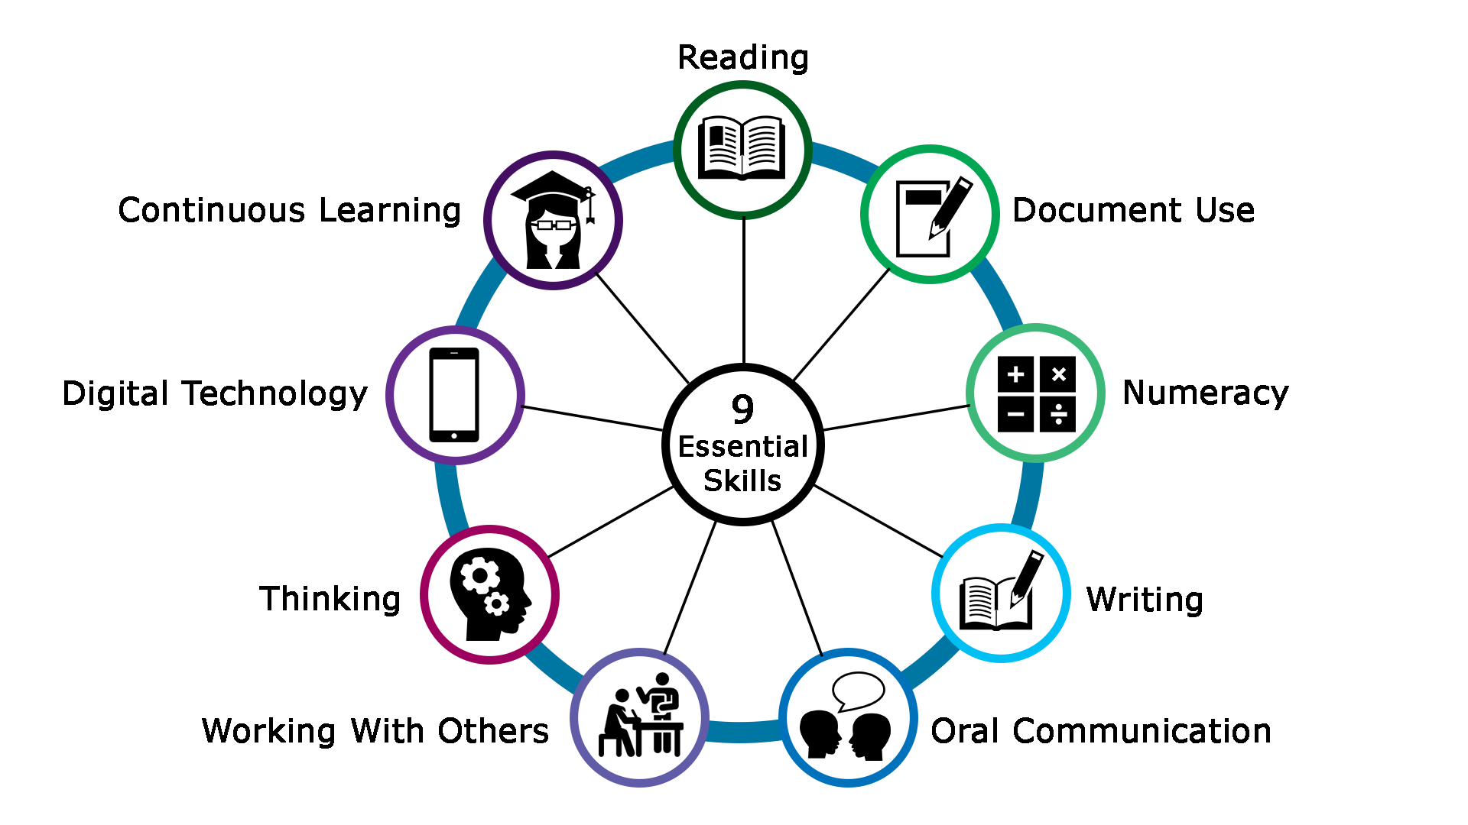
Figure 1; Developing Employment skills [1] [2]

Employability skills refer to the abilities that individuals need to gain and maintain employment. One of the key challenges employers face today is finding skilled workers and providing effective training. A major concern is the gap between the skills required for a job and those that candidates have. This mismatch, often referred to as the “skills gap” is a significant issue for employers and human resource managers seeking competent staff. These skills can be taught and developed through both education and workplace training. It is important to establish clear aims and objectives when teaching employability skills to ensure successful outcomes. Learning programmes should be carefully planned to help individuals achieve these goals. In addition, parents play an important role by supporting goal setting and demonstrating positive behaviours to young people in school. A collaborative and inclusive teaching approach should be used to improve students understanding of values, attitudes, and workplace responsibilities. Teachers, trainers, and supervisors must act as role models by demonstrating appropriate behaviour. Students should also be given opportunities to observe and understand real workplace expectations. Where possible, learning environments should reflect real conditions to better prepare individuals. Finaly, high standards should be clearly communicated, and learners should be held accountable for their behaviour [3].
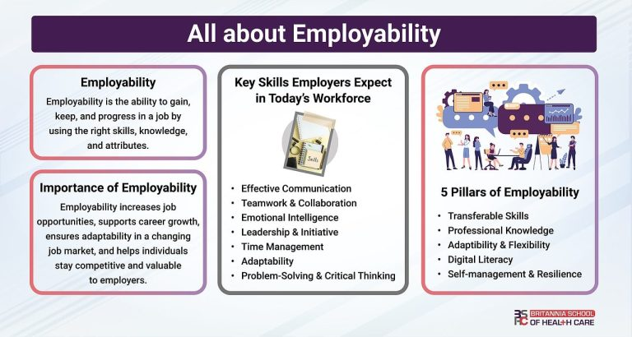

Figure 2; Developing Employment Skills [4]
The commonwealth department of education, science and training commissioned this report to examine effective methods for assessing and reporting the employability skills of senior secondary students. Its main purpose was to analyse various approaches to evaluating eight employability skills using five keys’ criteria: validity, reliability, objectivity, feasibility, and usability. The report also sought to recommend the most appropriate method for assessment and reporting [5].

Task 1 (b): Evaluation of Task 1 (a) based on Similarity report
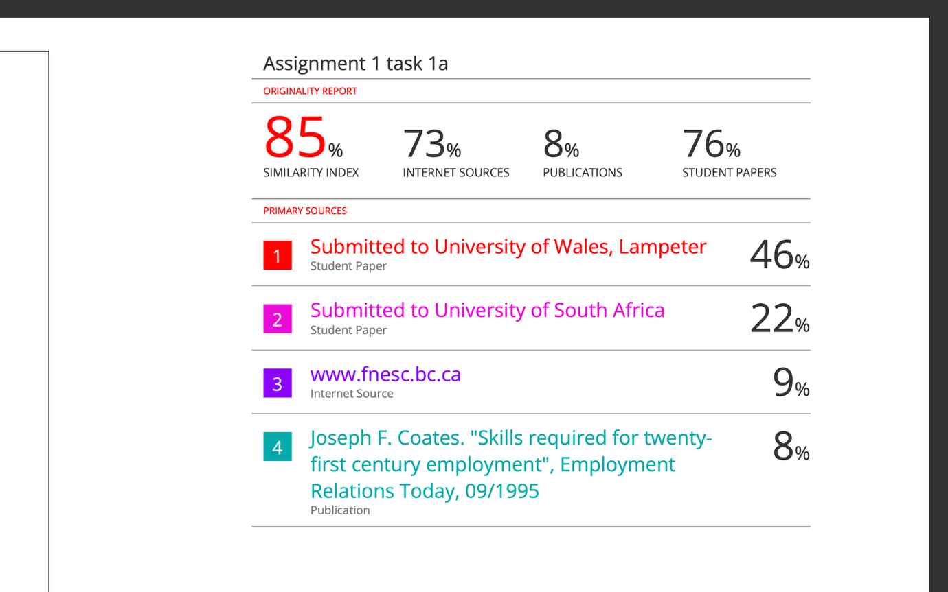
Based on Task 1 the similarity is high score due to temple/instructions.
This evaluation analyses task1 (a) in relation to the similarity report generated after submission. A similarity report highlights matching text between the submitted work and existing sources. Overview of the similarity report indicated that some sections of task 1(a) contained similarities with online sources academic materials, or previously published content. Additionally, referencing plays a crucial role in reducing similarity concerns. Any direct quotations should be placed in quotation marks and supported with proper in text-citations. In future assignments, I will plan my work more carefully, write drafts in my own words before consulting sources, and review similarity reports before final submission. This will help maintain academic integrity and improve the overall quality of my academic writing.

I’ll rate myself 90/100 only because I’ve done good search and uploaded pictures. Also, everything I do I give references. Technically, the similarly came from the temple I’ve used like any other students. I believe this is a very good mark for my wok, as I think I’ve completed my work with required details to the very good standards.

Task 2: Collaborative Mind Map and Individual Poster
Mind Map Link: https://mm.tt/map/3952802803?t=4jEESQx3A9
Mind Map Image:

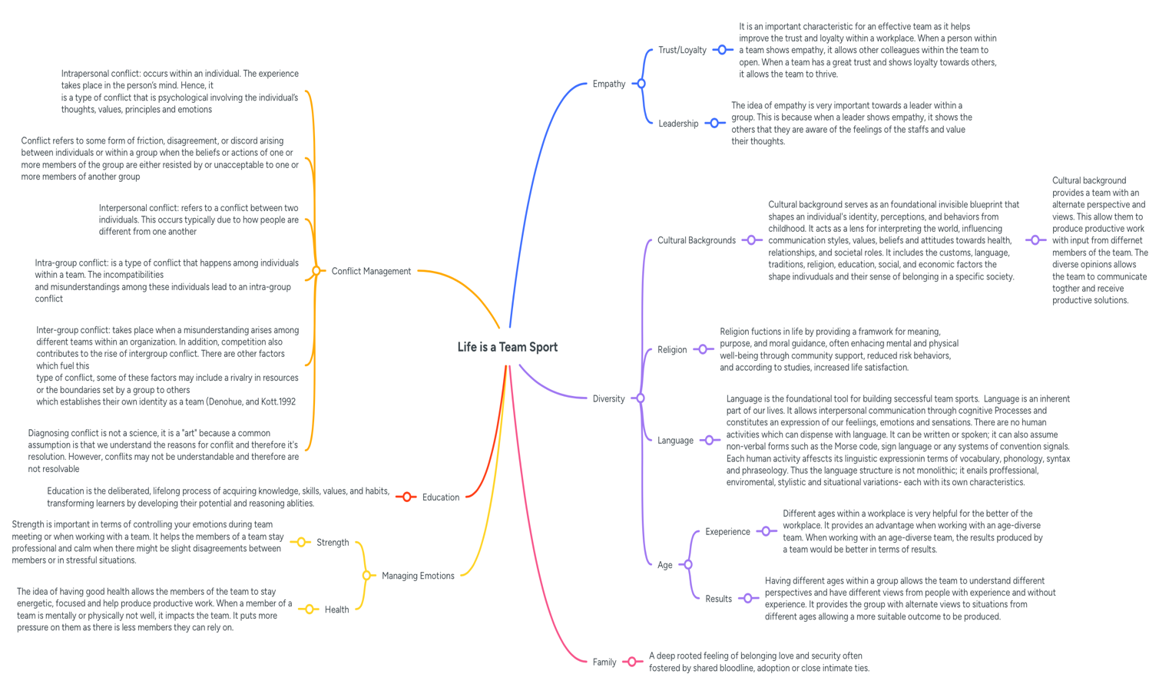

Poster Link:

https://www.canva.com/design/DAHDHiYHf5w/Rr1YqzVH0W4XfphKMEXnhw/edit?utm_content=DAHDHiYHf5w&utm_campaign=designshare&utm_medium=link2&utm_source=sharebutton
Poster Image: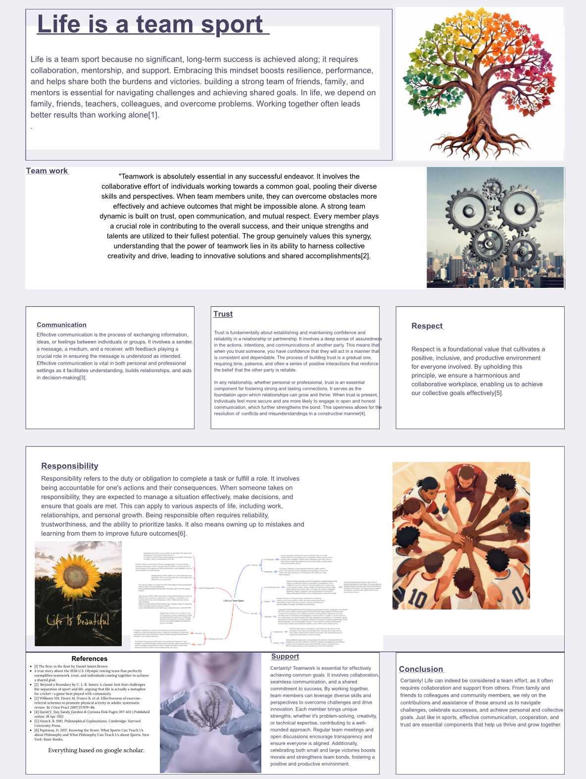

Task 3: Virtual Collaboration and RefWorks

Report on Virtual Collaboration
Topic1: Forming team
The idea of joint action plays a central role in a wide range of research areas. These include philosophical studies of social behaviour, research on human communication, human computer interaction, computer-supported collaborative work, multi-agent systems, distributed artificial intelligence, simulation systems, and contract law. Despite its importance, this concept has received relatively limited in depth analysis compared to the study of individual actions. However, in recent years, interest in joint action has increased, particularly among philosophers and researchers in artificial intelligence.
Team formation involves identifying the most cost-effective group of individuals or agents that can collectively meet a required set of skills. This paper introduces the concept of recoverable team formation (RTF), which extends this idea by considering the changing nature of real-world environments. It recognises that, after a team has been formed, members may become unavailable unexpectedly due to reasons such as failure or illness[1]

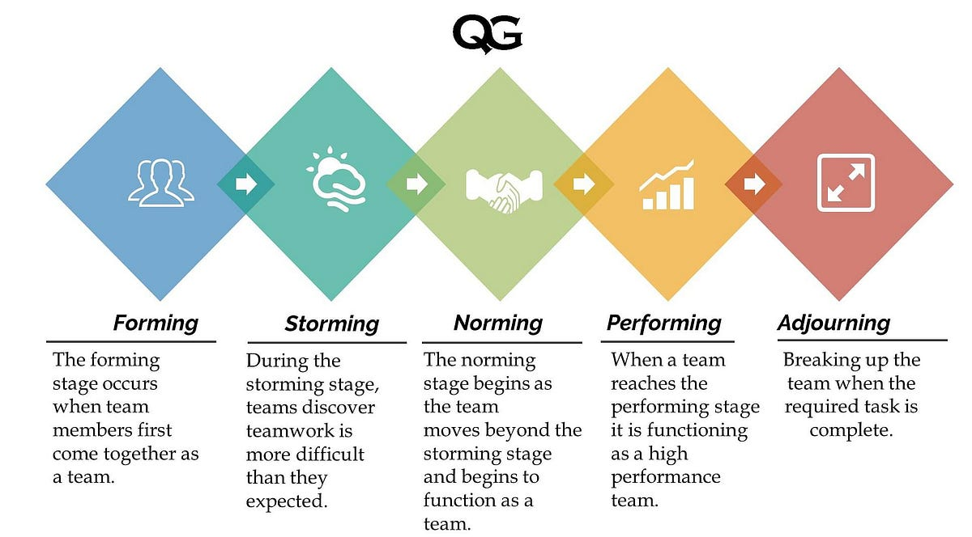

Reference: [6]
Selecting multi-functional teams is an important challenge in problem-solving. At present, there is a lack of research in the literature that focuses on analytical methods for team formation. Additionally, no comprehensive model exists to prioritise team members based on customer needs or product characteristics . To address the complexity of the team selection process, a structured methodology for forming teams has been developed [2].
In recent years, the team formation problem has gained significant attention in the field of quantitative research (QR). This problem involves selecting a group of individuals whose combined skills meet specific requirements while maximising one or more positive social outcomes. The current study has two main objectives. First, it introduces two new dimensions to the team formation problem by considering multiple projects and varying levels of individual commitment. This extended problem is referred to as the multiple team formation problem.
Second, the study proposes an optimisation model that includes a quadratic objective function, linear constraints, and integer variables. The model is solved using three different approaches: a constraint programming method implemented through a commercial solver, a local search heuristic, and a variable neighbourhood search metaheuristic[3].
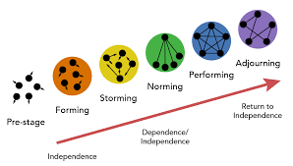
Reference: [7]
Teamwork forms the foundation of interaction within any organisation. It is essential that all members work towards a shared objective and that their psychological traits align or complement one another. Additionally, every team member should be encouraged to contribute ideas and participate in decisions about how goals are achieved. An effective team not only recognises the strengths and abilities of its members but also supports the development of new skills and knowledge. Managing relationships within a team can be delicate and must be handled carefully. Feedback should always be fair, constructive, and focused on behaviours that may evolve over time. Therefore, when creating a new team, it is crucial to consider the psychological characteristics of everyone. To achieve the best outcomes in group development, particular attention should be given to the initial “forming” stage, which supports progression through the storming, norming, and performing stages. Psychological traits can be expressed in various ways, such as through writing style, frequently used words, and responses to specific topics. These indicators can help indicators can help identify personality traits. As a result, the language individuals use in daily life reflects their mental, social, and even physical state. In this context, personality profiling can be used to predict behaviours, habits, personal qualities and unique talents [8][4].

Step-by-step process of using RefWorks with visuals:

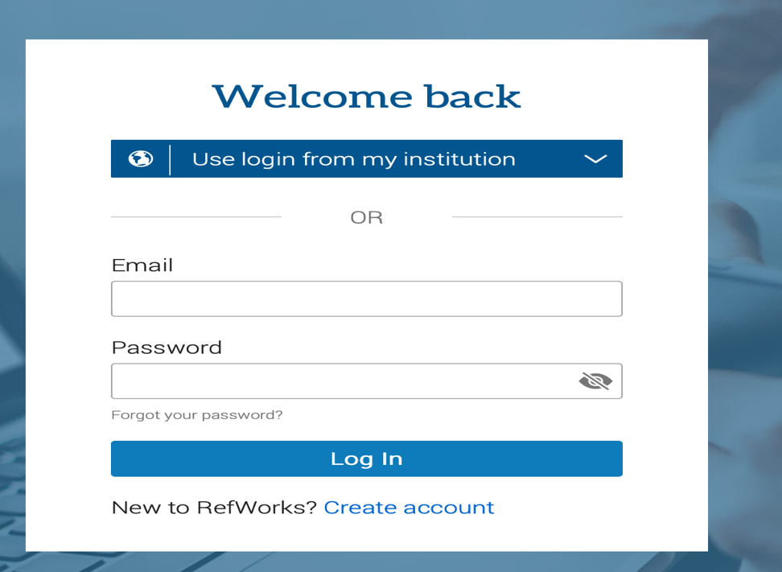
Step 1: First, I create the account complete all questions needed. I used my student email and check the identifications if it’s match.

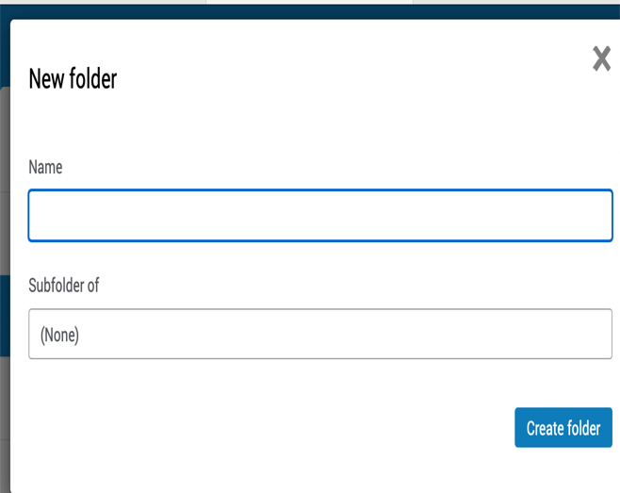
Step 2: After I sign in and can used the RefWorks. Also understand the RefWorks dashboard. Once you login you will see References, folders and Search bar.

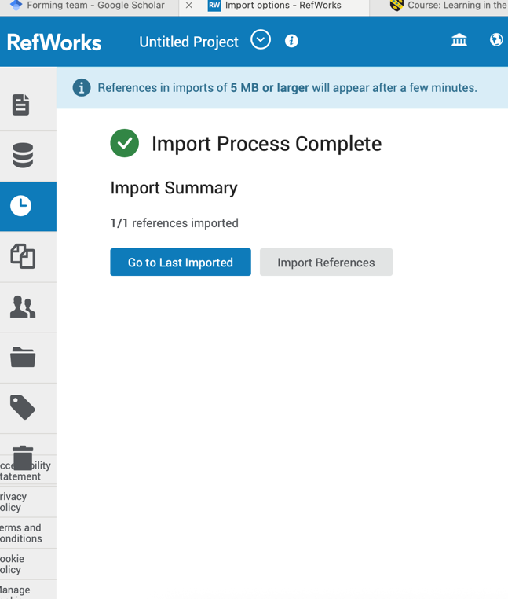
Step 3: Now I can create the folder which I can put all my information. This will help you used RefWorks on word.
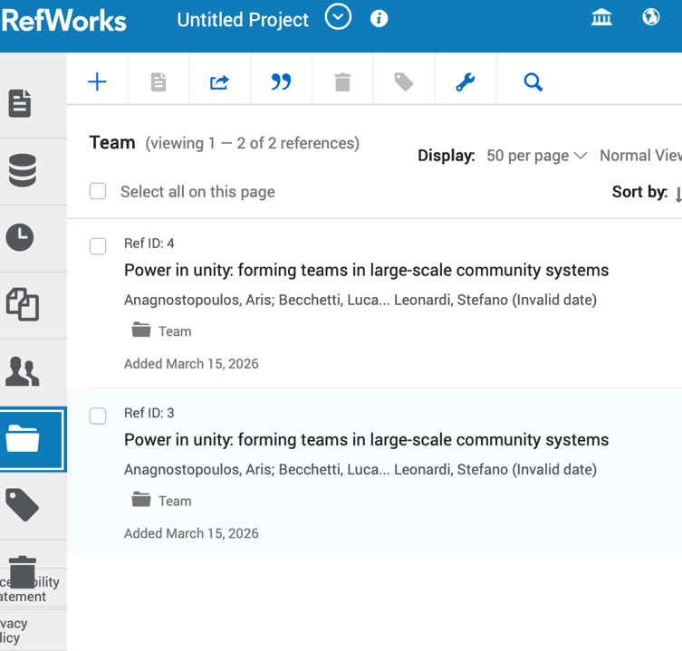
Step 4: Now you can see all the cite that I uploaded from google to my RefWorks. Both listed references share the same title: “Power in unity forming teams in largescale community systems”

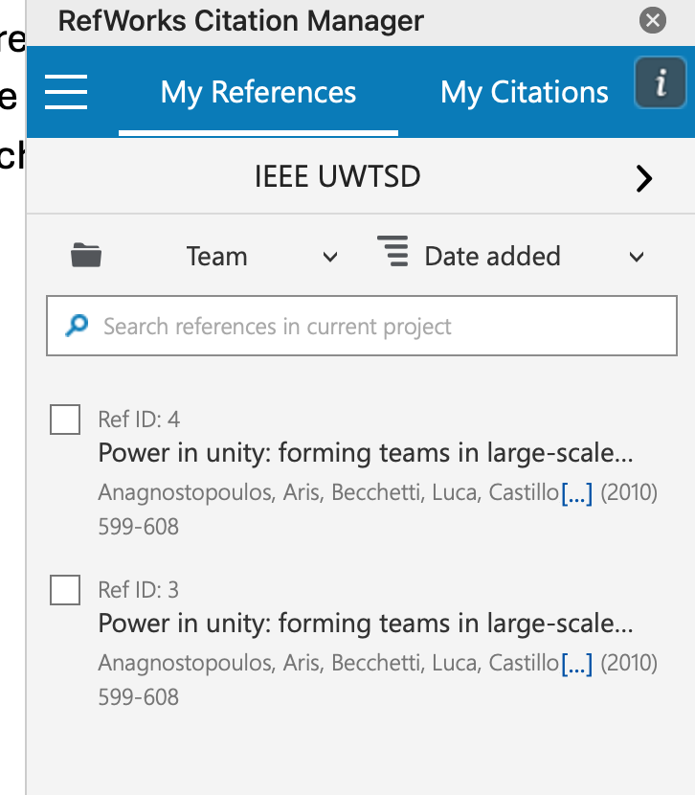
Step 5: This displays the RefWorks citation manager plugin interface, likely within a processing application like Microsoft word or google docs. This tool is used for collecting, organizing, and inserting academic references into documents.
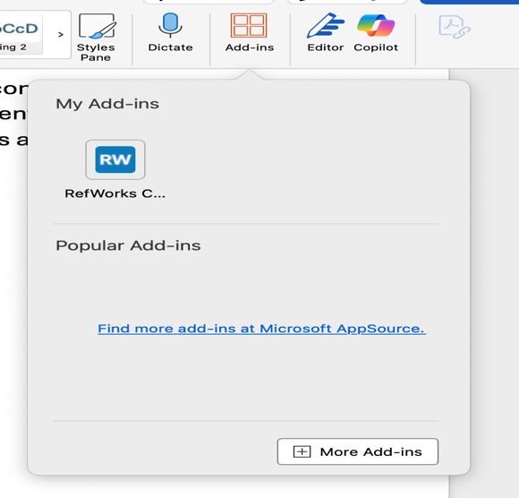
Step 6: This step shows a Microsoft word “Add-ins” dialog box, which allows users to install optional features and commands to enhance functionality.

Step 7: The RefWorks citation manager interface, showing a list of references in the “team folder’. Also, you can change the citation style to IEEE UWTSD each we used.
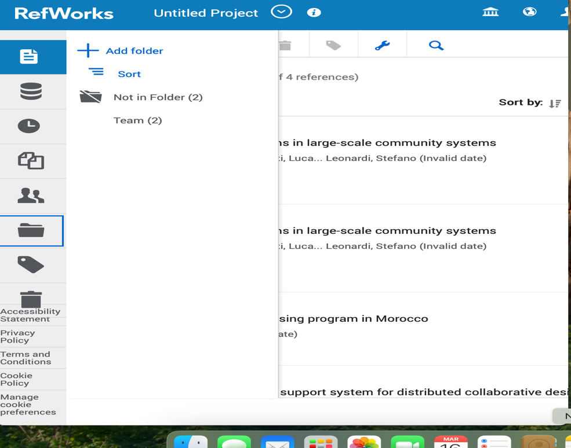
Step 8: RefWorks is a cloud-based service used to collect, manage, and organize research references and bibliographies.

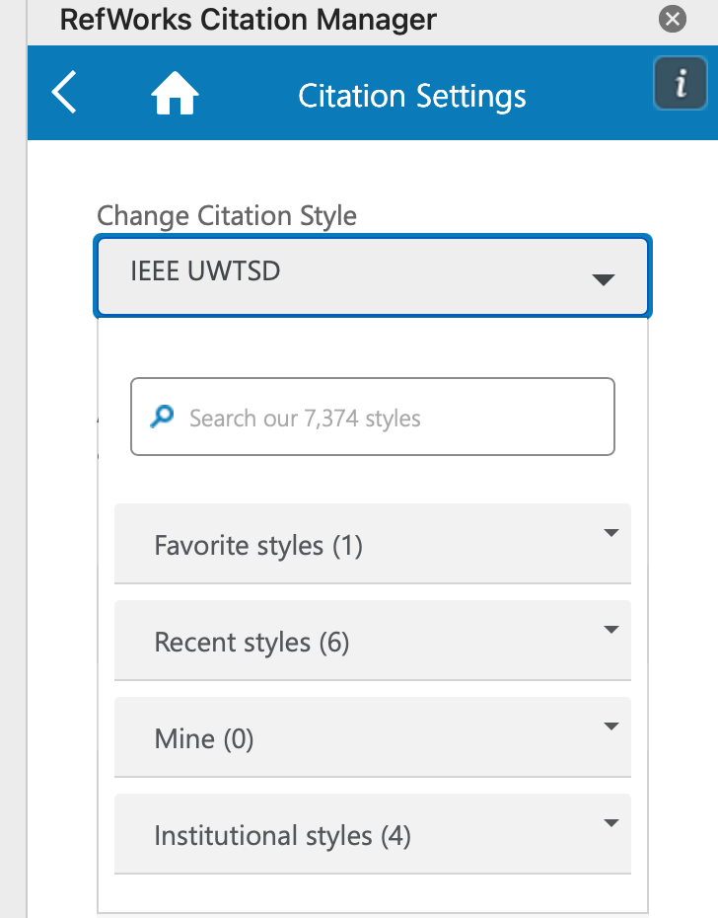
Step 9: This screenshot shows the citation settings menu within the RefWorks Citation Manager application, specifically configured for the university of Wales trinity Saint David. The current style is IEEE UWSTD.
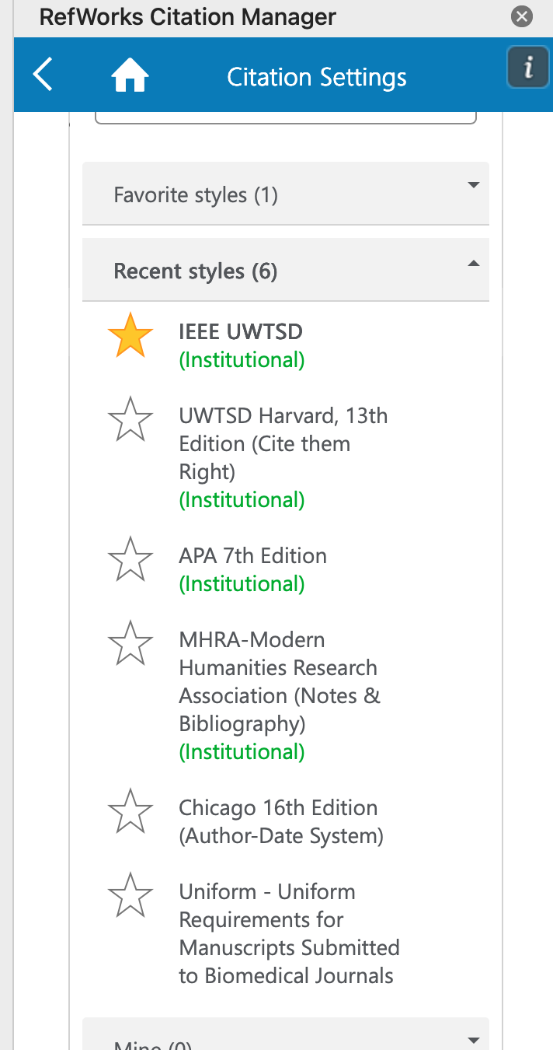
Step 10: This image demonstrates different Citation styles which allows users to select academic referencing styles.



Step 11: This shows google search bar with predictive search queries to google scholar. Google scholar is a free search engine specializing in academic literature, including articles, theses, books, and court opinions.
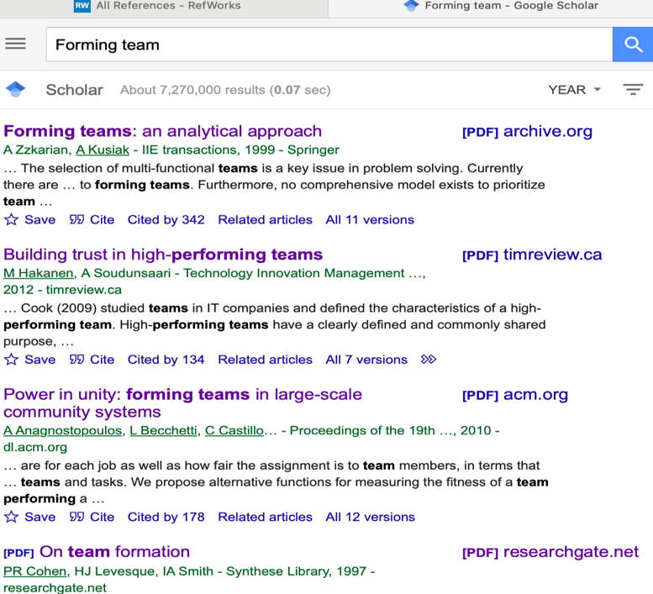

Step 12: This shows different search information for team forming. You click cite to put the all the information in the RefWorks.

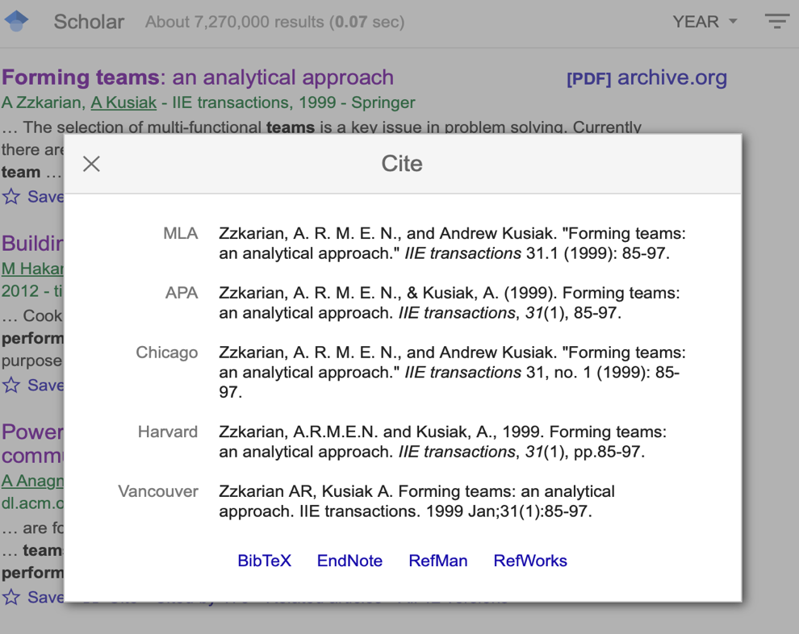
Step 13:This image displays a citation pop up window from google scholar for an academic paper on team forming.
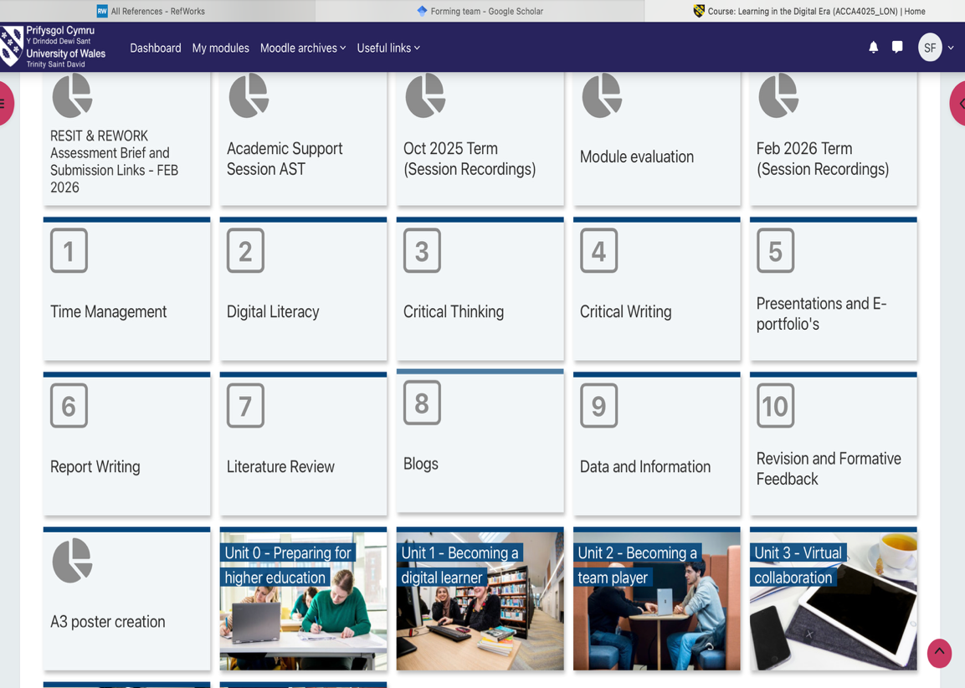
Step 14: This shows the university learning management system dashboard, likely Moodle or a similar platform, listing academic support modules.

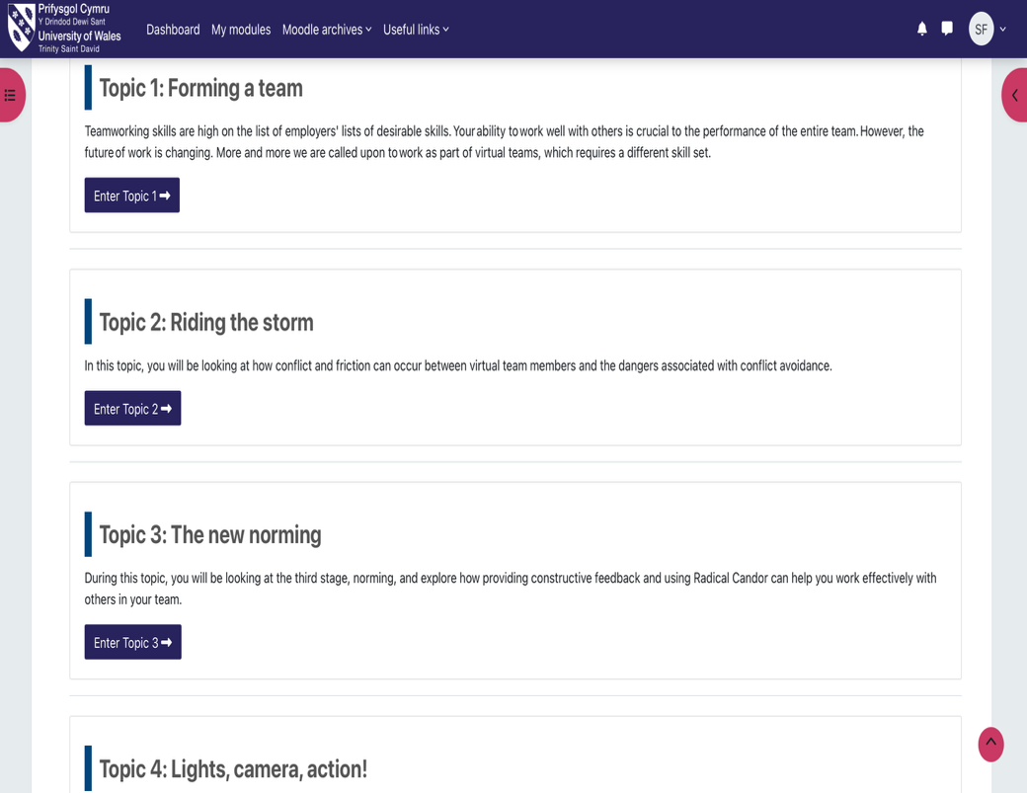
Step 15: This shows different type of topic given by the university which you can choose any of them to work on it.
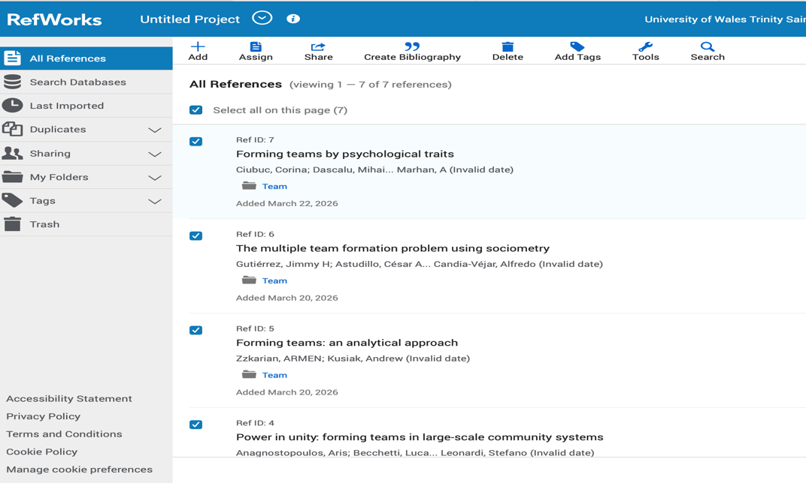
Step 16: This screenshot shows a user interface for RefWorks, an online research management tool used for organizing references, creating bibliographies, and collaborating on academic projects.

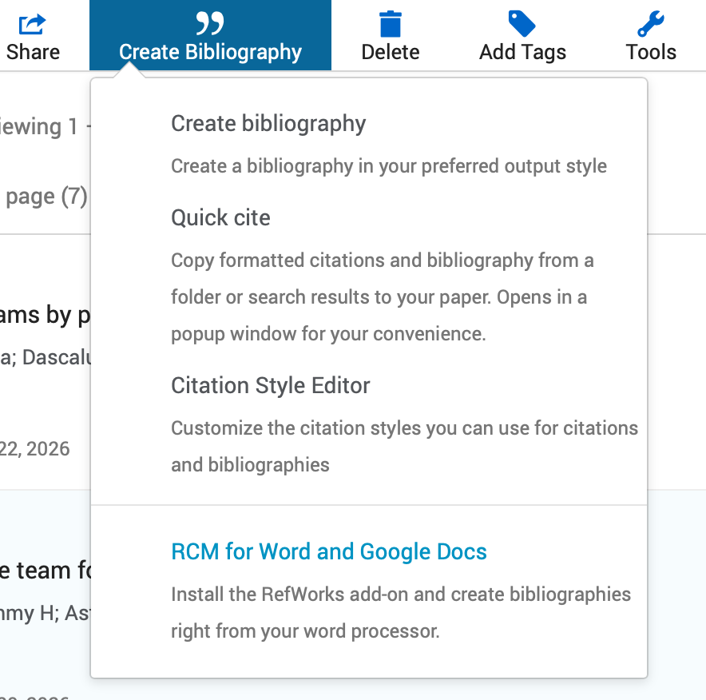
Step 17: This screenshot displays the options available under the “create bibliography” menu in research management tool, likely RefWorks. Create Bibliography allows you to generate a bibliography in your preferred citation style.
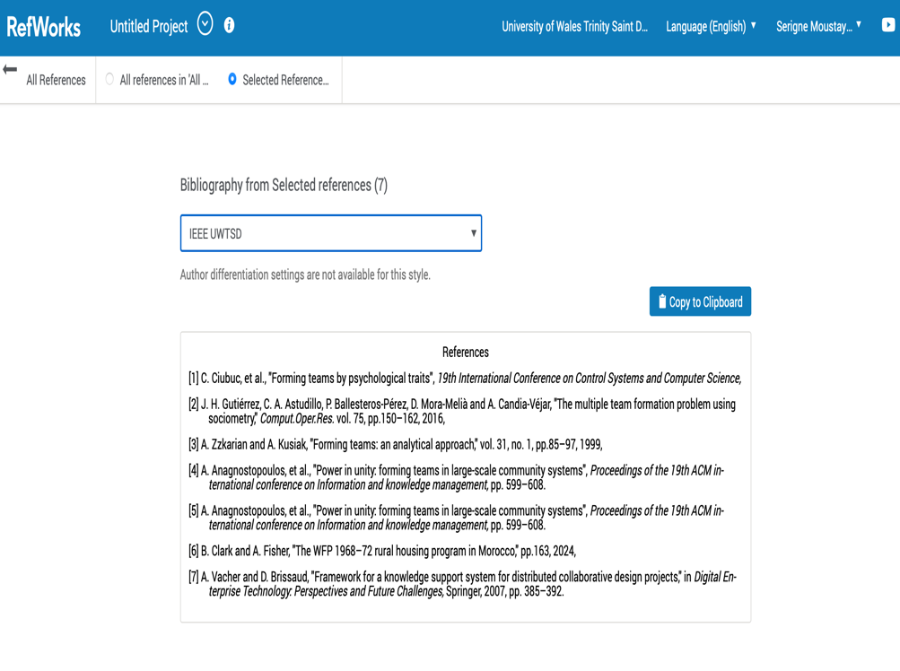
Step 18: I navigated to the bibliography from selected references section. This usually occurs after selecting specific references from a project or folder and clicking the create bibliography icon represented by quotation marks in the main navigation bar.

Task 4: E-Portfolio Creation and Evaluation

Task 4 (a): E-Portfolio Creation
My E-portfolio:
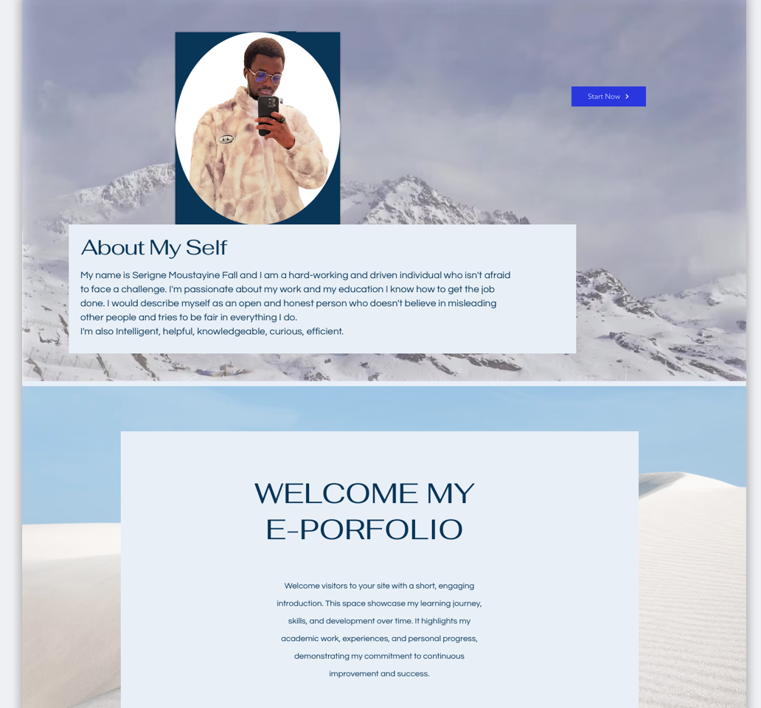
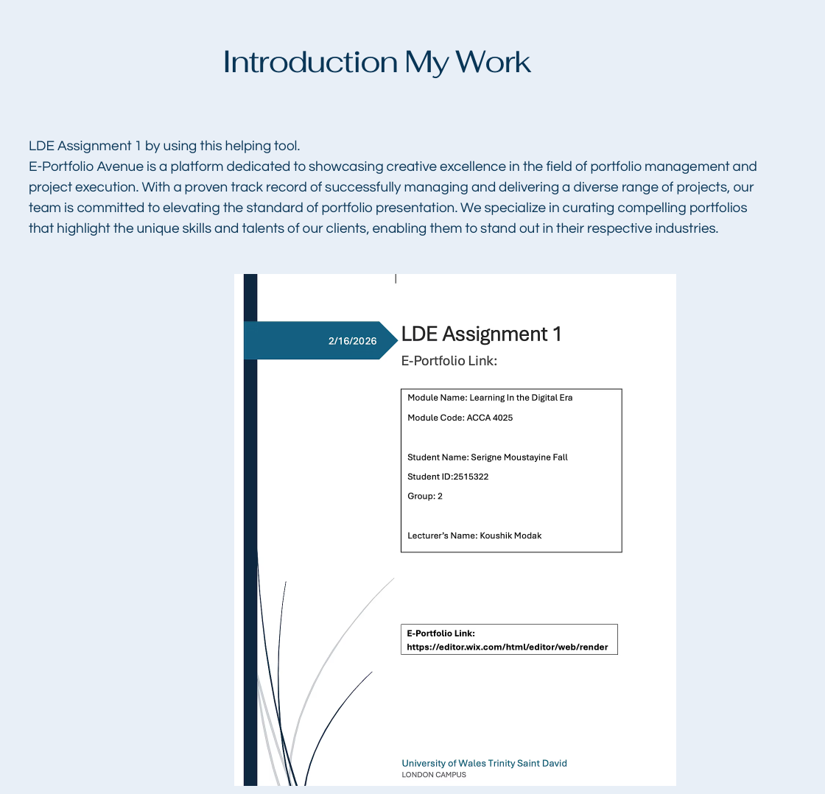
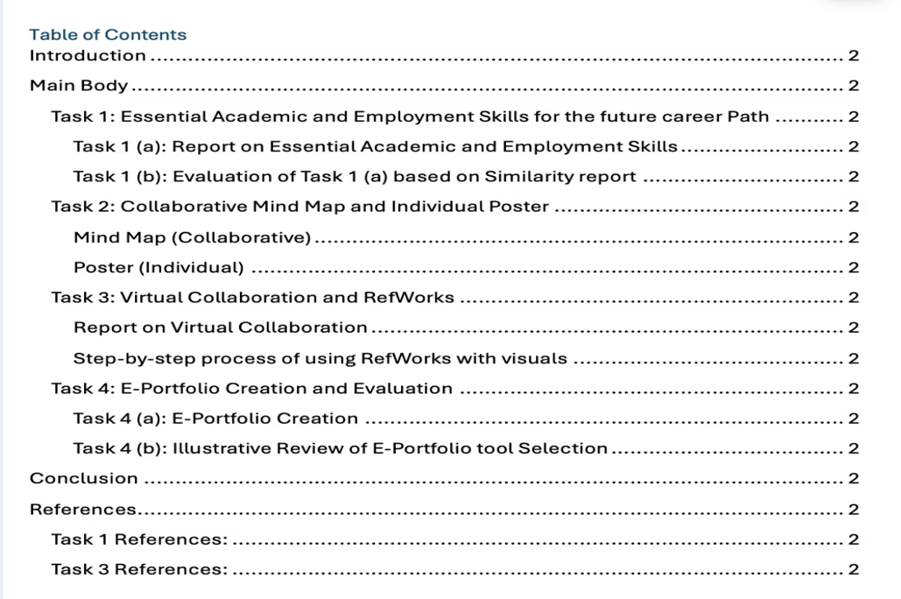

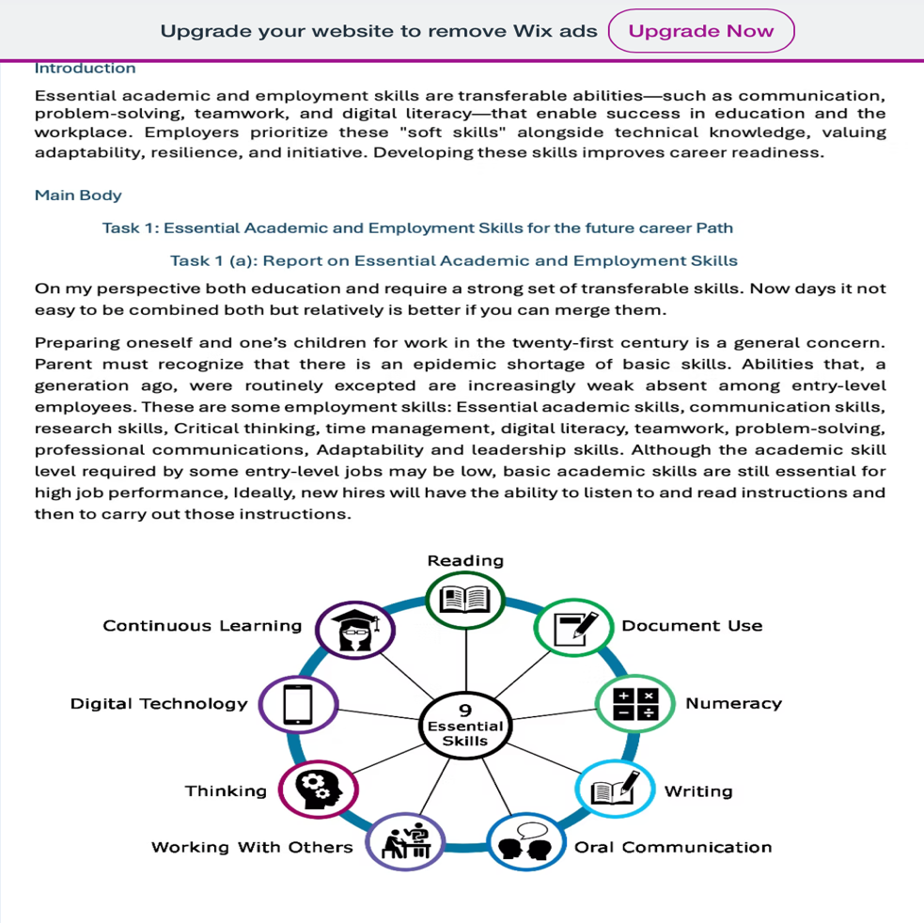

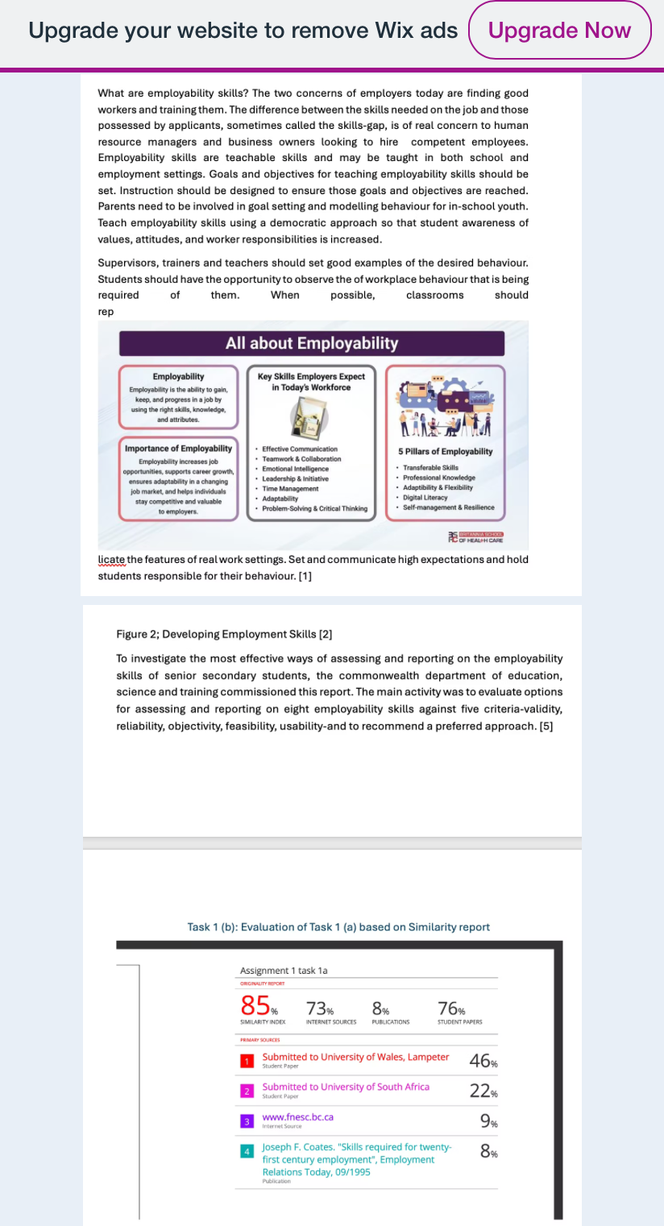

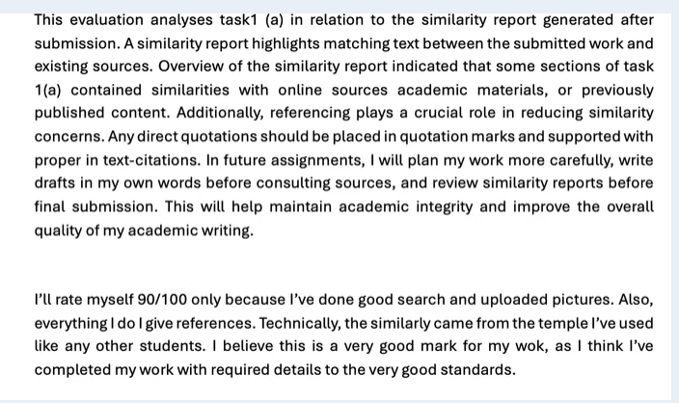

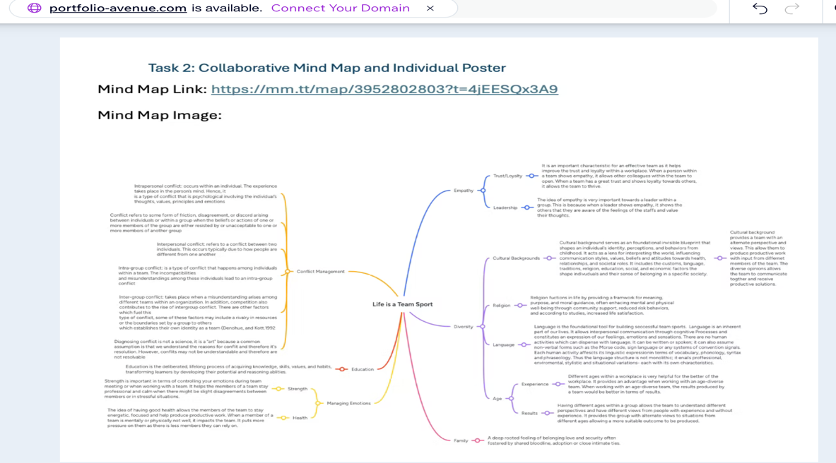
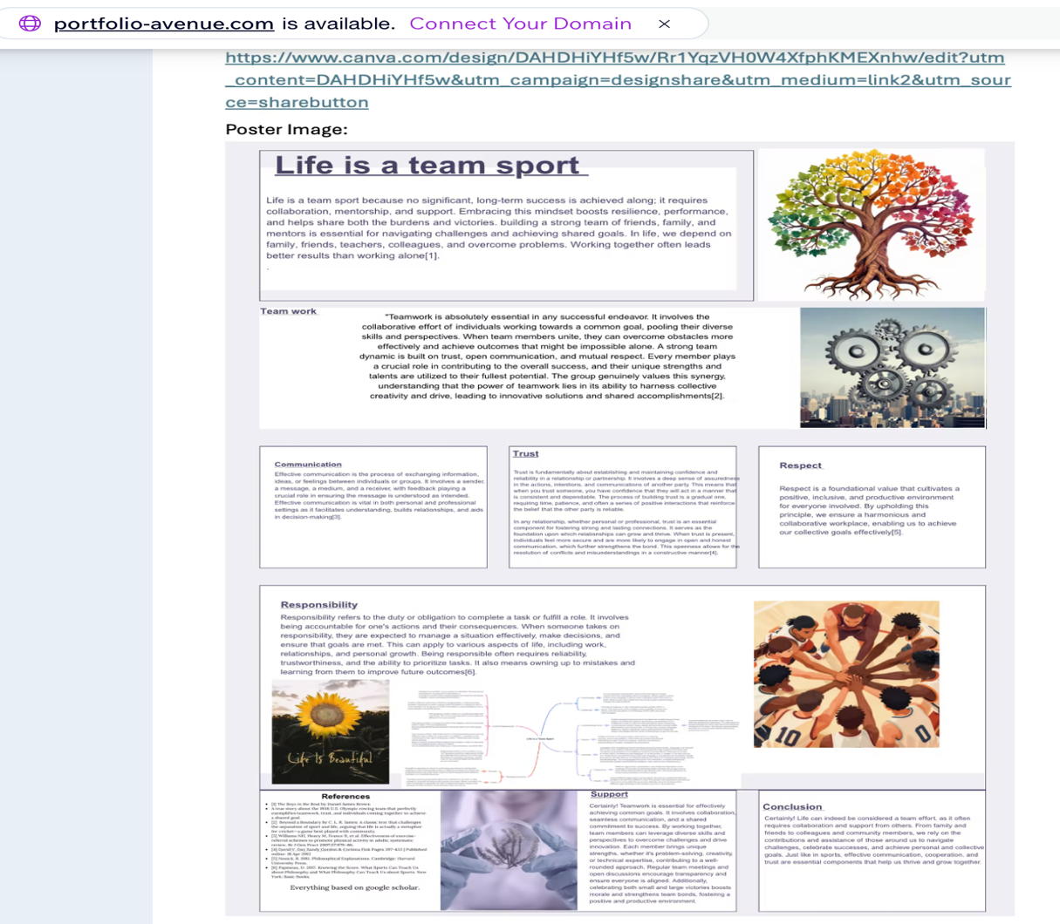

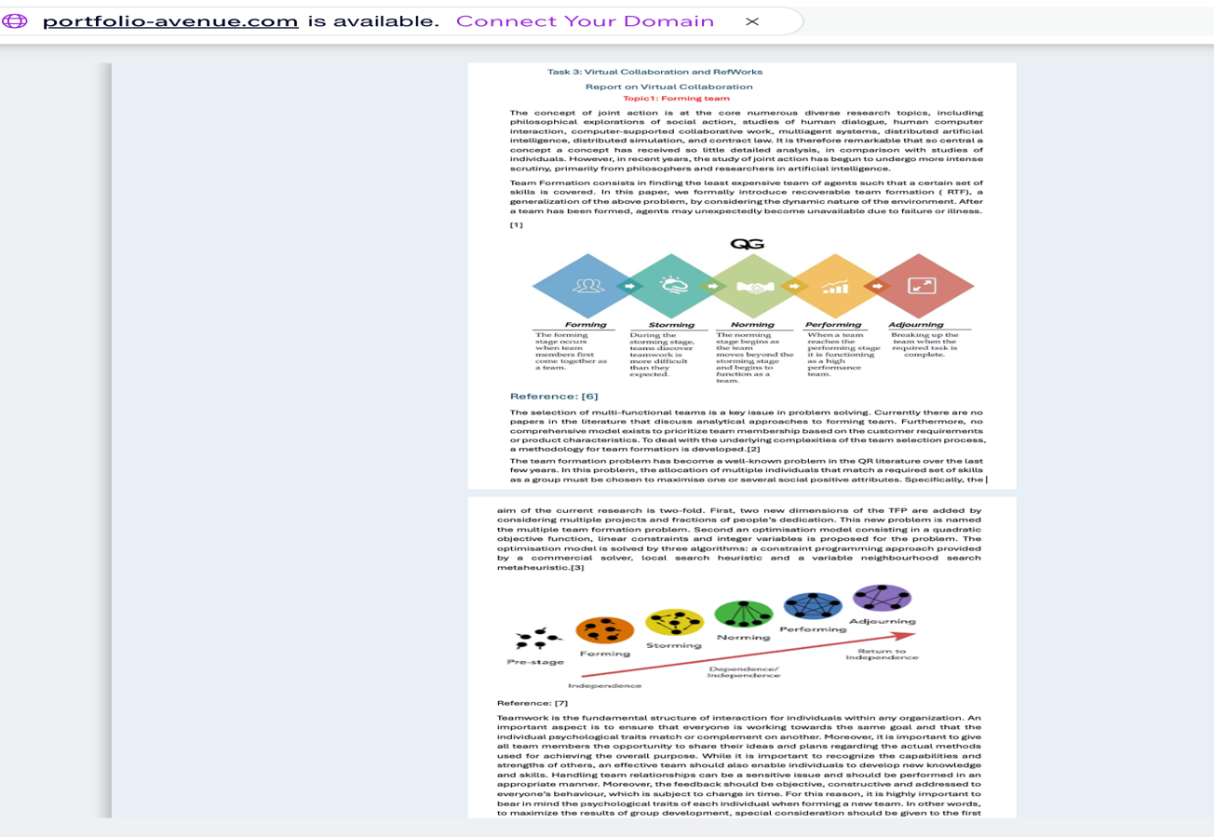
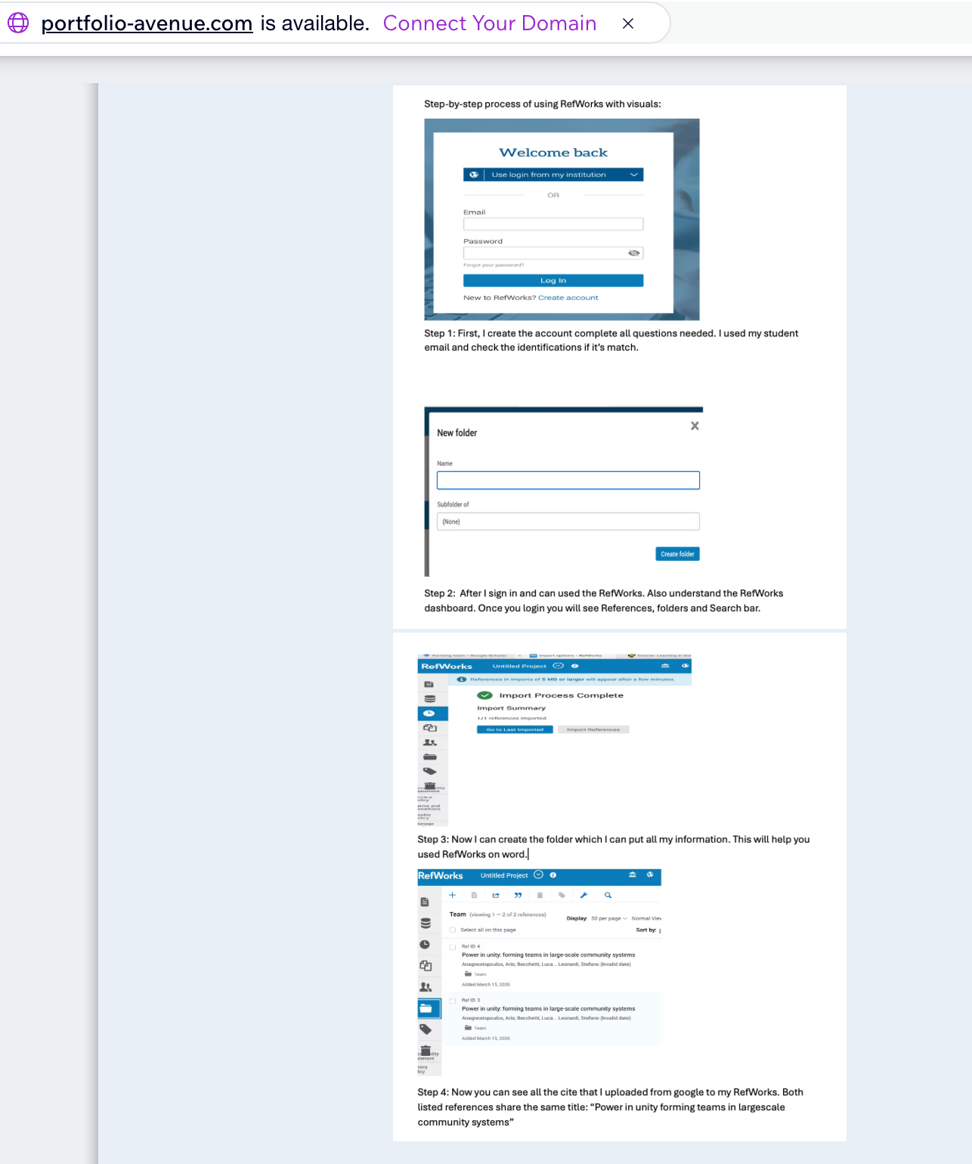

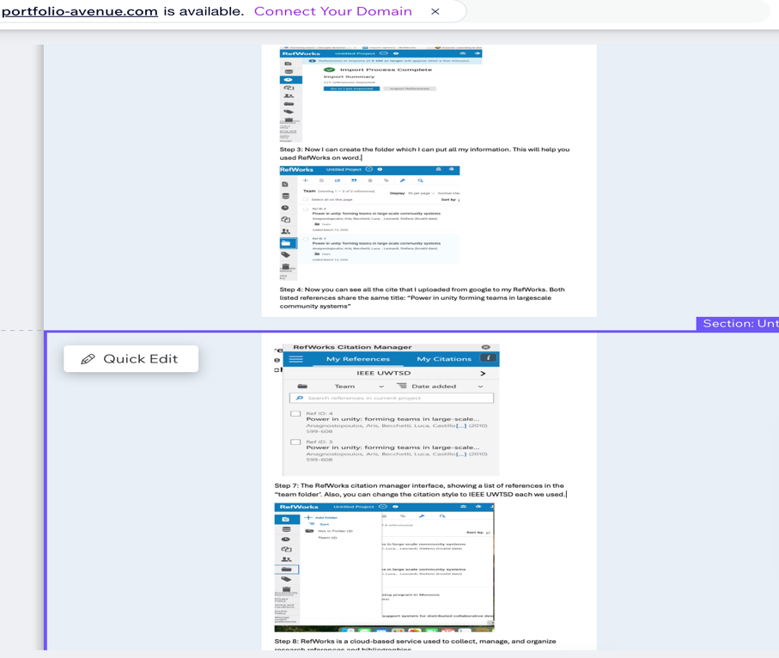

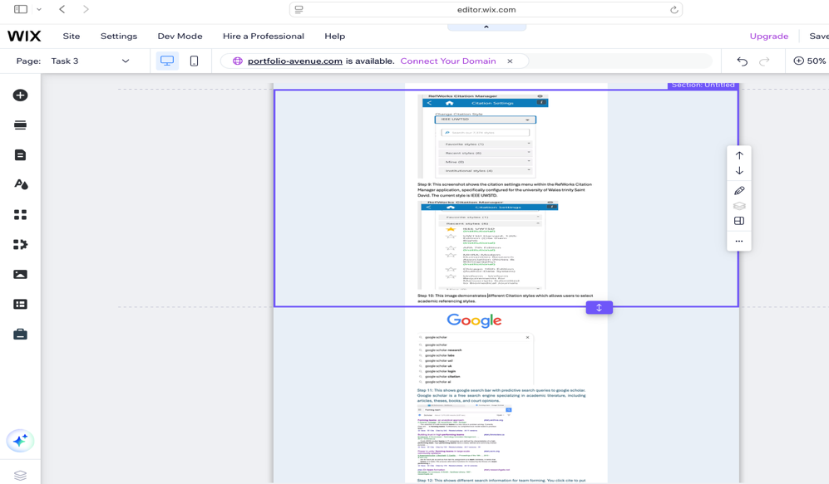

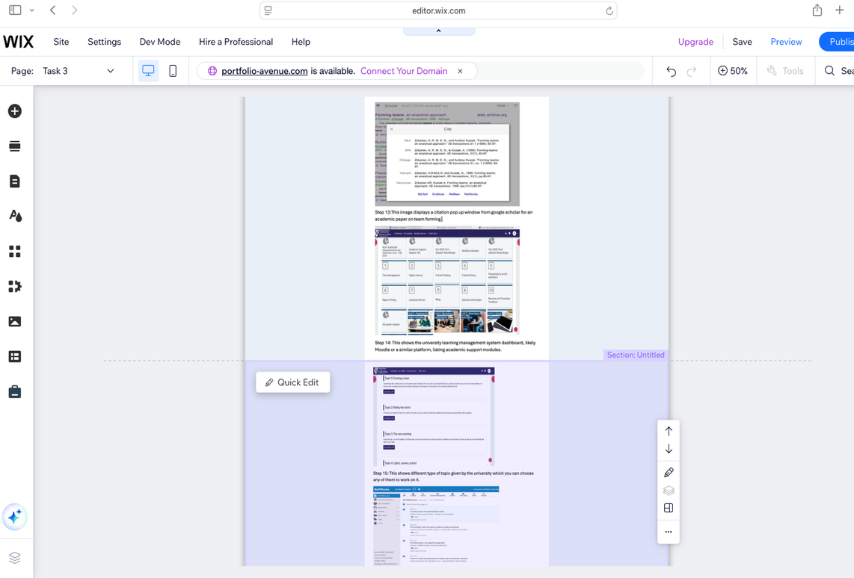
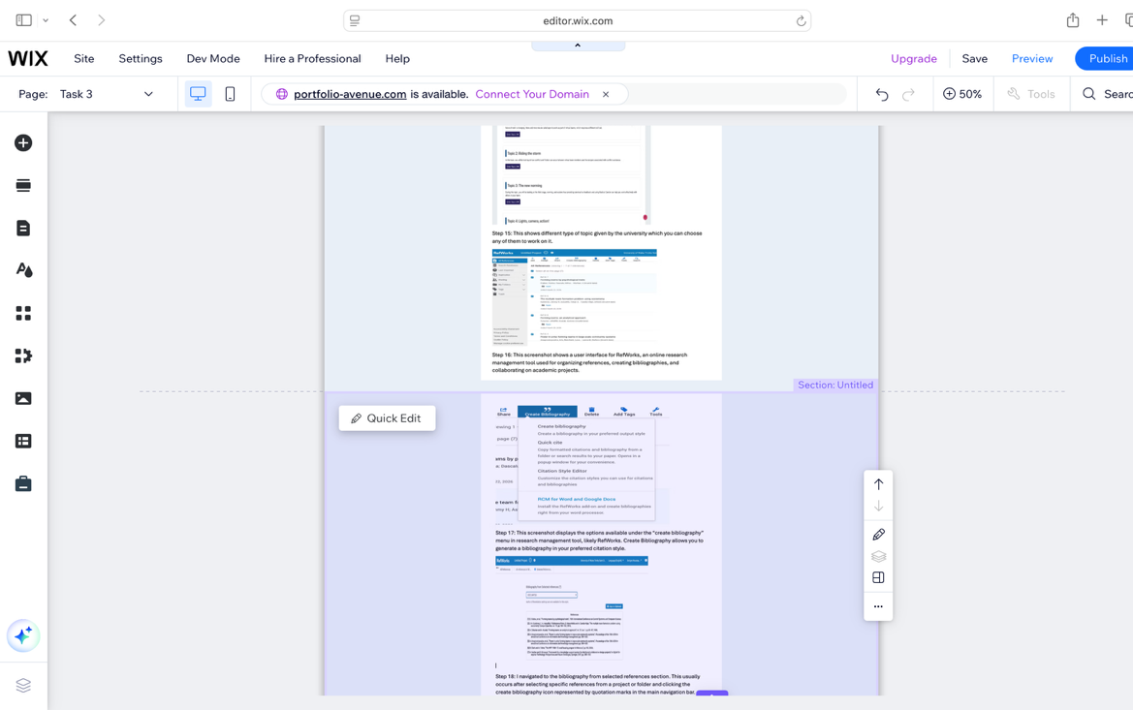

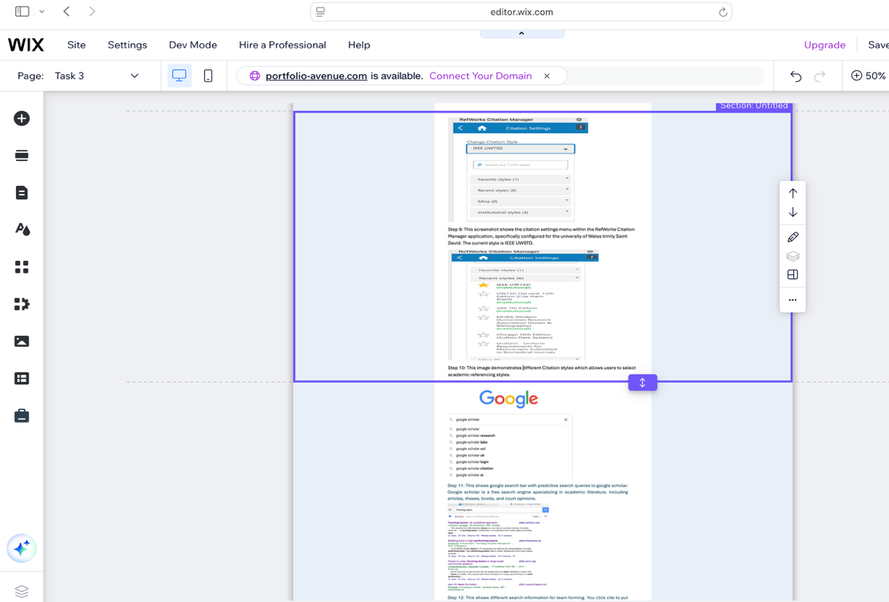

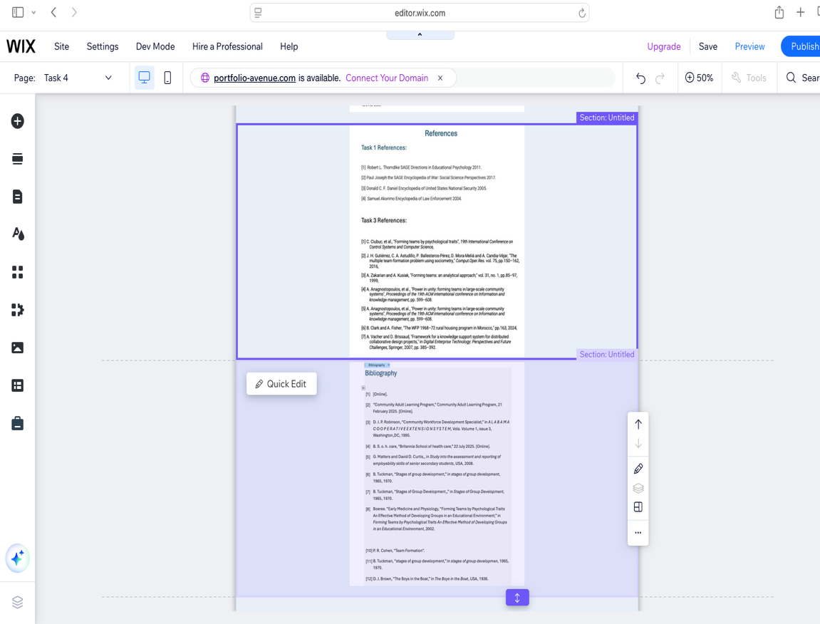

Task 4 (b): Illustrative Review of E-Portfolio tool Selection

About Wix: It is a cloud-based website builder that allows people to create websites without coding. It uses a drag-and-drop editor, meaning you can design your site visually by moving elements ( text, image, buttons) wherever you want.
Advantages of Wix: Easy to use, no coding skills needed, drag-and-drop makes it beginner-friendly. Also, many templates, hundreds of professional templates, designs for different industries (business, fashion, food). All in one platform hosting included domain connection available, built in tools (analytics, email and marketing.) Furthermore, this adds extra feature like booking systems, chat, or online payments and you can build a website in few hours.
Disadvantages of Wix: Limited flexibility once you choose a template, it’s hard to change it later. Free version shows Wix ads on your site and limited control. It’s not as customizable as coding your own site, performance issues some websites may load slower compared to custom-built sites. I have learned that Wix is designed to make web development accessible to everyone, even those without technical or coding skills, through its drag-and-drop interface and ready-made templates.

Conclusion
In conclusion, writing this report help me understand different skills and all the basics that I will need in the future for my academic year. It also allows me to use different tools like Wix to make an E-portfolio, RefWorks, Mind Master to make the mind map and Canva to make a Poster. It trains me to achieve a good teamwork goal. I also gained knowledge about both the strengths and limitations of Wix. This assignment has improved my awareness of how website builders work and helped me evaluate when wix is the right tool to use.

References

Task 1 References:

[1] Robert L. Thorndike SAGE Directions in Educational Psychology 2011.

[2] Paul Joseph the SAGE Encyclopedia of War: Social Science Perspectives 2017.

[3] Donald C. F. Daniel Encyclopedia of United States National Security 2005.

[4] Samuel Akorimo Encyclopedia of Law Enforcement 2004.

Task 3 References:

[1] C. Ciubuc, et al., "Forming teams by psychological traits", 19th International Conference on Control Systems and Computer Science,
[2] J. H. Gutiérrez, C. A. Astudillo, P. Ballesteros-Pérez, D. Mora-Meliá and A. Candia-Véjar, "The multiple team formation problem using sociometry," Comput.Oper.Res. vol. 75, pp.150–162, 2016,
[3] A. Zakarian and A. Kusiak, "Forming teams: an analytical approach," vol. 31, no. 1, pp.85–97, 1999,
[4] A. Anagnostopoulos, et al., "Power in unity: forming teams in large-scale community systems", Proceedings of the 19th ACM international conference on Information and knowledge management, pp. 599–608.
[5] A. Anagnostopoulos, et al., "Power in unity: forming teams in large-scale community systems", Proceedings of the 19th ACM international conference on Information and knowledge management, pp. 599–608.
[6] B. Clark and A. Fisher, "The WFP 1968–72 rural housing program in Morocco," pp.163, 2024,
[7] A. Vacher and D. Brissaud, "Framework for a knowledge support system for distributed collaborative design projects," in Digital Enterprise Technology: Perspectives and Future Challenges, Springer, 2007, pp. 385–392.

Bibliography

[1] | [Online].
[2] | “Community Adult Learning Program,” Community Adult Learning Program, 21 February 2025. [Online].
[3] | D. J. P. Robinson, “Community Workforce Development Specialist,” in A L A B A M A C O O P E R A T I V E E X T E N S I O N S Y S T E M, Vols. Volume 1, issue 3, Washington,DC, 1995.
[4] | B. S. o. h. care, “Britannia School of health care,” 22 July 2025. [Online].
[5] | G. Matters and David D. Curtis,, in Study into the assessment and reporting of employability skills of senior secondary students, USA, 2008.
[6] | B. Tuckman, “Stages of group development,” in stages of group development, 1965, 1970.
[7] | B. Tuckman, “Stages of Group Development,,” in Stages of Group Development, 1965, 1970.
[8] | Boeree. “Early Medicine and Physiology, “Forming Teams by Psychological Traits An Effective Method of Developing Groups in an Educational Environment,” in Forming Teams by Psychological Traits An Effective Method of Developing Groups in an Educational Environment, 2002.
[10] | P. R. Cohen, “Team Formation”.
[11] | B. Tuckman, “stages of group development,” in stages of group developmen, 1965, 1970.
[12] | D. J. Brown, “The Boys in the Boat,” in The Boys in the Boat, USA, 1936.

