NAME: MARI-NICOLLE SPIREA

STUDENT NUMBER: 1816301

MODULE: M4X01916

ASSIGNMENT TITLE: ANALYSE THE IMPORTANCE OF MARKETING INFORMATION SYSTEM, ITS EFFECTIVESS WITHIN THE HOSPITALITY AND TOURISM INDUSTRY AS A TOOL FOR MAKETING, INFORMATION GATHERING AND COMMUNICATION

MODULE LECTURER’S NAME: OLU ADEGBITE

Table of Content

- Introduction
- Discussion/ Evaluation and critical analysis
- Conclusion
- Important tips

Introduction
“It is a system that consists people, equipment, and procedures that gather, sort, analyse, evaluate, and distribute needed, timely, and accurate information to marketing decision makers.”
This study investigate the effect of market investigation system used by Qatar Airways on the market studying the market research, market intelligence, records and marketing decision system.
Discussion / Evaluation and Critical Analysis
In the first hand, in these days the staff need to be very good training to delivery high services. The company need to focus on what our customers need then what they want. Delivering services with high standards the feedbacks will come more positive and will help us to discover more about our customers.
Qatar Airways is not so cheap; the price is for the middle and high class of people who travel in the world. This company come from a very expensive area in world, the country Qatar its between Saudi Arabia and United Arab Emirates, both of them got a huge hospitality and tourism industry, making lots of money. The place have underground diamonds which was a big help for the future what they build today, so Qatar was a good place because been between them have the same source in the paste which helped the people building a big industry in tourism making this airline on these days. Qatar is also the first airline company who fly for the first time in Doha from Qatar country, so this it was a big promotion and publicity to show on social media and get more customers. Oversize the product was what they needed and then what they wanted so the aeroplane and airline give to the people chance to travel more and get close more business from country’s who are near Qatar or from another continent.
In the second hand, the technology in these days is huge so if the company know how to use the network in the advantage then we get more profit, making new customers. Technology means digital from phones to pc, everything which you can use from everywhere in this world. A customer can post on social media (Facebook/Instagram/Twitter) from the phone: “Today I fly with the company Qatar from Dubai to America, and I was impressed of the high quality what they had, the way how they treat all the passengers and aeroplane condition. It was a great experience and I will use this service often from now.” (Mari-Nicolle Spirea)This will make the friends of customer and they family has to go and try the company what been praised because the customer speak nice about it on social media.
However, the company never can satisfy all the customers and the company need to understand this. Once they understand that can improve the business. Not everyone like to fly, but is the situation necessary for them to do this to see they family’s or making some business maybe, so how the company can help them to feel more comfortable in aeroplane? That is easy.
Well, the social media, network and programs is the answer. To make a study or for collecting data from customers to improve the services use technology. However, they need to be careful when this do, they need to focus on that person who have a discomfort and see the problem, giving an easy way to speak with the company about it. An online page/program for feedback or a special number phone to contact company. Oversize the customer can post on social media a bad feedback and the making of company get a bad imagine which will end with a bad change for the economy.

Technology helps to delivery to the customer’s great value, high standards and help to progress for business the price, product, place and promotion. In addition, the company need to play intelligent which means to make a marketing smaller but with a big impact of our customers, to make they mind to catch all the information from the first time when they see us somewhere in social media. The strategy is to do something easy, small and good that is the key for publicity, and this will make the company to be different in a good way from competitors. (K. Murray)
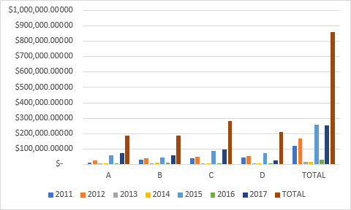

Source: Mari-Nicolle Spirea

Therefore, that is a graphic of Qatar Airways economy from 2011 to 2017. However, after so many years, the economy grow up and now the company is sponsor of FIFA, CHI AL SHAQAB and QATAR TENNIS FEDERATION: MAN’S OPEND AND LADIE’S OPEN, WEATER SKYNEWS. Making an airline in Doha improve the economy with 70% from 2015 to 2017, also the economy of country because many offices been opened here after this airline been opened. With the big profits, they invest in the company for services to give to the customer’s high comfort and satisfy. Invest in social media too, in publicity on TV, radio and Facebook. ( https://www.qatarairways.com/en-gb/about-qatar-airways.html )
The Qatar Airways is an Arabic fly company old from 22 years. In time, they got 5star from Skytrax and different distinctions in the last few years. This company have 160 destinations from six continents. ( https://www.qatarairways.com/en-gb/about-qatar-airways.html )Flying in so many countries and cities across with six continents make us a huge imagine and give them more opportunities for business. Making new relationships and new partnership's help to grow up economy, find new information, which they can use to put value on. To wish a good business they need to “speak with the right person at the right time on the right place.” (Lecture 6)
Charity support is a big deal what this big company done. They help the kids who cannot go to school and study because they family’s do not have money to keep them studying. Is a nice and noble gesture to help the next generations to learn and have an education. Also, they support the kids who are not healthy, who have tumour brain and need different treatment's and operations and/or implants, which are very expansive for the poor family's from where they come. (https://www.qatarairways.com/en-gb/about-qatar-airways/social-projects.html )
This aeroplane company had the one of the most luxury and elegance 1st class. This aeroplane had pub, launch area, beds to sleep in, TV’s on every seat’s and the staff very high educated and sell good services. ( https://www.youtube.com/watch?v=MZv54ssUQpw)

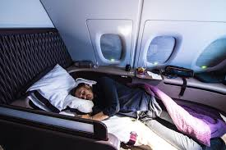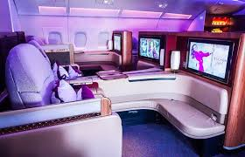
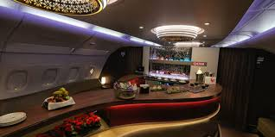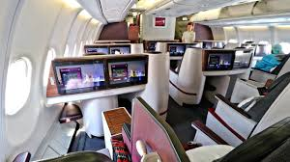

Source: Google; 1st class of Qatar Airways. (https://www.google.co.uk/search?q=1st+class+of+qatar+airways&hl=en&gl=uk&source=lnms&tbm=isch&sa=X&ved=0ahUKEwiExJTtzLLiAhUBUlAKHdQyC3gQ_AUIDigB#imgrc=_)

