Apply the principles and practices of Data security, Governance and Compliance based on a given scenario

Module | Data Security,Governance and Compliance
Module code | ACCA7028
Student name | Biao Liu
Student ID number | 2200546

Apply the principles and practices of Data security, Governance and Compliance based on a given scenario
Biao Liu

Abstract
The arrival of the digital economy era is the need of social development, and the information management and operation of enterprises are also the inevitable products of the times. Information management has brought a lot of convenience to the development of enterprises. The level of information management of an enterprise is the external performance of the enterprise 's ability most of the time. Many core technologies are actually the way of information management. Enterprises rely on information management means and data processing technology development, these technologies and management models have high commercial value. Therefore, many network hackers will find the network vulnerabilities of enterprises by any means for the benefit, and then steal relevant information for trafficking. Therefore, enterprises should do a good job in data security management.

Keywords: data security management, network security, departmental organizational structure, technical protection, project management tools

I. Introduction

1.1 Information security framework and model
Information security model is used to describe the security characteristics of information system accurately and formally, and to explain the reasons of system security related behaviors. The security model can improve the understanding level of successful implementation of key security requirements, so as to achieve the purpose of developing a set of security evaluation criteria and key description variables.

Common network security models include P2DR and PDRR.P2DR is the representative model of dynamic network security system, and the prototype of dynamic security model : 1) Policy:network security policy usually consists of overall security policy and specific security policy. 2) Protection. PDRR model is a dynamic technology system composed of Protection, Detection, Reaction and Restore.
The International Organization for Standardization (ISO) is an international standard organization.The organization has developed many standards including ISO 27000 series.Among them, ISO 27014 mainly covers the following :
- Risk management - in particular, information security risk management,
- Control measures - especially ISMS itself as a continuous management framework
- Compliance and assurance activities - in particular internal audit, management review and certification audit
- The relationship between information security governance, IT governance, information governance and corporate governance
- Differences and linkages between 'governance' and 'management'

1.2 Security challenges posed by new facilities
As the basic carrier of core data processing for individuals, enterprises and countries, network infrastructure is the key link of data security protection. According to the traditional definition, network infrastructure generally includes computing equipment, storage equipment and other software. However, with the development and innovation of new technologies, the network infrastructure is increasing. Data centers and mobile terminals have integrated various functions of basic software and transformed into extremely important data infrastructure, which brings more challenges. On the one hand, attackers focus their attention on cloud computing data centers, making up to 70 % of their attacks. On the other hand, frequent information leakage incidents in society make information leakage a huge security risk.

II.Data Security Management Approaches

2.1 Case study
The arrival of the information age has indeed greatly promoted the development of modern economy. All walks of life are in a stage of steady rise. Under the management and operation of network information, enterprises have saved costs and improved production efficiency and development speed. For example, in the case of CoffeeBlend, the company uses cloud services to provide IT services to employees and customers, becoming one of the most popular coffees in the world. But in the era of digital economy, all this becomes easy, only need to establish a public communication platform between the corresponding enterprises. We can see the advantages of information management, but it is not difficult to note that all aspects involve the transmission of information. Imagine if these information is stolen and leaked by criminals in the middle of the way. How much loss will be caused to the enterprise, which is also the current situation of the development of the digital economy era, but accompanied by the risk of information leakage under the benefits of rapid development. If criminals secretly cut into CoffeeBlend 's cloud database to steal information such as coffee recipes or customer information, the sales of CoffeeBlend genuine products will inevitably plummet due to information theft. In fact, this phenomenon may occur in all information management enterprises. Therefore, enterprises must pay attention to the risk of information leakage, prepare for information protection, and reduce the risk of enterprise development.

2.2 Strengthen enterprise systems and network security
According to different departments, the senior management of the enterprise needs to be equipped with different subsystems and networks to ensure that all the systems and networks can operate independently and do not interfere with each other. At the same time, all departments will be upgraded to network security firewalls, and all subsystems and networks will be incorporated into the only main system of the enterprise. The main system will implement a one-way management system, just like the past ruling system. Local levels have the power of self-management, but they must obey the central government and belong to the central control. Therefore, the loss can be reduced when the department encounters an intrusion, because the systems and networks between the departments are independent and will not have a connection. The criminals can only steal the information of a single department that has been invaded, and cannot break the information management system of the entire enterprise. In addition, the main system of the enterprise is a one-way management of various departments of the enterprise. The enterprise can receive the intrusion prompt at the first time and make the prevention and control means to ensure the information security of the enterprise. Finally, it is necessary to establish a random system service password. Each department and even the main system need to change the password regularly, and it is necessary for a separate department to manage these passwords, and handover them at each replacement. In this way, it is difficult for criminals to crack the password, and it is impossible to break the first line of defense of enterprise information security.

2.3 Optimize departmental organizational structure
Enterprises should be in accordance with the relevant requirements of national laws and regulations, combined with their own system, a clear classification of data information classification standards. Under this requirement, it is divided into tasks of different departments. In addition, enterprises should also create a top-down data security management organizational structure. Make the person in charge to the business organizers have relevant awareness. In order to effectively implement the safety management system, but also set up a certain security management positions, good communication and convergence within the enterprise, to further implement the data security management requirements. As an enterprise itself, should also strengthen their legal awareness and compliance awareness.
The enterprise can recruit relevant talents, or can select the relevant professional graduates from the original staff of the enterprise, and then send them to the professional network security information technology training institutions at home and abroad to learn advanced technology. These talents can specialize in the network security maintenance of the enterprise, supervise the network operation in peacetime, and have the ability to take the initiative when encountering danger, and solve the hidden danger internally. Secondly, it is necessary to train or introduce specialized information management personnel. In the era of digital economy, network security and information management are advancing together. While ensuring security, it is also necessary to effectively manage enterprise information.
The more information-based enterprises should have their own network security and information management operation departments. In order to establish and improve the information management system of the information security management platform, clarify the management responsibilities, ensure the safe, efficient and stable operation of the information system of the platform company, provide the company with accurate and effective financial, production, technical and other relevant information, and provide the basis for the company 's high-level scientific decision-making, so as to further enhance the core competitiveness of the enterprise, the group information department is specially set up to coordinate the management information construction and be responsible to the technical director.With talents, they need to establish special departments. The organizational structure is shown in the following figure 1.
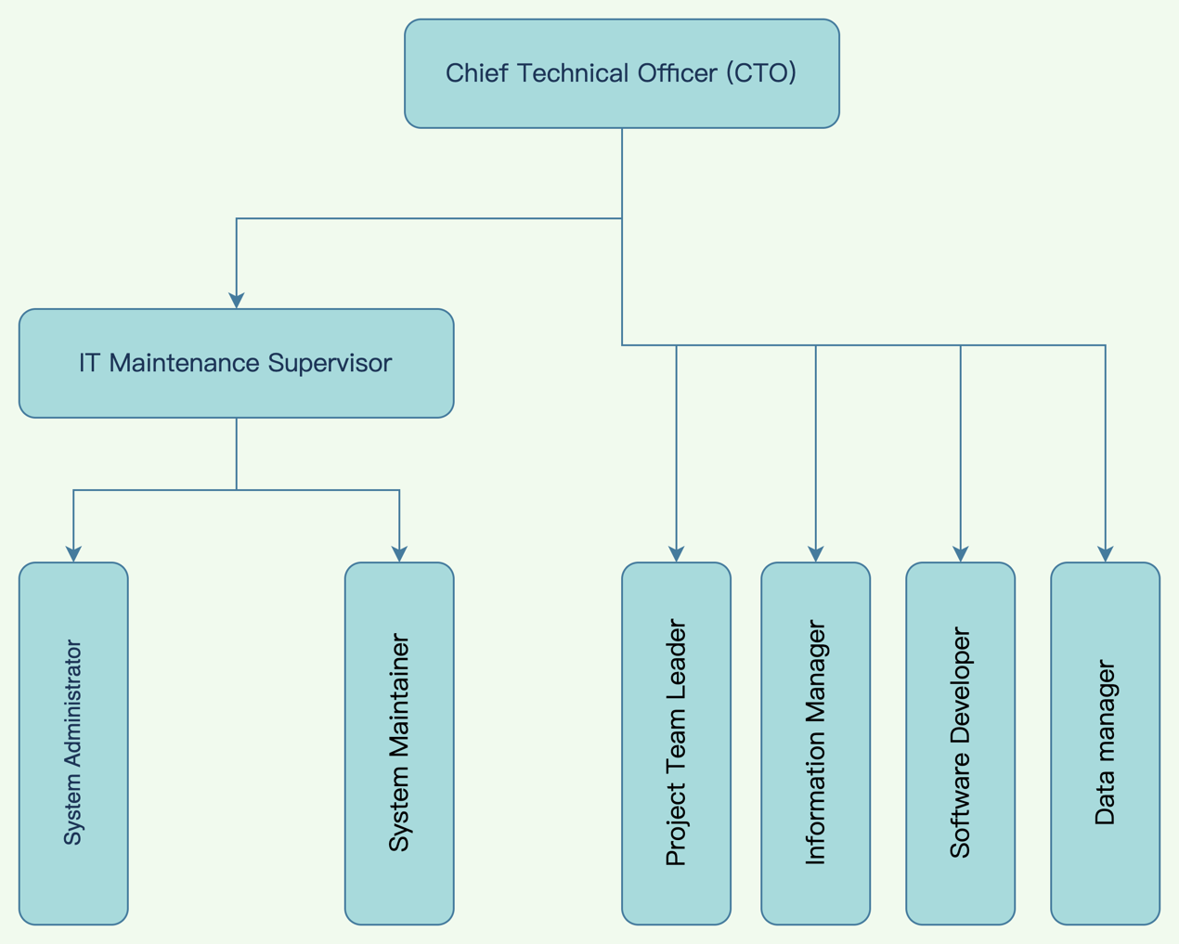
Fig. 1: departmental organizational structure
Duties of Information Department:
- Responsible for the overall planning of group informatization construction and the design of network system structure, responsible for the selection of group informatization system, and responsible for the preparation of group informatization overall planning and selection report, and reported to the group leadership for approval ;
- Responsible for the promotion and implementation of the Group 's information system, responsible for the daily management of the Group 's information project implementation, and coordinate to solve the problems encountered in the project implementation process ;
- Responsible for organizing and researching the information needs of various departments of the group and summarizing them. Responsible for organizing the development of the group 's financial, production, technology, and office automation system software, so that the company 's information system forms a seamless connection. Responsible for the company ' s various summary reports, query software, analysis software for the secondary development of leadership decision-making and business operations to provide timely and accurate decision-making information ;
- Responsible for the continuous improvement and daily maintenance of all information projects of the group, responsible for the safety management, technical support and maintenance of the company 's computer network and information management system. Under the premise of ensuring the safe operation of the company 's computer network, establish a sense of service and provide the best service for the company 's leaders and various business functional departments.
The main responsibilities of CTO include :
- Under the leadership of the Group 's Executive Vice President, responsible for the overall day-to-day work of the Information Department, responsible for the formulation of this; the management system and organization construction of the department, and supervise the personnel of the department to fully complete the tasks within the scope of the department 's responsibilities ; responsible for the department staff work inspection, assessment and evaluation.
- The implementation of the headquarters post responsibility system and work standards, close working relations between departments, strengthen cooperation with the various departments of the group, do a good job of convergence and coordination ;
- Responsible for the overall framework of the group information system, build the group information implementation organization, combined with business processes, project management, the implementation of the company integrated information system. Responsible for controlling the informational project budget. Responsible for controlling the department information budget, reduce costs.
- Responsible for the supervision, control and risk assessment of the key control points of the group 's informational project ;
- Responsible for the organization of the Group 's information security work, continue to strengthen the Group 's information security management.
- Responsible for the organization of computer network and information system maintenance, ensure the normal operation of the network and information system.
- Responsible for the development of new information systems and new projects, and responsible for the whole process of information project system development.
The main roles of IT Maintenance Supervisor in information security management are :
- Under the leadership of the Information Department, responsible for the daily management of IT maintenance. Responsible for arranging and supervising the work of system administrators and system maintainers.
- Responsible for the design and improvement of computer and network systems.
- Responsible for hosting the computer network and hardware system maintenance, to ensure the normal operation of the network and hardware system. Responsible for testing and implementing appropriate measures to ensure the security of network and hardware system applications.
- Responsible for group computer and peripheral equipment, network equipment and office automation equipment maintenance, acquisition, acceptance and distribution of registration and filing.
- Responsible for group external network access control.
The main roles of Project Team Leader in information security management are :
- Project feasibility demonstration ;
- The implementation of the project according to the plan ;
- to coordinate the work within the project team ;
- other work assigned by the supervisor.

The main roles of Information Manager in information security management are :
- According to the development plan of the new information system project development work ;
- responsible for the continuous improvement and daily maintenance of the Group 's information systems Responsible for the security management, technical support and maintenance of the company 's information systems, establish service awareness, and provide the best service for the company 's leaders and business functional departments ;
- responsible for the Group ' s information system security, continue to strengthen the Group ' s information security management.
- Other work assigned by the supervisor.
The main roles of Software Developer in information security management are :
- Responsible for the technical research of new systems and new programs ;
- according to the plan of the group 's independent development software project, the software development design is carried out and promoted.
- It is responsible for investigating and summarizing the information needs of various departments of the group, responsible for the secondary development of the group 's outsourcing software ( finance, production, technology, office automation system software, personnel management system ), and responsible for the secondary development of the company 's various summary reports, query software, and analysis software. Provide timely and accurate decision-making information for leadership decision-making and various business operations.
- Other work assigned by the supervisor.

The main roles of System Administrator in information security management are :
- Responsible for the design and improvement of computer and network systems.
- Responsible for testing and implementing appropriate measures to ensure the security of network and hardware system applications.
- Responsible for maintaining stable operation of various services running on the network platform.
- Other work assigned by the supervisor.

The main roles of System maintainer in information security management are :
- Responsible for troubleshooting computer and network systems ( including software ).
- Repair or replace damaged computer and network equipment or components ;
- assist in maintaining the stable operation and security of computer network ;
- other work assigned by the supervisor.

2.4 Suggestions on technical protection measures
Enterprises should strictly follow the whole life cycle of data and strengthen the protection function of data security technology. When collecting data, companies should classify it and follow certain criteria to determine its type and security level. At the same time, enterprises should also embed relevant functions into the operation and maintenance management system, so that different data security systems can be implemented. When storing data, enterprises can apply hard disk encryption and data encryption to ensure storage security. For cloud data, it should follow the cloud computing security assessment technical standards or data center security assessment technical standards, the application of the corresponding technical means. When transmitting data, enterprises should use anonymization or encryption to process data.
What is encryption and security in computer systems ? Let 's take an example : Suppose Bob wants to send Alice an email. In the process of email transmission, hackers may steal the content of the email, so they need to prevent eavesdropping. Hackers may also tamper with the content of the email, and Alice must be able to identify whether the email has been tampered with. Finally, hackers may impersonate Bob to send Alice mail, Alice must have the ability to identify forged mail. Therefore, in response to potential security threats, we need to do three aspects of protection : anti-eavesdropping, anti-tampering, anti-counterfeiting.
In terms of encryption and security, coding algorithm, Hash algorithm, Hmac algorithm, symmetric encryption algorithm, password encryption algorithm, key exchange algorithm, asymmetric encryption algorithm, signature algorithm and other computer technologies can be used.In practical applications, asymmetric encryption is always used together with symmetric encryption. Assuming that user A needs to transfer the encrypted file to user B, they first exchange their public keys, then : user A generates a random AES password, then encrypts the password through RSA with the public key of user B, and sends it to user B ; user B decrypts the AES password with his RSA private key ; both parties use this shared AES password to encrypt the communication with AES. It can be seen that asymmetric encryption is actually applied in the first step, that is, encrypting ' AES password '. This is also our common practice in the HTTPS protocol in the browser, that the browser and the server first exchange AES password through RSA, then the communication between the two sides is actually faster AES symmetric encryption, rather than slow RSA asymmetric encryption.Thus,Kerberos middleware can be used as a technical means in information security management.

2.5 Project management tools
Different enterprises in the establishment of a sound information security management system and the implementation of the application process, according to their own characteristics and specific circumstances of the different implementation strategies.The implementation process of enterprise information security management in the big data environment can refer to the PDCA ( Plan, Do, Check, Action ) spiral cycle principle. The process model is shown in the figure. The specific management implementation process of each cycle is divided into four stages, and the iterative cycle continues to improve over time.The PDCA process diagram is shown in the following figure 2.
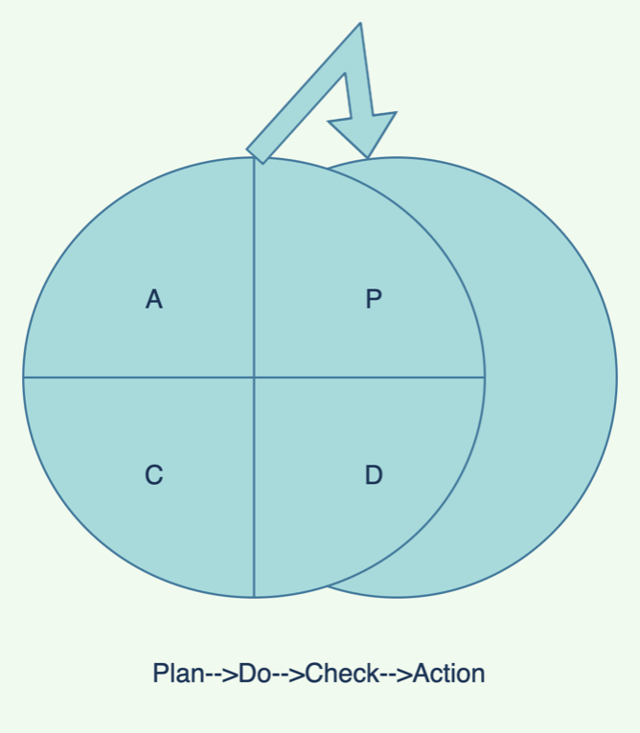
Fig. 2: PDCA process diagram

Program Evaluation and Review Technique ( PERT ) is an arrow diagram similar to a flowchart. PERT diagram usually contains the following three elements :numbered nodes, directional arrows and divergent arrows.The PERT chart example is shown in the following figure 3.
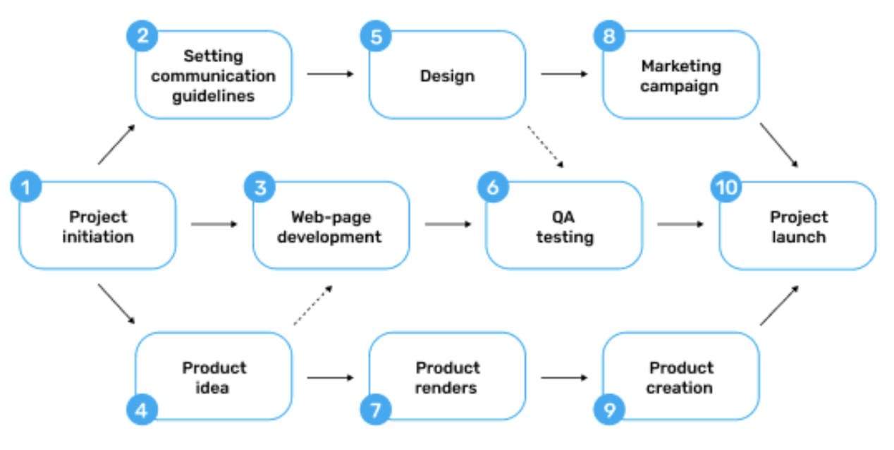
Fig. 3: PERT chart example
In addition to using PERT for project management, enterprises can also use the Gantt Chart. Both methods can improve the efficiency of project information security management.Gantt chart shows the duration of items through activity list and time scale. The Gantt chart example is shown in the following figure 4.A company can use a roadmap and Gantt chart for the same large-scale initiative. The roadmap defines the why behind the project. The Gantt chart establishes how and when.
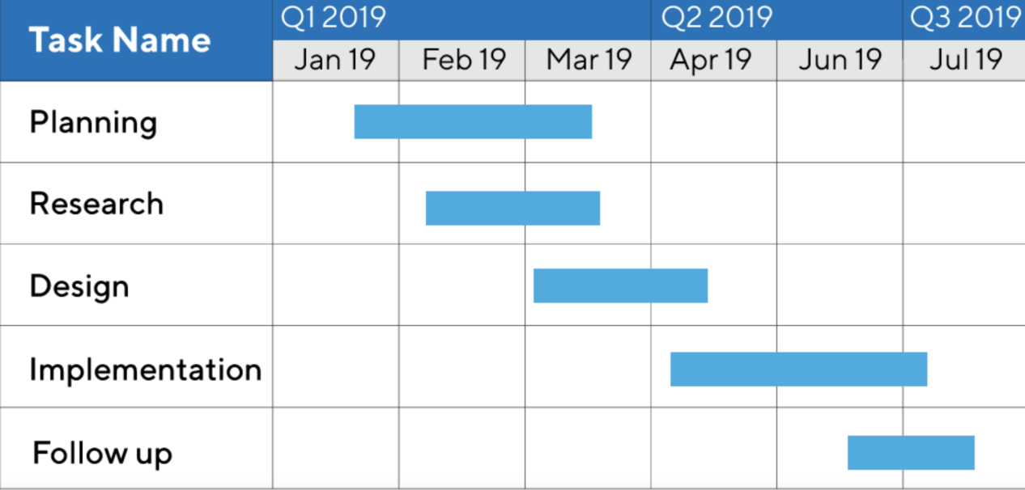
Fig. 4: Gantt chart example

Common RMF frameworks include NIST, COBIT and COSO, among which this article focuses on NIST.
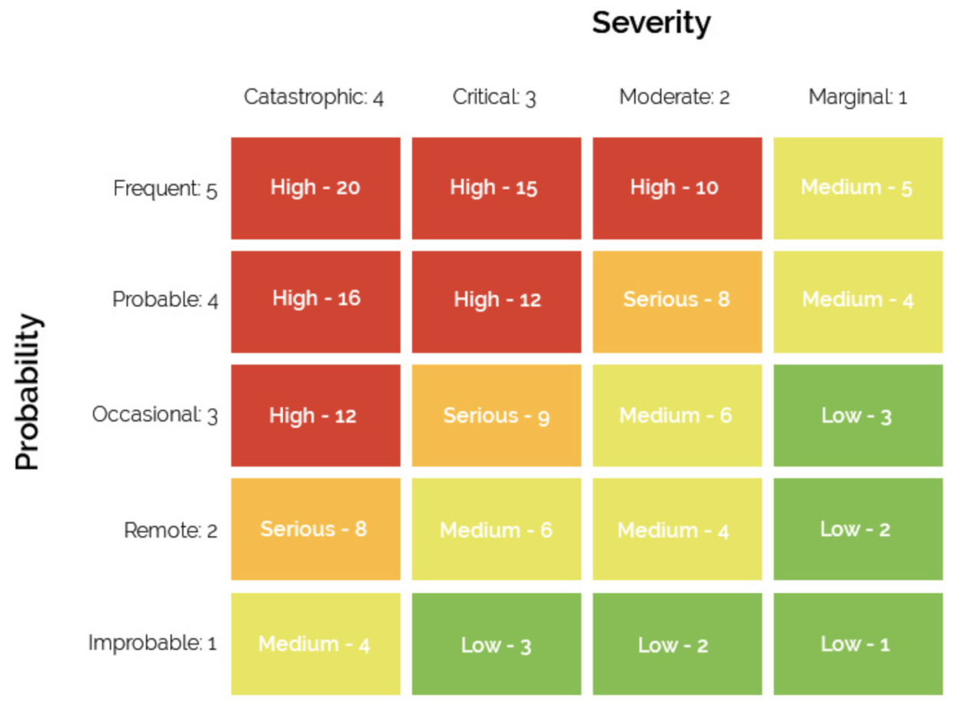
Fig. 5: risk matrix example

III. The importance of creating new regulations and standards
Nowadays, with the application of various new technologies, the storage capacity and processing capacity of data resources continue to improve. This also brings more challenges to enterprise data protection. The most significant representative is cloud computing and multi-service integration. First, cloud computing is the use of distributed storage and computing capabilities to avoid large-scale leakage of personal data. But there are still hackers who can use the analysis information in the form of fragments to recover the original data that has been segmented. Second, the integration of multiple information and communication technologies has led to more complex new services and expanded security application risks. The original security protection technology system has been difficult to cope with increasingly complex data services. A single technology has formed a relatively complete security solution, but the cross-integration of multiple technologies makes it difficult for a single solution to take effect.

IV.CONCLUSION
This paper first introduces the background of data security management, and then integrates the case of coffee company from the aspects of technology, organizational structure, wind direction management and so on, puts forward some specific measures of data security management, and finally explains the importance of creating new rules and standards.

REFERENCES

[1] Wachter S, Mittelstadt B. A right to reasonable inferences: re-thinking data protection law in the age of big data and AI[J]. Colum. Bus. L. Rev., 2019: 494.
[2] Kaissis G A, Makowski M R, Rückert D, et al. Secure, privacy-preserving and federated machine learning in medical imaging[J]. Nature Machine Intelligence, 2020, 2(6): 305-311.
[3] Price W N, Cohen I G. Privacy in the age of medical big data[J]. Nature medicine, 2019, 25(1): 37-43.
[4] O'Loughlin K, Neary M, Adkins E C, et al. Reviewing the data security and privacy policies of mobile apps for depression[J]. Internet interventions, 2019, 15: 110-115.
[5] Wachter S, Mittelstadt B. A right to reasonable inferences: re-thinking data protection law in the age of big data and AI[J]. Colum. Bus. L. Rev., 2019: 494.
[6] Xiong J, Zhao M, Bhuiyan M Z A, et al. An AI-enabled three-party game framework for guaranteed data privacy in mobile edge crowdsensing of IoT[J]. IEEE Transactions on Industrial Informatics, 2019, 17(2): 922-933.
[7] https://www.productplan.com/glossary/pert-chart/
[8] M. E Whitman, H. J. Mattford, Management of Information Security, Cengage Learning, 6th ed 2019.
[9] Lu Y, Huang X, Dai Y, et al. Blockchain and federated learning for privacy-preserved data sharing in industrial IoT[J]. IEEE Transactions on Industrial Informatics, 2019, 16(6): 4177-4186.
[10] Ali B, Gregory M A, Li S. Multi-access edge computing architecture, data security and privacy: A review[J]. IEEE Access, 2021, 9: 18706-18721.

