Student Name: Fatou Bah
Student Number: 1805829
Module Name: Knowledge & Information Management Skills for the Workplace
Module Number: BMSW5106
Lecture Name: Dr. Kalam

Table of Contents
Introduction 3
Evaluation of the concept and importance of knowledge management in the context of an organisation’s knowledge assets 3
The Relationship between Data, Information and Knowledge 4
The relationship between individual knowledge and organisational knowledge 6
Apply analysis and modelling techniques to identify knowledge assets 7
Evaluate actual and potential knowledge assets 8
Rationale for capturing and managing knowledge 9
Importance of Information and Knowledge Management 9
What it requires to create, store, apply and integrate knowledge 10
Impact of Intellectual Property rights 11
Framework for establishing a knowledge management culture 12
The contribution knowledge assets have on an organisation 12
Evaluate the knowledge requirements for an organisation 12
Evaluate the organisation’s framework for enabling knowledge sharing 12
Recommendations 13
Reference 13

Introduction

The aim of this report is to identify a specific organisational context to demonstrate and evaluate the importance of understanding the effective creation, sharing, storing and management of information as it is an essential requirement of the development of good knowledge management development practices. This report will also review the methods through which an organization can convert individual knowledge into organizational knowledge.
This report will focus on Queens Oak care home, a residential and nursing home for elderly with different needs. Queens Oak care centre is a care home located in Peckham, London and an outlets of Excel care delivering an extensive variety of residential homes, nursing and domiciliary. Excel care is one of the biggest UK’s care home providers.
Queens Oak Care home is a four-floor building that lodges elderly people and individuals living with dementia and related diseases. Employees of queen’s oak provide the following activities but not limited to regular wellbeing checks, washing, medication administration and paper working, feeding, stock replenishment, cleaning and equipment setup. However, nearly all these activities have complex processes that need professional knowledge and experience to assume responsibility of such to offer effective treatment to the elderly people.
Queens Oak Care home has been given Beacon Status; the top achievable accreditation offered by the Gold Standard Framework for end of life care in care homes. Queens Oak Care Centre provides personalized care and support residence to maintain high quality service of its residence. Both residence and staff are notified of the morals of the home and recognize everyone as people with diverse responsiveness, needs and desires for improved value of life.
Queens Oak is part of the stakeholders of NHS that reduce the burden and provide support to the elderly with long-term care service needs. Therefore, it is very significant for the right information to be collected since that information is used support the elderly and vulnerable people.

Evaluation of the concept and importance of knowledge management in the context of an organisation’s knowledge assets
Knowledge is the flow of the present market, an essential organizational asset and a key to establishing a balanced competitive advantage. The significance to identify, obtain/acquire, share and recycle knowledge cannot be over emphasis and are the activities controlled over knowledge management. It is slightly challenging duty to assess the phase of knowledge and knowledge management in an organization. Knowledge is a significant resource to preserve the attractiveness of the organization. Organisations must be conscious of the means to classify knowledge and means to share it. A trial that is influential to recognise the level of knowledge and assess the level of knowledge management (Bostjan Delak, 2015).
Queens Oak care home place the residence and their care need first and foremost. Queens Oak has outlined its purpose to determine the information and knowledge required, therefore the challenges involve in knowledge management is minimised. Consequently, there will not be too much of data or information collection. The purpose of the organisation tells the kind of data in need and makes it easy to identify and obtain the information that supports the development of the business.
Information and Knowledge management is an extremely important element of knowledge-oriented industries in the 21st century. Information management permits organisations to be extra efficient by sharing the information all over the business. This encourages an organisation to perform as a team, in which every participant has access to the knowledge support of others. Information management is hardly problem free (Degler, D. & Battle, L. 2007).

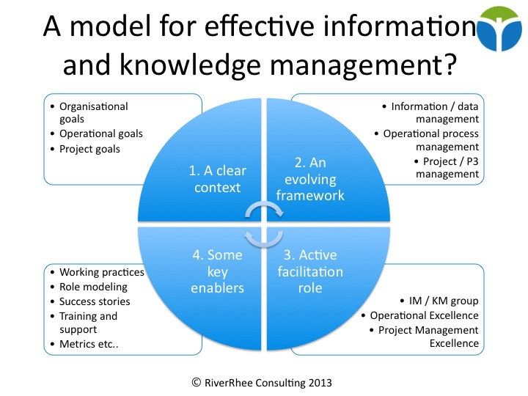

The Relationship between Data, Information and Knowledge
knowledge management works has frequently outlined that it is significant to differentiate data, information and knowledge. The commonly recognized belief perceives data as uncomplicated facts that is turn into information as data is linked into expressive arrangements, which then become knowledge as meaningful information is set into a framework and when to use for projections. This picture perceives data as a requirement for information, and information as a requirement for knowledge (Tuomi, I. (2002).
Data is a raw fact or observation that is believed to have little or no sense until it has been converted or transformed into something meaningful. Basically, data simply exists and has no importance beyond its reality. It can occur in any form, practical or not, it does not have significance of itself. When a random number has been written without been categorized in a sequence to give a meaning, it is data (Stenmark, D. 2002).
Information is data that has been processed to something meaningful by way of interactive context. This "meaning" can be useful but does not have to be. This simply means that not all information is equally useful. An organisation can implement resource to extract accurate, timely, and useful information to address corporate strategic problem (Stenmark, D. 2002).
knowledge is the right gathering of information, for a useful purpose as concluded process. When someone given an information of for example, the weight of her new-born baby, it automatically become knowledge. This knowledge has useful meaning to them but might not be useful to other people. Knowledge has generally been recognized as one of the most significant components for business effectiveness (D Stenmark, 2002).
Data refer to evidences and specified characteristics, as gender, name, address, phone number, date of birth, temperature, and so on. Connecting significance to data converts them into information. The next level is knowledge which means classified information, which is information understood by the receiver and from the viewpoint of the receiver. The high-ranking stage on this variety-understanding relates to a situation of developed, transferred knowledge that provides the receiver the possibility to enhance collaboration with the atmosphere (Gudea, S. 2005).
In countless occasions the transformation among information and knowledge is quite unclear. Some operators may explain one set of data as information, while some others it is knowledge. There are important encounters in gathering, organizing, and obtaining benefit from data composed in the development of delivering healthcare. With healthcare organizations, the challenges engaged in retrieving resident information across various software applications and within organizational limitations are important, generating a possible for exclusive errors (Ben Hamouda, I. et al 2015).

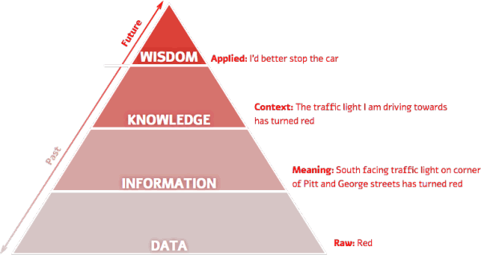

The relationship between individual knowledge and organisational knowledge

The breakdown of the relationship between individual and organizational knowledge outline the frequent and connecting circumstances that describe the contented and procedure of knowledge in organizations, the strategies of knowledge at work and the recognized uniqueness of people’s knowledge as a replication of organizational knowledge (Antonacopoulou, P. E. 2006). Information considered by an individual when defensible fact and stored in memory that is, it can be recovered in an intellectual form across an intellectual activity is labelled learning. Individuals often would like to maintain their knowledge to themselves. Individual know-how usually turns into a competitive advantage at work or at least that is how many people see it.
Individual knowledge supports to do their job competently and save time by better decision making and problem solving. It also secures a perception of team connections within the organization and keeps the employees informed and establishes tasks and opportunities to deliver. Individual knowledge, on the other hand, depends fundamentally on the skills of the person. It is acquired through understanding, training and individual engagement and is deeply tied up with the specific community situations of the person such as biography, interests, values, and so on. It contributes to, and is in turn inspired by, a person's own viewpoint (Efi Vladimirou, 2001).
Individual knowledge therefore involves what may be defined as skills, personal talents and practical abilities. This kind of knowledge is often called procedural knowledge and refers to knowledge of how something is done. Getting individual knowledge accessible to the organisation obviously requires a comprehensive determination. The following tactics are regularly recommended.
- Set an example: share your own knowledge and connections.
- Give reasons to share. Bonuses are important but acknowledgment even more: celebrate when someone shares, note and express gratitude.
- Create a clear corporate situation for shifting from individual to organisational knowledge. What will the tangible and quantified corporate accomplishment advantages be?
- Establish an image of what sharing appears in practice. Present graphic illustrations and convey them repeatedly.
- Create means and methods that make sharing simple. These can consist of straightforward Client Relationship Management Systems (CRMs), databases or internal ‘flash’ reports.
- Honour achievements like deals secured, efforts saved, and problems prevented.
- Develop trust by underlining the importance of the knowledge, and the protection carried with employees’ contact networks (Efi Vladimirou, 2001).

The combined knowledge and skills acquired by the individuals of an organisation is refer to organisational knowledge. Knowledge is shared and applied by individuals but can be tough to handover and hold as a living type of information (Spacey, J. 2017).
knowledge has developed to a significant resource to every single organisation. However, organizations cope with immeasurable trials in development and managing knowledge. Different from industrial events, knowledge happenings are complicated to supervise and manage, since only a portion of knowledge is affected by the organization, the other part is affected by the individuals. This division between individual knowledge and organizational knowledge requires separate collections of management approaches in knowledge management (Bhatt, G. D. 2002).
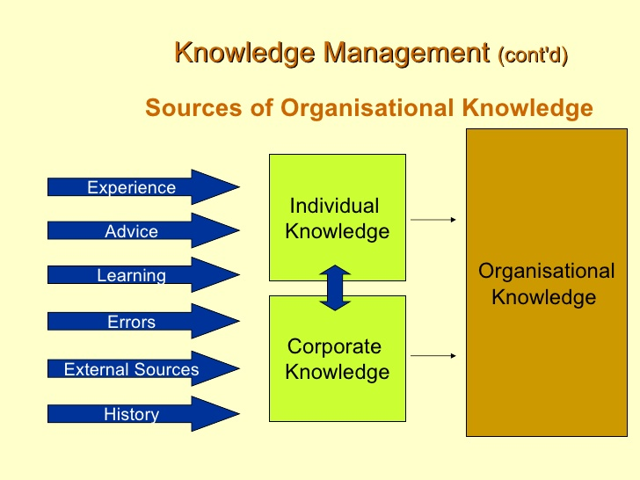

Apply analysis and modelling techniques to identify knowledge assets

The strategic stage of knowledge management requires the organisation to study and strategies its organisation in relations to present knowledge and the required knowledge for upcoming business methods. The tactical level is anxious with the organisation recognising and validating current knowledge, obtaining new knowledge for imminent practise, recoding it in organisational recollections and producing schemes that permits operative and competent application of the knowledge within the organisation. The operational level knowledge is applied in normal exercise by specialised workers that has access to the precise knowledge, at the correct time, in the exact setting (Mackintosh, A., Kingston, J. & Filby, I. 1999).
Therefore, the three viewpoints below are recommended and from studying the knowledge management spreading requirements of a huge organisation, three different level profiles have developed:
1. A business-focus perspective of accessible means and methods to manage knowledge resources well is described as Knowledge Development Manager. Usually a high-ranking representative who is responsible for managing the knowledge management program, recognizing crucial knowledge management strategies and certifying that these developments meet the general corporate aims of the organisation.
2. Knowledge Developers should be capable to secure, form and evaluate knowledge by occupied along with the suitable qualified workers. Eventually be disseminated in reports, or over intranets, or executed in knowledge-founded schemes. Knowledge Developers varies from IT experts with great software design skills that support systems in corporate divisions in the organisation. These are the people that the organisation has selected to create their knowledge quality base.
3. Expert must be aware that their knowledge can be controlled efficiently and are required to understand that it can be broadly shared and re-used within the organisation. It is essential that once the organisation has launched a knowledge management programme, these knowledge workers understand its significance and appreciate how to dynamically support.
Modelling method in other words, conclusions are founded on models of the organisation. Nevertheless, the three groups described above require separate viewpoints on the knowledge assets:
1. Knowledge Development Managers require a tactical standpoint on all knowledge assets. They need to comprehend the present situation of the assets and develop an image of how these knowledge assets can be enhanced or applied to shift the organisation ahead.
2. Knowledge Developers call for a thorough considerate of individual knowledge assets. They must comprehend all the procedures, responsibilities, rights, and limitations related with each knowledge asset, for them to signify all that may be applicable once communicating or utilizing that knowledge asset.
3. Specialised people must understand the presence of important knowledge assets and must recognize how to use them at the operative level (Ann Mackintosh, John Kingston & Ian Filby (1999).
Knowledge has developed increasingly more important due to the improved level of globalization and the teamwork of technology and organizational change. The increasing evaluation of knowledge in an organization is that it is no longer categorized as just an impact to organizations today (Ann Mackintosh, John Kingston & Ian Filby (1999).

Evaluate actual and potential knowledge assets

Knowledge assets are the key outcome of the knowledge management process. The process starts out to recognise potential knowledge assets, initiates the decision whether or how much must be invested in getting the knowledge asset accessible for supplementary use and ultimately embraces all actions required to execute upon this decision (MacMillan, I. 2015).

The vital experimental about knowledge assets is the term “assets” like you would with tangible assets. However, some aspect of knowledge that are just not useful from the view of the organization are identified during the process of knowledge management and are classified as potential knowledge. On the hand, actual knowledge is identified during the same process of knowledge management and are basically classified as fundamental to the capacity to compete. The differentiate between “knowledge assets” occur and “strategic knowledge assets,” appears to be the part of knowledge that make a difference in the capacity to contest and succeed (MacMillan, I. 2015).

Detailed tasks connected with how strategically knowledge is applied and how to go about revolutionizing. knowledge is collected and refined out for people to recognises, the encounters are unlike from essentially being clever to go in and apprehend the knowledge of the crucial individuals in the organization and consider how to use that knowledge to produce good advantage. Therefore, actual knowledge can be the essential knowledge that can be use in a competitive marketplace.

Queens Oak care home recruitment team ensure that employees are experience and knowledgeable of the care sector and its requirements. Trainings, workshops, meetings, seminars, consultations are essentials activities that queens oak care home apply to share knowledge and improve their overall performance. Their key strength is that they are financially stable and have the opportunity of lots of experience and stakeholders engagement, however they have weaknesses like they do not have powers over the policies and procedures and covid 19 and so many care homes around is a threat.

SWOT analysis is one of the greatest common tactical investigation models. It includes observing at the strengths and weaknesses of your business' capabilities, and any opportunities and threats to you or your organisation. When you recognise them, then evaluate by what means to:

- Take advantage of on your strengths.
- Lessen the impact of your weaknesses.
- Make use of the opportunities.
- Lessen the effect of any threats.

What it requires to create, store, apply and integrate knowledge
Capturing, storing and sharing knowledge is critical to any knowledge management systems. It begins with finding the site of the knowledge within the organization which is discussed as knowledge map. Recording performance and decision-making developments to recognize significant knowledge employees in the organization is logically involved in producing knowledge mapping (Zandbergen, P. 2013).
Capturing takes place when the location of the knowledge has been known as class of detailed individuals or set. This comprise gathering all the applicable records and arrange in a meaningful way. Capturing knowledge also involve interviews, surveys, and questionnaire, however not all knowledge is capture in a formal way (Zandbergen, P. 2013).
According the Hussein, S. T. et al, 2018, Job responsibilities, customer service, performance results and decisions making, are all about sharing captured knowledge. Information moves from different stages, creating corporate strategies, competitive environments, modern technology kit’s, work procedures, thoughts for structural development, share skill and knowledge, share progress agendas, support in solving problems and corporate action.
Integration is the consolidation of practical and corporate procedures used to association information from unlike foundations into meaningful and treasured information.” There are systems of getting knowledge composed into an integrated sight and there are methods for gathering collected information physically, for an integration form. Equally are a sort of information integration, the difference being whether the information was physically moved or operated (Murali R. S. 1999).
Knowledge application carries vital transformations at different stages of the organisation. Information sharing is part of the elements that shows an important position in the achievement of knowledge management. These transformations are meant for evolving individual and business skills, and leading organisations in improve environment. Transformation schemes are largely endorsed in circumstances below: generating a new product or a service; shifting the information system; the operation of a new organisation; emerging a new policy, operation of a new regulation; or the application of a new management system (Murali R. S. 1999).
This information’s are required to be stored in the right place so that it is easily accessible and shared with the right people. Managers are continuously seeking efficient strategies that inspire staffs to share knowledge with others within the organisation. The suitable organisational motivations are challenging to explore due to human factors and other recognized complications influencing the sharing behaviour of individual (Heng-Li Yang &Ted C.T. Wu, 2008).
Queens Oak care has been among the organizations that are been monitored in the methods involve in storing and sharing of information and knowledge acquired from the residence and their family members. However, it is advised to share their information within the workplace and to the stakeholders involve in fulfilling the purpose of the organisation but limited to certain people and institution that play a role in the process of maintaining their dignity.
The use of information and knowledge management creates a significant adjustment as it involves and requires knowledge sharing which is the key aspect of a care home considering the stakeholders involve. All information and knowledge necessary for the home is to be collected, stored, shared, and applied. This involve all employees, residence, and stakeholder’s information to be managed properly by collecting the right information, stored in the right places, hare with the right people, and use in the right manner.
Information technology has been facilitating the storing and sharing of knowledge within queen’s oak care home and with their stakeholders. Information technology is a very significant in the home, however, it is complicating to some employee because they are computer illiterate
and are not willing to cooperate or develop individually.
Acquired knowledge becomes that which is believed tacitly in the minds of individuals into explicit, documented knowledge. It is necessary to understand that not all knowledge requires to be acquired in that form. Acquiring knowledge enhance its possibility for re-use. It is a further effective means to allow such re-use where the knowledge has broader application, and especially in situations where it is at risk of being vanished to the organisation, for example over the loss of knowledgeable employee.

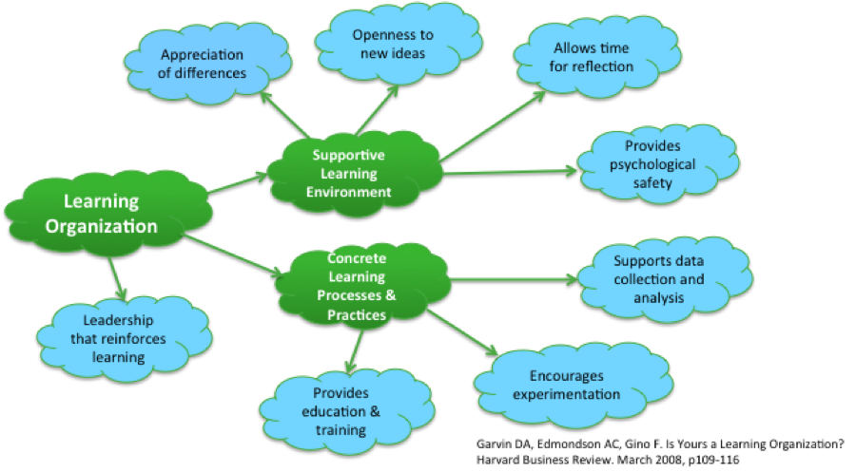

Impact of Intellectual Property rights
Many organisations advance knowledges in demand to expand their attractiveness in the market and disseminate them all over the world to shield their intellectual property. Therefore, the position of an organisation in the market typically relies on the technologies it develops. (Park, Lee, & Jun, 2015). Something that the mind fashioned - for example, a story, manufactured thing, an imaginative work or a character.
The intellectual property rights protect the musical, legendary, inventive, creations, findings, and even projects, artworks, slogans, and symbols. Certainly, Intellectual property rights include any exertion of the mind and the field of the works that are protected is really increasing as clearly the 21st century has observed a burst of returns that are conceptions of the intellect. Trademarks, patents, copyright, trade secrets, and rights over industrial designs are all kind of intellectual property right (Juneja, P. 2015).
Queens Oak care home acquired the excel care trademark which is recommended and protected by its members. Therefore, they ensure that each resident care plan is available, accessible and understandable to support nurses and care assistants to provide quality care and decision making. But safeguarding the information of the residence is their number one priority. Exchange of information and knowledge is another crucial process that queen’s oak is ensuring within the home.

Framework for establishing a knowledge management culture

The contribution knowledge assets have on an organisation
Knowledge assets are the knowledge managers of an organization’s achievement and can be formless with tacit knowledge for instance the great expertise of important employees. knowledge assets can also be controlled, explicit knowledge, organized. Examples would be patents, copyrights and intellectual proprietary rights in categorized system. What is captivating with knowledge assets is that the more you constructed, the more you codify knowledge, the simpler it is to share, both within and outside. Extremely codified knowledge can be shared in seconds through the Internet, while great professional or knowledgeable, additional time to share it with other people.
The applicable learning and teaching offered to nursing home key workers, makes the requirements of the residence known or easily identified by nurses and care assistants, therefore complete treatment and support can be provided (Glaister and Blair, 2008). As a result, knowledge has been acquired this will increase the productivity and efficiency of the home in general.
Information and knowledge management, and knowledge managers are very important in the healthcare sector. The procedure of knowledge management is a complete necessity to knowledge managers with problems solving and decisions taking in healthcare is highly supported on the access to knowledge. Consequently, it is rapidly becoming necessary for healthcare organizations to competently manage both inner knowledge and outwardly create knowledge in mandate to maintain reachable healthcare, realize real value, and inspire transformation. A well planned and operative approach for knowledge management in healthcare can support organizations realize these goals (Haughom, J. 2014).

Evaluate the knowledge requirements for an organisation
These care assistants, nurses and management are the assets of the home and the knowledge provided to them are for the benefit of the home since they will use the same knowledge to manage the home. Knowledge management is understood as a recurring procedure of recognizing knowledge assets which are possibly treasured by the organisation, analysing the knowledge assets to regulate which ones requires to be managed better, choosing activities which circulate, apply or otherwise manage these knowledge assets, and then studying development to agree what to do next.
According to Barry et al. (2012), knowledge and approach of nurses and care assistants are important elements in managing the quality of support provided to the residence. The key factor for the purpose of queen’s oak is to provide quality support to its residence therefore, qualified nurses and care assistant need to be equipped and maintained for better productivity of the service provided to the residence.
Queens Oak Care Centre has various resources and methods that are applied for managing residence correct and complete data. A resident may obtain care at more than one physical resource connected within the home, as part of the health care service management procedure. Resident identification is very important for queens Oak because the home is also a nursing home that administer and document medication. Therefore, access to complete and accurate resident medical documents is essential and has importance for strengthening the excellence of care. Knowledge management can increase the pace and correctness of subject dissemination, improve customer service and fulfilment, enhance need for learning, urge feedback, lower training costs and encourage change.

Evaluate the organisation’s framework for enabling knowledge sharing
Organisations that board on a knowledge management agenda endorse the status and responsiveness of how knowledge management can be achieved indoors, and across, operational divisions. It creates a consciousness of a framework to attain knowledge management and create a set of workers with skills in knowledge management techniques to empower them to simplify the expansion, preservation, use and share of the organisation’s knowledge assets.
Knowledge is a ﬂux combination of outlined experiences, values, appropriate information, and professional understanding that presents a context for assessing and integrating new experiences and information. It is created and is utilized in the minds of knowers. In organizations, it often becomes embedded not only in documents or warehouses but also in organizational practices, processes, procedures, and customs (Efi Vladimirou, 2001).
Validation management is a technique for pursuing decision making throughout the project development. Producing a method for recording the basis for strategic decisions supports in quality control and in offering valuable information to individuals that might request to reuse results. Many tools and tactics have been previously established to enable basis management. The key methods to rationale management are defined as an introduction to analysing the structure of an organizational. The sole feature of this model is that it surrounds rationale management into a more general analysis and result assortment tool. The tool simplifies several mechanisms for the automated collection of relevant data (Douglas, I. 2005).
Queens Oak care have a dashboard meeting every morning to update and inform necessary information. An intranet platform to share required information to key personnel for efficiency and productivity.

Recommendations
Acquiring information just for having access to it will not help in the development of an organisation. Therefore, an organisation needs to primarily outline its purpose before it can gather information and then utilize it. Because it is useless to acquire information that is meaningless to an organisation after wasting time, energy and resources. Recognize and acquire information that enhance the organisation’s key requirements.
Through software, data managers produce systems to collect and organise information base on an organisations requirement. Therefore, data managers need to be very particular and logical for an effective and meaningful management to the organisation. The value of the organisation is profoundly supported on tacit knowledge, managing tacit knowledge and protecting intellectual property is important.
The most significant input management requires to make in the 21st century is to improve the efficiency of knowledge responsibilities and knowledge managers. Knowledge and revolution played a vital role in the development of people. The revolution from an agricultural culture to the information culture has mainly been taken about as a result of gathering of knowledge through the periods.
Knowledge management is very significant to Queens Oak care home because it acquires individual knowledge that eventually becomes an organisational knowledge which is meant for the benefit of the resident and the productivity of the home. Without appropriate knowledge management programmes, the knowledge might fall in the wrong hands or been abused.

Reference
Delak, B., Majewski, G. M. & Damij, N. (2014) How to identify knowledge and evaluate knowledge management in organization – case studies report. Online Journal of Applied Knowledge Management. 2.2 Available at: http://www.iiakm.org/ojakm/articles/2014/volume2_2/OJAKM_Volume2_2pp162-171.pdf (Accessed: 29th March 2020).
Stenmark, D. (2002) "Information vs. knowledge: the role of intranets in knowledge management," Proceedings of the 35th Annual Hawaii International Conference on System Sciences, Big Island, pp. 928-937, Available at: https://ieeexplore.ieee.org/abstract/document/994043/authors (Accessed: 30th march 2020)
Heng-Li Yang &Ted C.T. Wu (2008) Knowledge sharing in an organization, Technological Forecasting and Social Change, 75(8) pp 1128 S– 1156. Available at: https://www.sciencedirect.com/science/article/pii/S0040162507002028?via%3Dihub#! (Accessed: 30th March 2020).
Tuomi, I. (2002) "Data is more than knowledge: implications of the reversed knowledge hierarchy for knowledge management and organizational memory," Proceedings of the 32nd Annual Hawaii International Conference on Systems Sciences. 1999. HICSS-32. Abstracts and CD-ROM of Full Papers, Maui, HI, USA, 1999, pp. 12 pp.-. Available at: https://ieeexplore.ieee.org/abstract/document/772795 (Accessed: 30th March 2020).
Bhatt, G. (2002) ‘’Management strategies for individual knowledge and organizational knowledge’’, Journal of knowledge Management. 6 (1), pp 31 – 39. Available at: https://www.emerald.com/insight/content/doi/10.1108/13673270210417673/full/html (Accessed: 2nd April 2020)
Vladimirou, E. (2001) ‘’WHAT IS ORGANIZATIONAL KNOWLEDGE’’ Journal of Management Studies. Available at: https://www.htsoukas.com/wp-content/uploads/2014/05/2001-E.-Vladimirou-What-is-organizational-knowledge.pdf (Accessed: 2nd April 2020).
Delak, B. (2015) ‘’How to Evaluate Knowledge and Knowledge Management in the Organization Using COBIT 5’’ Isaca Journal Available at: https://www.isaca.org/resources/isaca-journal/issues/2015/volume-3/ (Accessed: 4th April 2020).
Haughom, J. (2014) ‘’Knowledge Management in Healthcare: It’s More Important Than You Realize’’ Available at: https://www.healthcatalyst.com/enable-knowledge-management-in-healthcare (Accessed: 04th April 2020)
Degler, D. & Battle, L. (2007) ‘’Knowledge management in pursuit of performance the challenge of context’’ Wiley Online Library Available at: https://onlinelibrary.wiley.com/doi/abs/10.1002/pfi.4140390609 (Accessed: 5th April, 2020)
Mackintosh, A., Kingston, J., & Filby, I. (1999) ‘’Knowledge Management Techniques: Teaching & Dissemination Concepts’’ Division of Informatics, University of Edinburgh Centre for Intelligent Systems and their Applications, Available at: https://www.inf.ed.ac.uk/publications/online/0049.pdf (Accessed: 5th April, 2020)
Douglas, I. (2005) ‘’Capturing and Managing Decision Making Rationale’’ Arizona State University, Research Gate Available at: https://www.researchgate.net/publication/4173566_Capturing_and_managing_decision_making_rationale (Accessed: 5th April 2020).
Barry, H.E., Parson, C., Passmore, A.P. and Hughes, C.M. (2012), “An exploration of nursing home managers’ knowledge of and attitudes towards the management of pain in residents with dementia”, International Journal of Geriatric Psychiatry, 27 (12), pp. 1258-1266. Available at: https://pure.qub.ac.uk/en/publications/an-exploration-of-nursing-home-managers-knowledge-of-and-attitude (Accessed: 7th April, 2020).
Glaister, J.A. and Blair, C. (2008), “Improved education and training for nursing assistants: keys to promoting the mental health of nursing home residents”, Issues in Mental Health Nursing, Vol. 29 No. 8, pp. 863-872.Avialable at: (Accessed: 7th April, 2020)
Gudea, S. (2005) ‘’Data, Information, Knowledge: A Healthcare Enterprise Case Study’’ Perspectives in Health Information Management Online Research Journal Available at: https://www.ncbi.nlm.nih.gov/pmc/articles/PMC2047317/ (Accessed: 7th April, 2020).
Ben Hamouda, I. et al (2015) ‘’Understanding Knowledge Sharing in Health Care System’’ Association for Information Systems AIS Electronic Library (AISeL), Available at: https://pdfs.semanticscholar.org/5b6a/d34349c0dbf4099ed1a8eb830aa080f0f600.pdf (Accessed: 10th April 2020).
Antonacopoulou, P. E. (2006) The Relationship between Individual and Organizational Learning: New Evidence from Managerial Learning Practices, SAGE Journals. Available at: https://journals.sagepub.com/doi/abs/10.1177/1350507606070220 (Accessed:11th April 2020).
Spacey J. (2017) ‘’8 Types of Organisational Knowledge’’ Simplicable. Available at: https://simplicable.com/new/organizational-knowledge (Accessed:12th April 2020).
Zandbergen, P. (2013) ‘’Knowledge Management: Capture, Store & Share Information with KM’’ Study .com, Available at: https://study.com/academy/lesson/knowledge-management-capture-store-share-information-with-km.html (Accessed: 15th May 2020).
Hussein, S. T. et al, (2018) ‘’Kurt Lewin's change model: A critical review of the role of leadership and employee involvement in organizational change’’ Journal of Innovation & Knowledge, 3(3), pp 123 – 127. Available at: https://www.sciencedirect.com/science/article/pii/S2444569X16300087 (Accessed: 15th May 2020).
S. Park, S.J. Lee, S. Jun. (2015) ‘’A network analysis model for selecting sustainable technology’’
Sustainability (Switzerland), 7 (10), pp. 13126-13141, Available at: https://www.scopus.com/record/display.uri?eid=2-s2.0 84949220812&origin=inward&txGid=b23a1021baabe927858c0ee621aa2e17 (Accessed: 15th May 2020).

Juneja, P. (2015) ‘’Introduction to Intellectual Property Rights’’ Management Study Guide, Available at: https://www.managementstudyguide.com/intellectual-property-rights.htm (Accessed: 15th May 2010).

