Charlene Morgan (1906685)
3/20/2020

PROBLEM SOLVING AND DECSION MAKING

Executive Summary

Asda has stood the test of time over the years; it continuously steps out of their comfort zones to keep up with their major rivals. When faced with the major problem into sales on the decrease, it identifies that Asda need to look for new outlet ideas to progress and find an understanding where they sit in the market in terms of progress and turnover. Asda can improve their sales by listening to employees feedback, taking an understanding on what sells and what doesn’t, offering great affordable prices for the average person. Management need to be resilient to be able to withstand and recover from difficult situations even though at times this can come under scrutiny, if it works then it shall stand the test of time and be a worthwhile outcome, ending in great results. Being efficient will help in finding a quicker solution by using all options given and following through the action plan provided. Using forms of modules, it will work out underlining problems and give ways of coming up with an outlook to perform better. If Asda remain true to their heritage, then they will never overlook their true meaning. ‘Save money. Live better.’

Contents
Executive Summary 1
1.0 Introduction 3
2.0 Main Findings 4
2.1 Overview of organisation 4
2.1.1 The history of Asda 4
2.1.2 What products does it offer? 5
2.2 Investigating Asda 5
2.2.1 Nature, Scope and Impact 6
2.3 SWOT Analysis 7
2.4 PESTLE Analysis 8
3.0 Conclusion 10
4.0 Options 11
5.0 Action Plan 12
6.0 Appendices 13
7.0 Acknowledgements 16
8.0 Reference List 17

Introduction

This report has been requested by Laura James it will be completed and submitted on Friday 20th March 2020. This report has been compiled by Charlene Morgan to illustrate and provide an analysis of problems that Asda currently faces. The problem which will feature in this report will focus on sales, and the lack of income and profit being received. It shall demonstrate certain analytical methods such as SWOT and PESTLE to show thorough research and gather all relevant information. To support the evidence, it will explore numerous books, journals, the world wide web and videos, to help support these findings. To give an in-depth knowledge it shall explain the process of communicating, monitoring and reviewing to execute these chosen options. Furthermore, it will outline an explanation on all theories that this report will provide, with a visual guidance as well as a written one. Once all knowledge has been greatly looked at in depth, it will create an understanding of how problem solving can be focused on solutions rather than an issue, again demonstrated through decision making, weather that be through creative or showing a sense of resilience within oneself, using Nature, Scope and Impact, working out the major factors contributing to the dilemma and seeking to find a solution.

Main Findings

Overview of organisation

Asda has become a giant over the years becoming a successful recognisable brand. They offer low “Rollback” prices across their stores and have always had at the forefront of their mind that the consumer must come first. An example of this is always wanting to stretch the British pound coin so you will effectively walk away with change in your pocket, this has become somewhat of a huge identity for Asda with the infamous “Tap your pocket” slogan. They have successfully taken over 631 stores within the U.K and currently look after over 165,000 employees. They currently work alongside 340 local suppliers which help to create more than 2,500 product lines on their shop floors. (Supplier Relations 2020)

The history of Asda
(Please see Full Timeline in appendences. Refer to page 10)
From humble beginnings back in the 1920’s the Asquith family ran a local butcher’s shop in West Yorkshire it later expanded in to seven further shops, the sons who were heavily involved in the family business later became the co-founders of the iconic brand Asda. (Our History 2020) They did not do this alone, with the help from Noel Stockdale whose father ran a business known as Associated Dairies & Farm Stores Ltd Noel managed to strike up a good relationship with the Asquith sons, this allowed him to become a co-founder of Asda and change in the way shoppers can purchase items for the foreseeable future. Little did anyone how much this would impact on today’s consumer. In 1958 the Asquith brothers knew there had to be more to retail than meets the eye and took a trip to USA to see what others were doing across the pond, on this trip they visited a supermarket named ‘Piggly Wigglys’ and the results were astounding, here they would find shoppers were able to leisurely shop with trolleys or baskets and pick up the products to look and feel before deciding whether to purchase, they also discovered that their food products were sold at a discounted price, after spotting an opportunity to mirror the exact same idea, they took it upon themselves to do just that, whilst coming up with a clever idea to introduce late night shopping on a Friday evening for the first time ever, the rise in customers was a magnificent sight to see. The mid 60’s paved way for its first ever Asda store with the added appeal of car parking (yet another opportunity noted), this meant the focus now had to turn to Asda and find someone else to run the butchery business the Asquith brothers made contact with Noel Stockdale at Associated Dairies and this is how the supermarket got its name ASquith + DAiries = ASDA. Provided is a timeline to show more information of how Asda has incorporated change and launched certain accomplishments over the years to help the brand become recognised and remain to this day a company not to be forgotten.

What products does it offer?

Asda is more than just a supermarket; it splits into different formats and provides diverse services and products throughout its stores. (Company Facts 2020) Supercentres are Asda’s largest its sits on a huge scale covering 100,000sq.ft. located in Milton Keynes. It offers services such as hairdressing, dry cleaners, banks and in 2016 a decathlon sports retailer has opened in three of their branches. Superstores have most customers as they offer fresh food and have introduced a Cafe, Pharmacy, Optician and George fashion. The third of its kind are supermarkets this is the smallest of them all as they look at providing convenience and selling non- essential food items. Lastly Asda Living as become the only store which does not sell any food related items; however, they do focus on homeware, clothing and entertainment goods. Another service that does not go unnoticed are petrol filling stations they offer 24 hour pumps with the choice of paying at the pump or paying at a kiosk, a small convenience store can be handy when needing food on the go and any travel products which may be needed. With all the diversity Asda has to offer it surely has broken the mould over the years and continues to do so.

Investigating Asda

Like all companies Asda has faced numerous problems and continue to do so, they have had a decrease in sales over the Christmas period in 2019. Asda believe that they are up against the uncertainty of Brexit. Strain has been considered a part of Asda and Sainsbury plan to merge, but this however came at a standstill as there were talks of prices rising throughout the stores and not giving quality of produce the best chance. (J. Kollewe 2020) and now Walmart who own Asda are putting pressure to sell the majority of their shares but still keeping a minority stake of the business. They also face online retailers, negative press and other online retailers providing delivered groceries straight to your door.
The major problem that shall be investigated here is Asda’s is loss of sales, in every company a decline in trading can cause significant and problematic challenges. A way of understanding why this is happening is by getting to the root of the problem and take time to work out how to use every possible source to reveal the answer.

Nature, Scope and Impact
(Please see full 5 whys appendences. Refer to page 14)
(Please see full Fishbone appendences. Refer to page 14)

Looking into the nature of Asda the research shows that a cause for concern presents Asda in the decline in sales, which has spread widely throughout all its stores. The reason for this is because of its main competitors which plays a huge part when it comes to the customer flocking to quality goods at very low prices. Whilst we look at low prices and quality in products it is vital that customers have their range of choice that best suits their taste and family’s needs. There is a continuous battle with their rivals, which significantly hinders Asda’s need for reputation and sales. Additionally, there is a sense of unpredictability over Brexit and if it shall become an ordeal in the future, Asda believes that this has contributed over the recent years, which can affect their suppliers with trade deals and productivity. (Sky UK (2019)
It greatly determines the outcome of thousands of jobs being put at risk; this can have a rippling on going affect throughout the stores internally and externally, the scope of this can be disastrous to their employees and everyone else who is involved within the company, such as Suppliers, Stakeholders, charities and the community which can all suffer a loss.
The impact can create a negative outcome for all aspects of working environment, employees lose their jobs, customers go elsewhere, stakeholders will seek other organizations to invest their money into, local suppliers will have lack of income, all these can collapse livelihoods. It strikes up fear and uncertainty within management too, sometimes the path is not always clear and there can feel like there is no end in sight without a resilient management team to overcome troublesome tasks.

The Jefferson A. 5 whys model illustrates how an underlying problem can occur, the goal is to get to the root cause, and when repeating why 5 times, your answer should effectively be the basis for the next question in line. In this instance Brexit has played a significant part in Asda losing in sales, as there is uncertainty over how the public spend their money wisely and what it holds for the future.
The second model used is Ishikawa K. fishbone. It is used as a cause and effect analysis to show several flaws and imperfections through using a visual aid. The head will show the major problem Asda faces while it flows through the spine dishing out the problematic areas. It will not give evidence but will give an opinion instead. (Project management skills 2010-2020)

SWOT Analysis
(Please see full SWOT in appendences. Refer to page 10)

Following the recent documentary (channel 5 2020) it clearly underlines how Asda have shown their strengths over the years, through their Infamous ‘Pocket tap’ slogan which is known throughout the U.K this gives the consumer comfort and reassurance. Asda provides a range of products whether they are locally sourced or transferred from overseas. Various brands and services give choice and extra help when needing a certain service e.g. Key cutting, Photo printing and even changing currency for travelling. Customers will always feel they are still able to have their vibrant and inexpensive shopping experience. All this being under one roof gives convenience and makes everyday life easier without the need to go elsewhere, when all the while Asda carries on putting the customer first.
Based through MarketLine (MarketLine. 2020) the weaknesses show very little with information coming forward, this is slightly biased as the retailer does not want to reveal any flaws to make it public, especially to the likes of the stakeholders. Although cash flow problems can become a common factor, not enough customer spending or not having the right terms with certain suppliers can make it strained. Asda do not have enough smaller convenience stores at hand, making it somewhat of a task to get to said store if you do not live near one. If they could implement a swot analysis every so often then, they could keep any key areas up to date and work on problem before concentrating just on their strengths.
Opportunities is a chance for the organisation to create somewhat of a step up in moving forward. With having an influential presence online, they can get ahead of the game and offer a variety of products and produce to their customers at a click of a button, if their website is designed in a clear and manageable way then it give the person confidence in using that service time and time again. Launching new products is exciting for the company as well as the customer, its shows diverse and a clear understanding of how times change, keeping up to date with all relevant news. Companies have merged in the past and while this could go either way in terms of success, sometimes a leap of faith is needed if a business is due to fail. Bringing two companies together to strengthen and give insight, whilst using others expertise and skills. If both companies come out on top, then the move was the right one to make in terms of profit and helps for future deals being made.
There are other grey areas which poses a threat and provides issues which cannot necessarily be controlled these can be anything from word of mouth, to critics, negative press and even the rise of taxes. Online retailers such as Amazon are even now making a bee line for supermarkets by also delivering fresh food to your front door. However, Asdas biggest threat to date is its competitors, the intense competition marks rivalry between the major recognisable supermarkets. Asda may be pushed to lower its margins in the future. It critically needs to analyse the larger multi-national retailers who have substantially greater resources, this gives them a chance to spend more money on advertising, produce and marketing. Knowing this information Asda can still turn this threat into an opportunity by using their own initiative.

PESTLE Analysis
(Please see full PESTLE in appendices. Refer to page 13)

To undertake a PESTLE analysis, it shall present a breakdown of the following acronym and give fundamental reasons to critically analyse the following framework.
Political carries somewhat of a degree of not being able to control of what is going on in the outside world, government puts plans in place and companies must adhere to them. These can be anything from rise in taxes, to government policies and a change in the economic environment. Trade prices are a factor here also, which will affect organisations to be forced to spend more. There are also the implications of where these stores are located, different councils mean different rules and regulations to comply by. (Perera, R. 2017)
Economic challenges Asda on certain areas which are an ever-growing issue, these factors can never be completely stopped. They include, different competitors constantly shaking things up to get a better deal when it comes to produce, wages increase year on year, rent on buildings can grow as well as energy suppliers is a commodity we cannot live without. Each of these go hand in hand when it comes to running a successful business, without maintaining and expecting things to rise then how can companies plan and forecast for the future. They have no sales if they don’t have the right fundamental issues. To establish the problem within the Macro environment its clear to use the same two PESTLE key areas which relate to financial worries. It helps to create a strong connection to evaluate the scope more in depth. Below are some other key areas which can interlink with these two PESTLES. (Howandwhat. 2020)
- Council tax
- Sugar tax
- Inflation rates
- Competitive Pressures
Another favourable link to relate this too is SWOT, as threats can get oneself to require action, bring teamwork together to brainstorm a great idea and a well thought out plan. Asda can propel itself once again being a force to be reckoned with and putting themselves back on par with other leading retailers. Threats may seem like an impossible task but there’s a chance that this can be turned into an opportunity as well. In the past Asda has pushed boundaries to win the rights of offering the consumer the best services and products at hand and have rightly won. They are constantly up against competition whether that is instore or online, to help Asda achieve the best they can do, is to keep spending in line by not over staffing, having market researchers to evaluate what works best for them, having the consumer in mind at all times, bringing management to the front line and actually speaking to their staff members so they can feel a sense of importance and making sure the location of Asda stores rightfully fits with enough people wanting to visit, purchase and making it a convenience store to them. (UKESSAYS 2016)

Conclusion

As stated above, the conclusion has centred around sales and what Asda can do to help become the best there is when it comes to giving the consumer their wants and needs. Asda has proved time and time again, that they always are trying to come up with new ideas. For example, Advertising, sending and receiving of parcels, online shopping, introducing a wider range of products when it comes to vegan, gluten free and anyone who may have lactose intolerance. They seek ways of trying to improve and merge with other retailers in order to stay on track and better themselves with their rivals.

Options

To resolve and think of ways that Asda can get over these stumbling blocks and manage them differently in case the situation arises again, they need to investigate certain end positive results. Asda will never compete with the likes of Aldi and Lidl, or even Waitrose and Marks and Spencer as they have a different based clientele, but they can gain back customers through the following options:
- Customer shopping experience
- Influencers on social media
- Advertising
- Marketing strategies
Walking into a store, customers feel they need a happy, organised, peaceful and effective enjoyable experience.
Using the likes of Influencers who speak out to millions of people, can give the biggest impact to the outsiders who follow their trends.
Advertising can speak volumes to consumers it can give the impression that their products are the best and persuade them to visit the store.
Making sure the person, business or government are happy with what they are buying, will not complain and will be happy to buy again if appropriate
Marketing strategies always promote new products by using end of aisle impulse buying for all customer to have plain view and entice customers with parting with their money.

Action Plan
Template for monitoring, Reviewing and Communicating a Decision
Decision implemented:
The decision is to stay at ‘Rollback prices’ and excel by putting customer needs first

Monitoring the decision:
Resources:

CEO’S, Management, Managers from stores, staff, Suppliers.

Key Indicators:

Information is reviewed from other competitors, staff, warehouse with stock control and customer feedback

Targets:

To meet a deadline in the next 24 months

Data Sources:

Social media, Articles, Newspapers, online reviews/feedback, MarketLine and documentaries

Reviewing the decision:
(Write here how you will evaluate/review the problem. What questions will you ask? Etc)

- How costly will it be to implement these changes?
- Has the current information provided any further knowledge?
- How effective has this decision become?
- How can we improve on customer service? And potentially drive sales forward?

Communicating the Decision:
Internal Stakeholders  Communication will begin with holding a management meeting across the board and rolling out a given time frame to create a solution and apply changes.  Further employees or anyone who has an impact on the company will be given full awareness through group meetings and emails, once the decision has been made final.  Customers will know through terms of media and word of mouth, also advertisements throughout stores. | External Stakeholders  Information shall be fed throughout to its external outlets:  - Customers  - Governments  - Local/Oversea suppliers  - Stakeholders  Letters and Emails will be carried out to provide information to all.

Appendices

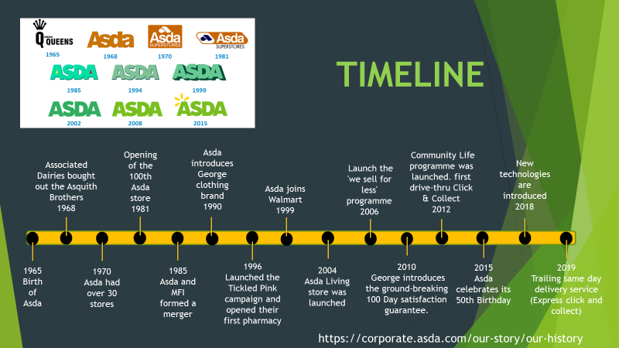

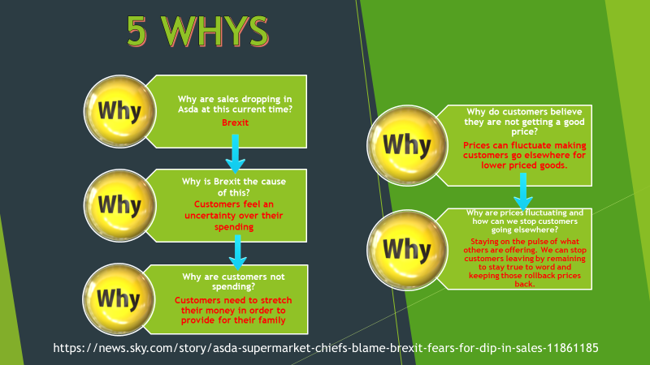

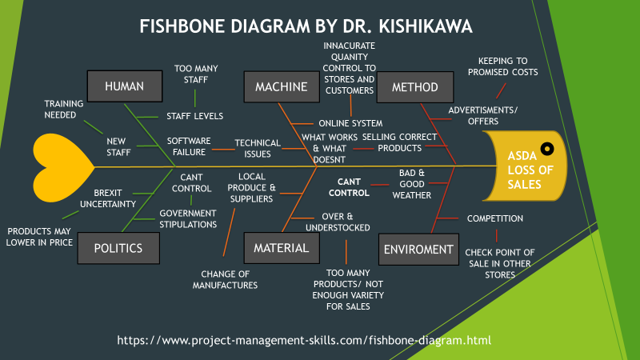

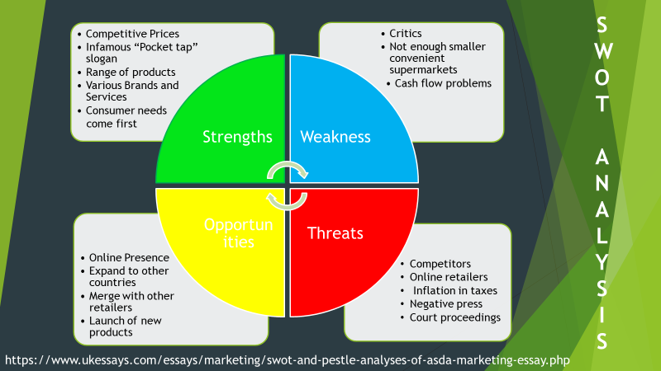

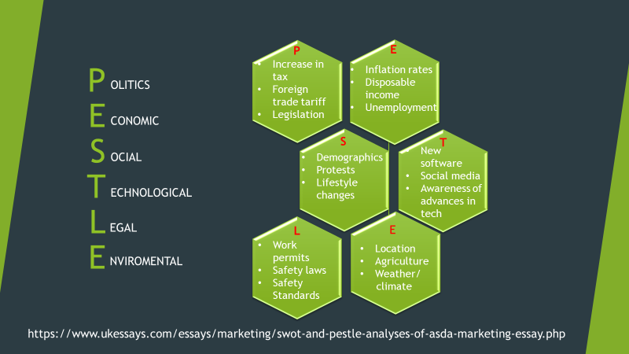

Acknowledgements

This report would not have been made possible without the help of certain people and resources accommodating to compile this report. The appreciation does not go un noted and a sincere thankyou to Laura James whose teaching skills are second to none and guides individuals on a road to success. The current channel 5 documentary gave insight on a whole new level regarding understanding Asda better, and brought to life different problems to highlight the way this report has been written. The library staff are efficient, polite and always keen to help, in a supportive manner. The peers who have had the same report have been understanding and a great way of learning different styles of information being given.

Reference List

© 2020 Sky UK (2019) [online].Available at https://news.sky.com/story/asda-supermarket-chiefs-blame-brexit-fears-for-dip-in-sales-11861185 (accessed 9th March 2020)

© ASDA 2020 Company Facts (2020) [online]. Available at https://corporate.asda.com/our-story/company-facts (accessed 1st March 2020)

© ASDA 2020 Our History (2020) [online]. Available at https://corporate.asda.com/our-story/our-history (accessed 1st March 2020)

© ASDA2020 Supplier Relations (2020) [online]. Available at https://www.asda.com/creating-change-for-better/better-business/supplier-relations (accessed 10th March 2020)

© Channel 5 Broadcasting Ltd (2020) Inside Asda: Bigger, Better, Cheaper? [online]. Available at https://www.channel5.com/show/inside-asda-bigger-better-cheaper/ (accessed 27th February 2020)

Howandwhat. (2020) PESTEL analysis of Asda. [online]. Available at https://www.howandwhat.net/pestel-analysis-of-asda/ (accessed 3rd March 2020)

J. Kollewe Walmart in talks to sell majority stake in Asda [online] https://www.theguardian.com/business/asda (accessed 4th March 2020)

MarketLine. (2020) Asda Stores Ltd [online]. Available at https://advantage-marketline-com.ezproxy.uwtsd.ac.uk/Company/Summary/asda_stores_limited (accessed 4th March 2020)

Perera, R. (2017) The PESTLE analysis. 1st Edition, Nerdynaut

Project management skills (2010-2020) Fishbone Diagram Cause and Effect Analysis [online]. Available at https://www.project-management-skills.com/fishbone-diagram.html (accessed 11th March 2020)
UKESSAYS (2016) Swot and Pestle Analyses Of Asda Marketing Essay [online]. Available at https://www.ukessays.com/essays/marketing/swot-and-pestle-analyses-of-asda-marketing-essay.php (accessed 3rd March 2020)

