Kieran Brown (2204069)
University Of Wales Trinity St David
Applied Computing – Network Operating Systems and Services
Assignment 1

Table of Contents

Page 3 – 4 : Hypervisor Research

Page 4 - 6 : IP Addressing Research

Page 6 - 7 : Research Protocols Research

Page 7 – 8 : Network Services Research

Page 9 – 19 : Topology Practical Evidence

Page 20 – 21 : Bibliography

Page 22 : Appendix

Hypervisor Research

Type 1 Hypervisors

Type 1 hypervisors, also known as bare metal hypervisors interact “directly with the underlying machine hardware” [1] this is done without requiring a host OS. This makes them highly efficient and are known as the “most efficient and best performing hypervisors available” [2] when it comes to managing virtual machines and resources. Type 1 hypervisors are commonly used in enterprise environments, cloud computing and data centres due to their high security and performance. They require enterprise grade servers with virtualisation support, RAM, CPUs and SSD storage. Type 1 hypervisors are best suited for dedicated server hardware and cloud platforms, as they integrate easily with enterprise virtualisation tools

Popular Type 1 Hypervisors

- Microsoft Hyper-V – Integrated with windows server
- VMware ESXi – Enterprise grade and widely used
- KVM – Open source, Linux Integrated
- Xen – Open source and cloud friendly

Type 2 Hypervisors

Type 2 Hypervisors which is also known as the hosted hypervisor “interacts with the underlying host machine hardware through the host machines operating system” [3] They are primarily used for testing, development and personal virtualisation. Unlike type 1, they run on standard consumer hardware with a host OS, which requires significant RAM, CPU and disk space for multiple VM operations to run. Type 2 hypervisors are compatible with multiple operating systems including, Windows, Linux and MacOS which implies that they are more flexible for different use cases. However, although type 2 hypervisors are more versatile in its compatibility with other operating systems, it does offer lower performance and security compared to a type 1 hypervisor.

Popular Type 2 Hypervisors

- Oracle Virtualbox – Free, user friendly
- VMware Workstation – For developing and testing
- Parallels Desktop– Optimised for MacOS
- QEMU – Open source, multi platform support

Comparison Table

Feature | Type 1 | Type 2
Performance | High | Moderate
Security | High | Lower
Setup | Complex | Easy
Scalability | High | Limited
Use Case | Enterprise | Development
Compatibility | Server grade hardware, cloud | Consumer OS (Windows, Linux, MacOS

Hypervisors Summary

In summary, Type 1 hypervisors offer a superior performance, security and scalability over a type 2 hypervisor which makes them more suitable for enterprises. However, Type 2 hypervisors do offer ease of use and versatility which would make them more suitable for smaller developments and testing.

IP Addressing Research

How data travels across the internet and role of IP addresses

During the group activity, we discussed how data is transferred across the internet and the role that IP addresses play in this process. “It is first broken up into smaller packets which are translated into bits” [4] Each of these packets contain the sender and receivers IP addresses, which help identify the source and destination. The packets then travel through multiple switches and routers by following the most efficient path to reach its destination. IP addresses play a vital role in this process as they provide unique identifiers for all devices on a network which ensures that data is sent to the desired location. Without IP addresses devices would not know where to send or receive data, making it impossible to communicate over the internet.

Roles of routers and switches in data transmission
Routers and switches are play a pivotal role in facilitating communication between different devices within a network. A switch operates within a local area network (LAN) and directs data to specific devices based on their MAC addresses. They are the referred to as the road between devices are communication is “not possible without switches to tie devices together.” [5]

Routers use routing tables and protocols to decide how data packets should be sent over the internet. They analyse the desired IP address of packets and send them through the most efficient path to ensure that the data reaches its desired location in the most efficient and reliable way across multiple networks. They are commonly referred to as the hub of network.

Structure, Format, and Representation of IP addresses

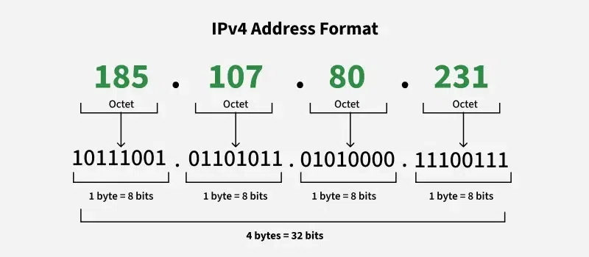
IPv4 (Internet Protocol Version 4) – IPv4 uses a 32 bit address format which is represented as four decimal numbers separated by dots. e.g 192.168.1.1. Each number ranges from 0 to 255. The first part of it identifies the network and the remaining identified the device. Despite its limitations it is the “most widely used version of the protocol” [6] This implies that IPv4 is the dominant version of the internet protocol in use for networking and communication. [Figure A]

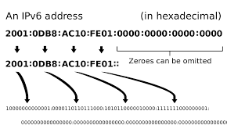
IPv6 (Internet Protocol Version 6) – IPv6 uses a 128 bit address format which is represented in hexadecimal notation and separated by colons. Although IPv4 is the most common protocol. IPv6 provides larger address space and improved security.
[Figure B]

Concept of Subnetting and Efficient utilisation of IP addresses

Subnetting divides large networks into smaller subnets, which will improve security and performance. Each subnet is defined by using subnet masks. This determines the number of available hosts. E.g In IPv4 a subnet mask of 255.255.255.0 means that the first three octets define the network and the last is the host address. However, in IPv6 prefix lengths are used e.g /64 where the first 64 bits define the network, and the remainder are assigned to devices.

CIDR (classless inter-domain) replaces the old class-based IP system which allows for flexible subnetting, and improves the efficiency of IP address allocation.

IP addressing Summary

In summary, IP addressing is an essential component of networking which helps communication across many devices worldwide.

Routing Protocols research

Routing protocols help direct data between different networks, ensuring data packets use the most efficient path based on the factors of the network topology and congestion of a network.

Fundamental Concepts of routing protocols

Routing protocols enable routers to exchange information. The two main types of this are static and dynamic routing

- Static Routing – Static routing is a straightforward type of routing that uses “manually configured paths for data transfer” [7] This suggests that static routing offers higher security due to the manual configuration, but makes it less scalable for larger networks as it does not adapt to changes.
- Dynamic Routing – Dynamic Routing uses protocols to automatically find “the best path for the data to travel over a network”[8]. This is done in real-time based on the network conditions. Protocols like OSPF, RIP and BGP give more scalability and flexibility as it continuously adjusts with the networks conditions.

Real world examples and case studies

An example of dynamic routing is BGP (Border Gateway Protocol). This is a form of dynamic routing used by ISPs to manage routing between networks. This directs traffic on the internet efficiently as it selects the best path based on network prefixes and policies.

Analysis of different routing protocols

BGP (Border Gateway Protocol) – BGP is a set of rules that “determine the best network routes for data transmission over the internet” [9] This offers flexibility but with more complexity.

OSPF (Open Shortest Path First) – OSPF is a “IP routing protocol that uses a mathematical algorithm to calculate the most efficient path to direct traffic” [10] This method is efficient but complex to set up and manage

RIP (Routing information protocol) – RIP is a “distance vector routing protocol” [11] which implies that it determines the best path based on hop count and relies on periodic updates to share routing information with neighbouring routes.

Routing Summary

Routing protocols are fundamental in the efficiency of network communication. Static routing is a more simple type of routing but lacks flexibility while dynamic routing protocols offer more adaptability and scalability which make it more suitable for large scale networks.

Network Services Research

Network services are very important in securing and managing network communication. Some of the key network services include VPNs, DHCP, Active Directory Domain services and Certification Authorities.

Virtual Private Networks (VPNs)

A VPN (Virtual Private Network) estabhlishes a secure, encrypted connection between remote users and a private network over the internet. VPNs prevent encrypting data transmissions and unauthorised access which enhances security. There are different types of VPNs such as site to site VPNs and Remote Access VPNs. Site to site is used to connect multiple networks and remote access VPNs are used for secure work. A best practice for VPNs would be to enable strong encryption and secure protocols, this is because weak encryption can expose data to hackers.

Dynamic Host Configuration Protocol (DHCP)

A DHCP “automatically provides an internet protocol host (IP)” [12] it does this to reduce manual configuration. It ensures that IP addresses are managed efficiently to prevent conflicts. Some of its features include lease durations, automatic IP address assignment and address pool management. Best practices involve using DHCP reservations for critical devices and securing DHCP servers.

Active Directory Domain Services (AD DS)

AD DS is a Microsoft directory service used to centralise authentication in windows based networks. It structures devices, groups, users and policies into hierarchy system. Some of its key features are Single Sign on (SSO) and Group Policy Management. A best practice for AD DS would be to regularly update and patch AD components as it helps protect against vulnerabilities that attackers may use to compromise the network.

Certificate Authorities (CAs)

Certification Authorities manage and issue digital certificates to ensure communication is securely encrypted and authenticated. CAs are essential for SSL/TLS encryption in websites. A best practice for CAs is to use strong encryption standards as it will ensure that digital certificates have a lower chance of being compromised which will prevent data breaches.

Evidence


Windows server set up
The windows server was set up in Oracle VirtualBox and successfully launched, confirming the installation and initial configuration were completed correctly.

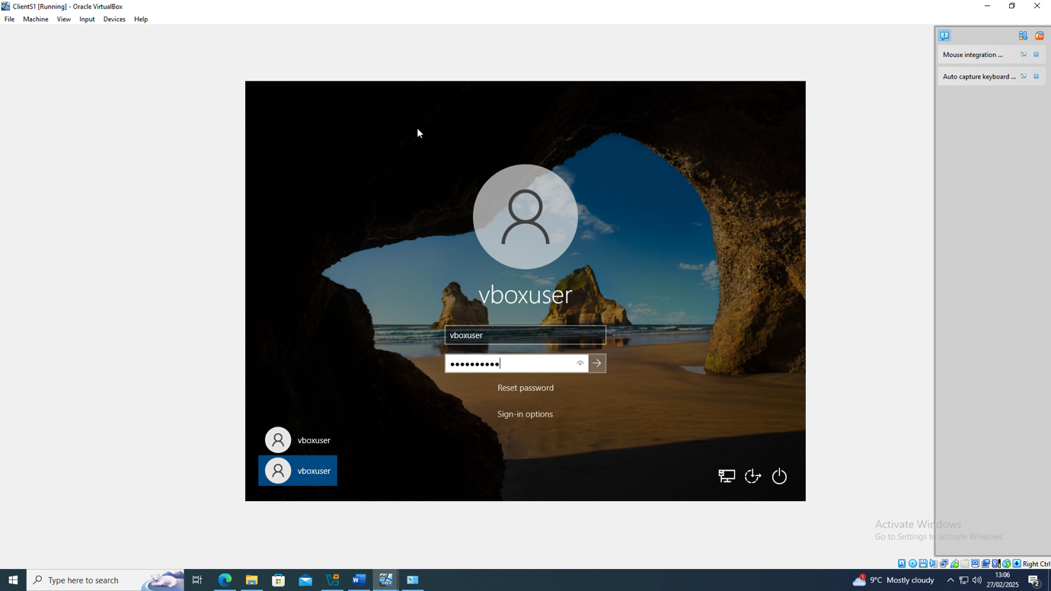
Windows client set up
The windows client was set up in oracle virtualbox and successfully launched which meant that the configuration was also correct for this.
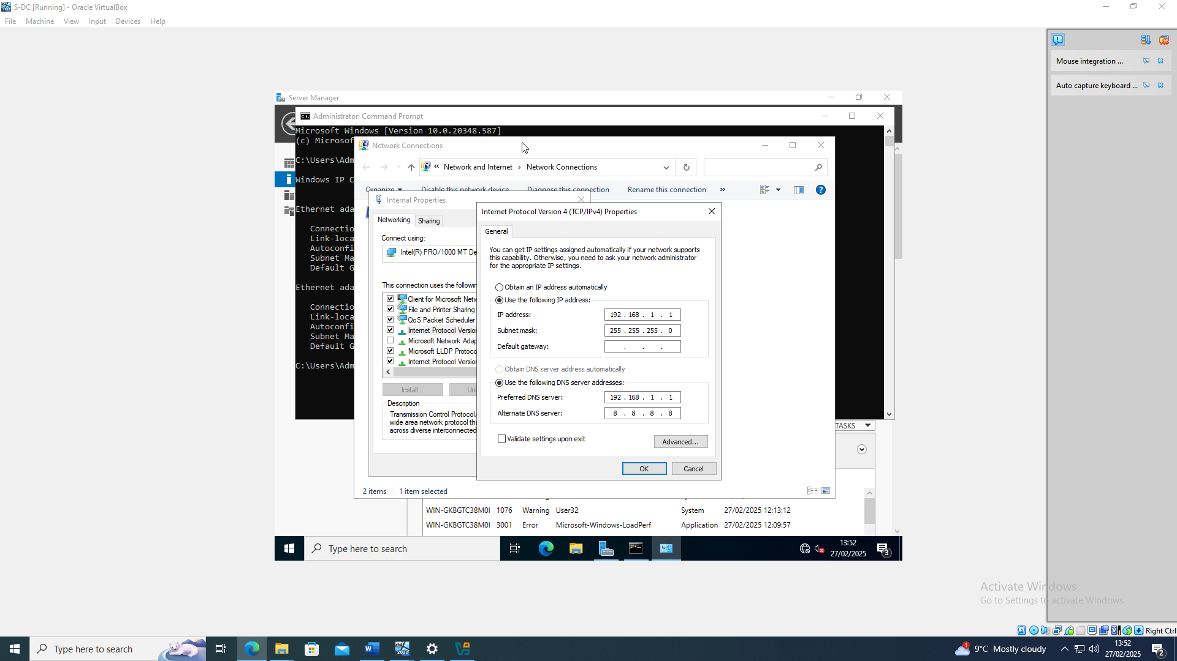
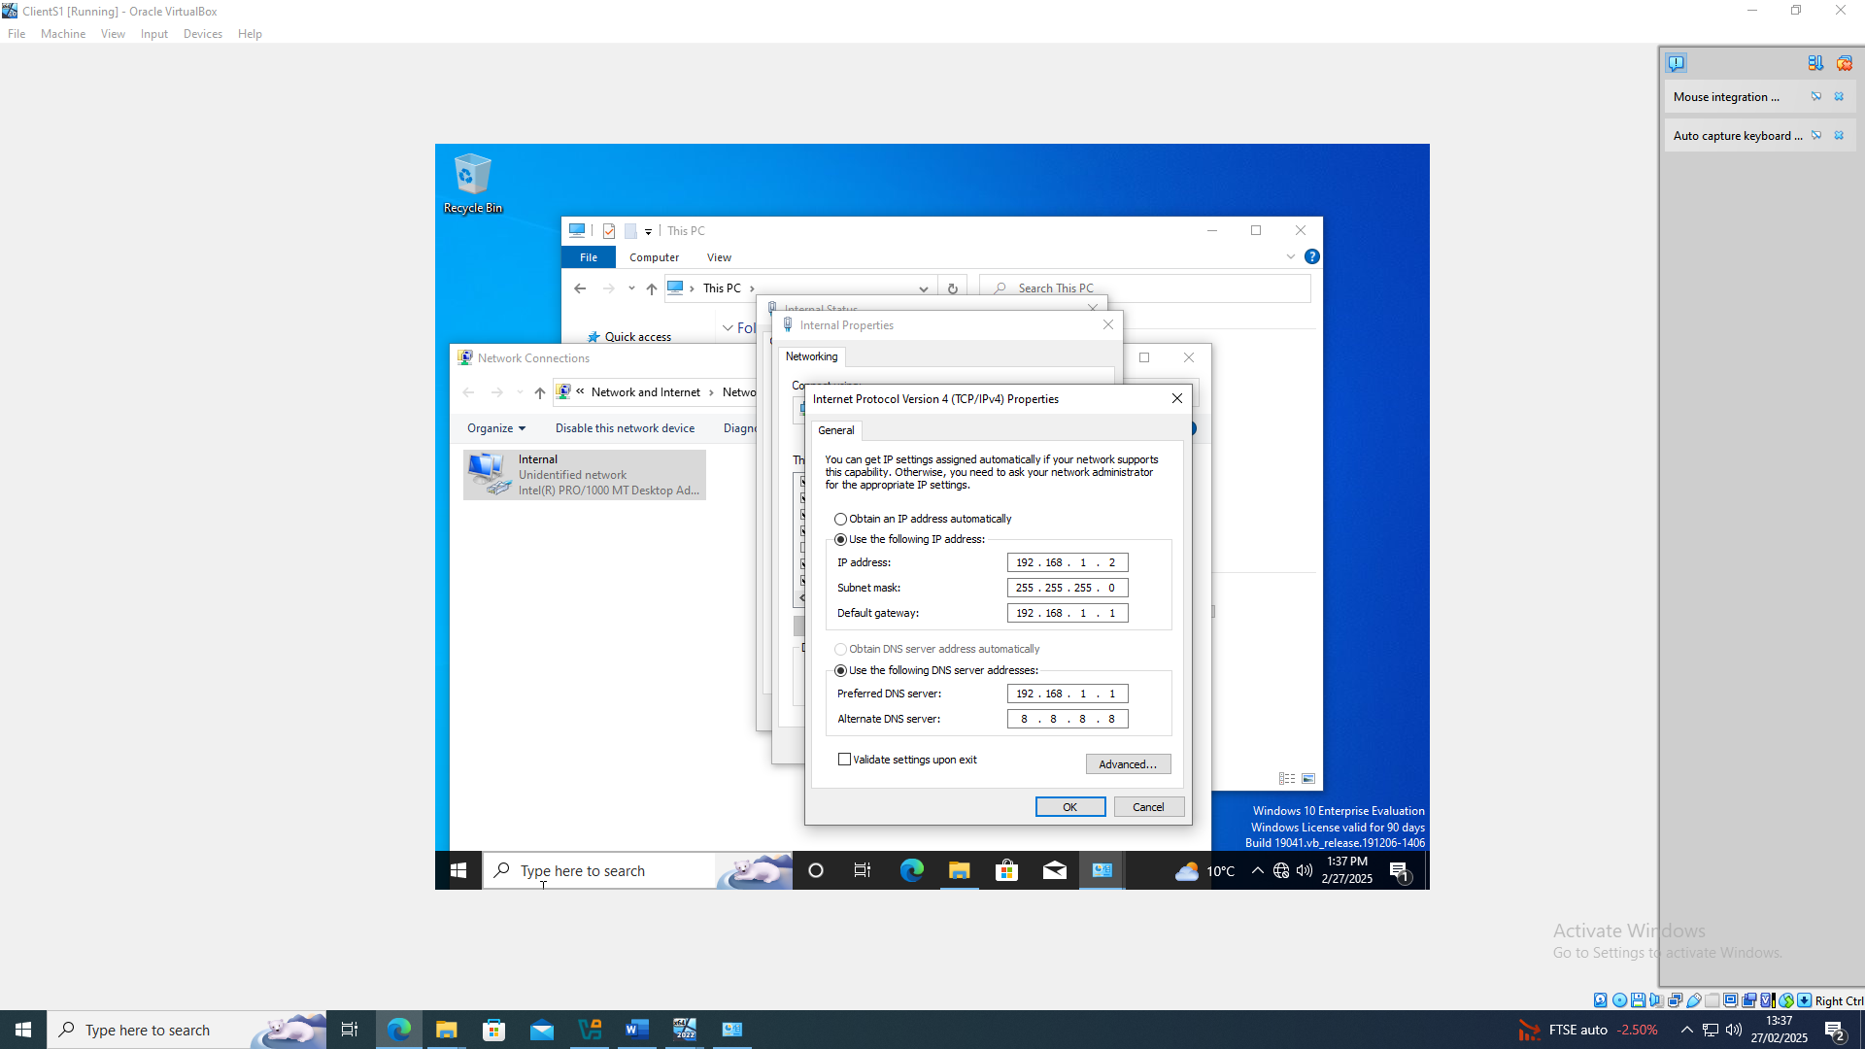
Windows client and server IP configuration

These screenshots show the user configuration of both Windows client and windows server IP addresses. These were adjusted to ensure proper network connectivity within the virtualised environment.

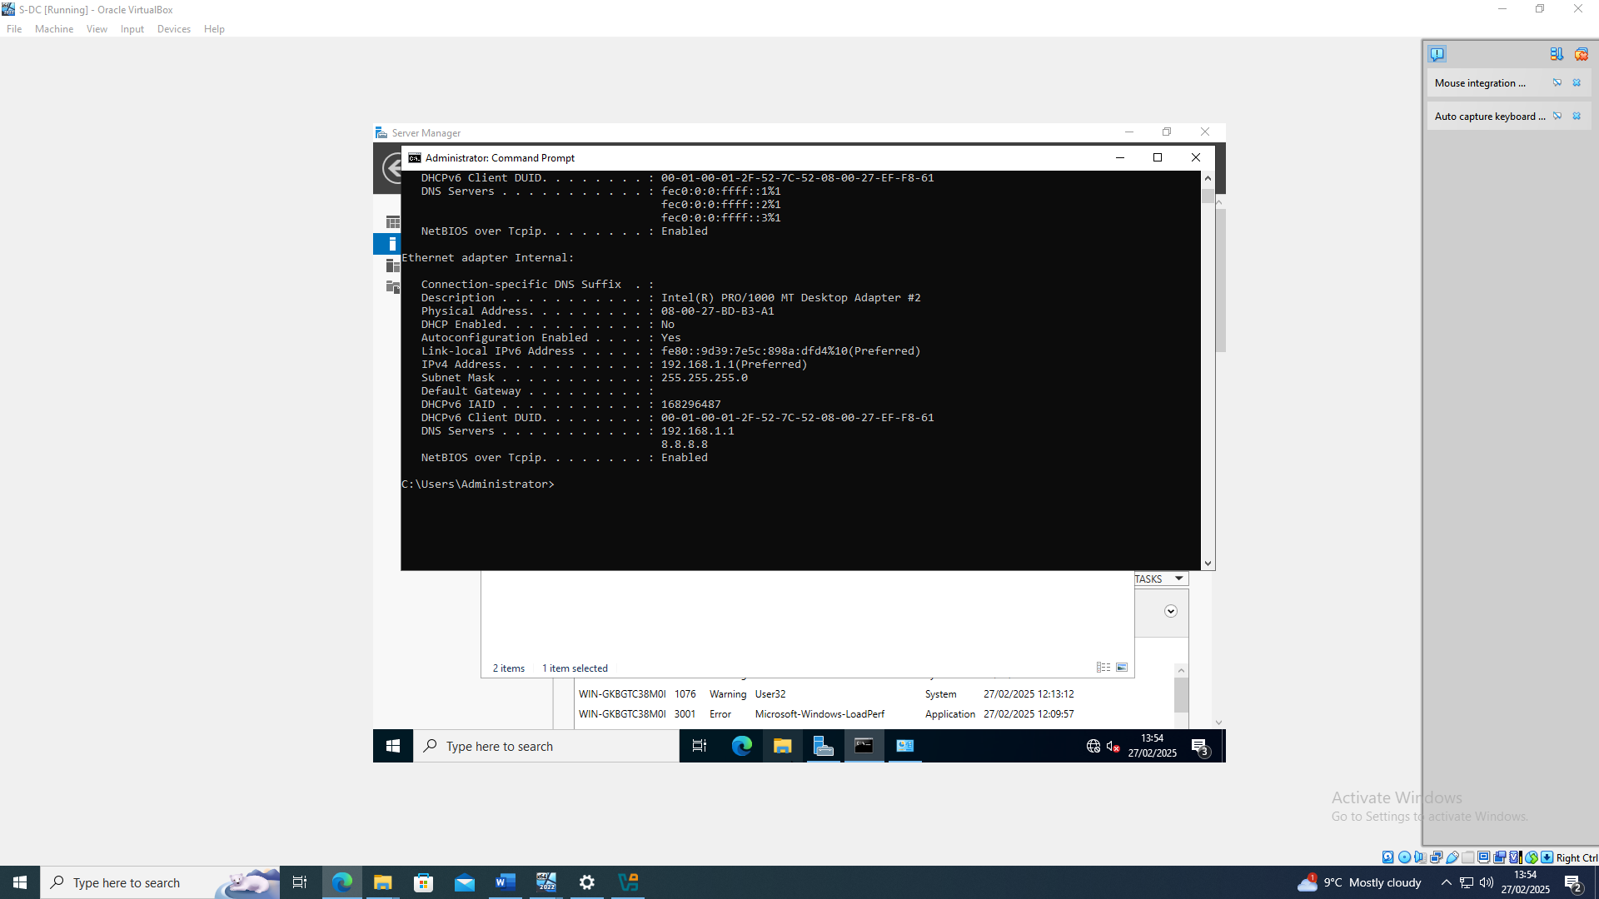
Server ipconfig

This screenshot displays the IP configuration of the server had been successfully implemented.

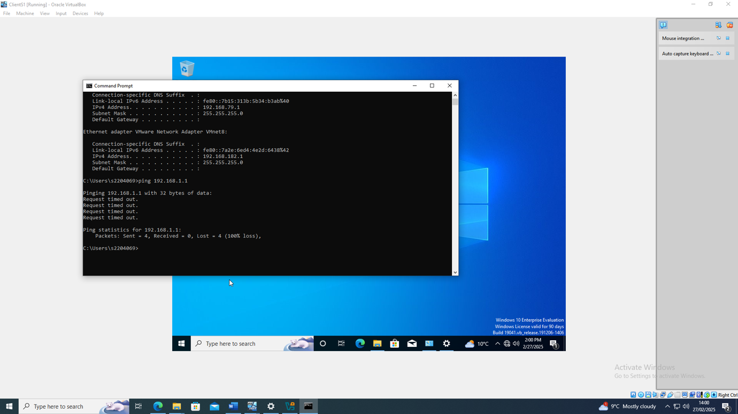
Client Ping time out

This screenshot shows the testing of pinging the windows client to server being unsuccessful.

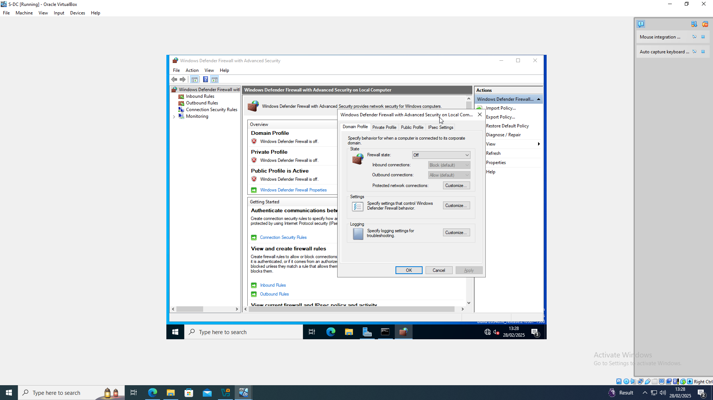
Windows firewall off

As the ping was unsuccessful the firewall needed to be disabled on the windows client this ensured that the firewall was not blocking the network traffic

Windows Client to server ping + Server to client
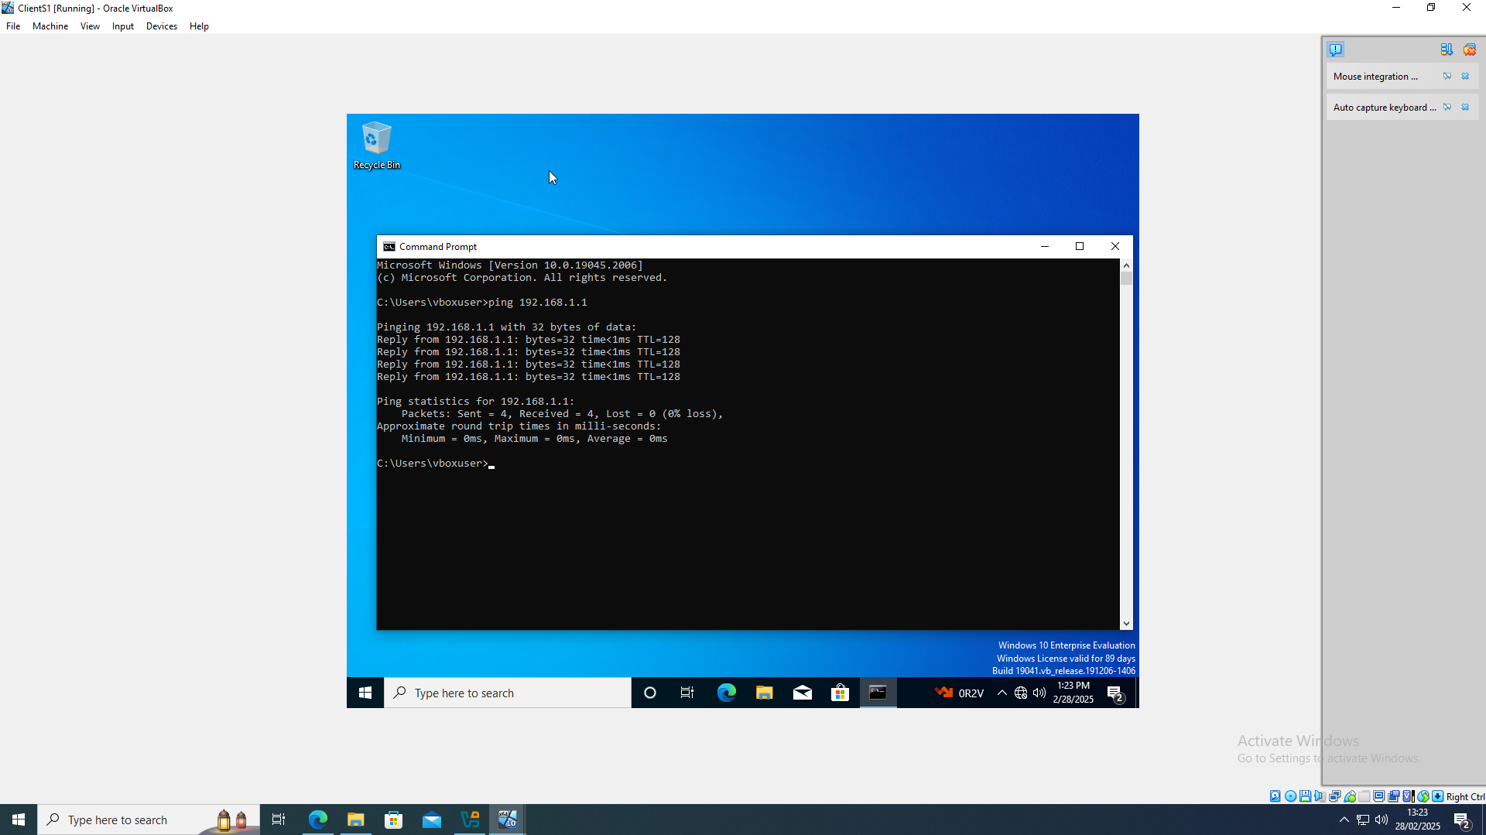

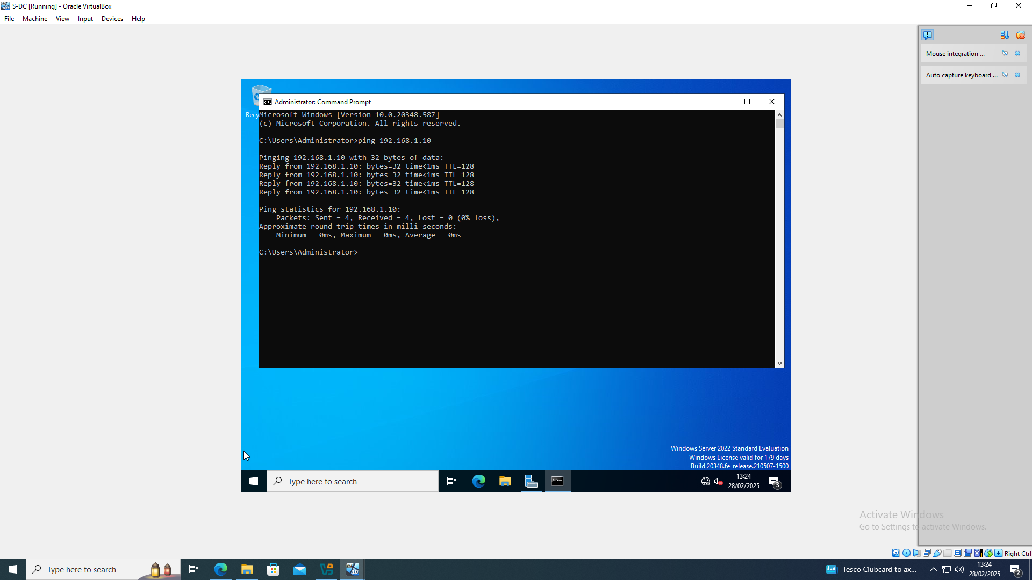
Once the firewall had been disabled and the IP addresses were correctly configured. The windows server and client were pinging successfully.

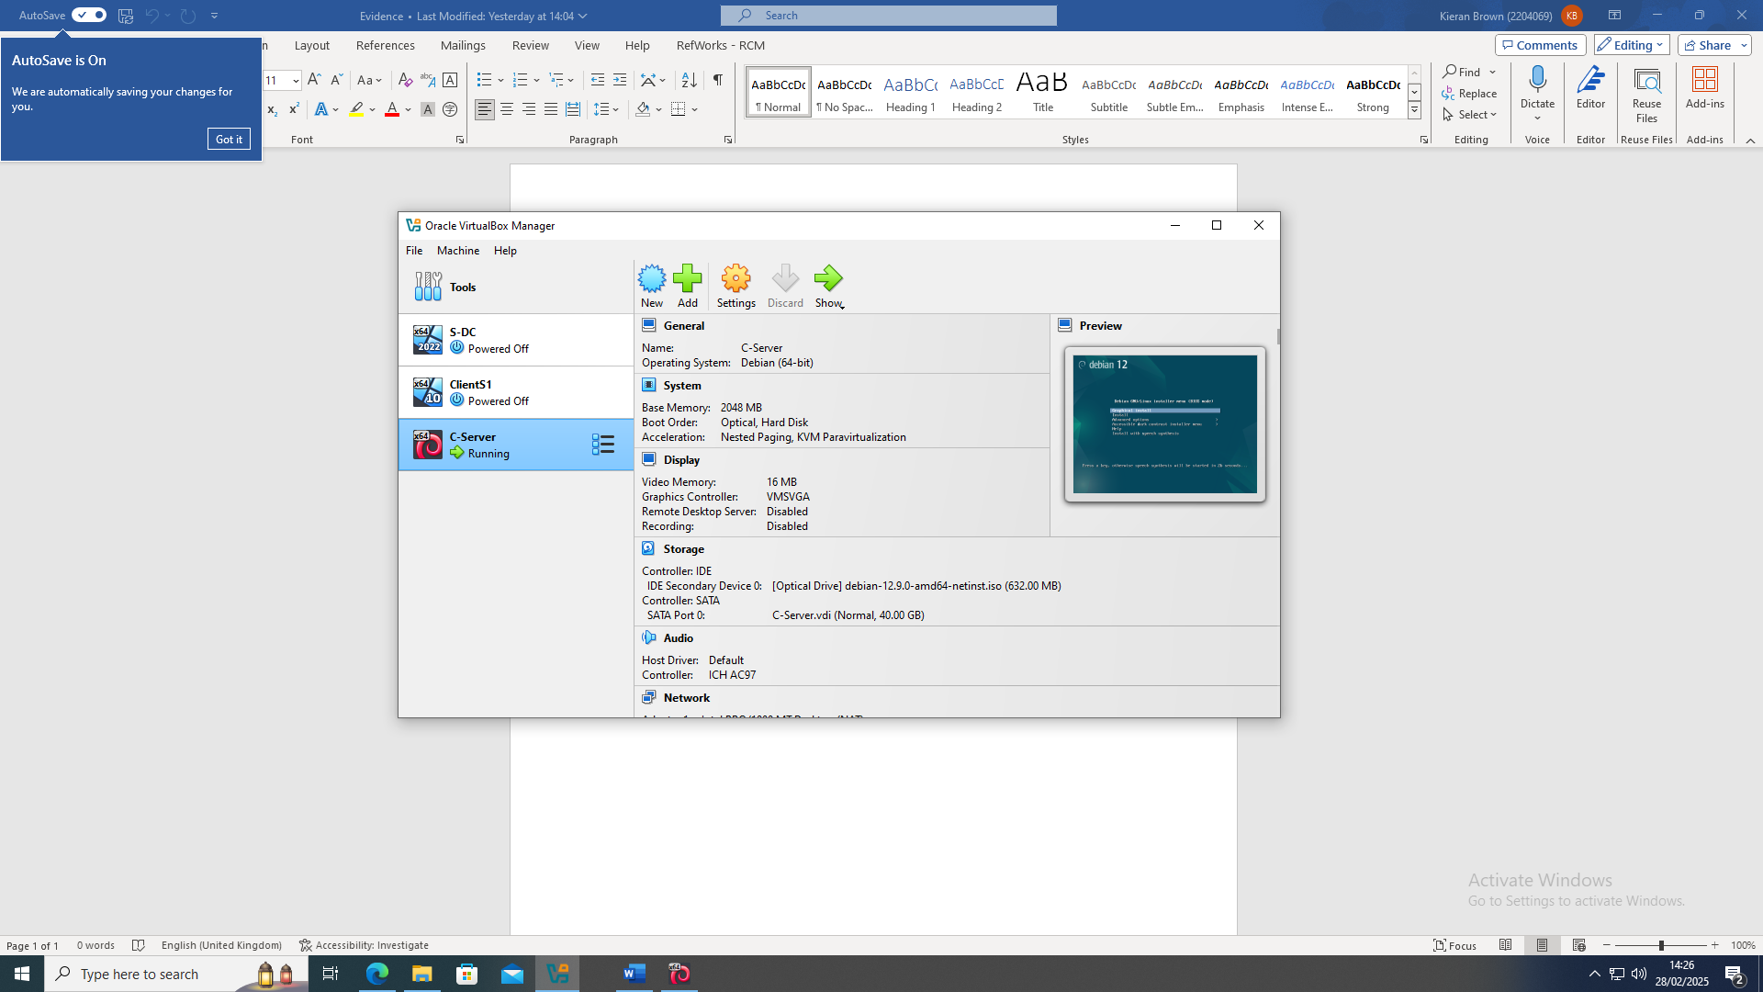
Linux Server setup

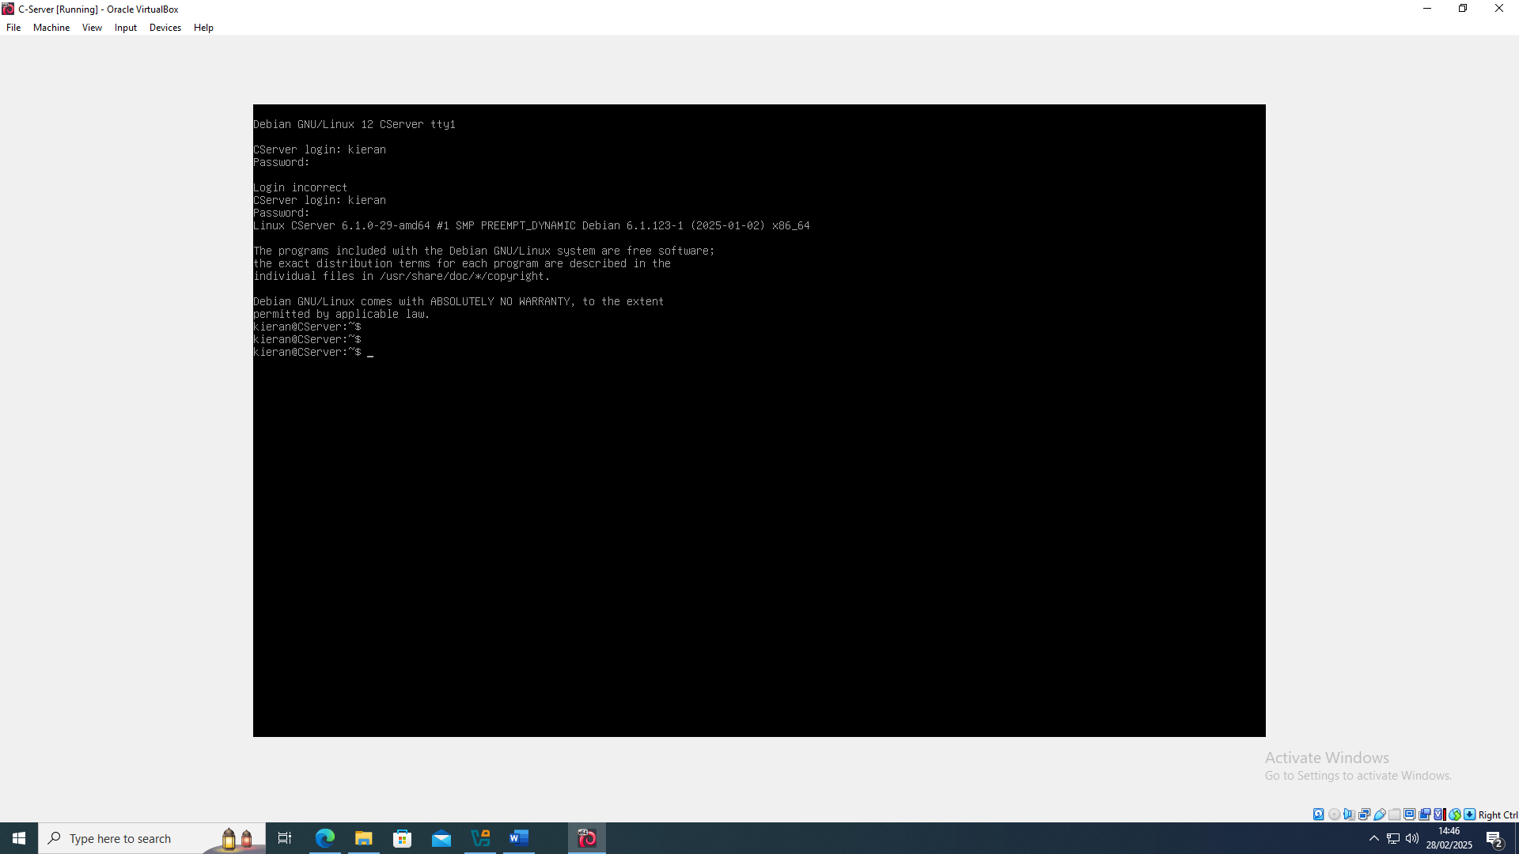
Linux server open

The Linux server was set up in Oracle VirtualBox and successfully launched, confirming the installation and initial configuration were completed correctly.

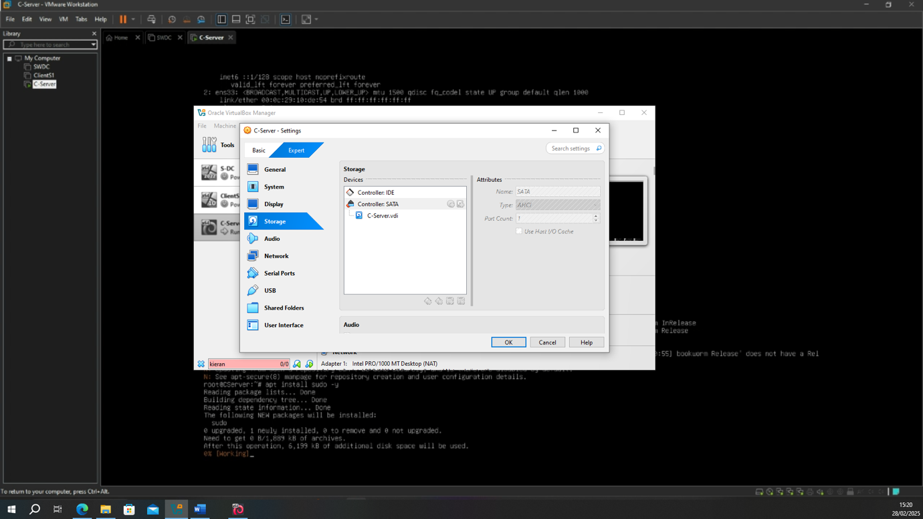
Linux disk error
This screenshot shows a disk error that was being received when setting up the Linux server. The settings were modified and correct iso was installed.
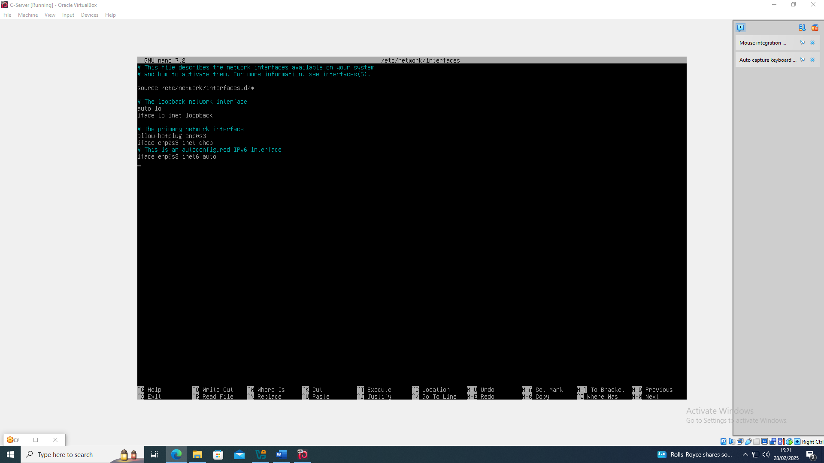
Linux server after install
Once the correct settings and iso were implemented the Linux server was running correctly.

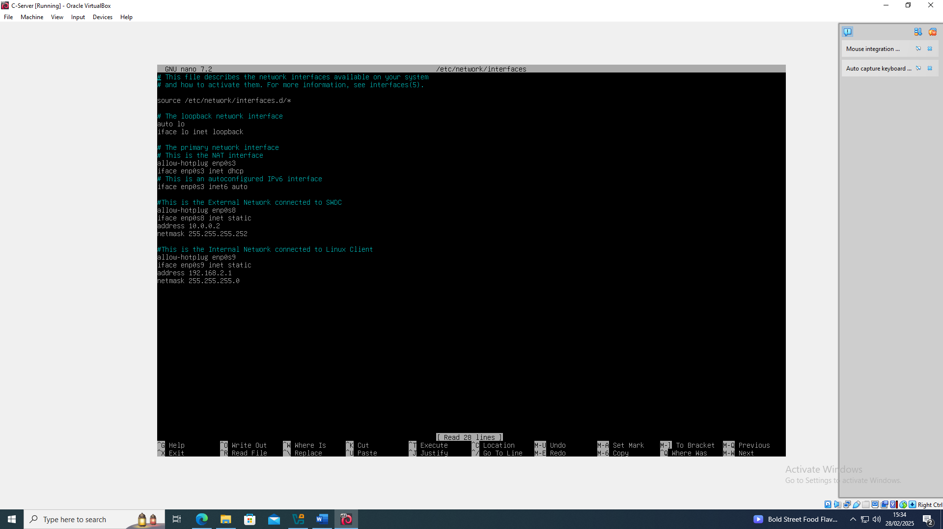
Linux server setting IP
This screenshot shows the configuration of the IP address on the Linux server. This was adjusted so that the Linux server would have a unique identifier for communication at later stages.
Linux IP config

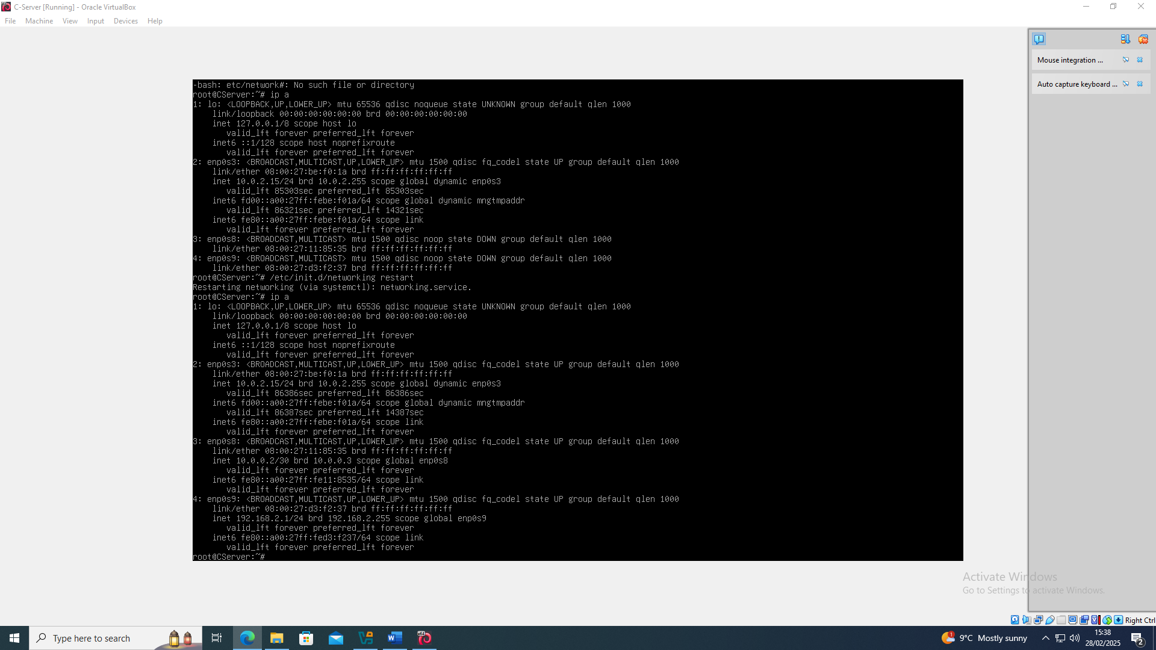
This screenshot shows ip a on the Linux server to show that the IP address had been set correctly.

Linux server to Windows server ping

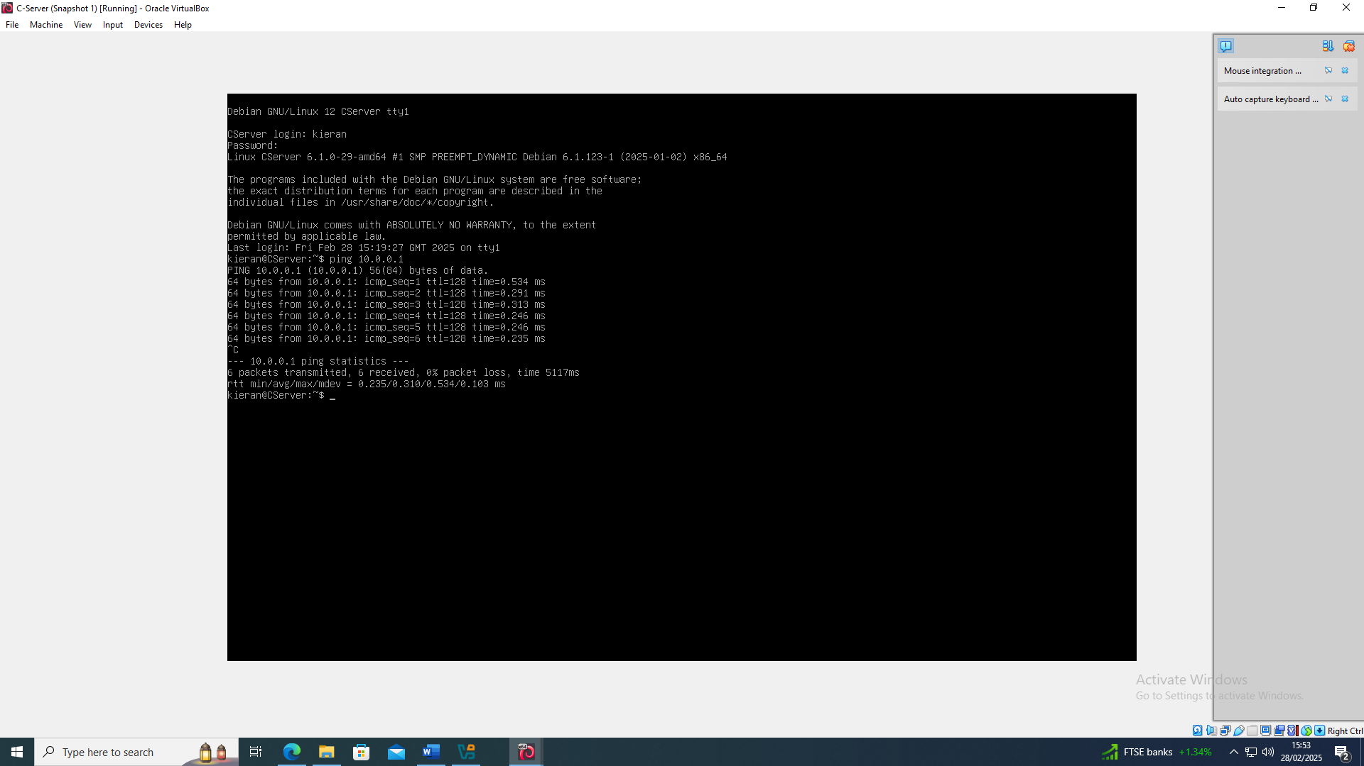
Once the Linux servers IP address had been set, the ping from Linux server to Windows server was tested and showed successful.
Windows server to Linux Server ping

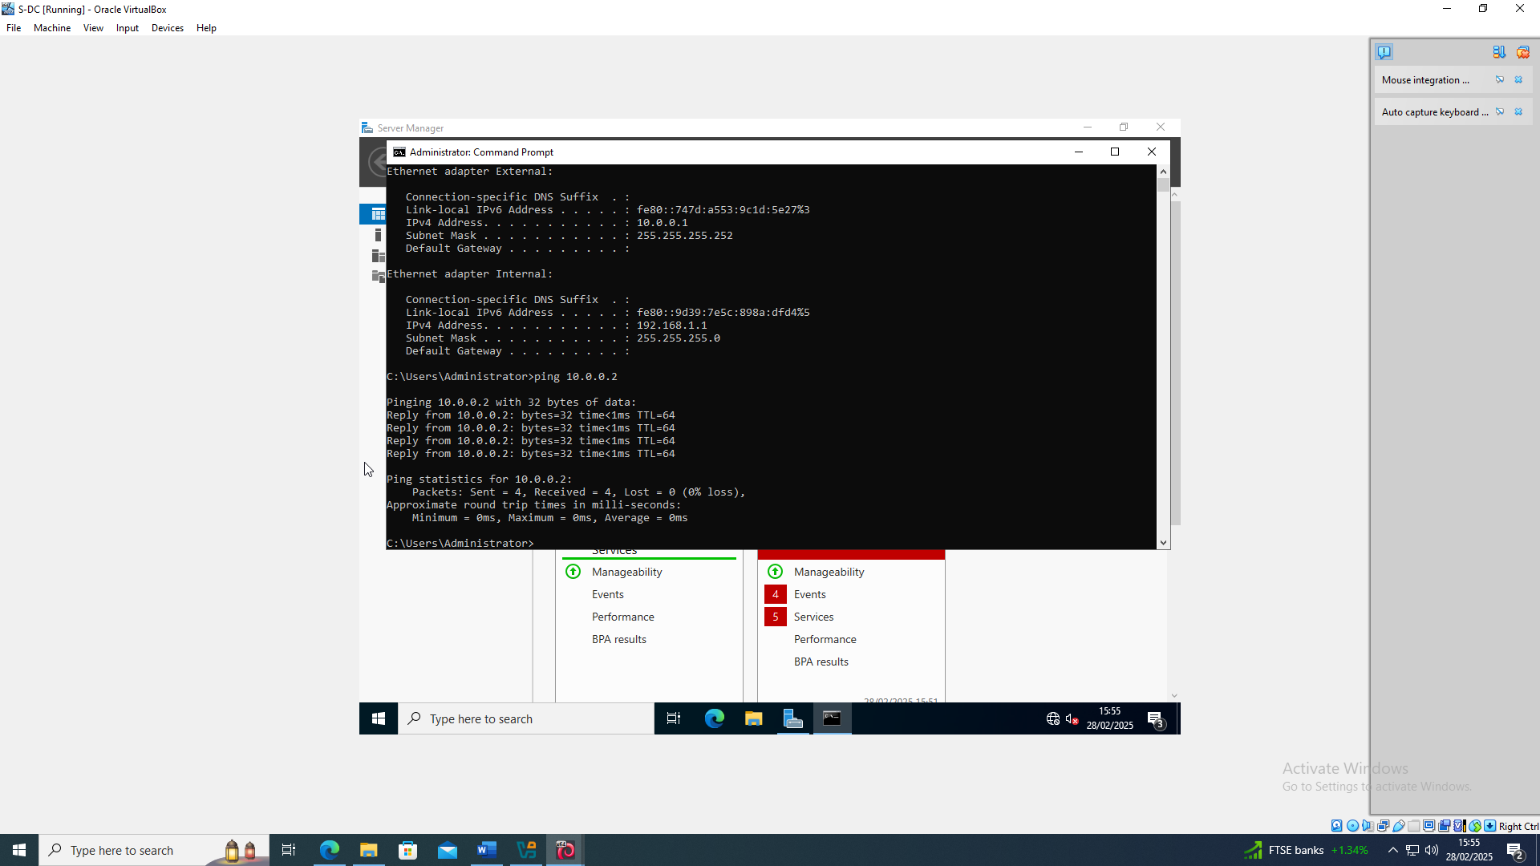
The ping was then tested from Windows server to Linux server and was a success.

Linux Client install

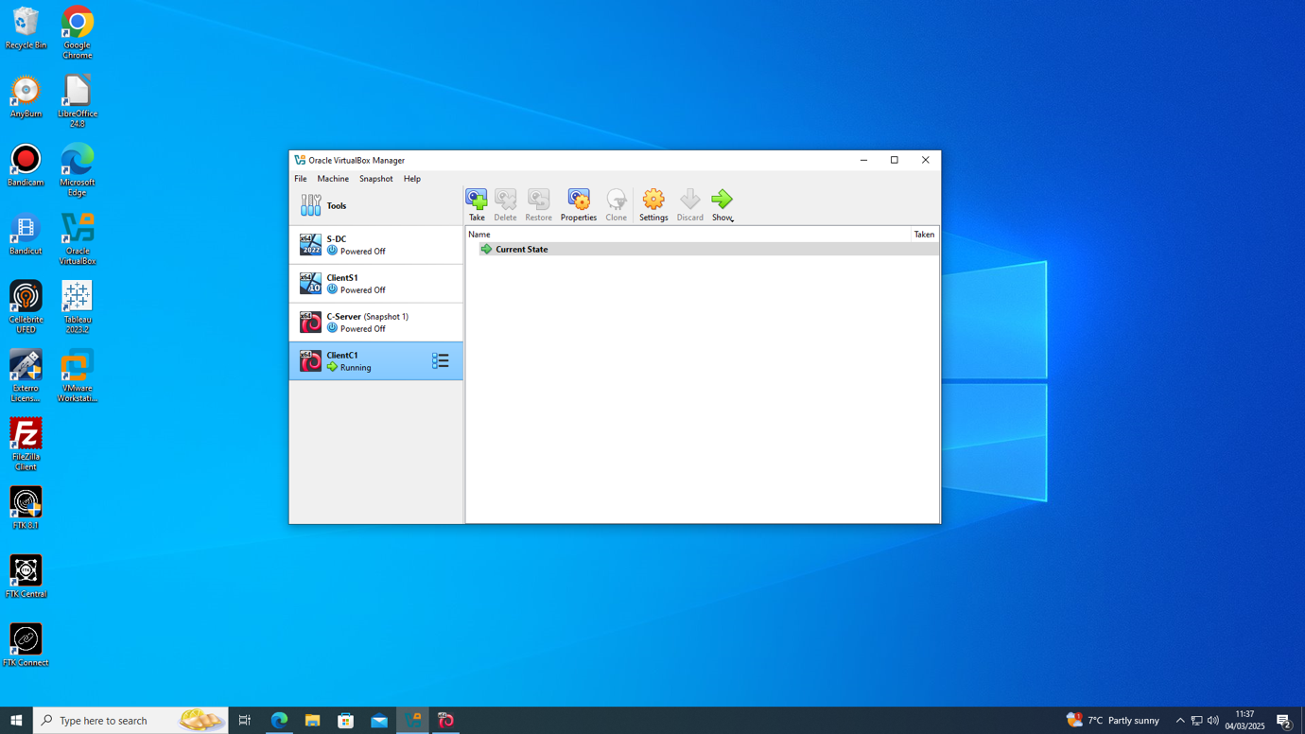

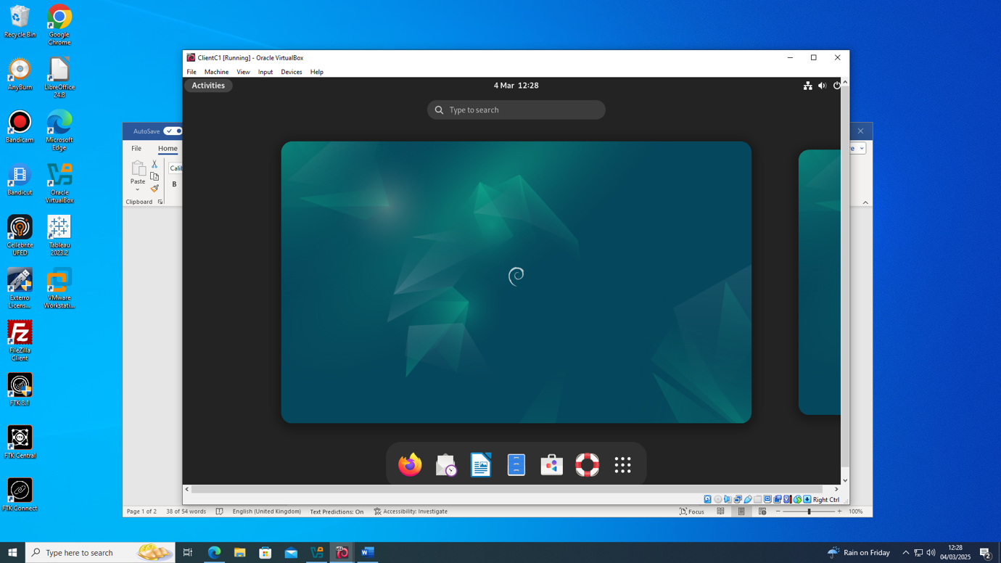

Finally, the Linux client was installed to complete the network.

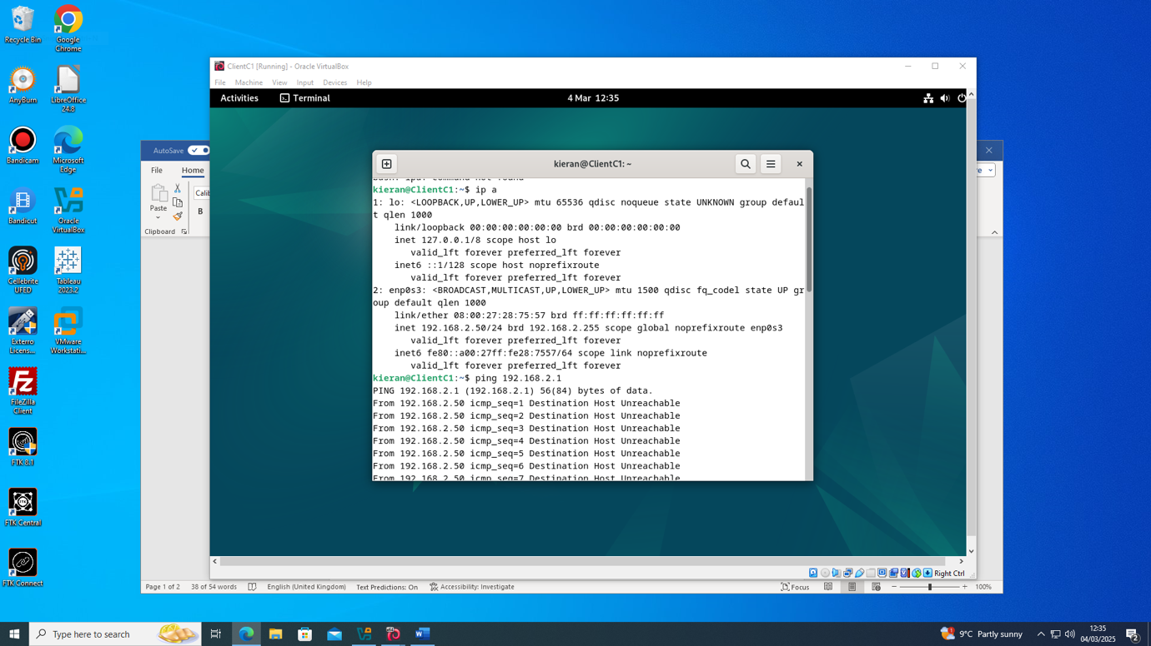
Linux Ping unsuccessful

The Linux client was showing an unsuccessful ping. This was due to the network settings on the Linux clients not allowing all VMs.

Linux Client to Linux Server ping

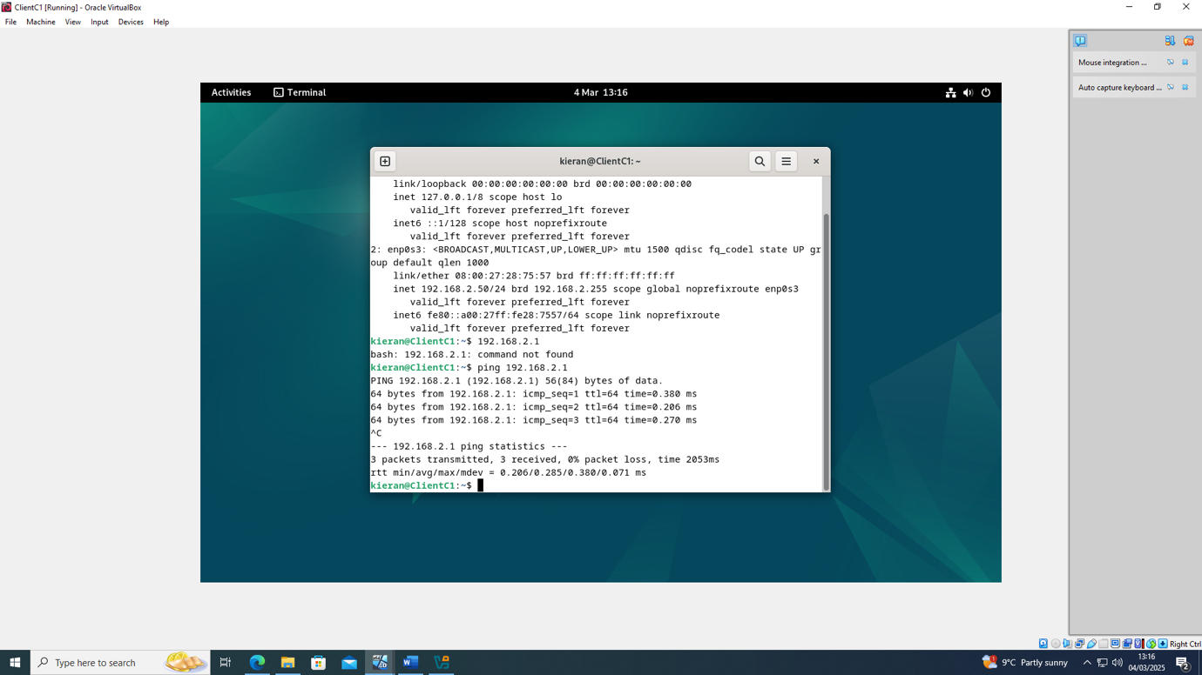

Once that was changed the Linux client was successfully pinging Linux server and vice versa.

Bibliography
[1]
aws, “Type 1 vs Type 2 Hypervisors - Difference Between Hypervisor Types - AWS,” Amazon Web Services, Inc.Available: https://aws.amazon.com/compare/the-difference-between-type-1-and-type-2-hypervisors/.
[Accessed: Feb. 20, 2025]

[2]
S. Bigelow and B. Kirsch, “What’s the difference between Type 1 vs. Type 2 hypervisor?,” Techtarget, Jan. 13, 2021. Available: https://www.techtarget.com/searchitoperations/tip/Whats-the-difference-between-Type-1-vs-Type-2-hypervisor.
[Accessed: Feb. 20, 2025]

[3]
aws, “Type 1 vs Type 2 Hypervisors - Difference Between Hypervisor Types - AWS,” Amazon Web Services, Inc.Available: https://aws.amazon.com/compare/the-difference-between-type-1-and-type-2-hypervisors/.
[Accessed: Feb. 20, 2025]

[4]
Cloudflare, “How does the Internet work?,” Cloudflare.com, 2024. Available: https://www.cloudflare.com/en-gb/learning/network-layer/how-does-the-internet-work/.
[Accessed: Feb. 25, 2025]

[5]
Cisco, “What is a Switch vs a Router?,” Cisco. Available: https://www.cisco.com/c/en_uk/solutions/small-business/resource-center/networking/network-switch-vs-router.html#~switches.
[Accessed: Feb. 25, 2025]

[6]
I. Uptrends, “What is IPv4? | Uptrends,” www.uptrends.com. Available: https://www.uptrends.com/what-is/ipv4.
[Accessed: Feb. 25, 2025]

[7]
GeeksforGeeks, “Difference between Static and Dynamic Routing - GeeksforGeeks,” GeeksforGeeks, May 20, 2019. Available: https://www.geeksforgeeks.org/difference-between-static-and-dynamic-routing/.
[Accessed: Mar. 01, 2025]

[8]
GeeksforGeeks, “What is Dynamic Routing in Computer Network?,” GeeksforGeeks, Dec. 14, 2021. Available: https://www.geeksforgeeks.org/what-is-dynamic-routing-in-computer-network/.
[Accessed: Mar. 01, 2025]

[9]
aws , “What Is BGP? - Border Gateway Protocol in Networking Explained - AWS,” Amazon Web Services, Inc.Available: https://aws.amazon.com/what-is/border-gateway-protocol/.
[Accessed: Mar. 01, 2025]

[10]
J. Burke, “What is OSPF (Open Shortest Path First)? - Definition from WhatIs.com,” SearchNetworking, May 2015. Available: https://www.techtarget.com/searchnetworking/definition/OSPF-Open-Shortest-Path-First.
[Accessed: Mar. 01, 2025]

[11]
GeeksforGeeks, “Routing Information Protocol (RIP) - GeeksforGeeks,” GeeksforGeeks, May 17, 2018. Available: https://www.geeksforgeeks.org/routing-information-protocol-rip/.
[Accessed: Mar. 01, 2025]

[12]
Microsoft, “Dynamic Host Configuration Protocol (DHCP),” learn.microsoft.com, Jul. 29, 2021. Available: https://learn.microsoft.com/en-us/windows-server/networking/technologies/dhcp/dhcp-top.
[Accessed: Mar. 03, 2025]

Appendix

[1]
geeksforgeeks, “What is IPv4?,” GeeksforGeeks, May 05, 2020. Available: https://www.geeksforgeeks.org/what-is-ipv4/. [Accessed: Feb. 25, 2025]

[2]
Comms.express.com, “What is IPv6?,” comms.express.com. Available: https://www.comms-express.com/infozone/article/ipv6/. [Accessed: Feb. 25, 2025]

