Contemporary Development in Employment Relations M5X02262
Louise Mordue
March 21st 2018

Contents
Introduction 2
Q1. What are external factors affecting the employment relationship? 2
Fig:1 Dimensions of Employement Relationship (Kessier & Undy, 1996) 3
Fig:2 Concepts of Relational or Transactional contracts (Rousseau, 1995) 3
Fig:3 Unitarist compared to Pluralist approach. 5
Q2. The increase in employment law has an impact on the balance of power in the employment relationship. 6
Fig:4 Contract Types Advantages and Disadvantages 6
Q3. Are Employee involved in decision making in the organisation? 10
Fig:5 What kind of employee representatives are there? 12
Fig:6 Stages of Employee Voice 13
Q4. How should the conflict be resolved? 14
Fig:7 Labour Disputes 1931 to 2017 (ONS, 2018) 16
Fig:8 Industrial Sanctions for Employer and Employee 16
Fig.9 Conflict Mode Instrument 19
References 20

Introduction
Southern Rail Drivers/ Guards dispute in 2016/2017, which resulted in industrial action. The issue was a change in the role of guards/ conductors. They were to become a single commercial role (renamed as On-Board Supervisors or OBS) cut of any safety critical issues which would become entirely the responsibility of the driver.

Q1. What are external factors affecting the employment relationship?
The term ‘Employment Relationship’ (ER) is used to describe the link between an employee and an employer by performing a service under a set of terms for payment, visualized by Kessier & Undy (1996) (Fig:1).

Fig:1 Dimensions of Employement Relationship (Kessier & Undy, 1996)
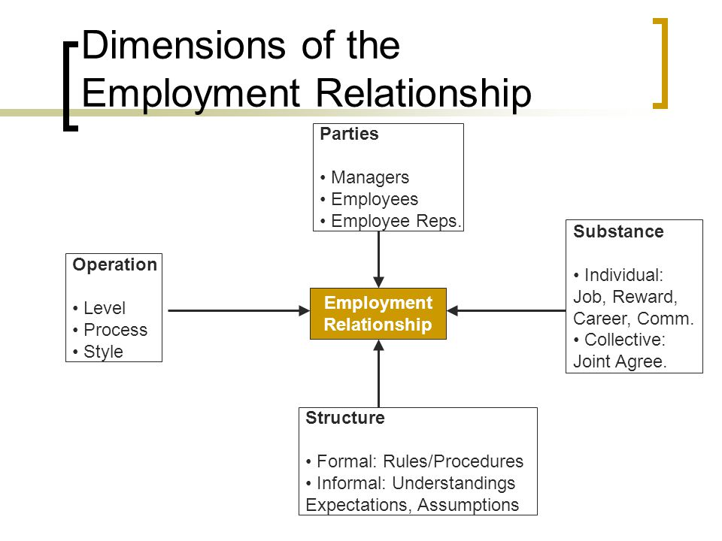
Armstrong & Taylor (2017) advises that within ER there are obligations by both parties to comply, and these are general in the power of the employer to set the terms unless been fixed by collective bargaining. Ideally, a positive ER would fundimentally combine management and employees as interdependent and both profit from mutally support and trust. Built into the ER is a Psychologcial contract, this can be Relational or Transactional (Fig:2).

Fig:2 Concepts of Relational or Transactional contracts (Rousseau, 1995)
Transactional (self-interest) | Relational (mutual interest)
Short-term financial exchanges | Open-ended relationship and time-frame
Specfic financial conditions (wage) | Investment by employees (company skills, career development) and employers (training)
Limited personal involvement in job | High degree of mutual interdependence and barriers to exit
Specified time-frame | Emotional involvement as well as economic exchange
Commitments limited to well-specified conditions | Whole-person relations
Limited flexibility | Dynamic and subject to change
Use of existing skills | General conditions (affects personal life)
Clear terms | Subjective and subliminally understood

External factors that can affect the ER are outlined within a PESTLE or SWOT analysis:
- Political - Change to government policy, Union intervention, Working hours
- Economic - Profit margins on service/ product, company financial numeration
- Social - Brand perception, Ageing population/ workforce
- Technological – Automation, AI development
- Legal – Introduction/ revised laws on work directives, Risk analysis, Employee contract change
- Environmental – Stakeholder influence, Transportation changes
External factors which were relevant to the Southern Drives Dispute was the Department for Transport (DFT) who specifies the parameters of all railway franchises. In this specific case, it was to be a tightly controlled Government Contract for a relatively brief period. As part of this, the DFT wanted to use Southern as a testbed for further extension of Driver Only Operation (DOO) but still utilising two members of staff. This is known as DCO (Driver Controlled Operation) and changed the role of a guard from ‘essential’ on the train to ‘if available’.
‘The report identified cost savings which could be made by removing the guard over a 5-year period without compulsory redundancy and replacing them by “cheaper Non Safety Critical On-train Staff”. It indicated that a number of guards would be halved over 9 years and the number of trains operating with Non Safety Critical On-train Staff would also be reduced.’ (RMT, 2016)
The railway, like many other nationalised industries, has a deeply embedded pluralist approach to the employee relationship. Consequently, the Trade Unions are involved at every level of any change to the employment contact and the daily working of the company.
The conflict of interest and disagreements inherent in large companies are considered perfectly normal with the Trade Unions seen as being legitimate representatives of the employees who do not speak for themselves as individuals.
When compared to a unitarist approach (Fig:3) where conflict is seen as a highly disruptive and irrational activity, and Trade Unions are denied a presence within the organisation; the pluralist approach may be a framework that encourages dispute. Conversely, this ignores the fact that organisations with a pluralist approach tend to have several external factors affecting the business which are outside of the control of both management and employees.

Fig:3 Unitarist compared to Pluralist approach.
Approach | Ideology | Power | Conflict | Processes | Trade Unions
Unitarist | All parties have common objectives.  Seen as a complete entity. | Management is a sole source of authority.  ER is consensual reflecting collective interest. | Unnatural or irrational.  Caused by mis-communication, misunderstanding or inciters. | Unilateral decisions making by management.  Employer actively seeks to suppress conflict legally and legitimately. | Unnecessary or illegitimate.  Management has the freedom to operate within the principles of the market.
Pluralist | All parties have combined and different objectives.  Seen as separate entities. | Management leads but can be questioned and challenged.  Power is transferable between dominate groups. | Inherent, unavoidable, expected and legitimate.  Expression of conflict by out of Industrial action. | Mixed processes to maintain equilibrium.  Resolved through Rules, Negotiation and collective bargaining. | Necessary and legitimate.

The factors resulting within a breakdown of the ER in this conflict were due to changes in the Psychological contract, Technology, and Economic. The profit and economic cost mixed with technology was a driving force for the Southern Driver dispute, as outlined in RMT (2016) with reference to the sanction of a specfic type of camera which had a lower risk factor but endorsed the cheaper option as the saftey standard.
“The Railway Safety and Standards Board report made clear that risk analysis had shown the best technology to reduce the risk of unsafe Driver Only Operation on platforms was to install a platform mounted camera. However, they recommended train mounted cameras as it is the cheapest option.” (RMT, 2016)

Q2. The increase in employment law has an impact on the balance of power in the employment relationship.
Employee relations should be a skill to manage workplace relationships and performance, focusing on both collective and individual employee relations. The CIPD (2017) states the use of ‘Employee voice’ (EV) and ‘Psychological contract’ can be used positively to encourage communication and prevent conflict by having a balance of power. In the Southern Drivers Dispute, the balance of power was not balanced, due to enforced employment changes, lack of communication which resulted in Trade Union intervention to resolve the conflict.
Employment contracts can be a primary source for conflict due to the variants on type (Fig:4) and

benefits for both employee or employer depending on the needs of the organisation as per

CollierBroderick (2018), GOV.UK (2018), Jobsite (2017), Jobsite (2016) and Taylor (2014).

Fig:4 Contract Types Advantages and Disadvantages
Contract Type | Advantage | Disadvantage
Full Time | - Long term commitment  - Improved loyalty to brand  - Additional Benefits/ incentives  - Training and development opportunities  - Promotion options | - Additional cost of Benefit packages  - Training and learning  - Redundancy/ Retirement costs
Part Time | - Flexibility  - Lower wage margin | - Restriction availability  - Lower wage margin
Fixed Term | - Additional opportunities  - Higher pay  - Flexibility  - No long term commitment  - Set duration for employment | - Lack of security  - Restriction on promotion options  - Lack of commitment  - Limited duration for employment
Zero Hours | - Flexibility  - No long term commitment  - Option to replace redundancy | - Lack of commitment  - Lack of security  - Lack of training needs meet

In the UK there are multiple sources of law as per Symonds (2008) and SOAS (2012) that comprise of Legislation, Policy, Common law, European Law and International Law. Employment laws are to protect employees from exploitation from employers by providing guidelines and regulations to adhere to, which considers fair wage, working time regulations, discrimination, and protection. CIPD (2018a) advises that the joint forces of the UK and EU have moulded the way laws are created. In 1973 the UK joined the European Economic Community (EEC) and both Europe and UK were developing equal pay for equal work not gender specific. The EEC evolved into the European Union (EU) and continued to broaden laws regarding employment some of which required parliament to adjust existing laws and others saw new introductions including-
- Health and Safety
- TUPE (transfer of business ownership for employee)
- Working time
- DPA (data protection) and GDPR (general data protection)
- Discrimination
Future changes to Employment laws may need to take place as part of UK due to leaving the EU including ongoing agendas. Currently, there is 14 flagged legislation for 2018 -2019 which cover a variety of topics from Gender pay gap, Brexit, grandparent leave and Fit for work assessments.
The TULRCA 1992, and amended Employment Relations Acts of 1991 and 2004, shape the process that industrial actions must be sanctioned to be lawful. Now the Trade Unions need to provide notification of ballot date, who is involved and any additional information to the employer that may support plans or information to the employees. A ballot is to be held at each location and be verified by an independent Scrutineer. Daniels (2016) and Eversheds (2011) advises on the format and stipulations that the ballot paper is required to be lawful including, number reference, date, and options. Within the Southern Drivers dispute the regulations were adhered to and strike action was carried out.
The Working Time Regulations 1998 (WTR) is the implementation of the Working Time Directive, which relates to health and safety of employees, expressing the minimum requirement of Holidays, rest periods and reasonable working hours. This regulation did not cover all employees and had exceptions in Train drivers, until the amendment in 2003 as per HSE (2018).
“Transport staff who are 'mobile', such as train drivers, do not get the same rights to breaks, but do benefit from the 48-hour average weekly limit, and must receive 'adequate rest'. This also applies to rail staff whose work is linked to railway timetables and ensuring continuity of rail traffic, such as signal box operators.” (TUC, 2018)
The following regulations reflect working hours with consideration on fatigue due to the exception from the WTR as per OOR (2012), Health and Safety at Work etc Act 1974 (HSWA), Management of Health and Safety at Work Regulations 1999 (MHSWR) and the Railways and Other Guided Transport Systems (Safety) Regulations 2006 (ROGS). These all consider the recommendations for working practice and express the average working week should not exceed 48 hours. Although this dispute was not related to Working Time Directive, the refusal to work overtime and rest days as part of the Trade Unions influence was a considerable factor.
“Passengers faced disruption from the end of the month as a result of a ban on drivers doing overtime by the union ASLEF” (Jamieson, 2017)
Historically these sorts of conflicts have occurred on a regular basis on the railways. The change to employment law over the last 20 years has mostly seen an increase in rights and protections for employees.
“Peter Wilkinson, then managing director of rail passenger services at the Department for Transport, publicly stated in 2016 that “over the next three years we're going to be having punch ups and we will see industrial action and I want your support” and that railway workers "have all borrowed money to buy cars and got credit cards. They can't afford to spend too long on strike and I will push them into that place.” Anybody who disagreed with the Department for Transport agenda could “get the hell out of my industry.” (RMT, 2016)
Many contracts had been negotiated by the Trade unions during the 1970s and 1980s before the Trade Union and Labour Relations (Consolidation) Act (TULRCA 1992) reduced the disruptive potential of the Trade Unions.
‘UK law starts from the position that industrial action is unlawful but provides immunity from sanction if certain prescriptive rules are followed. Industrial action can take the form of a strike, or something less than a strike – such as an overtime ban or withdrawal of goodwill. It almost always involves employees acting in breach of their contracts of employment. Were it not for the protections afforded to employees by the law, such a breach of contract would ordinarily lead to fair dismissal of the employee and, of potentially more value to the employer, a claim for damages against the trade union that procured the breach.’ (Kerr-Williams, 2016)
It can therefore be argued that the recent legislations had a greater impact on the non-unionised and traditionally unitarist workplaces. In the Southern dispute, the role of the Trade Union has been central to the conflict.
‘Last month the RMT, in a legal move to protect job security and despite not agreeing to the changes, advised their guard members to sign the new contracts but it is unclear how many have done so.’ (Murray, 2016)
In a unitarist approach, the change of the role from guard/conductor to OBS would have just been implemented. Where the loyalty of management and employees is mutually exclusive, any changes must logically be of benefit to both sides. With Trade Unions involved any changes are very likely to be considered a problem for either management or staff and therefore conflict is inevitable. The conflict itself can even be between different unions representing employees for the same dispute but different employee roles, as reported in The Guardian with reference to ASLEF (generally Train Driver Union representation) and RMT (generally Train Conductor Union representation).
“While GTR had previously offered to always roster a safety-trained second crew member, the company wanted to reserve the right to run trains with only a driver in times of disruption or exceptional circumstances – a caveat rejected by the RMT union, which represents conductors and launched a series of strikes from last April.
However, ASLEF appears to have agreed on a set of circumstances in which no second crew member would be required, as part of a package of measures to address concerns about DOO trains on the network.” (Topham, 2017)
As the scope of statutory Trade Union Recognition has increased, the number of workplaces which have become pluralist in their employee relationship causing conflicts may become more frequent, especially where management has been instructed, trained and accustomed to the unitarist approach.

Q3. Are Employee involved in decision making in the organisation?
Organisations can work on Employee involvement in the decision-making process, generally, they will be Employee Voice (EV), Participation or Partnership. The three variants work on different levels and varied outcomes can result due to the employer or employees’ contribution. EV gives employees the opportunity to have an opinion and affect changes often carried out in the form of collective response via surveys, forums or suggestions. An individual cannot implement a change themselves as this would be a management directive.
‘Research has repeatedly pointed to a relationship between how people are managed, their attitudes and behaviour, and business performance. Positive relationships are evidenced by profit, revenue growth, customer satisfaction, productivity, innovation, staff retention, efficiency and health and safety performance.’ (CIPD, 2017a)
Participation is trusting employees to make and act on their own decisions by directing the balance of power over to the individual or team. The ownership of responsibility can be a motivation tool and can create cooperation to collectively achieve.
Partnership is the combined force of multiple parties, this could be Union and Management working together or Management and workforce, dependent on the type of partnership and can have a formal or informal approach. Lucio & Stuart (2005) and Armstrong & Taylor (2017) discusses the concept of partnership and its development within the changing workforce arrangement with key consideration on the requirement of trust, communication, cooperation and respect for both sides.
‘Thus engagement on a broader level between managers and unions is contingent on the character of the employment relations processes and the manner by which joint regulation is developed.’ (Lucio & Stuart, 2005)
The Southern Drivers Dispute from press coverage and Trade Union publications would express that employees had no original value placed on the EV until Industrial action was engaged. This reflects that employees are not part of the decision making for the organisation and mere facilitators of instructions dictated by management. The conflict in the dispute could only be resolved with the use of the Trade Union partnership, as both EV and Participation prior to the union involvement had been negligible and contractually void of employee negotiation.
‘They said if the new contracts were not signed by Friday and industrial action halted, then all offers currently on the table would be withdrawn and the company will press ahead with changes to the role of the guard anyway.’ (Murray, 2016)
‘the recent interest in employee engagement has placed emphasis on those aspects of the employment relationship, and wider leadership styles, which lead employees to become committed to, and engaged with, the organisation which employs them. Having a voice, and being listened to, is one of the most important antecedents of engagement.’ (ACAS, 2012)
There are Union and Non-union employee representatives (Fig:5), this is dependent on the individual organisation. Public sector and large key companies in the private sector tend to be more unionized, others rely on ER and EV to establish and resolve issues. Neither avenue is flawless and will aim to appease all parties throughout the interaction, example- Trade unions have collective power and can be resilient to pressure from management, but Non-unions have direct access to management for timely and accessible communication. In some organisation ‘hybrids’ - a mix of union and non-union committees - work in partnership to provide the greatest flexibility.

Fig:5 What kind of employee representatives are there?
Union representatives | Non-union representatives
Collective bargaining | Employee safety
Union learning | Information and consultation
Health and safety | Pensions
Equality issues | Transfer of undertakings (TUPE)
Information and consultation | Collective redundancy
Pensions | Workforce agreements
Transfer of undertakings (TUPE)
Collective redundancy
Workforce agreements

Where employee involvement and representation in the workplace committees are unions led then during any proposed change it is likely to be assumed by management that there will be two differing opinions naturally opposed to each other requiring collective bargaining. Where there is no union involvement then it will be assumed that a basis for agreement already exists within the management/employee relationship and mutually beneficial outcome is achievable with the use of participation as opposed to compromise where neither side get what they want, and both may feel defeated - as in the Southern Drivers dispute.
‘But he insisted that the change from guards to supervisors will still happen. Mick Cash insisted the RMT would not be backing down on that issue. Both sides seem as far apart as ever… and the ones who will continue to suffer are the passengers.’ (LBC, 2016)
The rationale of EV is to give employees the opportunity to have an input into the organisations and how it integrates with their individual daily roles and lives.
‘Consistency in the long-term is important here. The more you can make employees feel safe, the more they will feel comfortable voicing their opinions in future, and the more they will proactively offer feedback without being asked. Achieving this shift at scale is key to embedding employee voice as part of the organisation’s culture.’ (People, 2017b)
Armstrong & Taylor (2017) and CIPD (2017b) advise that the EV can allow employees to express their views, improve understanding of company perceptions and emotional loyality, promote cooperatition mentality, infuence management on workforce issues and promote communication of innovation. The extent of the use of EV will have direct corolation on the attitude and openess of individual employee response (Fig:6). People (2017a) explain that employees with low EV will tend to display behavious depicted by the current trend and not true individual emotions. Those with High EV are able to express harmoniously with true feelings and not suppress themselves for the current culture.
Fig:6 Stages of Employee Voice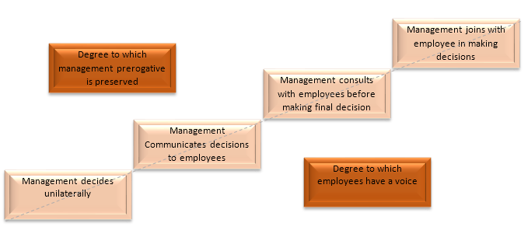
EV can be achieved by Joint consultations, Trade Unions, Employee surveys, Social media, Suggestion schemes and Improvement representive groups. The reaction by the Southern Drivers Dispute would emphises that the organisation had a low EV and required the use of Trade Union participation in Collective representation to agree on a collective bargining, as internal resolutions had failed and intervention was in motion.
‘A lack of employee voice can frustrate employees, meaning they take their grievances elsewhere, often voicing them on public channels like Glassdoor and social media. This can damage an organisation’s ability to recruit talent, as candidates will invariably browse these sites before submitting applications or accepting invitations to interview.’ (People, 2017)
The Brand perception of the organisation is lowered due to ongoing disputes and negotiontions, that is resulting in disruption and poor customer service levels. The conflict hasa direct negative experience for Southern Rail customers and highlighted that ongoing customer service levels could be effected due to the proposed changes to employee contracts.
‘It is also objectively the case that if there is no longer the guarantee of a guard on all services, disabled passengers will be disadvantaged, especially at unstaffed stations and on the train in the event of an emergency. This is particularly the case when many Govia Thameslink Railway stations are unstaffed.’ (RMT, 2016)

Q4. How should the conflict be resolved?
Unofficial industrial action and misbehaviour are rare in current British workplace disputes because of the various Trade Union Acts of the eighties and nineties. All forms of industrial action are now tightly controlled and will comprise of set regulations and conditions before official action can be taken. Ballots must take place and the employer given notice of any proposed action.
“For the avoidance of doubt, should your next planned action proceed at 00.01 on 4 November the offer is withdrawn in its entirety and will no longer be available for the RMT to accept.…There have now been 15 days of wholly unjustified strikes, with your union now set to inflict a further seven days of disruption and misery on passengers in the coming weeks…..I hope you will reconsider your position. We are ready to meet you any time this week should you want to discuss our offer”. (Murray, 2016)
Divergence from the criteria makes the industrial action illegal and unofficial, leaving the Trade Unions open to legal action from the employer. For example, a Union rep telling their colleagues to stop working if an employer doesn’t change a certain procedure would be constituted as unofficial union action and illegal, but if the employees individually choose to stop working with no union involvement then it would not be union based but a breach of contract.
In the Southern Drivers dispute, there were both forms of industrial action, the official action occurred when the drivers went on strike after a ballot and provided notification to the employer of proposed strike action, following the TULRCA 1992 as described in Daniels (2016) and GOV.UK (2017).
‘Planned strikes on Southern
Friday, November 4 and Saturday, November 5
Tuesday, November 22 and Wednesday, November 23
Tuesday, December 6 - Thursday, December 8’ (Murray, 2016)
The unofficial action occurred when drivers unilaterally chose to not to work any voluntary overtime and work to rule. Both stem from the conflict but paradoxically cause conflict by creating a breakdown of employee and management relationship.
The Southern Drivers dispute issue occurred due to a proposed change in job terms and conditions, which caused the action to be taken as part of conflict by changing the psychological contract. If the drivers had chosen to stop working overtime because of a general dislike to their employer or to punish the employer this would be deemed as misbehaviour. The increase in absence due to sickness is a potential method for unofficial action but is convoluted in proving intentional disruption as discussed by Kerr-Williams (2016) in Personnel Today.
“The reason such action is perceived as popular is that, while strike action usually leads to a deduction in pay, sickness absence does not. Employees can, therefore, have the same impact on the employer’s business without losing money…. The primary question being whether employees are genuinely sick or are withdrawing their labour and hence taking strike action. Unions who endorse such action face sanction, but proving such endorsement can be very challenging.” (Kerr-Williams, 2016)
According to the data from the ONS (2018a), industrial disputes in 2017 was the lowest in both private (232,000 lost days) and public (44,000 lost days) sectors since 1996, with a total of 79 stoppages, taken by 33,000 individuals. The information from ONS supports the notion that conflict disputes escalating to industrail action is not a new concept and will continue, but they are historically becoming indecline and a last resort (Fig:7). Gennard & Judge (2005) discusses that only actual strike action is recorded but the threat or imposed threat of industrial sanctions, can bring about the same changes.

Fig:7 Labour Disputes 1931 to 2017 (ONS, 2018)
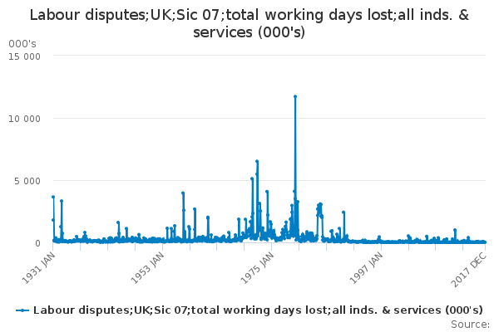
Gennard & Judge (2005) discusses that only actual strike action is recorded but the threat or imposed threat of industrial sanctions, can bring about the same changes, without the cost and may improve reconsilation. The main industrial sanctions avalibile to employers and employees are as per table (Fig:8) but both sides need to consider the successes and credibility of the action.

Fig:8 Industrial Sanctions for Employer and Employee
Employer Sanctions | Employees Sanctions
Locking out some or all workforce | Ban on overtime
Closing location/ site / branch | Working to Rule
Relocating to alternative location/ site/ branch | Impostion of a selected strike
Dissmissal of employees taking part in non authorised strike action | Full scale strike

The Southern Drivers dispute the road to resolution was multi-faceted. Starting with mediation by forms of Meetings between the driver reps (Trade Union) and company reps (Management), then third parties became involved including the Secretary of State for Transport. The Advisory, Conciliation and Arbitration Service (ACAS) become involved to try and help resolve the dispute.
The introduction of a 3rd party to resolve the dispute are Conciliation, Arbitration, and Mediation. All use the aspect of an independent perspective, but all have differing characteristics of resolution.
‘Settlement of a dispute (whether of fact, law, or procedure) between parties to a contract by a neutral third party (the arbitrator) without resorting to court action’
‘the practice of bringing together the parties in a dispute with an independent third party, so that the dispute can be settled through a series of negotiations’ (BusinessDictionary, 2018)
Armstrong & Taylor (2017) compare the three options and suggest that Mediation is the suggestion of recommendations that are not bound but may provide an early agrreable resolution in the place of employment tribunals. Conciliation is the go between to find an amicable compromise, without applying own suggestions or opinions. Whereas Arbitration is the last resort and allows the 3rd party to select the outcome if no compromise can be formulated between the parties.
Conflict in the workplace can present itself in many forms and for several reasons. Typically, they are linked to the difference in opinions, character, values or approach whether this towards a task, process or a direct individual/ team. It is essential that the conflict is addressed and resolved to prevent escalation as highlighted in ACAS (2014) ACAS (2014a) and Doyle (2017). There are numerous skills to conflict resolution from Active listerning, negotiations, assertivness and influencing (Soehern & Harrison, 2017) and (Doyle, 2017) along with modes of practice, eg Thomas Kilmann - Conflict Mode Instrument (Thomas, 1976), John fisher - The process of Transition (Chapman, 2000), Ibrahim Maslows- Hierachy of needs Theory (Petty, 2004) and David McCelland- Theory of Needs (Badley & Robins, 2017).
Conflict be both positive and a negative natural occurrence, which will continue to happen due to the interaction of power and needs. By establishing a process to address potential conflict will result in improved ER. CIPD (2018) advises on areas managers to consider to resolve future issues-
- Be responsible for Employement relationships even when deteriating
- Prevention is better than Repair
- Focus time on negotiating rather than delivery
- Build resiliance skills within the workforce to balance change
- Communication (Active Listerning, Negotitaion, Compromise)
Active listening is the combination of words, tone, and facial/ body language to understand another’s verbal communication (ACAS, 2014). Negotiation works on the principles as per Tricia Harrison and David Soehern (2017) and Ted Johns And Graham Perkins (2016) of understanding your own prefered outcome and combine that with fairness, mutual understanding and commitment to the relationship. Whereas Compromising as part of Kilmann Conflict mode Instrument (Thomas, 1976) (Fig: 9) is the finding of the middle ground, effectivley no one gains but there is a mutual acceptance.
“The ability to manage conflict remains a key issue for all organisations because conflict is inherent in the employment relationship. The increased popularity of ‘alternative dispute resolution’ (ADR) techniques such as early neutral evaluation and mediation to resolve workplace differences represent an important shift from the traditional industrial relations framework. The emphasis of the traditional approach tended to be on formal discipline and grievance procedures, but ADR represents more of a ‘win-win’ approach, aiming to halt conflict at an early stage.” (CIPD, 2017)

Fig.9 Conflict Mode Instrument
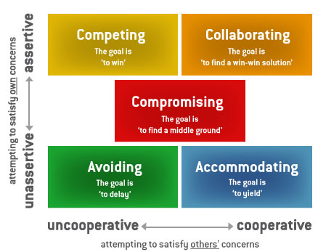

Organisations need to be aware of the power and importance of ER, EV and psychological contracts to be proactive in avoidance of potential conflict. Conflict and resistance will always be prevalent but used constructively and positively will embed relations and strengthen organisation for a positive

References
Lucio, . M. M. & Stuart, M., 2005. Partnership and Modernisation in Employment Relations. Oxon: Routledge.
ACAS, 2012. Voice and Participation in the Modern Workplace: challenges and prospects.. [Online]
Available at: http://m.acas.org.uk/media/pdf/g/7/Voice_and_Participation_in_the_Modern_Workplace_challenges_and_prospects.pdf
[Accessed 13 03 2018].
ACAS, 2014. Challenging conversations and how to mange them, London: ACAS.
Armstrong, M. & Taylor, S., 2017. Armstrong's Handbook of Human Resource Management Practice. 14th ed. London: Koganpage.
Badley, R. & Robins, R., 2017. The Knowledge, Skills and Behaviours Required of Learning and Development Practitioners. In: J. s. a. P. Rogers, ed. Studying Learning and Development context, practise and measurment. London: Charter Insitute of Personnel and Development, pp. 9 - 37.
BusinessDictionary, 2018. Definition. [Online]
Available at: http://www.businessdictionary.com/definition/arbitration.html
[Accessed 18 03 2018].
Chapman, A., 2000. Personal Change Stages - John Fisher. [Online]
Available at: https://www.businessballs.com/change-management/personal-change-stages-john-fisher-162/
[Accessed 10 2017].
CIPD, 2017a. Employee engagement and motivation. [Online]
Available at: https://www.cipd.co.uk/knowledge/fundamentals/relations/engagement/factsheet#6229
[Accessed 13 03 2018].
CIPD, 2017b. Employee voice. [Online]
Available at: https://www.cipd.co.uk/knowledge/fundamentals/relations/communication/voice-factsheet
[Accessed 08 03 2018].
CIPD, 2017. Employee relations: an introduction. [Online]
Available at: https://www.cipd.co.uk/knowledge/fundamentals/relations/employees/factsheet
[Accessed 18 02 2018].
CIPD, 2018a. Employment law: EU and Brexit. [Online]
Available at: www.cipd.co.uk/knowledge/fundamentals/emp-law/about/eu-impact
[Accessed 12 03 2018].
CIPD, 2018. The psychological contract. [Online]
Available at: https://www.cipd.co.uk/knowledge/fundamentals/relations/employees/psychological-factsheet
[Accessed 20 02 2018].
CollierBroderick, 2018. Fixed-Term Contracts – Pros and Cons. [Online]
Available at: https://www.collierbroderick.ie/info-centre/employment-law/fixed-term-contracts/fixed-term-contracts-pros-and-cons/
[Accessed 16 03 2018].
Daniels, K., 2016. Introduction to Employment Law: Fundamentals for HR and Business Students. 4 ed. London: British Library.
Doyle, A., 2017. Conflict Resolution Skills List and Examples. [Online]
Available at: https://www.thebalance.com/conflict-resolutions-skills-2063739
Eversheds, 2011. Lawful Industrial action in the UK. [Online]
Available at: www.eversheds-sutherland.com/documents/.../Industrial_Action_Client_Guide.pdf
[Accessed 28 02 2018].
Gennard, J. & Judge, G., 2005. Employee Relations. 4th ed. London: Charter Insitute of Personnel and Development.
GOV.UK, 2017. Code of Practice: Industrial action ballots and notice to employers. [Online]
Available at: https://www.gov.uk/government/publications/code-of-practice-industrial-action-ballots-and-notice-to-employers--2
[Accessed 09 03 2018].
GOV.UK, 2018. Contract types and employer responsibilities. [Online]
Available at: https://www.gov.uk/contract-types-and-employer-responsibilities/fulltime-and-parttime-contracts
[Accessed 11 03 2018].
HSE, 2018. The Working Time Regulations. [Online]
Available at: http://www.hse.gov.uk/contact/faqs/workingtimedirective.htm
[Accessed 10 03 2018].
Jamieson, . S., 2017. Southern Rail drivers reject £75,000 pay deal and trigger overtime ban. [Online]
Available at: https://www.telegraph.co.uk/news/2017/06/19/southern-rail-drivers-reject-75000-pay-deal-trigger-overtime/
[Accessed 2018].
Jobsite, 2016. From zero to hero? The pros and cons of zero hour contracts. [Online]
Available at: https://www.jobsite.co.uk/worklife/hero-21864/
[Accessed 11 03 2018].
Jobsite, 2017. What’s the difference between fixed-term and permanent contracts?. [Online]
Available at: https://www.jobsite.co.uk/worklife/contract-contract-20037/
[Accessed 11 03 2018].
Kerr-Williams, T., 2016. Southern rail dispute: suspected unofficial industrial action and how to deal with it. [Online]
Available at: https://www.personneltoday.com/hr/ssouthern-rail-dispute-suspected-unofficial-industrial-action-and-how-to-deal-with-it/
[Accessed 21 02 2018].
Kessier, I. & Undy, R., 1996. The New Employment Relationship: Examining the psychological contract. lONDON: Chartered Institute of Personnel & Development.
LBC, 2016. Why Southern Rail's Strikes May Go On For Years. [Online]
Available at: http://www.lbc.co.uk/news/the-news-explained/lbcs-long-read-the-southern-rail-debacle/
[Accessed 10 03 2018].
Murray, D., 2016. Southern Rail bosses issue ultimatum to staff planning further strikes: 'Sign new contracts or you're out'. [Online]
Available at: https://www.standard.co.uk/news/transport/southern-rail-bosses-issue-ultimatum-to-staff-planning-further-strikes-sign-new-contracts-or-youre-a3382821.html
[Accessed 10 03 2018].
ONS, 2018a. UK labour market: February 2018. [Online]
Available at: https://www.ons.gov.uk/employmentandlabourmarket/peopleinwork/employmentandemployeetypes/bulletins/uklabourmarket/february2018#labour-disputes-not-seasonally-adjusted
[Accessed 18 03 2018].
ONS, 2018. Labour disputes;UK;Sic 07;total working days lost;all inds. & services (000's). [Online]
Available at: https://www.ons.gov.uk/employmentandlabourmarket/peopleinwork/employmentandemployeetypes/timeseries/bbfw/lms
[Accessed 18 03 2018].
OOR, 2012. Managing Rail Staff Fatigue. [Online]
Available at: http://orr.gov.uk/rail/health-and-safety/health-and-safety-strategy/working-patterns-fatigue
[Accessed 08 03 2018].
People, I. i., 2017a. Employee voice: how does it impact the culture?. [Online]
Available at: https://www.investorsinpeople.com/resources/ideas-and-inspiration/employee-voice-culture-climate
[Accessed 13 03 2018].
People, I. i., 2017b. Employee voice: 6 ways employers can activate it. [Online]
Available at: https://www.investorsinpeople.com/resources/ideas-and-inspiration/employee-voice-workplace-activate-enable
[Accessed 10 03 2018].
People, I. i., 2017. Employee voice: why is it important to sustainable success?. [Online]
Available at: https://www.investorsinpeople.com/resources/ideas-and-inspiration/employee-voice-work-engagement-productivity
[Accessed 14 03 2018].
Petty, G., 2004. Teaching Today. 3rd ed. Cheltenham: Nelson Thornes.
RMT, 2016. SOUTHERN RAIL DISPUTE facts. [Online]
Available at: www.rmt.org.uk/news/.../southern-gtr-doo-facts/southerngtrdoofactsfinal.pdf
[Accessed 08 03 2018].
Rousseau, D., 1995. Psychological Contracts in Organizations. London: Sage Publications.
SOAS, 2012. Sources of EU Law. [Online]
Available at: www.soas.ac.uk/library/subjects/law/research/file70378.pdf
[Accessed 28 02 2018].
Soehern, D. & Harrison, T., 2017. Working Collaborativley as a Member of a Team or Working Group. In: J. S. a. P. Rogers, ed. Studying Learning and Development: Context, Practice and MEASURMENT. London: Chartered Institute of Personnel and Development, pp. 59-88.
Symonds, S., 2008. How laws are made in the UK and how to influence the law-making. [Online]
Available at: www.ilpa.org.uk/data/resources/4731/08.10.1188.pdf
[Accessed 12 03 2018].
Taylor, S., 2014. Resourcing and Talent Management. 6th ed. London: Chartered Institute of Personnel and Development.
Thomas, K., 1976. Conflict and Conflict Management. In: M. Dinnette, ed. The handbook of Industrial and Organisational Psychology. Chicago: Rand McNally.
Topham, G., 2017a. Aslef asks members to bring Southern rail dispute to an end. [Online]
Available at: https://www.theguardian.com/business/2017/oct/19/aslef-asks-members-to-bring-southern-rail-dispute-to-an-end
[Accessed 21 02 2018].
Topham, G., 2017. Southern rail and union agree deal to end strikes over driver-only trains. [Online]
Available at: https://www.theguardian.com/business/2017/feb/02/southern-rail-deal-reached-to-end-strikes-over-driver-only-trains
[Accessed 21 02 2018].
TUC, W., 2018. WHICH GROUPS OF WORKERS ARE NOT COVERED BY WORKING TIME RULES, OR TREATED AS A SPECIAL CASE?. [Online]
Available at: https://worksmart.org.uk/work-rights/hours-and-holidays/working-hours/which-groups-workers-are-not-covered-working-time-rules
[Accessed 12 03 2018].

