Ana Carden-Coyne, David Morris and Tim Wilcox, eds., The Sensory War, 1914–2014(Manchester Art Gallery: Manchester, 2014)
Images from section entitled ‘Bombing, Burning and Distant War’

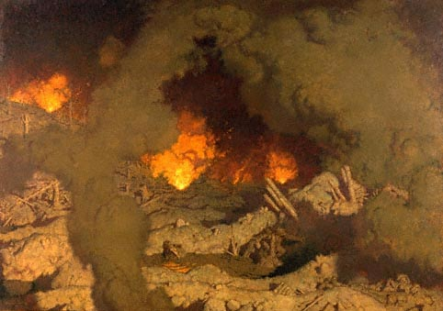
George Leroux, Hell, 1921

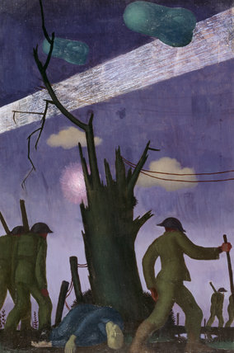
Colin Gill, Evening after a Push, 1919

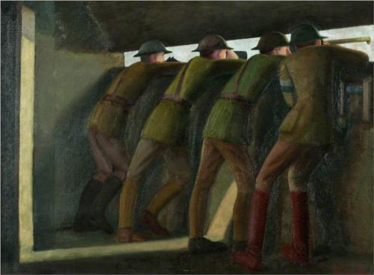
Leon Underwood, Concrete Observation Post, Mount Kemmel, 1919

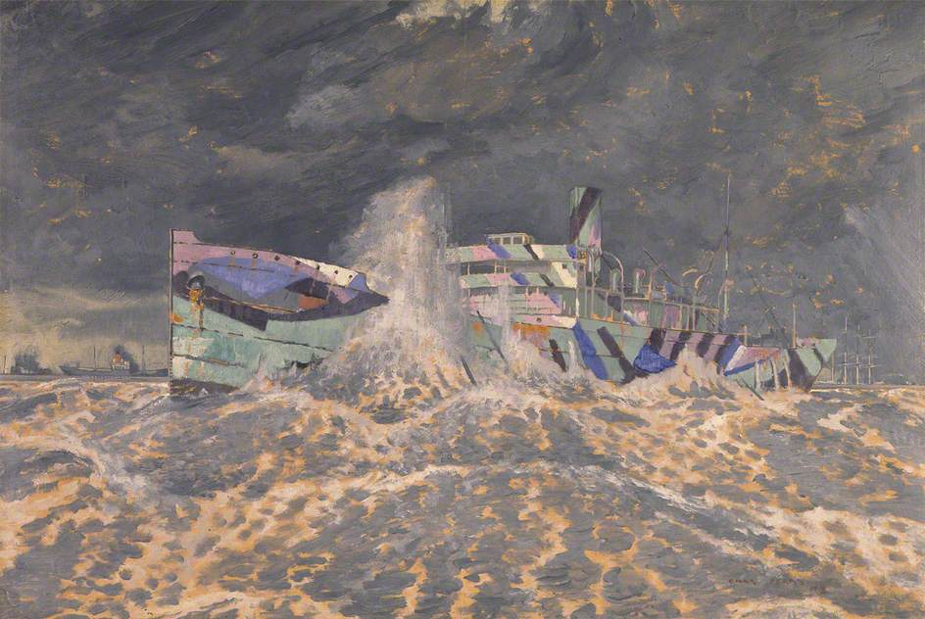
Charles Pears, Camouflaged Merchant Steamer Aground, 1918

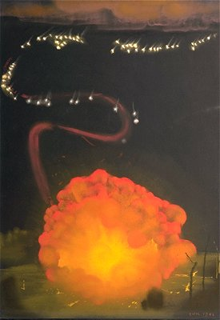
Eric Kennington, Stevens’ Rocket, 1941

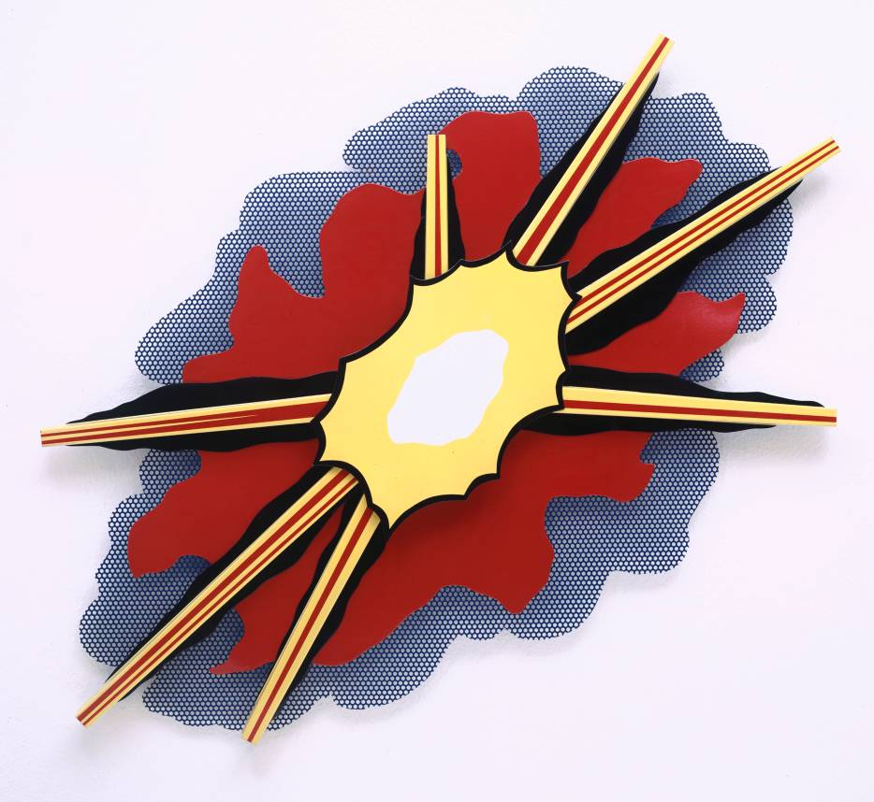
Roy Lichtenstein, Wall Explosion II, 1965

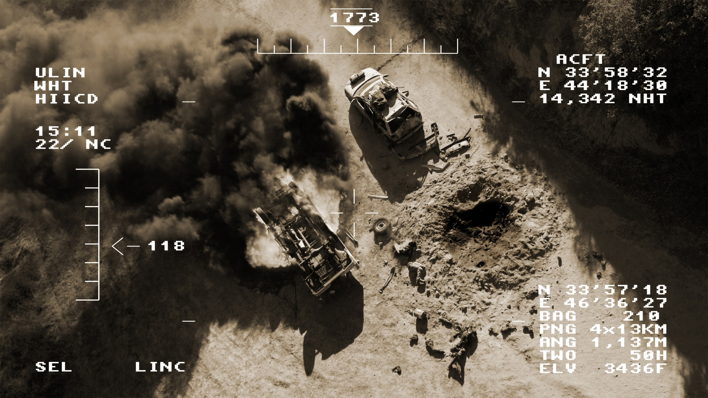
Omer Fast, 5000 Feet is the Best, 2011

Hibakusha Works
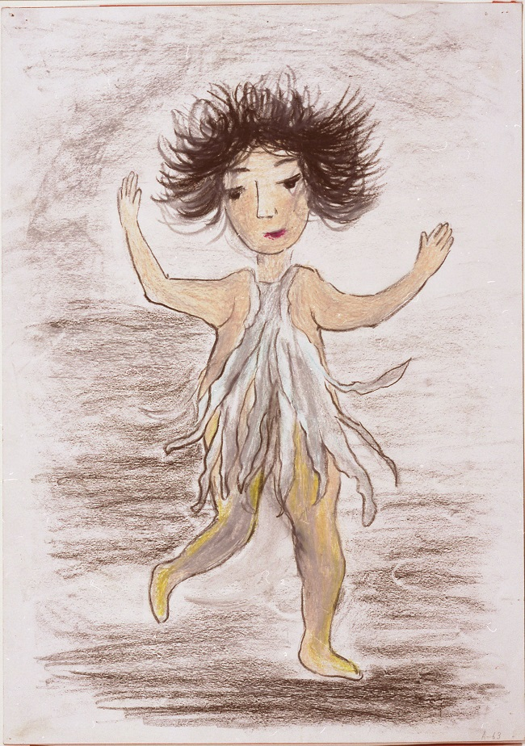
Sadako Kimura, Running Girl, 1974

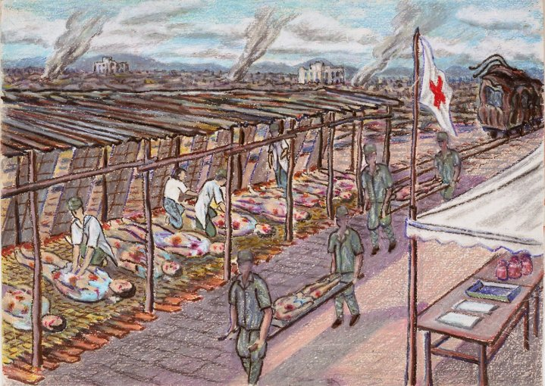
Fumiko Ya, Hospital, 1973-1974
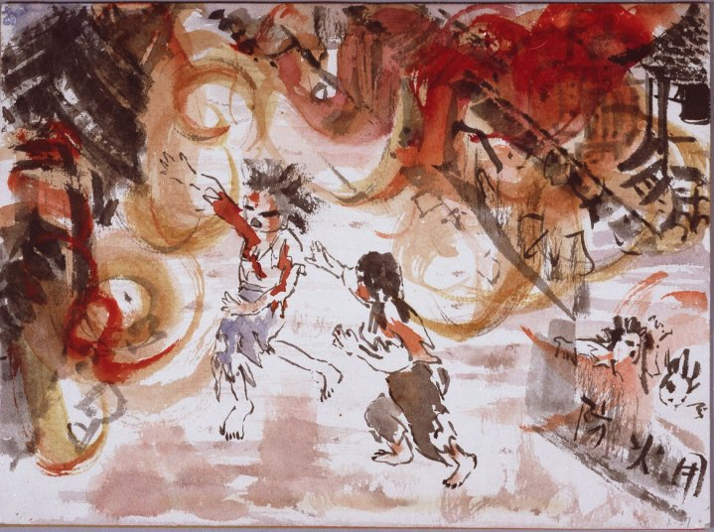
Yoshiko Michitsuji, I ran Towards my House through a Sea of Flames, 1974

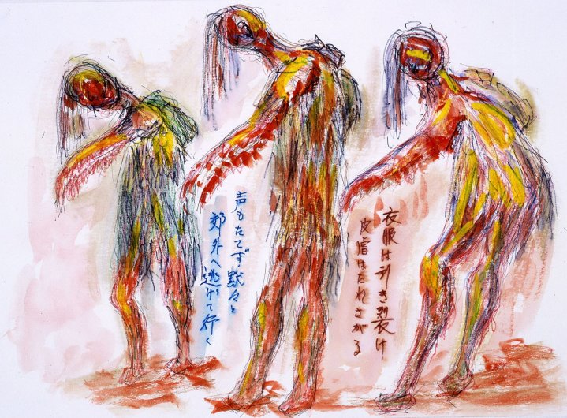
Kichisuke Yoshimura, Riverbank near Hiroshima Railway Station, Their Clothes Ripped to Shred, Their Skin Hanging Down, 1973–1974
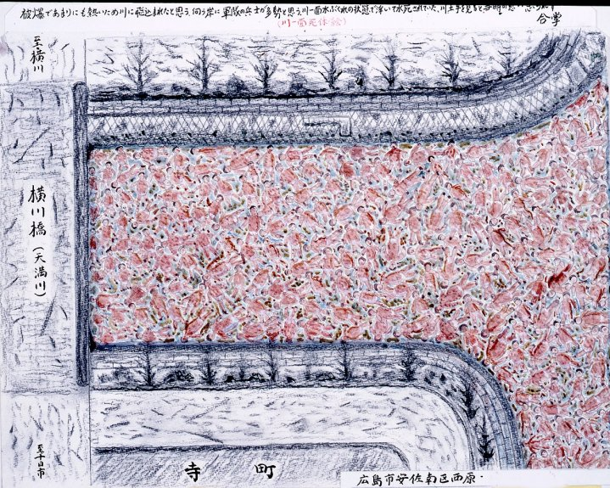
Masahiko Nakata, Bloated Bodies in the River over Yokogawa Bridge, 1973–1974
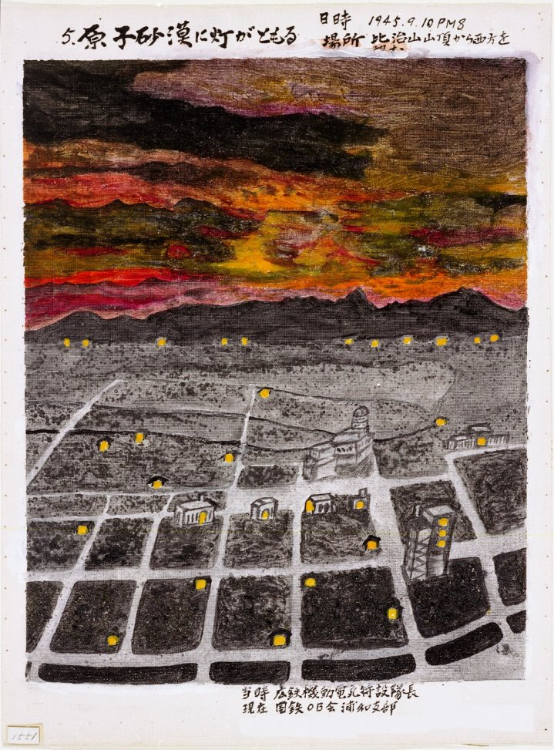Gisaku Tanaka, Lights Blinking on in the Atomic Desert, 1973–1974

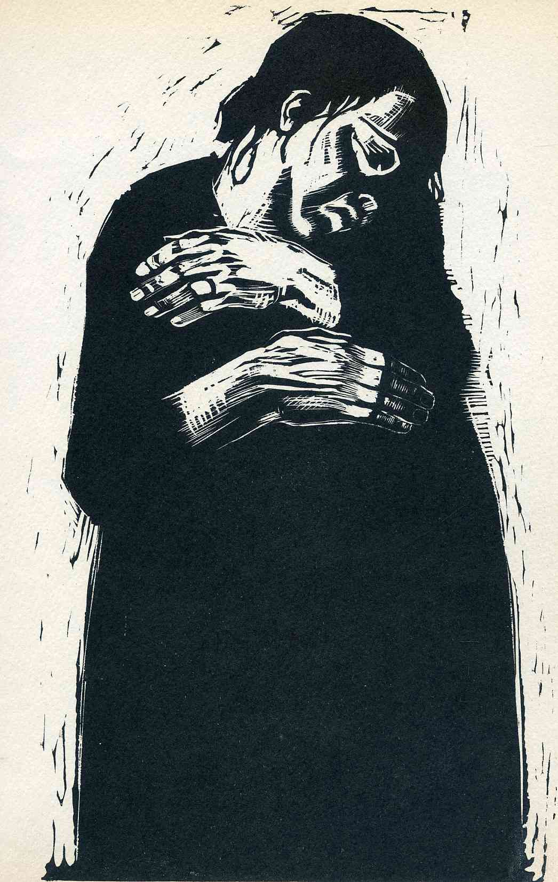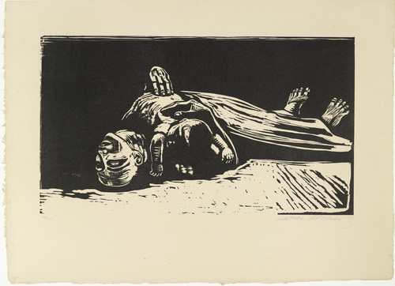
Käthe Kollwitz, The War: The Widow I & II (1923–1924)
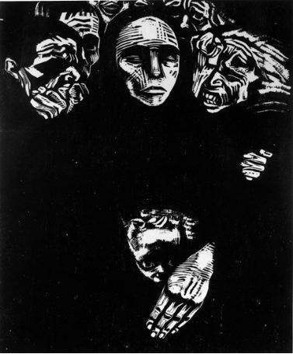
Käthe Kollwitz, The War: The People (1923–1924)
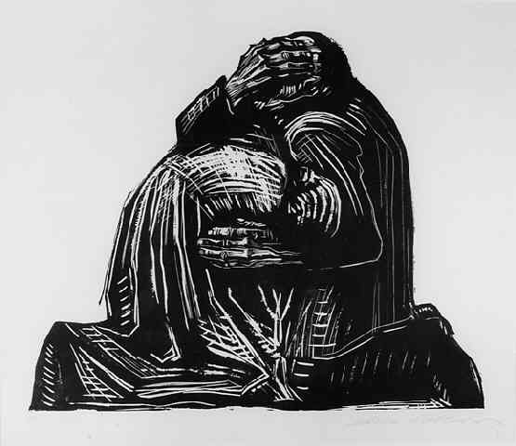
Käthe Kollwitz, The War: The Parents (1923–1924)

