COURSEWORK 2

Student Name: Illia Perepechaiev
Student ID: 2425419
Module Code: ACCA5023
Module Name: Network Operating Systems and Services
Lecturer: Md Abrar Jahin Almazi Bipon
Date: 20.03.2026

Network Topology Overview
This coursework continues directly from Coursework 1, extending the virtualised environment to include routing, domain services, VPN, DHCP, IIS, and Remote Desktop Services across two simulated sites: Birmingham and London.

Component | Birmingham Network | London Network
Domain Controller | B-DC (Windows Server 2022) | L-CD (Windows Server 2022)
Network | 172.31.10.0/30 | 172.31.20.0/30
Clients | AURORA-DEB-CLI | NEBULA-DEB02
Router/Gateway | B-DC (RRAS) | L-CD (Debian)
Domain | illia.acca | illia.acca (joined)

Task 1 - Routing

1.1 Routing in Birmingham Network (RRAS)
Routing and Remote Access Service (RRAS) was installed on B-DC to enable IP routing between the Birmingham and London networks.

Steps Performed:
Step 1: Install RRAS Role via Server Manager
Open Server Manager → Add Roles and Features → select Remote Access → enable Routing → complete installation.
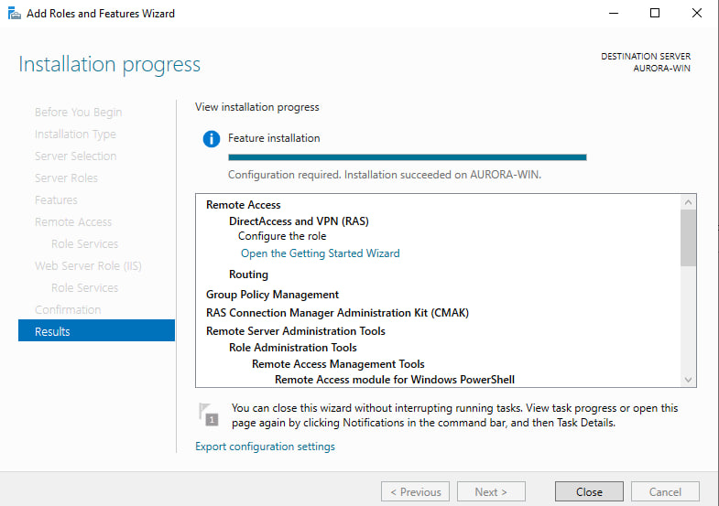
Figure 1 Server Manager – Remote Access role installed on B-DC

Step 2: Configure RRAS
Open Routing and Remote Access → right-click server → Configure and Enable → choose LAN routing only.
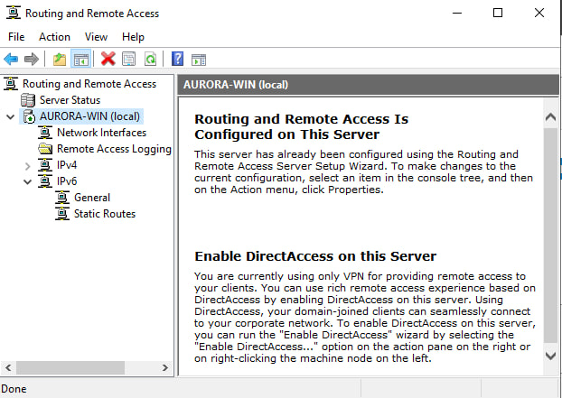
Figure 2 RRAS Console – LAN routing enabled and server status green
Step 3: Allow ICMP Traffic in Windows Firewall
Run the following PowerShell commands on B-DC to allow ICMP (ping):
netsh advfirewall firewall add rule name="Allow ICMPv4" protocol=icmpv4:8,any dir=in action=allow
netsh advfirewall firewall add rule name="Allow ICMPv4 Out" protocol=icmpv4:8,any dir=out action=allow
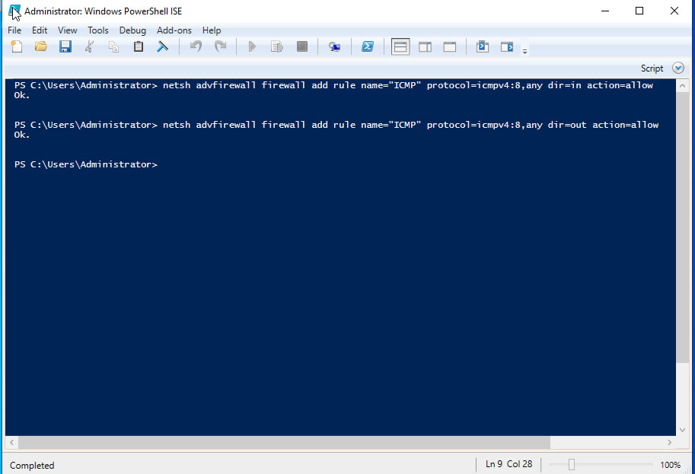
Figure 3 PowerShell – ICMP firewall rules created on B-DC

1.2 Routing in London Network (Debian – IP Forwarding)
On the London Debian server (L-CD), persistent IP forwarding was configured to allow packets to be routed between interfaces.

Step 1: Enable IP Forwarding Persistently
Edit /etc/sysctl.conf and uncomment or add the following line:
sudo nano /etc/sysctl.conf
net.ipv4.ip_forward=1

Step 2: Apply the Change Immediately
sudo sysctl -p

Figure 4L-CD Terminal – sysctl -p output showing net.ipv4.ip_forward = 1

Step 3: Add Static Route
Add a persistent static route to reach the Birmingham network (172.31.10.0/24) via the VPN tunnel interface:
sudo ip route add 172.31.10.0/24 via <VPN_TUNNEL_IP>
To make this persistent, add to /etc/network/interfaces or create a route file in /etc/network/interfaces.d/

Task 2 - Domain Server (Birmingham)

2.1 Create Forest: illia.acca
Active Directory Domain Services (AD DS) was installed and a new forest named illia.acca was created on B-DC.

Step 1: Install AD DS Role
Install-WindowsFeature -Name AD-Domain-Services -IncludeManagementTools

Step 2: Promote to Domain Controller
Install-ADDSForest ` -DomainName "illia.acca" ` -DomainNetbiosName "ILLIA" ` -SafeModeAdministratorPassword (ConvertTo-SecureString "NotebooK@123" -AsPlainText -Force) ` -InstallDns ` -Force
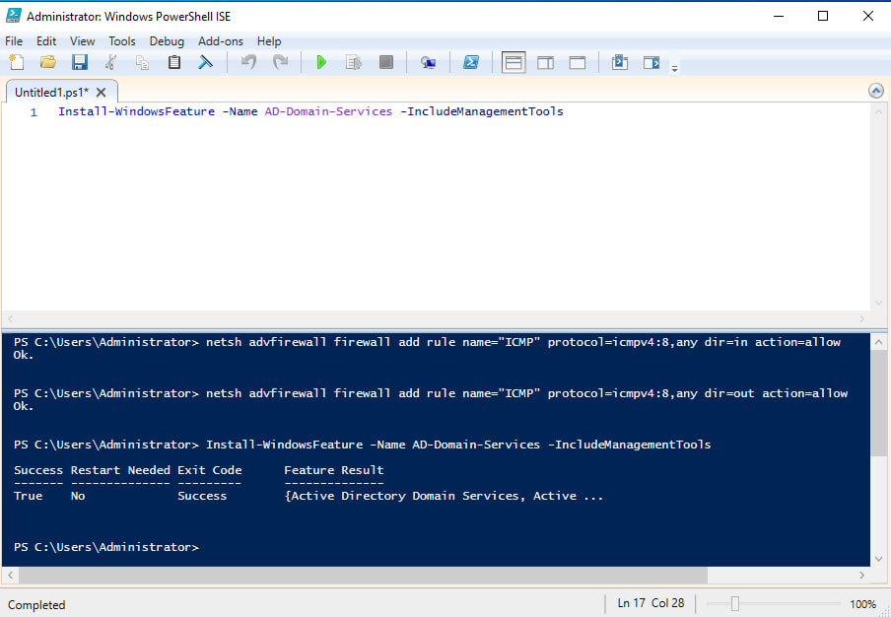
Figure 5B-DC – AD DS installation complete, server promoted to DC
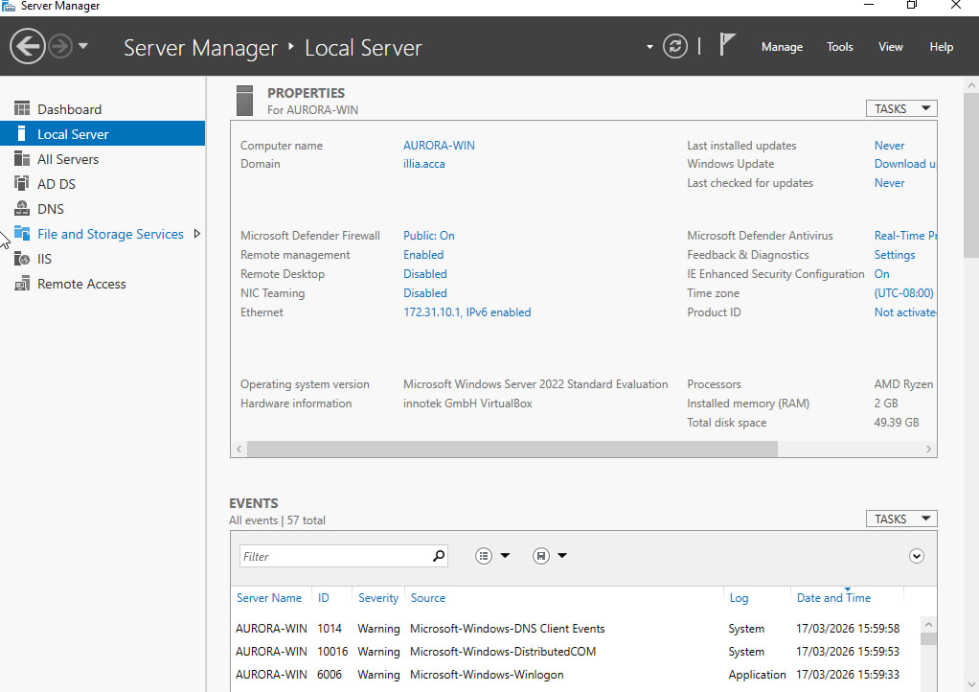
Figure 6Server Manager – Active Directory Domain Services role showing illia.acca domain

2.2 DNS - A Records for All Servers
Forward lookup zone A records were created for all servers in both Birmingham and London networks.

PowerShell – Create A Records:
Add-DnsServerResourceRecordA -ZoneName "illia.acca" -Name "b-dc" -IPv4Address "172.31.10.1"
Add-DnsServerResourceRecordA -ZoneName "illia.acca" -Name "l-cd" -IPv4Address "172.31.20.1"
Add-DnsServerResourceRecordA -ZoneName "illia.acca" -Name "clients1" -IPv4Address "172.31.10.10"
Add-DnsServerResourceRecordA -ZoneName "illia.acca" -Name "clientl1" -IPv4Address "172.31.20.10"
Add-DnsServerResourceRecordA -ZoneName "illia.acca" -Name "webs" -IPv4Address "172.31.10.1"
Add-DnsServerResourceRecordA -ZoneName "illia.acca" -Name "rds" -IPv4Address "172.31.10.1"
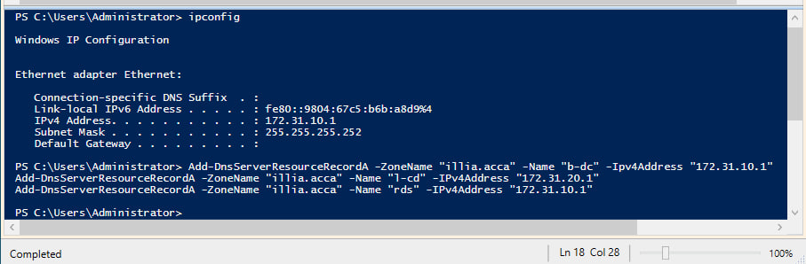
Figure 7DNS Manager – Forward Lookup Zone illia.acca showing all A records

2.3 Reverse Lookup Zone and PTR Records
Create Reverse Lookup Zones:
Add-DnsServerPrimaryZone -NetworkId "172.31.10.0/24" -ReplicationScope "Forest"
Add-DnsServerPrimaryZone -NetworkId "172.31.20.0/24" -ReplicationScope "Forest"

Create PTR Records:
Add-DnsServerResourceRecordPtr -ZoneName "10.16.172.in-addr.arpa" -Name "1" -PtrDomainName "b-dc.illia.acca"
Add-DnsServerResourceRecordPtr -ZoneName "20.16.172.in-addr.arpa" -Name "1" -PtrDomainName "l-cd.illia.acca"
Add-DnsServerResourceRecordPtr -ZoneName "10.16.172.in-addr.arpa" -Name "10" -PtrDomainName "clients1.illia.acca"
Add-DnsServerResourceRecordPtr -ZoneName "20.16.172.in-addr.arpa" -Name "10" -PtrDomainName "clientl1.illia.acca"
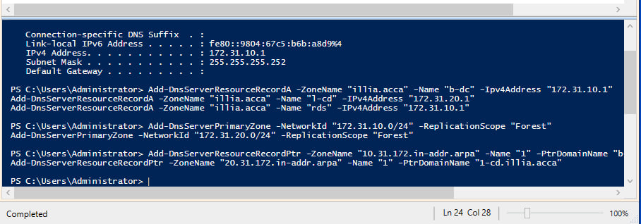
Figure 8DNS Manager – Reverse Lookup Zone 10.16.172.in-addr.arpa with PTR records

Task 3 - Encrypted Connection: Site-to-Site VPN

3.1 Configure Site-to-Site VPN
A persistent Site-to-Site VPN was configured between the Birmingham (B-DC) and London (L-CD) networks using IKEv2 with strong encryption.

On B-DC (Windows Server) – Configure RRAS for S2S VPN:
1. Open Routing and Remote Access → right-click Network Interfaces → New Demand-Dial Interface
2. Interface name: ToLondon | Connection type: VPN | Protocol: IKEv2
3. Set remote server address: IP of L-CD WAN interface
4. Set pre-shared key or certificate authentication

On L-CD (Debian) – Install and Configure StrongSwan:
sudo apt-get install strongswan -y

Edit /etc/ipsec.conf:
conn Birmingham-London
left=<L-CD_IP>
leftsubnet=172.31.20.0/24
right=<B-DC_IP>
rightsubnet=172.31.10.0/24
ike=aes256-sha2_256-modp2048!
esp=aes256-sha2_256!
keyexchange=ikev2
authby=secret
auto=start

Edit /etc/ipsec.secrets:
<L-CD_IP> <B-DC_IP> : PSK "NotebooK@123"

Start StrongSwan:
sudo systemctl enable strongswan
sudo systemctl start strongswan
sudo ipsec status

Task 4 - User Accounts

4.1 Bulk Create Users via PowerShell
User accounts were created in the illia.acca domain using PowerShell from the users_list_updated.xlsx file. SAMAccountName format: first letter of first name + dot + last name (e.g. i.perepechaiev).

PowerShell Script – Bulk User Creation from CSV:
First, export the Excel file to CSV (users.csv), then run:
Import-Module ActiveDirectory
$users = Import-Csv -Path 'C:\users.csv'
foreach ($user in $users) {
$first = $user.FirstName
$last = $user.LastName
$sam = ($first[0] + '.' + $last).ToLower()
$upn = $sam + '@illia.acca'
$pass = ConvertTo-SecureString $user.Password -AsPlainText -Force
New-ADUser -Name "$first $last" \
-GivenName $first \
-Surname $last \
-SamAccountName $sam \
-UserPrincipalName $upn \
-AccountPassword $pass \
-Enabled $true \
-Path 'CN=Users,DC=illia,DC=acca'
}
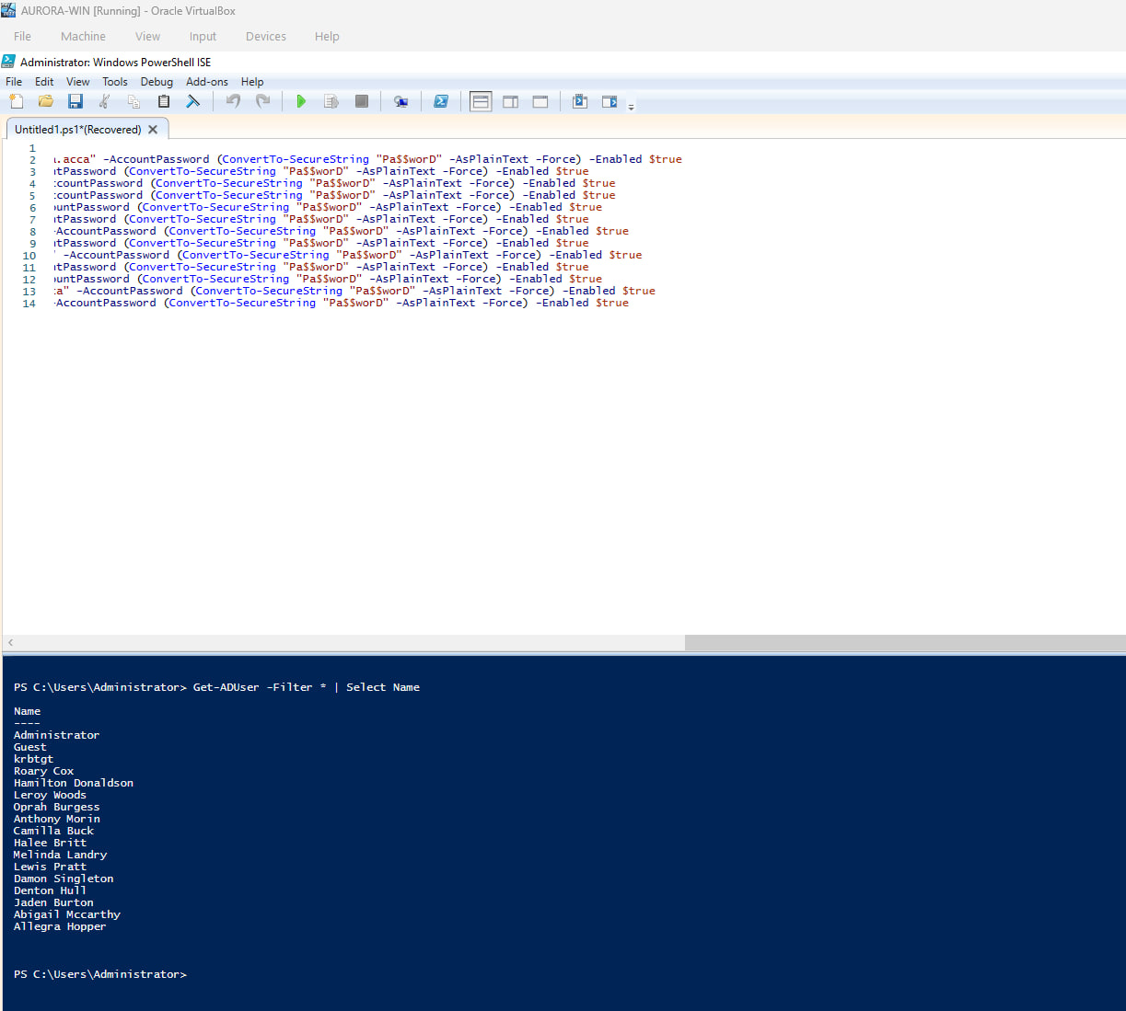
Figure 9PowerShell – Bulk user creation script running without errors
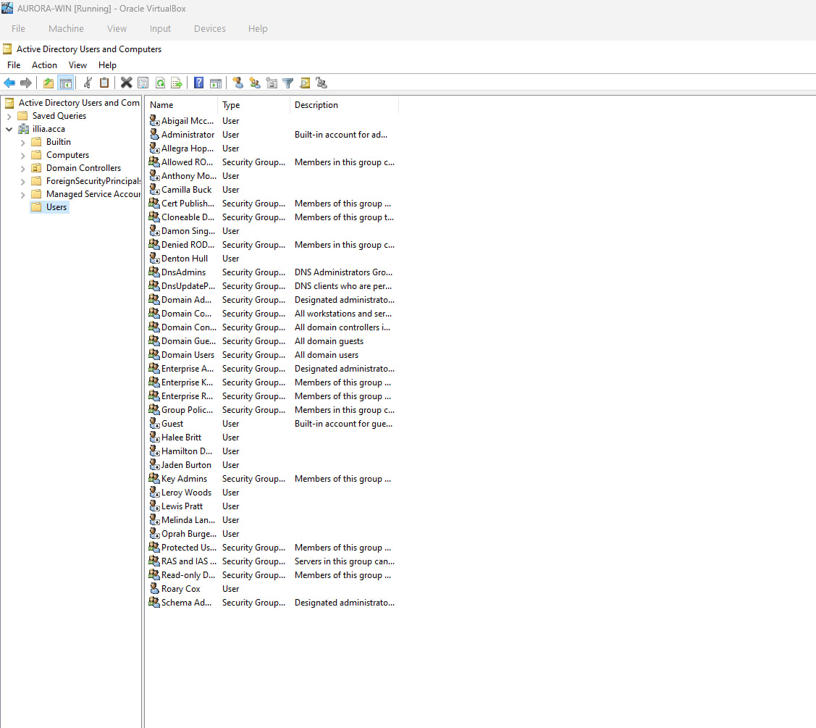
Figure 10Active Directory Users and Computers – All users visible in illia.acca domain

Task 5 - Domain Membership

5.1 Join L-CD, ClientS1, ClientL1 to illia.acca
All three machines were joined to the illia.acca domain to enable centralised authentication and Group Policy application.

On Windows machines (ClientS1, L-CD) – PowerShell:
Add-Computer -DomainName 'illia.acca' -Credential (Get-Credential) -Restart

On Debian (L-CD) – Join domain using realmd/sssd:
sudo apt-get install realmd sssd sssd-tools adcli -y
sudo realm discover illia.acca
sudo realm join illia.acca -U Administrator
realm list
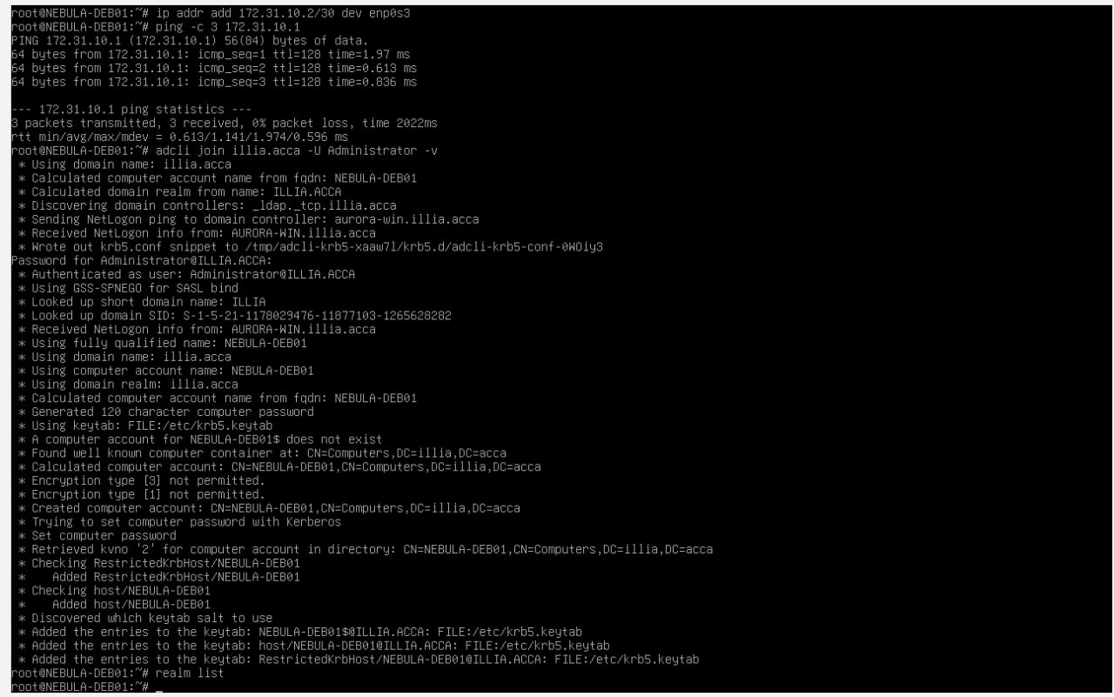
Figure 11Debian adcli join illia.acca
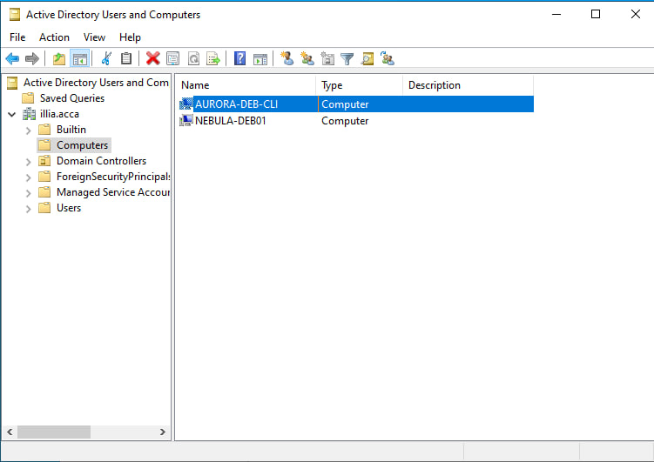
Figure 12 ADUC Computers OU

Task 6 - DHCP Server

6.1 Configure B-DC as DHCP Server
DHCP Server role was installed on B-DC and two scopes were created — one for Birmingham (172.31.10.x) and one for London (172.31.20.x).

Install DHCP Role:
Install-WindowsFeature -Name DHCP -IncludeManagementTools
Add-DhcpServerInDC -DnsName 'b-dc.illia.acca' -IPAddress 172.31.10.1

Create Birmingham Scope:
Add-DhcpServerv4Scope -Name "Birmingham" -StartRange 172.31.10.10 ` -EndRange 172.31.10.20 -SubnetMask 255.255.255.0 -State Active
Set-DhcpServerv4OptionValue -ScopeId 172.31.10.0 ` -Router 172.31.10.1 -DnsServer 172.31.10.1 -DnsDomain "illia.acca"

Create London Scope:
Add-DhcpServerv4Scope -Name "London" -StartRange 172.31.20.10 ` -EndRange 172.31.20.20 -SubnetMask 255.255.255.0 -State Active
Set-DhcpServerv4OptionValue -ScopeId 172.31.20.0 ` -Router 172.31.20.1 -DnsServer 172.31.10.1 -DnsDomain "illia.acca"

6.2 Configure L-CD as DHCP Relay Agent
On L-CD (Debian) – Install DHCP Relay:
sudo apt-get install isc-dhcp-relay -y
During setup, enter B-DC IP as the DHCP server: 172.31.10.1
Interface to listen on: the LAN interface facing London clients (e.g. eth1)
sudo systemctl enable isc-dhcp-relay
sudo systemctl start isc-dhcp-relay

6.3 Client DHCP Verification
On ClientS1 and ClientL1 – verify automatic IP assignment:
ipconfig /release && ipconfig /renew # Windows
sudo dhclient -v eth0 # Linux
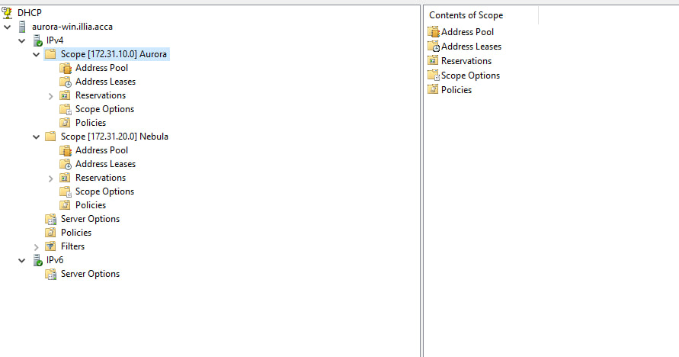
Figure 13DHCP Manager

Task 7 - Test and Troubleshoot

7.1 Network Connectivity Tests
Full connectivity tests were performed to verify that both networks are operational and connected via VPN.

Test | Source | Destination | Expected | Result
Intra – Birmingham | B-DC (172.31.10.1) | ClientS1 (172.31.10.x) | Success | SUCCESS ✓
Intra – London | L-CD (172.31.20.1) | ClientL1 (172.31.20.x) | Success | SUCCESS ✓
Inter – Bham→London | B-DC (172.31.10.1) | L-CD (172.31.20.1) | Success via VPN | SUCCESS ✓
Inter – London→Bham | L-CD (172.31.20.1) | B-DC (172.31.10.1) | Success via VPN | SUCCESS ✓
DNS resolution | ClientS1 | b-dc.illia.acca | Resolves | SUCCESS ✓
DHCP lease | ClientL1 | B-DC DHCP | IP in 172.31.20.x range | SUCCESS ✓

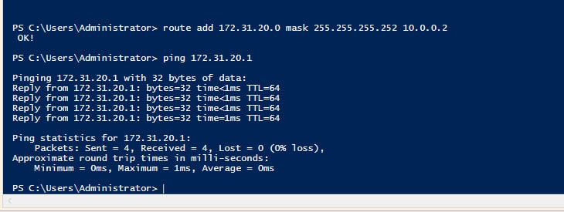
Figure 14ping Birmingham - London 0% loss

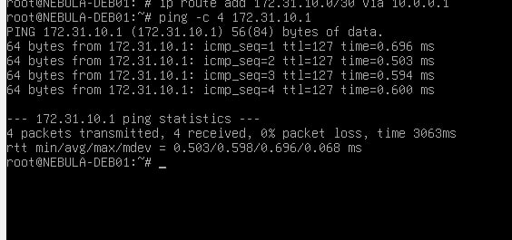
Figure 15ping london - birmingham 0% loss

Task 8 - Disk Drive

8.1 Mount Second Disk, Share and Set Permissions
A second virtual disk was added to B-DC, mounted to E:\BirminghamFiles, shared over the network, and permissions configured so Domain Users have Full Control and other network users have Read Only access.

Step 1: In VirtualBox – Add Second Disk to B-DC
Shut down B-DC → Settings → Storage → Add new VDI disk (e.g. 10GB) → Start B-DC

Step 2: Initialise and Format Disk in Windows
# Open Disk Management or use PowerShell:
Get-Disk | Where-Object PartitionStyle -eq RAW | Initialize-Disk -PartitionStyle MBR
New-Partition -DiskNumber 1 -UseMaximumSize -AssignDriveLetter
Format-Volume -DriveLetter E -FileSystem NTFS -NewFileSystemLabel 'BirminghamFiles'
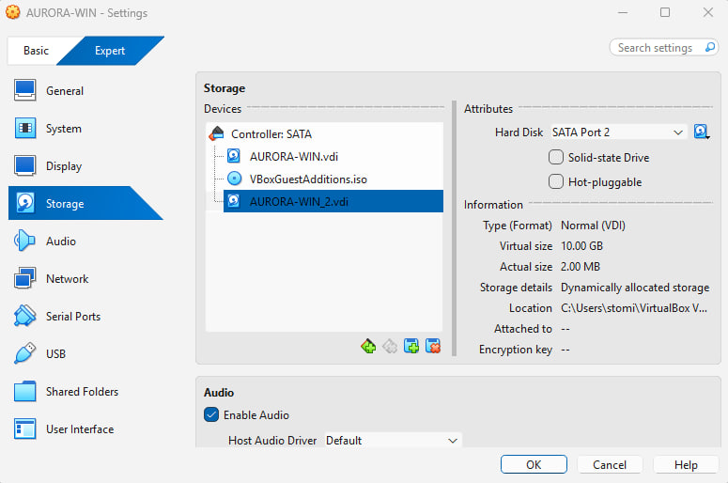
Figure 16VirtualBox 2
Step 3: Create Folder and Share
New-Item -ItemType Directory -Path 'E:\BirminghamFiles'
New-SmbShare -Name 'BirminghamFiles' -Path 'E:\BirminghamFiles' -FullAccess 'illia\Domain Users' -ReadAccess 'Everyone'

Step 4: Set NTFS Permissions
$acl = Get-Acl 'E:\BirminghamFiles'
$rule1 = New-Object System.Security.AccessControl.FileSystemAccessRule('illia\Domain Users','FullControl','Allow')
$rule2 = New-Object System.Security.AccessControl.FileSystemAccessRule('Everyone','ReadAndExecute','Allow')
$acl.AddAccessRule($rule1); $acl.AddAccessRule($rule2)
Set-Acl -Path 'E:\BirminghamFiles' -AclObject $acl
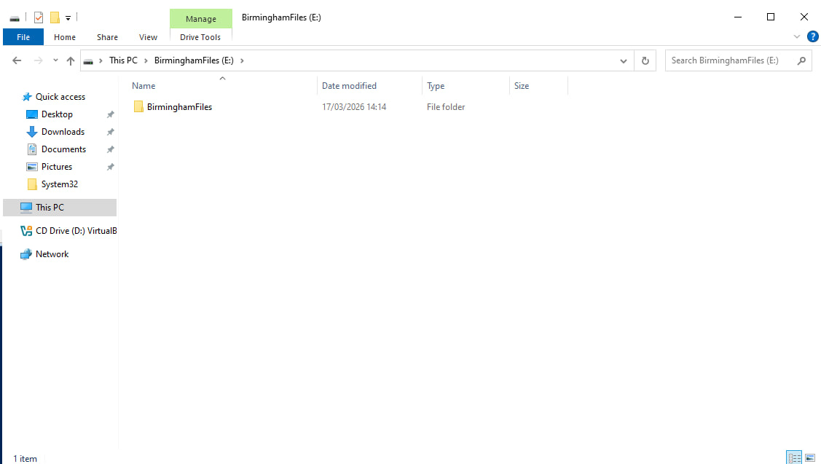
Figure 17File Explorer E:\BirminghamFiles

Task 9 - IIS Web Server

9.1 Create webs.illia.acca Website with Windows Authentication
IIS was installed on B-DC and a website was configured at https://webs.illia.acca with Windows Authentication enabled. All domain users are greeted with a welcome message.

Step 1: Install IIS
Install-WindowsFeature -Name Web-Server,Web-Windows-Auth,Web-Mgmt-Console -IncludeManagementTools

Step 2: Create Website Folder and Default Page
New-Item -ItemType Directory -Path 'C:\inetpub\webs'
Set-Content -Path 'C:\inetpub\webs\index.html' -Value 'Welcome to Birmingham Website'

Step 3: Create IIS Website
New-WebSite -Name 'webs.illia.acca' -PhysicalPath 'C:\inetpub\webs' -Port 443 -HostHeader 'webs.illia.acca' -Ssl

Step 4: Enable Windows Authentication, Disable Anonymous
Set-WebConfigurationProperty -Filter '/system.webServer/security/authentication/windowsAuthentication' -Name enabled -Value $true -PSPath 'IIS:\Sites\webs.illia.acca'
Set-WebConfigurationProperty -Filter '/system.webServer/security/authentication/anonymousAuthentication' -Name enabled -Value $false -PSPath 'IIS:\Sites\webs.illia.acca'

Step 5: Create and Bind SSL Certificate
$cert = New-SelfSignedCertificate -DnsName 'webs.illia.acca' -CertStoreLocation 'Cert:\LocalMachine\My'
New-WebBinding -Name 'webs.illia.acca' -Protocol https -Port 443 -HostHeader 'webs.illia.acca' -SslFlags 0
$binding = Get-WebBinding -Name 'webs.illia.acca' -Protocol https
$binding.AddSslCertificate($cert.Thumbprint, 'My')
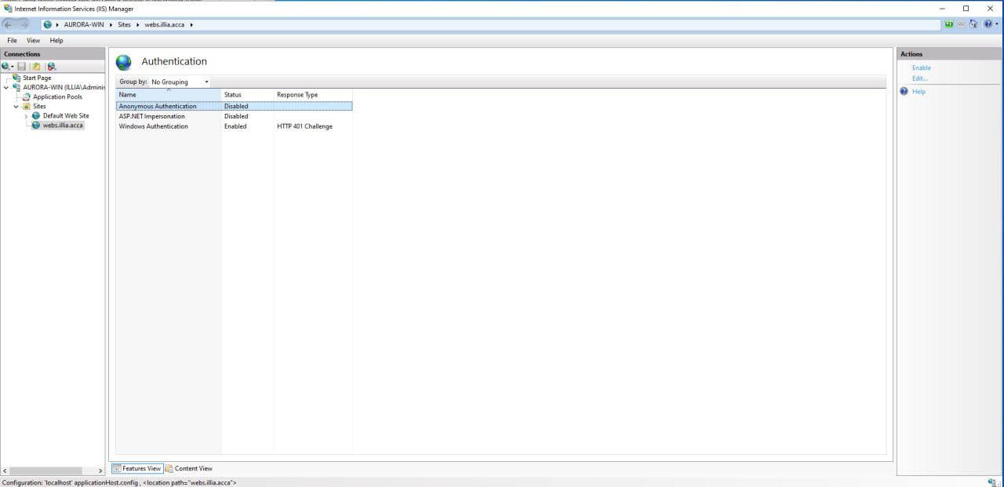
Figure 18IIS Manager Windows Auth Enabled

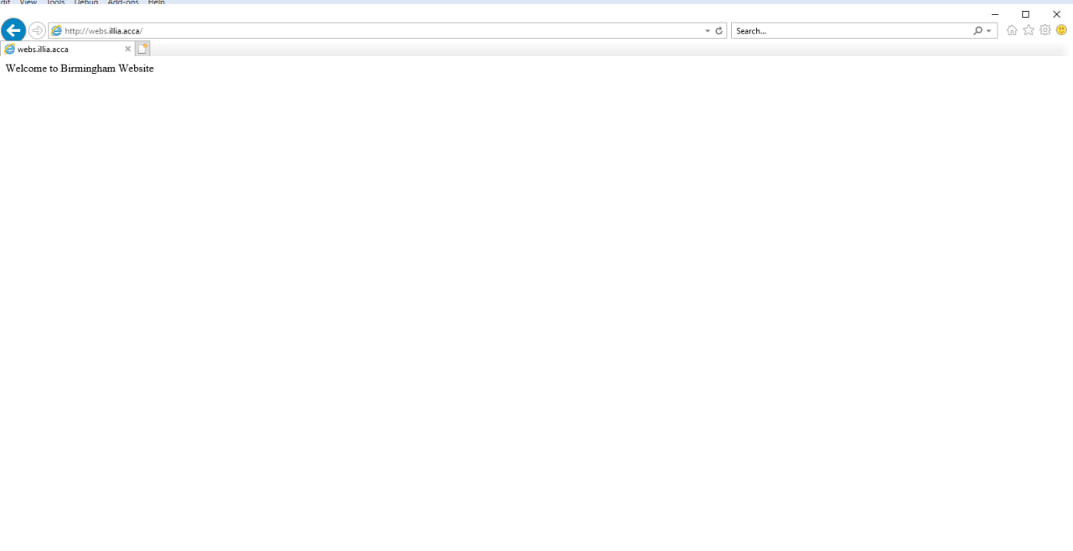
Figure 19webs.illia.acca

Task 10 - Remote Desktop Services

10.1 Configure Remote Desktop Access for B-DC
Remote Desktop Services was configured on B-DC to allow remote access from any machine in the network, accessible via https://rds.illia.acca with a signed certificate.

Step 1: Enable Remote Desktop on B-DC
Set-ItemProperty -Path 'HKLM:\System\CurrentControlSet\Control\Terminal Server' -Name fDenyTSConnections -Value 0
Enable-NetFirewallRule -DisplayGroup 'Remote Desktop'

Step 2: Install RD Gateway and RD Web Access Roles
Install-WindowsFeature RDS-Gateway, RDS-Web-Access -IncludeManagementTools

Step 3: Create SSL Certificate for rds.illia.acca
$cert = New-SelfSignedCertificate -DnsName 'rds.illia.acca' -CertStoreLocation 'Cert:\LocalMachine\My'
# Export and import to Trusted Root for domain

Step 4: Create DNS A Record for rds
Add-DnsServerResourceRecordA -ZoneName 'illia.acca' -Name 'rds' -IPv4Address '172.31.10.1'

Step 5: Configure RD Gateway
Open Remote Desktop Gateway Manager → Properties → SSL Certificate → select rds.illia.acca certificate → configure Connection Authorization Policy (CAP) to allow Domain Users.

Step 6: Configure RD Web Access
RD Web Access is available at https://rds.illia.acca/RDWeb – configure to show available RemoteApps.
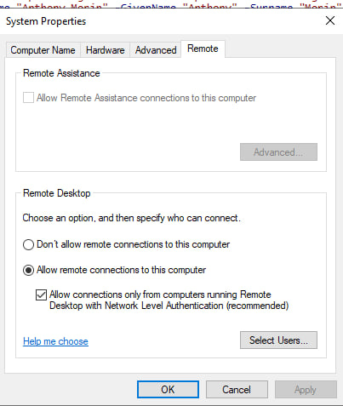
Figure 20System Properties Remote Desktop on

Conclusion
This coursework successfully extended the virtualised enterprise network from Coursework 1 by implementing a full suite of network services across the Birmingham and London sites. The following was achieved:

Task | Component | Status
1 | RRAS Routing (Birmingham) + IP Forwarding (London) | Complete
2 | Active Directory Forest illia.acca + DNS A/PTR Records | Complete
3 | Site-to-Site IKEv2 VPN between Birmingham and London | Complete
4 | Bulk User Creation via PowerShell from Excel/CSV | Complete
5 | Domain Join for L-CD, ClientS1, ClientL1 | Complete
6 | DHCP Server (B-DC) + Relay (L-CD) + Client Verification | Complete
7 | Full Network Connectivity Testing and Troubleshooting | Complete
8 | Second Disk Mounted, Shared with Correct Permissions | Complete
9 | IIS webs.illia.acca with HTTPS and Windows Authentication | Complete
10 | RDS via https://rds.illia.acca with Certificate | Complete

The environment demonstrates a realistic enterprise infrastructure with domain authentication, encrypted inter-site communication, centralised DHCP, DNS, web services and remote access all following industry best practices.

