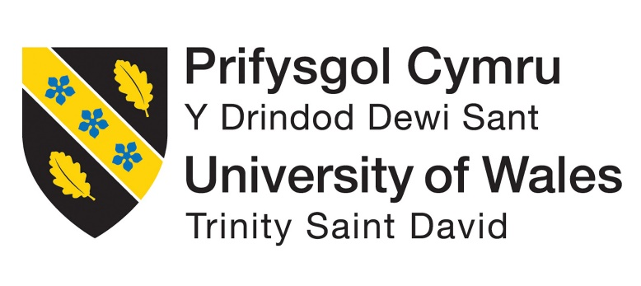
LCMB7024 Marketing Management
Assessment 2: Portfolio: Brand Extension
Programme: Master of Business Administration
Module: Marketing Management
Module code: LCMB7024
Lecturer: Haoran Liu
Assignment Title: Assessment 2: Portfolio: Brand Extension
Student Name: MD JUWEL
Student ID: 2426380
Word Count: 2461
Submission Deadline: 28th April 2025 14:00 (2 pm)

Table of Contents
Introduction 3
Brand Extension 5
Description of the Proposed Brand Extension 5
Alignment with Brand Values and Market Position 5
Value Addition and Market Opportunity 6
Segmentation, Targeting, and Positioning (STP) for Rolls-Royce SIA 6
Market Segmentation 6
Targeting Strategy 7
Positioning 7
Customer Personal Profile 8
Demographic Profile 8
Psychographic Profile 9
Marketing Mix Strategy – 7Ps 9
Product 9
Price 9
Promotion 10
Place 10
Process 10
People 11
Physical Evidence 11
Conclusion 12
Reference List 13

Introduction
Rolls-Royce is an advanced engineering and power systems company, supplying the world’s most prestigious engines and integrated power systems and service solutions. (For Trent jet engines, civil aerospace and defence, in nav and air propulsion, and power systems (diesel engines, hybrid-electric solutions for marine and energy sectors)) It is the company’s core product offering (Aaker, and Moorman, 2023). Rolls-Royce is well known as a company with the long-standing traditions of innovation, precision engineering and technical excellence in more than 50 countries worldwide.
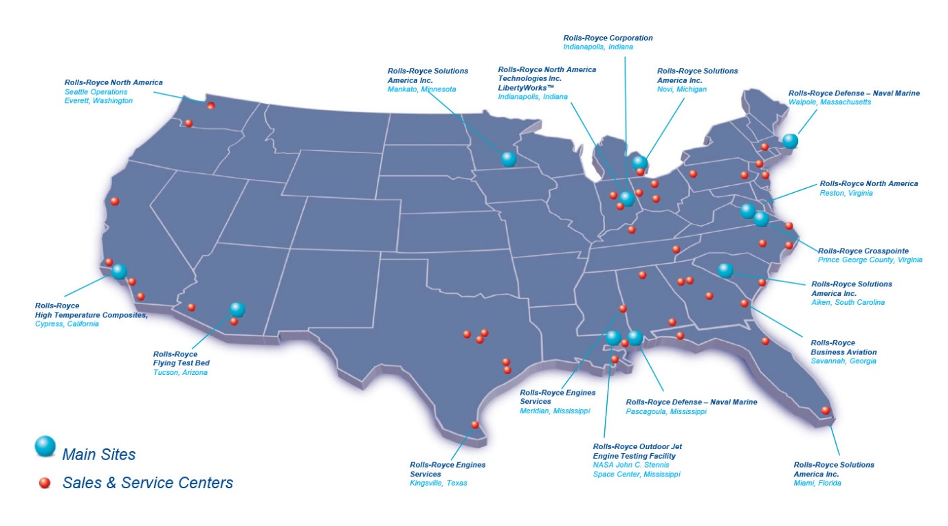
Figure 1: Global Presence of Rolls-Royce.
Apart from its engineering expertise, it is also considered a reliable partner for some of the most demanding global industries because it builds the brand identity of Rolls-Royce around the values of quality, reliability, and forward-looking innovation. In recent years, the company has embarked on a strategic transformation whereby digital innovation and sustainable technologies are integrated into its operations to reach its goal of becoming a net-zero company by 2050 (Kotabe, and Helsen, 2022).
The report follows this progression in line and offers a new brand extension in the digital world — Smart Infrastructure Analytics (SIA). This AI platform intends to help the smart cities meet their growing requirements, predicting maintenance, real-time data analytics and energy optimisation on all fronts. These subsequent sections about this brand extension strategy, target market and profile of the customers, will lay out the ground for a successful launch of the brand (Alsem, 2023).

Brand Extension
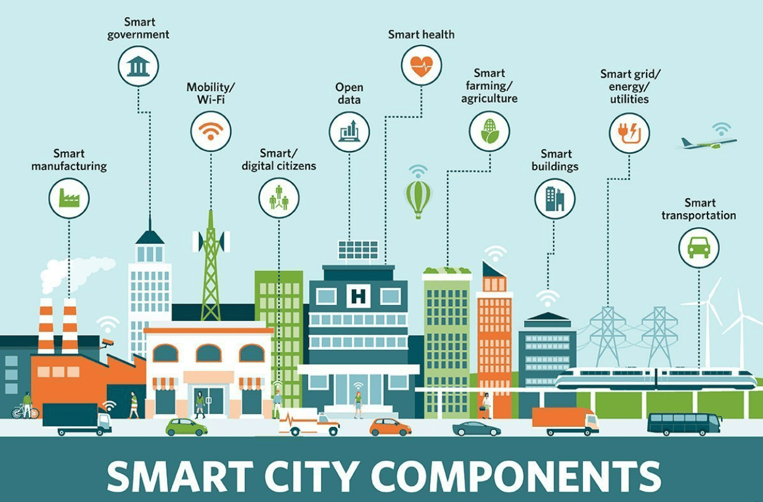
Figure 2: Smart City Components (Infrastructure) (Shrimal, 2024).

Description of the Proposed Brand Extension
Rolls-Royce Smart Infrastructure Analytics (SIA) is a brand extension which can be carried out through an innovative digital platform to augment the functionality and extend the lifetime of complex urban infrastructure systems. The city planners, utility managers, and infrastructure operators receive real-time data of what is happening in the assets, i.e. the power grids, the transport hubs, and the public utilities through artificial intelligence, predictive analytics and a digital twin simulation (Kinicki, and Williams, 2020). SIA allows users to foresee faults, help optimise energy consumption, perform data empowered maintenance planning and thus increase efficiency, reliability and long-term sustainability.

Alignment with Brand Values and Market Position
All this is very well known of Rolls-Royce's engineering precision, technological leadership and sustainable innovation. SIA shines the light on the company’s existing capacities in smart technologies, like in aerospace, Intelligent Engine, as well as digital twin technologies used in the power systems (Czinkota et al., 2021). Additionally, the platform works to support Rolls-Royce’s strategic commitment to net-zero emissions by 2050. It is strengthening its position in the market by expanding into the smart infrastructure sector as an enabler of powerful, future-focused solutions while staying on its promise of innovation with purpose.

Value Addition and Market Opportunity
By addressing a growing demand in the global infrastructure market, where many cities still depend on outdated systems which can’t meet the needs of modern urbanisation and climate goals, SIA is highly positioned to fill this niche. Energy inefficiencies, unplanned outages, and a lack of real-time monitoring are the current challenges (Dibb, et al., 2019). In this gap, the SIA platform is filling because it acts as an integrated solution by enabling stakeholders to make sustainable and economically sound decisions.
Branding is extended in this brand extension, and adds quite a lot of value because it allows the already established brand to move into a new, high-growth market (Dianlin and Ruokai, 2025). It is creative of the company to differentiate itself from traditional infrastructure providers and to position itself in line with the trends of the smart city development, digital transformation and environmental stewardship. SIA thus offers an important strategic move that diversifies Rolls-Royce’s portfolio while fitting within the digital world.

Segmentation, Targeting, and Positioning (STP) for Rolls-Royce SIA

Market Segmentation
To fully introduce the concept of Smart Infrastructure Analytics (SIA), it is necessary to structure a market segmentation approach. A mix of demographic, geographic, psychographic and behavioural criteria is used to draw up this segmentation.
Demographic, Geographic, Psychographic and Behavioural Segmentation
Demographic Segmentation:
Its primary market is B2B clients, mostly government agencies, infrastructure development companies and utility service providers. Most of these entities were in charge of managing large-scale infrastructure systems and are looking for ways to enhance efficiency and sustainability (Ennew, Waite and Waite, 2024). They also have access to the required financial resources as well as decision-making structures that can come up with innovative technologies.
Geographic Segmentation:
The device has been designed for the application in the urban centres of these regions that are developed and at the same time fast developing, the Europe, Gulf countries, and Southeast Asia. Progress of these regions is growing, as populations grow, urbanisation happens, and governments are committing to climate targets, thus venturing into investing heavily in smart city initiatives (Minutes, 2015).
Psychographic Segmentation:
The mindset of the target organisations is the same, as they are progressive, innovation-oriented, and sustainability committed (Pepels, 2021). Most of these institutions are beyond cost efficiency and are looking into long-term environmental impact and digital transformation.
Behavioural Segmentation:
In this, it is the early adopters of smart city technology, Iot Enabling infrastructure, predictive maintenance tabs as the focus. If the experimental or leading-edge technologies implemented offer operational or environmental existence benefits in a measurable form, these stakeholders may be better receptive to accepting or adopting those technologies (Ray and Yin, 2019).
Table 1: Demographic, Geographic, Psychographic and Behavioural Segmentation (Self-Made)

Targeting Strategy
Considering how many potential customers there are, little and how much potential there is for marketing, Rolls-Royce will decide to have a concentrated marketing strategy. The term smart city relates to city councils, urban development authorities, transport regulators and private consortia that form smart city projects. For the most part, these entities are looking to make strategic partnerships, as well as digital platforms, to help with data-driven infrastructure planning (Griffin, 2022). This leads the brand to focus on a finely tuned segment it can offer tailored value propositions to, which in turn it can support, as well as develop long-term strategic relationships.
Given that it is a B2B product too, targeted communication via industry-specific channels such as infrastructure forums, government procurement platforms, and international smart city expos will be helpful for the same (Camilleri, and Camilleri, 2018).

Positioning
As a premium, intelligent and trusted analytics platform, Rolls-Royce SIA will enable cities and operators of infrastructure to safely reach into the future and become smart, sustainable operations. The positioning statement is:
“Using intelligence to predict and enable the smarter cities.”
This statement, to a certain extent, tracks how the brand has always been rooted in engineering excellence, but also clearly points to the platform’s ability to enable transformation based on data-led insights. SIA, however, focuses on ‘predictive intelligence’ as opposed to conventional monitoring tools, giving it a proactive and strategic value instead of a reactive one (Khandelwal, Jakhar, and Khandelwal, 2020).
This positioning positions Rolls-Royce to target the stakeholder who is seeking strong, future-proof infrastructure solutions based on engineering integrity, technological innovation and sustainability leadership.

Customer Personal Profile
The target audience for Rolls-Royce Smart Infrastructure Analytics (SIA) is a smart city project director or a sustainability officer, working in a public sector organisation or a private infrastructure consultancy, which continuously aims to maintain or improve urban development and planning (Hossain, Akter, and Muzareba, 2024).

Demographic Profile

Diagram 1: Customer’s Demographic Profile (Self-Made)
The age of this customer persona is usually between 38 and 55 years of age, with gender inclusive representation of the role as it applies to both a male and female professional. This general category includes Directors of urban innovation, heads of infrastructure planning or CxOs (chief sustainability officers). Salary is usually between £80,000 and £150,000 a year, and is earned by the individual in the geographic area in which the institution is located, as well as the individual institution's size (Berndt, Altobelli, and Sander, 2023). With a postgraduate qualification such as a Master’s in Urban Planning, Engineering, Sustainability Management, or Public Policy, in addition to more than a decade of experience working in infrastructure strategy and development, they hold.

Psychographic Profile
Here, they have a persona with core values aligned with innovation, environmental stewardship, efficiency, and accountability. They have a progressive attitude towards technology, being an adopter of digital tools that support in the medium and long term, of resilience and performance enhancement (Ray, and Yin, 2019). This professional's lifestyle is generally fast-paced, intellectual and aims at attending policy forums, industry expos and strategic workshops.
To put it in purely buying behaviour terms, they are cautious with a little bit of a forward look. It is a decision based on evidence, evidence-based decisions with much preference for backed data and platforms with data, predictive tools, and success stories based on peer review. Frequently, they benchmark themselves against global smart city initiatives and search for partners as part of their mission to increase their organisation’s reputation as a place for innovation and infrastructural sustainability impact (Rachmawati, and Afifi, 2022). They aspire to be at the forefront of building transformational change in urban development with intelligent infrastructure solutions.

Marketing Mix Strategy – 7Ps
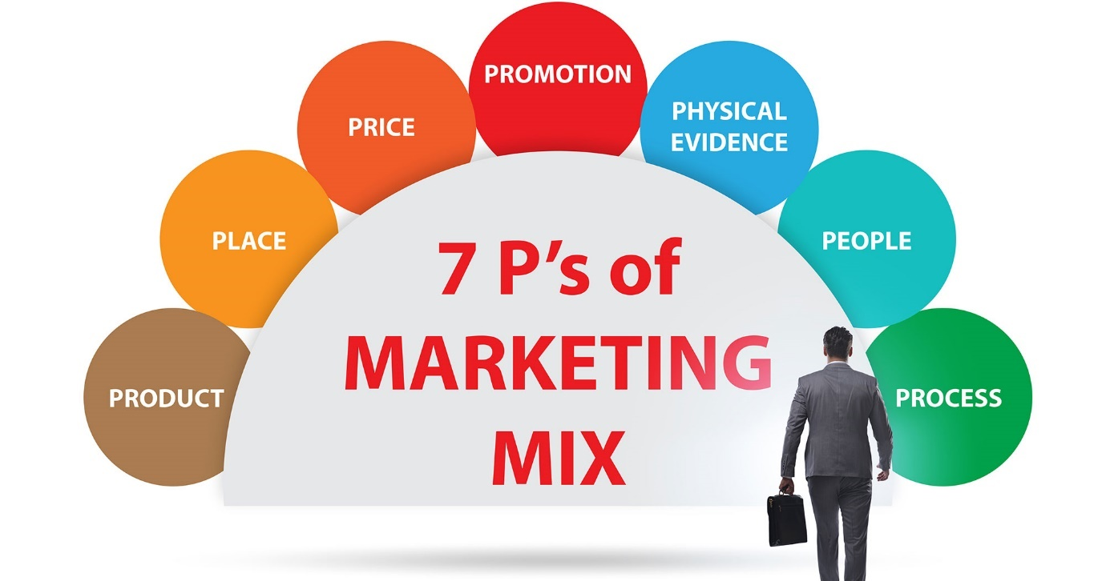
Figure 2: 7Ps of Marketing Mix (Kusdiana, and Yulita, 2024).

Product
Our cloud-based digital platform for cities and infrastructure, and a collaborating risk engineer, would be referred to as Rolls-Royce Smart Infrastructure Analytics (SIA). Predictive maintenance, optimising energy, measuring real-time data, making automatic updates, and using artificial intelligence (AI), machine learning, and digital twins are all feats that the platform uses. Included in the list of key product features are customisable dashboards, live data visualisation, automated alerts to detect anomalies, as well as integrated simulations for long-term planning (Cao, 2024). Their features allow clients to take action on the information, even to improve operational resilience and reduce environmental impact. The SIA is designed to be modular to other infrastructure systems such as power grids, public transport, water utilities, etc.

Price
As the high value of the solution aligns with the brand positioning for Rolls-Royce, SIA will be priced on a premium subscription basis. It will also be scalable according to the size and the complexity of the infrastructure that will be managed with pricing tiers. Custom packages, based on the number of users, activated modules and level of support that is required, will be offered to municipalities and big corporations (Aaker, and Moorman, 2023). This model allows for setting forth predictable costs in terms of clients while having flexibility in terms of budget sizes and infrastructure needs. There will be additional customisation or consultancy services priced separately on an individual project basis.

Promotion
The target marketing is through the professional and government channels, hence it will be a B2B promotional strategy. Participation in Smart City Expo, urban planning conference and infrastructure technology exhibition will be some of the key promotional activities (Park, 2020). SIA’s performance as well as sustainability benefits will be highlighted through digital case studies, white papers, plus thought leadership articles published by Rolls-Royce. Platforms such as LinkedIn are going to be used to run digital marketing campaigns to industry professionals, policymakers, and technology consultants. Awareness and credibility will be further sparked by co-branded webinars with strategic partners and demonstration of a pilot programme (Andrews, and Shimp, 2018).

Place
SIA will be distributed directly and via strategic partnerships. Rolls will use its consultants to reach out, demonstrate products, and begin to negotiate. There will be sales managed regionally, akin to the company’s global footprint and adapting to local market dynamics. Onboarding, training and ongoing delivery of service will be facilitated online with an online client portal (Grewal, and Levy, 2022). Having market-ready solutions that can easily partner with existing infrastructure providers, as well as government agencies, will greatly increase its market penetration and integrate within larger smart city projects.

Process
This will be essential to have a perfectly seamless and structured implementation process, which will bring client satisfaction. Open APIS will be used to integrate the SIA platform and make it compatible with existing urban systems. First, it is a needs assessment and the customary deployment comprises onboarding workshops, technical exchanges, and a prepared dashboard. Technical 24/7 support, periodic software updates and health checks will be made available to clients (Wichmann, et al., 2022). It allows for long-term optimisation of the platform and the user interaction in the lifecycle of the service.

People
To support SIA’s development, delivery and after-sales service, Rolls-Royce will deploy a team of highly trained professionals. The role of data scientists, software engineers and smart infrastructure consultants is to bring data scientists and systems integration expertise around predictive analytics (Morgan, et al., 2019). These professionals will interact with clients directly to set up the platform, using analytics outputs to determine what constitutes operational value and how it may be maximised. There will be a dedicated client success manager as the main point of contact.

Physical Evidence
The physical evidence to build confidence in the platform will come from live demonstration, interactive dashboards and simulation models. Additionally, proof of value will be presented in the form of performance reports from pilot projects and case studies, which present measurable outcomes (Gu, 2020). As already described, the Rolls-Royce brand itself globally has recognised quality, innovation, and all the trust that its product represents.

Conclusion
Rolls-Royce have the opportunity to strategically align and create a forward-looking brand extension in the form of the proposed Smart Infrastructure Analytics (SIA) platform. It leverages the company’s existing strengths in engineering and digital innovation by offering intelligent infrastructure solutions catering to the developing global market’s demand (Doole, Lowe, and Kenyon, 2019). Using such technology as artificial intelligence, machine learning, digital twins, and power deuces, SIA helps cities and power utility operators become more operationally efficient, resilient, and environmentally stewarded.
The extension of Rolls-Royce helps fill the brand within the fast-developing smart city ecosystem, and complements the current digital transformation and sustainability agenda of the brand. By targeting customers, the platform focuses on high-potential B2B customers like city councils, infrastructure planners and utility service providers through a concentrated marketing strategy (Deepak, and Jeyakumar, 2019). The 7Ps marketing strategy provides a complete perspective on market entry; it offsets private service delivery to the point of being scaled down.
One recommended best start to ensure successful implementation is to roll out in a phased manner by starting with pilot projects in some cities already having smart infrastructure initiatives. It also offers the provision for performance validation, local customisation or case study development. If risk mitigation is needed, responsible data security strategies, checks of regulation compliance and contingency planning for the integration challenges should constitute the risk mitigation strategies (Hunt, Mello, and Deitz, 2021). There are future enhancements that could be brought by integrating with evolving areas of technologies like 5G, blockchain, or edge computing to make the platform more adaptable and long-term valuable.

Reference List
Aaker, D.A. and Moorman, C., (2023) Strategic market management. John Wiley & Sons.
Aaker, D.A. and Moorman, C., (2023) Strategic market management. John Wiley & Sons.
Berndt, R., Altobelli, C.F. and Sander, M. (2023) International Marketing Management. Springer Nature.
Cao, Y., (2024) Analysis of Li Auto's Marketing Strategy Based on Marketing Mix Theory. Advances in Economics, Management and Political Sciences, 83, pp.8-14. https://doi.org/10.54254/2754-1169/83/20240709
Deepak, R.K.A. and Jeyakumar, S., (2019) Marketing management. Educreation Publishing.
Dibb, S., Simkin, L., Pride, W.M. and Ferrell, O.C., (2019) Marketing: Concepts and strategies. Cengage Learning EMEA.
Doole, I., Lowe, R. and Kenyon, A., (2019) International marketing strategy: analysis, development and implementation. Cengage Learning.
Griffin, R.W., (2022) Fundamentals of management. Cengage Learning, Inc..
Kinicki, A. and Williams, B.K., (2020) Management: A practical introduction. McGraw-Hill.
Kotabe, M.M. and Helsen, K., (2022) Global marketing management. John Wiley & Sons.
Morgan, N.A., Whitler, K.A., Feng, H. and Chari, S., (2019) Research in marketing strategy. Journal of the Academy of Marketing Science, 47, pp.4-29. https://doi.org/10.1007/s11747-018-0598-1
Park, S., (2020). Marketing management (Vol. 3). Seohee Academy.
Ray, S. and Yin, S. (2019) Channel strategies and marketing mix in a connected world. Springer Nature.
Wichmann, J.R., Uppal, A., Sharma, A. and Dekimpe, M.G., (2022) A global perspective on the marketing mix across time and space. International Journal of Research in Marketing, 39(2), pp.502-521. https://doi.org/10.1016/j.ijresmar.2021.09.001

