
Assessment 1 – E-Portfolio
BSc in Health & Social Care


Student name | Viktoria Koleva
Student ID | 2028456
Module tittle | Changemakers – Creativity and Value Creation
Module code | BMHP 5014
Lecturer name | Dr Azora Hurd
Assignment tittle | Assessment 1 – E-Portfolio



Table of contents

Introduction 2
Artefact 1 – A Flyer/leaflet 3
Idea, approach, and design for the flyer 3
An Elevated Pitch 5
Reference list 7

Introduction

In this E-Portfolio, I am going to present two artifacts – a flyer and an elevator-style pitch.The goal of my project is to create a fresh concept to highlight the advantages of swimming classes for autistic children and to explain why it is so crucial for them and why every child should have the chance to learn to swim. With the use of swimming classes, this new project plan will clarify how to encourage the growth of body knowledge, imitation, joint attention abilities, and more effective social communication.

Artefact 1 – A Flyer/leaflet

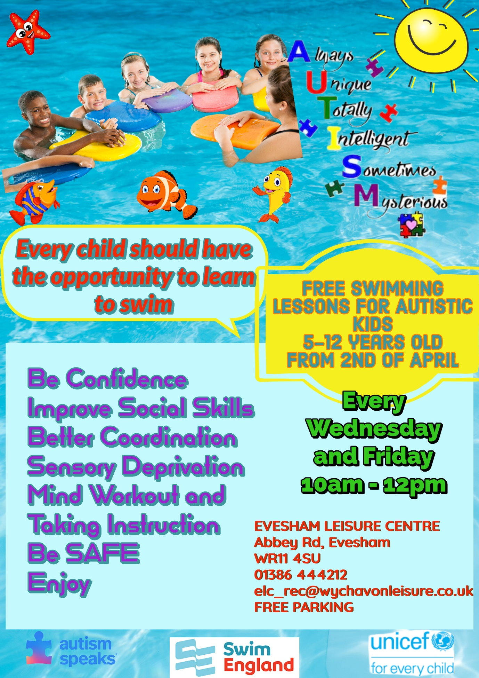

Idea, approach, and design for the flyer

In 1943, Autism was first recognized. Typically began to show up in the first two years of life. 4 times more boys are affected than girls. across all racial and social groupings, observed. Children with autism appear normal on the outside. Neurodevelopmental disorders include autism. It leads to less social contact, impediments to verbal and nonverbal communication, and repetitive behaviour. The ability to communicate, form relationships, and one's attitude toward others are all impacted by the developmental disease known as autism. Autism is characterised by the inability to communicate effectively, which is seen in both children and adults. Their capacity to establish friendships and comprehend the emotions of others has been damaged. At his-lama, part of them is also seen lack of fear of real dangers, increased or decreased sensitivity, unexpected bursts of crying, intolerance to feasting, and eating and sleeping issues.
My flyer's goal is to offer free swimming lessons to kids with autism between 5-12 years old. The purpose of this program is to educate parents of autistic children about the advantages and raise their level of awareness. The issue of which sports are appropriate for a child with this condition is one that many parents must consider. Sports are not a trend among parents or a way to downplay one's condition. On the one hand, research has shown that autistic children are more likely to have metabolic and obesity-related disorders. On the other hand, if the right sport is chosen for the child's condition, it can enhance social integration in autistic children. Swimming lessons can increase a child's joy, confidence, and coordination while simultaneously lowering the danger of unintentional drowning in autistic children.
The flyer provides details on the start date of the swimming lessons (April 2), the days they will be held (every Wednesday and Friday), the start time (10 am), and the finish time (12 pm). Additionally, it provides the address, contact details (including phone and email), and free parking information along with the location of the swimming classes (Evesham Leisure Centre). World Autism Awareness Day is celebrated on April 2. The purpose of my decision to feature in that initiative on that day was to increase public awareness of the issues facing kids who have developmental abnormalities.
The colours I used to make the flyer are very colourful and sunny because no matter how incredible it may seem to you, with the right colors you can influence the child's mood, health, and skills. The predominant blue colour symbolizes a sense of calm for the autists and acceptance in a world that can sometimes be very noisy and challenging. And as well as the most iconic and recognizable symbol of autism - the puzzle. The other important part of the flyer is the organization sponsors of this new initiative:
- Autism Speaks - The largest autism-related research organisation is Autism Speaks, a foundation that advocates for people with autism.
- Swim England - The only recognised national governing organisation for swimming in England is Swim England.
- UNICEF for every child - The United Nations Children's Fund, or UNICEF, aims to create a better future for all children, everywhere, every day.

An Elevated Pitch

Good morning and Welcome to the initiative of my fresh concept of providing free swimming lessons for autistic youngsters at the Evesham Leisure Centre, everyone. It is a delight for me and the sponsors to see so many parents interested in the new program who want to learn more about the advantages of swimming for Autistic children and the reasons why every kid should have the chance to learn to swim. The goal of this workshop is to enlighten and increase knowledge of why swimming is a good activity for most individuals, including kids with autism. Kids who struggle with ball control can succeed with simple strokes and standard water play. Furthermore, because swimming is an individual activity, strong swimmers with autism can succeed on swim teams. Children with autism find solace in swimming's repeated motions. Additionally, it exercises every region of the body, strengthening muscles. Children might find friends and a fulfilling activity via team sports or group swimming classes. The most crucial aspect is that kids will leave swimming classes pleased with what they learned. Swimming has several advantages, one of which is its capacity to reduce stress. Water provides resistance, pressure, cosy temperatures, and pleasant sensory stimulation for kids with autism. Although it is intense, it is the good sort of stimulating. Additionally, because class numbers are small, there is typically less social pressure in the water, and it's simple to ignore your surroundings while you're preoccupied with keeping afloat.
It's no secret that kids on the autism spectrum sometimes struggle to communicate and frequently have trouble following directions. In a classroom setting, it might be difficult to learn arithmetic by verbal explanation alone and then go on to another subject before you fully understand the first. Swimming or sports, in general, may be quite helpful for teaching kids how to accept directions efficiently without the pressures encountered in a more formal atmosphere. Beyond the survival advantages, you would immediately consider, teaching your child to swim has many other advantages. Your kid will benefit from the mental and physical stimulation that swimming offers while also learning important life skills like following directions, taking turns, repetition, and breathing techniques.
All swimming sessions will be funding by the organization sponsors of this new initiative: Autism Speak, Swim England, UNICEF, and Evesham Leisure Centre. We appreciate your warmth, support, and extended hand. Thank you.
I sincerely want to thank everyone present at my presentation, thank you for your time and attention, and that we were able to talk about autism as a difference and not as a deficit. For the fact that Autism is a way to understand true patience towards others and to be able to have the strength to change socially accepted laws, it cannot be done because this child is autistic. If you get in touch with me with any suggestions on how to make things better yet for the unique kids, I'll be pleased to hear from you.
Thank you.

Reference list

2022. [online] Available at: <https://www.sheffieldchildrens.nhs.uk/services/child-development-and-neurodisability/autism-home/> [Accessed 13 July 2022].
Bremer, E., Crozier, M., & Lloyd, M. (2016). A systematic review of the behavioural outcomes following exercise interventions for children and youth with autism spectrum disorder. Autism, 20(8), 899–915. https://doi.org/10.1177/1362361315616002
Changemakers: Creativity and Value Creation, 2022. E-Learning, Unit 3, Topic3, Session 3
Ellis, K., Casey, A., O’Dwyer, W., & Vaughan, K. (2020). An evaluation of a community based swim programme for autistic children. Good Autism Practice (GAP), 21(1), 25–32.
Hubená, K. (2021). Diagnostics of Swimming Skills in Preparatory Swimming Teaching of Children with Autistic Spectrum Disorder. Acta Facultatis Educationis Fisicae Universitatis Comenianae, 61(1), 86–96. https://doi.org/10.2478/afepuc-2021-0008
Koegel, R. L., Rincover, A., & Egel, A. L. (1982). Educating and understanding autistic children. San Diego, Calif: College-Hill Press.
Moor, J. (2008). Playing, laughing and learning with children on the autism spectrum : a practical resource of play ideas for parents and carers (2nd ed.). London: Jessica Kingsley.
Roscigno, R., 2022. Your Autistic child can have a great life. Here's how.. [online] Ted.co.Availableat:<https://www.ted.com/talks/robin_roscigno_your_autistic_child_can_have_a_great_life_here_s_how> [Accessed 12 July 2022].
Yilmaz, I., Yanardağ, M., Birkan, B., & Bumin, G. (2004). Effects of swimming training on physical fitness and water orientation in autism. Pediatrics International, 46(5), 624–626. https://doi.org/10.1111/j.1442-200x.2004.01938.x

