9 Ensuring integrity

Task 1
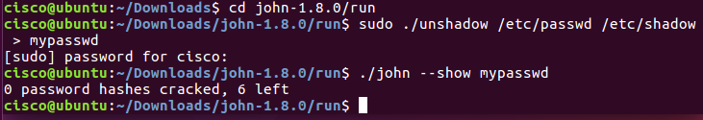
Why are there no cracked passwords?
No attempts have been made
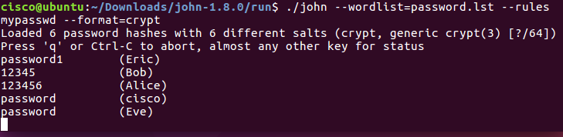
There are cracked passwords, list them
- Password1
- 12345
- 123456
- Password
- Password

Task 2
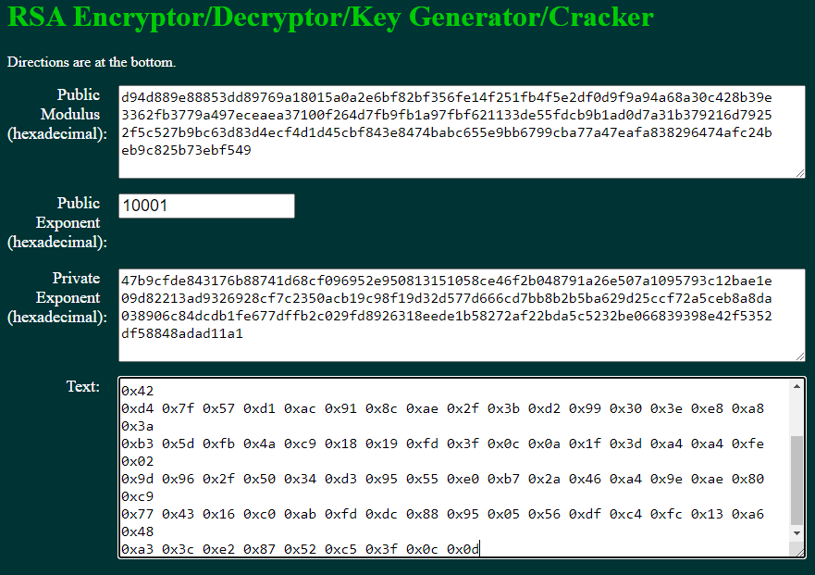
Verify
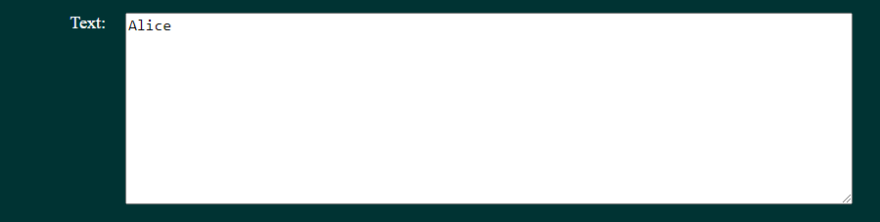
Response signature
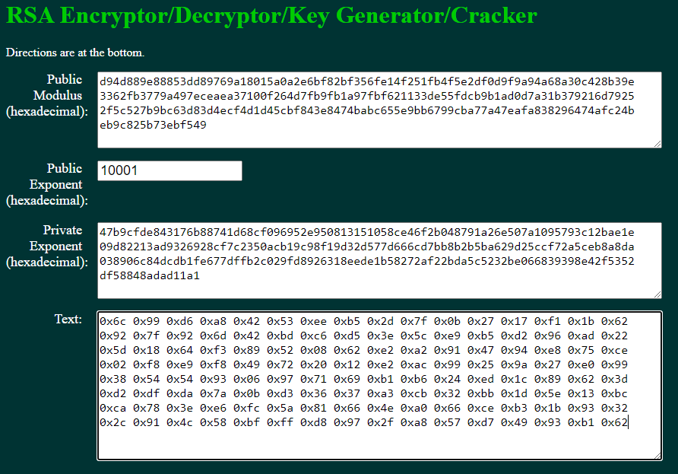
Verify
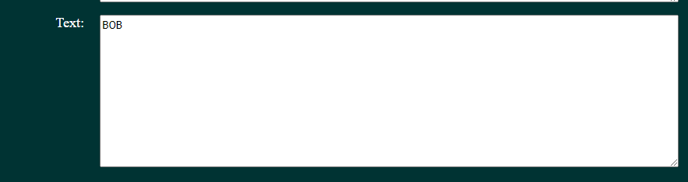

Next signature
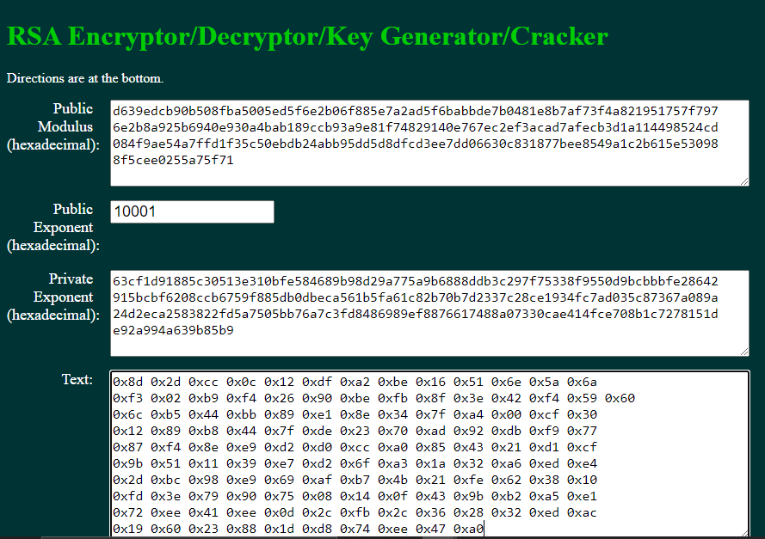
Verify
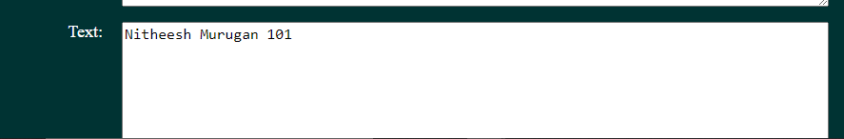

Make your own
Public key | bd91d30411c4048358f094867ce6d76963dcfa95896004f59eb240e25eaf6605e5a024ce590a6707  58630d7dfdccdf4bba8c7601a98a682a6b6562f518234a6d49ac23823e6b1dd67809bd6ba54b8d8f  abf6c110570f61e17d24515cd0c9244cbe0fbf1f9287d1d775cf932a0c80a8eb0ac8e6d702ab914e  c2a99264c7e2b0d9
Private key | 1bfffdfb0be4b805ee8d1a6302efd5c16b4ea8748de5f0d596ab1d8a5211f62fc8caeea4cbe20d75  b8486925c2e70fd44fa98f848f56322c91d057dd7bc33aaac8a5c2598ded4e2a56828b5a60ee5f11  e7b2dac88a5d51c2bb184c1f20a2ddd6c27d457d20dcc8c2dde65b4430d9678a8c05a913e77d53ba  b64048f5ed560d01
Personal digital signature | 0x5c 0xc8 0xd2 0x7e 0x07 0xea 0x9f 0xea 0x4d 0x22 0xc0 0x73 0x21 0x7d 0x1e 0x1d 0x25 0x1d 0x78 0xdb 0x03 0xa3 0x7e 0xaf 0x0e 0x99 0x24 0xdb 0x51 0x9b 0x5b 0xf6 0x80 0x62 0x34 0xf1 0xa9 0x8c 0x58 0x9e 0xc1 0x28 0xf0 0x84 0xde 0xdd 0xbc 0x1b 0xfc 0x74 0x8c 0xab 0x38 0xd3 0x55 0x17 0xae 0x1e 0xb6 0x9d 0xfa 0x21 0x91 0x89 0xeb 0x5c 0xff 0x15 0x46 0xe3 0xf9 0x83 0xcb 0x4a 0xc6 0xac 0xc5 0x7d 0x4f 0x6a 0x8b 0xa4 0x12 0x7c 0xbb 0xc7 0x8b 0x8c 0x39 0x5f 0x4e 0x24 0x1f 0x2f 0xb7 0xe3 0xeb 0xee 0x32 0x04 0x30 0x3c 0xa5 0x5b 0x76 0xa3 0x5c 0x78 0x5f 0x0d 0xd5 0x29 0xd5 0x09 0x24 0x23 0x2d 0x9e 0xc0 0xdd 0xb6 0x10 0x06 0x8e 0xa8 0x43 0x38 0x98
Personal digital signature  2 | 0x64 0x7e 0xec 0x81 0x0c 0xa6 0x39 0x05 0x3c 0x11 0xa5 0x05 0x75 0x48 0x77 0x14 0x24 0x35 0x16 0x5e 0x1c 0x14 0x8e 0xbd 0xd7 0xee 0xbd 0x21 0xb4 0xf8 0xad 0x5c 0x94 0x27 0x32 0xc7 0xee 0xc9 0xa5 0x04 0xc3 0xbb 0x4b 0x91 0x1c 0xe5 0x41 0x5c 0xc4 0x8a 0x68 0xea 0xc9 0xb6 0x8c 0xf2 0xcc 0xd7 0xd1 0xde 0xb0 0xea 0x2e 0x38 0x68 0xab 0x08 0xc9 0x1b 0x63 0xc2 0xe3 0x54 0xe8 0xb6 0xf0 0x8a 0x7d 0xa0 0x4f 0x50 0xba 0xef 0xd1 0xd8 0x36 0x0a 0x8d 0x64 0xf4 0x04 0x2b 0x80 0xe5 0x2d 0x82 0x44 0x63 0xe0 0x25 0xfa 0x41 0x86 0x72 0x4b 0xc9 0x20 0xfc 0x9f 0xe0 0xea 0x47 0x29 0x53 0x2b 0x6b 0xb7 0xb4 0xe1 0x5e 0x49 0x73 0x47 0x63 0xc7 0x3d 0x3d 0xea

Lab partner signature
What shows up in the text box?
Robert Jamieson

