Residential Care Homes in the UK

Explaining the Service, Its Function and Current Challenges

What Is a Residential Care Home?
A residential care home is a service that provides accommodation and 24-hour personal care for individuals who are unable to live independently in their own homes. It supports people with activities of daily living such as washing, dressing, toileting, eating, mobility, and medication assistance.
Unlike nursing homes, residential care homes do not usually provide on-site registered nursing care. However, residents can receive healthcare support from external professionals such as GPs, district nurses, occupational therapists, and social workers.
The purpose of residential care is to promote dignity, independence, safety, and wellbeing in a supportive and structured environment. The service follows a person-centred approach, meaning care is tailored to each individual’s needs, preferences, and background.

Recent History of Residential Care Homes (Last 10 Years)
In the last 10 years, residential care homes have focused on improving safety and quality of care. In Wales, the Regulation and Inspection of Social Care (Wales) Act 2016 strengthened inspection and accountability.
The COVID-19 pandemic also led to stricter infection control, visiting rules, and better safeguarding measures.
Overall, care homes now place more emphasis on person-centred care, dignity, and residents’ wellbeing.

Who Uses the Service?
Residential care homes are mainly used by:
- Older adults who can no longer live safely at home
- Individuals with physical disabilities
- People living with mild to moderate dementia
- Adults who are socially isolated or vulnerable
- Individuals recovering from illness or hospital discharge
Many residents have multiple or complex needs, including reduced mobility, sensory impairments, long-term health conditions, or cognitive decline. The service supports individuals whose needs cannot be safely met through domiciliary care alone.

Who Provides the Service?
Residential care homes are staffed by trained professionals, including:
- Care assistants and support workers who provide personal care
- Senior carers who supervise shifts and oversee care delivery
- Registered managers who ensure legal compliance and quality standards
- Activity coordinators who promote social engagement
- Catering and domestic staff
Homes are regulated and inspected in England by the Care Quality Commission (CQC) to ensure safety, effectiveness, and quality of care.

Function of the Service
Residential care homes provide several key functions within the UK health and social care system:

Personal Care
Assistance with washing, dressing, toileting, grooming, and mobility.

Medication Support
Administration and monitoring of prescribed medication safely.

Nutrition and Hydration
Provision of balanced meals, specialist diets, and monitoring food intake.

Social and Emotional Support
Organising activities such as games, exercise sessions, celebrations, and outings to reduce loneliness and promote wellbeing.

Safeguarding and Monitoring
Observing residents for changes in health or behaviour and protecting them from abuse or neglect.

Care Planning
Developing personalised care plans that are reviewed regularly.
Residential care homes also reduce pressure on hospitals by preventing unnecessary admissions and supporting safe discharge.

Challenge 1: Workforce Shortages and Staff Retention

What Is the Issues

One of the most significant challenges facing residential care homes in the UK is a shortage of staff. Recruitment and retention problems have worsened in the last decade and increased significantly after the COVID-19 pandemic.
According to Skills for Care (2023), there were approximately 165,000 vacancies in adult social care in England in 2022–2023. Staff turnover rates were around 30%, meaning nearly one in three workers leave their job each year.
The House of Commons Library (2022) reports that low pay, limited career progression, high stress, and demanding workloads are key reasons for the crisis.

Why Is This a Problem?
Impact on Staff:
- Increased workload and longer shifts
- Higher stress and burnout
- Reduced morale and job satisfaction
- Increased sickness absence
Impact on Service Users:
- Less one-to-one time with carers
- Reduced emotional support
- Delays in care
- Increased risk of accidents or neglect
- Fewer organised activities
When staffing levels are low, care becomes task-focused rather than person-centred. This can reduce quality of life and overall wellbeing for residents.

Challenge 2: Funding Pressures and Rising Costs

What Is the Issue?
Residential care homes are experiencing significant financial pressure. Rising energy costs, food prices, staff wages, and inflation have increased operating expenses. At the same time, funding from local authorities has not kept pace with rising demand.
The Health Foundation and King’s Fund (2021) describe adult social care as “chronically underfunded,” with increasing pressure due to an ageing population.
The Care Quality Commission (2023) reported that many care providers are struggling financially, and some homes are at risk of closure due to rising costs and insufficient funding.

Why Is This a Problem?
Impact on Staff:
- Limited pay increases
- Reduced training opportunities
- Staff shortages worsen due to inability to offer competitive wages
Impact on Service Users:
- Higher care fees for families
- Reduced availability of placements
- Risk of home closures causing relocation stress
- Reduced investment in facilities and activities
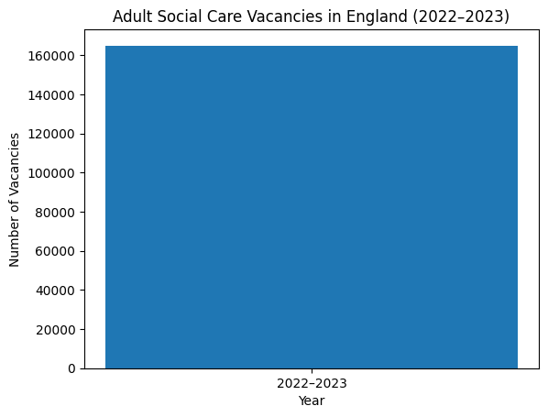
Financial instability threatens the long-term sustainability of residential care services. If homes close, vulnerable individuals may face disruption, distress, and limited alternatives.

Why These Challenges Matter
Both workforce shortages and funding pressures directly affect the quality, safety, and sustainability of residential care homes.
If staffing remains insufficient and funding gaps continue:
- Quality of care may decline
- Staff burnout may increase
- Residents may experience reduced wellbeing
- More homes may close
- Pressure on hospitals and families may increase
Addressing these challenges requires improved funding, better workforce planning, higher wages, and long-term reform of the social care system.

Conclusion
Residential care homes play a vital role in supporting vulnerable individuals who cannot live independently. They provide 24-hour personal care, emotional support, safeguarding, and structured routines that promote dignity and quality of life.
However, the service faces serious real-world challenges in the UK, particularly workforce shortages and funding pressures. These issues impact both staff and residents and threaten the sustainability of the sector.
Improving recruitment, retention, and financial investment is essential to ensure residential care homes can continue to provide safe, effective, and person-centred care in the future.

REFERENCES
Care Quality Commission (2023) The State of Health and Social Care in England.
Skills for Care (2023) The State of the Adult Social Care Sector and Workforce.
House of Commons Library (2022) Adult Social Care Workforce.
The Health Foundation & The King’s Fund (2021) Social Care Funding Pressures.


