Name:Florin Ciobu
Student Number:1913409
Module Lecturer:Nadeem Mirza

Global Business Environment
TABLE OF CONTENTS

Introduction 1
Assignment 2
Critically analyze the changes that the company have made in the last few months in light of the COVID 19 Pandemic. 2
Explain the extent to which you think these changes are sustainable. If you feel they are not sustainable, would you recommend any other changes? 5
Conclusion 9
References 10

LIST OF FIGURES
Figure 1: Almost empty BA flight 3
Figure 2: Covid-19 measures 4
Figure 3: Aircraft cleaning post Covid-19 5
Figure 4: BA volunteers 6
Figure 5: BA Boeing 747 Retirement 7
Figure 6: Porter's Five Force Analysis 7

Introduction
The global business environment is described as an environment in different countries, with relative factors in the home country of the organization (Popescu,2013). The report is prepared on the impact of the Corona Virus pandemic over British Airways. The airline operates flight services in domestics and international routes. The report will provide information about the condition of the airline since the virus outbreak, and measure taken by the management to change the business policies and operations in such crisis to overcome the losses and challenges with the help of PESTLE analysis. It will also provide knowledge regarding the extent the new strategies were useful and recommended measures to achieve business sustainability with the application of Porter's Five Force Model.

Assignment

Critically analyze the changes that the company have made in the last few months in light of the COVID 19 Pandemic.
British Airways (BA) is the UK’s leading airline service and one of the strongest one that operates in more than 500 destinations worldwide. BA begins its operations in 1919 and is a flight service provider in domestic and international countries (Airways,2017). The airline carries up to 33 million passengers every year and earns millions of profits. After the Coronavirus outbreak, the aviation industry worldwide remained close for more than three months, causing a lot of distress in the economy. The below-provided PESTLE analysis BA will provide important information about the business impact, and modifications in the business policies for BA in the Covid-19 period.
Political – The crucial factors like political stability, government policies, and legal compliances and regulations affect the aviation industry market, profitability, and operations. The UK airline industry is regulated by EU legislation in terms of traffic rights, safety, licensing and other vital areas (Fonseca and Azevedo,2020). After the Coronavirus outbreak, domestic and international travelling got banned in many countries. The global travel has now laid down new quarantine restrictions that have resulted in limited booking. BA suffers substantial financial loss in Covid-19 period, and its relationship with government is also cracked.
Economical – The travelling and flight business is highly influenced by factors like economic stability, GDP, unemployment, exchange rates, and other related factors. The economic slowdown due to Covid-19 has negatively impacted the business operations, investments, and income of BA. Government travel restrictions hardly hit March's performance of BA due to Covid-19, and it also affected the flight demand (Seyitoğlu and Ivanov,2020). The management has to cut down 12,000 jobs to save money due to the global crisis in the airline industry. The airline recorded a 1.5 billion pounds loss in the initial their months of 2020 as BA had to stop operations of its 90% flights.
BA has been coping up with this issue and has managed to restart it is business and growth due to high investment in strategic areas, changes in business policies, lowering down the fare rates, cutting facilities in flights, and focusing on running business digitally (Gupta et al. .2019). For example, BA will seek less staff, including pilots to emerge from Covid-19 with smaller air travel and fewer aircraft. The management is planning to eliminate 955 pilot jobs.
Social – BA's primary target market is Millennial that have travel habits different from old generations. In the Covid-19 period, safety, and convenience had become the major issue for BA. In the initial phase of the outbreak, BA cancelled several fleets. For example, total of 216 flights were aborted from 16 to 28 March. The travellers have developed a fear of visiting foreign destinations.
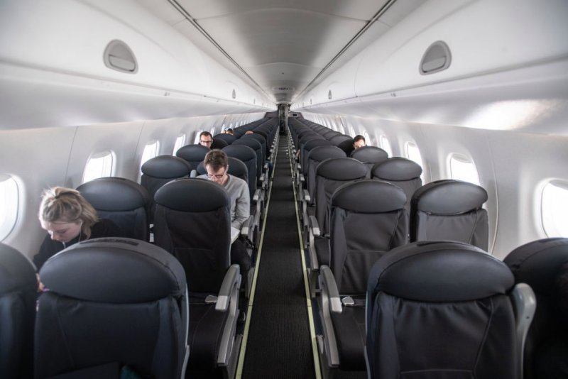
Figure 1: Almost empty BA flight
(Source: Bloomberg, 2020)
BA has made several changes in the business policies since the beginning of the unlocking of Covid-19. The customers will books flights tickets only through online mediums like website or app (Isphording and Pestel,2020). The travellers are eligible for refunds and redemption of vouchers due to flight cancellation till August 2021. Also, while travelling with BA, the passenger will have to wear the mask all the time at the airport, and onboard unless of any government exemption, eating food or drink or any other issue. To reduce physical contact, the flight attendant will not serve any food or beverages.
BA also made agreements with 30,000 employees to pay only 80% of the monthly salary until May under its Corona Virus Job Retention Program and a cut down of 50% pay of cabin crew as well. BA has replaced the former CEO Alex Cruz from the job as a measure of board shake-up due to Covid-19. The new CEO, Luis Gallego, will lead the airline with cost-cutting strategies, and expected to demonstrate positive changes for BA for sustainable recovery. Other examples of the preventative measure under Covid-19 take by BA includes the passengers will be given a personal protection mask after onboarding the flight along with anti-bacterial wipe, sanitizer gel, and a sealable disposable bag (figure two).
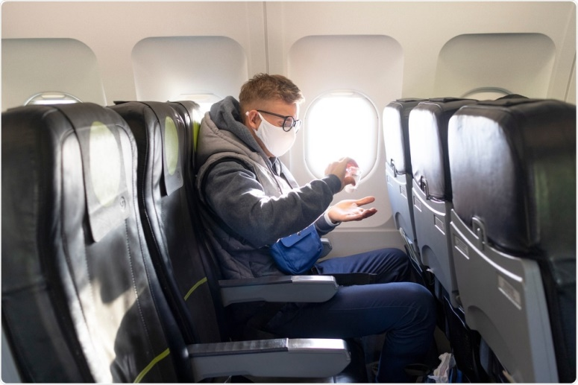
Figure 2: Covid-19 measures
(Source: Angela Betsaida, 2020)
Technological – Technological factors entirely drive the global airline industry. For example, heavy fuel-efficient and safe aircraft, achieving better sales, profitability, and technical services etc. the covid-19 guidelines assist in taking Covid-19 test before boarding the flight and will only be allowed if tested negative (Gupta et al. .2019). BA is planning to go entirely digital to continue safer service without disruptions. The ticket booking, payment, and boarding pass all are acquired through the BA app. BA has also transformed the other operations like handling cargo and business process automation. The entire management is now focusing on managing the data and analytics with higher efficiency in the system and retains its customer base.
Environmental – BA is among the first airline of the UK to mitigate the negative impact of flight operations over the environment and adopt sustainable business policies. The management has invested a high amount, time, and energy in the sustainability field (Isphording and Pestel,2020). For example, BA claims to reduce the carbon footprints to zero levels by the end of the year 2050 under its Flight Path Net Zero approach. The airline has also taken adequate measures to reduce carbon emission to zero in domestic flights by the end of 2020. The organization is serious about its social reputation in the industry and works smartly to gain government aid and positive response from stakeholders in this context.
Legal – Legal compliance is mandatory for the aviation industry worldwide. The non-adherence will result in severe fines and deteriorated the image of the brand (Seyitoğlu and Ivanov,2020). BA takes the full face of customer satisfaction, employees' rights, passenger security, environmental impacts. The legal changes in business policy since the Covid-19 have changed the working pattern of the airline to an extent. For example, BA travel insurance partner, Allianz Assistance now is offering medical coverage for Covid-19 for travellers in the UK and a few nearby countries. The legal changes also state that BA would not fly more than 30% of its scheduled flights as compared to last year.
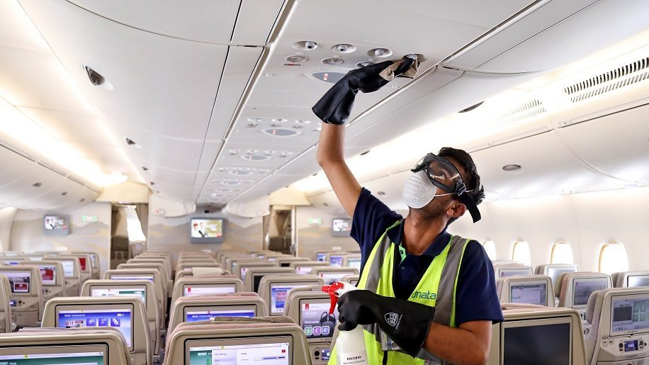
Figure 3: Aircraft cleaning post Covid-19
(Source: Seher Asaf, 2020)

Explain the extent to which you think these changes are sustainable. If you feel they are not sustainable, would you recommend any other changes?
The above PESTLE analysis shows that changes made by BA will generate business on slower speed due to the live threat of the virus in traveller’s minds (Bauer et al. .2020). However, the digital transformation of business operations and maintenance of safety and hygiene is supporting the airline business to a significant extent and open requirements for travelling. The cost-cutting measure is expected to help BA to cover up its losses incurred in previous months. Figure four shows BA volunteers and many more that worked in the donation of 2,00,000 items to more than 90 community projects, hospitals, food banks across the UK to support the Covid-19 response.
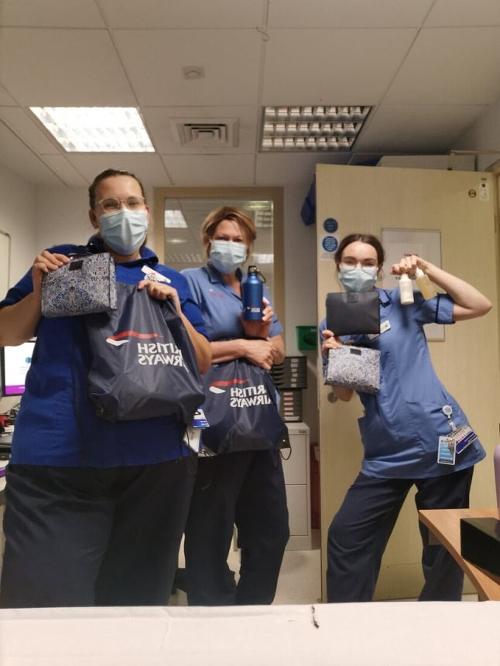
Figure 4: BA volunteers
(Source: British Airways, 2020)
Hundreds of thousands of airline jobs came to massive risk and loss in the UK itself, and BA is one of its parts (Fonseca and Azevedo,2020). Jobless individuals will suffer the most due to loss of income, shelter and food. The staff cutting will also impact the business operations of BA. For example, BA might end up losing its skilled staff, and the working of the airline will also slow down. The image below shows Boeing 747 passenger aircraft retirement by BA due to falling demand caused by Covid-19.
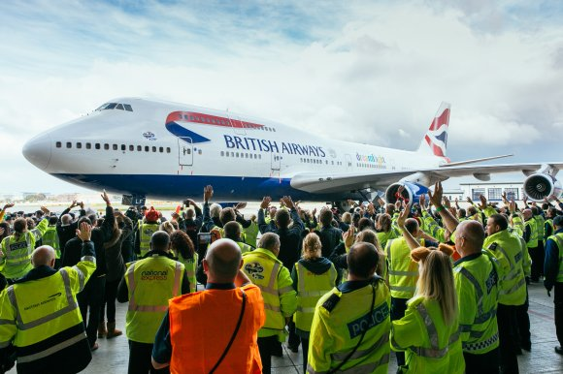
Figure 5: BA Boeing 747 Retirement
(Source: David Casey, 2020)
Porter’s Five Force Analysis along with improvement strategies for BA for sustainable growth
The below discussion will provide an overview of Porters Five Force framework for evaluating British Airways competitive environment in the current period and using this tool to develop business strategies to enhance its competitive position in the market and industry by meeting the challenges of Covid-19.
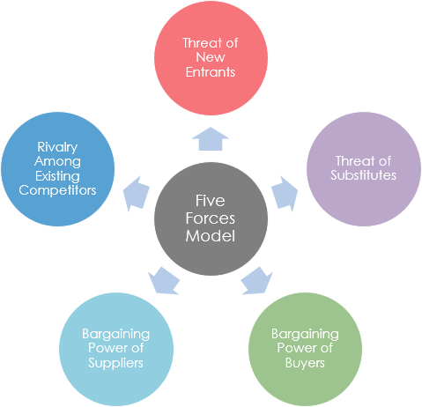
Figure 6: Porter's Five Force Analysis
(Source: Sukant Kumar, 2020)
The threat of new entrance – The UK airline industry is deregulated to a significant extent, and BA faces lesser direct entry of new airlines in the domestic market (Saeed,2016). To cope up with the pandemic situation maintain its position in the industry BA can lower the threat factor by taking advantages of various key supportive areas like First, using its abundant financial resources for redesigning thee business policies, process, and structure. Second, high customer care and loyalty, less competition from local airlines like Ryanair, Easy Jet. Third, high power gained by the allowance of notable routes and hubs. BA would also be benefited from the restricted entry of new brands with less potential due to Covid-19 outbreak.
The threat of substitute and competitive rivalry – Till 2019, the danger for BA in terms of the large-haul market remained low. Due to minimized travelling and government restrictions after Covid-19, the local competition has increased in the domestic market (Moreno-Izquierdo et al. .2016). The regional airlines were also offering cheap fare rates and cleaned and safer flights to needy customers. BA must focus on cutting its flight fares and allowing safer travelling opportunities to domestic and foreign travellers. For example, early booking discounts least physical contact services, hygienic aircraft, shorter routes and time of travelling, etc. BA should enhance its local packages to meet the aggressive competitors in the domestic market.
Power of supplier – Before Covid-19, BA had a robust supply chain management of 25 suppliers (Kılıç et al. .2019). The distraction of the supplier after the virus outbreak has also weakened the BA. The suppliers have not fulfilled the demand of the airline, and it has disturbed its operations. In the economic crisis time, BA needs to maintain good relations with suppliers like Airbus and Boeing. For example, the airline must retain back their skilled and experienced staffs that have high bargaining power with the help of their unions. It will help the business make new profits.
Power of buyer – Presently, the needy travellers do not have much bargaining power for international travel especially. The limitations of flights by BA have forced the airline to fixed prices on the seat and other facilities to recover the old financial loss and costly expenses (Thompson et al. .2016). The other airlines are also practising competitive pricing methods to attract a higher number of buyers. BA must start more flights to popular routes, and fly big aircraft to increase the passenger capacity. This way, the price differentiation would not much affect the airline.

Conclusion
The ill-effects of Covid-19 are directly visible on the overall economy of the world. The restrictions and fear of travelling have lowered the business development of the aviation industry in the UK, and British Airways is one such example. From the above report, it can be concluded that the airline has suffered heavy financial and non-financial losses in the past few months due to the virus outbreak and is fighting back to cover up for it. The transformation of business objectives, working, and policies have impacted the airline in both a positive and negative way. The recommendations aim at assisting BA to attain long-term, sustainable growth with effective business strategies, and innovative approaches.

References
Books and journals
Airways, B., 2017. British Airways. Where we fly.[online] Available at: https://www. britishairways. com/travel/where-we-fly/public/en_gb/map [Accessed 13 November 2017].
Bauer, L.B., Bloch, D. and Merkert, R., 2020. Ultra Long-Haul: An emerging business model accelerated by COVID-19. Journal of Air Transport Management, 89, p.101901.
Fonseca, L.M. and Azevedo, A.L., 2020. COVID-19: outcomes for Global Supply Chains. Management & Marketing. Challenges for the Knowledge Society, 15(s1), pp.424-438.
Gupta, A., Gupta, N. and Gupta, M., 2019. British Airways-A SWOT and PESTLE Analysis-The impact of Europe 2020 policy. NOLEGEIN-Journal of Corporate & Business Laws, pp.1-11.
Isphording, I.E. and Pestel, N., 2020. Pandemic meets pollution: poor air quality increases deaths by COVID-19.
Kılıç, M., Uyar, A. and Karaman, A.S., 2019. What impacts sustainability reporting in the global aviation industry? An institutional perspective. Transport Policy, 79, pp.54-65.
Moreno-Izquierdo, L., Ramón-Rodríguez, A.B. and Perles-Ribes, J.F., 2016. Pricing strategies of the European low-cost carriers explained using Porter's Five Forces Model. Tourism Economics, 22(2), pp.293-310.
Popescu, G.H., 2013. Macroeconomics, effective leadership, and the global business environment. Contemporary Readings in Law and Social Justice, (2), pp.170-176.
Saeed, M.S., 2016. Obtaining a Sustainable Competitive Advantage through Innovative Marketing Strategies. Developing Country Studies, 6(6), pp.112-118.
Seyitoğlu, F. and Ivanov, S., 2020. A conceptual framework of the service delivery system design for hospitality firms in the (post-) viral world: The role of service robots. International Journal of Hospitality Management, 91, p.102661.
Thompson, I., Pech, R., Oh, K.B. and Marjoribanks, T., 2016. An assessment of delivery changes for UK terminal air navigation services. Journal of Air Transport Management, 57, pp.155-167.
Online references
About British Airways, 2020 (Online) [Accessed through] <https://www.britishairways.com/en-gb/information/about-ba?source=BOT_about_ba>, [Accessed on 13 November, 2020]
Aircraft cleaning post Covid-19, 2020 (Online) [Accessed through] <https://www.businesstraveller.com/business-travel/2020/03/02/coronavirus-what-are-airlines-doing-to-protect-travellers/>, [Accessed on 13 November, 2020]
Almost empty BA flight, 2020 (Online) [Accessed through] <https://time.com/5877270/flight-restrictions-travel-coronavirus/>, [Accessed on 13 November, 2020]
BA Boeing 747 Retirement, 2020 (Online) [Accessed through] <https://www.routesonline.com/news/29/breaking-news/292538/analysis-british-airways-boeing-747-retirement/>, [Accessed on 13 November, 2020]
BA volunteers, 2020 (Online) [Accessed through] <https://mediacentre.britishairways.com/pressrelease/details/86/0/12343>, [Accessed on 13 November, 2020]
Covid-19 measures, 2020 (Online) [Accessed through] <https://www.news-medical.net/news/20200706/COVID-19-risk-halved-when-airplane-middle-seats-empty-expert-statistician-says.aspx>, [Accessed on 13 November, 2020]
Porter's Five Force Analysis, 2020 (Online) [Accessed through] <https://medium.com/product-gyaan/porters-five-forces-analysis-868945aa5846>, [Accessed on 13 November, 2020]

