Amina Bibi 1807446
Module children’s and young people and families
Module code BMHP5004
Lecturer Crisford Chogugudza

Contents
Introduction
Question 1
Conclusion
Reference

Introduction

In this report I will be discussing the importance of safeguarding and policies and procedures in the uk. I will be commenting on two high profiled safeguarding cases in the last 20years.

Discuss the importance of children safeguarding policies and procedures in uk and comment on two high profile safeguarding cases in the last 20 years.

Child safeguarding is a set of policies and procedures that are put into place for organisations to follow when they hare concerns for a child our young adult. These procedures will have set guidance to follow when they are concerns of child or young person is in danger or their well-being. (Safeguarding children and child protection | NSPCC Learning, 2022)
Safeguarding means protecting children from harm abuse and maltreatment.it also means protecting then from harm to their development and health. It’s also in place to make sure children are growing up with effective and safe care.
The policies in place are
The children’s care Act 1989
The children’s and social work Act 2017
Keeping children safe in education 2019
Working together to safeguard children’s 2018
The education act 2002
The United Nations convention on the rights of the child 1992

The importance of safeguarding
Safeguarding is important because every child or adult no matter of race colour background or ethnicity should always feel safe.
Workplace or organisations such as care homes, school, hospitals, will all have strict safeguarding procedures in place. This is because every person should live life no matter where they are or who they are with without harm and feel safe.
Organisations or workplaces must be very vigilant when it comes to safeguarding procedures as if these procedures are acted out poor can lead to major incidents and have a massive effect on the organisations as poor safeguarding procedures. Having poor safeguarding procedures can lead to abuse to the service users and cause incidents that cannot be corrected ie deaths, abuse etc.
Common Types of abuse
Elderly sick people can be neglected simply because they are unable to care for themselves and be taken advantage of.
Young children are unable to recognise rights from wrong at a young age and can be manipulated into doing things they think are ok.
Elderly memory issue is a big one as they are unable to rember certain things and have memory issues.
Emotional abuse
Sexual abuse
Physical abuse
Racial abuse
These are just the main forms of abuse that do sadly take place and we must be vigilant in organisations as safeguarding procedures are in place at all time.

CASE 1
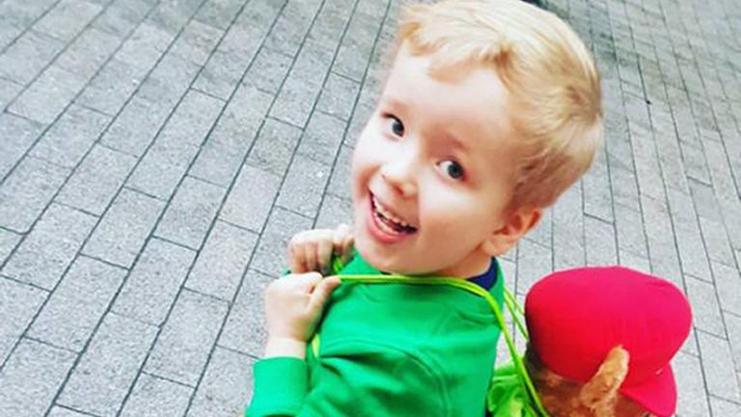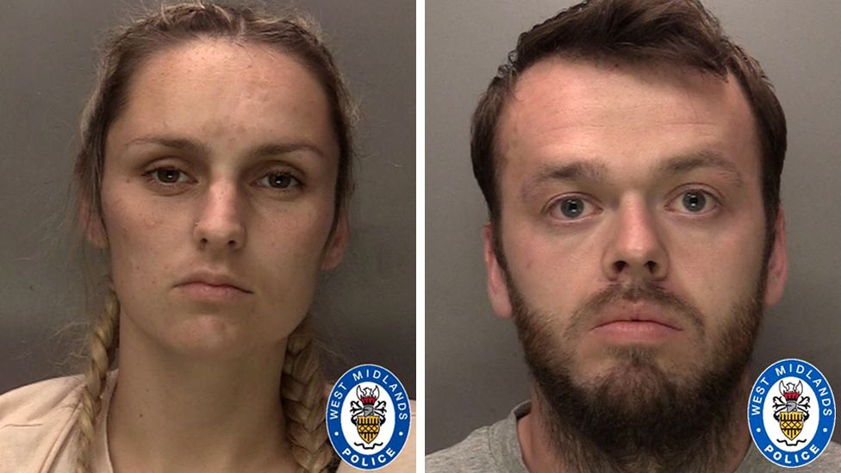

Arthur labinjo-hughes
Arthur labinjo hughes was a six-year-old little boy who suffered from physical abuse and was murdered during the covid 19 pandemic.
Arthur was abused and mistreated over a course of several months by his very own father Thomas hughes and his girlfriend Emma Tustin. Arthur died on 17th June at children’s hospital Birmingham with an injury to head after Emma his stepmother forcefully pushed him. Both parents were taken to court after investigations took place and where convicted of murdered and child abuse for life in prisoment.
Arthur was originally cared for by his own biological mother Olivia Labinjo Hughes however when Olivia was sent to prison for killing her boyfriend custody of Arthur was given to his dad who then moved into Emma Tustin home. Arthur’s abuse became very increasingly neglectful having spent long hours standing in hallway and poisoned with significant amount of salt and then finally a brain trauma to the head due to his step mother pushing him which caused his death. Arthur had 130 bruises to his body.
Arthur’s case had a massive response from public and it really did question the protection of children like Arthur who suffer from abuse.

Arthurs case was a very high profiled case which had a massive response from public due to the fact Arthur was abused during covid 19 pandemic.

Case 2
Baby P

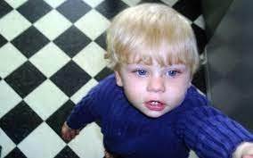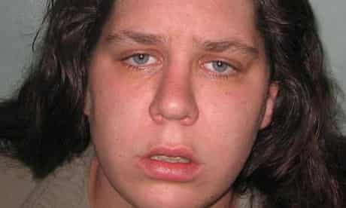

Baby P was another little boy who suffered from significant injuries and abuse he was 17months old and was repeatly chocked, and his mother encouraged a rottweiler to attack him. Baby p was abused by his own mother her boyfriend and his brother who moved into the family home. Baby p died 3rd august 2007. baby p mother got into a relationship with steven baker 2 months after he was born which started the whole abuse on baby P. (Baby P the tragic tot whose horrific tale of abuse appalled the nation, 2022)
Baby p suffered 50 injuries in total and was visited more then 60 times by local authorise prior to his death and yet still baby p wasn’t saved. Baby p suffered horrendous physical abuse including his back broken damaged to his head,ciggarate burns and rib fractures.

Authorities who had undertaken a investigation found that baby P death could have and should have been prevented.
The found lack of professional’s curiosity.
Lack of openness and transparency.
Failure to protect siblings
Poor response by local authorities.
Lack of necessary awareness
(blog article 2009)

Conclusion
The above two cases are highly profiled cases of child abuse. These are 2 among loads of cases which children end up dying due to the abuse and lack of care amongst their own families or extended families etc.

References

https://www.coventrytelegraph.net/news/local-news/remembering-arthur-labinjo-hughes-two-24257739

https://www.thesun.co.uk/news/4567187/baby-p-killers-tracey-connelly-steven-barker-jason-owen/

Conclusion

References

https://www.google.com/search?q=safeguarding+policies+and+procedures+in+uk&client

