Comprehensive Business Intelligence System Design and Analysis Overview

Ben Williams
Student number:2223458

University Wales saint trinity David
Introduction
In this essay I will talk about business intelligence and focus on how it can help elevate an organisation and research how much of an effect it has on my chosen business being a sports store. Furthermore I will talk about the many advantages having an effective business intelligence structure can bring to an organisation whilst also pointing out some of the potential negatives it could bring. I will also be going more into depth with business intelligence talking about data warehousing architecture, internal data sources and also external data sources. Whilst doing all of this I will propose my own detailed design of a business intelligence system to specifically fit Asda’s criteria and targets ensuring they get the best results possible.

System design (part 1)
In this section I am going to talk about the proposed design I have of a business intelligence (BI) system for my chosen business which is a sports store. I have chosen to a sports store because sports is something I am passionate about and have always been interested in. To address the businesses current challenges with data and slow reporting, this proposal recommends the development of a modern Business Intelligence system suited to its needs. The system will bring together data from multiple places into a data warehouse, enabling the business to maintain a single, reliable version of data. Using ETL processes, the system will ensure that all data is consistently cleaned, validated, and updated, reducing errors and improving reporting accuracy. A sports store having an effective business intelligence is crucial for utilising massive amounts of transactional, customer, and operational data as the retail industry becomes more competitive. In addition sports stores can be very competitive when it comes to rival stores trying to compete as there are so many brands out there, so having good business intelligence within the organisation is something very important to them and something they value. Business intelligence is a set of processes involving managing data, collecting data and analysing data to help produce insights that inform business strategies. Furthermore a business intelligence analyst is someone who is capable of using data analysis tools to help businesses such as sports stores make the correct decisions going forward to ensure they hit their goals and targets, the way they do this is by transforming raw produced data into actionable insights, According to CIO magazine “Although business intelligence does not tell business users what to do or what will happen if they take a certain course, neither is BI only about generating reports. Rather, Business intelligence offers a way for people to examine data to understand trends and derive insights”. Some advantages a data analyst can bring to an organisation is decision making, a business analyst can almost act as a second opinion, they provide the people higher up within the organisation with more accurate data which they can follow, business analysts are able to provide more accurate information by taking the time to collect the most relevant data and analysing patterns and trends, for a business analyst, trend analysis is crucial because it enables the company to make proactive, well-informed decisions rather than responding too late. Trends show patterns in internal procedures, market changes, customer behaviour, and operational performance. Furthermore understanding your customers behaviour and participation towards your business is important because you know what they like and what they don’t like, this is good because you can put all of your focus on certain types of products that specific customers like and avoid products they don’t tend to invest in. In contrast there are a couple of downsides to having data analysts such as time, it can be quite time consuming being a data analyst as it can take a lot of time to collect data and then look all through it to clean, however this is more dependent on the person as some can be quicker than others if they have more experience or skill.

Another thing organisations use is data warehousing architecture, this is the overall structure of a warehouse system, it explains the process of gathering data from various sources, transforming and cleaning it, storing it, and delivering it to users for reporting and analysis. The original data they gather from different places such as transactional databases, spreadsheets or external sources. The way this data is processed is through something called ETL also known as (Extract, Transform, Load), ETL is split into three parts with the first one being extract, this is where data is extracted from different sources, this is a simple process as the only thing they need to do in this step is collect. The next part is to transform, this is where data is looked over and made more organised for a people to look over in a more easily accessible way. In addition the way the data is organised is by doing things such as deleting any duplicated data and converting data to a suitable type that fits your organisation. The final part is to load, this is where after all of the data has been cleaned up its then moved into the data warehouse in an organised format which makes the data a lot more understandable for business analysts to look over. Furthermore moving on to OLAP operations, OLAP operations stand for online analytic processing. Online analytical processing is a technology that allows for the rapid analysis of vast amounts of data from many angles. It gives decision-makers, managers, and business analysts the flexibility to examine data. Organisations use this because it is efficient for technology to be able to analyse so much data so quickly which saves organisations a lot of time for such a big job, in addition (Chaudhuri & Dayal 1997, Kimball & Ross, 2013) states that “OLAP allows businesses to run complex queries on large datasets quickly, improving decision-making speed”. Some more advantages of OLAP include being able to look at data from various angles, for example it can view where the data has come from and also who it has come from. In contrast there are some potential downsides to using OLAP such as cost, it can be quite expensive to install an OLAP system as it requires certain type of software, hardware and specialised staff are needed to work this system. (Kimball & Ross 2013, Inmon 2005) also states that Implementing OLAP can be expensive and complex, requiring specialized software, hardware, and trained personnel (Kimball & Ross, 2013; Inmon, 2005). Also it is heavily dependent on accurate data from a data warehouse meaning the ETL process has to be spot on otherwise it will be led to misleading information and insights. (Chaudhuri & Dayal 1997, Golfarelli & Rizzi 2009) also mentions that OLAP performance can degrade with very large datasets, and it relies heavily on clean, structured data from data warehouses.
For this BI system, Power BI has been selected as the primary Business Intelligence tool because it offers interactive automated reporting, and seamless integration with common data sources such as Excel, SQL databases, and cloud services. These features align with the businesses need for real time performance monitoring and accessible visual insights for staff. I have chosen this system because I believe it is best suited for my chosen business and having an advanced Business intelligence system especially in the modern era is very important and having good data mining tools are something that can really boost the chances of my chosen business intelligence system to work. A data mining tool is a software application or platforms designed to analyse large datasets, discover patterns, and extract useful information that can support decision-making. They go beyond simple reporting by using algorithms to find trends and point out anomalies within the data. Some features included in data mining is classification, for example this can point out the differences between the amount two customers spend or even point out two different customers incomes and then compare to see who is more beneficial to the business etc. Another feature to data mining is prediction, this is where it will focus on trends purely based on past patterns. There are many advantages to data mining tools such as being able to find hidden patterns within data which is a difficult job to do without these tools, they do this by identifying trends, correlations, and anomalies in large datasets that are not too obvious for someone to see. (StudySmarter, 2025) backs this up by saying “By uncovering hidden patterns and trends in customer data, data mining supports improved customer segmentation, personalised marketing, and increased customer satisfaction.” Another advantage is that it can give a competitive advantage to any business that uses these tools by uncovering trends and opportunities, businesses can stay ahead of competitors and respond quickly to market changes before anyone else. In contrast there are some disadvantages towards data mining tools such the cost, data mining tools can be very expensive to purchase and maintain meaning this can be a be an issue for businesses on the smaller scale who do not have the budget to install this type of technology, meaning they won’t be able to get as much of a competitive advantage like these larger scaled businesses tend to have. (Technosoft Engineering, 2025) Also states that “Data mining solutions can be costly to acquire and implement, and they often require personnel with specialized technical expertise to use effectively.” Furthermore another disadvantage is the complexity of it, using these tools are not easy and businesses using them are required to have a lot of knowledge in things such as programming and statistics. This knowledge is needed to avoid issues such as incorrect analysis or incorrect results. All this being said I have chosen python programming as my main data mining tool because python works well with Power BI because it has built in support for running Python scripts directly within the platform, which allows users to perform advanced data preparation, statistical analysis, and machine-learning tasks before visualising the results in dashboards. In addition python is great for my business intelligence system because it is a simple set up yet powerful, it is known to be an tool that is ideal for beginners to use because of its simplicity but yet still serve more advanced users at the same time which is ideal for both types of users. In addition it has fast development timing meaning only simple coding is necessary for harder tasks which proves to be efficient to the user. However there are some potential disadvantages to using this tool such as not being able to perform well in larger scaled systems.

There are many ways in which I can ensure data security and quality management for my proposed BI system such as frequent checks and monitoring, this will make sure that the system is always up to date without any errors, also having a secure data gateway would be beneficial because it is able to transfer encrypted data meaning no outsider will be able to translate this, another reason why it is beneficial because all paths have controlled access meaning you can decide what people see and who sees it.

Excel Implementation and Data Analysis
In this section I will demonstrate the practical implementation of Business Intelligence techniques using Microsoft Excel. In addition I will speak about why I've chosen Power BI as my intelligence system going forward with this.

Raw data sheet (part 1)
https://mail.google.com/mail/u/0?ui=2&ik=497bd8017d&attid=0.2.0.1&permmsgid=msg-f:1850340255683587498&th=19adbaa8b5a02daa&view=att&disp=safe&realattid=f_minmcipu0&zw
This is a link to the entire raw data sheet provided for the sports stores sales. This raw data sheet represents the first stage of the data warehousing process, where data is imported exactly as it is in the system. This data sheet includes the transaction number, time of purchase, product type, sales channel (In store or online), purchase amount and payment method. It is important that this raw data is kept separate from other types of data because this is original and untouched meaning nothing has been changed and prevents accidental loss of original information.

Below is a screenshot of what my raw data sheet looks like: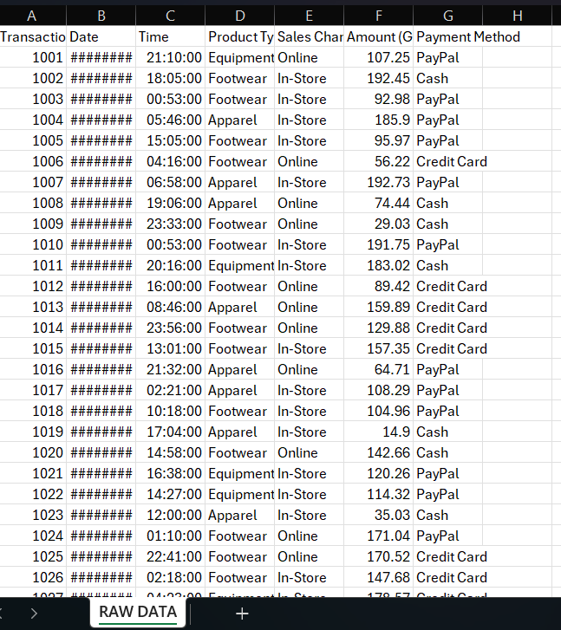

Transformed data (part 2)
The transformed data sheet contains the processed version of the raw dataset and represents the transform stage of the ETL pipeline. This is a cleaned up and more organised data sheet. I have added fields to support Business intelligence insights such as a Sales Category column which sets transactions into high, medium, and low value, I added this because a business analyst can now compare things such as customer spending patterns and can compare the different types of customers. In addition I have also added a Payment Grouped field that simplifies payment methods into Online and Offline, I added this because it simplifies the many varieties of payment methods the customers use whilst in broader categories, this is an important change because it makes things less complex whilst being able to offer me better insights.

Below is my cleaned up and transformed date offering better insights:
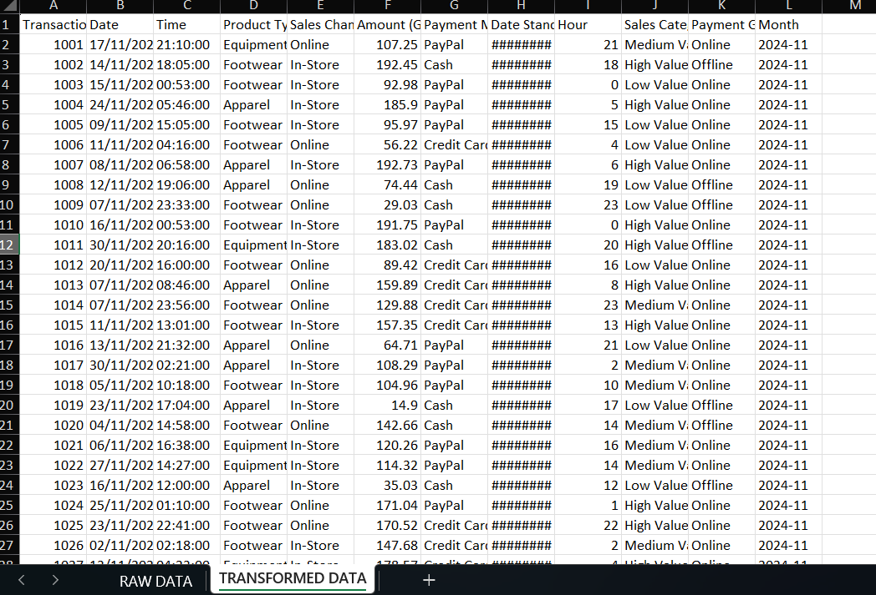

Dim product types (part 3)

Dim Product Type is a small table that groups products into different categories in my case, equipment, footwear or apparel. Furthermore It helps make the data easier to analyse because instead of looking at every individual product I can look at how different product types perform overall.

My table:
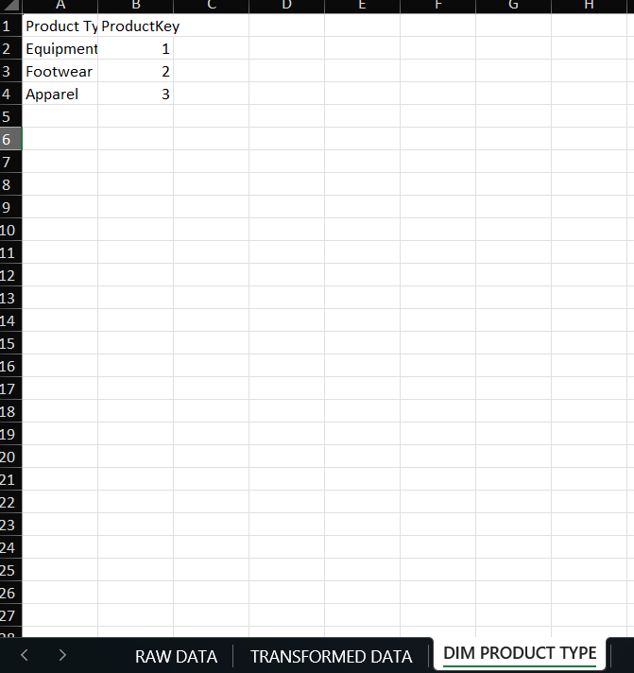

The link below is my whole data sheet:

Complete data sheet.xlsx

The Excel data sheets I created is designed to follow the same structure that Power BI uses when importing and modelling data. By organising the data into fact and dimension tables, the Excel sheets act as a smaller scaled data warehouse that Power BI could easily connect to. This means that if the sports store wanted to expand their project, the same Excel tables could be loaded directly into Power BI to create interactive dashboards and visualisations because the data is already cleaned and structured. Following up from points I made earlier in this report I chose Power BI because it is easily connected to excel because Power BI can open Excel files directly, the same way Excel can open a spreadsheet. It automatically finds any tables in the workbook and imports them, meaning no manual setup or coding is needed. Although Power BI is the main BI system used for reporting in this project, Excel is used to simulate the role of a data warehouse. The raw data is cleaned, transformed, and structured inside Excel first, and then imported into Power BI for analysis and visualisation. This reflects how BI systems operate in practice, where data preparation happens in one system and reporting happens in another. However there are other AI systems which can be used instead of power BI such as google looker studio, this is a good alternative to power BI because its accessible to everyone being free and also easy to share online. However compared to power BI it has less visualisation options and is limited on data transformation as its mostly a reporting tool and it can lack strong built in ETL or data-preparation features, so data cleaning, joining, and complex transformations generally must be done before hand in excel.

Critical evaluation

My proposed business intelligence system (power BI) is effective because it does a great job of transforming data into useful insights for businesses to use to their advantage. Another reason why Power BI is effective is because of the amount of people it can provide for because it can benefit big or small businesses looking for reporting and analytical capabilities beyond Excel as it offers easy data visualization and analysis across the entire business and gets deep insights into the business operation and performance. In addition Microsoft always stays on top of updating Power BI making it one of the most up to date systems to exist, being constantly up to date in such a fast paced marketing era is crucial for businesses, also Microsoft regularly introduce new features which support power BI and ensures it remains as one of the best business intelligence systems available to the public. The main objective of any business intelligence system is to improve decision making by providing managers with relevant and actionable information. Furthermore, not only can my business intelligence system provide people with information, but it can also provide this information fast which is important because if there is any issues within the stores data then it gives people more time to deal with these issues and correct them. Another way in which my proposed business intelligence system is effective is because it outlines trends and patterns easily, it can outline things such as their best selling products, worst selling products and customer buying patterns, these are all important to know as because the business can look at what to invest in more and what to stop investing in to create a larger profit margin. However there are some challenges my proposed business intelligence system can have such as security risks, all business intelligence systems contain data about customers such as names, card details and other things, this is only an issue if a mistake is made such as cyber attacks or data leaks, this is why it is important for a business to have a strong security system to prevent things like these from happening. Another challenge my proposed design can face is the preparation for unusual events happening, for example when COVID-19 happened many businesses were forced to close because the lack of preparation for these types of events as they were only relying on past data and didn’t have any new data to go off which is a massive disadvantage.
Scalability and adaptability
Scalability describes the system’s ability to grow alongside the business. A scalable BI system can process increasing volumes of data, support more users, and integrate new tools or data sources without a drop in performance. This ensures the organisation does not outgrow the system and can continue to rely on it as operations expand over time. It is good to have a scalable business because it comes with benefits such as growth with no major extra costs, this is because scalable businesses usually use AI to automate tasks meaning they don’t need to invest into new employees. Following on from my last point this also means that they are able to cut down on staff’s wages leaving themselves with more money to spend elsewhere. Another benefit to having a scalable business is that digital systems like business intelligence can handle more customers and transactions just by increasing the capacity which is cheaper than buying physical equipment. In contrast there are some downsides to having a scalable business such as the initial cost it will take to set up, businesses will need things such as technology, staff and the software in order to become a scalable business. Another downside can be that people within a business can tend to be too reliant on their technology, this is bad because if there were to be any technical issues within a business this may cause the organisation as a whole to slow down and lose their momentum. My proposed business’ scalability is good because as I mentioned earlier it is able to take on more customers and transactions easily due to my business intelligence system, as my business grows it will be able to process more data without any issues. Another reason why my business is scalable is because it is always up to date thanks to Microsoft frequently updating Power BI, this is good because it offers me the most up to date options which can be used to my advantage. My businesses adaptability to future developments will be good because working with Power BI already enables me to work with the most modern technology meaning it will easily connect to new software if needed to. In addition as my business grows or changes, the system can be adjusted to show new types of data and reports. This makes it easy for the company to keep up with new trends, new tools, and any changes in how the business operates. Furthermore it is important that a business not only is able to adapt but to adapt quickly because being able to adapt quickly in business gives you a big advantage against competitors as you will already be prepped for the change and will know how to handle it better than others.

Ethical implications
There are several ethical implications related to data usage within a BI system. These include protecting data privacy, ensuring strong security, and only collecting information that is necessary. Ethical data usage in business is so important because it’s the one thing that builds the initial trust between the buyer and seller, if the buyer feels like their data is stored in a safe space then they are more likely to return more than once and become a regular source of income, following on from this if a buyer knows their data is secure then it can give the business a good reputation which has its own benefits such as enticing other people to buy from it meaning more profit from more people. Another reason why it’s important is because it can support overall long term success, this is made up many factors involving reduction of risk and data breaches, this is possible by having good security, having this can prevent things like loss of information or hacking happening to your business. Another reason for long term success is by avoiding fines as a business, it is important for a business to avoid fines so they remain stable not only to the public but to themselves, the way they can avoid these fines is by Following data laws like GDPR, if these laws are followed the business won’t have to worry about fines, court cases or immediate shutdown. Lastly my proposed system will ensure that there is absolutely no misuse of data because it is a guaranteed lost of money and will stop my business from reaching its main goal which is profit, not only can it delay profit but if any data is misused or leaked it can fall in to the hands of existing competitors which means they can access private business data potentially harming my own businesses growth.

What Is Business Intelligence (BI)? | IBM

