19/12/2025
Afroza Siddique (1818786)
[company name]
IWD
Assignment 2 : Website design and development
Module Name: Introduction to Web and Database Concepts
Module Code: ACCA 4023

Student Name: Afroza Siddique
Student ID: 1818786
Group: 3

Lecturer’s Name: Suneth Fernando
Table of Contents
Introduction to your case study which you choose 2
User Requirements 2
Website Design 2
Home page Wireframe (screenshot from Visio) 2
Website Implementation 3
Home page (screenshots) 3
Validating my website 4
Self-evaluation of my website 4
Usefulness (usability and utility): 4
Search Engine Optimisation (SEO): 4
Accessibility: 4
Reference list 5

Introduction to your case study which you choose
Please explain what type of business which you have chosen and what type of business function which you are going to consider when you design and develop required website.
The project focuses on designing and developing a website for a clothing retail business. This business operates within the fashion and apparel industry and offers a range of products such as casual wear, formal wear, accessories, and seasonal collections. As a modern retail business, its goal is to attract customers, showcase its products effectively, and provide a convenient online shopping experience.
To ensure the website supports the overall goals of the business, several key business functions will be considered throughout the design and development process. These include marketing and promotion, online sales through e-commerce features, customer service support, inventory and product management, and effective communication of business information. By incorporating these functions into the website, the business can enhance its online presence, engage customers, and streamline its operations.

User Requirements
List down user requirements. In other words, please identify what user is expecting from your website. This should include, type pages required, each page, what type of content which you need to include.
Users visiting the clothing website expect an online shopping experience that is simple, fast, and visually appealing. First, users require easy navigation, meaning the website must have a clear and well-organized menu that allows them to move between pages such as Home, Products, About Us, Contact, and Login without confusion. They also expect the website to load quickly and work well on different devices, including phones, tablets, and computers. This ensures accessibility and convenience for all users.
In terms of content, users expect clear and detailed product information. This includes high-quality images, product names, prices, descriptions, available sizes, and colours. They also want to see which items are in stock. To meet these expectations, several specific pages are required on the website. The Home page should introduce the brand, display featured products, and provide visual appeal to engage users immediately. The Products page should present a full list of clothing items in a grid format, allowing users to browse easily. Each product should display an image, name, and price so users can quickly understand what is being offered.
Users also expect background information about the company, which is provided through the About Us page. This page should explain the history of the brand, its mission, values, and what makes it unique. Additionally, users want a simple way to contact the business. The Contact page must include a contact form, as well as details such as email, phone number, or location, so users can ask questions or seek support.
Because many users may want to create an account or log in, the website also needs a Login/Register page. This page must include forms for entering email, password, and other details. Users expect this process to be safe and secure, protecting their personal information.
Overall, the user requirements focus on ensuring that the website is easy to use, visually appealing, informative, and secure. By meeting these expectations, the clothing website will be user-friendly and effective in helping customers browse and purchase clothing items.

Website Implementation
Please explain what type of text editor (Visual studio code) used and what type of scripting languages use used to develop your website. Then provide screenshots of each page. (DO NOT COPY AND PASTE CODE IN THIS REPORT). PLEASE annotate each screenshot

To develop my clothing website, I used Visual Studio Code (VS Code) as the main text editor. Visual Studio Code is a popular and powerful code editor that developers use because it is easy to work with and supports many programming languages. It provides helpful features such as syntax highlighting, auto-completion, and error detection, which make writing code faster and more accurate. The Live Server extension also allows me to preview the website instantly in a browser, making it easier to test and check changes in real time. Because of these features, Visual Studio Code is an effective tool for building and managing all the files needed for the website.
For the development of the website, I used HTML and CSS. HTML (Hypertext Markup Language) is the main language used to structure the website. It allows me to create the layout and add content such as text, images, buttons, and forms. CSS (Cascading Style Sheets) is used to control the appearance and design of the website. With CSS, I styled the pages by adding colours, fonts, spacing, layouts, and making the website look modern and visually appealing. Together, these languages allow the website to be functional, attractive, and user-friendly.
In summary, Visual Studio Code was chosen as the text editor because it makes coding easier and more efficient, while HTML and CSS were used to build the website’s structure, design, and interactive features.

Home page (screenshots)
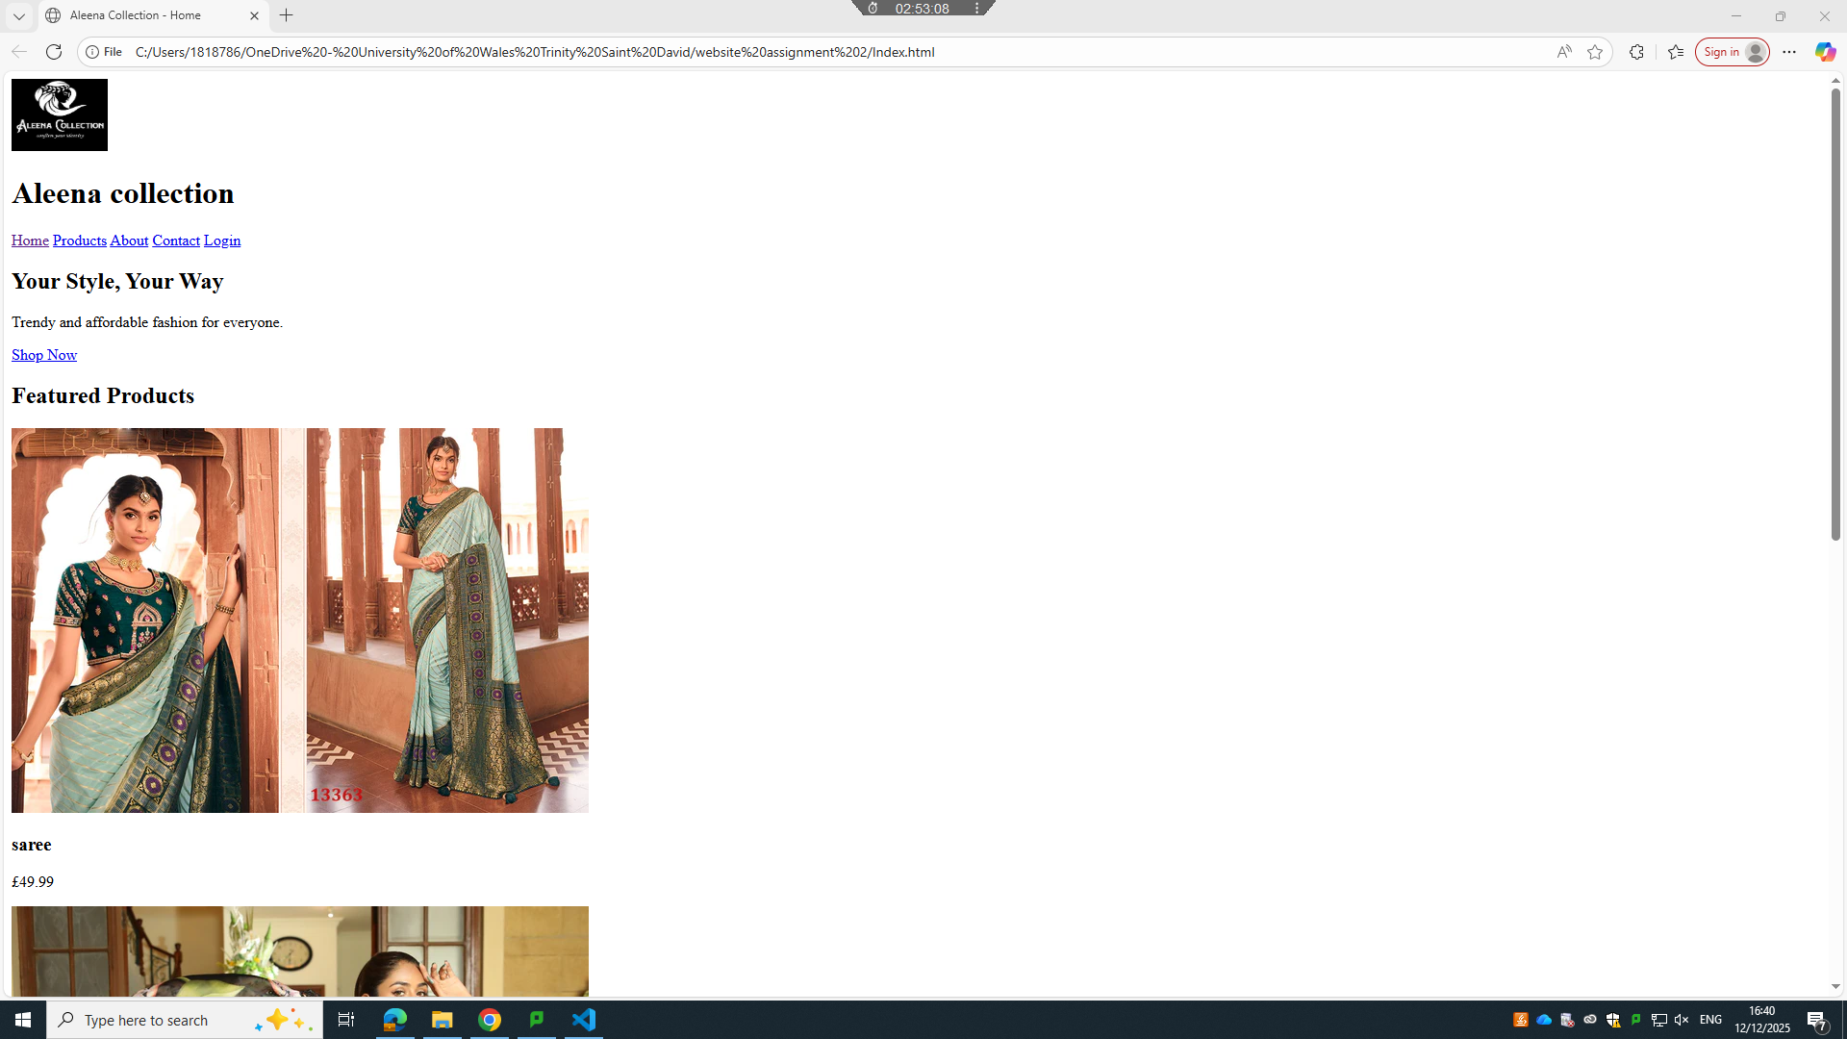

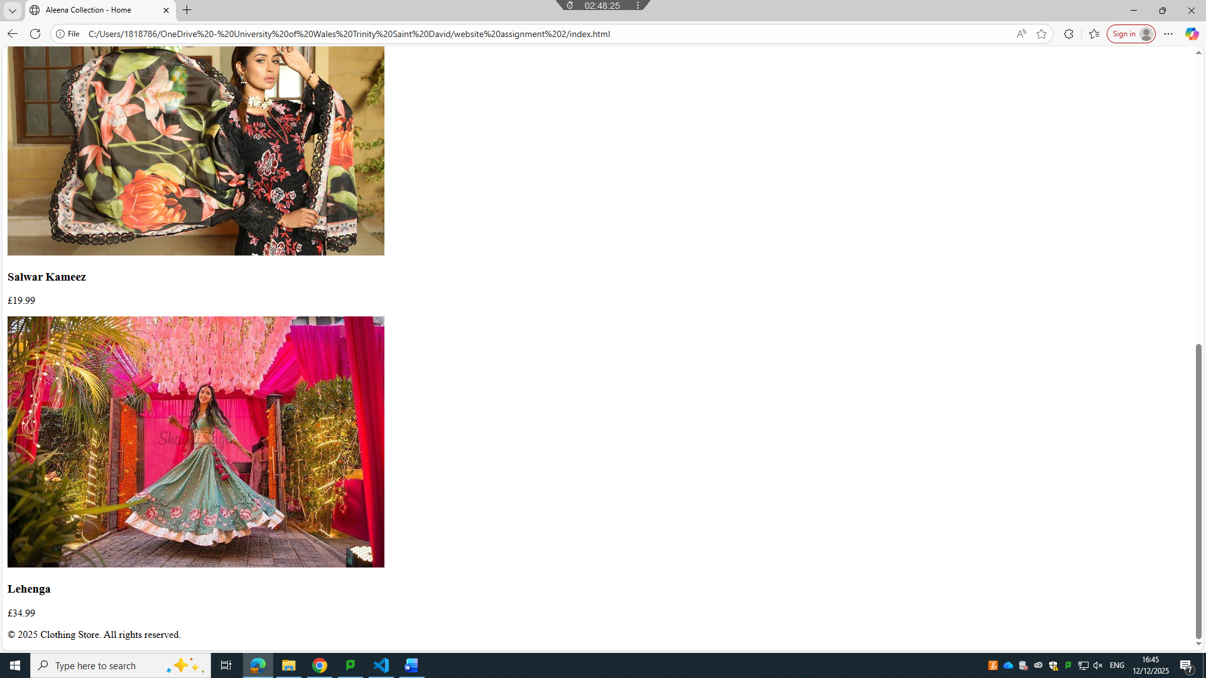

Other pages (screenshots)
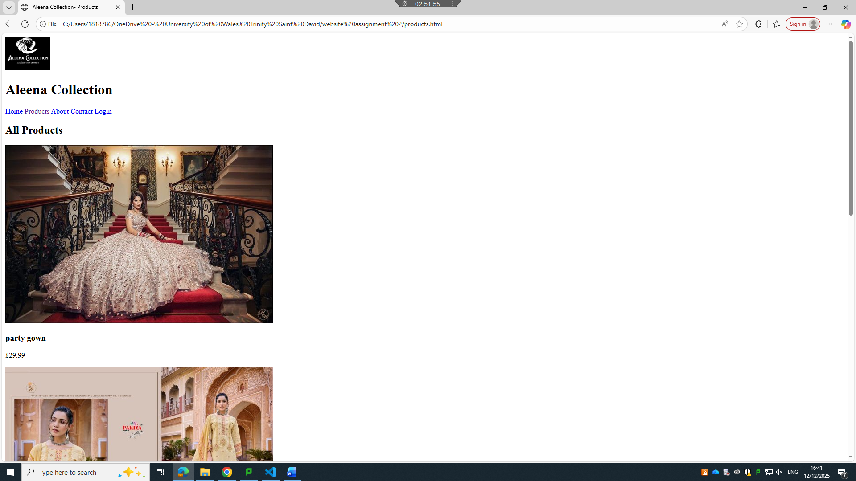

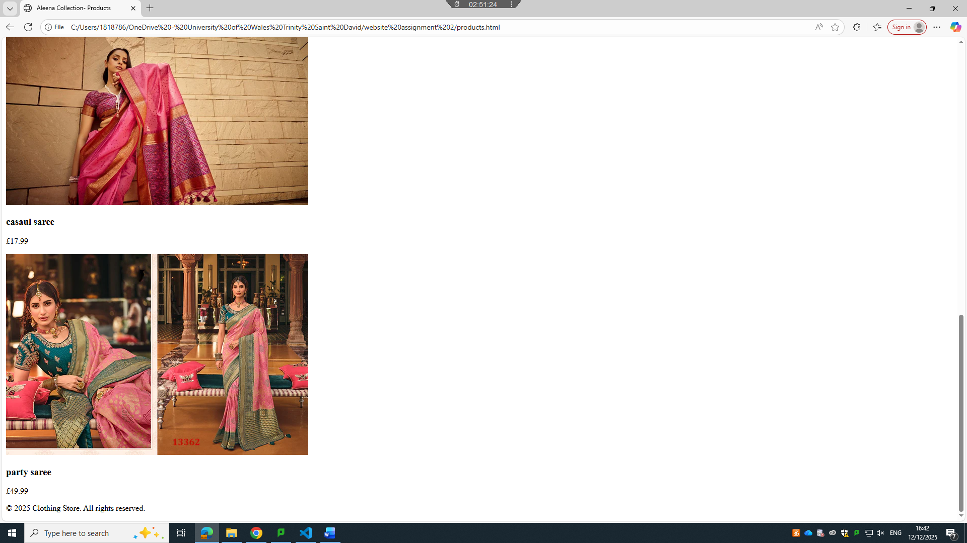

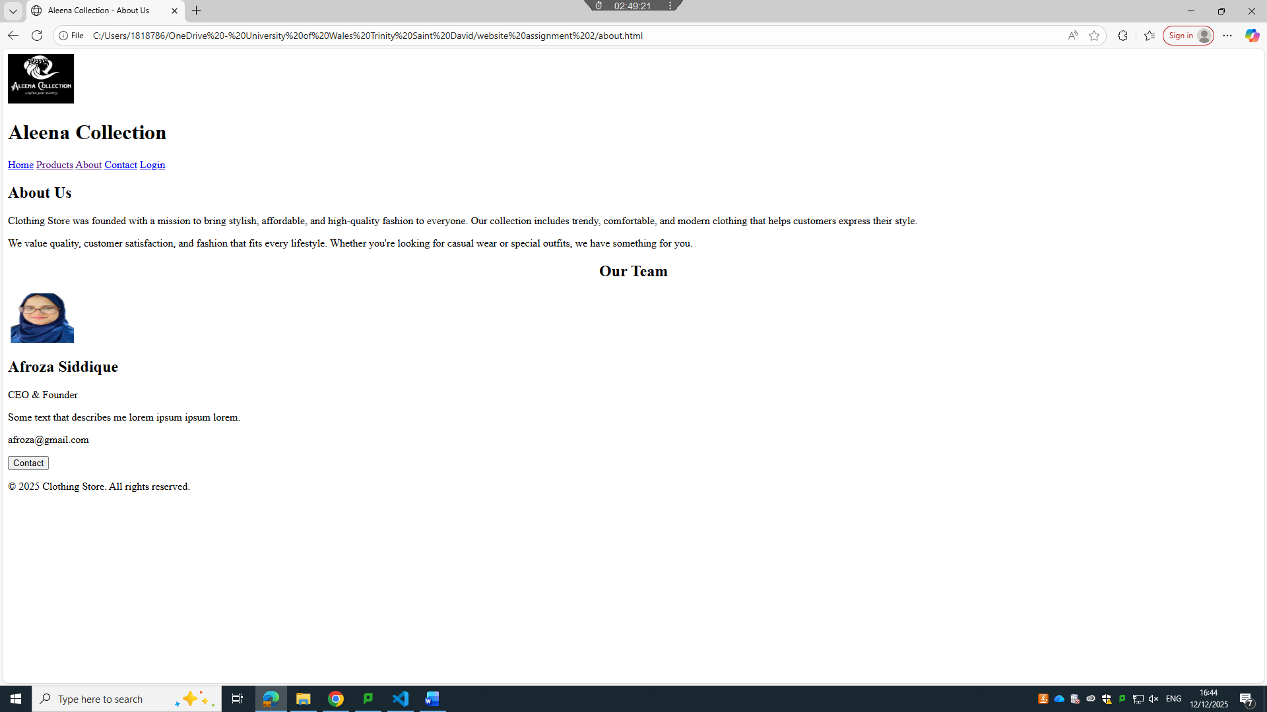

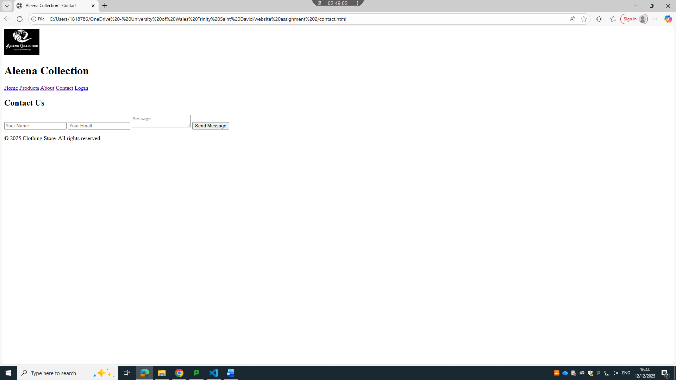
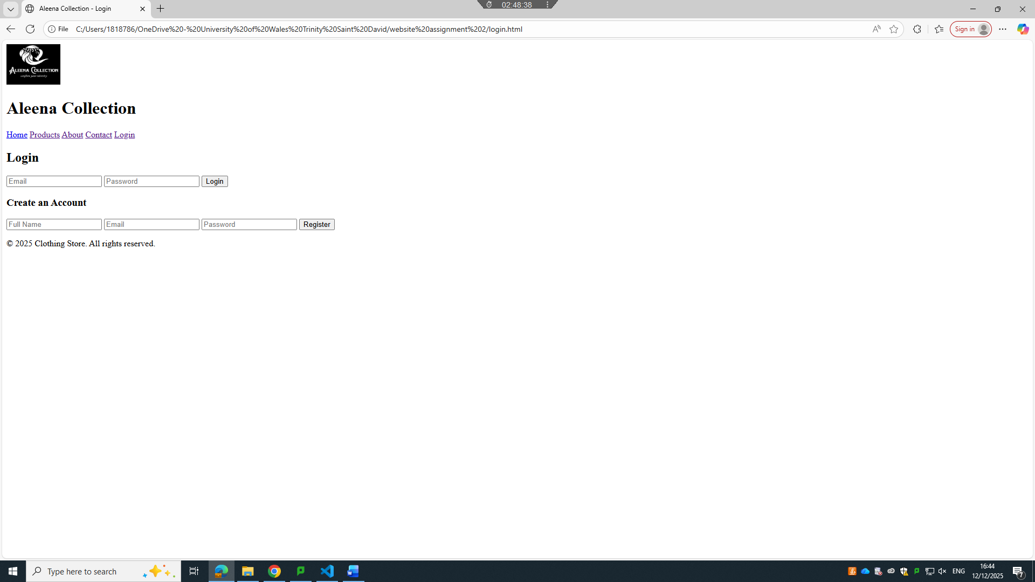

Validating my website
Please use the links provided in assignment brief to validate ONE HTML PAGE AND ONE CSS PAGE
Please find the links below
HTML VALIDATION LINK : https://validator.w3.org/
CSS VALIDATION LINK : https://jigsaw.w3.org/css-validator/
Please load the page and upload one of your HTML pages and generate the report. Take screenshot of each error message and explain what type of coding standard missing in your code.
Do the same to the CSS file as well.
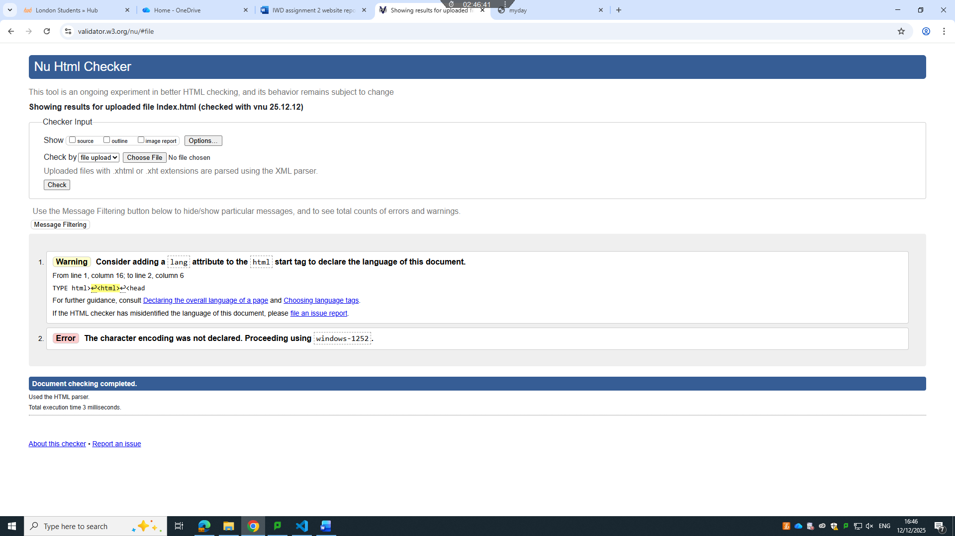

The HTML validator identified two issues in the webpage: one warning and one error.
- Warning: The HTML document does not include a lang attribute in the <html> tag. This attribute is important for accessibility, as it helps screen readers and browsers identify the language of the page.
- Error: The character encoding has not been declared. As a result, the browser defaults to windows-1252. This can cause text display issues and should be fixed by specifying the correct encoding.

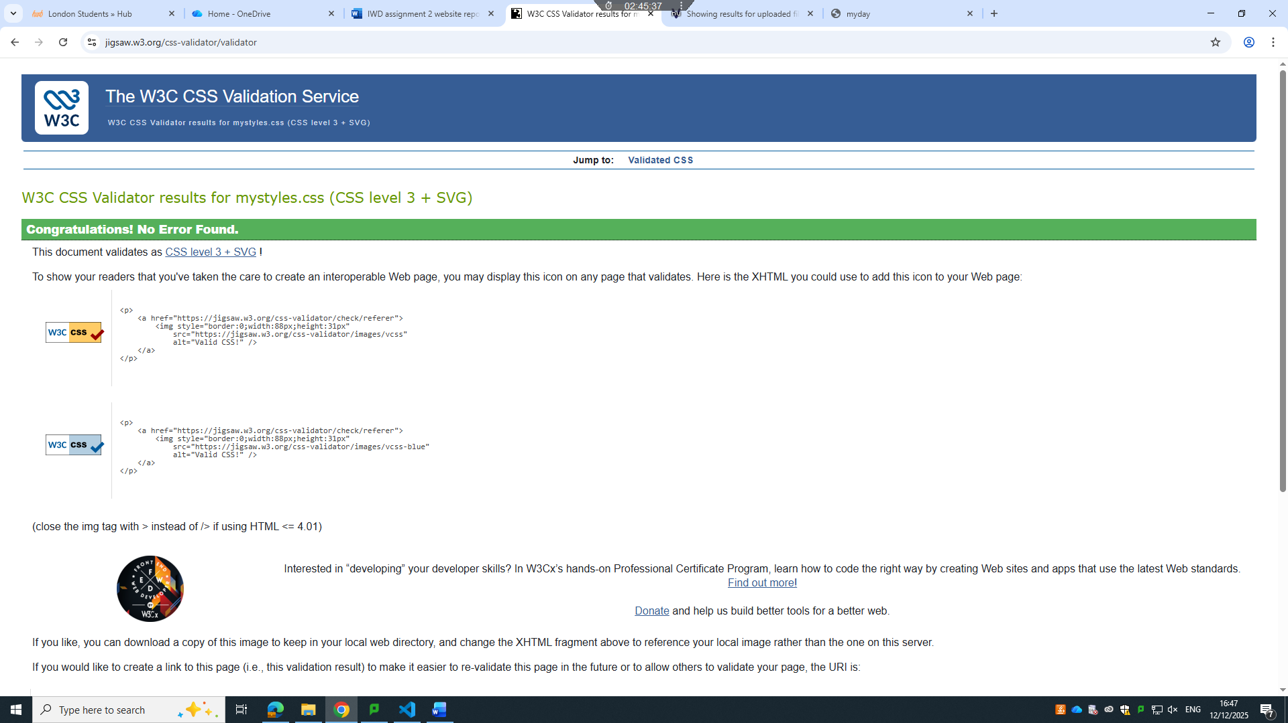

The screenshot shows the results from the W3C CSS Validation Service for the stylesheet mystyles.css. The validator confirms that no errors were found and that the CSS code complies with CSS Level 3 standards. This indicates that the stylesheet follows correct syntax and web standards, ensuring better compatibility across different browsers. Validating CSS helps improve code quality, maintainability, and overall website performance.

Self-evaluation of my website

Usefulness (usability and utility):
Use academic sources to identify what website usability means and compare your website with this criterion, whether you have met this criterion or not.

The ideas of utility and usability come from the concept of “affordance” in ecological psychology. This perspective asserts that evaluating a learning environment requires understanding which actions it makes possible, since different kinds of learning must be supported in different ways. [1]

There are four main methods to assess usability:
Automatic Evaluation: The interface standards are processed through evaluation tools to get usability metrics.
Empirical Evaluation: By seeing actual users interact with the interface, usability is evaluated.
Formal Evaluation: Calculates usability metrics using exact models and algorithms.
Informal Evaluation: Uses generic heuristics, expert judgement, and experience to pinpoint usability problems.
A system's efficacy and user experience can also be evaluated using a variety of methods, such as testing, inspection, inquiry, analytical modelling, and simulation, which can be applied singly or in combination. [2]

The clothing website (Aleena Collection) largely meets usability standards, providing a user-friendly and attractive online shopping experience. With small enhancements in accessibility, error handling, and product filtering, the website could fully align with usability best practices.

Search Engine Optimisation (SEO):

Search Engine Optimisation (SEO) involves many elements that influence how well a website ranks in search results. It’s essential to create a strategy tailored to each search engine you want to perform well in. Keyword research plays a key role, as it signals to search engines the nature of your website. There are various methods available to improve a site’s optimisation. Understanding the factors that contribute to better rankings is crucial when developing a website. Building strong connections and communication with other sites is especially valuable. Increasing online links can help drive more traffic. SEO is a free and natural method to achieve higher positions in search engine listings. [3]

Website Accessibility:

Web accessibility typically involves using technical methods in website design to make it easier for people to use, especially those who rely on assistive technologies. These methods include correctly implementing validated code such as Hypertext Mark-up Language (HTML) or Extensible Hypertext Mark-up Language (XHTML) to structure the content, along with using cascading style sheets (CSS) to control how that content appears. [4]

In conclusion, the website for this clothing business is designed to support both sales and customer engagement efficiently. By integrating e-commerce capabilities, inventory management, and a seamless user experience, the website not only promotes the brand but also provides convenience and satisfaction for the customers. A well-developed website acts as a bridge between the business and its target audience, ensuring growth, accessibility, and competitive advantage in the retail market.

Reference list

[1] Y. Tang and K. F. Hew, "Examining the utility and usability of mobile instant messaging in a graduate-level course: A usefulness theoretical perspective," vol. 35, no. 4, 2019,
[2] N. S. Aziz, et al., "A review of website measurement for website usability evaluation", Journal of Physics: Conference Series, pp. 012045.
[3] S. O’Neill and K. Curran, "The core aspects of search engine optimisation necessary to move up the ranking," vol. 3, no. 4, pp.62–70, 2011,
[4] P. Brophy and J. Craven, "Web accessibility," vol. 55, no. 4, pp.950–972, 2007,

