
Modelling Industrial Control Systems in MATLAB

Control Systems

28/07/2024

Taylor Davies

Contents
1
1. Introduction 4
Task 1 5
2. System Overview 5
2.1 Mechanical Build 5
2.3 PLC Inputs and Outputs 5
2.2 Auto-Tune Process 6
2.4 Communication Protocol 9
2.6 Enhancements and Upgrades 9
Task 2 10
3. MATLAB Script 10
3.4 Encoding and Decoding Functions for Sensor, Demand and Actuator Signals 10
3.5 Feedback Controller Code 11
3.6 Gain Selection 12
3.7 Sampling Time and Bit Range 14
3.8 Performance Trade-offs 14
Conclusion 15
References 16

Figure 1: Heater Plate Assembly Drawing 5
Figure 2: Heater Plate Assembly 5
Figure 3: CJ2H 6
Figure 4: Wiring Schematic 6
Figure 5: Wiring Schematic (2) 7
Figure 6: PIDAT (191) Function 7
Figure 7: First Word Parameters 7
Figure 8: PIDAT (191) in CX-Programmer 8
Figure 9: Autotune Process 8
Figure 10: HMI Screen 9
Figure 11: Heater Plate Autotune Graph 9
Figure 12: HMI Screen after AT 9
Figure 13: Wiring Schemtic for Network 10
Figure 14: Moxa Router 10
Figure 15: Decoding Function 11
Figure 16: Encoding Function 11
Figure 17: Calc Control Script 12
Figure 18: PID Calculations 12
Figure 19: Initial Gain Selection 13
Figure 20: Introducing Integral Gain 13
Figure 21: Introducing derivative gain. 14
Figure 22: Optimal Gain Selection 14

1. Introduction

The purpose of this task is to research and analyse The PID control of the Heater Plate within the AM 500Q series via the PLC in the machine. This will delve into various aspects of the control system, including the inputs and outputs, hardware involved, control algorithms, sampling times, communication protocols, software and potential improvements.

The heater plate is a vital component of the Additive Manufacturing process as it is used throughout the build process as it is ensuring proper adhesion, reduces warping and defects, supports a wider range of materials, enhances print quality, and facilitates easier removal of finished parts. Understanding this system can lead to potential improvements which will add value to the customers.

In many industrial control systems, proportional-integral-derivative (PID) controllers are essential components. They are widely employed in numerous industrial applications, including robotics, HVAC systems, power generation, chemical refining, and manufacturing processes. PIDs provide a strong way to regulate and optimise important process parameters when precise control is essential for efficiency, safety, and product quality.

This study examines the use of a digital PID controller for a MATLAB-modelled cruise control system in a car. The aim is to write a MATLAB Script and tune the system to achieve an efficient control system which matches demand with as little error as possible.

Task 1

2. System Overview

2.1 Mechanical Build

The heater plate is a system which is beneficial to the customer as it is a vital part of the additive manufacturing process. To ensure the heater plate is functioning correctly and efficiently the system is tuned via a PID controller within the PLC.

The Heater plate is made up of several components which include a Top Plate, Heater Plate Seal, Heater Pack, Heater Support Plate, Insulator and a thermocouple cable.

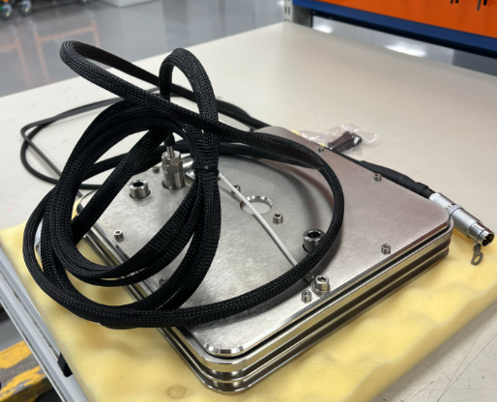
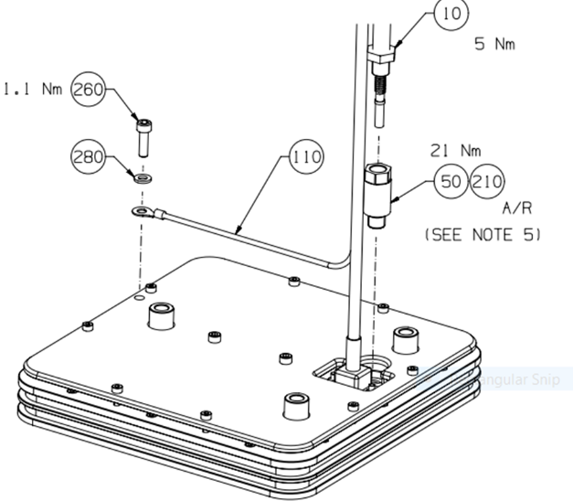
Figure 1: Heater Plate Assembly Drawing
Figure 2: Heater Plate Assembly

The heater plate is then controlled by the PLC during the auto tune operation and through standard operation (machine builds). The system is designed to ensure the heater plate is operating at the desired temperature requested by the customer. During the autotune procedure the heater is set to achieve 100˚C and can take up to 1 hour to achieve. The system architecture involves several interrelated components operating in a hierarchical arrangement. At the lowest level, the heater pack and thermocouple feedback information to the PLC system which then displays the temperature on the HMI screen for the operator to view.

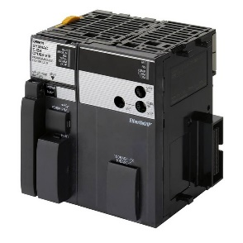
2.3 PLC Inputs and Outputs
Figure 3: CJ2H

To ensure the heater plate is operating correctly the heater plate is autotuned via a PID system within Omron PLC. The PLC used within the AM machines is the Omron Sysmac CJ2H. The PLC is the brain of the AM machine and controls/monitors every single control system within the machine (Omron, n.d.).

The heater has inputs and outputs from the PLC to allow it to be signalled to be ON and OFF. It also has inputs that read the temperature of the heater so it can be displayed on the HMI, used within the auto tune process and for safety reasons on the safety PLC. The safety PLC will not allow to open the door if the heater is reading above 50˚C.

The wiring schematic below shows the heater pack temperature sensor wired to the input card 23A1. This allows the PLC to understand the temperature of the heater which is used for setting heater plate values and the auto tuning process (AMG, 2024).
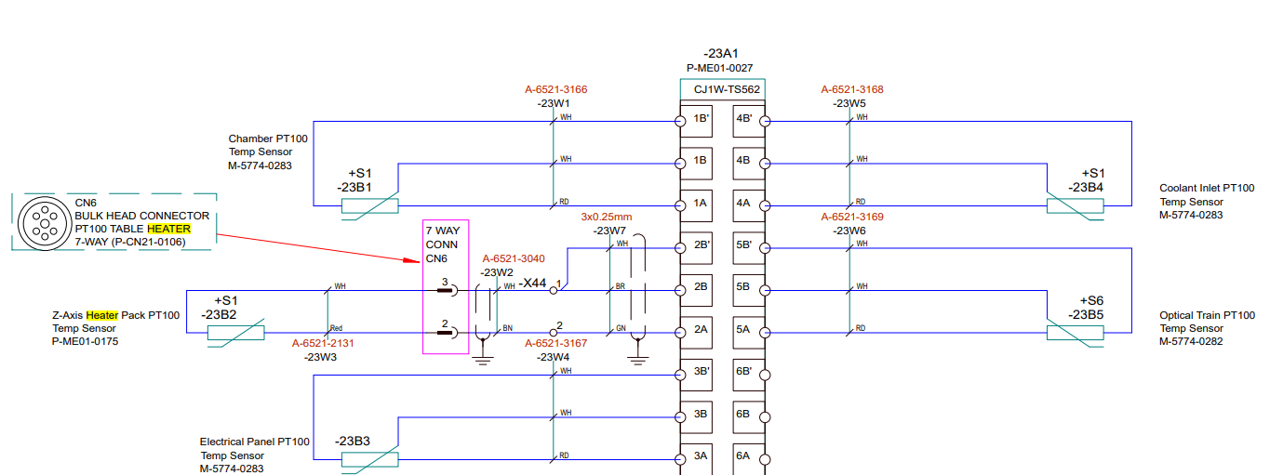
Figure 4: Wiring Schematic

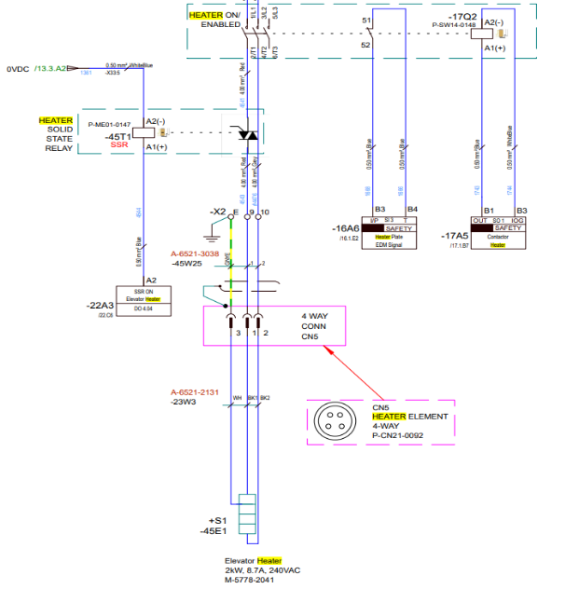
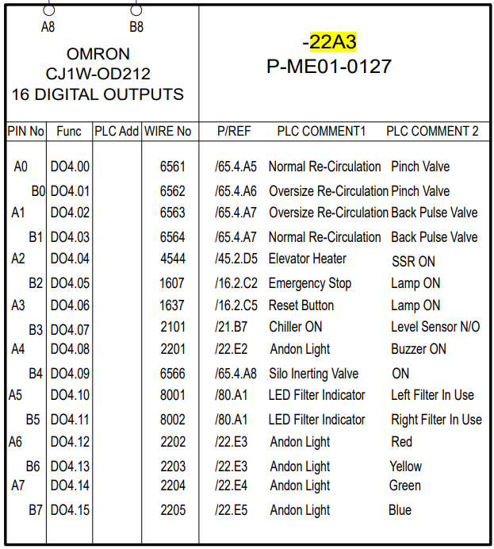
Figure 5: Wiring Schematic (2)
In addition to the temperature sensor, we also have the input from the safety PLC to the contactor for it to give a signal that it is safe to turn on the heater. Following that we have the input from the main PLC which then switches the solid-state relay on from the heater to begin operation.

2.2 Auto-Tune Process
To tune the heater plate’s temperature a function within the PLC called PIDAT (191) is used. When the Auto Tune function is triggered by the technician via the HMI, PIDAT (191) carries out target value filtered PID control with two degrees of freedom according to the parameters designated by the set value. It performs the PID operation in accordance with the parameters that are set after taking the designated input range of binary data from the contents of input word S. Next, the outcome is kept in output word D as the modified variable. The image below shows the operands used within the PIDAT (191) function (Omron, 2007).
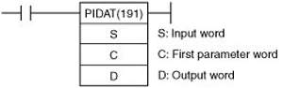
Figure 6: PIDAT (191) Function

The image below shows the first parameter words, a word can be used for several different functions such as Fixed-point numbers, floating point numbers, addresses, registers, memory-processor transfer and instructions. In this case it is used for fixed point numbers and instructions (Kirvan, 2023).

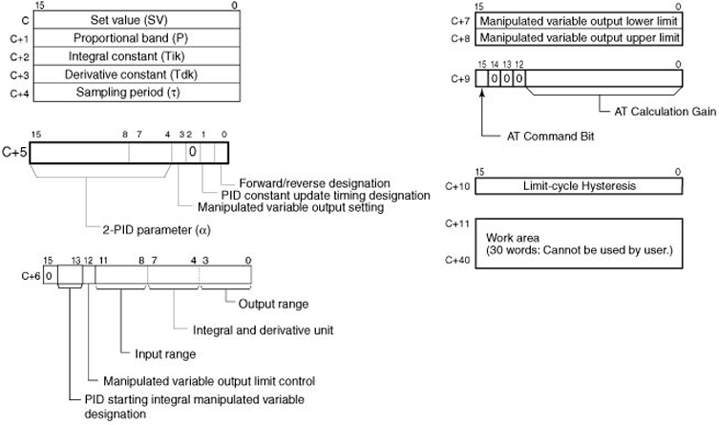
Figure 7: First Word Parameters
The status of the Auto Tune Command Bit (bit 15 of C+9) is checked every cycle. If this control bit is turned ON in each cycle, PIDAT (191) will begin autotuning the PID constants. (The changes in the Set Value will not be reflected while autotuning is being performed) (ACC Automation, 2017). The Auto Tune sampling time is 1s, this is considered low in comparison to other control systems however the temperature of the heater plate does not change that much at a fast pace therefore a 1s sampling time is adequate.

For autotuning, the limit-cycle approach is employed. PIDAT (191) observes the properties of the controlled system while forcing changes to the manipulated variable (max. manipulated variable X min. manipulated variable). Based on the observed features, the PID constants are computed, and the new P, I, and D constants are automatically placed in C+1, C+2, and C+3. PID control now continues using the revised PID constants in C+1, C+2, and C+3, and the Auto Tune Command Bit (bit 15 of C+9) is set OFF. The flow chart below shows the auto tuning procedure and an example of the PIDAT (191) function within CX-Programmer (Omron, 2007).
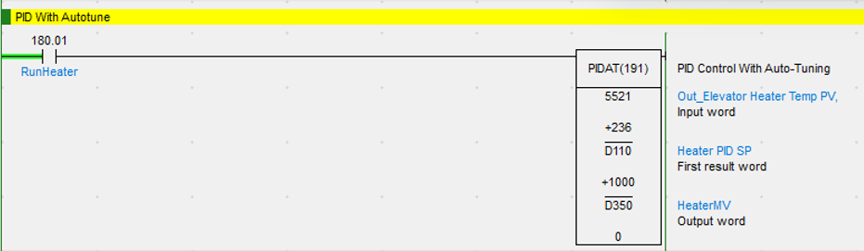
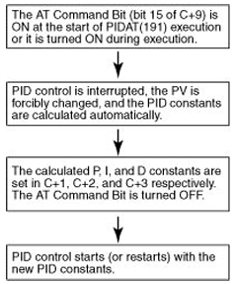
Figure 8: PIDAT (191) in CX-Programmer
Figure 9: Autotune Process
The image above shows that S = Out Elevator Heater Temp PV (Measured Value), C = Heater PID SP (Set Point) and D = Heater MV (Manipulated Value). When investigating this control system within the workplace a test run was performed to see the calculation method of the PID values. The automatic tuning method ‘Limit Cycle’ and takes around one hour. Due to being an automatic tuning method there is no input required from the technician other than the set value. The technician will input the target temperature to 100˚C on the HMI as shown below.

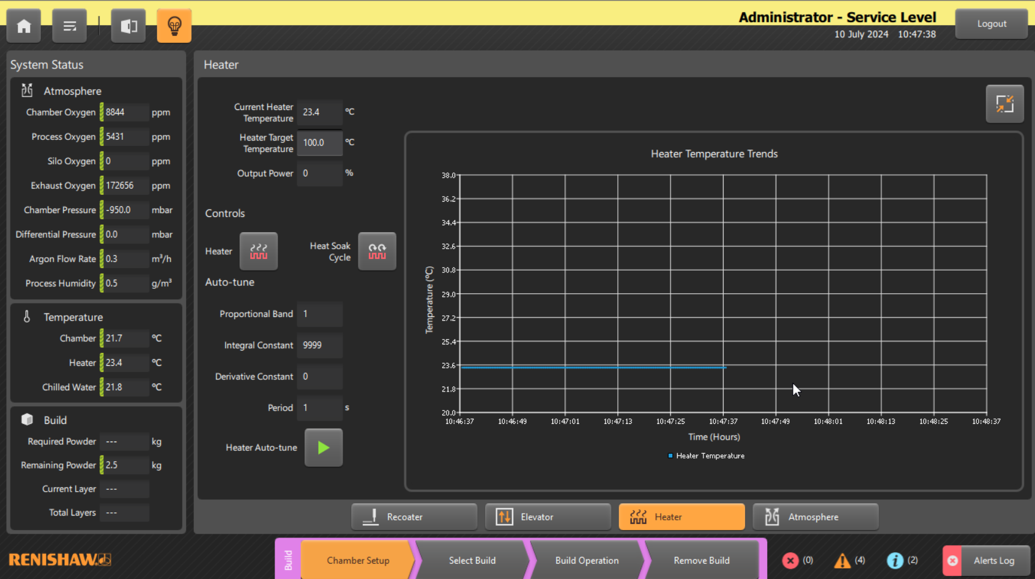
Figure 10: HMI Screen
After the Auto tune has completed the PID values are displayed on the HMI also. These values are then used whenever the heater is turned on as the PIDAT (191) function has calculated these values as the most optimised. To look at the performance of the tuning the additive manufacturing department developed a program called ‘RenAssist’ to analyse the logs from an AM machine. An example of an auto tune is displayed below along with the PID values displayed in the HMI.

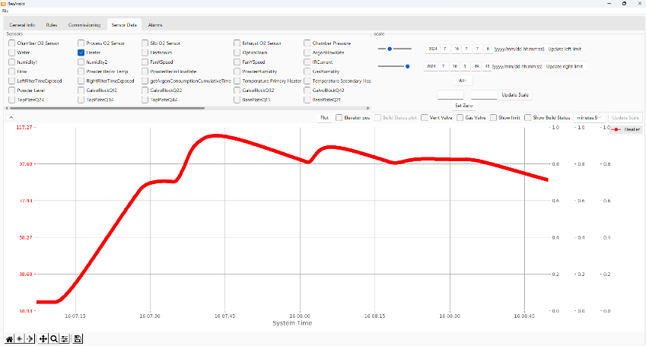
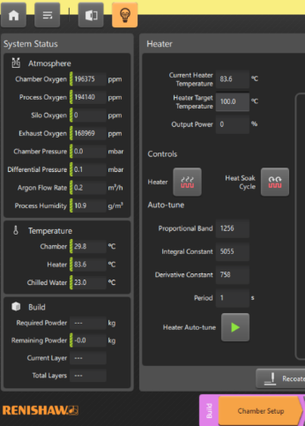
Autotune Complete
Figure 11: Heater Plate Autotune Graph
Figure 12: HMI Screen after AT

2.4 Communication Protocol

Ther are several different types of network protocols, for example Modbus, Profibus, ethernet, RS-232 and many more. They all have positives and negatives and are suitable for different types of control systems (INSTBLOG, 2020). The PLC communicates to the HMI via a router which has been programmed and set up as part of the commissioning process. Ethernet/IP (Ethernet Industrial Protocol) is an extensively used industrial communication protocol. It is a member of the DeviceNet and ControlNet families of Common Industrial Protocols (CIP). The purpose of Ethernet/IP architecture was to give automation devices a reliable, fast, and scalable way to be connected via conventional Ethernet networks (PLC Place, 2021).
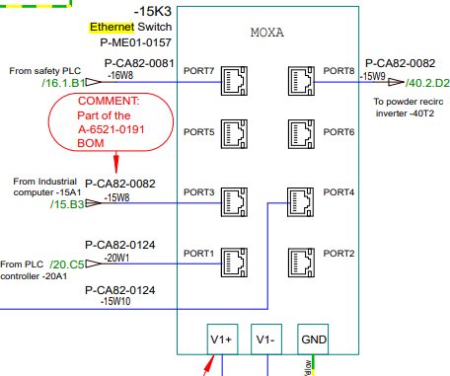
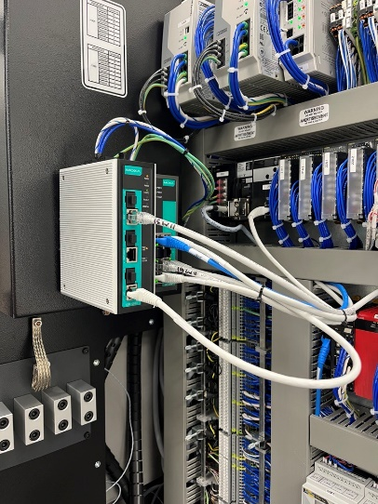
This also allows the benefit for issues to be diagnosed at a faster pace by engineers who support customers. A software commonly used by service/ software engineers is TightVNC. In addition to this some other benefits consist of high-speed communication, scalability, compatibility and security. The high-speed communication is vital in a complex control system as the safety PLC and Control PLC need to be able to communicate at a fast pace; this is because the PLC relies on safety signals and limits to be met to allow certain processes to begin for example inert cyclers, heater operation and to fire lasers.
Figure 13: Wiring Schemtic for Network
Figure 14: Moxa Router

2.6 Enhancements and Upgrades

The control system operates efficiently and is a great function used both by production, service and customers when required. However, there is some enhancements/ upgrades which could make the system for efficient for the user.

One disadvantage of the autotune process for the users is the time taken to complete the autotune process. To improve this a more powerful heater pack could be included in the design and then the sampling time could also be increased to read the temperature of the heater plate and allow the PID system to autotune the system at a quicker rate.

In addition to this I think the PLC system could be upgraded to a more commonly practiced brand like Siemens. In discussions with service engineers and production staff it was found that most of the employees learnt to use siemens during education and then had to learn Omron systems as part of trainings. However, the disadvantage of this is that siemens is typically a mor expensive package to purchase.

Task 2

3. MATLAB Script

To simulate the Cruise Control System in a car a MATLAB script was modelled. The script contains several functions which all contribute to tuning the system via a PID controller.

3.4 Encoding and Decoding Functions for Sensor, Demand and Actuator Signals

When completing the script, it is important that all signals are encoded and decoded. The simulation loop is where the main encoding and decoding takes place.

Firstly, the vehicles raw velocity is measured through a sensor from the communication bus, to ensure this is a true value this is decoded from x-bit binary into miles per hour. This is an important function as it allows raw data to be decoded into usable information. Another example of this would be decoding a signal from a temperature sensor into a degree, which makes it into a human readable format. The image below shows the part of the code which completes the decoding.

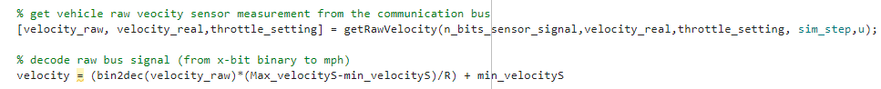
Figure 15: Decoding Function

In addition to decoding the script, encoding is also used. The control signal is calculated via a Calculation Control Function. This signal is then encoded into a binary format to allow for the signal to be communicated to the actuator via communication bus. In control systems, encoding ensures that the control signals are accurately represented and transmitted to the actuators, leading to precise control of the processes and systems.

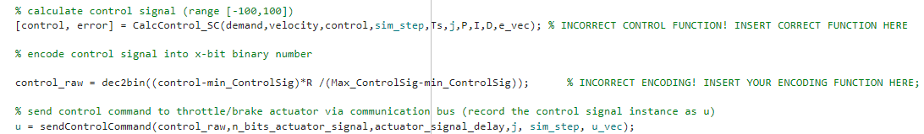
Figure 16: Encoding Function

3.5 Feedback Controller Code

To ensure the control system provides sufficient performance a function was created. The function created is the CalcControl_SC this applies a basic PID control based on the variables stated in the image below. The aim of the script is to reduce the steady state error as much as possible and meet demand.

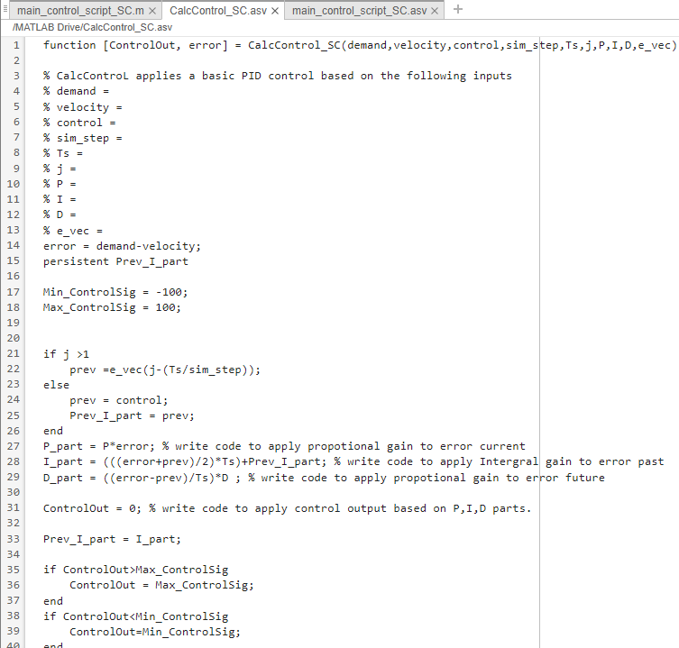
Figure 17: Calc Control Script
It was important to set a up the variables to ensure they are calculating the correct vales, for example error is defined as Error = Demand-velocity, this shows the difference between the demand and the real time velocity being outputted by the system.

In addition to this the calculation behind the P_part, I_part and D_part was created. Firstly, the P_part calculation was created to ensure proportional gain is applied to the error in the current system, I_Part was created to apply integral gain to the past error and lastly D_Part was created to apply proportional gain to the future error.
Figure 18: PID Calculations

3.6 Gain Selection

To calculate the optimum performance a manual tuning method was used. To begin the process the Proportional gain was set to a value of ten and the integral and derivative being set to zero. From the graphs below you can see the graph is very noisy with a lot of error.

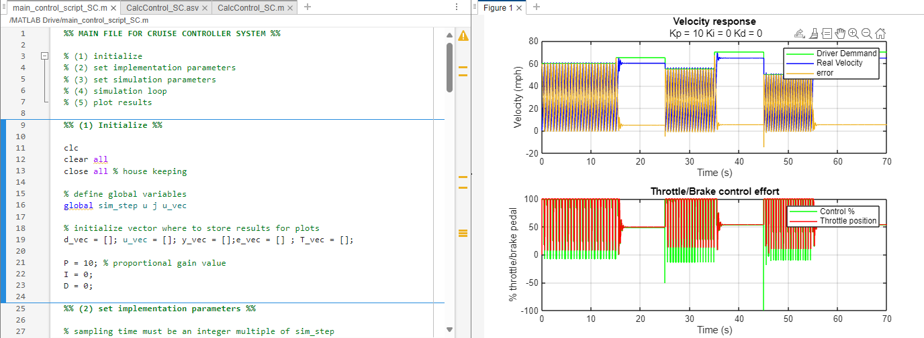
Figure 19: Initial Gain Selection

To counter this an integral value has been introduced to ensure try and eliminate the past error, the integral was set to 0.5. Typically, its known that the proportional gain is the greatest in magnitude, followed by the integral and the derivative being the smallest. The graph below shows an improvement to the system with demand being met however there is still a considerable amount of error within the system.

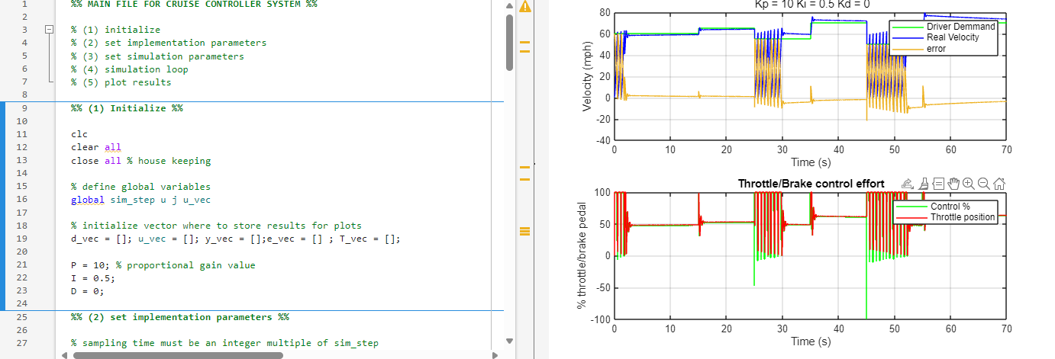
Figure 20: Introducing Integral Gain

Finally, the derivative was introduced with a gain of 0.2. This improved the system considerable by reducing a lot of the error and maintaining the velocity in comparison to demand however there is still slight noise within the system.

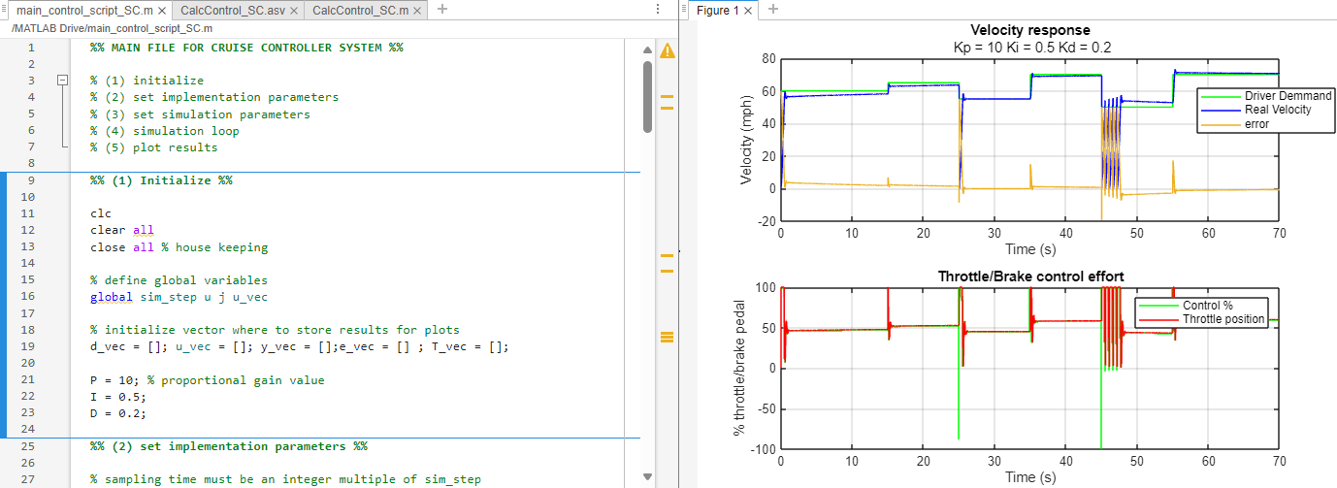
Figure 21: Introducing derivative gain.

To calculate the optimum performance a lot of trial and error took place following the same process as above. The final values calculate were Kp = 14, Ki = 1.5 and Kd = 0.7. This graph below shows the demand and velocity corresponding with and very little error in the system. However, there is some issues with the script as there are drops in velocity at 25 and 45 seconds. In the future this would be improved to represent a cruise control system more accurately.

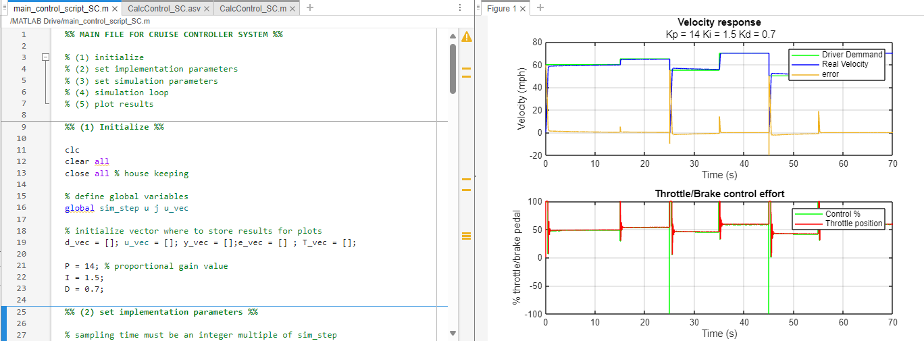
Figure 22: Optimal Gain Selection

3.7 Sampling Time and Bit Range

Setting a bit range of 16 bits and a sampling duration of 0.05 seconds in the MATLAB script typically involves specifying settings for data gathering or signal processing operations. To properly capture the dynamics of the signal from the cruise control system, the sampling time which is the gap between successive samples is essential. The signal is sampled every 50 milliseconds in this instance, according to the 0.05 second sampling time. The MATLAB script can guarantee that the signal is appropriately sampled to prevent aliasing while collecting crucial features of the signal's behaviour by defining this sampling rate.

The resolution of the analog-to-digital converter (ADC) employed in the data acquisition process is denoted by the bit range of 16 bits. This high resolution allows for precise representation of the signal's amplitude, which is critical in applications requiring detailed signal analysis or when dealing with signals with a wide dynamic range (DATAQ, 2024). The script can efficiently balance amplitude precision and temporal resolution by combining a 16-bit bit range with a 0.05-second sampling time, resulting in a reliable and precise signal representation.

3.8 Performance Trade-offs

The vehicle's velocity response is the measure of how fast and precisely its speed achieves the intended setpoint. A velocity response that is good shows a fast rise time which is the time it takes for the velocity to reach the initial setpoint, minimal overshoot and a short setting time. While increasing the proportional gain usually shortens the rise time and lowers the steady-state error, it also increases the risk of instability and overshoot. Zero steady-state error is ensured by the integral gain, but an excessively large value can slow down the system and lead to instability. The derivative gain attenuates the system's response to abrupt changes in error, which helps to lower overshoot and increase stability.

The control effort refers to the amount of action taken by the controller to achieve the desired velocity. High control effort can lead to increased actuator wear and inefficiency. One way to reduce the control effort is to decrease the proportional gain. This can lead to a higher steady-state error yet decreases the mistake's quick response. Cutting down on the integral gain This reduces the number of past errors accumulated, which lowers control effort but might allow steady-state error. modifying the gain from a derivative as a result, there may be less sudden shifts in the control action.

Conclusion

The heater plate is a critical component in the additive manufacturing process, maintained through a PID controller within an Omron PLC. The system's mechanical build includes several parts such as the top plate, heater pack, and thermocouple cable, ensuring efficient operation. During the auto-tune process, the heater plate is calibrated to achieve precise temperature control, taking approximately one hour to reach 100˚C. This process, though time-consuming, guarantees optimal PID constants for consistent performance. Enhancements such as a more powerful heater pack and upgrading to a more widely used PLC brand like Siemens could further improve system efficiency and user experience.

The MATLAB script simulates a car's cruise control system using a PID controller to ensure efficient and accurate velocity control. It includes encoding and decoding functions for sensor, demand, and actuator signals to translate raw data into usable information. The feedback controller function CalcControl_SC aims to minimize steady-state error and meet velocity demands. Gains were manually tuned, with final values of P = 14, I ​=1.5, and D ​=0.7 providing optimal performance. The script's 16-bit range and 0.05-second sampling time ensure precise signal representation, balancing amplitude precision and temporal resolution. Trade-offs between velocity response and control effort were carefully managed to achieve a stable and efficient control system.

References

ACC Automation (2017). Omron CP1H Data Control Instructions | ACC Automation. [online] accautomation.ca. Available at: https://accautomation.ca/omron-cp1h-data-control-instructions/?utm_content=cmp-true [Accessed 28 Jul. 2024].

AMG (2024). RenAM 500ML Wiring Schematic. [online] Renishaw. Available at: Inetrnal Document [Accessed 28 Jul. 2024].

DATAQ (2024). How Much ADC Resolution Do You Really Need? [online] www.dataq.com. Available at: https://www.dataq.com/data-acquisition/general-education-tutorials/how-much-adc-resolution-do-you-really-need.html#:~:text=The%20bit%20value%20of%20an%20analog-to-digital%20converter%20refers [Accessed 28 Jul. 2024].

INSTBLOG (2020). 30+ Most Useful PLC Communication Protocols. [online] INSTBLOG. Available at: https://instrumentationblog.com/plc-communication-protocols/ [Accessed 28 Jul. 2024].
Kirvan, P. (2023). What is word? | Definition from TechTarget. [online] WhatIs.com. Available at: https://www.techtarget.com/whatis/definition/word [Accessed 28 Jul. 2024].

Omron (n.d.). Programmable Logic Controllers (PLC) | What is a PLC? | PLC Types? [online] industrial.omron.co.uk. Available at: https://industrial.omron.co.uk/en/products/programmable-logic-
controllers#:~:text=Programmable%20logic%20controllers%20hardware%20and%20programming&text=The%20CPU%20is%20the%20brain [Accessed 28 Jul. 2024].

Omron (2007). PROGRAMMING MANUAL SYSMAC CP Series CP1H-X40D@-@, CP1H-XA40D@-@, CP1H-Y20DT-D CP1L-L14D@-@, CP1L-L20D@-@, CP1L-M30D@-@, CP1L-M40D@-@ CP1H/CP1L CPU Unit. [online] Available at: https://www.fa.omron.com.cn/data_pdf/mnu/w451-e1-03_cp1h_cp1l.pdf?id=1916 [Accessed 28 Jul. 2024].

PLC Place (2021). Understanding PLC Communication Protocols: Modbus, Profibus, and Ether. [online] PLC.PLACE. Available at: https://plc.place/blogs/state-of-automation/understanding-plc-communication-protocols-modbus-profibus-and-ethernet-ip [Accessed 28 Jul. 2024].

