

LEVEL 6

SEMESTER 2

MODULE CODE: SHSS6078
Assessment in Physical Education
aSSESSMENT TYPE: aSSIGNMENT
Assessment/Component: 1
COMPONENT WEIGHTING: 50%
WORD COUNT: 3000 WORDS
MODULE TUTOR: Dylan Blain

Assessment portfolio:
You are a Physical Education teacher and have been tasked with preparing a report for a pupil who is moving on from your school. As part of the process you are required to create and use an assessment rubric which is firmly based in the literature surrounding the valued outcomes for physical education. Once the assessment is complete and report written, you are required to reflect upon the effectiveness of the assessment process undertaken.
The portfolio should contain four parts:
- A detailed rationale underpinning the creation of the rubric. This should be firmly based on high quality and relevant literature form the field.
- An assessment rubric to assess outcomes within a physical education lesson (please include a copy of the completed assessment).
- Having used the rubric to assess a pupil, a report detailing the pupil’s current levels and their next stages of learning.
- A critical reflection on the effectiveness of the assessment process undertaken. Use relevant literature to support this.

SUBMISSION DETAILS: 13th April 2018

School of Sport, Health & Outdoor Education

Assessment Feedback Sheet

Student No./Name: 1501026/ Adam Butler
Module: Assessment in Physical Education
Module Code: SHSS6078

Personal Evaluation – to support your academic progress please complete the section below BEFORE submitting your work.
What do you consider to be the best aspects of this work? |  |  | I feel that the rubric is in great detail, encompassing a wide range of the aims within PE
Which aspects do you consider could have been improved in this piece of work? |  |  | I feel that the process of assessment could have been more effective, with some vague criteria.
What have you found most satisfying whilst undertaking this submission? |  |  | The positive impact that assessment can play within a quality PE experience for all pupils, and its role for teachers.
ASSESSMENT CRITERIA | Learning  Outcomes |  | GRADE
ASSESSMENT CRITERIA |  |  | Poor  0-25% | Unsatisfactory  26-39% | Satisfactory  40 – 49% |  | Good  50 – 59% | Very Good  60 – 69% | Excellent  70 – 85% |  | Exceptional  86– 100% | %
Detailed assessment rubric | 1, 2, 3 |  |  |  |  |  |  |  |  |  |  | 35%
Quality of rationale underpinning assessment rubric | 1 |  |  |  |  |  |  |  |  |  |  | 15%
Pupil report | 2 |  |  |  |  |  |  |  |  |  |  | 25%
Reflections on the assessment process | 1, 2, 3 |  |  |  |  |  |  |  |  |  |  | 25%
It is expected that students will present work that is proof read, correctly referenced and adheres to the Assessment Checklist. Therefore a range of 0 – 10 marks will be deducted for non-completion of any of the points on the checklist below.
TUTOR COMMENTS:

Submission date:  via Turnitin |  | Return date:  (at least within 4 weeks) |  |  |  | Tutor: |  |  |  | Mark:

Assignment Checklist

- Please complete the Personal Evaluation section of the Assessment Feedback sheet, add your name and details, and paste the whole of this assignment document into the front of your assignment

- Submission is a single word file, clearly labelled with your name and module code
- Font style - Times New Roman, size -12 for text and 14 for headings
- Ink colour – black only
- Line spacing – 1.5 line spacing and 2cm- 2.5cm page margins
- Quotations more than three lines to be indented 1 line spacing
- One line space between paragraphs, paragraphs must be left aligned
- Pagination (your assignment should have page numbers)
- All tables and figures are internally referenced and have a title
- Word count checked and written at end of text (before references and any appendix)
- Assignment is within 10% of the word limit (excluding references and any appendices)
- All references in the text are included in the reference list
- Correct referencing following the Harvard style, as described in the Palgrave study skills book ‘Cite them Right’.
- Correct spelling using UK English
- Correct use of punctuation
- Grammar and syntax correct- double check anything that has a green line under it
- I have read my assignment out loud to myself and it makes sense and is easy to read
- Somebody else has read my work and it makes sense to him or her!
- I have checked and I have not plagiarised
Failure to follow these guidelines will cost you marks!
Assessment Portfolio.

The assessment portfolio will be focusing on the physical education (PE) report of one pupil hypothetically transferring schools. In order to construct a report, there will be a rubric created in order to identify what the aims of learner development should be included within key stage 2 physical education, and what would the learner need to achieve in order to gain an accurate level of their physical education and how they can develop and progress on their individual journey. In order to obtain an accurate assessment of the pupil, there will be a rationale for the aims of physical education and literature to support what domains of pupils learning should be assessed within PE. Following the identification of domains and aims to assess in PE, there will be a rubric created, including the criteria for each level, and paths of progressions for each domain of learning. This rubric will be used in an attempt to assess the pupil through a quality and authentic form of assessment, thus providing the basis for writing a report on the pupil in relation to level and what they need to aim for to achieve the next progression in each domain. Following the report there will be a critical reflection on the assessment process.

What to assess
Assessment within PE have varied and developed in parallel with the ever dynamic aims within PE (Kirk, 2010; Placek, 1983). Aims of PE have progressed from the times of war preparation through drill and gymnastics, through to the overemphasised focus on traditional team sports (Lawson, 1998), producing the “physical education-as-sport-techniques” (Kirk, 2010: 222). Decontextualizing team sports to the basics of multiple introductory units of work and skills being taught over and over again, through a directive, command style of teaching (Siedentop, 2002; Lounsberry and Coker, 2008; Kirk, 2010). Assessment has very much taken a progression journey of its own, from merely objectifying to ensure that students are active and having fun, or “busy, happy, good” (Placek, 1983), through to assessing physical fitness and skills, complying with the current aims of PE (Birky, 2012). Birky (2012) mentions of the problems that arose from the transition, and which are arguably remain a barrier to authentic assessment within PE.

“Physical fitness tests and other skill tests are often employed in an attempt to give a semblance of objectivity to physical education grades. These tests do not accurately assess learning within physical education. Students with little ability and lots of desire are often handed below-average grades, which can discourage them from remaining physically active”
(Birky, 2012: 19).

There are currently discussions on the inclusions of fitness testing, and forms of assessment within PE (e.g. Cale and Harris, 2007; Lloyd et al, 2010), therefore consideration of the aims of PE and what to assess within PE weighs heavily on the pupils holistic development (Lund and Veal, 2013; Wang and Rairigh, 2006).

Physical Education can achieve a range of learning outcomes for its pupils, providing the experience is rich, high in quality and authentic (Kirk, 2013; Lockwood, 2000; Siedentop, 2002). Bailey et al (2009) emphasise the four broad aims of PE as; Physical, Social, Affective and Cognitive. These four components are believed to influence students with rich experiences within PE, in turn, creating physically activity individuals whom recognise the value and importance of leading a healthy and active life (Bailey et al, 2009). These learning domains influence the assessment rubric greatly due to their importance.

The physical domain is the arguably the most evident domain focused within PE, with the importance of the fundamental motor skills (FMS) regarded as the ABC’s of movement, or the building blocks within development of pupils physical competence, aiming to reach a proficient level in order to participate in lifelong physical activities, sport and games (Gallahue et al, 2012). Seedfeldt (1980), Clarke and Metcalf (2002), and Stodden et al (2008) all emphasise the importance of a proficient level of FMS needed to successfully participate within a range of PE, with the mastery of FMS “the foundation of almost all later sporting and physical activities” (Gallahue & Ozmun, 1998). Through pupils development of FMS, progressions into game specific motor and movement skills can occur (Clarke and Metcalf, 2002), influencing pupils’ intrinsic motivation to partake fully within physical activities and sports within PE and outside of education, essential to leading a healthy and active lifestyle (Ryan and Deci, 2000; Stodden et al, 2008). Pupils participation within physical activity and sport beyond PE is therefore a factor in which is considered within the rubric, with pupil application and effort a contributing element in order to gain a holistic understanding of the pupils physical capabilities and recognise progressions related to the pupils unique leaning needs (Birky, 2012; Giblin et al, 2014).

The social and affective domains are both considered within the rubric, PE has the capacity to engender positive social behaviours such as cooperation, personal responsibility, empathy, leadership and negotiation within its roots of participation within a wide range of social situations and environments (Ennis, 1996; Bailey, 2005; Bailey et al, 2009). These dynamic, social environments available to PE, contribute value to pupils acquisition and accumulation of a range of personal, social and social-moral skills which can influence pupils ability to function successfully and acceptably in various social situations which arise in and outside of physical activities and sports (Bailey, 2005; Sandford et al, 2006). The opportunity to partake in a range of social interactions gives pupils the opportunity for instant feedback, with visibly bad attitudes other pupils, peers and teammates evident, with various degrees of consequences for the pupils, from extremes of exclusion from the group for a period of time, or realisation of their own behaviour leading to adaptation of their approach to interaction to others and themselves within a physical activity setting (SHAPE America, no date).

The cognitive domain is one which is last learning domains to occur within pupils of a younger age, with every pupil’s brain, developing at their own individual rate (Bailey et al, 2009). Within PE, the cognitive domain aims to develop the knowledge and understanding of different skills, movements, and behaviours, and how they can effect different changes to the body (Ontario Curriculum, 2015; Bailey et al, 2009). The domain endeavours the progression to promoting a ‘healthy body, healthy mind’ cognitive process (Snyder and Spreitzer, 1977), supporting Whiteheads (2001) monist concept of being, emphasising the holistic human development of an individual, rather than the dualist approach, decontextualizing the body and mind. With these factors I mind, the assessment will consider not only the cognitive capabilities, but the ability to develop the knowledge and apply it to various physical situations, environmental situations and lifestyle behaviours which all develop pupils health simultaneously. This somewhat relates to Biggs and Collis (1982) SOLO taxonomy, focusing on the individuals cognitive or SOLO levels, which Biggs and Collis (1982) set out as;

- Prestructural (no to little understanding)
- Unistructural (understanding of one element)
- Multistructural (understanding number of elements but not the pattern of relationships between them)
- Relational (understanding of the links between the elements)
- Extended abstract (the ability to relate the concept to context and other concepts)
(In: Dudley, 2015)

Biggs and Collis (1982) SOLO taxonomy is the an aim within the cognitive domain of PE, with the aim of developing pupils to reach the relational an extended abstract levels of understanding, which promotes a deeper thinking and understanding to imagery and seeing the bigger picture within a range of PE, sport, physical activity, and overall health contexts (Dudley, 2015; Hattie and Brown, 2004). Therefore, pupils level of SOLO taxonomy will be considered when assessment of their progress.

Through a reoccurring theme of body and mind as one, and a holistic development of pupils, there is growing emphasis on the inclusion for Whitehead’s (2010) Physical Literacy to become a main aim within PE (Giblin et al, 2014; Jurbala, 2015). Through the concepts growing popularity with “breath-taking rapidity” (Jurbala, 2015: 367), through its embracement in the Canadian Sport for Life movement, the Canadian Sport Policy 2012, and is included within sport plans across Canada as a foundation for sport participation and community sport strategies (Balyi and Way, 2005; City of Mississauga Sport Plan, 2013; Vancouver Sport Strategy, 2008; Jurbala, 2015 ), considering the concept as “both a new approach to physical education and a stepping stone to sport excellence” (Jurbala, 2015: 367). Therefore it would be ignorant to dismiss the influence of Whitehead (2010) 3 components of physical literacy; Physical, Behaviour and Psychological within the rubric, considering pupils physical competence and performance, perceived confidence, enjoyment, and their beliefs on whether physical activities are valued and considered worthwhile (Giblin et al, 2014; Whitehead, 2007). These elements combined with the ability to set goals, imagery and reflect, which influence individual’s ability to invest time to practice and stay committed to pursuing personal excellence within physical activity for the life course (Giblin et al, 2014; Whitehead, 2010). These are factors that have been integrated to within the assessment rubric.

In addition to the learning domains, influences of physical literacy, there are elements that contribute to the leading of a holistic development of a pupil’s healthy life, incorporating a physical education and health stance on the rubric (Ontario Curriculum, 2015). Elements such as; nutrition, time spent on electronics, and mental and emotional health, all contribute to the holistic health of pupils (Ontario Curriculum, 2015; Welsh Assembly Government, 2017a, b).

Assessment methods:
Assessment within the rubric is one which can occur in various forms, assessing various aims and learning outcomes of PE, with Penney et al (2009: 435) stating that: “quality assessment practices in PE should focus on intended student learning; be authentic from a learner perspective; be inclusive in construction and enactment, and be defensible in relation to validity and reliability.” The argument of what should be assessed within PE has prolonged over decades, from Placek (1983) emphasising the need for change from fitness testing pupils, and comparing their scores to those of the class, year and area (Macdonald and Brooker, 1997), or furthermore, de-contextualised case of assessing skills within isolation, with assessment ultimately focusing on the product (Metzler, 2000; Penney et al, 2009). Lopez-Pastor et al (2012) mentions of the need for children to be able to play the game successfully, not only focusing on assessing motor skills, but game awareness and knowledge. In order to provide a quality and authentic form of assessment, the focus must not only focus on the product of fitness or isolated skills. Macdonald and Brooker (1997) stated that “quality assessment within PE should focus on intended student learning; be authentic from a learner perspective; be inclusive in construction and enactment” (Penney et al, 2009).

To enrich the assessment process of the rubric factors influencing the quality of assessment has been taken into consideration. The forms of assessment is focused on students learning, with students a part of the assessment process, through a peer and self-accessible assessment rubric (Metlzer, 2011). The rubric forms the platform for both summative and formative assessment opportunities, although in this instance the assessment used to form the report is the later. Through the formative assessment, the aim is provide an opportunity for teachers gain feedback on student learning, to ensure changes can be made during the pupils unit of work to work towards (Metzler, 2011). Therefore the outcome is for the teacher to use an assessment ‘for’ learning, to provide guidance and set goals for individuals to go on and achieve (Black and Wiliam, 2001). The formative assessment has been shown to contribute to student learning with Black and Wiliam (2001) stating that formative assessments can ‘so called low attainers.’ Fuchs et al (1997) supports this as frequent assessment feedback aids with students valuing their own learning, which can deter some students from becoming disruptive within lessons and gain more a greater educational experience. An important factor within the feedback and pupil centred learning is the shared experience of assessment between pupils and teacher (Tolgfors, 2018). Although this assessment focused on a report, could be considered a summative assessment, if the report comes concluding a unit of work or term, there may be elements of assessing the pupils’ knowledge on the content learnt (Metzler, 2011). The rubric has also followed a criterion-based assessment, through the use of levels the students’ scores which can be compared to standards and then equated into levels (Metzler, 2011). These criteria’s can be versatile and adapted in order to broaden on specify different aims which may be relevant to the further development of pupils. This rubric also uses a form of ipsative assessment, where the pupil has the opportunity to set their own target and are assessed based in relation to their previous experience or score (Metzler, 2011). These methods of assessment have been chose to create a student centred approach, with the aims and goals being individually set to each student, progressing their own unique learning needs (Placek, 1983; Birky, 2012). In order to achieve a holistic understanding, various forms of assessing must be used, from a formal written exam to a shooting drill where the coach counts the number of mistakes and goals, to informal discussions and interactions surrounding different topics relating the skills, well-being and understanding (Metzler, 2011). Overall all these forms of assessment must be considered in order to gain a rounded understanding of an individual’s knowledge (Placek, 1983; Penney et al, 2009; Birky, 2012).

Student Report
*The name of the student has been changed for this report to ensure confidentiality.

Name: Carl Jones.
Age: 10.
Key stage: 2.

Carl Jones has been a pleasure to teach during his time with us at the school and has begun to develop his skills within the Physical, Social, Affective, and Cognitive domains. His recent observation assessment has been included for your viewing.

Within the Physical domain, Carl has recently achieved a range of level 2 movement skills, with evidence of a basic practice of movement skills in some activities participating in. Carl does require goals set to practice his object control and fine motor skills. Carl achieved a level one in object control, catching and throwing. To achieve level 2 in these techniques, attention should be provided in enabling to revisit the correct techniques on how to hold and control objects, catching and throwing, before allowing opportunities to improve the techniques through the use of different equipment and different activity contexts. Carl also requires guidance and assistance when progressing isolated or free techniques into skills specific activities, with difficulties arising when specific movements and skills are required to be successful in an activity, Carl finds strike and field, and certain net ball games especially problematic. To ensure Carls physical development progress, continued guidance on the techniques of movement is required with guidance into how these can transpire into skills specific to activities and various forms of physical activity.

Carls Social and Affective assessment was extremely pleasing to see, achieving level 3 in the aspects of engagement, his attitude towards classmates and teacher and his general mood and well-being. He has achieved this through good attention and interaction within lessons, always trying his best in any activity, and interacting with classmates and the teacher respectfully, and is often empathetic to others ideas in group tasks. Carl does have some areas for improvement within the domain, when faced with a problem he cannot solve, frustrations run high and does not like to be around anyone and will exclude himself from the task. Therefore guidance and encouragement can allow him to become more patient in problem solving, and planning for progressive problem solving tasks could be used to aid his development. This approach combined with his general manner should see him achieve level 3 in due time. Carl achieved level 2 in participating within discussions, which is an average level for pupils of this age, but can be improved through contributing further in discussions, some ‘icebreaker’ activities would aid Carl in becoming more familiarising with his class, especially within a new class. To ensure Carls positive social and affective development constructive feedback should occur on regular occasions, formal and informal assessments of his general wellbeing, with carefully planned problem solving activities with praise for effort within a range of various tasks.

Carl’s cognitive development has begun to show signs of development, through achieving a level 2 in activity knowledge and understanding. As mentioned within the physical domain, Carl finds it difficult to transfer techniques into game specific skills, although he has a basic understanding of the activity, the missing like to achieving higher aims is the physical competence of the skills. This problem also contributes to Carl’s development of ideas, he can develop progress some ideas one stage or two stages further in one or two activities, but requires assistance in reaching that level. Therefore some peer-assessment techniques could be a learning tool for Carl. Through the use of his good communication and social skills, pair work where he must observe and question the others movements may encourage his thought process to recognise how different movements can progress.

Through a quality PE, there is nothing stopping Carl from achieving the higher levels across all domains of learning, with regular forms of formal and informal assessment and feedback contributing to the effectiveness of both education and assessment effectiveness.
I have no doubt that Carl will develop into a competent individual, and wish him all the best in his physical education.

Kind regards,
Mr Adam Butler.

Evaluation of assessment process:

The process of assessment has been a challenging one providing the short opportunity for assessing the pupil, with only observational assessments available to gain an insight into the knowledge and understanding of the pupil towards various aims of PE and without context of what has been taught so far in order to assess what the pupil has been taught. Through the limited observational assessment, it was problematic to identify the level of physical capabilities, assessing without much reliability, as they may perform a certain skill well 2-3 times in the one lesson, numerous throws for example. Is it an accurate reflection of their capabilities and goal hitting the target twice in succession without other opportunities to assess, or two very good shots that the pupil hasn’t really understood how he’s hit them, or not even necessarily knowing they were aiming at the targets hit? (Penney et al, 2009). The process of assessment definitely requires various forms of assessment, ranging from both formal to in-formal to gain an authentic understanding of the pupils’ development (Metzler, 2011). Although this process can be seen to be an uphill task, with the large class sizes, limited time for PE and a range of criteria, the teacher has many barriers to assessing every child authentically and accurately (Birky, 2012; Tolgfors, 2018). The use of shared assessment is portrayed within the assessment form attached (‘My PE journey’) (Metzler, 2011). Through this approach with guidance of setting goals and highlighting the things needed to improve on as a process. Through student involvement a unique guide to their development, emphasising not only their knowledge and planning, but relatedness with the teacher also can be provided (Ryan and Deci, 2000; Tolgfors, 2018).

During the creation of the rubric, there was some emphasis on elements influences from physical literacy and other health and physical education curriculums, with assessment of elements focusing on behaviour and psychological attitudes (Giblin et al, 2014). Elements such as technology usage, participation in physical activity outside of PE, knowledge on food and water consumption, and elements revolving mental health and general wellbeing cannot be assessed accurately within an observation, but are all argued as important health elements that need to be considered for pupils (Giblin et al, 2014; Welsh Assembly Government, 2017a, b). Therefore assessments such as; feedback, logs, the use of social media, and entry and exit cars could be helpful in gaining knowledge and understanding of the area focused on within the lessons and level of health and well-being (Lopes-Pastor et al, 2012; Lynch and Monk, 2017). The additional focus on assessing behaviour and attitudes within PE a positive as attendance and willingness to exert themselves can impact their perceived value of learning and value physical activity, corresponding to its effects (Tolgfors, 2018).

Therefore the role of assessment can have a positive impact on pupils learning through formative assessing throughout, with regular assessment and feedback to ensure all leaners are progressing and developing.

Word count: 3288.

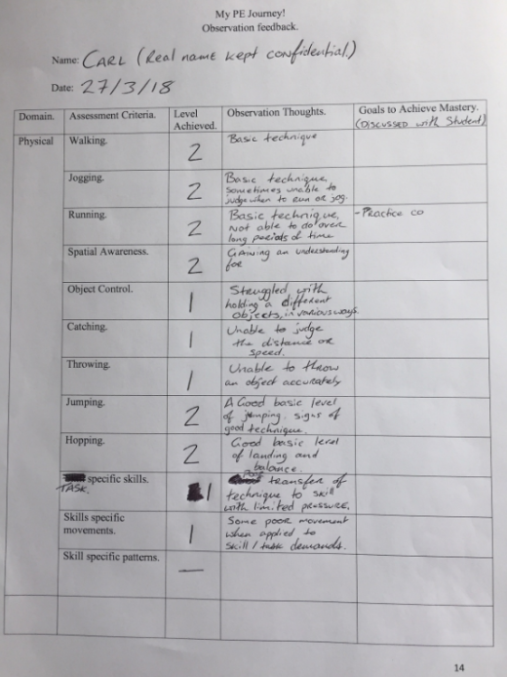

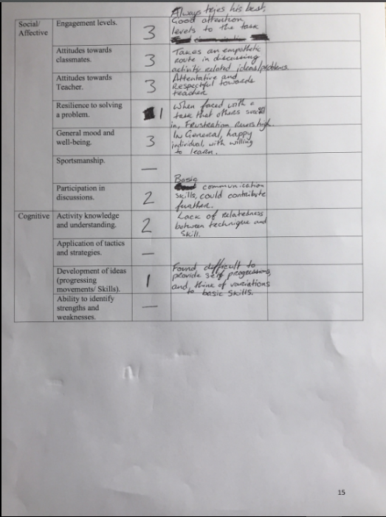

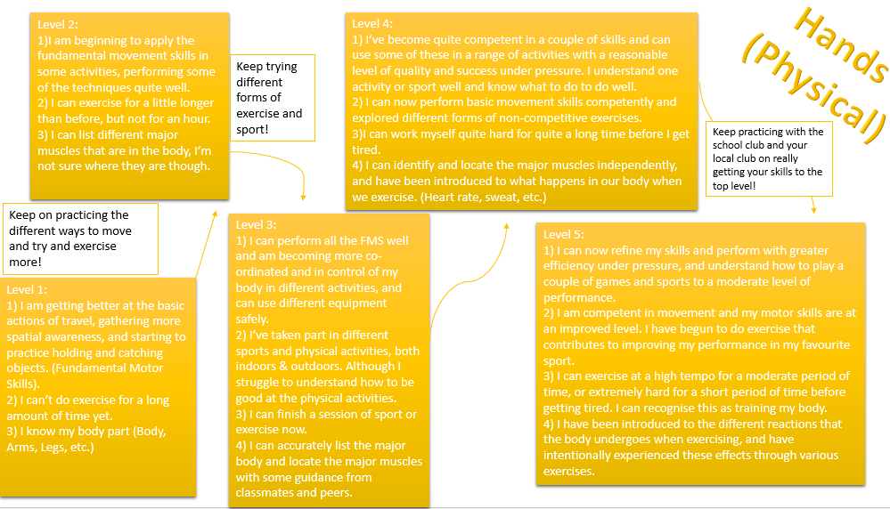
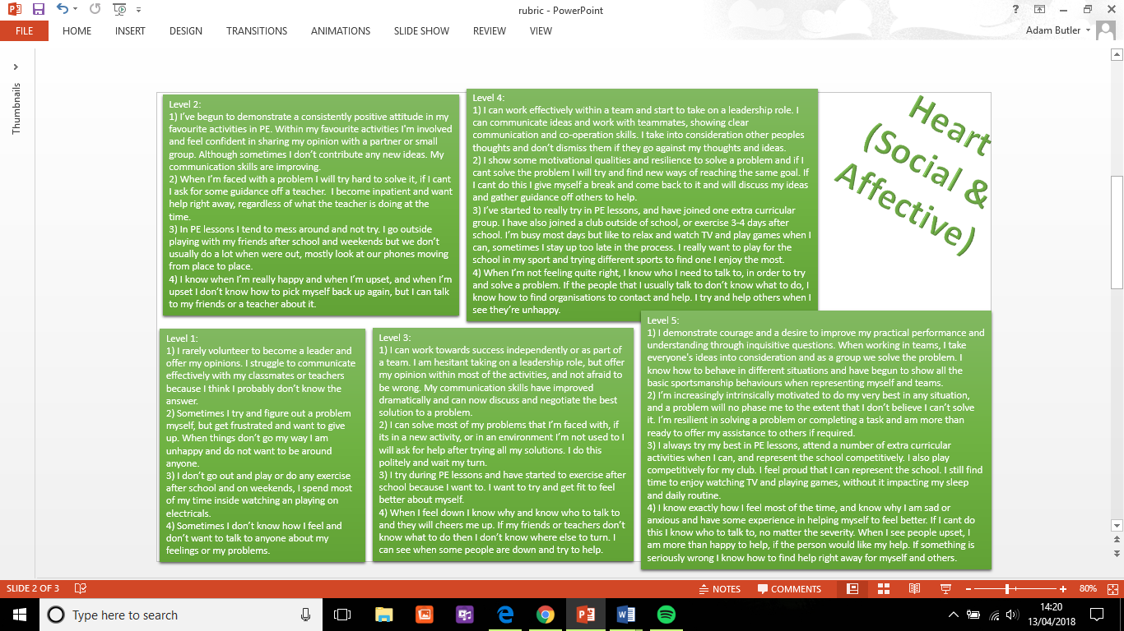
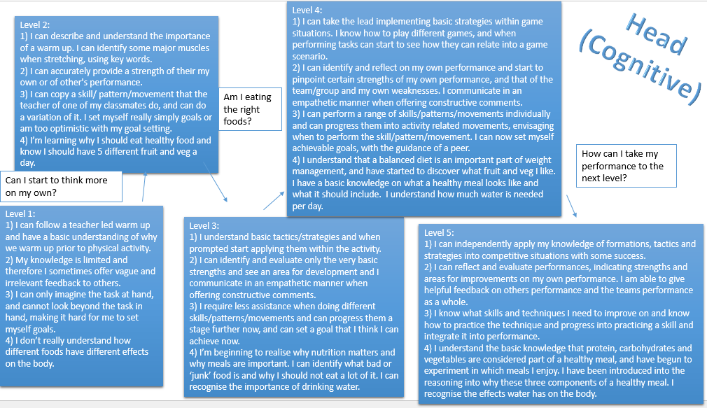

Bibliography:

Bailey R. (2005). Evaluating the relationship between physical education, sport and social inclusion. Education Review 57, no. 1: 71–90.

Bailey, R., Armour, K., Kirk, D., Jess, M., Pickup, I., Sandford, R. (2009). The educational benefits claimed for physical education and school sport; an academic review, Research Papers in Education, 24; 1, 1-27.

Balyi, I., & Way, R. (2005).Canadian Sport for Life: Long-term athlete development. Vancouver: Canadian Sport Centres.

Biggs, J., & Collis, K. (1982). Evaluating the quality of learning: The SOLO taxonomy. New York, NY: Academic Press.

Birky, B. (2012). Rubrics: A good solution for assessment. Strategies, 25(7), 19-21.

Black, P., & Wiliam, D. (2005). Inside the black box: Raising standards through classroom assessment. Granada Learning.

Canadian Sport Policy 2012. (2012). Ottawa, Canada: Government of Canada, Department of
Canadian Heritage.

Clarke, J, E., and Metcalfe, J. (2002). The mountain of motor development: A metaphor. Cited from J.E. Clark & J. Humphrey (Eds.), Motor development: Research and reviews, Vol. 2. (Pp. 163 – 190). NASPE Publications: Reston, VA.

Dudley, D. A. (2015). A conceptual model of observed physical literacy. The Physical Educator, 72(504), 236-260.

Ennis, C. D. (1996). When confrontation leads to avoiding content: Disruptive students' impact on curriculum. Journal of Curriculum and Supervision, 11: 145–162.

Gallahue, D. L., & Ozmun, J. C. (1998). Understanding Motor Development: Infants, Children, Adolescents, Adult. 5th edn. Boston.

Gallahue, D.L., Ozmun, J.C. and Goodway, J. (2012). Understanding Motor Development: Infants, Children, Adolescents, Adults. McGraw-Hill, New York.

Giblin, S., Collins, D., & Button, C. (2014). Physical literacy: importance, assessment and future directions. Sports Medicine, 44(9), 1177-1184.

Jurbala, P. (2015). What Is Physical Literacy, Really? Quest, 67:367-383.

Kirk, D. (2010). Physical education futures. New York: Routledge.

Kirk, D. (2013). Educational value and models-based practice in physical education. Educational Philosophy and Theory, 45(9), 973-986.

Lawson, H. A. (1998). Here today, gone tomorrow? A framework for analysing the development, transformation, and disappearance of helping fields, Quest, 50:225-37

Lockwood, A. (2000). Breadth and balance in the physical education curriculum. Cited from: Capel, S. and Piotrowski, S. (2000). Issues in physical education. London: Routledge.

López-Pastor, V. M., Kirk, D., Lorente-Catalán, E., MacPhail, A., & Macdonald, D. (2013). Alternative assessment in physical education: a review of international literature. Sport, Education and Society, 18(1), 57-76.

Lounsbery, M. and Coker, C. (2008). Developing skill-analysis competency in physical education teachers, Quest, 60: 255-67.

Lund, J. L., & Veal, M. L. (2013). Assessment-driven instruction in physical education. Human Kinetics.

Lynch, S. and Monk, H. (2017) The A-Z of assessment, Physical education matters, Spring: 13-15.

Macdonald, D. and Brooker, R. (1997). Assessment issues in a performance-based subject: a case study of physical education, Studies in Educational Evaluation, 23(1), 83-102.

MacPhail, A., Gorley, T. and Kirk, D. (2003). Young people’s socialisation into sport: a case study of an athletics club, Sport, Education and Society, 8 (2), 251–267

Metzler, M, W. (2000) instructional models for physical education. Allyn and Bacon,MA, Boston.

Metzler, M, W. (2011) Instructional models for physical education. 3rd ed. Holcomb.

Ontario Curriculum for Health and Physical Education (2015). Available at: http://www.edu.gov.on.ca/eng/curriculum/elementary/health1to8.pdf Accessed: 09/04/2018.

Penney, D., Brooker, R., Hay, P., & Gillespie, L. (2009). Curriculum, pedagogy and assessment: three message systems of schooling and dimensions of quality physical education. Sport, Education and Society, 14(4), 421-442.

Placek, J. (1983). Conceptions of success in teaching: Busy, happy, good? In T. Templin & J. Olsin (Eds.), Teaching in physical education (pp 45-56). Champaign, IL: Human Kinetics.

Sandford, R.A., Armour, K. M., and Warmington, P. C. (2006). Re-engaging disaffected youth through physical activity programmes. British Educational Research Journal 32, no. 2: 251–71.

Seefeldt, V. (1980). Developmental motor patterns: Implications for elementary school physical education. In C. Nadeau, W. Holliwell, K. Newell, & G. Roberts (Eds.), Psychology of motor behaviour and sport (pp. 314– 323). Champaign, IL: Human Kinetics.

SHAPE America (No Date). Connecting the Four Domains of Physical Education. Available at: https://www.shapeamerica.org/about/districts/southern/upload/Castelvecchi-Gilbert-Connecting-Assessments-with-the-Four-Domains-of-Physical-Education.pdf Accessed: 09/04/2018.

Siedentop, D. (2002). Content knowledge for physical education. Journal of teaching in physical education, 21(4), 368-377.

Snyder, E. and Speitzer, E. (1997). Sport, eduation and schools. In Lueschen, G., Sage, G. (eds) Handbook of Social Science or Sport. Champaign, Ill: Stripes; 119-146.

Stiggins, R. (1988). Revitalizing classroom assessment: The highest instructional priority. Phi Delta Kappan, (69)5, 363-368.

Stodden, F. D., Goodway, J. D., Langendorfer, S. J., Roberton, M. A., Rudisill, M. E., Garcia, C., and Garcia, L. E. (2008). A Developmental Perspective on the Role of Motor Skill Competence in Physical Activity: An Emergent Relationship. Quest. 60.

Tolgfors, B. (2018). Different versions of assessment for learning in the subject of physical education. Physical Education and Sport Pedagogy, 1-17.

Vancouver Sport Strategy. (2008). City of Vancouver. Retrieved fromvancouver.ca/files/cov/ Vancouver-Sport-Strategy.pdf. Cited from: Jurbala, P. (2015) What Is Physical Literacy, Really? Quest, 67:367-383.

Wang, J. & Rairigh, R.M. (2006). Using instructional rubrics on physical education. Teaching Elementary Physical Education, 17(3), 37-41.

Welsh Assembly Government (2017a) ‘Positive Choices for a Healthy You.’ Available at: https://dysgu.hwb.gov.wales/playlists/view/096ae767-d3f9-4029-81af-599aad377b6f/en#page5 Accessed:07/04/2018

Welsh Assembly Government (2017b) ‘Primary-Screen time overload.’ Available at: https://dysgu.hwb.gov.wales/playlists/view/efc44417-571f-44df-8943-aa77b9066463/en#page6 Accessed: 07/04/2018.

Whitehead, M. (2001). The Concept of Physical Literacy. European Journal of Physical Education. 6:2, 127-138.

Whitehead M. (2007). Physical literacy: philosophical considerations in relation to developing a sense of self, universality and propositional knowledge. Sport Ethics Philos;1: 281–98.

Whitehead, M. (2010). Physical Literacy: Through the Lifecourse. London: Routledge.

