Maria Nelly Basora Castillo (2022089)

Student Name : Maria Nelly Basora Castillo
Student ID : 2022089
Programme : CertHE Skills for the Workplace
Module Name and Code : Professional Career Development BMSW4005
Lecturer : Anita Nan
Table of contents
INTRODUCTION……………………………………………………………………………………………
PERSONAL LIFELINE……………………………………………………………………………………
REFLECTION ON THE ROLE PLAY………………………………………………………………..
SELF MOTIVATION……………………………………………………………………………………
WHAT EMPLOYEES WANTS……………………………………………………………………….
LEARNING STYLES……………………………………………………………………………………
SWOT ANALYSIS ……………………………………………………………………………………
PROFESSIONAL DEVELOPMENT PLAN ……………………………………………………
GOALS…………………………………………………………………………………………………..
CONCLUSION ……………………………………………………………………………………..
REFERENCES ………………………………………………………………………………………..
APPENDIX 1: APPLICATION FORM
APPENDIX 2:5 QUESTIONS

INTRODUCTION
The term professional career development is the self-improvement needs that each person has.(High Speed Training, 2021)
In this assignment I will be able to identify: How self-motivated I am , career development planning, my strengths and areas to develop…The assignment is structured as follow : Personal lifeline , role play,self-motivation,What employees wants , swot analysis, Personal development plan and goals ..
Personal Lifeline
I feel is helpful to look back on my experience based on the day I was born to the present day. This could help to think a bit what was your high and low points you have.
Below I will attach my lifeline:
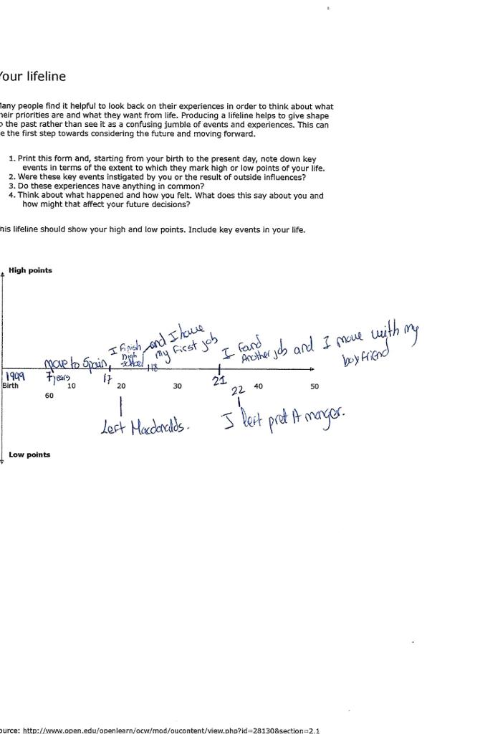

I was very lucky that with only 7 years I travelled for first time to Spain and I started to study there, the education is more better than my country. However I finish high school with 17 years, when I was 18 I decided to move to London with my dad for better life and future . I found my first job at MacDonald’s and I step up for shift manager and when I was 20 I left MacDonald’s . I went to work at pret a manger but I left after 1 year . Now in 2021 , I am currently 22 and I am working at Five guys as a crew member but soon I will step up for Supervisor .

Reflection on the role play
It is a group dynamics technique that aims to help develop social perspective and empathy through the representation on different roles. (University, 2021)
My lecturer assign to do a role play with a partner where we had the role of being interviewed and interviewer.
1.We have to completed a job application to find out the position we desire
2. After we got the job application , we make five questions for the role play .
3 . We answered it , show it to our lecturer and we received the feedback .
4. My colleagues and I practice plenty of time .
When we started to practice the presentation, I felt very stressed because I don’t know if we were doing it properly. However, we share our ideas and we supported each other all the time , When we were doing the role play , I was very nervous but at the same time we had eye contact and we smiled during whole presentation. Looking back I feel very sastified and happy because we done great job and we passed our role play.
The things were good and went well was the fact that we engage very well from the beginning, My colleague Maria was very friendly and helpful person. Also we were very motivated and we do our presentation on time. The only thing that I can say is that next time we should make it longer…
I think things went well because from the beginning we have the ideas and the way to divide the work between us . We organize ourselves quite well, every day we dedicate time to our roleplay,
Next time , we should practice time management , as I said before our presentation was a bit short because we didn’t reach the twenty minutes that the lecturer gave to us to presented our roleplay but this is not a bit issues , it is something that we could improve and develop for the future and further roles play at university or different places .
We searched some information to get some good points how to do a good roleplay. However we have some knowledge that helped us to put it on practice ,
From this I learned that we have to be confident all the time , if we work and practice everyday a bit , we can success …It is very important be enthusiastic in everything you done , so the people can be motivated and the audience can see that you effort to be successful .I really enjoyed working with my colleague and doing this roleplay , we shared each other the feeling we had before doing the presentation and all the time she said to me “Do not worries , we can do it “ It really help me to calm down .

Self-Motivation
Is the ability and practice for a person to motivate themselves to achieve the objectives thet have been proposed. (Lindenfield, 2000)
Four factors are necessary to build the strongest levels of self motivation:
1.Self-confidence and self-efficacy.
2.Positive thinking and positive thinking about the future.
3. Focus and strong goals
4. A motivating environment.

My greatest motivation is to achieve my studies, that is why every day I feel more confident of myself .At the moment my studies is the priority because through that I can achieve more goals ,this will help me to have a better life and better future.
At my workplace I work hard and long hours because I have a goal and I also want to save money to open a small business in the future. I have passion for clothes and shoes , my dream is to open a business to sell clothes at my country .I really like to spend all the money buying things.
The way that I motivate myself:
- Every day I think I am closer to my goal
- I push myself
- I set a date to get it done

Something that help me a lot to discover how motivate I am is that online class we did some questionnaire and base on my answer that said how motivate I am :
I got score 28-43 that explain “I am doing good on self-motivation but I could achieve more . That suggest me to increase the motivation factor in all the areas of my life .
What employees want
Employees want integrity and honesty to do the right things . It is really important be honest at workplace . For example: if you have any problem and you need to leave the shift early , they will trust you and they will try to solve out the problem .
Also they want desire to learn because that helps you move up faster in the company.
Teamwork for me is very important , is good to get a long with the rest of the team and accept suggestion from others . If I finish quick the task that my manager assign me , I will be able to help others or ask them if they need any help . I am that kind of person that all the time help others.
Working in a team requires leadership , decision making skills and perform your role pn the team well.
These are some of the requirements I have , I am very honest person at all times , I always ready to learn new things and I am very open mind. Also vert good teamwork skills , I get engage very quick with others and I always help ,.
Top 10 skills employees want
1. Commercial awareness
2. Communication skills
3. Teamwork skills
4. Negotiation and persuasion skills
5. Problem solving ability
6. Leadership ability
7. Organisational skills
8. Perseverance and motivation
9. The ability to work under pressure
10. Confidence
Learning Styles VAK
A learning style consists of a series of personal characteristics. There is three types:visual , auditory and kinesthetics. (Anon., 2021)
I feel that I am more visual because :
- I have difficulties when explanations are verbal.
- I am very observant.
- I learn best when the material is represented visually.
- I am able to memorize using patterns, images and colours,
- I have an easier time remembering images and videos.
- I have a hard time explaining verbally or remembering verbal information.
- I think and store information using images.
- I have a great imagination and a strong sense of color.
Below I will attach the questionnaire that we completed in the class :
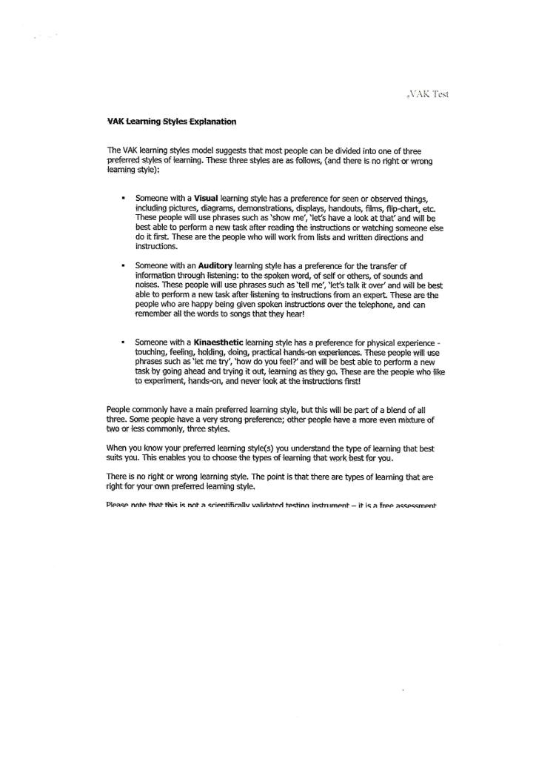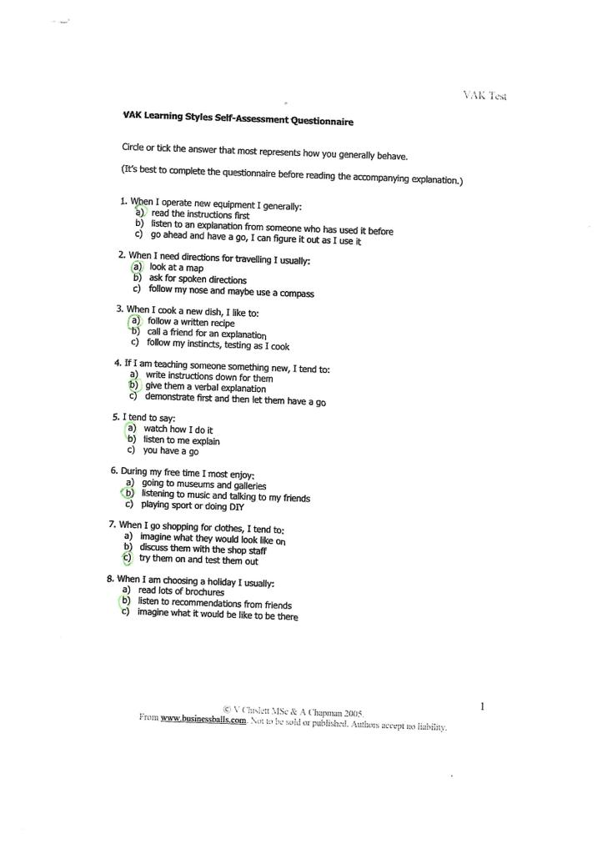
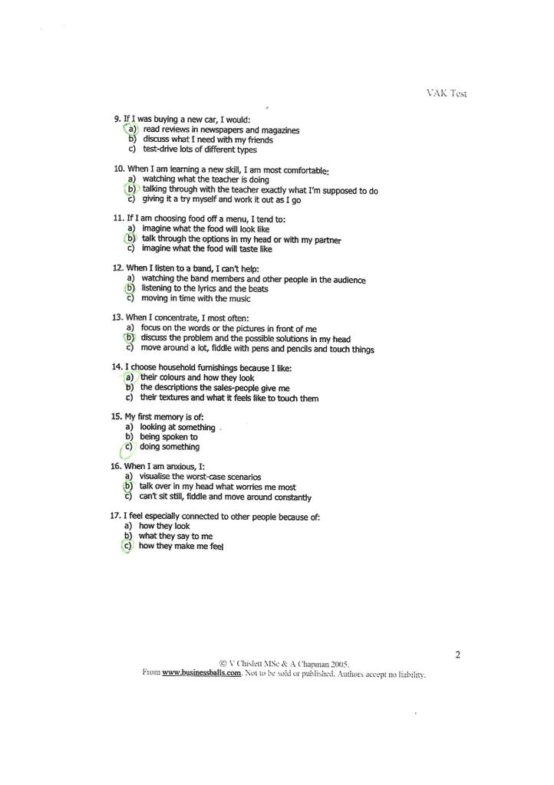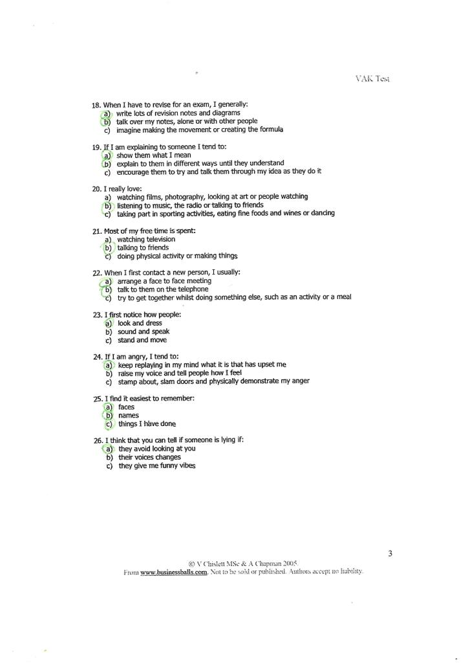
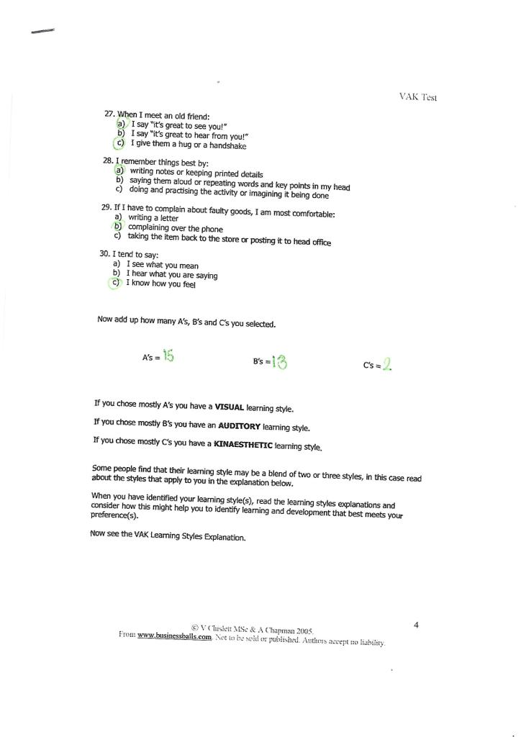
SWOT Analysis stand for strengths, weaknesses, opportunities and threats (Mindtools,2021)
My strengths are: | - My time management skills are excellent, and I’m organized, efficient and take pride in excelling at my work. I pride myself on my customer service skills and my ability to resolve what could be difficult situations.  - As a customer service for the past three years, I’ve learned how to deal with a wide variety of personalities. I enjoy handling tough cases as it gives me a chance to problem solve. I enjoy interacting with the public and love doing outreach
My weaknesses are: | - I used to leave my assignments for the last day .I used to like to work on one project to it completion before starting on another , but I’ve learned to multi-task better , I think it allows me to be more creative and effective in each one.  - My expressions are real and I cannot be fake .  - My weakness is my commitment toward work. Generally, I don’t fully rest until my work is finished.  - I am not very competitive.
My opportunities are: | - Practice languages .  - I will go for my promotion at university.  - I will get good opportunity to create innovation in my family business.
My threats are: | - Due to the work stress and tired might impact the studies  - I’m afraid of not achieving my study career.

Professional development plan
Is the process through which people acquire ideas or ways of thinking.
Professional development plan
WHAT? | I want to be accountant
WHY? | - Studies in accounting offer great professional opportunities to their students , in many different fields .  - Autonomy and decision-making power  - Variety of development opportunities  - Good Salaries
WHEN? | By 30/12/2026

Be an accountant is my dream , is the profession that I want to be in the future . There is many reasons to became accountant :
- I have strong mathematics skills
- When I was in high school I studied a bit of accounting.
I guess that I will achieve it by 30/12/2026 because that take me about four years.
Goals
Is the desired that a person plan and commit to achieve.
When I decide to achieve a goal, I like to focus in what I want to do first .
For example: This year 2021 , I plan to do a self-makeup course to look pretty because I like to do makeup but I didn’t have the knowledge . I travelled to Spain for 4 days because I found a professional artist makeup and she taught me great. Now I got my self-makeup certificate.
Another goal that I plan is to have a gastric sleeve because I put on weight but I haven’t made it yet , I am in process to achieve .
When you want to get something, you just need to be confident and plan well what you really want to do .

Conclusion
After have done this assignment I am able to know how motivated I am ,how to keep motivate until get my dream , how to achieve my goals , What type of learning style I have … Also help me to reflect about the role play applying the Gibb’s reflective Circle which taught me a lot such as : the feelings I have before and after the presentation , it is really good feel the difference between each process.

REFERENCES
Anon., 2021. Business balls. [Online] Available at: https://www.businessballs.com/self-awareness/vak-learning-styles/ [Accessed 20 12 2021].
Lindenfield, G., 2000. Self motivation. In: s.l.:Thorsons, p. 256 pages.
Ltd., H. S. T., 2021. High Speed Training. [Online] Available at: https://www.highspeedtraining.co.uk/hub/professional-development-plan/#:~:text=A%20Professional%20Development%20Plan%20%28PDP%29%2C%20also%20known%20as,them.%20Creating%20a%20PDP%20takes%20time%20and%20planning. [Accessed 11 11 2021].
Mindtools, 2021. Mindtools. [Online] Available at: https://www.mindtools.com/pages/article/newTMC_05.htm [Accessed 29 11 2021].
University, C., 2021. Dictionary Cambridge. [Online] Available at: https://dictionary.cambridge.org/dictionary/english/role-play [Accessed 24 11 2021].

Appendix 1: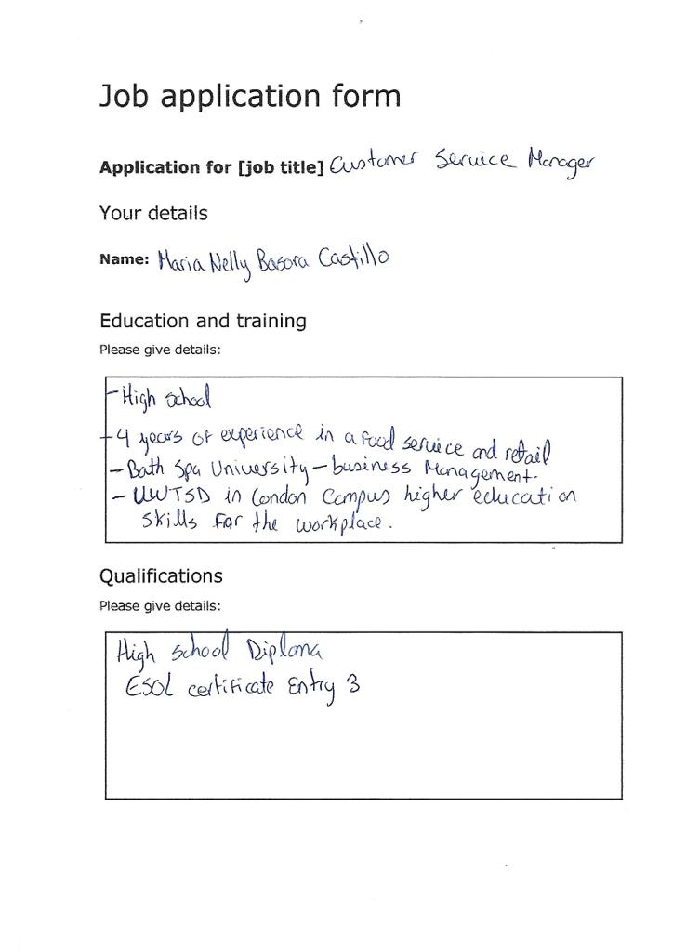
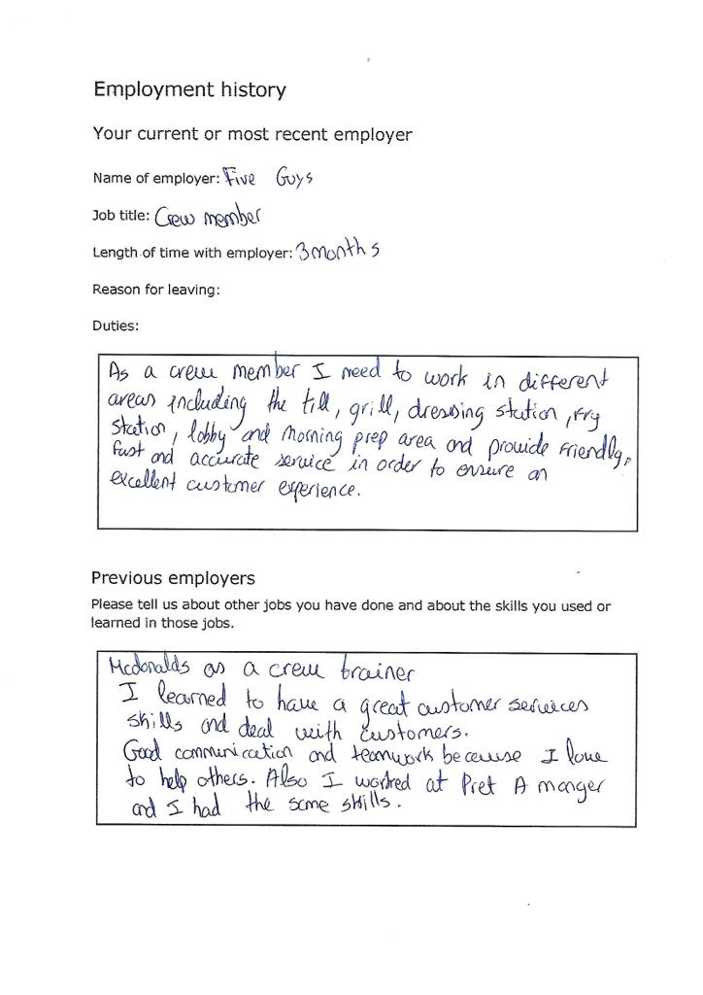
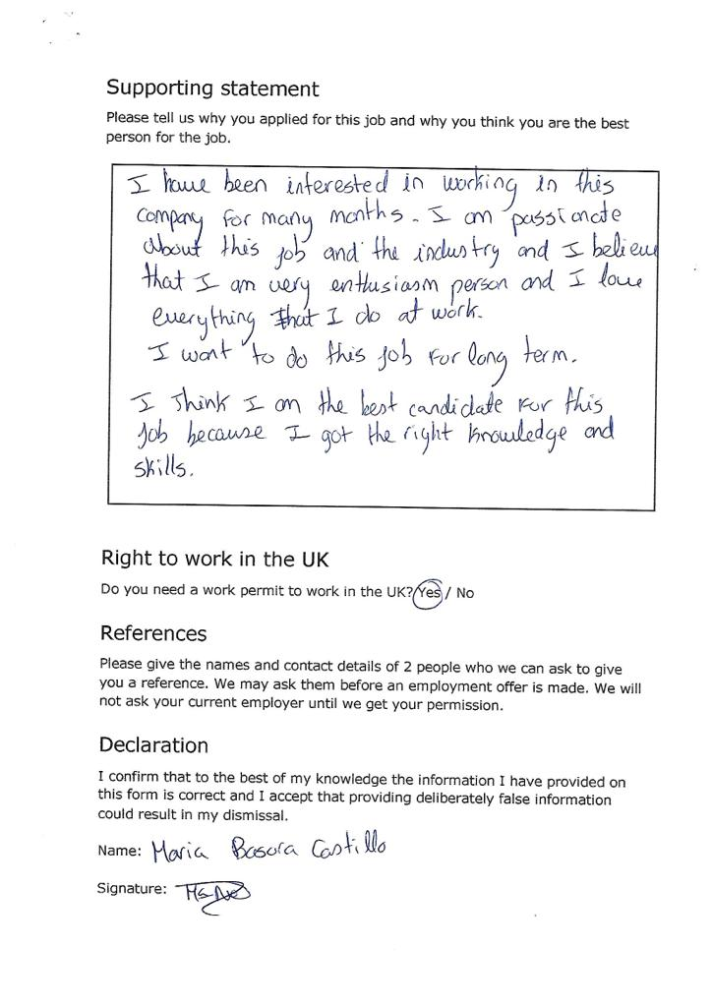
Appendix 2:


