TOURISM
IN
THE UK

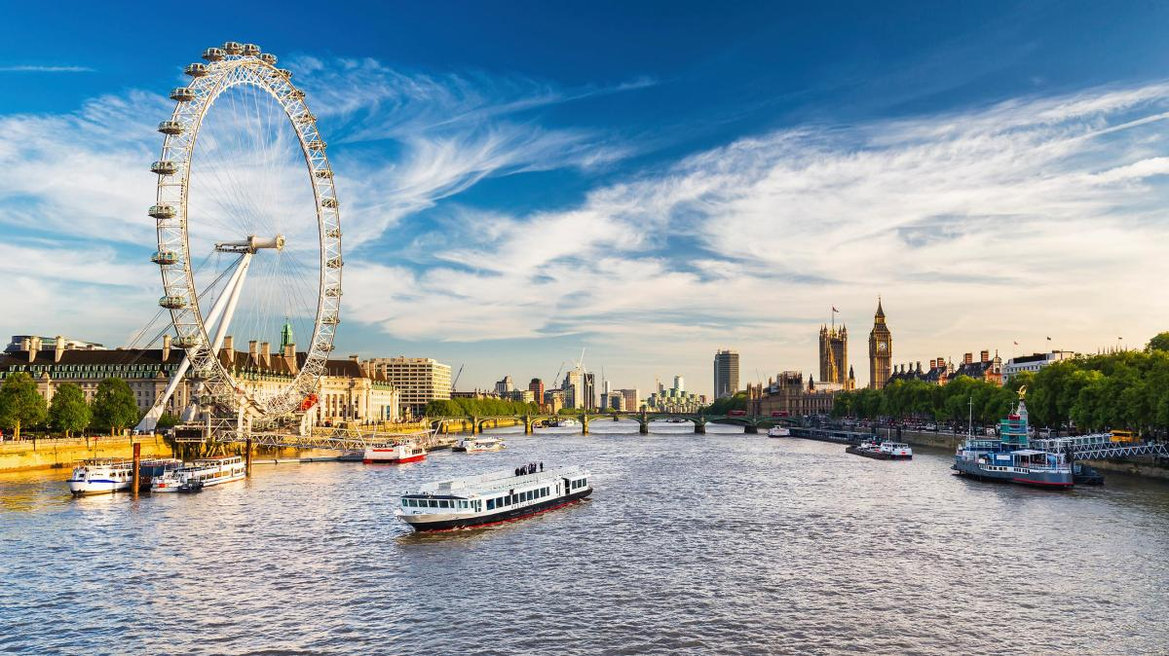

ESSAY
University of Wales
Saint Davis trinity
Sandra Peralta Galisteo
Content page

PAGE NUMBERS

INTRODUCTION 3

MAIN BODY 4-7

CONCLUSION 8

BIBLIOGRAPHY 9-10

Introduction

This essay has been done by a student of tourism and leisure who is looking for information about the tourism in the U.K. for this assignment.

Tourism is one of the most economical and cultural activity that a country or region can count on. The way to spread and promote tourism has been changing over the years, same as the tourism and leisure offered by a country. Through the years, the technology has been incorporated into life to produce a new life-style.

Thanks to the quick and easy access to social media, we can check any events or places that we would to visit. Compared to how it used to be, it has significantly improved as we can pick the place and time or cancel it if so, instantly.

The UK is one of those countries which you can visit in any season, whether it is summer or winter. The reason why is because the weather is unpredictable and you cannot plan for it so it does not matter when you visit the UK. Everybody knows that it is really rare to go on holiday to the UK and find a sunny day. “The UK has cold, wet winters and warm rainy summers. The UK’s weather conditions are variable but it rarely reaches extreme points of hot or cold, drought or strong winds” (The climate of the UK - Atmosphere and climate - Edexcel - GCSE Geography Revision- Edexcel - BBC Bitesize, 2020). England has approximately 25 million tourists a year unlike Wales, which only has 1 million annually (Tourism in Wales | Key Stage 3 | Geography in the News, 2020).

Although the Coronavirus has had a massive impact on the tourism industry, causing a lot of economic damage as well. This is awful because with the economy being affected by COVID we cannot even rely on tourism to bring in money as it is also being hugely affected by COVID.
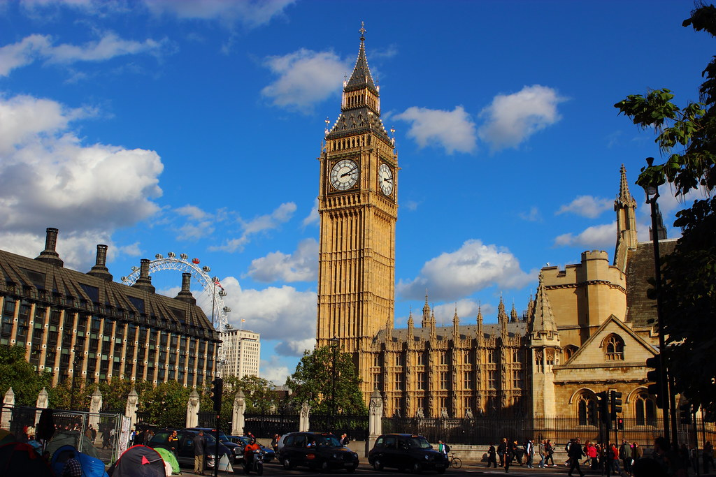
This Photo by Unknown Author is licensed under CC BY
“Maslow theory is that every individual has to have their needs fulfilled before they can work on further self-development (1987, p. 69). Tourists needs are met when they travel as they need to escape from their routines, giving people the opportunity to get away from home and everyday problems and relax and enjoy themselves. As a social positive impacts it helps them to expand their knowledge of different cultures, meeting new people and personal growth (Šimková and Holzner, 2020).

Tourism is vital for the economy in every country, for creating jobs and also for people to expand their knowledge about different cultures (Yehia, 2019). The tourism industry in the UK has created 400,000 new jobs during the last 10 years and also brought 63,8 billion to the UK economy, which has had a positive economic and social impact on the country (UK Tourism statics, 2019).

Tourism in London statistics displays how popular the capital is compared to other places in the UK as the city has 8 times more visitors than the second most visited city. Holidays is the number one reason as to why tourists visit the UK, 63% of visits to the UK are for a holiday away” (Latest UK Tourism Statistics 2020: Top Trends & Data, 2020). In comparison to Wales, England has substantially more international tourist. An example of this is in 2019, England had 36.1 million visitors, which spent a total of £24.8 billion and Wales only had 1,023,000 visitors and a total of £515 million spent (Wales tourism performance: 2019 | GOV.WALES, 2020) (The value of tourism in England, 2020).

As England’s capital, London is globally known and where most people visit if travelling to the UK. There are many different parts of tourism and one of the main are attractions. This report will be focusing attraction in England, more specifically, the London Eye classified as a private sector, being the most well liked paid tourist attraction in the UK. This attraction is situated by the River Thames. Most people from anywhere knows about the London Eye as it is located in London the capital of England, and it is almost where everyone goes to travel in the UK. Especially international tourists who want to visit and experience the different culture of the United Kingdom (Leading UK city destinations 2019 | Statista, 2020) (Attraction Management Analysis of London Eye, 2020).

The currently owner of the London Eye is Merlin Entertainment group. The London Eye is a Ferris Wheel where people can get on the carriage and as it takes you up the top and enjoy the views of London. (Attraction Management Analysis of London Eye, 2020) The tickets have different prices depending on where they are bought, online in advanced or if people buy them at the place. Booking in advance costs £27 for adults and £22 for children. Buying them at the place costs £30 adults and £24 children. The ride takes up to 30 minutes. (The London Eye tickets prices and on-line advance discount details, 2020)

The tourists type of the London Eye is going to be based on Plog’s model: allocentricity and psychocentricity, which is a popular model in the tourism and travel industry. He found that different types of tourists prefer different locations and that is the reason why he developed a typology which is a way to categorise people based on certain features. Plog labelled the tourists depending what motivated them: allocentric and psychocentric. The allocentric tourist prefer going to destinations that they are either under developed. These tourists could be the ones to adventure to unknown places. However psychocentric tourists are more identify with places that are well-developed. These types of tourists prefer visiting places that they have been before as they feel more relaxed. The last type that he consider is Mid-centric tourists which is for tourists that does not fit in any of the other two types.

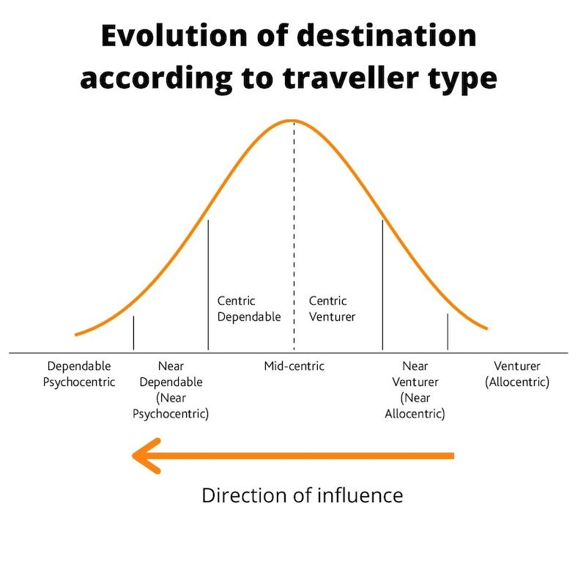
On the image show psychocentric visitors are situated on the left of the scale and allocentric visitors are placed on the right (Stainton, 2020).

The type of people that are most likely to visit the London Eye are international tourists as they are more likely to want to experience everything London has to offer, compared to residents of the UK who are used to the architecture, culture, people, etc so they could be classified as allocentric. Families are more likely to go on the London eye compared to couples or groups of people as children are going to be more interested in experiencing this ‘ride’, asking their parents to go, or vice versa with the parents wanting the children to experience it.

Technology has been huge and beneficial for tourism as it allows people to view any place they want, attractions, hotels, travel options. They are also able to compare prices between different websites or companies and cancel at any time without having to phone anybody. Social media has had a big impact on tourism as well, as people are constantly posting pictures, videos of their holidays, travels, adventures, etc… resulting in free advertisement for the country. It has also allow advertising to become a lot easier as companies can simply pay to have their adverts automatically displayed throughout websites on the Internet. The technology impacts on the tourism industry is also beneficial for the environment as the companies are reducing the use of paper, the chances of people throwing their rubbish on the streets are less as people can buy their tickets online and they do not have to be waiting on any long queues to buy the tickets at the place and also avoiding the agglomeration of people.
(How Technology Has Changed the Way You Travel, 2019).


This Photo by Unknown Author is licensed under CC BY

COVID has had a huge beneficial impact on the environment as the airports have been restricted, also travel has been reduced massively resulting in a decrease of 97% of flights in the UK (Committee, 2020). On the other hand COVID has been a massive social and economic issue for the UK industry is COVID19. The UK tourism has increased through the years apart of 2020 due to the impacts of COVID. COVID is impacting the tourism industry in the UK in a really bad way, due to lockdowns and flight restrictions the total number of tourists

have drastically been reduced by 74% this year, resulting in a 79% decrease in spending. The original forecast predicted 31.1 million tourists and up to £23.8 billion in spending, now it is predicated as 10.6 million tourists and only £6.1 billion spending. (2020 tourism forecast, 2020). The table below shows the number of tourists and money spent in each year and the impacts of COVID can clearly be seen.

YEARS | 2017 | 2018 | 2019 | 2020
VISITORS (million) | 41.080 | 40.283 | 40.283 | 10.6
MONEY | £28.396 | £26.508 | £28.448 | £6.1
(2019 snapshot, 2020)

COVID has had impact as there have been changes, the groups have been reduced in size to 6 people (needs to contact them for larger groups) and some requirements while people are enjoying the ride. For example they need to wear face masks at all times unless they are under 11 or have health conditions, adhere to social distancing, temperature checks, booking online in advance, card payments only and provide sanitising stations at the place. During the lockdowns they have to close until advised otherwise from the government. They also have to reduced their services and offer the most basic package to the customers when they are open. (Know Before You Go | The London Eye, 2020)

Another issue that has an impact on tourism is Brexit as the government is going to change the rules and it could affect international visitors in the UK, especially EU people who currently have the freedom to travel the UK how many times they like. Even if they let international tourists travel to the UK it will not be the same as now. Companies will also be affected by Brexit as they have deals with the European Union and this will be changing. (How Will Brexit Impact Travel And Tourism 2020).

Conclusion

The tourism industry in the UK has decreased due to COVID and that is a fact that the figures shows. The tourism has stopped while the country is in lockdown and that has had a negative impact on the economy, also people cannot travel, socialise, experience different cultures or have the opportunity to find a job in this sector. Merlin Entertainment group have been handling The London Eye very well throughout the pandemic, they have abided to all the government guidelines and regulations whilst still running efficiently when possible. Once people are able to travel freely again and the lockdown has ended Merlin Entertainment group will be able to go back to normal. This could lead to them to be more creative and motivated after what the country has been through, they will understand what it is like to be closed and not generate any revenue so this could push them to try to reach out to more people. This would also make people more appreciative and respectful towards the places they visit as they have also suffered from this pandemic, they know what it feels like to be in lockdown, not being able to travel or visit loved ones.

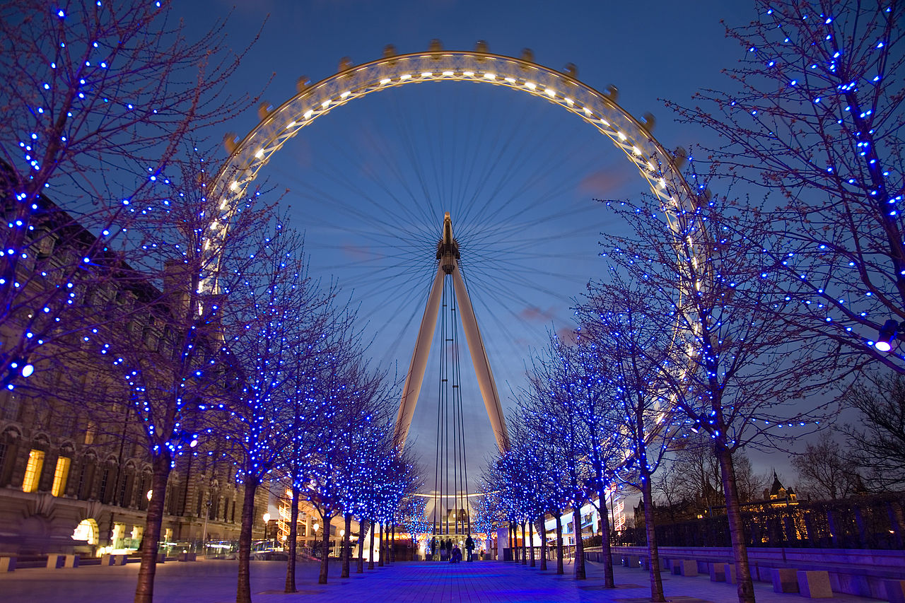
This Photo by Unknown Author is licensed under CC BY-SA

Bibliography

BBC Bitesize. 2020. The Climate Of The UK - Atmosphere And Climate - Edexcel - GCSE Geography Revision - Edexcel - BBC Bitesize. [online] Available at: <https://www.bbc.co.uk/bitesize/guides/zpykxsg/revision/3> [Accessed 2 December 2020].

Committee, T., 2020. Coronavirus Has Reduced Air Travel By 97% This Year. [online] Houseofcommons.shorthandstories.com. Available at: <https://houseofcommons.shorthandstories.com/coronavirus-impact-aviation-transport-report/index.html> [Accessed 3 December 2020].

Condor Ferries. 2020. Latest UK Tourism Statistics 2020: Top Trends & Data. [online] Available at: <https://www.condorferries.co.uk/uk-tourism-statistics> [Accessed 25 November 2020].

Creativecommons.org. 2020. Creative Commons — Attribution 3.0 Unported — CC BY 3.0. [online] Available at: <https://creativecommons.org/licenses/by/3.0/> [Accessed 25 November 2020].

En.wikipedia.org. 2020. London Eye Twilight April 2006.Jpg. [online] Available at: <https://en.wikipedia.org/wiki/File:London_Eye_Twilight_April_2006.jpg> [Accessed 25 November 2020]. IMAGE

Encyclopedia Britannica. 2020. London Eye | History, Height, & Facts. [online] Available at: <https://www.britannica.com/place/London-Eye> [Accessed 2 December 2020].

Flickr. 2020. Big Ben Tower And The London Eye. [online] Available at: <https://www.flickr.com/photos/averain/6533128891> [Accessed 27 November 2020].

Geographyinthenews.org.uk. 2020. Tourism In Wales | Key Stage 3 | Geography In The News. [online] Available at: <https://www.geographyinthenews.org.uk/issues/issue-4/tourism-in-wales/ks3/> [Accessed 1 December 2020].

Globaledge.msu.edu. 2020. The Importance Of Tourism On Economies And Businesses. [online] Available at: <https://globaledge.msu.edu/blog/post/55748/the-importance-of-tourism-on-economies-a> [Accessed 27 November 2020].

Ons.gov.uk. 2020. UK Tourism Satellite Account - Office For National Statistics. [online] Available at: <https://www.ons.gov.uk/economy/nationalaccounts/satelliteaccounts/bulletins/uktourismsatelliteaccountuktsa/2017> [Accessed 24 November 2020].

Šimková, E. and Holzner, J., 2014 Motivation Of Tourism Participants. [online] ScienceDirect. Available at: <https://pdf.sciencedirectassets.com> [Accessed 1 December 2020].

Simplypsychology.org. 2020. [online] Available at: <https://www.simplypsychology.org/maslow.html> [Accessed 27 November 2020].

Stainton, D., 2020. Plog's Model Of Allocentricity And Psychocentricity: Made Easy - Tourism Teacher. [online] Tourism Teacher. Available at: <https://tourismteacher.com/plogs-model-of-allocentricity-and-psychocentricity/> [Accessed 2 December 2020].

Statista. 2020. Leading UK City Destinations 2019 | Statista. [online] Available at: <https://www.statista.com/statistics/289010/top-50-uk-tourism-destinations/> [Accessed 2 December 2020].

The Dope. 2020. How Will Brexit Impact Travel And Tourism? | The Dope How Will Brexit Impact Travel And Tourism?. [online] Available at: <https://thedope.news/how-will-brexit-impact-travel-and-tourism/> [Accessed 3 December 2020].

The London Eye. 2020. Know Before You Go | The London Eye. [online] Available at: <https://www.londoneye.com/plan-your-visit/before-you-visit/know-before-you-go/> [Accessed 3 December 2020].

Times, T., 2020. Best Places To Live In London 2020. [online] Thetimes.co.uk. Available at: <https://www.thetimes.co.uk/article/best-places-to-live-london-england-sunday-times-wrjwxxq2j> [Accessed 27 November 2020].

Tourismalliance.com. 2019. UK TOURISM STATISTICS. [online] Available at: <https://www.tourismalliance.com/downloads/TA_408_435.pdf> [Accessed 2 December 2020].

Travel Daily. 2020. How Technology Has Changed The Way You Travel. [online] Available at: <https://www.traveldailymedia.com/how-technology-has-changed-the-way-you-travel/> [Accessed 2 December 2020].

VisitBritain. 2020. 2019 Snapshot. [online] Available at: <https://www.visitbritain.org/2019-snapshot> [Accessed 24 November 2020].

VisitBritain. 2020. 2020 Tourism Forecast. [online] Available at: <https://www.visitbritain.org/2020-tourism-forecast> [Accessed 27 November 2020].

VisitBritain. 2020. Introduction To Tourism. [online] Available at: <https://www.visitbritain.org/introduction-tourism> [Accessed 25 November 2020].

VisitBritain. 2020. The Value Of Tourism In England. [online] Available at: <https://www.visitbritain.org/value-tourism-england> [Accessed 27 November 2020].

Witt, S., 1987. Economic impact of tourism on Wales. Tourism Management, 8(4), pp.306-316. [Accessed 27 November 2020].

World-tourism-articles.blogspot.com. 2020. Attraction Management Analysis Of London Eye. [online] Available at: <https://world-tourism-articles.blogspot.com/2015/01/attraction-management-analysis-of.html?m=1> [Accessed 2 December 2020].

