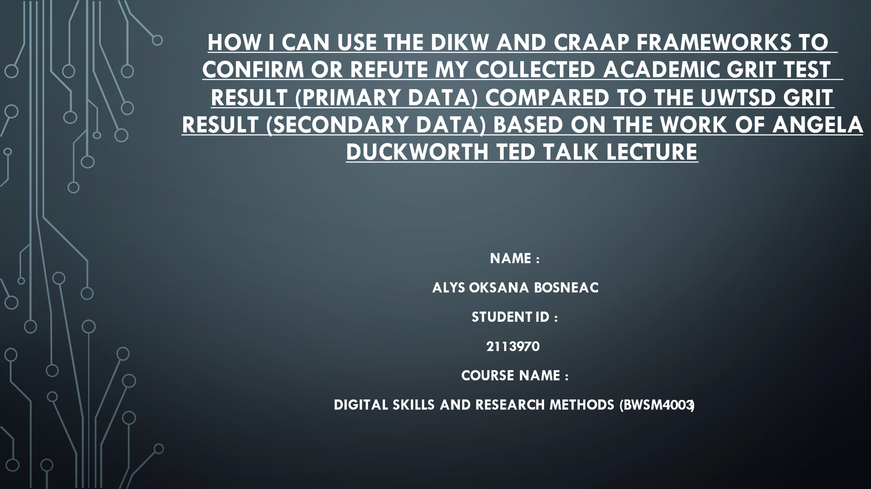

How I can use the DIKW and CRAAP Frameworks to Confirm or Refute my Collected Academic GRIT Test Result (Primary Data) Compared to the UWTSD GRIT Result (Secondary Data) Based on the Work of Angela Duckworth TED Talk Lecture

Name :
Alys Oksana Bosneac
Student Id :
2113970
Course Name :
Digital skills and research methods (BWSM4003)
Table of Contents
Introduction 3
DIKW Research Model 4
Data 5
Information 5
Knowledge 6
Wisdom 6
CRAAP Test 7
Ackoff’s Work 8
Influence of GRIT 9
Primary Data Chart 10
Secondary Data 11
Conclusion 12
References 13

Introduction
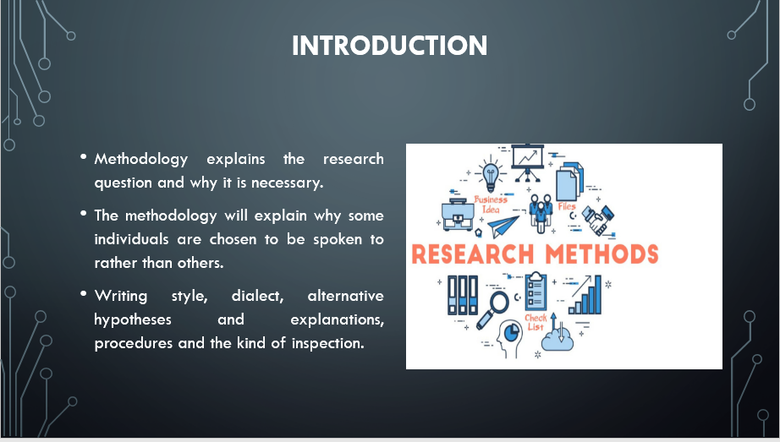
It is the methodology that explains the research question and why it is necessary. When the study is concluded, it will be able to tell you where the research is headed and what it may lead to. Writing style, dialect, alternative hypotheses and explanations, procedures and the kind of inspection used to comprehend the information and data acquired are all aspects of methodology (Pandey and Pandey, 2021). The technique shows that the researcher is not merely doing things because they are helpful, humble, or because they simply prefer not to do whatever else may be offered.
Furthermore, the methodology will explain why some individuals are chosen to be spoken to rather than others, why some individuals are chosen to be spoken to rather than others and why the data from unrecognised evaluations or bad habit verse is used rather than the data from a social event or gathering (Snyder, 2019). As a result, choosing the right methodology for performing a research study is quite important. Here, the researcher's understanding of various models and tests is critical in deciding on the most effective study strategy.

DIKW Research Model
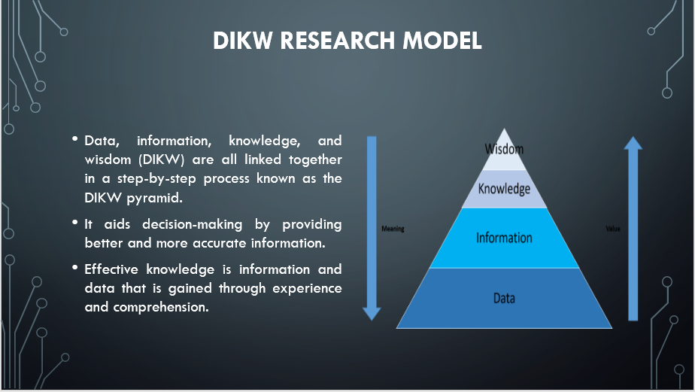
Data, information, knowledge, and wisdom (DIKW) are all linked together in a step-by-step process known as the DIKW pyramid. It consists of four levels, each of which represents a step toward a greater degree of knowledge, information, or wisdom. In addition to providing meaningful answers to a variety of questions about the data and information, each phase in the process also adds worth and significance (Deepu and Ravi, 2021). There are more insights available when more purpose and perspective are given to data and information. It aids decision-making by providing better and more accurate information. To begin, the first step of the Data processing relates to the fact and statistics that are mostly unpredictably so that they may be used.
The second step, information, is the structured data that has a context that is related to the data gathered. Effective knowledge is information and data that is gained through experience and comprehension. It has meaning and may be referred to as a kind of education. Wisdom is formed when data is coupled with knowledge. Using it as a framework for making choices is a useful tool. A significant quantity of data may be selected easily in the DIKW hierarchy (Deepu and Ravi, 2021). In the framework of DIKW, the GRIT system is shown to have a positive influence on academic performance. Data from primary and secondary sources may then be analysed in order to arrive at an answer. Students' academic achievement is also examined in this study.
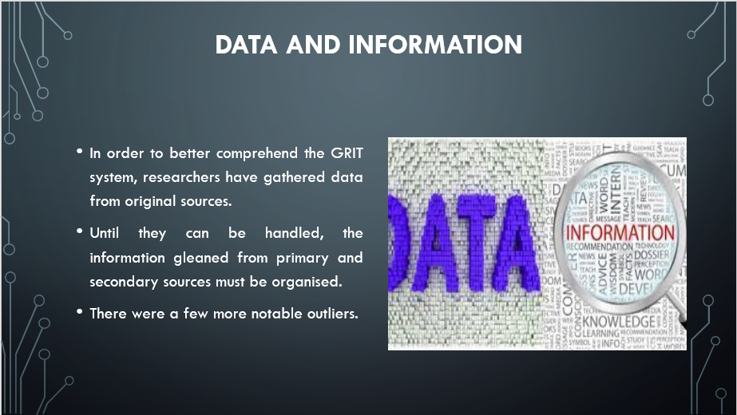

Data
In order to better comprehend the GRIT system, researchers have gathered data from original sources. This data is critical to the study since it aids in obtaining the information needed to achieve the research's goals and objectives. According to the main data, 11 people completed the questionnaire (Osadchy et al., 2021). The GRIT exam has also been shown to be linked to academic level. All respondents received an average score of 10 and the outstanding educational level was likewise 10. The key data sources are the ones that provide this data. The major sources have provided the data. In order to have a better grasp of the subject, this data has been used to acquire the correct GRIT score.

Information
Until they can be handled, the information gleaned from primary and secondary sources must be organised. Organising data results in a structured representation of that data. Due to its organisation, the data may be understood by a broad variety of individuals. Data obtained from primary and secondary sources may be used to build a structure. There were a few more notable outliers (Yusof, Zakaria and Zainol, 2018). The bulk of the participants had a higher grit score. There were still many pupils who outperformed their colleagues in the classroom.
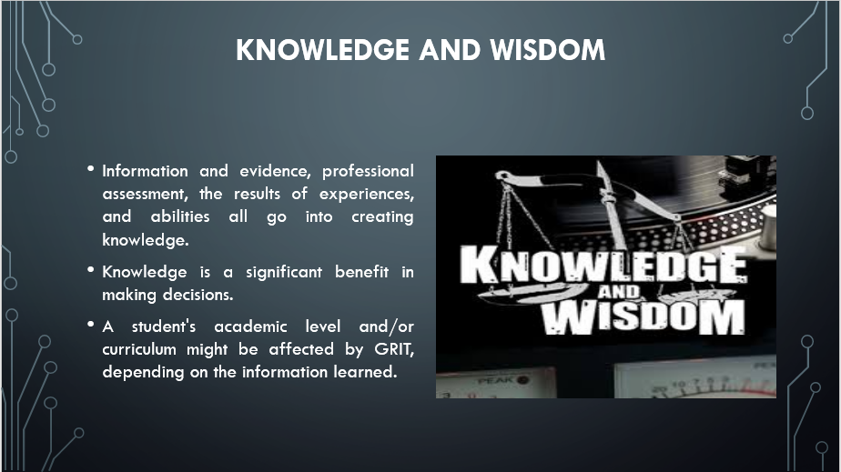

Knowledge
Information and evidence, professional assessment, the results of experiences, and abilities all go into creating knowledge. Knowledge is a significant benefit in making decisions. A collection of information and data that has been gathered and processed to demonstrate knowledge of a current issue or activity (Osadchy et al., 2021). As a consequence of this study's findings, it is apparent that a vital drive to work even harder when everything is happening bad may flip the life of a man around and contribute to a student's academic achievement.

Wisdom
The greatest level of knowledge involves foresight, the capacity to see beyond the horizon, and the ability to see into the future. There are still some people who doubt proof that tenacity has an impact on schooling, and an example from a research conducted just a few years ago might be deceptive. To a certain extent, knowledge may be gained by this investigation into the existing state of affairs, and remedies or alternatives can be implemented as a result of the discoveries (Yusof, Zakaria and Zainol, 2018). A student's academic level and/or curriculum might be affected by GRIT, depending on the information learned. Student resilience is required to deal with the high and low points in their academic schedule.

CRAAP Test
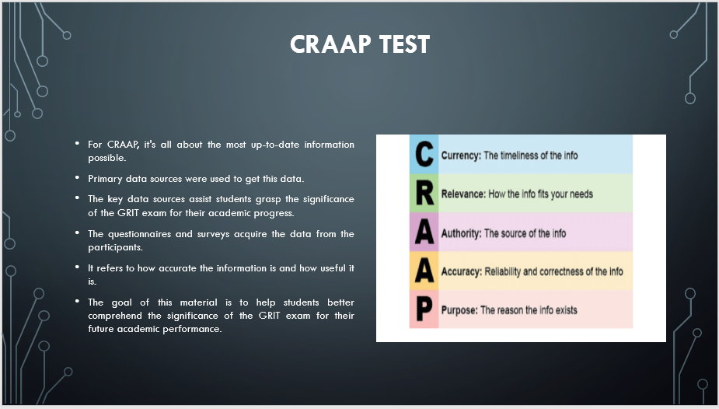
The CRAAP Test is a method of assessing a person's competency. It was founded by the Meriam Library at the University of California, Chico. For CRAAP, it's all about the most up-to-date information possible. It contains a list of questions to help individuals evaluate the information they get (Kilcrease, 2021). A better understanding of the requirements of the project will help them choose resources that are appropriate for the task.
Currency
It refers to how quickly information is available. Primary data sources were used to get this data (Liu, 2021). The data is up-to-date and based on this year's events. Also, it connects the lipids of the subject matter.
Relevance
It refers to the significance of the data. The data analysis relies heavily on this information (Liu, 2021). The key data sources assist students grasp the significance of the GRIT exam for their academic progress.
Authority
The questionnaires and surveys acquire the data from the participants (Kilcrease, 2021). Applicable information may be found in the sources.
Accuracy
It refers to how accurate the information is and how useful it is (Liu, 2021). Since the data is gathered directly from the individuals who will be using it, the researcher can be sure that it is reliable and up-to-date.
Purpose
The goal of this material is to help students better comprehend the significance of the GRIT exam for their future academic performance (Kilcrease, 2021).

Ackoff’s Work
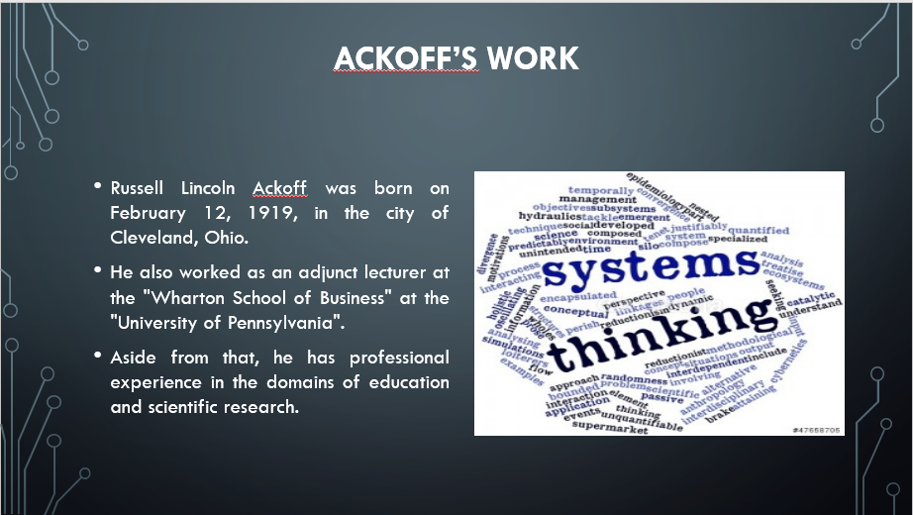
"Russell Lincoln Ackoff was born on February 12, 1919, in the city of Cleveland, Ohio". He was the son of a banker and a lawyer. He was a consultant and corporate theorist from the United States who worked in the field of organisational theory. He also worked as an adjunct lecturer at the "Wharton School of Business" at the "University of Pennsylvania". Aside from that, he has been designated the Anheuser-Busch" Professor in Emeritus of Management Science at the University of Wisconsin" – Madison.
A pioneer in the fields of strategic planning and operations analysis, as well as management science, among other topics, he was the most well-known and respected figure in the world. He was the writer of Ackoff's Best: "His Classic Writings on Management" (Ackoff's Classic Writings on Management, 1999), which was a collection of his classic writings on management. His publications include more than thirty books as well as over one hundred pieces that have appeared in a variety of magazines and periodicals. Aside from that, he has professional experience in the domains of education and scientific research.

Influence of GRIT
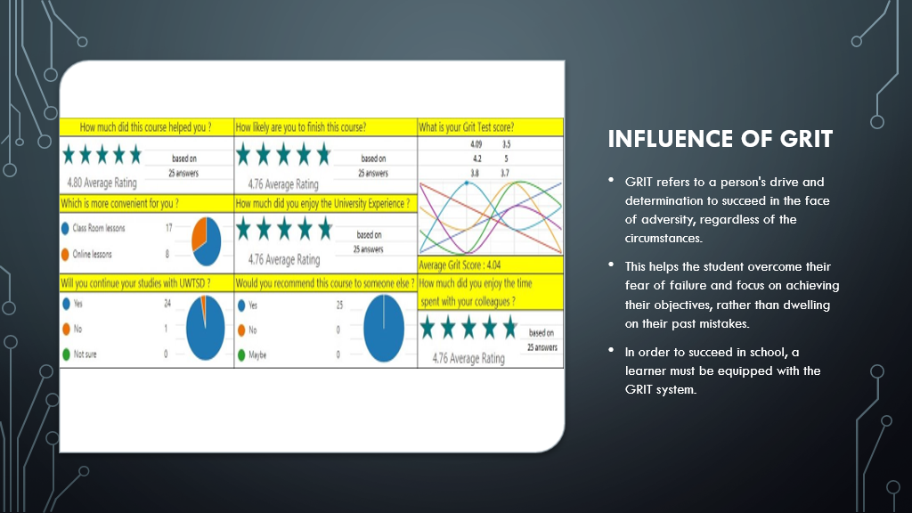
When it comes to accomplishing long-term goals, grit is an important quality to have. It's the ability to stick with a goal. It also refers to the capacity to grow enthused about it and persevere in the face of adversity. GRIT refers to a person's drive and determination to succeed in the face of adversity, regardless of the circumstances. It's a skill that may help students become fired up about achieving their academic ambitions (Li et al., 2018). It motivates the learner to work through a variety of concerns and challenges, allowing them to achieve their objectives. A student's ability to persevere in the face of setbacks and obstacles is directly related to their level of passion.
This helps the student overcome their fear of failure and focus on achieving their objectives, rather than dwelling on their past mistakes. It is essential for every student to have this degree of dedication. To reach one's full capability and attain success in all aspects of one's life, one must be even more precise and patient (Jeong et al., 2019). In order to succeed in school, a learner must be equipped with the GRIT system. As a result, it is clear that Grit is a critical component of academic success. As a result of the GRIT system, a learner will be able to succeed in life and attain their full potential.

Primary Data
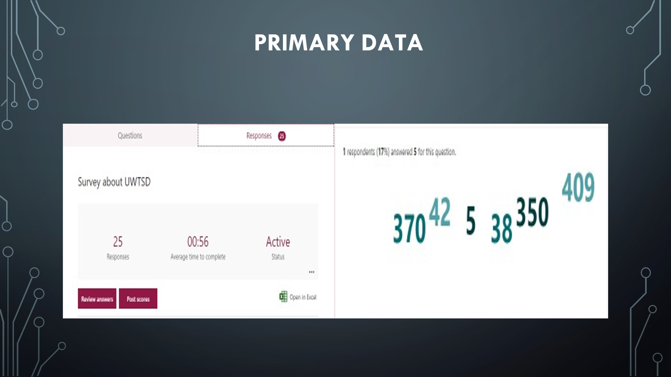
The "Primary Data" refers to the kind of information acquired via interviews, questionnaires, and surveys, as opposed to secondary data. The key data sources are in charge of gathering the data and information. Because individuals are the primary sources of knowledge, this sort of information is obtained directly from the sources. The information was gathered from eleven individuals. The GRIT demonstrated in the greed grade is connected to the student's academic performance. Five applicants received a perfect score of ten for being confident in their ability to complete the digital course, based on their excellent taste.
Three competitors received a perfect score on the academic portion of the test. Additionally, according to the main data, six applicants have a one-year programme length, while two participants have a four-year programme duration. Only one applicant applied online, and the majority of those who applied were from the same class. Five of the contestants are really dedicated. It is also obtained as information that four out of five course participants achieved a perfect score of ten by answering a question regarding the digital skills and research technique course in their own words.

Secondary Data
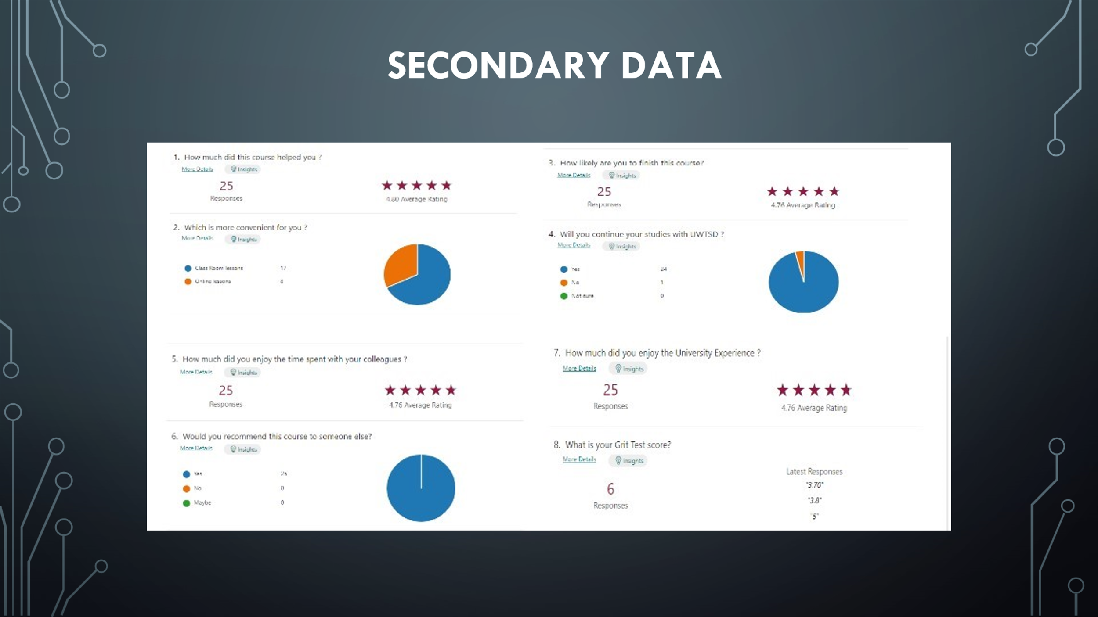
Experimentation, questionnaires, and conversations are used to gather secondary information and data for the final report. Secondary information will focus on providing light on a student's GRIT test score and academic standing. Finding appropriate data to answer project questions and gaining an in-depth knowledge of the subject matter are the researchers' primary goals (Johnston, 2017). There are two charts in this report that show the average GRIT score and the total number of surveys. The secondary data will include a vast amount of information. Using this information, users can determine the GRIT test score. There was a wide range of GRIT scores here, ranging from 4.3 to 3.7.
In terms of academic level, the best score was a five, and the lowest was 3. GRIT scores averaged 3.7. In the GRIT exam, most of the applicants had scores of 4 or above. Almost all of the applicants received a score of 4, which is the highest possible. A total of 9 was the most common answer, while the least common answer was 1 (Cole, Friedlander and Trinh, 2018). The secondary analysis data is very important since it connects the academic level to the given score. It also shows the average GRIT test score relative to the academic level based on the results of surveys.

Conclusion

Children's willingness and capacity to engage in extracurricular activities are both influenced by GRIT, according to the findings of this research. As a result, the findings of this research may be used to future trials that need the newest data, new equipment, and, most likely, a poll of the same individuals over time to assess their GRIT success rate. GRIT is obviously linked to an individual's ability to exercise self-discipline. Nevertheless, further research is required. Nonetheless, more study is required to have a better understanding of this topic. A link was discovered between GRIT and academic level characteristics in a recent research. It is possible to achieve academic success when a student cultivates a positive outlook on life. In addition, society has to encourage this procedure so that each kid grows up with a purpose and a strong desire to attain it, no matter the obstacles they face. Basically, the research illustrates how GRIT has a wide-ranging impact on people's lives, not simply in the classroom.

References
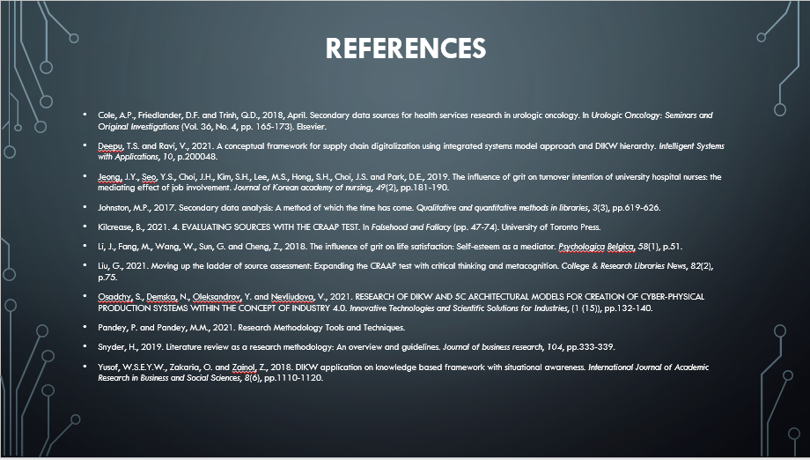
- COLE, A.P., Friedlander, D.F. and Trinh, Q.D., 2018, April. Secondary data sources for health services research in urologic oncology. In Urologic Oncology: Seminars and Original Investigations (Vol. 36, No. 4, pp. 165-173). Elsevier.
- DEEPU, T.S. and Ravi, V., 2021. A conceptual framework for supply chain digitalization using integrated systems model approach and DIKW hierarchy. Intelligent Systems with Applications, 10, p.200048.
- JEONG, J.Y., Seo, Y.S., Choi, J.H., Kim, S.H., Lee, M.S., Hong, S.H., Choi, J.S. and Park, D.E., 2019. The influence of grit on turnover intention of university hospital nurses: the mediating effect of job involvement. Journal of Korean academy of nursing, 49(2), pp.181-190.
- JOHNSTON, M.P., 2017. Secondary data analysis: A method of which the time has come. Qualitative and quantitative methods in libraries, 3(3), pp.619-626.
- KILCREASE, B., 2021. 4. EVALUATING SOURCES WITH THE CRAAP TEST. In Falsehood and Fallacy (pp. 47-74). University of Toronto Press.
- LI, J., Fang, M., Wang, W., Sun, G. and Cheng, Z., 2018. The influence of grit on life satisfaction: Self-esteem as a mediator. Psychologica Belgica, 58(1), p.51.
- LIU, G., 2021. Moving up the ladder of source assessment: Expanding the CRAAP test with critical thinking and metacognition. College & Research Libraries News, 82(2), p.75.
- OSADCHY, S., Demska, N., Oleksandrov, Y. and Nevliudova, V., 2021. RESEARCH OF DIKW AND 5C ARCHITECTURAL MODELS FOR CREATION OF CYBER-PHYSICAL PRODUCTION SYSTEMS WITHIN THE CONCEPT OF INDUSTRY 4.0. Innovative Technologies and Scientific Solutions for Industries, (1 (15)), pp.132-140.
- PANDEY, P. and Pandey, M.M., 2021. Research Methodology Tools and Techniques.
- SNYDER, H., 2019. Literature review as a research methodology: An overview and guidelines. Journal of business research, 104, pp.333-339.
- YUSOF, W.S.E.Y.W., Zakaria, O. and Zainol, Z., 2018. DIKW application on knowledge-based framework with situational awareness. International Journal of Academic Research in Business and Social Sciences, 8(6), pp.1110-1120.

