Managing Performance
Name:
Student Id:
Assessment name:
Word count: 5000 words

Table of Contents
1. Introduction 3
2 Performance Management 3
3 Organisational and employee concerns 8
4 Employee engagement and employee involvement 13
5 Recommendations 18
6 Conclusion 23
7 References 24

Introduction
Performance management ensures that a company's objectives are met promptly and successfully. Performance management might be used to oversee the performance of a company, a department, or individual employee. Performance management periodically assesses and discusses an employee's progress towards achieving the company's goals (Cesário, 2022). Traditionally, performance management has been a forward-looking strategy that primarily depends on hindsight.
The employee's performance is evaluated depending on how he has done in recent years. Performance management proactively controls a staff member's performance and ensures the person has met all of the objectives set by the company's goals, objectives, and fundamental beliefs. SainCo has 2000 employees throughout the 10 different locations, with increasing pressure on the lower management to boost their performance. SainCo currently uses an authoritarian style of management where no advice and feedback related to their performance are ignored. Just because of the authoritarian management style, the line managers and HR managers are advised by Human Resource Consulting firms to work on the modern performance management style with new management styles like democratic.
In this report, there is an appointment of the Human Resources Consultant for one of the leading Human Resource Consulting Firms in the UK, which offers Retail Clients outsourced Human Resource solutions, including staff performance management. The CEO of SainCo approached this consulting firm to advise on a new performance management approach for the Company that aligns with the current business environment and the Company’s goal.
This report has four sections: performance management – what is involved, organisational and employee concerns, employee engagement and employee involvement and recommendations, both in the short term and in the longer term.

2. Performance Management
According to Cesário (2022), performance management requires a structured and thorough strategy that focuses on increasing productivity among staff members and growing individuals' and groups' skills to guarantee an organisation's long-term success. Performance management refers to giving periodic input and contact between management and employees to meet the company's primary goals.
According to Almohtaseb (2020), achieving a standard comprehension of the company's objectives and goals requires a strategy that assists employees in acknowledging and comprehending their role in accomplishing those objectives and, as a result, increasing the company's overall efficiency. Performance management differs from talent management because it is an ensemble of initiatives to engage employees and keep them on board. Performance management, on the other hand, is a process that guides employees through the process of setting and attaining targets that are consistent with the company's long-term objectives (Robert, Giuliani & Gurau, 2022).
As a result, performance management is centred around subjects such as setting targets and measurements, continuous learning and improvement, a strategic vision and orientation, planning and thus integration, enhancing employee engagement and involvement and shifting from an authoritarian approach to a democratic management approach.

Purposes of performance management
Murphy (2020) has discussed some relevant purposes of performance management, which are necessary to discuss and include in this report, as SainCo’s CEO is concerned towards implementing a new performance management approach for their organisation to drive their business powerfully in the competitive management. Hence, readers need to know precisely what performance management serves the company.
To ensure accountability: Employees are assessed against performance management criteria that promote responsibility. A typical instance is the sales quota. These approaches may be highly successful since employees are aware of them and encouraged to achieve the goal. It is critical to understand the standard and how it is determined. Having many people in the SainCo performing the same well-defined obligations is preferable (Van Waeyenberg, Peccei & Decramer, 2022). For example, when 15 salespeople complete the same work, you can determine what degree of performance is acceptable.
To Encourage Teamwork, Collaboration and Communication: Human resource leaders continue to search for ways to build a sense of belonging and cooperation inside their companies. As a result, improved interactions and cooperation occur, which benefits the company's general efficiency. Different sorts of businesses manage this differently, but many rely on a combination of interactions with others along with access to the right kind of technology to achieve their goals (Spanò & Ginesti, 2022). Employees' sense of community and connection can be cultivated through group activities like Slack or other real-time communication tools, as well as company-organized occasions like collaborative activities and happy hours.
To Identify human development areas: One of the most essential objectives of performance management is talent management. Collaboration with employees is essential to implementing initiatives to foster growth. The capacity to focus on growth needs enables managers and employees to build successful initiatives, resulting in higher individual performance (Bauwens, Huisman & Decramer, 2019). As a result, worker happiness and productivity will rise since they will regard themselves as essential teammates instead of just another gear in the machine, resulting in improved output.
To ensure employees are engaged and happy: Performance management systems are equally concerned with the employee as they deal with the employer. With good cause, "employee engagement" has become common in HR circles in the last few years. Companies are currently well aware of the multiple economic benefits that committed personnel provide. They also understand the risks of having an actively disconnected person at work (Holzer, Peng & Deat, 2019). The primary objective of performance management is for managers to remain current on engagement trends, conduct surveys regarding employee engagement, and make every effort to ensure that staff are happy, motivated, and pleased.

Performance management: the drive towards competitive advantage
Companies like SainCo can retain their competitive power over the market with the help of various things that they can take as drivers to gain a first-mover advantage in the business world. The best way to remain in a competitive advantage is with the help of effective performance management or appraising its people to drive their work performance.
Improving employee morale: Everyone appreciates the remark that they will perform a good job. Because they are objective and fair, performance evaluations are a good arena for establishing and documenting employee gratefulness. However, evaluations deserve in addition to setting goals for the subsequent quarter. It must additionally offer a setting for a supervisor to recognize teammates (Arsawan, Supartha & Suryantini, 2022). Employees who are content are more productive. An incredible 69 percent of employees believe they would push themselves harder if their accomplishments were acknowledged. A salary check is no longer a sufficient form of recognition, but frequent evaluations and comments are essential to maintaining the spirits of staff members.
Improving accountability: Accountability is vital for a firm to perform at its best, but ensuring its success is difficult. Accountability is sometimes used as a synonym for blame. This is damaging to both company culture and staff morale. Everyone in an organization should grasp the mission, values, and goals of the company. Natural HR simplifies the implementation of a performance management system (Azeem, Haider & Sajjad, 2021). Create personalized performance management forms and schedule reminders for employees and managers to keep everything on track.
Improves the retention of talent in the company: With people being an irreplaceable resource, it is essential to devise methods of retaining SainCo's employees. Working towards goals on a consistent basis gives employees complete autonomy and the chance to emphasize areas they would like to focus on, offering reasons to stay.
Improves the company's efficiency and productivity: All of the benefits above contribute to overall better company success. Employees who are prospering will produce better work and become more inspired to try new things and grow. This underlines the importance of performance administration and the benefits it may bring to the company as a whole when done correctly. For all of the benefits and advantages, performance management may encourage the company to compete in the local as well as global markets (Al Aina & Atan, 2020).

Factors affecting the performance management of SainCo
According to Darwish (2022), impact(s) of culture on performance management
The corporate culture serves several purposes, it achieves the following objectives:
It offers a sense of identity to those who work for the company,
It allows the emergence of a commitment to something more profound than the employees' gain, and
It acts like a social adhesive that helps unify the company by establishing the appropriate standards to be accomplished by the employees.
Members of the SainCo are considered employees. They are a vital component of the company and engage in its daily affairs. They are the driving force behind the business's success because they are in charge of all the components that keep it working correctly. They ensure the company's continual existence or longevity. The success of the company depends on the performance of its personnel. Therefore, employees have to be flexible, adaptable, hardworking, and constantly vigilant to stay one step ahead of their competitors (Hartinah, Roslina & Jermsittiparsert, 2020). Furthermore, determined by staff engagement, the company's total success depends extensively on the level of performance achieved by its staff members. As a result, employee performance can be regarded as an operation in which employees successfully perform the task entrusted to them.
It is concluded that performance management drives a factor in getting a first-mover competitive advantage for SainCo, as it contributes to increasing employee morale, talent retention, and the company’s productivity and outputs. However, throughout this section, it is also realized that the corporate culture contributes to performance management, a kick to go further in the company. Ultimately, a culture drives the performance management process.

Impact(s) of organisational structure on performance management
For instance, formal structure techniques such as regional, geographical in nature, centralized, and decentralized impact performance management. For example, if SainCo adheres to regional and geographical techniques for the formal organization, it will prove difficult to monitor employee performance adequately. On the other hand, a centralized management structure helps management effectively execute performance management. On the other hand, following a flat or straightforward organizational structure assists the company in successfully and effectively implementing performance management. Third, the level of autonomy granted to employees by an organization influences performance management (Collings, Mellahi & Cascio, 2019). For example, SainCo's management takes an autonomous strategy, which is beneficial in implementing performance management but does not encourage and inspire individuals.
Brief conclusion
This discussion concludes that the term culture plays a critical role in managing and ensuring performance management, as it creates a foundation for companies to evaluate the performance of the employees based on the "What" organizational structure and management style SainCo follows. As discussed, SainCo follows an organization's flat, straightforward structure with an authoritarian management approach and a destructive framework. Even SainCo needs to transform its organizational structure by having a cluster structure with all seniors and subordinates coordinated effectively. Moreover, SainCo needs a new managerial approach to manage performance management and evaluate employees with full potential.

3. Organisational and employee concerns
This section has discussed some challenges and concerns that organisation like SainCo face regarding managing an organisation and performance management. There is such a definition of organisation concerns or any employee concern, as they are concepts with actual issues they face. In this section, various challenges/concerns that happened because of the authoritarian approach by SainCo and applied in the performance management framework are mentioned.
According to Wang (2022), due to the authoritarian approach in managing the company, the upper-line manager and HR manager have observed some issues/challenges related to the performance management in the SainCo, which are given as follows: -
Competencies/Skills Gaps: Organisations need to be made aware of the skills shortages in the individuals, positions of power, or teams under their supervision. Managers frequently fall blind to the skills provided by their staff and those necessary by the company due to their absence of knowledge.
Performance operations are irregular: Regular assessments of performance and management action must be made. As a result, until the following scheduled performance review, businesses will be made aware of performance concerns developing or embedded within the workforce.
Lack of Objective Evaluation: Too often, employee performance is left to the manager's discretion. Needless to add, the objectivity of even the most successful leaders may be questioned if they provide less than favourable feedback.
Inadequate feedback: Just telling people how well or poorly they perform is insufficient, as performance management is required. Not only should feedback assess and expose performance gaps, but it should also give clear avenues to performance development (Rojas-Lema, Alfaro-Saiz & Verdecho, 2021).
Inadequacy of official assessment systems: A single issue with the management of performance systems is that they need to be more formal. These systems could be more effective since they are often scheduled annually or bimonthly and frequently carried out using a template/cookie-cutter-based methodology (Murphy, 2020). When it comes to prompt and in-the-flow-of-work performance management, more than relying on formal appraisal procedures is frequently required.
Irrelevant job descriptions: In most companies, the job description is the key instrument for assessing and controlling performance. Employees must make assumptions about their goals for performance when descriptions of jobs are inappropriate or imprecise, and managers need to work on implementing such ambiguous expectations (Kuzmanovic, Tomic & Stamenic, 2019).
Absence of a "plan" for addressing insufficient performance: Highlighting deficiencies in performance is pointless unless the organization has a strategy to close such gaps. The absence of a performance improvement plan resulted in squandering performance management opportunities.
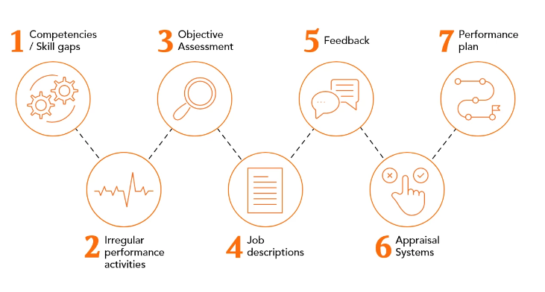
Figure 2: Issues/challenges related to the performance management in the SainCo
(Source: Murphy, 2020)
SainCo uses an authoritarian approach where traditional performance management and appraisal are commonly used. Autocratic leadership has pros, such as prompt decision-making, clear direction, and a disciplined workplace. It can work well while handling novice team members or in emergency scenarios. The ability of authoritarian leadership to impede innovation and creativity is one of its main cons. Because they worry about facing the consequences of a strong leader, team members can be hesitant to take the lead or provide fresh ideas. As discussed in the challenges associated with the companies in the context of performance management, certain employees’ concerns need to be addressed. The challenges are the concerns of SainCo’s employee performance management mechanism and expectations, which groups and teams expect to be evaluated (Fawehinmi et al., 2022). There are some justified solutions to the challenges of measuring group/individual performance that should be an immediate concern to apply for the SainCo.
In the SainCo setting, authoritative bosses can be oppressive. Their attitude can appear prescriptive, and they do not give their employees the flexibility to pursue independent thought or operate in the manner that best suits them. Employees who report to authoritative supervisors frequently have low morale. The line manager/HR manager needs to think about the mixed culture where there should be a democratic approach to taking employee feedback and reviews on their overall performance.
In the context of SainCo, the upper line manager and HR manager can take certain decisions are as given under: -
Competency gaps must be identified for progress and enhanced performance management and corrected proactively. Appraisers might recommend additional training, improved guidance, or even send mentors and counsellors to fill these deficiencies.
Frequent assessments, check-ins, and different kinds of feedback are critical elements of a successful performance management process. Never restrict improvements in performance feedback to annual or bi-annual periods. Management of real-time feedback (in-the-flow-of-work) (notice, teach, foster, guide, and determine) can result in enhanced productivity across all levels.
Implementing systems such as 360-degree appraisal, on-the-job assessment, management by objectives, peer evaluations, and trait/behaviour-based evaluations are tools for addressing objectivity in evaluations.
Explain how employees’ function within the group and the more prominent company, their expectations for performance and how performance can be tracked. Set accessible and observable (SMART) goals for performance as part of the job definition. Connect company objectives to an employee's job description and performance against the descriptions.
The leading cause of such deficiencies usually comes in the form of either short remarks ("Needs improvement" or "Work on communicating better") or feedback provided long after a potentially "teachable moment" has gone. Giving short yet unambiguous feedback across various performance metrics is an excellent method to handle this issue (Tang & Zhang, 2021).
Performance management should not involve a "timed" or too structured approach. Supervisors and managers who function as the front-line instructors, or "in the flow of work" or "at the moment" performance assessors, substantially impact worker performance more than bi-annual or annual evaluation systems.
Implement a powerful performance support system as part of a performance strategy for management. Consultations and counselling are some of the plan's components, as are recommendations for extra training, ongoing instruction, continual skill enhancement, and the appointment of mentors (Bianchi & Caperchione, 2022).
There are various rationales that tell why SainCo needs a modern style of performance management where they had used authoritarian to process their organizational work, and accordingly, their performance management is framed identically. Due to the authoritarian management style, all performance appraisals are done by the HR and line managers without any peer evaluation and feedback by the colleagues, which in reality is not any performance management.
Conclusion
The discussion concludes that the authoritarian approach to management looks like a traitor's method of managing business operations. Under such approaches, performance management looks against employees' willpower and interest in working with SainCo. It has been determined that performance management should avoid being "timed" or overly organized. Leaders and managers who serve as front-line educators, or "in the flow of work" or "at the moment" performance assessors, significantly impact worker performance more than biannual or annual evaluation methods. In further discussion, it is a sound call of action to focus on employee engagement and involvement to know suitable performance management approaches and develop strategic goals as part of the recommendations.

4. Employee engagement and employee involvement
This section has discussed the concept of Employee engagement and employee involvement in the context of SainCo and evaluated the existing performance management approach. According to Degbey (2021), employment engagement is the HR concept that mainly illustrates employees' enthusiasm level and dedication towards their job or work under which they are engaged. The concept of employee involvement is discussed separately on page 15. When evaluating total satisfaction with work, one of the most essential variables to look into is employee involvement. Employees nowadays want themselves to be engaged with their positions, to be enthusiastic about the company with which they work, to feel as though they belong, and to have the option to work from their homes or a variety of other places. According to the most recent Global Workforce Trends survey, cultivating an awareness of belonging in employees is critical to their company's prosperity in the next two to three years, with a whopping 79 percent of all those who took part agreeing that a sense of belonging is the factor that drives organizational performance (Ahmed, Siraphatthada & Phumdara, 2020).
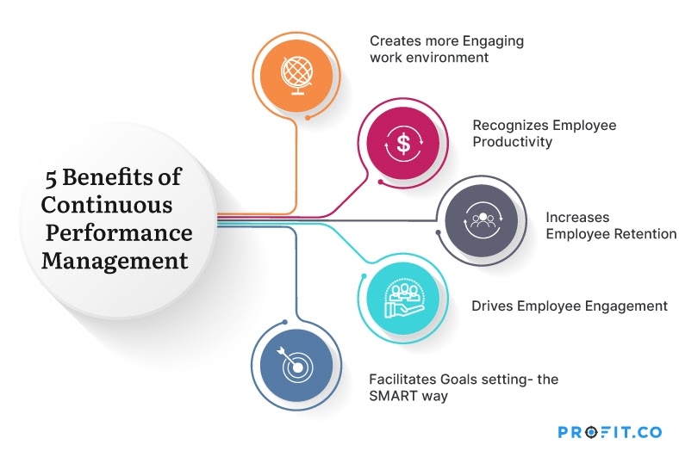
Figure 3: 5 benefits of continuous performance management
In the context of company in general, the major process of employee engagement consists of the concept called 5Cs of employee engagement. 5C stands for Care, Connect, Coach, contribute and congratulate, which was founded by Brain Hartzer to judge and measure the level of employee engagement.
Care: Caring for SainCo's employees is the initial and crucial step toward engaging them. Gallup indicates that 48 percent of employees show signs of disengagement because they sense that their employers do not care for them. This additionally has an impact on their job, but it also leads to "quiet quitting." Employees may be in the workplace yet psychologically absent.
Understanding the unique requirements and goals of employees plays a vital role in the quest for employee care. Companies may develop greater employee engagement by transforming assistance and fringe benefits to these demands. Caring can take many forms, including providing flexible work hours, supplying psychological support, and establishing a healthy balance between work and life.
Connect: Organisations need to promote open discussion and create possibilities for staff members to share ideas while helping to improve engagement among workers. This is particularly relevant for distant and mixed work, where successful interaction is frequently hampered. Collaboration technology, whether in the form of virtual chat rooms, occurrences, or a social wall for all employees unique to the organisation, can help bridge this gap (De-la-Calle-Durán & Rodríguez-Sánchez, 2021).
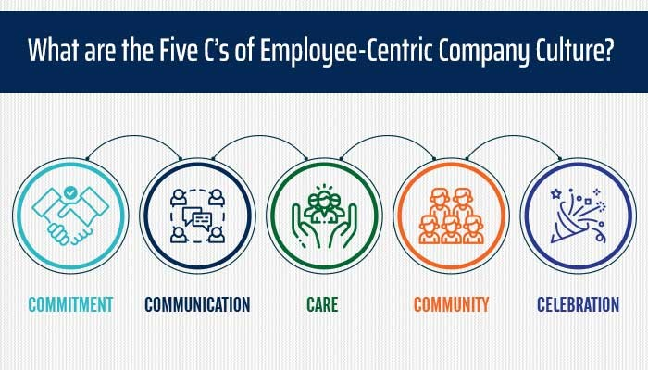
Figure 4: 5Cs of employee engagement
(Source: Sulistiana & Darma, 2023)
Coach: Coaching is important in assisting staff members in reaching their full abilities. According to McKinsey, coaching may serve as a successful plan for keeping and nurturing talent. Employees are more likely to be involved and dedicated to the organisation when they receive direction and help in developing their abilities and ambitions.
Businesses could promote their staff member's progress and help them accomplish their true potential by promoting teaching and mentoring through 360-degree evaluation and acknowledging staff members. This leads to enhanced fulfilment in work and loyalty, which encourages staff participation.
Contribute: Employees need to have confidence that what they do is important and helps to a greater cause. According to Gartner, employees are constantly searching for their own significance and purpose in their place of employment. As a result, tying performance to the bigger company vision and goals is vital for making people feel valued. This can be achieved by instituting a strict R&R programme (Kamila, Annna & Urszula, 2020).
Encouraging individuals to make significant contributions to the company's corporate social responsibility objectives can further enhance engagement while addressing employees' fundamental human desire to give back to a greater good.
Congratulate: It is critical to recognise and appreciate employees' efforts in order to sustain high levels of engagement. According to McKinsey, an amazing 87% of organisations had difficulty attracting and retaining personnel. Furthermore, according to a Glassdoor survey, 53% of respondents would consider remaining longer at their employer if they felt valued by their supervisor. As a result, one of the most straightforward ways for combating this issue is to offer appreciation and acknowledgement (Sulistiana & Darma, 2023).
Employers may drive their staff and make them feel appreciated by fostering a culture of acknowledgment and celebration. This raises morale and fosters a favorable work atmosphere, resulting in increased levels of participation.
The current level of engagement of employees inside SainCo is lower, as the line managers and HR managers are practicing an authoritarian approach to management, which means no active engagement of employees in sharing their thoughts and ideas. In such a situation, there is no means of utilizing performance management. Due to the lack of 360-degree feedback from the employees, they felt they needed to be more engaged by the senior managers of the SainCo.
Before implementing the new performance management, first of all, SainCo must replace its management style with the democratic which allows the sharing of ideas, opinions, and thoughts of employees.

Employee involvement
According to Antony (2018), employee involvement is a method of allowing individuals to voice their thoughts on company choices. This can be accomplished through company conferences, groups, and other means. When employees participate in making choices, they're granted more power over their job and surroundings. The extent in which an employee links with what they do, takes an active role in it, and derives an impression of self-worth from it is commonly referred to as job involvement.
Cognitive involvement: When an employee completely comprehends the business's beliefs, objectives, and mission.
Emotional involvement: Emotional involvement relates to an employee's feelings with regard to their job, their coworkers, their management, or the company as a whole (Xu, Tang & Guo, 2023).
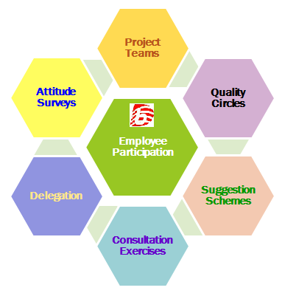
Figure 5: Employee involvement
(Source: Li & Luo, 2021)
In SainCo, due to the authoritarian approach of management, employee involvement is less, and just because of this approach, employees need to participate actively in the performance appraisal processes. Employees believe that the line managers and HR managers have no care for their employees and are partially assessing the employees' performance on their own (Li & Luo, 2021). The pluralist theory of employee involvement is applicable here, according to which employees should be heard and talked about as an essential part of their work engagement.
Collective Negotiation: Employees are given the opportunity to establish and organise unions according to the pluralist theory. As a result, they are able to participate in union negotiations, which will help employees negotiate better benefits, conditions of employment, and wages (Literat & Van Den Berg, 2019).
Job Security: According to the pluralist idea, employees have a safer place to work since their viewpoints and views are considered and taken into account. As a result, they are considered important members of the SainCo.
Increased Representation: The theory of pluralism ensures that different people and organizations are taken into account inside a company. As an outcome, employees who are part of minority groups or possess various conclusions and preferences can be confident that their opinions are going to be acknowledged and their points of view are being considered (van Assen, 2021).
Balance Between Work and Life is Upgraded: The pluralist idea understands the fact that workers have lives outside of the office and that work should not comprise the main objective of their lives. As a result, programs that promote a harmonious balance between work and life, such as paid time off, vacation leaves, and flexible schedules, are inspired.
As SainCo is not a public organization where a labour union is allowed, employee involvement is only possible with the application of sound performance appraisal, work-life balance, collective discussions with the line managers, and job security.

5 Recommendations
Strategic goals of the SainCo
SainCo has decided to bring a new “Performance Management” approach in their current business environment to prospect their employees in such a way that their performance would get excelled with the help of performance management and at last, they contribute their best of the efforts in this business organisation. The agenda of the SainCo is to foster the work performance of the employees along with ensuring their inclusion and participation in the SainCo’s future business endeavours.
- The main strategic goal is to enhance the employees’ performance by 4-5% every quarter so as to ensure the business productivity and efficiency at a top-notch level,
- The agenda is to strengthen the workforce to the 2500 employee size before going for the significant expansion in the business,
- The strategic goal of SainCo is to expand their business to new horizons and expect to see a hike in their revenue by 8-10%, so they are expecting a modern or beyond-imagination performance management system to accelerate employee performance in the coming months.
The prior analyses done in the previous section have focused on the long-term opportunities for SainCo to transform its performance management framework, which is currently followed by the company, and adopt a new style of management, like a democratic style, where the performance management/appraisal are core based on the feedback from employees, not solely from the line managers/HR managers. The concern of the top management of SainCo shows that the company is in trouble due to its current authoritarian approach and existing PM approaches. As a result, the given strategic goals to achieve are recommended.

Short-term goals for next 1-2 years
Performance management strategies for the SainCo
Performance appraisal: As SainCo is a family-run business with 2000 employees, it is the better call option to enable a 90-degree appraisal system where the employees of the respective divisions will be evaluated based on the feedback mechanism in order to ensure shorter but authentic management inside the company’s premises. Additionally, the line manager and HR manager should ensure the change in the management style from authoritarian to democratic. This new appraisal technique is only applicable when management is democratic, which allows others to “SPEAK UP,” not remain silent.
Assessment centre method: According to Zaal (2013), the German Army originated the assessment center concept in 1930, but it has since been further developed and adjusted to match today's environment. The assessment centre method provides employees with an honest understanding of the way other people judge them and how this affects how they perform. The primary benefit of this method is the fact that it additionally assesses an individual's present efficiency but also forecasts future work effectiveness (Slabbert & Hoole, 2021).
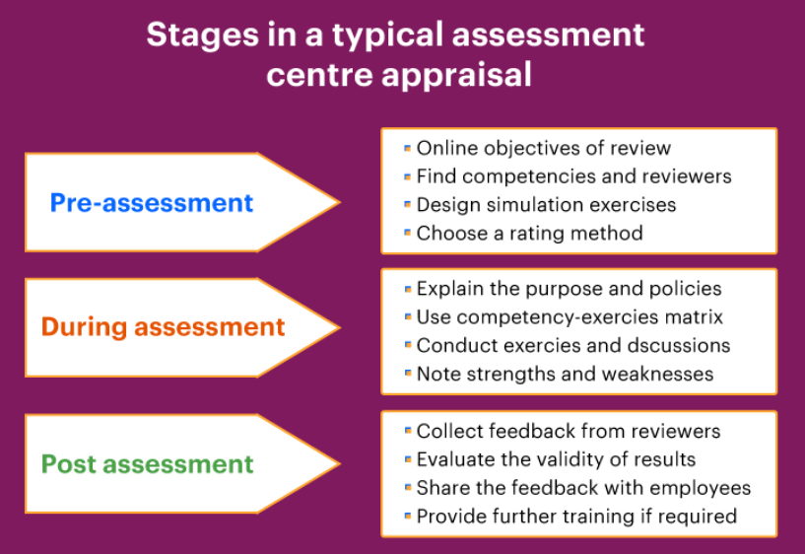
Figure 6: Assessment centre method
Employees are required to participate in social simulation exercises such as within-basket exercises, casual speaking, fact-finding exercises, decision-making difficulties, job-playing, and other activities that guarantee success in their position during the assessment. The main drawback of this strategy is that it is an expensive and time-consuming process that is hard to control.
How to implement this performance management strategy
- Determine the elements of efficient performance using job evaluation.
- Determine which accomplishment indicators may be assessed with this assessment center.
- In the assessment process, categorize pertinent and significant candidate behavior.
- Find methods of evaluation that are able to elicit optimal behavioral data.
- Assessors and assessees on the spot, with the exception of immediate leaders
- Assessors and reviewers should be thoroughly trained.
- Maintain a performance record system for every potential employee.
- Examine records and reward or teach employees accordingly.

Long term solutions for more than 3-5 years
Performance management strategies for SainCo
Behaviourally anchored rating scale: In a performance appraisal process, behaviourally anchored rating scales (BARS) draw out the qualitative as well as the quantitative advantages. BARS evaluates staff performance to specified behavioural patterns that are quantitatively rated. Each level of achievement on a BAR scale is backed by a number of BARS assertions that define prevalent behaviours that an employee works on an ongoing basis. These assertions serve as a yardstick for measuring an individual's performance to preset standards relevant to their job duties and job duties level. The first stage in developing BARS is to generate crucial episodes that illustrate typical workplace behaviour. The next step is to edit these critical incidents into a standardized structure and remove any redundancy (Matosas-López, Leguey-Galán & Doncel-Pedrera, 2019). Following standardization, significant instances are randomized and evaluated for effectiveness. The remaining essential occurrences are utilized to build BARS and assess employee performance.
Management by objective (MBO): Management by objectives (MBO) is a system of evaluation in which managers and staff members collaborate to develop, plan, organize, and share goals to concentrate on during an identified appraisal period. After establishing defined goals, employees and managers meet on an ongoing basis to talk about progress toward controls and debate the prospect of accomplishing those goals.
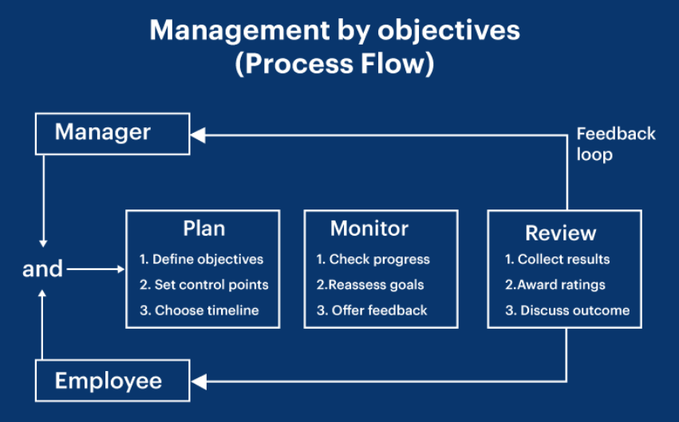
Figure 7: Management by objective (MBO)
This performance appraisal method is designed to effectively connect overall organizational goals with personnel objectives while verifying goals using the SMART approach in order to determine if the defined objective is specific, quantifiable, doable, accurate, and time-sensitive. Employees are given assessments based on their performance at the end of the period under review (every quarter, twice a year, or annually). Success gets honored with a promotion and a rise, while failure will be dealt with through transfer or additional training (Abdallah & Elhoss, 2019). This procedure typically places a greater emphasis on quantifiable objectives, while intangible variables like communication abilities, dedication, and so on can occasionally be overlooked.
These two long-term goals are linked to the mentioned strategic objectives in the following ways: -
- Each leader has to set 5-10 objectives that are achievable and quantifiable.
- Managers can write down their targets, which are going to be finalized following evaluation.
- Every objective must have a summary along with a detailed strategy (task list) for completion.
- Determine when and how frequently performance is going to be measured (minimum quarterly).
- List the necessary measures that will be implemented if progress fails to fulfil expectations.
- Ascertain that targets at every level are linked to organization goals and levels above and below.
In the context of SainCo, these recommendations are strategically aligned to fit into the strategic goals developed (at the top of this section) to enhance the employees’ performance by 4-5% every quarter to ensure business productivity and efficiency at a top-notch level. As a result, new performance management recommendations are relevant to accomplish this strategic goal. These recommendations are reliable for implementing new performance management approaches like 90-degree evaluation, management by objective, etc., as the CEO of SainCo stated. These recommendations will assist SainCo employees in engaging themselves with SainCo, ultimately resulting in an authentic performance evaluation.

6 Conclusion
This report has covered some exciting and learning-oriented discussions on the SainCo as a case study. In the report, some discussions, like organizational concerns, have concluded why SainCo needs a new modern performance management system to achieve the strategic goals mentioned in the fourth section of the recommendations. This assessment differs from a report; it is like a case study to understand why SainCo needs a modern PMS. Due to the authoritarian style of management, due to which the performance management system looks like a failed deal for SainCo as of now, a sound suggestion is made according to which the SainCo line managers and HR manager should adopt the democratic management style to ensure employees to share their thoughts and ideas on how well they performed. The report concluded that employee engagement is necessary for the employee’s performance appraisal, as the previous PM approach was based on authoritarianism, where employees were not involved. Senior managers took random feedback and evaluated the employee’s performance.
The report also concludes that the collective negotiation technique allows employees to establish and organize unions according to the pluralist theory. As a result, they can participate in union negotiations, which will help employees negotiate better benefits, conditions of employment, and wages, which is vital for employee involvement.
In the recommendation section, two solutions classified into short-term and long-term are suggested, where new performance management strategies are mentioned. However, there is a weakness: if SainCo opts out of applying a democratic management style where employees are free to speak, then in such a situation, the new PMS will also fail.
The management by objective (MBO) performance appraisal method recommended in this report is intended to connect overall organizational goals with personnel objectives while verifying goals using the SMART approach to assess if the defined objective is specific, achievable, quantifiable, precise, and time-sensitive. Employees are given feedback according to their performance at the end of the time frame for review (every quarter, twice a year, or annually).

7 References
Arsawan, I.W.E., Supartha, W.G. and Suryantini, N.P.S., 2022. Leveraging knowledge sharing and innovation culture into SMEs sustainable competitive advantage. International journal of productivity and performance management, 71(2), pp.405-428.
Al Aina, R. and Atan, T., 2020. The impact of implementing talent management practices on sustainable organizational performance. Sustainability, 12(20), p.8372.
Azeem, M., Haider, S. and Sajjad, M., 2021. Expanding competitive advantage through organizational culture, knowledge sharing and organizational innovation. Technology in Society, 66, p.101635.
Almohtaseb, A.A., 2020. Impact of talent management on organizational performance: The moderating role of an effective performance management system. International Journal of Business and management, 15(4), pp.11-24.
Antony, M.R., 2018. Paradigm shift in employee engagement–A critical analysis on the drivers of employee engagement. International Journal of Information, Business and Management, 10(2), pp.32-46.
Ahmed, T., Siraphatthada, Y. and Phumdara, T., 2020. Impact of employees engagement and knowledge sharing on organizational performance: Study of HR challenges in COVID-19 pandemic. Human Systems Management, 39(4), pp.589-601.
Abdallah, F. and Elhoss, W., 2019. The Impact of Management by Objectives (MBO) on Organizational Outcome in a Digital World: A Case Study in the Aviation Industry. In Digital Economy. Emerging Technologies and Business Innovation: 4th International Conference, ICDEc 2019, Beirut, Lebanon, April 15–18, 2019, Proceedings 4 (pp. 15-28). Springer International Publishing.
Bianchi, C. and Caperchione, E., 2022. Performance management and governance in public universities: Challenges and opportunities. Governance and Performance Management in Public Universities: Current Research and Practice, pp.1-14.
Collings, D.G., Mellahi, K. and Cascio, W.F., 2019. Global talent management and performance in multinational enterprises: A multilevel perspective. Journal of management, 45(2), pp.540-566.
Cesário, F., 2022. The role of reaction to feedback in the relationship between performance management, job satisfaction and the leader–member exchange (LMX). EuroMed Journal of Business, 18(1), pp.129-144.
De-la-Calle-Durán, M.C. and Rodríguez-Sánchez, J.L., 2021. Employee engagement and wellbeing in times of COVID-19: A proposal of the 5Cs model. International Journal of Environmental Research and Public Health, 18(10), p.5470.
Darwish, T.K., 2022. Talent management in the public sector: empirical evidence from the Emerging Economy of Dubai. The International Journal of Human Resource Management, 33(11), pp.2256-2284.
Degbey, W.Y., 2021. The impact of psychological ownership on employee retention in mergers and acquisitions. Human Resource Management Review, 31(3), p.100745.
Bauwens, R., Huisman, J. and Decramer, A., 2019. Performance management fairness and burnout: implications for organizational citizenship behaviors. Studies in Higher Education, 44(3), pp.584-598.
Fawehinmi, O., Yusliza, M.Y. and Farooq, K., 2022. Green Human Resource Management and Employee Green Behavior: Trends, Issues, Challenges and the Way Forward. In Green Human Resource Management Research: Issues, Trends, and Challenges (pp. 167-201). Cham: Springer International Publishing.
Holzer, M., Peng, S. and Deat, F., 2019. Obstacles and opportunities for sustaining performance management systems. International Journal of Public Administration, 42(2), pp.132-143.
Hartinah, S., Roslina, R. and Jermsittiparsert, K., 2020. Retracted: Teacher’s performance management: The role of principal’s leadership, work environment and motivation in Tegal City, Indonesia. Management Science Letters, 10(1), pp.235-246.
Kuzmanovic, B., Tomic, M. and Stamenic, M.S., 2019. Performance management methods: a case study from international industrial companies. Engineering Economics, 30(1), pp.103-111.
Kamila, S., Annna, S. and Urszula, C.B., 2020. Employee engagement level in ICT organizations as a barrier to the use of social media functions.
Li, R., and Luo, J., 2021. How do authoritarian leadership and abusive supervision jointly thwart follower proactivity? A social control perspective. Journal of Management, 47(4), pp.930-956.
Literat, I. and Van Den Berg, S., 2019. Buy memes low, sell memes high: Vernacular criticism and collective negotiations of value on Reddit’s MemeEconomy. Information, Communication & Society, 22(2), pp.232-249.
Matosas-López, L., Leguey-Galán, S. and Doncel-Pedrera, L.M., 2019. Converting Likert scales into Behavioral Anchored Rating Scales (Bars) for the evaluation of teaching effectiveness for formative purposes. Journal of University Teaching & Learning Practice, 16(3), p.9.
Murphy, K.R., 2020. Performance evaluation will not die, but it should. Human Resource Management Journal, 30(1), pp.13-31.
Murphy, K.R., 2020. Performance evaluation will not die, but it should. Human Resource Management Journal, 30(1), pp.13-31.
Robert, M., Giuliani, P. and Gurau, C., 2022. Implementing industry 4.0 real-time performance management systems: the case of Schneider Electric. Production Planning & Control, 33(2-3), pp.244-260.
Rojas-Lema, X., Alfaro-Saiz, J.J., and Verdecho, M.J., 2021. Performance measurement in SMEs: systematic literature review and research directions. Total Quality Management & Business Excellence, 32(15-16), pp.1803-1828.
Spanò, R. and Ginesti, G., 2022. Fostering performance management in healthcare: insights into the role of big data. Meditari Accountancy Research, 30(4), pp.941-963.
Sulistiana, I.N. and Darma, G.S., 2023. Digital Leadership, Work-Life Balance, Compensation, Job Satisfaction, and Employee Engagement. Quantitative Economics and Management Studies, 4(5), pp.981-993.
Slabbert, B. and Hoole, C., 2021. A competency framework for coaches working in coaching development centres. SA Journal of Industrial Psychology, 47(1), pp.1-10.
Tang, L. and Zhang, P., 2021. Human resource management in shipping: Issues, challenges, and solutions. Routledge.
Van Waeyenberg, T., Peccei, R. and Decramer, A., 2022. Performance management and teacher performance: the role of affective organizational commitment and exhaustion. The International Journal of Human Resource Management, 33(4), pp.623-646.
Xu, H., Tang, C. and Guo, L., 2023. Exploring service employees’ involvement in value co-creation: dimensions, antecedents and consequences. Journal of Services Marketing, 37(5), pp.650-670.
van Assen, M.F., 2021. Training, employee involvement and continuous improvement–the moderating effect of a common improvement method. Production Planning & Control, 32(2), pp.132-144.
Wang, Y., 2022. Do authoritarian leaders also have “fans”? The relationship between authoritarian leadership and employee followership behavior in the Chinese context. Management Decision, 60(5), pp.1237-1256.
Zaal, J.N., 2013. Assessment centre methods. A Handbook of Work and Organizational Psychology: Volume 3: Personnel Psychology, 3, p.89.

