Name: Nikole Atkinson
Student ID: 1910236
Module code: BMHP5014
Lecturer: Dr Azora Hurd
Assignmnet: E-Portfolio Evidence of learning

Content page

Page No
- Introduction 3
- Pitch 3
- Front flyer 4
- Back flyer 5
- Poster 6
- Reference 7

Introduction

In this Assignment I will be pitching my idea of a virtual reality app that stimulates the mind targeted at the yunger generation, this pitch intends to attract the right stakeholders needing to support and invest into my idea, there will also be a flyer and a poster that supports my busniess idea.
Pitch
Hi let me introduce myself, My Name is Nikole Atkinson, and I will be giving you the latest idea of healthy minds in the new digital era. Virtual Health in Mind is a Virtual Reality App geared at young Adults and children struggling from mental wellbeing, there has been a ground-breaking spike in mental health within young people according to Mental Health Foundation, (2021) statistics, 50% of mental health disorders develop before the age of 14 and 75% by the age of 24. While 10% of children and young people (aged 5-16 years) have a clinically diagnosable psychiatric illness, 70% of children and teenagers who have mental health issues do not receive adequate interventions at an early enough date. This App will allow the targeted audience to login with their online health records information such as the NHS Number it will then introduce them to a version of themselves in a reality form, it will enable them to indulge in various scenarios and activities that are related to getting a healthy mentality to make better decisions for themselves and display happy emotion stimulus, this App will also be Data secured and tracked by doctors and phycological therapist, as it would be linked to the EMR and EHR mechanism such that it contributes to a heathier mind.. The idea of Virtual health in Minds will be just as addictive as INSTAGRAM, SNAPCHAT and LINKEDIN it will provide outlets of a healthy lifestyle for the millennial generation, but most importantly it will have its own imagination and optimistic trajectory making it separate from the rest. Think on how many life’s this will keep save within the younger generation safeguarding them and removing them away from the stigma that affects social media outlets such as cyber bullying an exploration creating it into a more constructive alternative and reduces the amount of young people taking their lives.


Virtual Health
in Mind
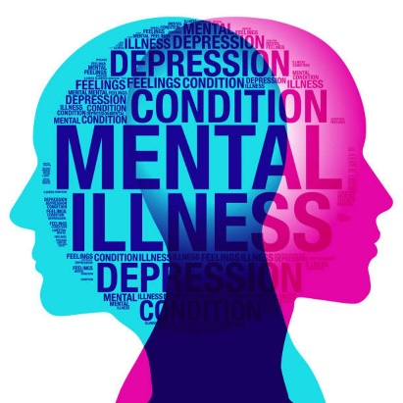

Have you ever been trapped within your own thoughts?

The Kim Foundation. (2018).

Technology is the new way of developing a healthy mind.
Technological advances could modify how acute and chronic illnesses are diagnosed and controlled, as well as how sickness is treated. diagnosed and treated, as well as how disease is avoided using artificial intelligence technical advancements,

Download the NEW APP which gives you a Piece of Mind.
According to Dimitri, P.,(2019). “Technology has transformed the way we provide healthcare. Smartphones, laptops, personal computers, and specialised technologies have allowed patients to remotely view health records, monitor their healthcare, and collaborate with medical professionals”.
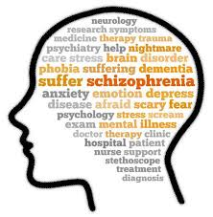
Riek, (2016)Robotics technology is being used in behavioural healthcare practise. Robots have been used to help patients with autism, dementia, and other neurological impairments, as well as to offer companionship to lonely people. So why not Mental Health ??
the dilemma for the National Health Service, as well as healthcare services around the world, is to offer more complicated healthcare at reduced costs while simultaneously enhancing quality of life and productivity.



.

This app does it all, it enhances quality of life at a reduce cost.
It allows primary care services to have more availability as it frees up spare time.
Remotely access EMR/HER system
Helping shape Mental illness I young generation creating positive change.

Contact us on:
  Download the App via your
APP STORE
Customer service 0197678889

PilotAware, 2015 Ward, C., 2018

Virtual Health
in Mind
Health is the NEW Technology

This app does it all, it enhances quality of life at a reduce cost.
It allows primary care services to have more availability as it frees up spare time.
Remotely access EMR/HER system
Helping shape Mental illness I young generation creating positive change.

Patal and Chevin,( 2007) Mental conditions account for a substantial part of the illness prevalence in young adults in all cultures. Most behavioural illnesses occur in adolescence (12–24 years of age), but they are often diagnosed later in life.
Download the Virtual Health in Mind APP and lets reverse this cycle through enhanced Technology

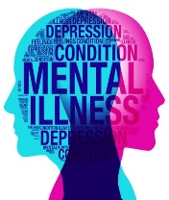

Contact us on:
Download the App via your APP STORE
Customer service 0197678889

PilotAware, 2015 Ward, C., 2018
Reference

Acharya, A., (2021). Here’s How You Can Care for Someone with Schizophrenia. [online] femina.in. Available at: <https://www.femina.in/wellness/health/heres-how-you-can-care-someone-with-schizophrenia-172628.html> [Accessed 6 February 2021].
Dimitri, P., 2019. disease in childhood. BMJ JOURNALS, [online] 104(2), p.1. Available at: <https://adc.bmj.com/content/104/2/184.abstract> [Accessed 20 March 2021].
Marr, B., (2021). The Important Difference Between Virtual Reality, Augmented Reality and Mixed Reality. [online] Forbes. Available at: <https://www.forbes.com/sites/bernardmarr/2019/07/19/the-important-difference-between-virtual-reality-augmented-reality-and-mixed-reality/?sh=6a4223735d34> [Accessed 18 March 2021].
Mental Health Foundation. (2021). Mental health statistics: children and young people. [online] Available at: <https://www.mentalhealth.org.uk/statistics/mental-health-statistics-children-and-young-people> [Accessed 18 March 2021].
Mental Health & Suicide Prevention Blog | The Kim Foundation. (2018). May is Mental Health Awareness Month - Mental Health & Suicide Prevention Blog | The Kim Foundation. [online] Available at: <https://www.thekimfoundation.org/blog/may-is-mental-health-awareness-month/> [Accessed 18 March 2021].
Patal, V. and Chevin, D.,(2007). Mental health of young people: a global public-health challenge. [ebook] London: Adolescent Health 3, p.1. Available at: <https://reader.elsevier.com/reader/sd/pii/S0140673607603687?token=370BBF0F27FAFD24EE4B61D60C32AE700FE72A5DEF329F286247BC510A77E5EF20A7D16D8380C62FFB9272EDD52AF7E7> [Accessed 20 March 2021].
Pilotaware.com. (2015). PilotAware. [online] Available at: <https://www.pilotaware.com/knowledgebase/ios-software-update> [Accessed 20 March 2021].
Riek, L., (2016). artificial intelligence in behavioral and mental Health care. Academic press, [online] pp.185-203. Available at: <https://www.sciencedirect.com/science/article/pii/B9780124202481000088> [Accessed 20 March 2021].
Ward, C., (2018). apps removed from Google Play Store in (2017). [online] Notebookcheck. Available at: <https://www.notebookcheck.net/Over-700-000-rogue-apps-removed-from-Google-Play-Store-in-2017.280554.0.html> [Accessed 20 March 2021].

