Suspect Interview Theft Task Sheet
Scenario 3 Commercial Burglary - Suspect brief

Burglary Suspect brief

!! Watch the film clip !!
You were arrested this morning by 2 officers at your home address of 112 High Street, BRIDGEND. You were arrested on suspicion of burglary. Your reply to caution upon arrest was;
“WHAT YOU ON ABOUT”
You were then transported by another two officer to the custody unit and whilst you were being booked in to custody you were informed that your property would be searched.
You will give a prepared statement to the officers at the start of the interview which you will read out and agree to sign. You will allow the officers to make copies of the statement but you will not answer any questions beyond the initial interview introduction.
‘I DO A BIT OF BUYING AND SELLING IN MY SPARE TIME TO MAKE EXTRA MONEY FOR MY FAMILY AS TIMES ARE VERY HARD.
I AM NOT A CRIMINAL AND I ONLY BUY SMALL THINGS I CAN SELL EASILY AT A CAR BOOT SALE.
I ALWAYS BUY AND SELL IN GOOD FAITH AND I AM NOT DISHONEST AT ALL
I AM A TRUSTWORTHY HARDWORKING PERSON
I WENT TO THE UNIT TO MEET A MAN NAMED ‘JOHN’ I MET HIM AT A CAR BOOT SALE HE WAS SELLING ELECTRICAL ITEMS FROM A RED VAN.
HE TOLD ME HE HAD A LEAF BLOWER I COULD BUY FROM HIM AND ASKED ME TO MEET HIM AT HIS UNIT.
I AM NOT A THIEF
I AM VERY UPSET THAT MY CHARACTER HAS BEEN QUESTIONED AND I WILL HELP THE POLICE AS MUCH AS I CAN’

You will answer ‘NO COMMENT’ to all questions put to you.
Occasionally say “LOOK I’M NOT SAYING ANYTHING ELSE, SO YOU DON’T NEED TO KEEP ASKING ME”
Aims of the Scenario

- The aim of investigative interviewing is to obtain accurate and reliable accounts from victims, witnesses or suspects about matters under police investigation.
- Investigators must act fairly when questioning victims, witnesses or suspects. Vulnerable people must be treated with particular consideration at all times.
- Investigative interviewing should be approached with an investigative mind-set. Accounts obtained from the person who is being interviewed should always be tested against what the interviewer already knows or what can reasonably be established.
- When conducting an interview, investigators are free to ask a wide range of questions in order to obtain material which may assist an investigation.
- Investigators should recognise the positive impact of an early admission in the context of the criminal justice system.
- Investigators are not bound to accept the first answer given. Questioning is not unfair merely because it is persistent.
- Even when the right of silence is exercised by a suspect, investigators have a responsibility to put questions to them.

Outcome of the Scenario

- Aim: To Provide interviewers with the competence to prepare and plan interviews with suspects.
- Objectives
- Assess information gathered about suspect(s)
- Assess the type and current condition of the suspect to inform the approach to the interview in accordance with legal requirements.
- Establish the correct interview approach utilising the engage and explain phase aide memoir
- Identify the nature of the allegation and identify investigative important information
- Produce a written interview plan that takes account of the suspect assessment , the needs of the investigation and legal requirements
- Select and set up the necessary interview location, resources and personnel.



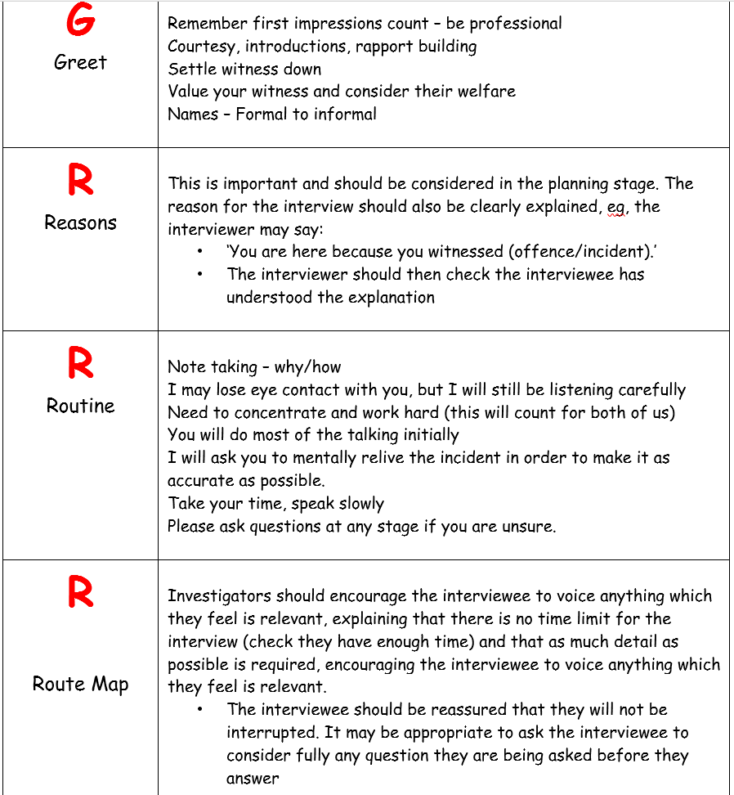

Section 9 of the Theft Act 1968 creates the offence of burglary.
9(1) A person is guilty of burglary if -
(a) he enters any building or part of a building as a trespasser and with intent to commit any such offence as is mentioned in subsection (2) below; or
(b) having entered any building or part of a building as a trespasser he steals or attempts to steal anything in the building or that part of it or inflicts or attempts to inflict on any person therein any grievous bodily harm.
9(2) The offences referred to in subsection (1)(a) above are offences of stealing anything in the building or part of a building in question, of inflicting on any person therein any grievous bodily harm (see note (v) below), and of doing unlawful damage to the building or anything therein.
9(3) penalty only - see below
9(4) References in subsections (1) and (2) above to a building, and the reference in subsection (3) above to a building which is a dwelling (see the mode of trial/penalty field below for more on dwellings), shall apply also to an inhabited vehicle or vessel, and shall apply to any such vehicle or vessel at times when the person having a habitation in it is not there as well as at times when he is.
Notes
(i) Below is an interpretation of some phrases used in the offence, but a detailed explanation of the other terms is also available.
Inflict grievous bodily harm:
In burglary there is a difference between the requirements for sections 9(1)(a) and 9(1)(b) of the Theft Act 1968 with regard to grievous bodily harm (gbh). In section 9(1)(a), the entry has to be with intent to inflict gbh, so sufficient evidence of an intent to commit an offence of section 18 of the Offences Against the Person Act 1861 is required. In section 9(1)(b) the gbh will already have been attempted or inflicted, therefore intent does not have to be considered, so an ulterior offence of section 20 is sufficient.
The word inflict, for these purposes, has been defined in the case of R v Wilson 1983. The Court decided that the meaning is not as narrow as 'assault', but is narrower than 'cause'.
The harm can be applied directly or indirectly. For instance, if someone is so frightened by an offender that he/she jumps through a window and breaks a leg, then harm can be said to have been 'inflicted' by the offender inducing substantial fear even though there is no direct application of force.

A good example is R v Burstow 1997, where a stalker made menacing phone calls, which were held to 'inflict' unlawful wounding (mentally) on his victim without any direct physical violence.
Steal:
It must be proved that the offender had
- the intention, at the time of entry, to commit an offence of stealing, i.e. theft (in section 9(1)(a)); or
- Having entered stole or attempted to steal (in section 9(1)(b)).
Where the facts will support either a charge of theft or fraud , burglary may only be charged if the ulterior offence in the charge is theft. If the circumstances only fit fraud then a burglary charge would not be appropriate.
Damage:
In section 9(1)(a) of the offence of burglary, the damage intended must amount to an offence of criminal damage under the Criminal Damage Act 1971. Intent to commit the damage has to be proved. Section 9(1)(b) does not support an offence of committing damage having entered.
(ii) Section 111 of the Power of Criminal Courts (Sentencing) Act 2000 imposes a minimum custodial sentence on conviction for a third domestic burglary.
(iii) A secure network which protects jewellery, watches and other treasured items, providing the Police with a nationwide database to search and trace the owners of recovered items can be found at www.police.e-register.net.
(iv) In subsection (2) is a second 'therein' (displayed as struck out) which was originally part of a reference to 'raping a person therein'. This reference was removed by the Sexual Offences Act 2003, however, when the amendment was made, the word 'therein' seems to have been left in the subsection by Parliament. For accuracy it has been left, but when read with the rest of the subsection, doesn't make complete sense.

