Gough's Cave Somerset.

Excavations began at Goughs Cave in the 1880's and continued until 1992 (Thomson Routers, 2017). It found artefacts dating from the Palaeolithic period and from the human remains found of the Magdalenian's, who were the early modern humans.
Magdalenian's were small groups of hunter gatherers who travelled across Southwest Europe and m.re importantly travelled to Britain via a land bridge which used to connect what is now France and Britain (Thomson Routers, 2017)
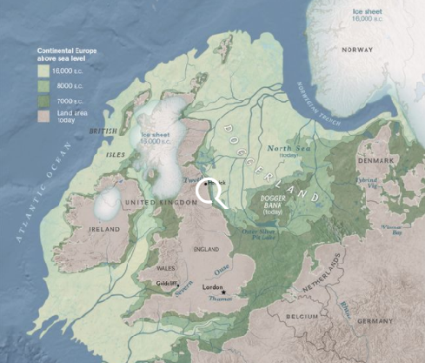
Fig. 1.
Many artefacts were discovered at Goughs Cave including ivory, large mammal bones, human remains and flint, (Thomson Routers, 2017)the humans remains are the main focus of this assignment and they way in which they are presented.(Hendry ,L. Dec 2017. The Cannibals of Goughs Cave )
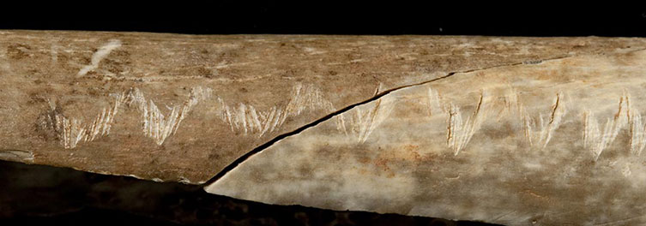
Fig. 2.
The forearm bones show incisor marks and appear to be broken carefully to extract the nutritive bone marrow, Skull cups were also found that had been carefully stripped off all soft tissue which suggests this wasn’t for nutritional value but for a more symbolic meaning. (Bello, M, S et al. Aug, 2017. An Upper Palaeolithic engraved human bine associated with ritualistic cannibalism. Pp1-4).
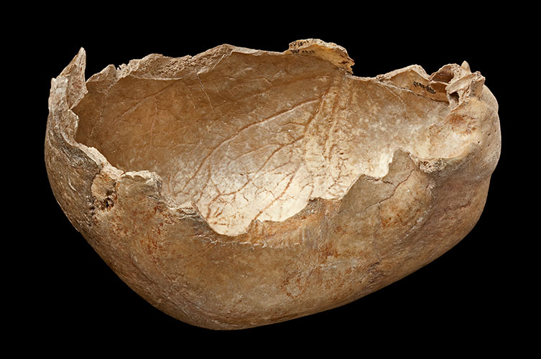
Fig 3.
The human remains discovered showed no signs of trauma or violence and appear to have died of natural causes although some of these remains were from infants as young as 3 years of age. This could suggest that this was more of a ritual practice maybe a way of preserving the knowledge of ancestors that have passed. (Bello, M, S et al. Aug, 2017. An Upper Palaeolithic engraved human bine associated with ritualistic cannibalism. Pp1-4)
Skull caps have also been found at a 7,000 year old site in Herxheim in Germany as well as at two imprecisely dated Magdalenian sites in France. Nine cranial remains found from the site of Le Placard Cave also showed care and attention had been given to the preparation of these skull caps.(Balter, M. 2011 Ancient Britons Used Skulls As Cups)
However the skull caps recovered from Herxheim showed very little evidence of cut marks suggesting the skull caps were made after decomposition had taken place many been even years after the death of the individual. (Balter, M. 2011. Ancient Britons Used Skulls As Cups)
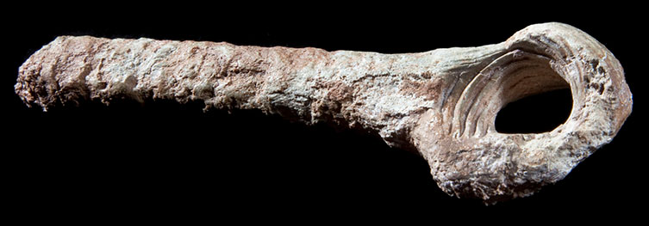
Fig. 4.

Magdalenian's left human remains and animals remains together which could be a sign that they were all treasured possessions , which does appear to be the case when you look at the carefully made tool (See Figure 4.) which is made from reindeer horn. (Hendry, L, 2017. The Cannibals of Goughs Cave)

Because of Radiocarbon dating we can see that the remains found in Goughs Cave were placed there over a relatively short period of time and more importantly whilst travelling in different seasons , which could suggest they made there journey to Goughs cave for either hunting purposes or for the purpose of burying their dead. (Bello,S. 2015. Journal of Human Evolution 82.Pp185)

Because of the significant amount of animal bones found in Goughs Cave it is unlikely the Magdalenian people were struggling for food and is unlikely they needed to consume each other. But the fact skull cups have been found throughout southwest Europe does hint that these were practises carried out by all of the small groups of nomads.(Thomson Routers, 2017: )
The way in which the human bones are cared for suggests that the Magdalenian's took care of their dead much in the same was we have mummification, burials and cremations. (Bello, M, S et al. Aug, 2017. An Upper Palaeolithic engraved human bine associated with ritualistic cannibalism. Pp1-4)

Bibliography:

Websites:
Reuters Science News. 2017. The Thomson Reuters Trust Principles. Available from: https://www.reuters.com/article/us-science-cannibals/engraved-prehistoric-human-bones-show-ritualistic-cannibalism-idUSKBN1AP282. Accessed: 22/2/18
Hendry, L. 2017. The Natural History Museum. Avaliable from: http://www.nhm.ac.uk/discover/the-cannibals-of-goughs-cave.html. Accessed: 22/2/18
Butler,M. 2011. Science Mag. Avaliable from: http://www.sciencemag.org/news/2011/02/ancient-britons-used-skulls-cups. Accessed: 22/2/18

Online Journals:
Bello, M, S; Wallduck, R; Parfitt, A, S; Stringer, B, C. August 2017. An Upper Paleolithic engraved human bone associated with ritualistic cannibalism. Plos One. Vol 12. No. 8. Pp1-4. JSTOR [Online].
Bello,M,S; Parfitt,A,S; StringerB,C. Feb 2011. Earliest Directly – Dated Human Skull Cups. Plos One. Vol 6. No.2. https://doi.org/10.1371/journal.pone.0017026

Images:
Fig.1. Map of Doggerland.2012. McNulty, E, W ; Cookson, N, J. National Geographic Magazine. Avaliable from: https://www.nationalgeographic.org/maps/doggerland/ Accessed: 22/2/18.
Fig. 2. Forearm bone. 2017. National History Museum. Available from: http://www.nhm.ac.uk/discover/the-cannibals-of-goughs-cave.html Accessed: 22/2/18.
Fig.3. Skull Cup. 2017. National History Museum. Avaliable from:http://www.nhm.ac.uk/discover/the-cannibals-of-goughs-cave.html Accessed: 22/2/18
Fig. 4. Reindeer Horn. 2017. National History Museum. Available from: http://www.nhm.ac.uk/discover/the-cannibals-of-goughs-cave.html. Accessed: 22/2/18.

