Learning In The Digital Era
Component 1: E-portfolio

Submitted by: Daniel Matthews

Student number: 2528997

Date: March 2026

Table of contents
Contents
E-portfolio link 2
Screenshot of e-portfolio cover page/ welcome page 3
Task 1 3
Screenshot of ‘Essential Skills’ 4
Screenshot of ‘Reflection’ 4
Task 2 4
Screenshot of mind map 5
Link to mind map 5
Screenshot of the academic poster 5
Link to the academic poster 6
Task 3 6
Screenshot of automatic referencing tool 7
Task 4 7
Screenshot of each page of e-portfolio 8

E-portfolio link

https://sites.google.com/view/danielmatthews/home

Screenshot of e-portfolio cover page/ welcome page

Task 1

Screenshot of ‘Essential Skills’

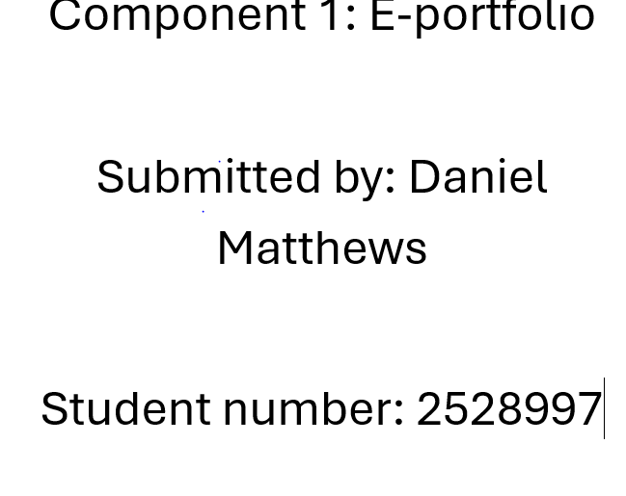

Screenshot of ‘Reflection’

Task 2

Screenshot of mind map

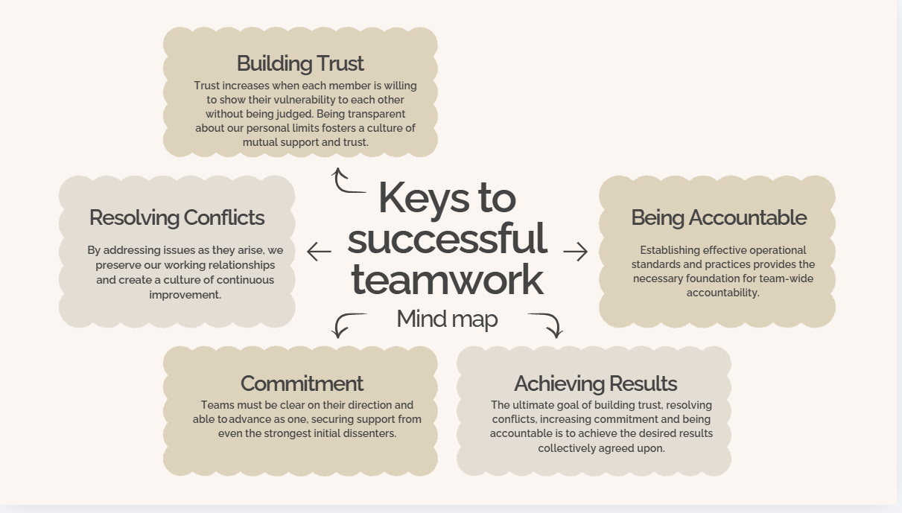

Link to mind m

Screenshot of the academic poster

Link to the academic poster

Task 3

Screenshot of automatic referencing tool

Task 4

