Name: Isaac Alake
ID Number: 2132943
Tutor Name: Alice Clayton Assignment Title: Component Written Report 2 Module: Mental Disorders and Psychopathology
Code: BMHP6006

Contents
1. Introduction 4
2. Classification and Diagnosis 5
3. Treatment and Rehabilitation 8
4. Evaluation and Recommendations 14
5. Conclusion 19
6. References 21

Table of figures
Figure 1: Cognitive-Behavioural Therapy 8
Figure 2: Biopsychosocial Model 10
Figure 3: Mindfulness-based stress reduction 11
Figure 4: Stepped Care Model 12

1. Introduction
This paper aims to analyse Depression and Anxiety Disorders as understood and classified under the ICD-10’s Chapter 5. It wants to assess the classification, diagnostic standards and treatments as well as the rehabilitative strategies of these mental disorders. Depression is defined as a state of low mood with various cognitive and motor deficits, whereas Anxiety Disorders comprise such entities as generalised anxiety disorder, panic disorder and social phobia and are associated with excessive fears and worries. Both conditions have a very significant effect on the recipients' quality of life and the person society, and the economy experience huge costs. Recommendations for enhancing the existing strategies will be offered and a consideration of the action plans to execute these recommendations, concerning patient care and practitioners’ work routes, will be given.

2. Classification and Diagnosis
2.1 Depression
ICD-10 Classification
The ICD-10 classification system presents a detailed method of diagnosing depression and is classified under F32 and F33. In the toolsets, the codes are formalised in the following manner:
F32 Depressive Episode: Out of these, it covers single episodes of depression as mild (F32. 0), moderate (F32. 1), severe no psychotic symptoms (F32. 2) and severe psychotic symptoms (F32. 3) (Fellinger et al., 2022).
F33 Recurrent Depressive Disorder: This code is for other episodes of depression and is also broken down into mild (F33.0), moderate (F33.1) severe non-psychotic (F33.2) and severe psychotic (F33.3). There are codes for recurrent depressive disorder in complete remission F33.4 and other recurrent depressive disorders (F33.8 and F33.9) (Fellinger et al., 2022).
Diagnosis Criteria
Diagnostic criteria for depression according to ICD-10 contain lists of signs, which have to be manifested for at least 2 weeks. The malaises which are associated with this illness include a subdued mood, decreased vitality and lethargy. This problem slows how much one can have fun, be interested, or concentrate and how fatigued one becomes with little doing. Night waking and poor eating become evident and the child is also embarrassed and lacks confidence in him or herself. Also, as a result of a lesion, the personalities could be pathologic and the individuals could have ideas of guilt and worthlessness. Depression may also feature somatic signs like lack of interest in things including activities and waking up early; the worst depression is in the morning, slowness of movements, agitation, loss of appetite, weight loss and even loss of sexual desire. All these criteria are useful in assessing, diagnosing and listing down those people who need depressive care and treatment (Belov, 2020).
Current Challenges
One of the challenges is that some of the symptoms depend on the sufferer's perception, which may not be universal since it can be influenced by the cultural background. Also, due to the similarity of some of the symptoms with other mental illnesses, the diagnosis of this disorder becomes challenging. In the same way, the ICD-10 provides general classifications of depression types and does not differentiate between, for example, atypical depression or dysthymia, so cases of under- or misdiagnosis might occur. Another major drawback is a criterion on the minimum symptom duration (two weeks) which can be an issue in acute care where early identification is vital (Verbitskaya et al., 2020).
2.2 Anxiety Disorder
ICD-10 Classification
Specific to ICD-10 anxiety disorders can be described under F40 to F41 which all pertain to distinct types of anxiety.
F40 Phobic Anxiety Disorders: This covers agoraphobia (F40.0), social phobia (F40. 1) and specific phobia (F40. 2) (Citkowska-Kisielewska et al., 2019).
F41 Other Anxiety Disorders: This covers calamity-induced panic (F41.0), generalised anxiety only (F41.1), mixed anxiety and depression (F41. 2) and other/situational (F41.3, F41.8, F41.9) (Citkowska-Kisielewska et al., 2019).
Diagnosis Criteria
Panic Disorder (F41.0): A specific type of anxiety disorder that consists of sudden attacks which are unplanned and disturbing; the patient may experience palpitations, chest pain, choking feeling, dizziness and a sense of unreality (‌Krawczyk and Święcicki, 2020).
Generalised Anxiety Disorder (F41.1): Characterised by long-standing and a generalised form of disturbance apart from situations where the anxiety is produced it includes nervousness, tremors, muscle rigidity, sweating, dizziness, fainting palpitations and epigastric distress (Krawczyk and Święcicki, 2020).
Mixed Anxiety and Depressive Disorder (F41.2): The patient has both anxiety and depression, but the symptoms are not severe enough to warrant a diagnosis of either condition on their own (Krawczyk and Święcicki, 2020).
Current Challenges
The diagnostic criteria of anxiety disorders with ICD-10 are not free from difficulties either. The fact that the criteria are broad and sometimes rather vague results in overdiagnosed or underdiagnosed conditions. Sometimes there is a clear overlap of symptoms with other disorders, for example, when it is difficult to identify the primary condition and the consequences of depression. Also, they indicate that cultural variations regarding the manifestation of anxiety disorder can influence the reliability of the identification of these disorders as specific manifestations can be more evident in distinct cultures. Another problem is an inadequate assessment or a more comprehensive and time-consuming one which is problematic implementation in clinical works (Terlizzi and Villarroel, 2020).

3. Treatment and Rehabilitation
3.1 Depression
Treatment Options
Pharmacological and non-pharmacological forms are both used in the treatment of depression. In pharmacological treatment, the main line is the usage of antidepressants. They include serotonin reuptake inhibitors which are the most commonly prescribed antidepressant type, serotonin-norepinephrine reuptake inhibitors and tricyclic antidepressants are also included. These drugs work on the chemical nature of the brain hence eradicating or reducing depressive symptoms (Maffioletti et al., 2020).
Other interventions apart from medication include counselling and the most preferred is cognitive behavioural therapy. CBT is centred on shifting the unhealthy ways of thinking and behaving that are linked to depression. Other schools of thought are IPT where interpersonal factors causing depression are tackled and behavioural activation as an approach that requires patients to be as active as possible to side-line depressive tendencies. Moreover, it is suggested that the patient engage in physical exercise, sleep at least 7-8 hours and maintain a proper diet as components of managing the condition (Cuijpers et al., 2019).
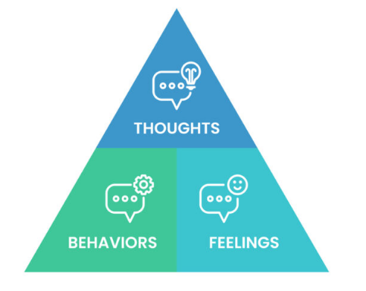
Figure 1: Cognitive-Behavioural Therapy
(Source: Think Profits, 2024)
Rehabilitation Measures
The strategy of rehabilitation for patients with depression is therefore to regain the highest level of functioning possible. These are generally vocational skills training and instruction in social skills as well as skills in support groups. Vocational training aids individuals in gaining back their capacity to work while social skills training assists in the social isolation problems and the mending of relations.
Mindfulness-based cognitive therapy (MBCT) and stress management are usually included in rehabilitation programs to support the client deal with stressful events that result in depression. CBR programmes also have the roles of supporting the client in the community, establishing them in the community environment and ensuring that they do not revert to their old habits (Musa et al., 2020).
Contemporary Theories
As a part of the National Health Service (NHS), several modern theories and approaches are used to help people with depression. There is, for example, the stepped care model which guarantees that a person receiving help will receive the least obtrusive and the most effective help suitable to a person's needs. This model, as mentioned earlier, spans individually facilitated self-help, to computer-administered CBT, online support stepped care face to face therapy and medication administration (Cladder-Micus et al., 2019).
The Biopsychosocial model is also relevant to the NHS's operations. Apart from the biological causation of the depression this model factors in psychology and social factors in the treatment of the patient with depression that involves all the areas of the life of such a person. In addition, the NHS adopts individual continuation care plans to meet the specific needs of the patients and focuses on the patient's needs during the treatment process (Gilbert, 2019).
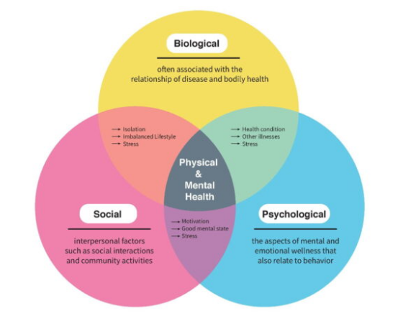
Figure 2: Biopsychosocial Model
(Source: Wustl, 2021)
Services that are provided through the National Health Service have a digital form, for instance, mobile applications and online platforms for mental health support. These tools provide features like mood diaries, explanations of mental disorders and online therapy sessions that expand the availability and scope of mental health care.
3.2 Anxiety Disorder
Treatment Options
In the case of Anxiety Disorders according to ICD-10, the available diagnosis and treatment entails the use of drugs, psychotherapy and other forms of treatments. Drug therapies employ the prescription of antidepressants hence selective serotonin reuptake inhibitors (SSRIs) work well in decreasing the levels of anxiety that are present. Some other drugs such as benzodiazepines may be used in cases of acute anxiety symptoms, but they have the possibility of causing dependence.
Cognitive behavioural therapy (CBT) stands as the most important one whenever anxiety disorders are in question. CBT involves reassembling the patient's distorted thoughts and emotions that precipitate anxiety, as well as skills for dealing with such symptoms. Mindfulness stress reduction Including Mindfulness-based stress reduction (MBSR) and other activities increasingly being prescribed to help relieve the patient's anxiety through relaxation techniques and maintaining awareness of the present (Foroughi et al., 2020).
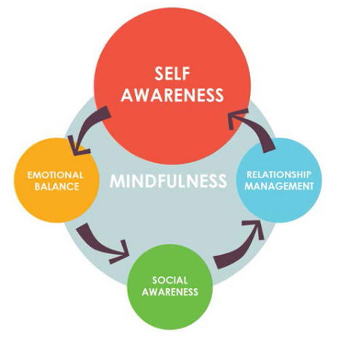
Figure 3: Mindfulness-based stress reduction
(Source: Making myself, 2024)
Rehabilitation Measures
Treatment of Anxiety Disorders entails conservational skills to enhance the quality of life and practical status of the patients. They, more often than not, encompass psych education and this entails enabling the patient to know about their condition and possible ways to address it. An important way of encouraging the participants to continue using appropriate coping strategies after the end of the intervention is through, supporting groups to enhance the participants' experience and feeling of togetherness.
Occupational therapy can help a patient acquire and learn proper strategies that can help them deal with anxiety in their workplaces and other spheres of their life. It might require learning such skills as time management, assertiveness and skills to show how to solve specific problems. Self-entertain, especially through the use of physical exercises, as the latter is recommended because exercises have anxiolytic effects because of the release of endorphins and because they promote general health.
Rehabilitation measures’ efficiency heavily depends on the subject’s involvement in the treatment process and the availability of the necessary resources. System monitoring and individualised care are critical when it comes to the client’s peculiarities.
Contemporary Theories
Modern theories and models implemented by the NHS for dealing with patients who suffer from Anxiety Disorders are based on the integrated approach. The biomedical model is still prevalent, though the Biopsychosocial model is more accepted acknowledging the role of biological, psychological and social aspects in the development of anxiety disorders.
The stepped care Model is one of today's approaches designed to outline the way to deliver scientific treatments. In this model, the least meddling, yet most constructive methods (such as self-determination or guided self-help) are utilised first and then more intense procedures (including CBT or drugs) will be applied if the former are not sufficient.
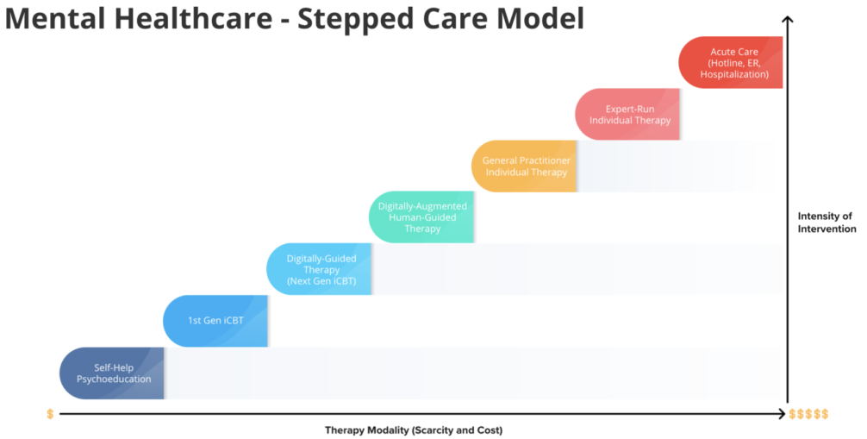
Figure 4: Stepped Care Model
(Source: Starling Minds, 2021)
They also include technology in treatment, for instance, Internet-based cognitive behavioural therapy was also noted to augment the accessibility of the treatment and has shown efficacy in various forms of anxiety disorders. Another modern practice is virtual reality or VR exposure, which provides the patient with the ability to expose him or her to the source of the fear in a controlled manner.

4. Evaluation and Recommendations
4.1 Depression
Evaluation of Current Practices
The present diagnostic procedures of depression put to use by ICD-10 carry some advantages as well as some drawbacks. The current ICD-10 offers a solid reference point for citing different types of depressed episodes that range from mild, moderate to severe with non-psychotic and psychotic symtoms. This broad to-specific differentiation allows the clinician to simulate the degree of the disorder for the specific treatment. Nevertheless, the diagnostic criteria can be quite restrictive at times as they do not allow for subtle differences between patients' symptoms to be taken into consideration. For example, the criteria that have been used concerning the number of symptoms with separate timeframes make it impossible for individuals who could be suffering from atypical depression to gain a diagnosis (Guerrera et al., 2020).
Modes of treatment have improved over the years mostly with more emphasis on the use of drugs as well as cognitive behavioural therapy (CBT). SSRIs and SNRIs are examples of medication that is frequently prescribed and is generally effective. However, there are issues concerning the side effects of these products, patients' compliance and the time that is always taken before the product starts showing its effect. CBT and other non-pharmacological treatments are helpful in many cases and present fewer adverse effects than medications; nonetheless, they have significant barriers like a long wait for a therapy appointment and a scarcity of neuroscience therapists (Guerrera et al., 2020).
Recommendations for Improvement
It is necessary to rethink the diagnostic criteria given in the ICD-10 and extend the list of symptoms and ways of depression manifestation to raise the individual approach. Also, sourcing patients' concerns and incorporating them as crucial values in the analysis can help increase diagnostic reliability and patient satisfaction (World Health Organization, 2024).
In the treatment domain, an enhancement of the access to as well as the availability of psychotherapy is required. The growth of telehealth programs could assist in alleviating the lack of mental health workers and consequently, decrease the number of months that people have to wait for therapy. In addition to this proposal, there appears to be a constant search for new antidepressant drugs that can work even faster and cause less harm to patient ‌ (World Health Organization, 2024).
Implementation in Practice
As a result, making these recommendations entails the following practical steps. As we have seen when attempting to revise the ICD-10 criteria it takes interdisciplinary effort of mental health workers, academics and policy makers. This process should be informed by the existing research on mental disorders and involve the patient's input along with other stakeholders in the patient's life such as the advocacy groups (Gałecki and Bliźniewska-Kowalska, 2021).
To increase the availability of psychotherapy, healthcare organisations must increase the number of faculty focusing on mental health care and enhance telemedicine services. Advertising can play the role of informing the population about opportunities for using telecare and eliminate prejudice concerning receiving mental health services (Gałecki and Bliźniewska-Kowalska, 2021).
The integration of patient-reported data can be realised in terms of ongoing follow-ups and questionnaires that are used to assess the patient's condition and the efficacy of further therapies. It also makes a plan quite flexible in a way that it can meet the patient's needs at a different stage thus enhancing treatment outcomes (Gałecki and Bliźniewska-Kowalska, 2021).
4.2 Anxiety Disorder
Evaluation of Current Practices
The current intervention strategies and diagnosis of Anxiety Disorder according to ICD-10 have limitations as well as benefits. The ICD-10 has given a clear guideline to dissect different anxiety disorders like Generalised Anxiety Disorder (GAD), panic disorder and social phobia among others. This classification aids in categorising these disorders so that they can be diagnosed systematically depending on set features, which encompasses excessive and persistent worry, anxiety, as well as; palpitations and dizziness, among others (Citkowska-Kisielewska et al., 2019).
The difficulty in distinguishing symptoms of different anxiety disorders as well as their relation to other psychiatric disorders, including depression. Such overlapping can cause diagnostic imprecisions and even misdiagnosis of the patient’s conditions. Moreover, the nature of the symptoms that patients describe is quite subjective, which may hinder the diagnosis process. Another is the factor where manifestations of the symptoms differ in different groups and that is due to cultural, social and individual differences (Citkowska-Kisielewska et al., 2019).
Recommendations for Improvement
ICD-10 diagnostic criteria should be further developed to avoid cross-over and to increase criterion reliability. This could entail the elaboration of more specific symptom descriptors for clients suffering from anxiety disorders as well as characteristics that distinguish anxiety disorders from other mental illnesses. More studies need to be urgently conducted on the establishment of biological indexes for anxiety disorders for confirmation of assessment findings. The clinicians should periodically update themselves, about the latest diagnostic standards and treatment guidelines. This training should comprise effective cultural competence given the diverse ways in which anxiety disorders manifest in different cultures ‌ (World Health Organization, 2024).
Translational care solutions in which mental health services are incorporated with primary care can help in providing seamless and continuous care to patients with anxiety disorders. This can also support the early detection and intervention hence improving the outcomes of the patients. Hence, the use of technology in healthcare like telemedicine and digital health tools will enhance provider proximity to patients in facilities that are physically located in remotest regions. These tools can also be applied for self-management and surveillance of symptoms of the patient ‌ (World Health Organization, 2024).
Implementation in Practice
Health organisations and the government sector should review their policies and procedures to incorporate the new diagnostic criteria and even evidence-based treatment plans. More funding should be provided for biomarkers and the advancement of new diagnostic methodologies. It is possible to create extensive packages for clinicians' training, such as workshops, online courses and certification, which will help to popularise best practices throughout the healthcare system (Garakani et al., 2020).
Primary healthcare organisations should expand the delivery of mental health care. This may include developing presumption teams and consequently comprehensive care programs. Promoting the implementation of Health IT solutions and telemedicine systems can help improve service capabilities (Garakani et al., 2020).

5. Conclusion
Summary of Key Findings
This report analyses and evaluates the methods of classification, diagnosis and treatment and also the rehabilitation procedures of Depression and Anxiety Disorders according to the ICD-10. Depression which falls under the F32 and F33 entails significant mood disorder coupled with functional loss. Anxiety disorders under F40 and F41 comprise specified conditions like panic disorder, generalised anxiety disorder and others. The former poses diagnostic difficulties because of overlapping and cultural-specific common symptoms similar to the latter. ESS supports pharmacological trials involving the use of antidepressants such as SSRIs and SNRIs, alongside non-pharmacological strategies such as therapies and lifestyle adjustments. Rehabilitation is aimed at regaining the abilities of a patient and the implementation of support in everyday life and the community.
Impact of Recommendations
All the discussed recommendations should help increase diagnostic precision as well as treatment effectiveness. If it has tightened the ICD-10 criteria for diagnosing mental disorders and included patients' points of view, diagnosis can be made personalised. It is suggested that psychotherapy can be made more accessible and which can include telehealth to treat the deficits that exist in today’s practice. In anxiety disorders, enhancing diagnostic tools and trying to use technology might be helpful to produce better results and avoid delays in admitting the sufferers to treatment. The combination of mental health care with the primary care model and the growth of digital technology will enhance the approach of health care systems in addressing issues affecting the said patients.
Future Directions
More research should be conducted after the one reviewed in this paper towards establishing objective biomarkers for Mental health disorders to determine the exact health conditions being experienced by patients. Researching potential new and improved treatments, for example, digital and VR therapy, may suggest novel methods of treatment management. Subsequently, reiterated the focus on cultural relevance in the assessment of, as well as intervention for, mental health will continue to be critical in unveiling how a given mental health disorder may present among culturally diverse communities.

6. References
‌Belov, O. (2020) ‘PERSONAL CHARACTERISTICS OF PATIENTS WITH DEPRESSIVE DISORDERS’ Scientific Journal of Polonia University, 43(6), pp.240-246.
Citkowska-Kisielewska, A., et al. (2019) ‘Anxiety symptoms in obsessive-compulsive disorder and generalized anxiety disorder’ Psychiatria Polska, 53(4), pp.845-864.
Cladder-Micus, M.B., et al. (2019) ‘Effects of mindfulness-based cognitive therapy on a behavioural measure of rumination in patients with chronic, treatment-resistant depression’ Cognitive Therapy and Research, 43(4), pp.666-678.
Cuijpers, P., et al. (2019) ‘Psychological treatment of depression in primary care: recent developments’ Current psychiatry reports, 21, pp.1-10.
Fellinger, M., et al. (2022) ‘Seasonality in major depressive disorder: effect of sex and age’ Journal of affective disorders, 296, pp.111-116.
Foroughi, A., et al. (2020) ‘The effectiveness of mindfulness-based cognitive therapy for reducing rumination and improving mindfulness and self-compassion in patients with treatment-resistant depression’ Trends in psychiatry and psychotherapy, 42, pp.138-146.
Gałecki, P. and Bliźniewska-Kowalska, K. (2021) ‘Treatment-resistant depression—Recommendations of the National Consultant in the field of psychiatry’ Psychiatr. Pol, 55(1), pp.1-15.
Garakani, A., et al. (2020) ‘Pharmacotherapy of anxiety disorders: current and emerging treatment options’ Frontiers in psychiatry, 11, p.595584.
Gilbert, P. (2019) ‘Psychotherapy for the 21st century: An integrative, evolutionary, contextual, biopsychosocial approach’ Psychology and Psychotherapy: Theory, Research and Practice, 92(2), pp.164-189.
Guerrera, C.S., et al. (2020) ‘Antidepressant drugs and physical activity: a possible synergism in the treatment of major depression?’ Frontiers in psychology, 11, p.857.
‌Krawczyk, P. and Święcicki, Ł. (2020) ICD-11 vs. ICD-10-a review of updates and novelties introduced in the latest version of the WHO International Classification of Diseases. Psychiatr Pol, 54(1), pp.7-20.
Maffioletti, E., et al. (2020) ‘Blues in the brain and beyond: molecular bases of major depressive disorder and relative pharmacological and non-pharmacological treatments’ Genes, 11(9), p.1089.
‌Makingmyself.com. (2024). Mindfulness-Based Stress Reduction (MBSR) - Mental Model. [online] Available at: https://www.makingmyself.com/en/mental-models/mindfulness-based-stress-reduction-mbsr-da90d [Accessed 23 Jul. 2024].
Musa, Z.A., et al. (2020) ‘Effectiveness of mindfulness-based cognitive therapy on the management of depressive disorder: Systematic review’ International Journal of Africa Nursing Sciences, 12, p.100200.
‌Starling Minds (2021). Stepped Care: The Future Healthcare Model of Mental Health. [online] Starling Minds. Available at: https://www.starlingminds.com/stepped-care-the-future-healthcare-model-of-mental-health/ [Accessed 23 Jul. 2024].
Terlizzi, E.P. and Villarroel, M.A. (2020) ‘Symptoms of generalized anxiety disorder among adults: United States, 2019.’
‌Think Profits (2024). Let’s Talk Business: Financial Success as a Naturopathic Doctor. [online] AANMC. Available at: https://aanmc.org/naturopathic-medicine/cognitive-triangle-cbt/ [Accessed 23 Jul. 2024].
Verbitskaya, M.S., et al. (2020) ‘Atypical depression in bipolar affective disorder: a clinical case study’ Neurology, Neuropsychiatry, Psychosomatics, 12(6), pp.144-150.
World Health Organization (2024). Diagnostic and management guidelines for mental disorders in primary care: ICD-10. Chapter 5, Primary care version. Who.int. [online] doi:https://doi.org/0889371482.
Wustl.edu. (2021). Three Aspects of Health and Healing: The Biopsychosocial Model in Medicine | Department of Surgery | Washington University in St. Louis. [online] Available at: https://surgery.wustl.edu/three-aspects-of-health-and-healing-the-biopsychosocial-model/ [Accessed 23 Jul. 2024].

