Cover Page
Course: DSBL

Name: Denise Fitzsimmons

Student Number: 2007361

Word Count: 4,360

Link to Blog on Sway: https://sway.office.com/7aOSELh8pd8mZizQ?ref=Link

Introduction
This blog draws on my experiences of working within an HR environment in HDUHB over the last 24 months. My experiences are described and evaluated to show where I have acquired skills and used them to support my learning and development. I am currently an Associate Member of the CIPD.
I will be using Gibbs’ reflective model throughout, as seen in Figure 1.
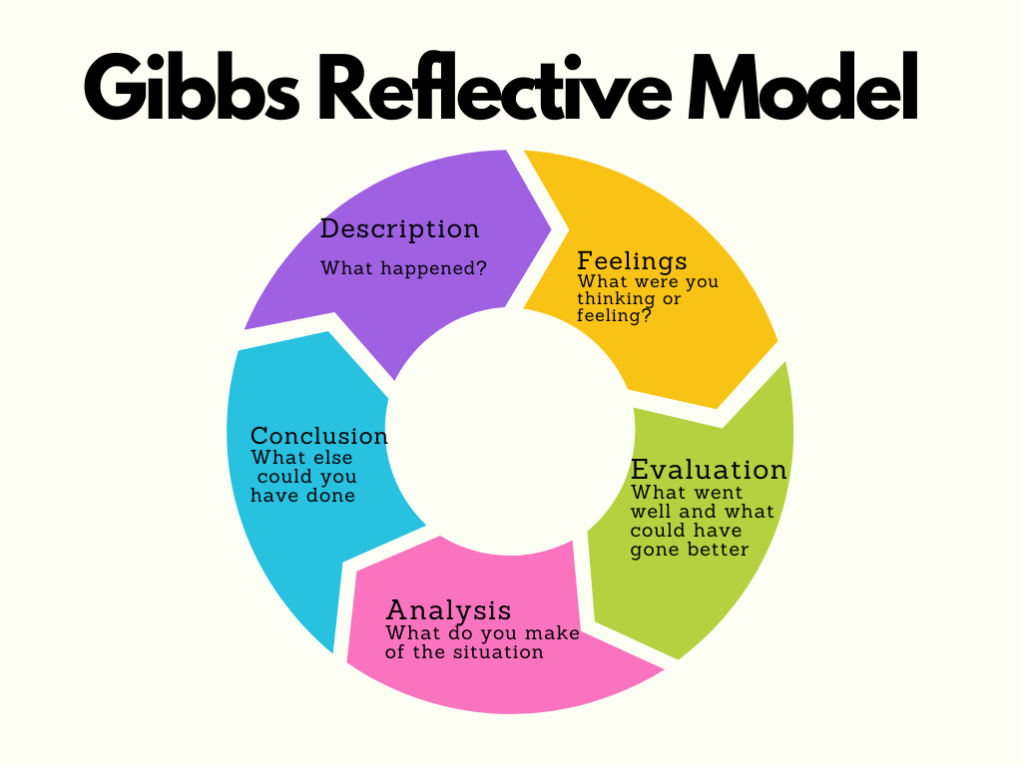Figure 1: Gibbs Reflective Model (The University of Edinburgh, 2020)

I have also used the CIPD Profession Map to assess my skills and experience against the work I’m currently doing; a reference to the map can be seen below in Figure 2.

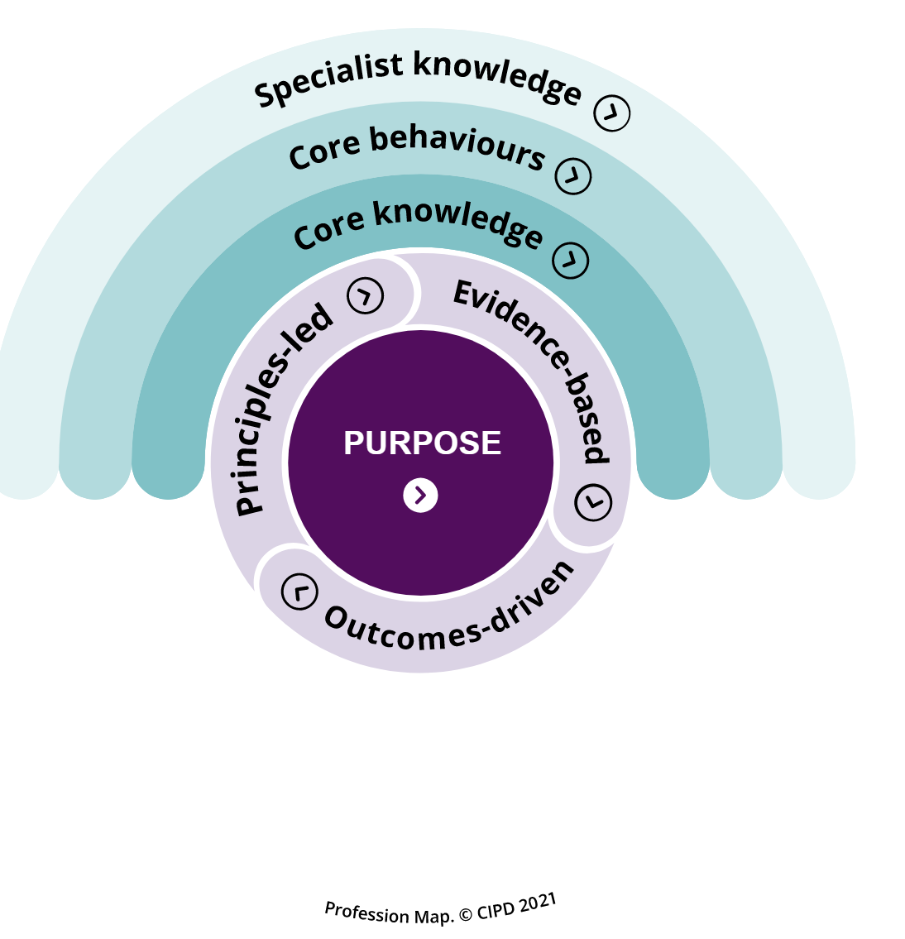
Figure 2: CIPD Profession Map image showing all the critical outcome areas (CIPD, 2021b)

Changing Tact – A job role change from operational HR to Organisational Development

Describe: In December 2021, I acquired a job in Organisational Development within HDUHB. This change has taught me about human process interventions such as training, coaching, group work facilitation, and strategic support such as culture change and transformation (CIPD, 2020a) . This was a learning experience, as I previously worked in an HR Advisor role.
I underwent additional training to help me manage myself more effectively at work (LOC 1). This has included 360-degree feedback using the NHS Leadership model (NHS, 2022), this included becoming trained as a facilitator; my certificate can be seen in Figure 3. I also completed a Myers Briggs 16 personalities questionnaire, which can be seen in Figure 4 (16 Personalities, 2022), (Myers Briggs Foundation, 2022)
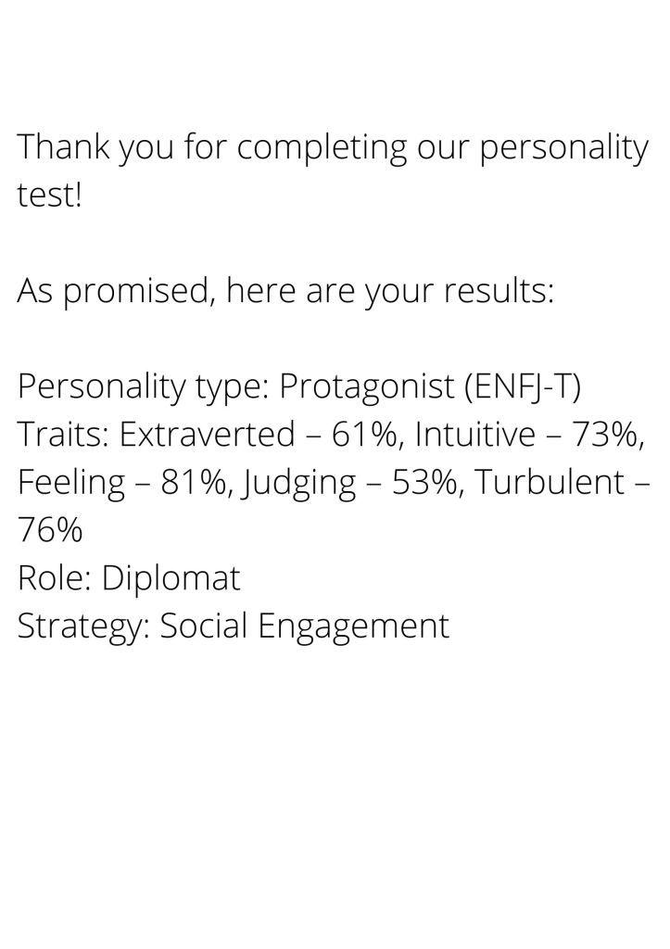
Figure 3: The Results of my 16 Personalities Test (16 Personalities, 2022)
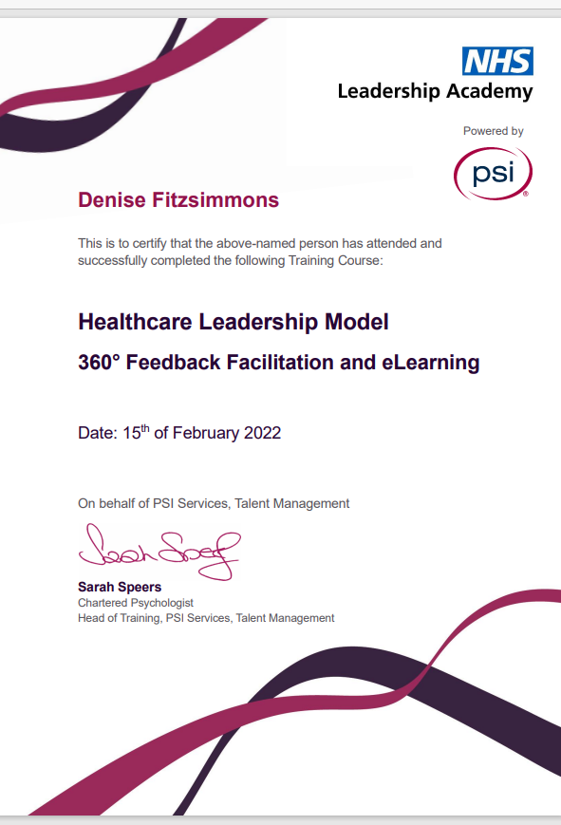

Figure 4: HLM 360 Feedback Facilitation training document (NHS, 2022)
Feelings: I felt excited and nervous about starting a new role. Before starting, I thought I was aware of how I worked, but I didn’t readily ask for feedback; I was interested in seeing how others perceived my work! I didn’t have experience coaching and developing others before undertaking this work, so it developed my leadership skills (LOC 4).
Evaluation:
Due to some of the limitations of the MBTI test, such as environmental factors having an impact on how my behaviour type performs (James, 2003,p.68), I also utilised the Johari Window (Saxena, 2015) , shown in Figure 5, to support my reflection by reviewing what others think of me and also areas of development that I might not be aware of. I found there were limitations to using this model with others, as although I feel comfortable receiving feedback, not all individuals are open to this.
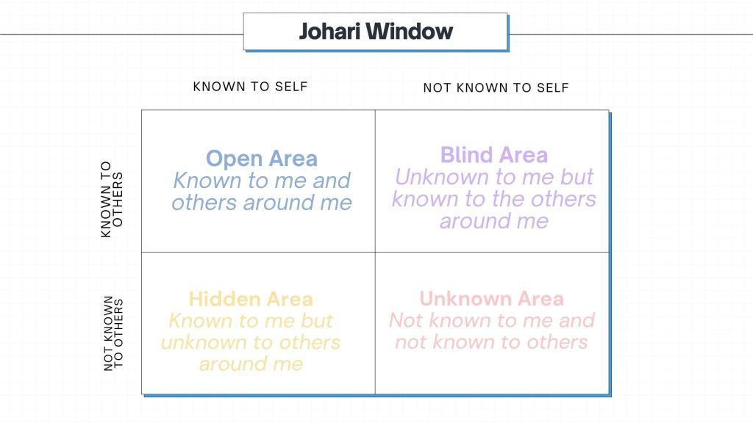Figure 5: Johari Window (Saxena, 2015)
I used my feedback to improve my self-awareness and become a better facilitator. For example, some of my feedback was "speaking less and allowing others more space to talk in group sessions.” This was a challenge for me, as I’m a big talker! But it helped develop my active listening skills (West, 2021,p.20)
This experience helped my emotional intelligence by making me aware of my behaviour's impact on others (Goleman, 2005, p.20). It challenged my professional identity; I would argue that Schein’s (1978) theory that attributes and beliefs remain stable and endure is not always the case. I feel that mine has been changed through my self-awareness during this process.
Using my feedback and enhancing my listening skills led me to use the OSCAR model, shown in Figure 6, to guide & influence others more effectively and support organisational change. This helped me adopt a coaching style that I used to respond to queries and advise others. I am helping to drive culture change in the organisation by promoting and encouraging constructive feedback and communication in teams. This, in turn, has helped remove some of the ‘culture blocks’ that can be barriers to organisational change (Forsyth, 2012, p.14) and increase performance (CIPD, 2020c). It was also crucial for me to consider that although feedback and coaching are beneficial, other factors such as appropriate skills and operational pressures can impact performance and change.

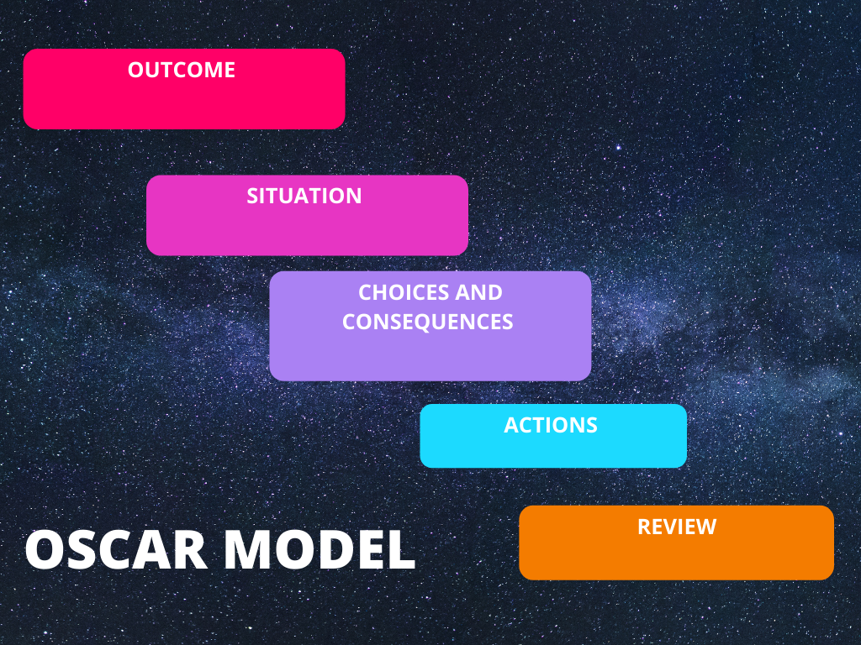Figure 6: OSCAR Model for Coaching (Bangor University, 2020)
Analysis:
Using self-reflection has helped my professional practice and approach to work in my new role.
Since completing the learning, I believe I’m closer to developing to the Chartered CIPD level because I am using various staff to facilitate culture change and build capability in areas of need (CIPD, 2022) . I have realised that effective listening and self-awareness are vital when managing myself in a work context.
Conclusion: Having detailed feedback has influenced how I give constructive feedback to others and support positive performance in HDUHB. I think that having a deeper understanding of myself and my impact on others will help me develop to the Chartered level (CIPD, 2022), I will need to do further team reflections to demonstrate this.
Action plan: To develop further, I would use Belbin’s team roles assessment (Belbin, 2022a)to help reflect on the work I currently do within my team. I would also like to complete my level 5 ILM Coaching training (ILM, 2022) as I feel that this would help further my ability to coach and develop others and coach myself.

Learning to work in ‘spaghetti’ – Becoming a workplace mediator
Description
In the summer of 2021, I became a workplace mediator and completed an ILM Mediation qualification (ILM, 2019), as shown in Figure 7. Although the training I received was beneficial, it is not the same as being in a conflict situation in a workplace. There were both positive and negative experiences when I came to do the mediation sessions face-to-face and on MS Teams.

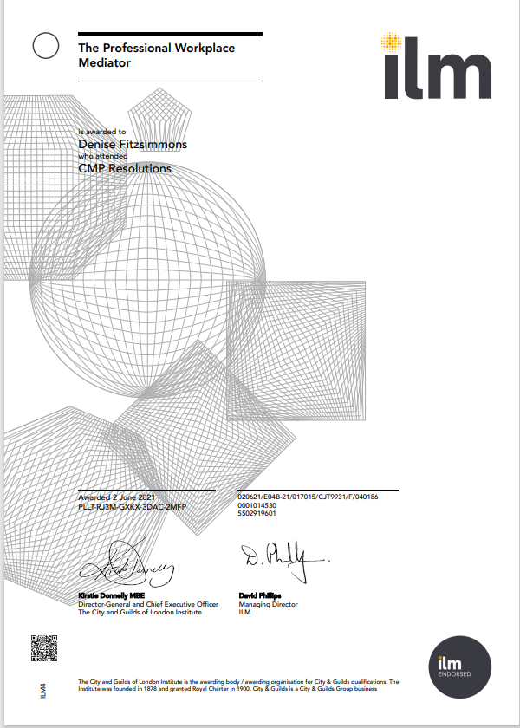
Figure 7: My mediation certificate (ILM, 2019)

Feelings
After initially feeling quite excited about becoming a mediator, I found the idea of trying to mediate in conflict situations quite daunting. After the first two sessions, I felt more comfortable dealing with conflict; however, one of the mediation sessions I facilitated was unsuccessful, and I found it disappointing. Before this experience, I felt good at building relationships with colleagues, but I could have done more to challenge conflict. After becoming a mediator, I felt more confident addressing conflict with colleagues (LOC 2). It also helped me feel more self-assured in conducting early resolution, which is essential in successfully managing conflict in organisations, according to the CIPD (2020b).
Evaluation
The positive outcomes of becoming a mediator have included better awareness of how I deal with conflict; for example, my understanding of the Thomas Kilmann model, shown in Figure 8 (Thomas and Kilmann, 1977), supported me in challenging my views of conflict, which I was unable to do before this learning. I am more likely to challenge ideas instead of shying away from conflict with my team members during group work. Although this model was a good starting point to review how I approached conflict, there are questions about the potential ‘social desirability bias’ of this method, (Dong-Heon Kwak, Xiao Ma and Sumin Kim, 2021, p.2) Therefore, it was vital for me to balance this model against other approaches.
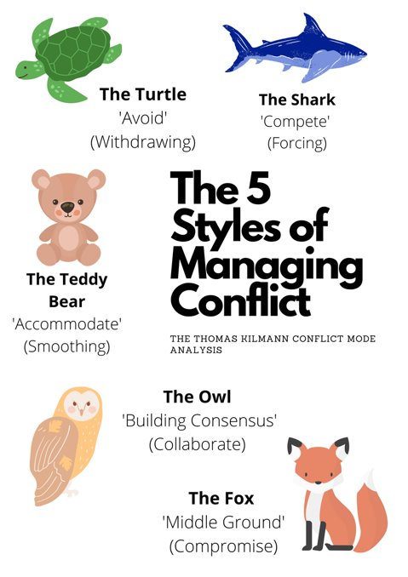
Figure 8: Thomas Kilmann 5 styles of conflict for the online training ‘handout pack’ I developed (HDUHB , 2022)
I have also used the Karpman drama triangle (Nelson, 2015, p.38), shown in Figure 9, to understand when I am being drawn into conflict at work. It has helped me become better when maintaining relationships; I would get caught in the ‘rescuer’ role before this.
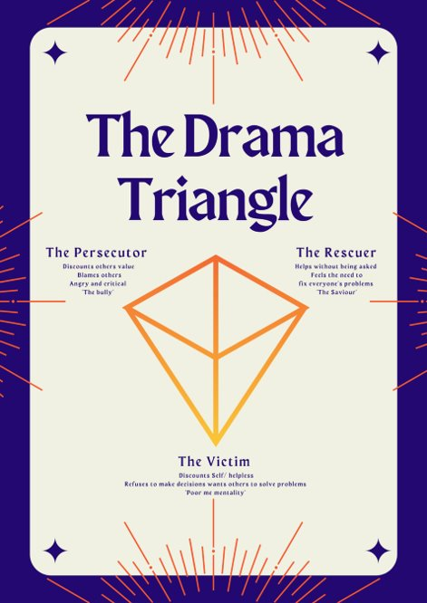
Figure 9: Karpman Drama triangle, the model used in internal training handouts (HDUHB , 2022) I developed for online sessions
I also used these new skills to create conflict management training. I needed to use IT skills such as Microsoft Teams to make the required training (LOC 6), shown in Figure 10. Before becoming a mediator, I had some experience delivering training online, but I had never created online training from scratch on Teams; I felt that I had to hone my IT skills to support using programmes for delivery. If I could have done anything differently, I would have experimented with more innovative technology such as different programmes and included some analytics, such as the cost of conflict, e.g. grievances, to strengthen my use of analytics to show the cost and value of interventions (CIPD, 2021c).
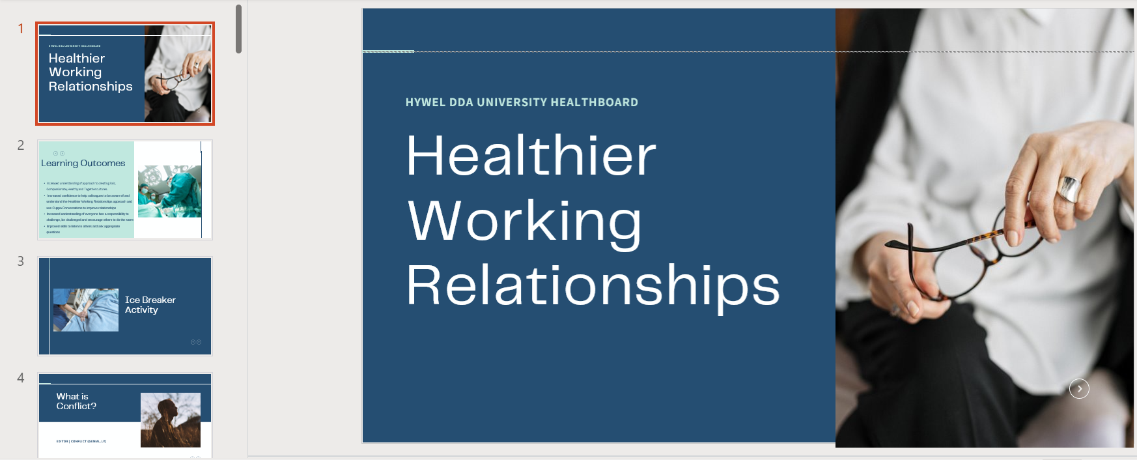
Figure 10: Conflict Management Intervention that I created using my newly learned IT skills on Canva (HDUHB , 2022)

Analysis
I feel that involvement in conflict situations has been educational because I now understand conflict and how to drive change and support positive relationships in work. I feel better at approaching topics with my colleagues now that I’ve had this experience. I have also developed my IT skills to create training online from this experience, which has been beneficial for the organisation in terms of agile working.
Conclusion
I feel that from this experience, I am better at managing interpersonal relationships at work. Reflecting on my conflict styles means I have become better at handling my emotions during conflict. Being involved in these situations has also improved my empathy and understanding.
To ensure a more favourable outcome in the next mediation that I do, I will not be so hard on myself when the mediation isn't successful and understand that not all relationships can be rebuilt this way. I now also feel that I have a bank of reliable sources and theories that I can draw on to use for further training and the IT skills needed to support agile training.
Action Plan
If I were to change anything, I would likely reflect more and debrief after the unsuccessful mediation. I would also have asked for support from our peer group of learners or a network of professionals to help share ideas. I will set up an internal peer group to develop my conflict management skills further and develop to the Chartered CIPD membership level in my Core Behaviours (2022). This will help to build collaborative relationships across the whole of the organisation.
I will also need to research other methods to ensure that I develop to the Chartered level of the CIPD map Core Knowledge (2022), where I will be exploring more innovative ways of using technology to support the use of online or hybrid training in the organisation.

The Art of Investigations – Being an Investigating Officer
Description
In June 2021, I became a Bank Investigating Officer; my offer letter is shown in Figure 11. This required me to investigate an alleged disciplinary issue (LOC 7). This was the first investigation I had undertaken in the organisation, and I had to learn the policies and processes.
When writing the report, I had to assess the information I was given and make justifiable decisions in my investigation report. If I failed to do this, then the disciplining officer would not be able to make clear decisions about the outcome. I had to be clear about the content of my report while understanding my role as an investigating officer and following the CIPD (2021a) and ACAS (2019) guidance.
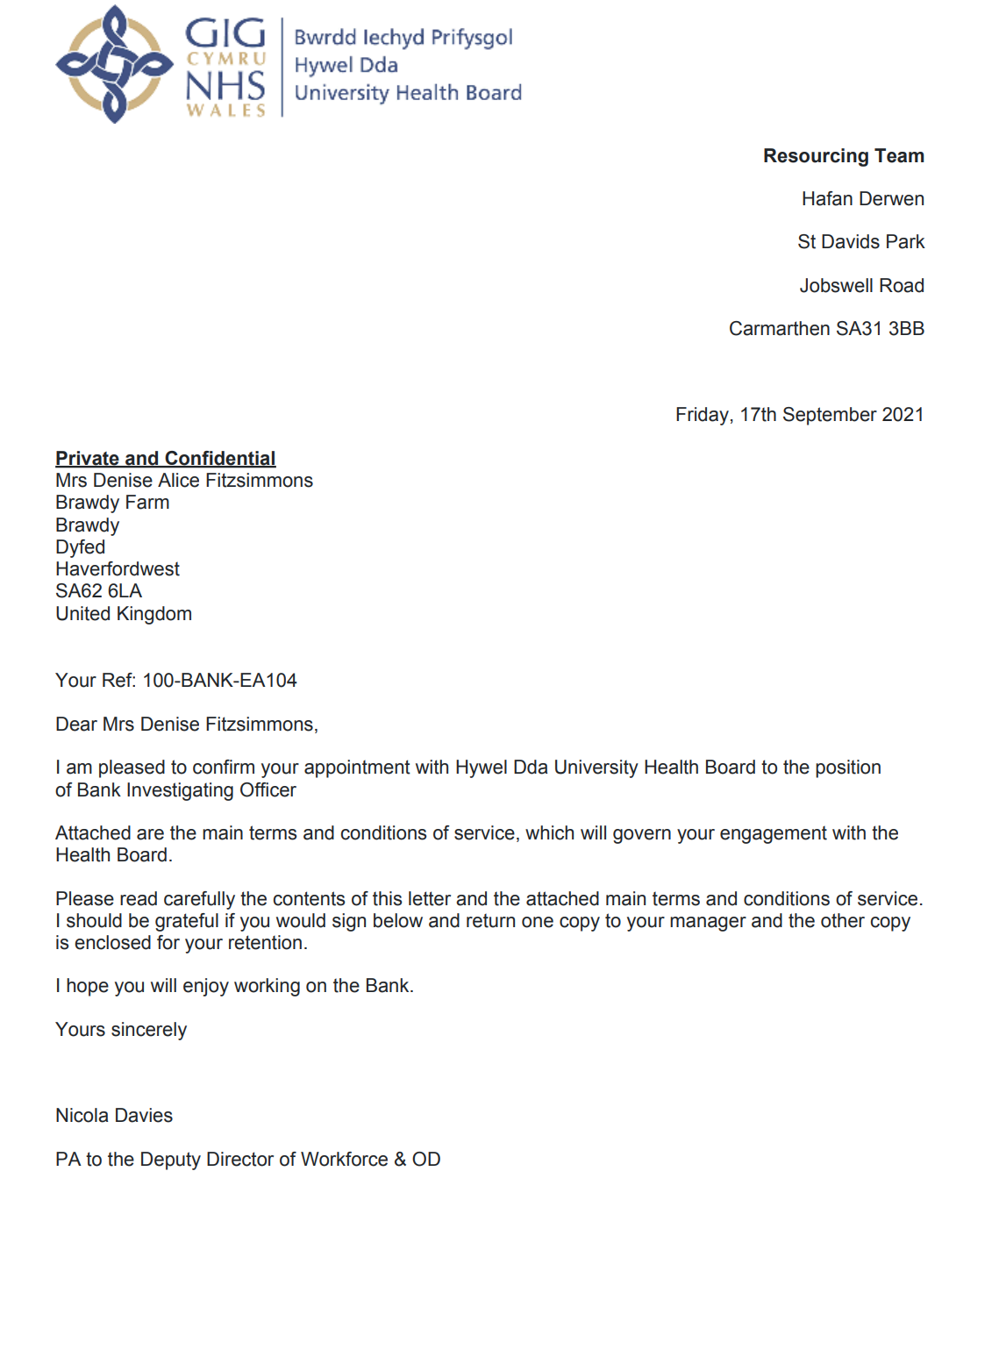
Figure 11: Internal offer letter for becoming a bank investigating officer.

Feelings
Conducting a disciplinary investigation was new to me working in HDUHB. The process was very stringent, and I wasn't used to doing an investigation in a public sector organisation. The training that I received was helpful, and it did help me feel more confident. However, I learned a lot from shadowing some of the processes with a colleague. I was also required to develop my knowledge and ensure that my outcomes were evidence-based.
Evaluation
I followed the suggested approach to conducting a disciplinary interview and ensuring that all the facts were collated before the meeting. Throughout the investigation, the employee knew why we were meeting and that the evidence was collected fairly. I reflected on the information I was given during the investigation by using interview questions and evaluating the options and evidence.
I feel that the investigation went well and that I could keep to timescales and work in an ethically sound, professional way (LOC 3). I kept the report objective and did not offer a solution or an outcome for the investigation. I don’t think it would have gone as smoothly if my colleague hadn’t been helping to coordinate the investigations! I felt like I had to do a lot of background reading despite having the training initially. I had to work through quite a few policies, and I found that quite stressful as I didn't want to miss anything and make the process unfair.
Analysis
From conducting this investigation, I feel that I was able to enhance my essential people management skillsets. In terms of elements that didn't go so well, I found the additional reading, for example, the terms of reference, the re-registration policy and accessing the re-registration guidelines, quite time-consuming. This is probably due to inexperience, and the next time I investigate, it will feel a lot smoother now I have this learning. I thought that I used an active listening style (West, 2021, p.20) in the interviews and remained objective, which helped me work professionally and ethically.
According to Armstrong and Taylor (2020, p. 297), to be ethically sound, I should do what is possible to establish the facts and uncover what isn’t explicitly being said. In the investigation, I identified that getting the facts is crucial for problem-solving and understanding the motivations for what is being alleged. Although this approach was practical, other factors, such as ensuring that I was impartial and that timescales were met, also impacted how ethically sound the investigation was (Personnal Today , 2012).
Conclusion
I learned the importance of being prepared and sure of the information I collected at the interview stage. Although the structure of a disciplinary hearing is very formal, I was very conscious of the human element of the process, which is why having a fair and ethical investigation was essential. In this situation, I could have spent some more time with some of the more experienced Workforce Advisors to go through what to expect and prepare for the disciplinary hearing. Having more practice in complex investigations would help me feel more confident.

Action Plan
According to the CIPD profession map (2022) , to work at a chartered member level, I should be able to interpret and use complex employment law knowledge and diminish risk. To do this, I could take more time to review our current policies and attend employment law updates to ensure my understanding. I will also need to conduct research and review sources of evidence-based research, for example, creating a knowledge bank of internal resources, to test conventions and theories to help me progress to the next stage of the CIPD profession map (2022).

Assessing the Impact of the Menopause on sickness absence in HDUHB

Describe
In Summer 2021, I was required to investigate a business issue as part of my Post Graduate Diploma. I chose to investigate the impact of Menopause on sickness absence in HDUHB. For the research, I decided to collect predominantly quantitative data relating to staff experiences of working whilst going through the Menopause. I also used Net Promotor questions and scores for the first time during this research, as shown in Figure 12.
This allowed me to develop my critical thinking and enhance my postgraduate skills (LOC 8). I learned new methods of approaching theory, as shown in Figure 1, the Inductive theory model that I used in my research. It also helped me understand how financial factors can help influence service decisions and how research can help highlight the financial aspects that impact organisations (LOC 5). According to sources, the critical drivers for organisational success lie in a close relationship with HR functions and finance (Bhatt, 2018) , (Hppy, n.d.)
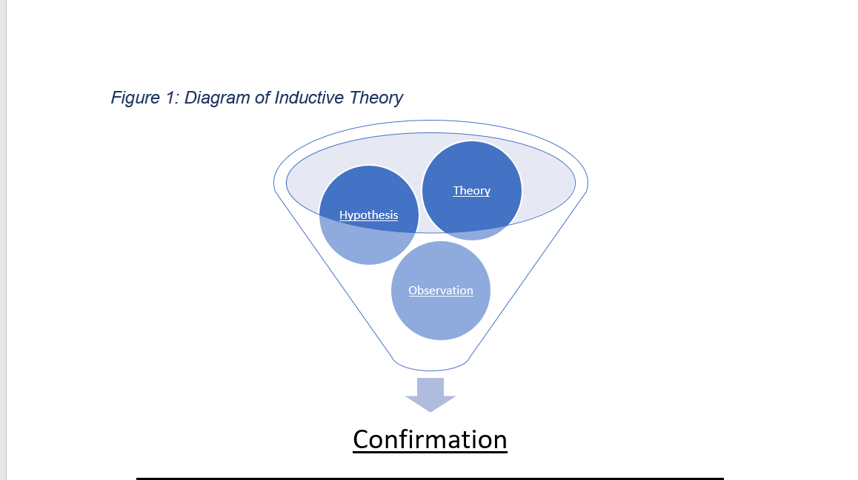
Figure 12: Diagram of Inductive Theory, used in my Investigating a Business Issue report (Business Research Methodology, n.d.)

Feelings
Initially, I felt out of my depth starting the research as I hadn’t completed anything like this previously, so it was quite a learning curve. I also felt that not having access to budget information or a prior understanding of many of the organisation’s financial factors would be challenging. However, I think that since undertaking this, my knowledge of financial factors has improved, along with my critical thinking skills.
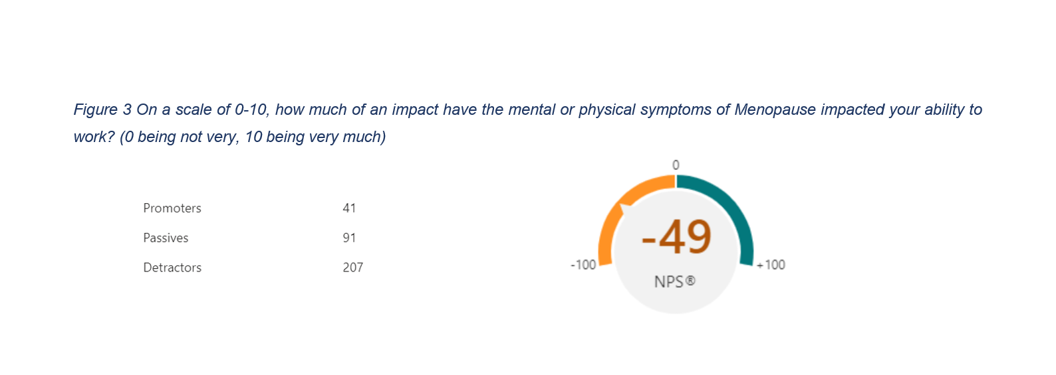
Figure 13: An example of utilising Net Promoter Scoring to gather and interpret information from my research (Anstead, 2008, p. 8)

Evaluation
In terms of what went well, I did have to test my knowledge and learn more about specific aspects, such as statistical analysis and coding for qualitative data. I found this quite tricky as it's something I hadn't done previously. Although I had experience with evidence-based research in my previous assignment, statistical analysis was very new. I did feel that I was successful in attaining enough responses to make my research valid; however, I did lose marks for not exploring my methodology further.
Regarding enhancing my financial awareness, the research paper allowed me to explore the financial impact that conditions relating to menopause can have on the organisation. It led me to look at the cost of overall sickness figures, as seen below in Figure 14. This highlighted the true cost impact of sickness on the organisation and how small reductions could lead to significant organisational savings.
 | Cumulative Absence FTE % | Absence Estimated Cost
2018- 2019 | 5.08% | 13,801,645.21
2020 - 2021 | 5.29% | 13,830,628.70
Figure 14: Internal data regarding HDUHB sickness rates and the estimated cost of sickness (HDUHB, 2021)

Analysis
Utilising the research onion model (Saunders, Lewis, and Thornhill, 2007), shown in Figure 15, supported me in effectively establishing my methodology; using this model, I decided how to collect the data and approach my research. This model was beneficial. However, I should have researched more models for my methodology to make it more robust, as it was one of the weaker areas.
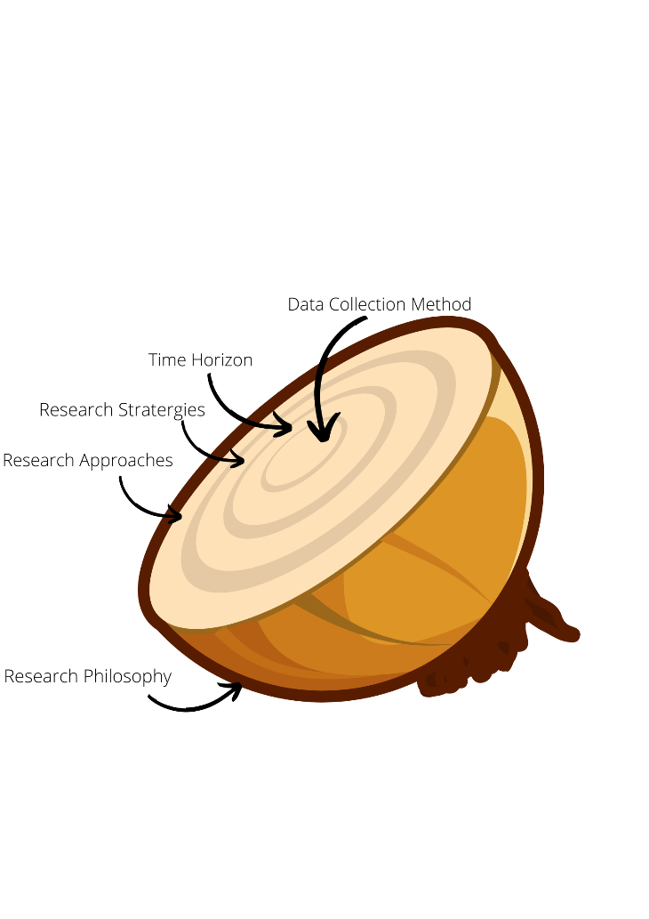
Figure 15: The Research Onion I used (Saunders, Lewis and Thornhill, 2007)
In addition to this, I used the Toulmin model (1958), shown below in Figure 16, to create the hypothesis for my research. This was useful when critically analysing the literature for my review. I ensured that I had data and information to back my theory. I made sure that I critically analysed my work, for example, when I reviewed my project to check the limitations. I also feel that I helped develop my critical thinking skills by utilising systematic and independently formulated ideas (Haber, 2020).
I felt that it was difficult to quantify some financial factors, such as presenteeism. If I were to conduct the research again, I would use calculations, such as those that suggest that presenteeism has a higher direct cost than sick leave (Karanika-Murray and Cooper, 2018, p.9), to show the overall cost impact.
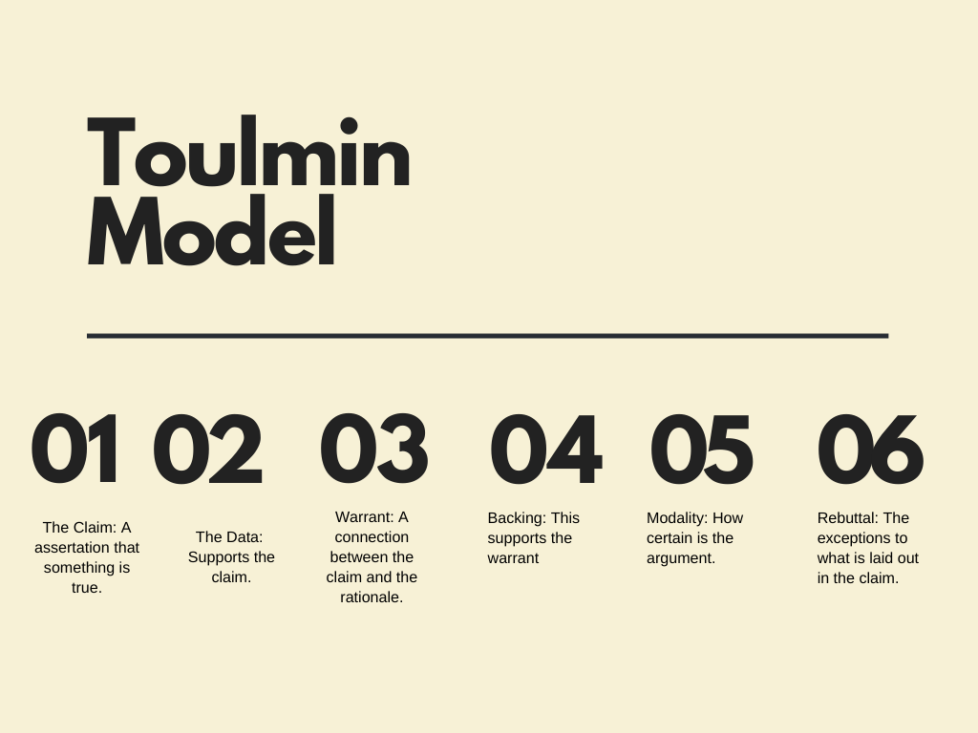
Figure 16: The Toulmin Model that I used to analyse my work (Toulmin, 1958) critically
Conclusion
Overall, I feel that my research went well; however, on reflection and using the CIPD profession map for reference, for me to be working at a chartered member level, I would be using my postgraduate skills to look for opportunities to test and develop new innovative ideas (CIPD, 2022). I felt that I used tried and tested evidence-based research methods in my report. I would explore other approaches to collecting data, such as experimental learning, to enhance this skill in future projects.
I also feel that how I interpret financial information and financial resources could be improved. Regarding the CIPD profession map, to develop to the next stage, I should work on presenting evidence-based solid business cases to exhibit a return on investment (CIPD, 2022). I feel that I did give a good business case as to why supporting menopause in the workplace is essential financially for the organisation. However, I need to have more exposure to budgets and financial forecasting to understand better how this would work in a practical setting.
Action Plan
If I were to repeat the research, I would spend more time reviewing my methodology to enhance my postgraduate skills and utilising the most innovative and appropriate analysis methods. I will also need to spend more time with our finance team to understand how research can help the organisation save money. By having an enhanced understanding of financial information, I would be better positioned to support the organisation with cost-saving measures.

Personal Development Plan
From: April 2022 To: November 2024

Planned Outcome: I would like to be working at a level where I am achieving the set outcomes at the Chartered CIPD level on the CIPD Map and working collaboratively and innovatively; below are the detailed outcomes using SMART objectives (MindTools, n.d.)
What do I want/ need to learn | what will I do to achieve this | what resource is or support will I need | what will my success criteria be | target dates for completion
Delivering innovative training virtually to staff (LOC 6). By learning to run learning through ‘Teams Webinars’ rather than just the Teams meeting app, I will be able to explore different types of digital learning.  This will help me develop my ‘Technology and People’ Core Knowledge (CIPD, 2022) | I will watch the how-to - Teams Webinar videos on the Microsoft 365 webpage (Microsoft 365 , 2021). | The how-to video on Microsoft 365 blog page is free, along with all the additional guides. | I will have delivered at least 2 Teams Webinars with positive feedback from delegates. | June 2022
To manage myself more effectively (LOC 1), I need to explore team dynamics and objectives.  This relates to the Chartered Level Core Behaviour ‘Working Inclusively’ (CIPD, 2022) | Learn how I fit into our teams using Belbin Team scores to ensure that I work effectively with my team. | The Belbin team Interplace programme costs £3995 + VAT (Belbin, 2022b). This would cover buying the Belbin Team Assessments across the organisation. | By completing a Belbin Team assessment alongside other team members, we will have an effective action plan based on the outcome of these assessments. | December 2022.
Identify crucial financial information, basic costing concepts, and techniques to enable me to build my ‘Business Acumen’ as suggested in the CIPD profession map standards (2022)  By doing this, I will be able to create and present strong business cases. This will enable me to give evidence-based recommendations and show return on investment (LOC 5). | Spend time with the HDUHB finance team to review the supply chain models in the organisation and see where value is created and lost. | I will need support from my manager in allowing time off to spend time with the finance team. | Creating one business case for services procurement and showing value in the changes I suggest regarding projects. For example, I will be able to offer the cost analysis for presenteeism in the organisation and demonstrate ROI on recommended interventions. | January 2023
To develop my postgraduate skills (LOC 8), I will need to pursue opportunities to test  And develop new innovative approaches. I will be able to identify the best practices for the organisational need.  This will help me develop my ‘Passion for learning’ Core Behaviour on the CIPD Profession Map. (CIPD, 2022) | Produce a report outlining the value of creating an All Wales NHS community of OD and HR professionals to share knowledge, benchmark and develop new thinking. | I will need time to complete this and buy-in from senior leadership. To do this, I will need to speak to other HR and OD professionals in the wider NHS Wales community to gain insight and ideas on new ways of working. | I will have set up an HR and OD Network focused on innovative new ways of learning, and we will have agreed on terms of reference, and we will have held at least one meeting. | January 2023
I need to find reliable evidence sources effectively, to test recommendations and ideas ( Loc 3).  I need to set up a reliable ‘evidence bank’ that will allow me to draw on implement effective and organisational change and expand my skills and capability.  This will help me develop my ‘Insights focused’ Core Behaviour (CIPD, 2022) | Sign up at the HDUHB library to get more information about how to conduct specific research and link in with the organisation’s research and development team to see if I can be involved in research projects | I will need access to the library and time with our research teams | I will have a bank of tried and tested evidence-based solutions to support organisational development and change in HDUHB. | September 2023
To build cooperative relationships across the organisation to understand better how conflict impacts employees and what can be done to help prevent it. (LOC 2)  This will help me develop my ‘Professional courage and influence’ (CIPD, 2022) skillset. | In the organisation, I will need to set up an internal network with staff from all disciplines that meet every quarter to review conflict-related issues, i.e. disciplinaries and bullying accusations. | I will need support from the organisation to create and build collaborative networks for early resolution. | I will have set up an early resolution network to support a reduction in conflict and grievances in the organisation. | December 2023
To review organisational Employee Relations policies and attend employment law updates to ensure I am aware of complex employment law updates (LOC 7).  This will help me develop my ‘Employee Relations’ specialist knowledge skillset (CIPD, 2022) | Spend time reviewing policies with members of the Senior HR teams and attend an employment law update in the next three months | Time to complete the review of the policies and attend an ACAS employment law update on 1st June 2022, costing £75 (ACAS, 2022) | I will have adequately reviewed the organisational policies and recommended any necessary changes, and I will also have attended an ACAS employment law update. | November 2024
To demonstrate an essential people management skillset, I should focus on my coaching skills to create a better people management capability in HDUHB(LOC 4).  This will help me achieve the required skills for ‘People Practice’ from the CIPD professional skills (2022). | Complete a Level 5 ILM coaching qualification to support coaching within HDUHB | I will need my manager to agree to fund the qualification, which costs £2,795 (Inspired 2 Learn, 2022). | I will be qualified to undertake coaching in the organisation and have coached two senior leaders in HDUHB. | November 2024

References
- 16 Personalities (2022) 16 Personalities Questionnaire.
Available at: https://www.16personalities.com/profile?utm_source=email&utm_medium=welcome-protagonist&utm_campaign=profile
(Accessed 20 March 2022).
- ACAS (2019) Acas guide to conducting workplace investigations.
Available at: https://www.acas.org.uk/acas-guide-to-conducting-workplace-investigations
(Accessed April 12 2022).
- ACAS (2022) Employment law update - digital event.
Available at: https://obs.acas.org.uk/ViewEvent.aspx?EventId=205498
(Accessed 7 May 2022)
- Anstead, M. (2008) 'Research: How & Why To Properly Use Net Promotor Scores' Credit Union Journal, 12(7), pp. 8.
- Armstrong, M. and Taylor, S. (2020) 'Ethical Dilemmas in Armstrong’s Handbook of Human Resource Management Practice. London: Kogan Page Limited, pp. 297.
- Bangor University (2020) OSCAR Model.
Available at: https://www.bangor.ac.uk/health-sciences/research/documents/OSCAR_Model.pdf
(Accessed 3 March 2022).
- Belbin (2022a) Belbin Team Roles.
Available at: https://www.bing.com/search?q=belbin+team+roles&cvid=f3ccf74fa6c942dfa70923353a40d0d1&aqs=edge.0.0l9.5001j0j1&pglt=43&FORM=ANNTA1&PC=HCTS
(Accessed 3 March 2022)
- Belbin (2022b) Belbin Interplace.
Available at: https://www.belbin.com/about/interplace
(Accessed 7 May 2022)
- Bhatt, N. (2018) Relationship Between HR and Finance.
Available at: https://www.linkedin.com/pulse/relationship-between-hr-finance-nidhi-bhatt/
(Accessed 1 April 2022).
- Business Research Methodology (n.d. )Inductive Approach -Inductive Reasoning.
Available at: https://research-methodology.net/research-methodology/research-approach/inductive-approach-2/
(Accessed 2 April 2022)
- CIPD (2020a) Organisational Development Factsheet.
Available at: https://www.cipd.co.uk/knowledge/strategy/organisational-development/factsheet
(Accessed 3 March 2022).
- CIPD (2020b) Managing conflict in the Modern Workplace.
Available at: https://www.cipd.co.uk/Images/managing-conflict-in-the-workplace-2_tcm18-70655.pdf
(Accessed 1 April 2022)
- CIPD (2020c) Performance Management: an Introduction.
Available at: https://www.cipd.co.uk/knowledge/fundamentals/people/performance/factsheet
(Accessed 2 April 2022)
- CIPD (2021a) Discipline and grievance at work.
Available at: https://www.cipd.co.uk/knowledge/fundamentals/emp-law/discipline/factsheet
(Accessed 1 March 2022)
- CIPD (2021b) Explore the Profession Map.
Available at: https://peopleprofession.cipd.org/profession-map?msclkid=0073083fce5511ec9ab57fb3a191bc34
(Accessed 2 May 2022)
- CIPD (2021c) People Analytics.
Available at: https://www.cipd.co.uk/knowledge/strategy/analytics/factsheet
(Accessed 3 April 2022).
- CIPD (2022) The Profession Map
Available at: https://peopleprofession.cipd.org/Images/full-standards-june-2021_tcm29-95364.pdf
(Accessed 1 May 2022).
- Dong-Heo, K. , Xiao, M. and Sumin, K. (2021), When does social desirability become a problem? Detection and reduction of social desirability bias in information systems research, Information & Management, Volume 58, Issue 7, pp. 1 -13
- Forsyth, P. (2012) Managing Change. London: Kogan Page.
- Goleman, D. (1996) Emotional Intelligence : Why It Can Matter More Than IQ. London: Bloomsbury Publishing.
- HDUHB (2021) Internal Buisness Intelligence Data. Unpublished.
- HDUHB (2022) Internal Training Document. Unpublished.
- Hppy (n.d) Why Finance and HR Should Have a Close Working Relationship.
Available at: https://gethppy.com/talent-management/finance-and-hr-close-working-relationship#:~:text=Why%20Finance%20and%20HR%20Should%20Have%20a%20Close,ineffective%20traditions%20and%20outdated%20perspectives.%20More%20items...%20
(Accessed 2 April 2022)
- ILM (2019) Mediation.
Available at: https://www.institutelm.com/resourceLibrary/mediation.html
(Accessed 3 April 2022).
- ILM (2022) ILM Coaching Level 5.
Available at: https://www.i-l-m.com/Learning-and-Development/management/coaching-and-mentoring/8580-level-5-coaching-and-mentoring
(Accessed 3 March 2022)
- Inspired 2 Learn (2022) ILM Coaching and Mentoring Qualifications.
Available at: https://www.inspired2learn.co.uk/learning/117/Level-5-Diploma-in-Effective-Coaching-and-Mentoring-/#:~:text=ILM%20Level%205%20Diploma%20in%20Effective%20Coaching%20and,-%20we%20adapt%20our%20support%20to%20your%20needs..?msclkid=f23df576ce4e11ec8e83f0f4aa
(Accessed 7 May 2022)
- James, M. (2003) 'Using the Myers-Briggs type indicator as a tool for leadership development? Apply with caution. Journal of Leadership & Organizational Studies, 10(1), pp. 68.
- Karanika-Murray, M. and Cooper, C. L. (2018) 'Presenteeism: An Introduction to a Prevailing Global Phenomenon,' Presenteeism at Work. Cambridge: Cambridge University Press (Cambridge Companions to Management), pp. 9–34.
- Microsoft 365 (2021) Introducing Webinars in Microsoft Teams: Easy, professional webinars to engage customers.
Available at: https://www.microsoft.com/en-us/microsoft-365/blog/2021/05/11/introducing-webinars-in-microsoft-teams-easy-professional-webinars-to-engage-customers/
(Accessed 7 May 2022)
- MindTools (n.d.) SMART Goals.
Available at: https://www.mindtools.com/pages/article/smart-goals.htm#:~:text=%20How%20to%20Use%20SMART%20Goals%20%201,it%20also%20aligns%20with%20other%20relevant...%20More%20?msclkid=cc2a4773ce9e11ecba2a46d0f2e7983f
(Accessed 5 May 2022)
- Myers Briggs Foundation (2022) MBTI Basics.
Available at: https://www.myersbriggs.org/my-mbti-personality-type/mbti-basics/home.htm?bhcp=1
(Accessed 3 March 2022)
- Nelson, J. B. (2015) 'The Karpman Drama Triangle and Diabetes’,. AADE in Practice, 3(1), pp. 38–42.
- NHS (2022) Healthcare Leadership Model 360 Feedback.
Available at: https://www.leadershipacademy.nhs.uk/resources/healthcare-leadership-model/supporting-tools-resources/healthcare-leadership-model-360-degree-feedback-tool/
(Accessed 4 March 2022)
- Personnal Today (2012) A 10-step guide to conducting a disciplinary investigation.
Available at: https://www.personneltoday.com/hr/a-10-step-guide-to-conducting-a-disciplinary-investigation/?msclkid=284d4dc0cebd11ec81452b8f29da1c29
(Accessed 6 May 2022)
- Saunders, M., Lewis, P. and Thornhill, A. (2007) Research Methods for Business Students. 5 ed. Essex: Pearson Education Limited.
- Saxena, D. P. (2015) 'Johari Window: An Effective Model for Improving Interpersonal Communication and Managerial effectiveness' Journal of Management, 5(2), pp. 134-146.
- Schein, E.H. (1978) Career Dynamics. Matching Individual and Organizational Needs. Reading: MA: Addison-Wesley.
- The University of Edinburgh (2020) Gibbs' Reflective Cycle.
Available at: https://www.ed.ac.uk/reflection/reflectors-toolkit/reflecting-on-experience/gibbs-reflective-cycle?msclkid=205ec514ceb611ec922ae2a20045eab5
(Accessed 3 May 2022)
- Thomas, K. W., and Kilmann, R. H. (1977) 'Developing a forced-choice measure of conflict-handling behaviour: The “mode” instrument' Educational and Psychological Measurement, 37(2), pp. 309-325.
- Toulmin, S. (1958) The Uses of Argument. Cambridge: Cambridge University Press.
- West, M. (2021) Compassionate Leadership. 1 ed. s.l.: Swirling Leaf Press.

