Student Name: Ffion Lavington
Student Number: 2204160
Programme of Study: BA Graphic Design
Chosen Question: The importance of Information Design
Word Count: 2318
Lecturer: Donna Williams

“Information design has become an essential and in-demand area to which graphic designers can contribute” (Marchese, 2021). Information graphics has been used for thousands of years for historical events to be kept. The earliest recording of information design is petrographs, which are cave drawings, which then developed into pictographs. The pictographs then helped to develop the earliest forms of the written language. Information design is now used for signage for drivers and to convey information. So, when is information design used? Information design is used for a visual solution of the organisation of information for a person’s problem in the form of design. Designs are created for communicating subjects such as something for safety, educational, meaning full and to raise awareness. Examples of this is how we associate certain colours, such as how we associate the colour red with danger and stop and the colour green with safe and go. There are four main channels of distribution such as yourself, print, internet, and broadcast. When the designs are being created, they are being created using visual tools and which tools should be used. These visual tools could be position, length, slope, angle, orientation, area, size, volume intensity, weight, opacity, colour and finally shape. It’s important for the designer to consider when are where these designs will be used, such as if it’s on a busy motorway where drivers are going past at speed there’s no point adding large amounts of information but to put that image in to pictures and to make sure it is easily understood. An example of information design is isotopes, isotopes are “a method for assembling, configuring and disseminating information and statistics through pictorial means”, Isotype Revised (2009). Isotypes are often created with the common misconception that they should be bigger to represent the amount of something, this will be further discussed later.

The life of the average population is heavily exposed to different types of information design every day as it is very important to the community in different ways.

Information design helps people in high adrenaline and stressful circumstances

Information design is heavily important for high adrenaline situations, where things need to be done quickly and precisely. It’s important for the designs to be extremely simple with there being images showing enough detail about what needs to be done but simple enough to be understood quickly.

The fire blanket is the first example of information design being used in high adrenaline situations. The design of the fire blanket depicts small designs of the three-step process of how to use the blanket in the moment of a fire, there is also small description printed next to the little designs. “Fire blankets are used to fight against fire connotes and avoid possible burns during the evacuation process of a fire”, making them extremely important in the instance of stopping small fires such as fan fires and small waste bin fires. The way this signage for the blanket has been design helps the right information stand out the person who needs it at the time. For example, the white bold font is easily read and stands out greatly against the bold bright red of the background. The colour red is also symbolic to the use of this piece of equipment, as the colour red represents danger and could also represent the colour of fire, giving the user a clear idea about why and when it should be used.
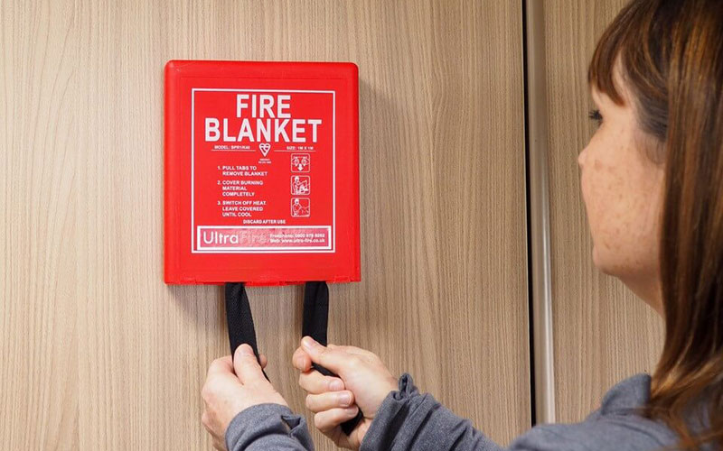
Fig. 1, Fire Blanket, 2019

In my second example, I will be discussing the design of the CPR poster and how it helps “Having more bystanders trained in this simple skill can help save lives by putting more cardiac arrest victims within a few steps of lifesaving assistance”. The design has been creating in a way where it is both educational and easily understandable at the same time. The designed is detailed but still simple enough to be read in the stressful environment if someone where needed to receive some CPR due to cardiac arrest or other ailments. There are many colours in this specific design which could distract the person who is in need of it to be a bit confused, compared to other medical information design this design could be simpler to make the image bigger and the font bolder making it easier to read.
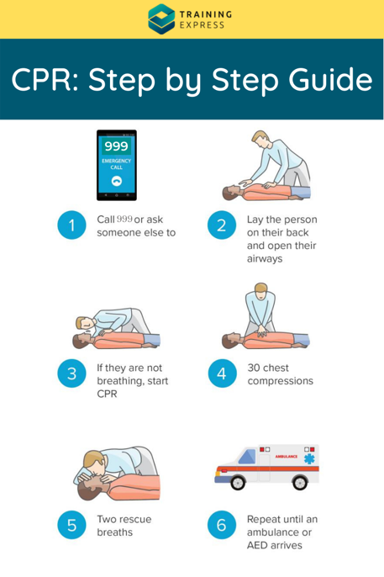
Fig. 2, CPR Poster, 2023

For my third and final example, it will be the information design created for using a defibrillator. “The chance of surviving a cardiac arrest jumps from 6% to 74% if the casualty is in a shockable rhythm and a defibrillator is deployed within 3 minutes, so it is important you know how to use one”, this information is extremely useful to be turned into a format which is easy and quick to read in a high adrenaline situation. The colour green used for this design has that sense of safety, which is commonly associated with the colour. The design also has the simplicity that is need for a quick use for someone who has gone into cardiac arrest. The white font and design are clear and simple with the process you should follow being described in image form first and then a description added below them.
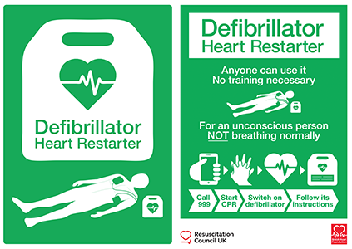
Fig. 3, Defibrillator Poster, 2014

Information design helps display statistics and is used daily in the news

What are isotopes? Isotopes, or the International System Of Typographic Picture Education, are an affective way to give clear visual information. The most important rule with isotopes when representing a greater quantity of something the isotopes should not be represented by an enlarged pictogram, but by a greater number of the pictograms represented in the same size. Isotopes are extremely important because “This knowledge should not be shrined in opaque scientific language, but directly illustrated in straightforward images and a clear structure, also for people who could not, or hardly, read”.

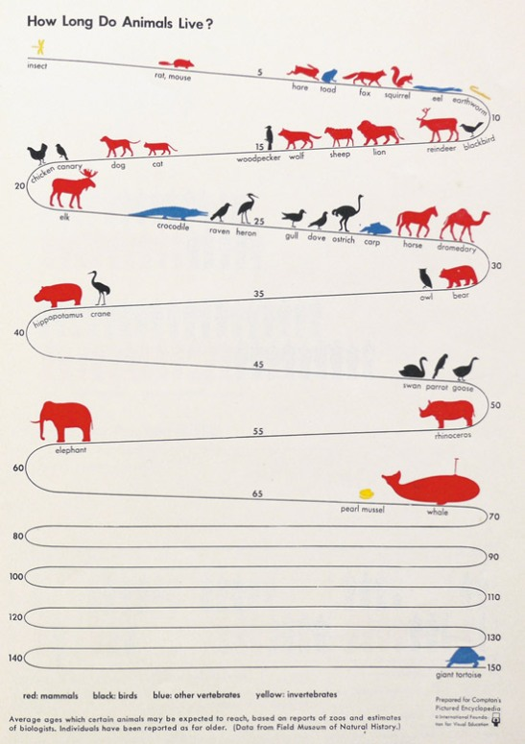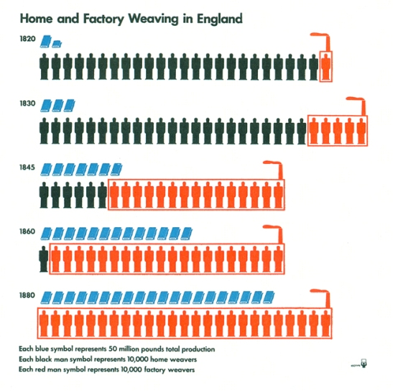
Fig. 4 & 5, Isotopes, 2008

In the first image of the left the artist has used isotopes to show to the life expectancy of different animals. It’s clear in the image that the line represents the time, and the colour of the animal represents what it is red is for mammals, black is for birds, blue is for vertebrates and yellow for invertebrates. In the second example of isotopes being used, it depicts them being used to show statistics simply. In the image I shows the difference between home weavers and factory weavers and the increase of factory weavers between 1820 and 1880. This information is represented with a blue symbol, a black symbol, and a red symbol. The colours used help the viewer distinguish what information is being used, this system keeps it simple for people understanding. Colour is also an important factor in this design, with it helping the viewer distinguish between each different pictogram and categorize the information it is trying to show and represent.

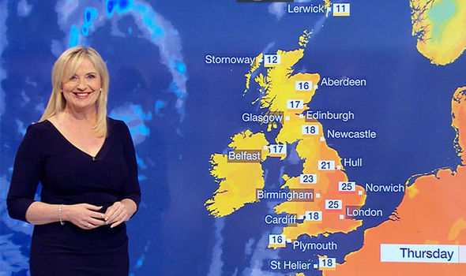
Fig. 6, Weather Highs, 2018
We may not realise but we see information design in the news everyday in different forms. Information design is used to show the weather, with different temperatures being represented by different colours. Hot temperatures are represented by orange to red colours and colder temperatures are represented by shades of blue. You can also see that rain is depicted to be moving in from the north west. Also, on weather apps the weather will be depicted using pictographs with sunshine being represented by a sun, cloudy by a cloud and rain by droplets dripping out of the cloud and so on. Without the use of information design to help communicate the state of the weather to people, people wouldn’t be able to look at the weekly forecast. The information design helps news producers efficiently show the public the weather in a simple way they will understand.
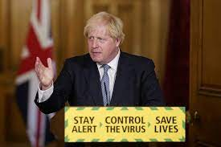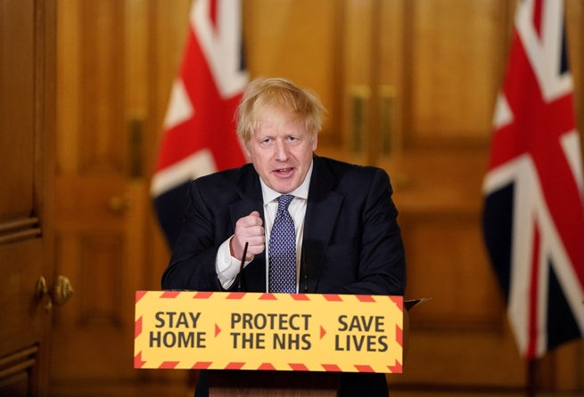
Fig. 7 & 8, Boris Johnson, 2020

These images above are taken from the press conference that Boris Johnson gave during the Covid-19 pandemic in 2020. This is an example of information design being used incorrectly which could have misinformed to public due to the colours the designer of the signs decided to use. It’s well known in the population that we associate the colours red with danger and green with safe, which is why the first image is misleading. How is it misleading? It misleads the public into a false state of security and safety. The colour red in the second image was from one of the first press conferences the current Prime Minister had done regarding the pandemic, it shows there urgency of pandemic with it boldly stating “STAY HOME, PROTECT THE NHS, SAVE LIVES” whereas in a later press conference its changed to green with “STAY ALERT, CONTROL THE VIRUS, SAVE LIVES” but the green used instead of green sugar coats the situation making it seem it’s not as serious as it is. It would have been communicated to the public better is the designer for the government have continued using colours associated with danger instead of turning it into a colour commonly associated with safety.

How we interact with different signage all day which is a form on information design

Information design is an important factor in our day-to-day life with it being used for simple things such as toilet gender signs and road signs for drivers. It’s important for the designer to be thinking of when and where someone would need to use this certain piece of information design, such as if it’s a road sign you wouldn’t want to fill the whole space with information distracting the viewer but also making them take too long to process the information. However, with a simple pictogram of a few words which will indicate the information needed the viewer can process the information quickly with enough information.
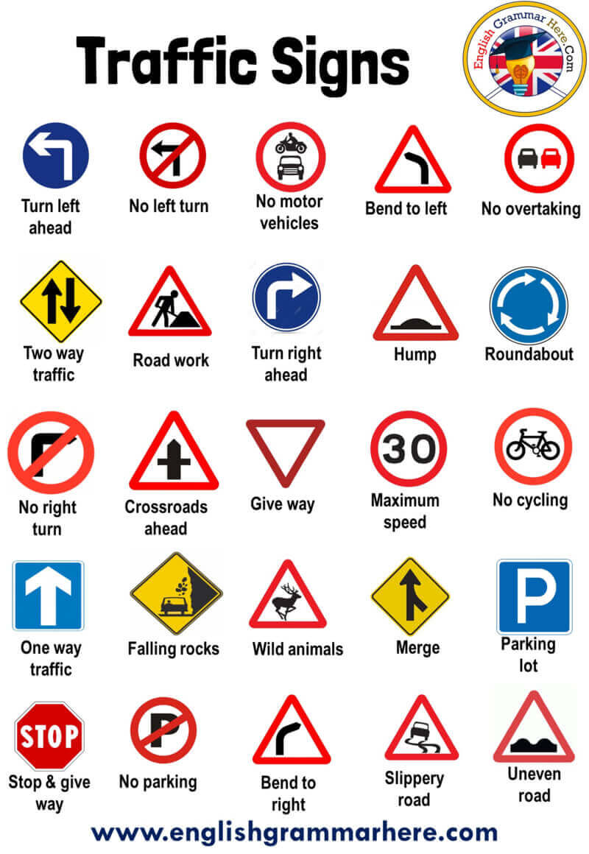
Fig. 9, Traffic Symbol and Road Symbols, 2020

Traffic signage is extremely important “they represent rules that are in place to keep you safe and help to communicate messages to drivers and pedestrians that can maintain order and reduce accidents. Neglecting them can be dangerous.” It’s important that the design of road signs is as simple as they can be and the colour also indicates the seriousness of the certain sign, such as the stop sign, and no entry sign is bright red conveying that warning and danger to the viewing who associate those colours with those words. The road signs were originally created by designers Jock Kinneir and Margaret Calvert and launched on all British roads on January 1st, 1965. The designers “Kinneir and Calvert designed the Motorway and Transport typefaces to use on all signs. Both mix upper and lower-case letters which helps people recognise words faster than when they are written using only capital letters.” They are three different types of basic road signs that each have a different shape, the circles are used for giving orders, rectangles are used for signs to give you information and triangles are used to warn you about something.

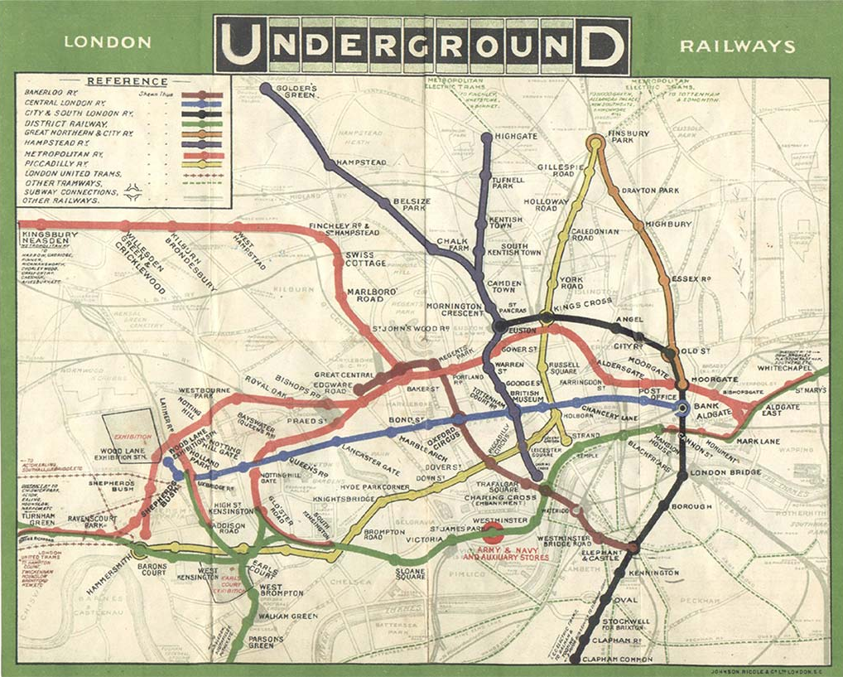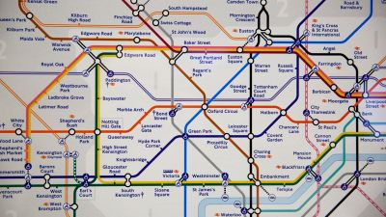

Fig. 10, London Underground Map, 1908 Fig. 11, London Underground Map, 2022

The original design for the underground is the image on the left and the “map was designed in 1931 by electrical draughtsman, Harry Beck, who compiled it in his spare time while he was working for London Underground. It was initially rejected by London Transport officials before they changed their minds and published the design in 1933.” The new map design was designed by Julie Dixon who said that designing the map was “both a challenge and a privilege” and that the new map will be used “for hundreds of years to come”. The map for the tube has had subtle changes over the years since it was originally created when new lines were created and adding to the map. The significant difference between the old and new map design is how much cleaner and simpler the new map looks. The new map has clear lines, and the line names are easy to read, whereas “the 1908 tube map was not the easiest to decipher. Station names were written in a very small font size, while some were twisted to fit around the coloured lines.” It is extremely important that the map is easy to read and to understand with thousands of locals and tourists using the Underground every day.

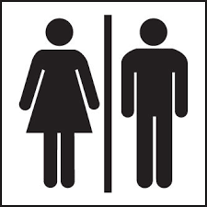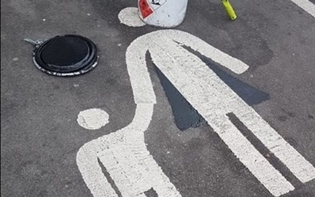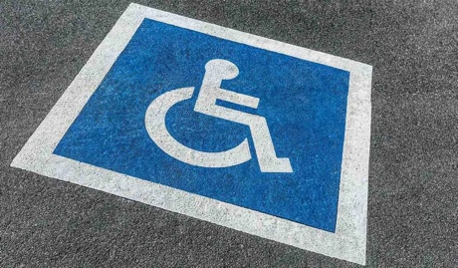
Fig. 12, Toilet Sign, 1992 Fig. 13, Child Parking, 2019 Fig. 14, Disabled Parking, 2023

Other forms of information design we encounter every day is simple signs for toilets and parking. Toilet signs are extremely important with them making sure every gender is using the correct bathroom assigned to them, the most common signs are that there’s an outline of a person wearing ‘trousers’ for the men’s, a person wearing a ‘dress’ for the women’s, and someone sitting in a wheelchair for the handicap toilets. Pictograms of people are also used when assigned parking to certain people of the community with there commonly being two different types of assigned parking in commercial car parks. With a pictogram of an adult and a child for baby and child parking and a pictogram of someone sitting in a wheelchair for the handicap parking spaces. Handicap parking is commonly painted in to different colour white and blue, both equally bright colours standing out against the dark grey concrete they are painted on.

From the information provided I can conclude that information design plays a crucial park in a person’s everyday life with it being used in large amounts of different circumstances. It’s also made clear that without information design being used for help display vital information and show vital information it makes certain difficult activates much simpler. When you go out next where it’s to go for a walk or to simply go food shopping stop and have a look around, look at the signs around you and how they are conveying that information. Think about what the information design influences and what would the current situation be if that sign wasn’t conveying that information. Would it still be the same? Would there be chaos? There are endless opportunities for information design to be used in the work to make sure things are run in order and information is sufficiently and quickly given.

Bibliography:

American Red Cross (2023) What is CPR?. Available at: https://www.redcross.org/take-a-class/cpr/performing-cpr/what-is-cpr#:~:text=Why%20is%20CPR%20Important%3F,few%20steps%20of%20lifesaving%20assistance. (Accessed: 22 November 2023).

Cargo Collective (2014) Visualization of The Weather. Available at: https://cargocollective.com/yukijp/Visualization-of-the-Weather . (Accessed: 22 November 2023).

Design 4 (2008) Isotype. Available at:
https://designmuseum.org/discover-design/all-stories/british-road-signs (Accessed: 22 November 2023).
https://parsonsdesign4.wordpress.com/resources/isotype/ .(Accessed: 22 November 2023).

Isotype Revisited (2009) Isotype Collection. Available at: https://isotyperevisited.org/2012/08/introduction.php (Accessed: 23 November 2023).

ITV (2022) London’s new Tube map: Elizabeth Line revealed on new design of iconic rail network. Available at: https://www.itv.com/news/london/2022-05-19/travel-update-elizabeth-line-unveiled-on-londons-new-tube-map (Accessed: 22 November 2023).
London Transport Museum (2020) Map; Pocket Underground map, by London Electric Railway, circa 1932. Available at: https://www.ltmuseum.co.uk/collections/collections-online/maps/item/1984-51-208 (Accessed: 24 November 2023).

Marchese, C. (2021) Information design for the common good; human-centric approaches to contemporary design challenges. 1st edn. London: Bloomsbury Visual Arts.

McCandless, D. (2009) Information is Beautiful. 1st edn. Glasgow: William Collins.

Online First Aid (2023) Why Defibrillators Are so Important and How to Use Them. Available at: https://onlinefirstaid.com/importance-of-defibrillators/#:~:text=However%2C%20the%20chance%20of%20surviving,know%20how%20to%20use%20one. (Accessed 23 November 2023).

Supa Quick (2019) Traffic Signs and Rules for Safety on the Roads. Available at: https://www.supaquick.com/blog/traffic-signs-for-road-safety (Accessed: 22 November 2023).

Texfire (2021) 10 Reasons to Have a Fire Blanket. Available at: https://texfire.net/en/blog/3_10-reasons-to-have-a-fire-blanket.html (Accessed: 22 November 2023).
The Design Museum (2015) Jock Kinneir and Margaret Calvert. Available at: https://designmuseum.org/designers/jock-kinneir-and-margaret-calvert# (Accessed: 24 November 2023). Available

The Design Museum (2020) British Road Signs. Available at:

Yau, N. (2011) Visualize This. 1st edn. New Jersey: Wiley.

List of Figures:

Figure 1: Fire Blanket, 2019. Available at: https://www.safelincs.co.uk/fire-blanket-guide/ (Accessed: 22 November 2023)

Figure 2: CPR Poster, 2023. Available at: https://trainingexpress.org.uk/how-to-do-cpr/
(Accessed: 23 November 2023)

Figure 3: Defibrillator Poster, 2014. Available at: https://www.resus.org.uk/library/additional-guidance/guidance-defibrillators/guidance-standard-sign
(Accessed: 22 November 2023)

Figure 4: Isotopes, 2008. Available at: https://parsonsdesign4.wordpress.com/resources/isotype/ (Accessed: 22 November 2023)

Figure 5: Isotopes, 2008. Available at: https://parsonsdesign4.wordpress.com/resources/isotype/ (Accessed: 22 November 2023)

Figure 6: Weather Highs, 2018. Available at: https://www.express.co.uk/news/weather/946761/BBC-weather-forecast-carol-kirkwood-heatwave-UK-2018-high-temperatures-sunshine
(Accessed: 23 November 2023)

Figure 7: Boris Johnson, 2020. Available at: https://www.gov.uk/government/speeches/prime-ministers-statement-on-coronavirus-covid-19-31-july-2020
(Accessed: 22 November 2023)

Figure 8: Boris Johnson, 2020. Available at: https://www.gov.uk/government/speeches/prime-ministers-statement-on-coronavirus-covid-19-31-july-2020
(Accessed: 22 November 2023)

Figure 9: Traffic Symbol and Road Symbols, 2020. Available at: https://englishgrammarhere.com/symbols-and-signs/traffic-symbol-signs-and-road-symbols/
(Accessed: 23 November 2023)

Figure 10: London Underground Map, 1908. Available at: https://www.historyhit.com/in-pictures-the-evolution-of-the-london-tube-map/
(Accessed: 23 November 2023)

Figure 11: London Underground Map, 2022. Available at: https://www.itv.com/news/london/2022-05-19/travel-update-elizabeth-line-unveiled-on-londons-new-tube-map
(Accessed: 23 November 2023)

Figure 12: Toilet Sign, 1992. Available at: https://www.warningsafetysigns.com/acatalog/unisex-toilet-symbol-sign-7043.html
(Accessed: 23 November 2023)

Figure 13: Child Parking, 2019. Available at: https://www.telegraph.co.uk/news/2019/01/18/supermarket-changes-car-parent-child-car-parking-signs-ensure/
(Accessed: 24 November 2023)

Figure 14: Disabled Parking, 2023. Available at: https://blog.asphaltkingdom.com/handicap-parking-space-qa
(Accessed: 24 November 2023)

