Construction of my Website

Contents
Construction of my Website 1
Introduction 1
JavaScript Components Produced 2
JavaScript Feature 1 2
JavaScript Feature 2 2
JavaScript Feature 3 5
Contact Form Validation 7
Google Maps 10
Methodology 12
Button Image Change Feature 12
Roll Over Image Change Feature 12
Hold & Release Image Feature 12
Contact Form Validation 12
Google Maps Feature 13
Annotated Code Listing 14
Code for First JS Feature 14
Code for Second JS Feature 14
Code for Third JS Feature 15
Code for Contact Form Validation 15
Code for Google Maps 19
Conclusion 23
References 24

Introduction

When creating my website, I decided to make a website that talks about the music genre hardstyle. I plan on explaining what the genre is and show people what it is like, hoping to gain more following for the genre. I feel that I have input features that are relevant and give my website a more immersive feel for the user.

JavaScript Components Produced

JavaScript Feature 1

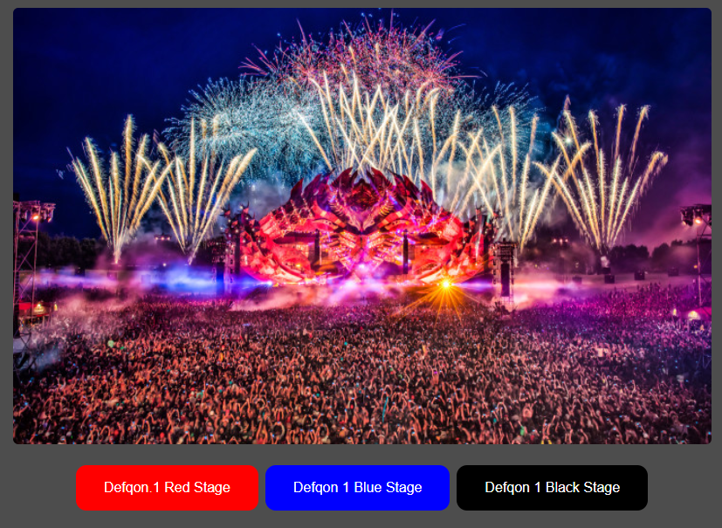

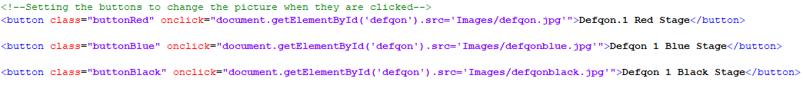
The first piece of JavaScript I implemented was the image change on the press of the button. This festival has many stages and I wanted the user to be able to see a handful of the ones there are.

JavaScript Feature 2

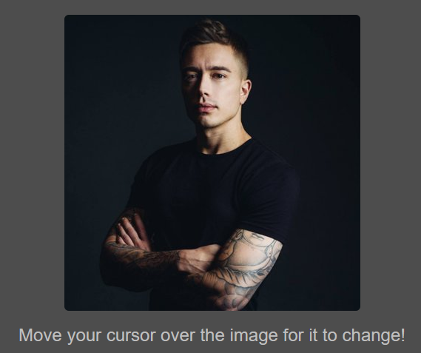
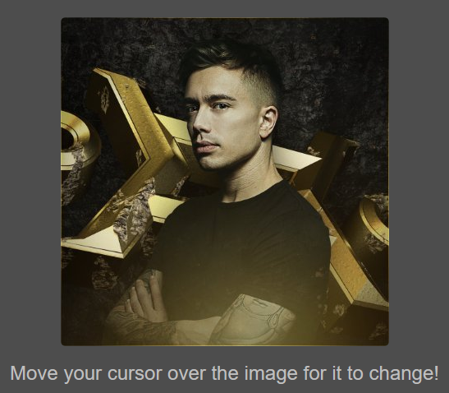

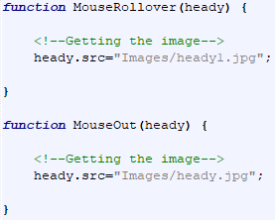
The second JS I implemented was for the image of Headhunterz to change when you rolled your mouse over the image. He is an icon in the hardstyle scene, and I wanted users to get a different look of him with ease.

JavaScript Feature 3

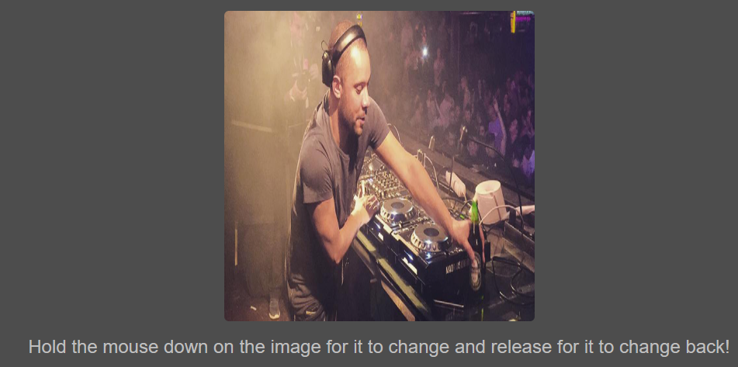

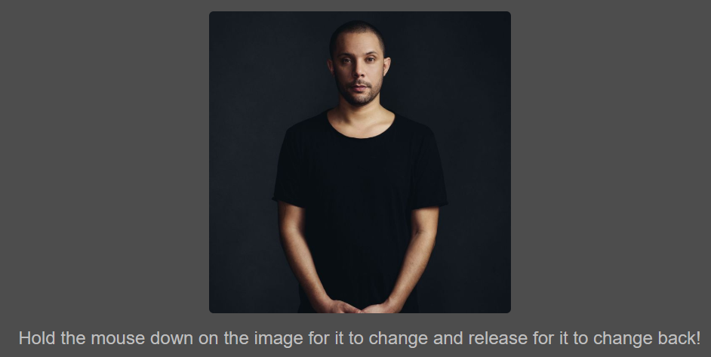
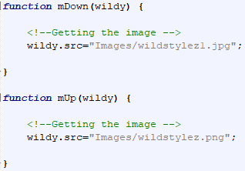
The third JavaScript feature I did something similar as the second, but instead of a rollover you must hold your cursor down on the image and it will change to another image. And then it will change back when released. Just like Headhunterz, Wildstylez is also a big name and I wanted to show users that.

Contact Form Validation

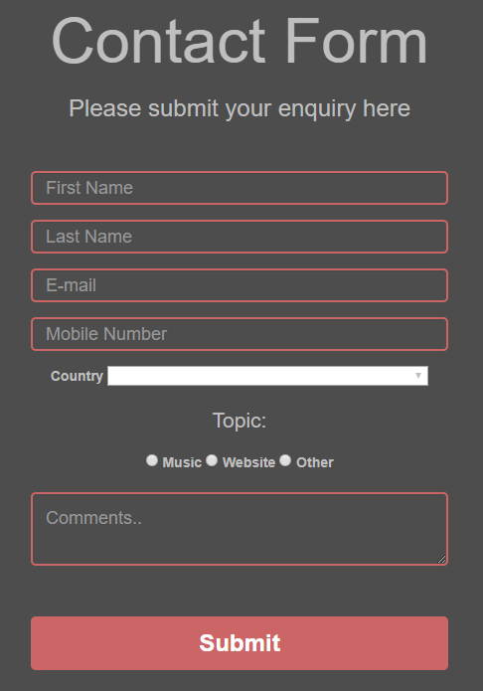

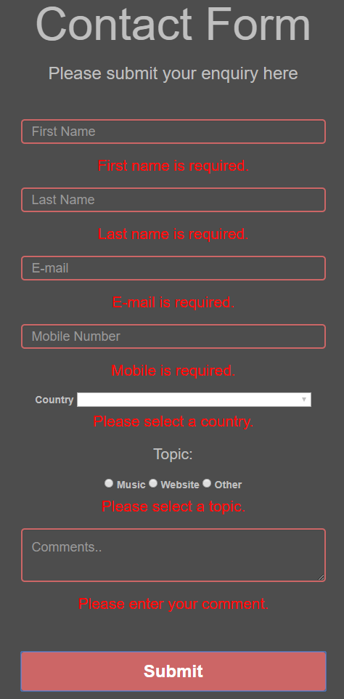
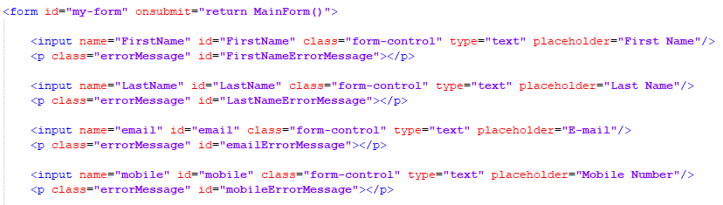
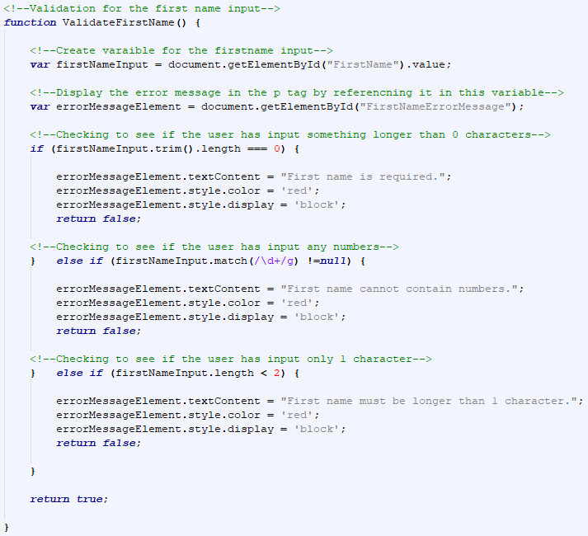
I implemented a contact form, so users can contact me with any regards to the website. I have only included some small snippets of code showing my actions taken with the contact form.

Google Maps

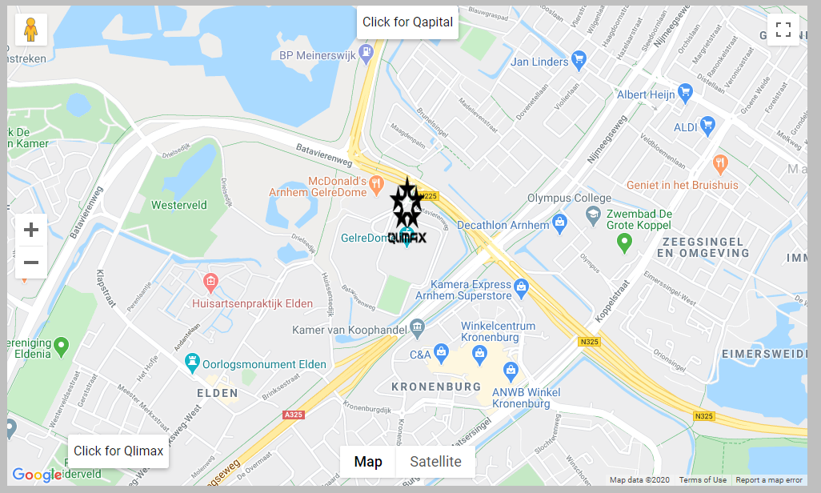

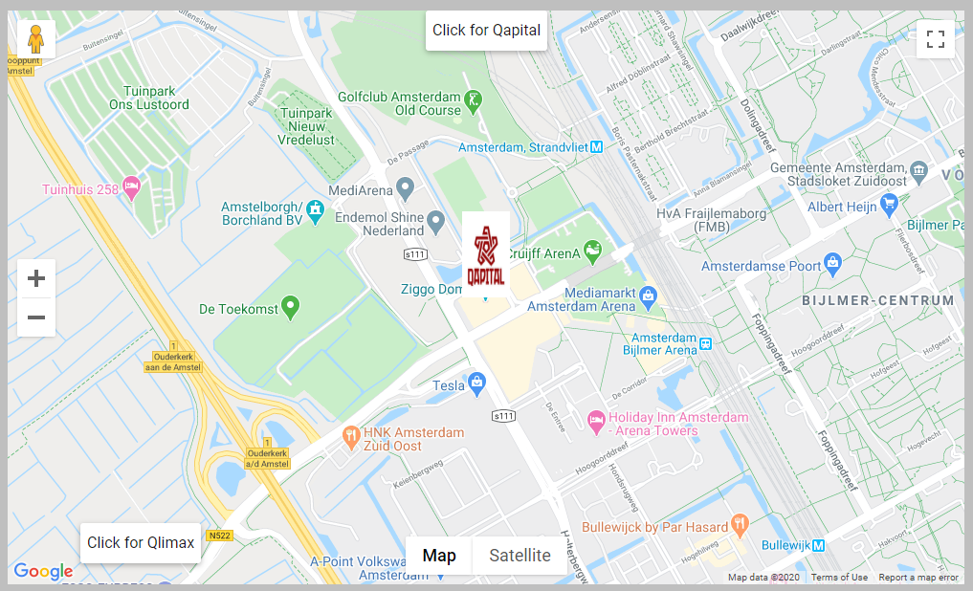
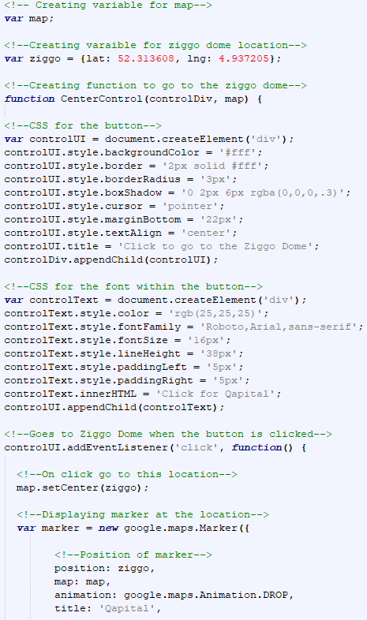
Again, I have only shown a small snippet of code for this. For my final JS feature, I decided to implement Google Maps within my website. I have set the map to focus on the location of Qlimax which is one of the biggest hardstyle events in the Netherlands. I also have additional features, such as a button that takes you to another hardstyle event, Qapital.

Methodology

Button Image Change Feature

When implementing this feature, I first created two buttons with the appropriate code to change an image back and forth. I then saved another image to change to from the original one. Once I got this working, I thought a better idea would be to display 3 buttons that show the main stages at Defqon.1. When I got this working, I modified the buttons colours and size to make it look more appealing for the user.
I decided it would be a good idea for the user to be able to immerse themselves within my website and for it to have some functionality. I believe I have done this by allowing the user to change between the different stages.

Roll Over Image Change Feature

When I implemented this feature, I looked at my website and saw an opportunity to further engage my audience by allowing them to change the picture of Headhunterz by rolling their cursor over the image. Firstly, I input a still image of him, and then I input another image that it would change to when hovered over. I simply done this by creating two functions, mouse over and mouse out and I would reference the image source in each one.

Hold & Release Image Feature

For this feature, when the user is scrolling down on the page, I decided to intrigue them even more by doing something similar with Wildstylez. I’ve allowed the user to change the image by clicking on the original image, which changes it to another image, and then back to the original when the mouse click is released.

Contact Form Validation

For my contact form, I wanted to make sure the user was able to input enough sufficient information as possible when submitting a request/complaint or anything else they wanted to talk about.
I first created the text boxes within the form, so the users can input the information they wanted. I then created a submit button so the user can send it to me. Although, I didn’t feel as if this was enough since anyone could type anything within the form, and it would show no errors and I would be getting some weird inputs sent to me.

So, I decided to implement validation within my form so that when users click the submit button, it would show errors and not send if there were any misinputs or data I did not want to be sent. I created script tags at the bottom of my page and created functions within them. For example, I have a function that validates the first name text box that will not submit if nothing is input. I also have it to not allow any numbers and for it not to be below 2 characters in the same function. I then have this called into a main function called main form which is what is called when the submit is pressed.

Google Maps Feature

My final JavaScript feature is an implementation of google maps within my website. There are many events within the hardstyle scene, and I decided it would be a good way to show the users a couple using google maps to display the location of an event.
Firstly, I linked the script source at the bottom of the page to the google API to get the google maps source. I then created an API key that I included in the script source. I then made a div tag with the id “map” so that my JavaScript can reference it and so it can be placed there on my page.
I then created a main function that displays google maps and some more features. I then included some additional features such as a marker to drop down onto the page to pinpoint where I want the user to look at. I then created two buttons that took you to different locations on the map.

Annotated Code Listing

Code for First JS Feature

I set the button classes so that I can change their styles and colour within my CSS at the top of the page. I then have the onclick feature with refers to the image that I am changing. Then I change the source image to something else once the button is clicked.

Code for Second JS Feature

I have my original image, which I then added the onMouseOver and onMouseOut features so that the JS functions can reference to it and know which element to change on the page.
The JS functions are called into action when the cursor is over the image and when it is taken back off. Within these functions, I have the image source change to a different picture when both features are used.

Code for Third JS Feature

Like my second feature, I have the features within the image html code. I then have the functions at the bottom of the page which change the image source when both are used.

Code for Contact Form Validation

First Name Validation

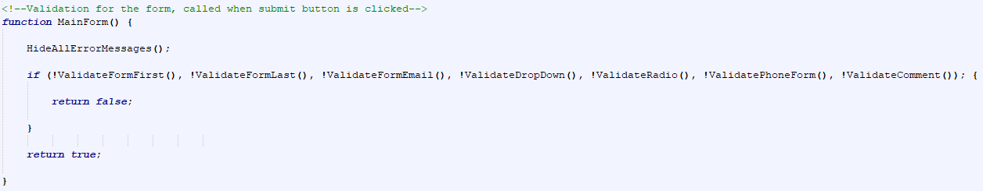
I have a main form function which is called when the submit button is clicked. It calls a function that hides the error messages from appearing if there are none. It also calls every function for my validation for the form.

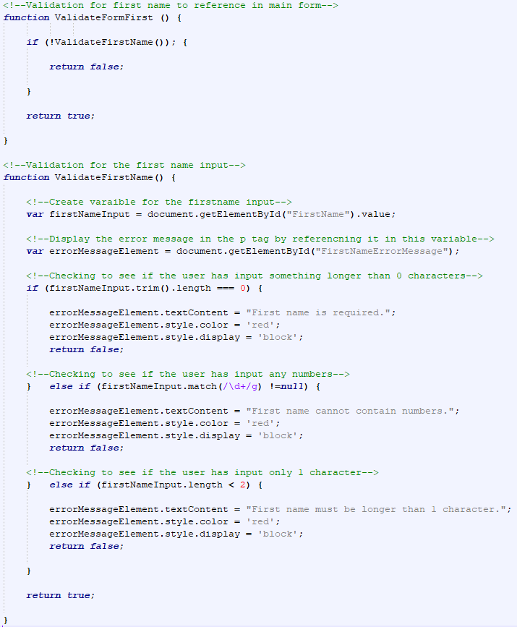

I have a function that calls my validation for the first name separately. I then have the function that has all the validation in it for the first name text box. I created a variable that references to the id of the first name text box. I then created another variable which will display the error message by referencing the p tag below the text box.
My first if statement shows that the first name input length cannot be equal to 0 characters which means the user must input something into it. I have the error message variable display this to the user, so they know what to do.
My second if statement means the input must not contain any numbers. The third if statement means the length cannot be 1 character. If any of these if statements are true, then the return will be false, and the form will not submit. If they are ok, then this part of the validation will be accepted. The last name validation is the same so I shall not reiterate myself about it.

Email Validation

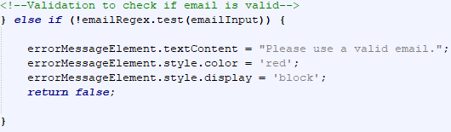

I created a variable for the regex so that the input can see if it is a valid email or not. I then have an if statement to check whether the input does not match the regex, and if so, display an error message.

Drop down Validation

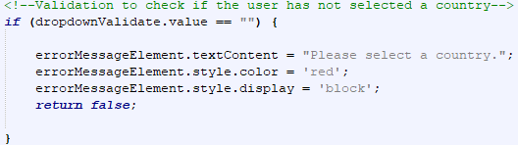

I have an if statement to see whether nothing is input in the drop down. I did this by making the first option of the drop down “” so if the statement matches that then the user needs to input something.

Radio Buttons Validation

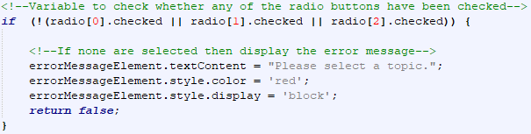
If statement to see if none of the radio buttons are checked then display an error message to tell the user to select one.

Hide Error Messages

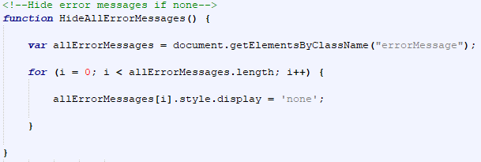

Create a variable that references every p tag with the id error message. If there are no errors message there nothing should be displayed.

Code for Google Maps

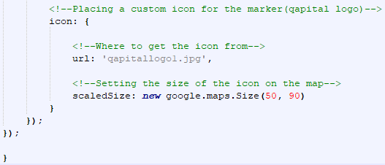
Creating a variable called map which I reference later. Another variable for the Ziggo dome location so I can reference it easily later. Created a function to create a button that allows you to go to the Ziggo dome when clicked. Also, some CSS for the button. Created a marker that displays on the map in the position of the Ziggo dome with a unique icon and drop animation. I also did the same for the other button to take the user to GelreDome.
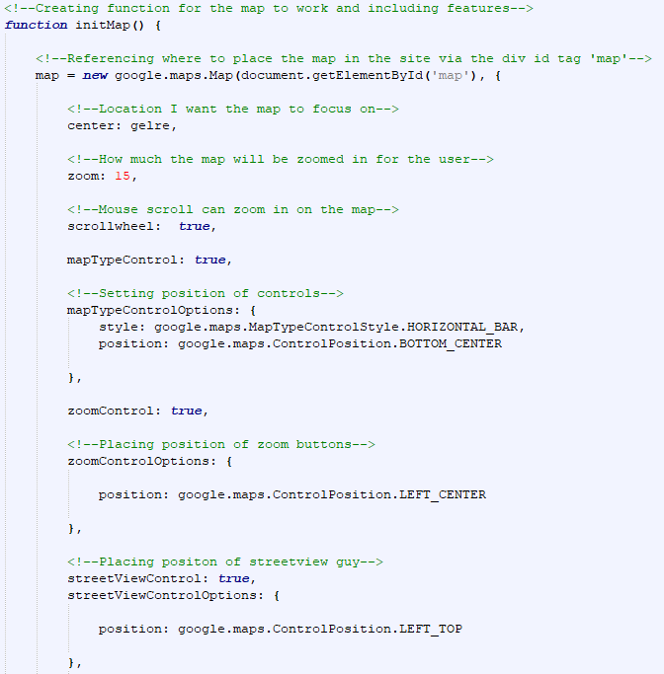

Created a function that will allow the map to work and included features within. The variable map I created earlier is used to reference the div tag in my page, so it knows where to place the map. I have the centre set to a variable called “gelre” which has the location of the GelreDome. Zoom is set to 15 for the user to see clearly. I have allowed the scrollwheel on the mouse to zoom in and out. And the rest I am just allowing my features to appear and setting the positions of them on my map.
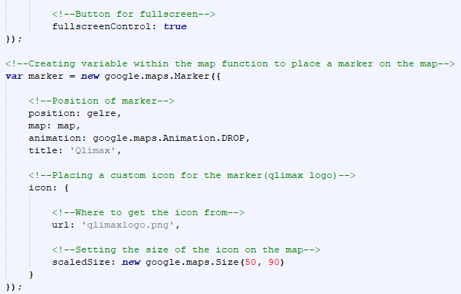

I have set the full screen button to appear. I made a marker to place on the map when the page first loads.
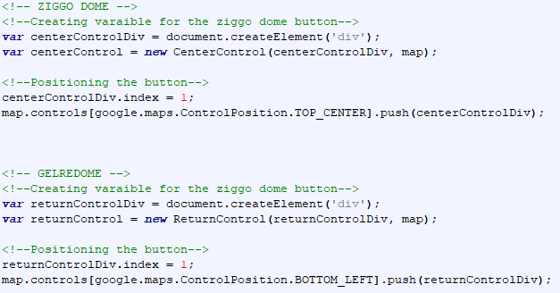
Positioning the buttons on the map that I created earlier for the user to move between locations when the button is clicked.

Conclusion

In conclusion, I think I have been able to implement relevant features within my website using JavaScript alone. I have allowed the user the chance to become more immersed within my site and allow them to feel more at ease when browsing through my pages.

References

- [1] Z. Saucier, Code Pen, 2020. [Online]. Available: https://codepen.io/ZachSaucier/pen/AIJpe. [Accessed: 05- Feb- 2020].
- [2] "JavaScript Regular Expression Email Validation", Stack Overflow. [Online]. Available: https://stackoverflow.com/questions/940577/javascript-regular-expression-email-validation. [Accessed: 05- Feb- 2020].
- [3] M. Khan, "Validate (Check) HTML Select DropDownList using JavaScript and jQuery", ASPSnippets, 2015. [Online]. Available: https://www.aspsnippets.com/Articles/Validate-Check-HTML-Select-DropDownList-using-JavaScript-and-jQuery.aspx. [Accessed: 05- Feb- 2020].
- [4] "Radio button validation in javascript", Stack Overflow. [Online]. Available: https://stackoverflow.com/questions/10339073/radio-button-validation-in-javascript. [Accessed: 05- Feb- 2020].
- [5] "Tryit Editor v3.6", W3schools.com, 2020. [Online]. Available: https://www.w3schools.com/js/tryit.asp?filename=tryjs_intro_lightbulb. [Accessed: 05- Feb- 2020].
- [6] "How to Make a JavaScript Image Rollover", wikiHow, 2019. [Online]. Available: https://www.wikihow.com/Make-a-JavaScript-Image-Rollover. [Accessed: 11- Feb- 2020].
- [7] "Tryit Editor v3.6", W3schools.com, 2020. [Online]. Available: https://www.w3schools.com/js/tryit.asp?filename=tryjs_events_mousedown. [Accessed: 11- Feb- 2020].
- [8] A. Gehman, "How To Add Custom Google Map To Website | MIND Web", MIND Development & Design, LLC, 2016. [Online]. Available: https://www.minddevelopmentanddesign.com/blog/add-custom-google-map-website-using-google-maps-javascript-api/. [Accessed: 15- Feb- 2020].
- [9] "Controls | Maps JavaScript API | Google Developers", Google Developers. [Online]. Available: https://developers.google.com/maps/documentation/javascript/controls. [Accessed: 15- Feb- 2020].

