

Information Engineering

By Student:
Mari I. Uchkunova
Student Number:
1917112
Course Title:
Information Engineering
Bsc Cloud Computing
Module Leader:
Suneth Fernando
Table of Contents
CASE STUDY 3
1.Data Flow Diagram 5
2.Entity Relationship Diagram 6
3.Use Case Diagram 7

CASE STUDY

Creating a system for the “Pizza For U”

The owners of the ‘Pizza For U’, is a successful catering business located in central Harrow, supply catering service to local businesses and organisation in the Harrow and outlying areas. They have recently expanded and now have stores in Slough, Reading, Watford and Amersham. They wish to upgrade their entire data processing provision and they believe it could help them with the running of their catering services and finances.

They would like to use a system that would allow them to record customer details, record information of any catering services and events that the customer request, and then automatically print out customer invoices thus keeping a record of the income generated from catering. They also have a number of supplies where they order ingredients used for the day to day running of a catering business. To complete the accounting records they would like to be able to record purchases as well as sales thus they may at some future date be able to calculated quarterly and yearly profits.

They currently have a very basic customer invoicing system an example print out is a follows:
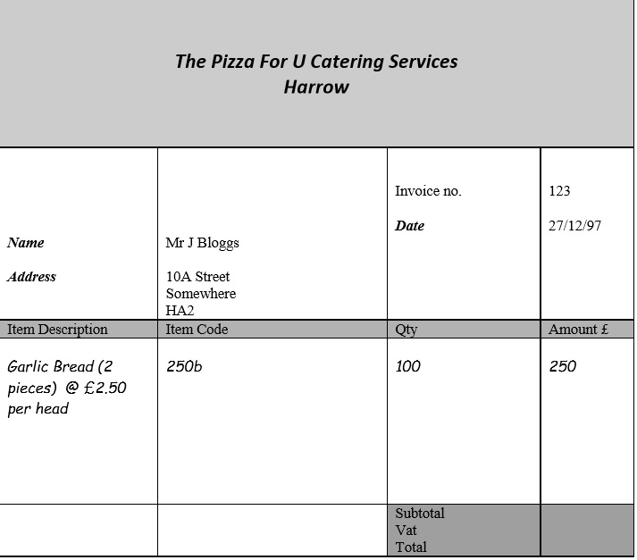

1.Data Flow Diagram
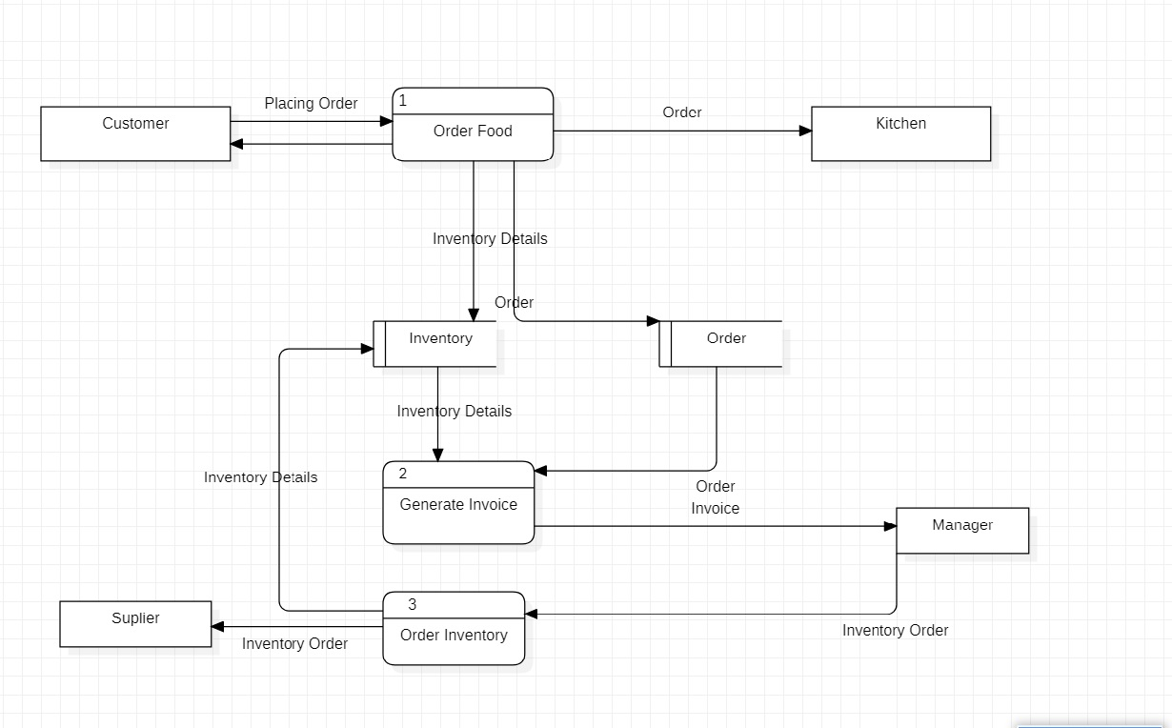

2.Entity Relationship Diagram
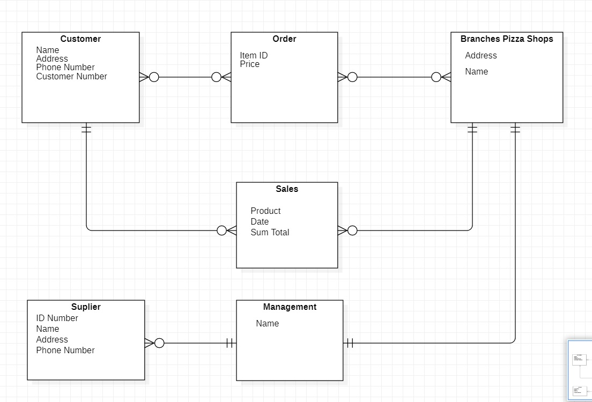

3.Use Case Diagram


