

Applied Computing
Wales Institute of Science and Art (WISA)

Networks and Cybersecurity Essentials (ACCA4024)

Home Work 3: Straight Through and Crossover
Cables

Submission Deadline: On or before 06/11/2020 23.59 Hrs.
Submission Via Moodle Link.


n.kaliyamurthy@uwtsd.ac.uk 1

Objectives
• Understand cabling standards for use in LAN cabling environments.

Background/ Scenario
The TIA/EIA has specified unshielded twisted pair (UTP) cabling standards for use in LAN cabling environments. TIA/EIA 568-A and 568-B stipulates the commercial cabling standards for LAN installations; these are the standards most commonly used in LAN cabling for organizations and they determine which color wire is used on each pin.
With a crossover cable, the second and third pairs on the RJ-45 connector at one end of the cable are reversed at the other end, which reverses the send and receive pairs. The cable pinouts are the 568-A standard on one end and the 568-B standard on the other end. Crossover cables are normally used to connect hubs to hubs or switches to switches, but they can also be used to directly connect two hosts to create a simple network.
Note: With modern networking devices, a straight-through cable can often be used even when connecting like devices because of their autosensing feature. With autosensing, the interfaces detect whether the send and receive circuit pairs are correctly connected. If they are not, the interfaces reverse one end of the connection. Autosensing also alters the speed of the interfaces to match the slowest one. For example, if connecting a Gigabit Ethernet (1000 Mb/s) router interface to a Fast Ethernet (100 Mb/s) switch interface, the connection uses Fast Ethernet.
The Cisco 2960 switch has autosensing turned on, by default; therefore, connecting two 2960 switches together works with either a crossover or a straight-through cable. With some older switches, this is not the case and a crossover cable must be used.
In addition, the Cisco 1941 router Gigabit Ethernet interfaces are autosensing and a straightthrough cable may be used to connect a PC directly to the router interface (bypassing the switch). With some older routers, this is not the case and a crossover cable must be used.
When directly connecting two hosts, it is generally advisable to use a crossover cable.
ACCA4024

Task 1: Analyze diagrams and tables for the TIA/EIA 568-A and TIA/EIA 568-B standard Ethernet cable.
The following table and diagrams display the color scheme and pinouts, as well as the function of the four pairs of wires used for the 568-A standard.
Note: In LAN installations using 100Base-T (100 Mb/s), only two pairs out of the four are used.
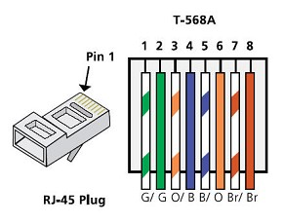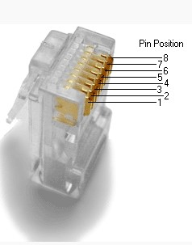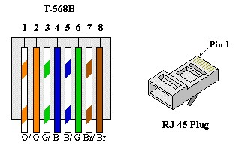

Record your reflection
- What are these TIA/EIA Standards? How do 568 A differs from 568 B? Are there any other standards? (100 – 300 Words)

TIA/EIA Standards are the UTP cables that are commonly coloured differently in the order to organise in which pin or the socket which cable will go, also they connect into different hubs and switches. The way 568 A differs from 568 B is that they cannot be linked or connected=, they are connecting the different ends of each port, which has it’s on value. As an example, 568-A can connect into the switch and the other 568-B can be connected to hub, from both ends of the computer and the hub or switch.
There are plenty of other standards with different lengths of the cable, however the main ones would be 568 A and 568 B.

_____________________________________________________________________________

2 n.kaliyamurthy@uwtsd.ac.uk

2. What is a Straight through Cable and Cross over Cable? Which cable should be selected during a simple network installation (Topology includes Routers, Switches and End Devices)? (100 – 300 Words). You shall use Tables, Diagrams to clarify.
So, a straight through cable, is the setup that is connected directly from the pc to the router, without any need for the hub or anything else, but they usually are shorter and since it is most likely UTP cable, people will have to be careful with it. Furthermore, the crossover cable is a setup that is a bit more complicated due to the fact that, it is more likely to connect to something like a switch and hub, that then leads to the server. The crossover cable is being used to build different topologies such as star network or the circle/ring network and many others, the reason why cross over cable is being used for it, is because of durability of the cable and the setup. Such as shown in the picture below, the image is linked to:https://www.bbc.co.uk/bitesize/guides/zh4whyc/revision/3
ACCA4024

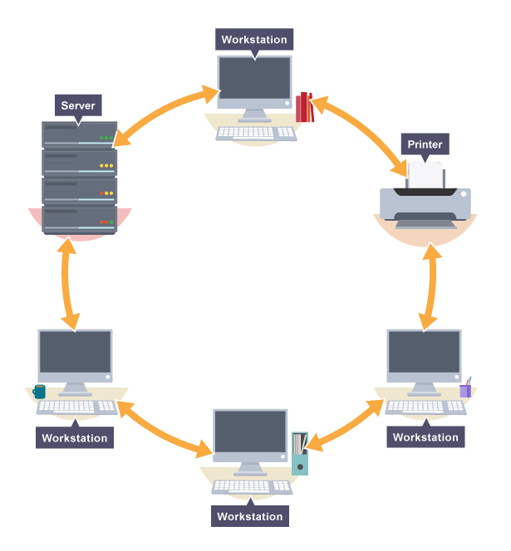

3 n.kaliyamurthy@uwtsd.ac.uk

