Indie Game Development
  - Lecture 12 Lab Tutorial Exercise

Creating an Audio Manager

Objectives
In today’s exercise, you will use Unity’s PlayerPrefs to save high scores.

Exercise 1: Adding a Canvas GUI
In this exercise, you will add a canvas user interface to the game.
- Open up your Close Combat project.
- Duplicate your current scene and rename it such that you know it is the one with the canvas GUI.
- Locate the current HUD game object in the scene. Uncheck the UI Control script attached to it, so you do not have overlapping UIs.
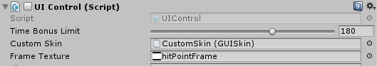
- If you cannot find the UI menu option, or if the UI starts misbehaving:
  - Close your project
  - Go to the folder where it is saved
  - Delete the Library folder
  - Reopen the project in Unity
- From the GameObject UI menu, add a Canvas object to your scene. You will probably notice that an EventSysem object is automatically added too. This is for UI interaction.
- Rename your canvas object to HUD Canvas.
- Look for icon images on Google for:
  - Settings icon images
  - Enemy Icon images
  - Close Icon
  - Volume on and Volume off images
  - Music Icon
- You want to create a display similar, preferably better, to the following:
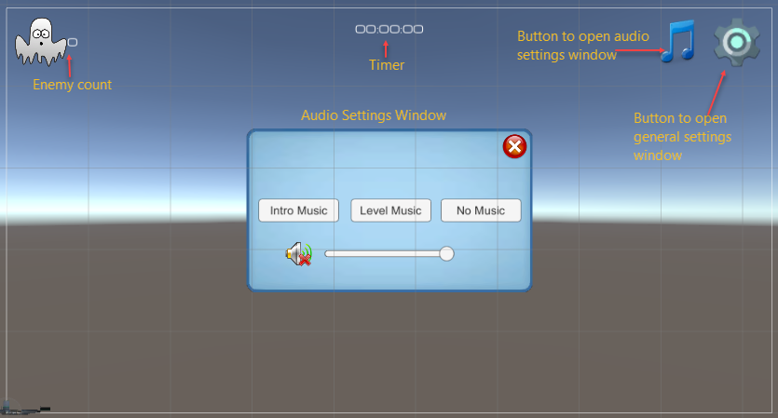

Image Buttons and Text UI Elements
- Download your preferred images and add to a folder in your project Assets directory. Set each image’s type to Sprite 2D. Click the Apply button.
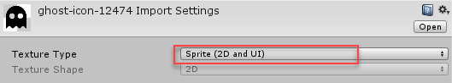
- You probably want to switch to 2D mode as we are using the screen space – overlay mode.
- In the inspector window, enable Pixel Perfect for the canvas, which can make elements appear sharper and prevent blurriness.
Note: if you have many elements that are scaled or rotated, or use subtle animated position or scaling, it may be advantageous to disable pixelPerfect, since the movement will be smoother without it.
- From the GameObject UI menu, add the following and drag the items to roughly position them according to the screen display above, so they do not overlap each other:
Note: UI elements need to be added as child elements of the canvas element
  - Image – rename to Score Image. Position it in the Top Left corner or wherever you want.
  - Set the image to the enemy image you found.
  - Set its size. If you want to use the original size of the image – you can click the Set Native Size button, otherwise set size manually.
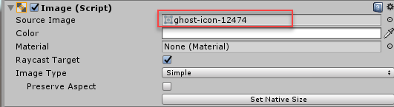
  - Add a nested Text object to the Score image that will be used to display the score and position it next to the Score Image. Rename it to Score Text.

- To position the Image, you need to define anchor points for the UI objects.
- Select the Score Image and hit the anchor settings button.
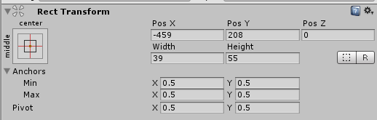
- You should get another window with a GUI to select different anchor points.
- Change the anchor setting for the Score Image to Top Left (see below).
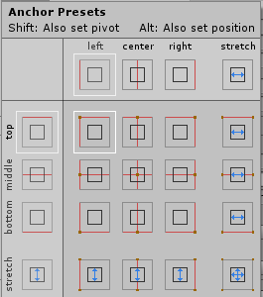
- Set the child Score Text game object’s text to 0.
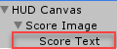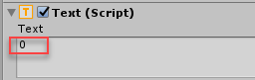
- Now add a Button to the HUD Canvas– rename to Settings Button. Position in the Top Right corner or wherever you want.
  - Delete the automatically nested Text object as it is not needed for this button.
  - Set the button’s image to your settings icon.
- Add a Text to the HUD Canvas – rename it to Timer Text. Position it towards the Top Centre or wherever you want.
  - Set the Paragraph alignment to centre.
  - Make any other changes to all the text elements as you wish.
  - Set the child text object’s text to 00:00:00
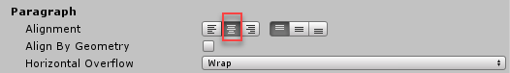

Adding a Popup Window
- Add a new Image element from the GameObject UI menu and rename it to Audio Settings Popup or whatever you like.
- Download the popup image on Moodle and add it to wherever you are saving your images.
  - Set its type to Sprite (2D and UI).
- Set the Source image to the popup sprite.
- By default an image is stretched over the entire image object. For the popup image, change the Image Type property to sliced.
A sliced image is split up into nine sections that scale different from each other. Scaling the middle part of the image separately from the edges ensures that the image can scale to any size while maintaining its sharp, crisp edges.
- You will probably get a warning saying the image doesn’t have a border. You need to define the nine sections.
- Go to the folder in the project view where you saved your image and select the popup sprite.
- In the Inspector window, click on the Sprite Editor Button. A new popup window should appear.
- Set all the Left, Right, Bottom and Top borders to 12. The green lines show you how the image is sliced up.
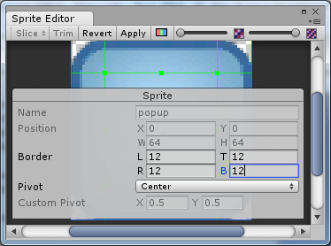
- Apply the changes.
- Adjust the audio settings popup’s width to 250 and height to 200 in the inspector window.
- Note: How images stack on top of each other is determined by their order in the hierarchy window.
- The popup window has a number of child controls. Redesign your popup window with the relevant UI controls similar to the following or as you wish. Look for appropriate icon images to use for the image buttons.
  - Close Button: Button with image (delete child text)
  - Intro Music, Level Music and No Music: are all buttons. Set the text to label on the button in the child text.
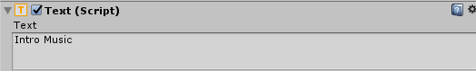
  - Volume On Button: Button with image
  - Volume Off Button: Button with image. This button should overlap the Volume On button (duplicate the previous button and change the image). One button will be hidden depending on whether the volume has been muted or not.
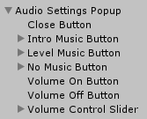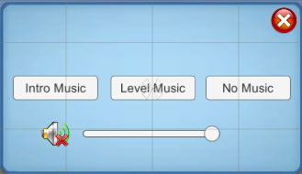
- Save your changes.

Exercise 2: Implementing an Audio Manager
Note: The audio controller will be responsible for playing two types of sounds/music:
- Sound effects: one-off sounds played during your game e.g. a sound effect when the player attacks/kills an enemy. The functionality for this will be associated with the sound related properties.
- Background music: background music playing for your game. The audio manager will provide the functionality to cross-fade between changing background sounds e.g. from intro music to level music, entering a dangerous region, etc.
- Copy the starting code for the Audio Manger from Moodle – it is the same code we have been using for all our state managers. (As C# is case-sensitive, you may get errors if your spelling of status and start up does not match mine).
The file contains most of the variables needed but you will add a few more properties.
- Add the following non-auto implemented property definition used to set or get the volume of the audio listener attached to this game object.
// gets or sets the volume of the audio listener attached to this object
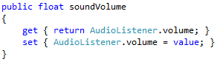
- Similarly, add the following property to mute or unmute the volume of the audio listener attached to this game object.
// gets or sets whether the volume of the audio listener is muted or not
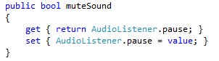
- Create a backing field as follows that will be used for a full property definition created in the next step.
// backing field for musicVolume property
- Now create the full property definition. We are using a full property definition because we are going to use the change to the property value to update the music source values too.
// property definition for the music volume using the more complex full definition method
// when setting the property, it also checks to see if a music source has been set
// and adjusts the volume of both music sources accordingly
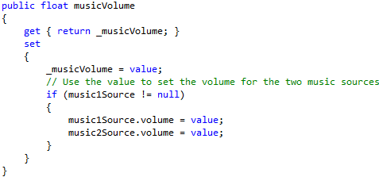
- Create a private backing field of type Boolean called _muteMusic
- Now create a full property definition of type Boolean called muteMusic and use the change to the value to update the two music source’s mute values too (Hint: very similar to what you did early, but you need to update the .mute property for the music sources).

Init Music Settings Method
This method will be used to initialise the music settings before game play starts.
- Create a new private method with a return type of void called initMusicSettings
- Deactivate volume settings on the two music sources as you will control these programmatically.
// Ignore audio listener volume settings
// as this is being set programmatically
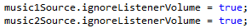
- Initialise the volumes for the two types of play sources to full blast.
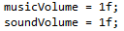
- Set the following as well.
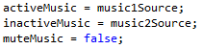

Start Up Method
- Go back to the start up method.
- Call the initMusicSettings method just before setting the status.

Play Sound Method
This method will be used to play the sound clip once.
- Create a new public method with a return type of void called PlaySound.
  - This method should accept an Audio Clip parameter called clip.
- Add the following to play the sound once.

Cross Fade Music Method
- Create a new private method that is a coroutine (remember to use the correct return type) called CrossFadeMusic.
  - This method should accept an Audio Clip parameter called clip.
- First update the isCrossFading variable to true to indicate that cross fading has started.
- Set the currently inactive music to the new clip to play and make it start from a volume of zero.
// set inactive music to the new clip to play and make it start playing from volume zero
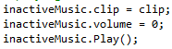
- Now gradually increase (inactive – new music)/decrease (active – old music) the volume by a scaled rate.
// gradually increase (inactive – new music)/decrease (active – old music) volume by crossfade rate
- BEGIN WHILE: start cross-fading music until old music’s volume is zero
// cross fade until currently active (previous) music's volume reaches zero
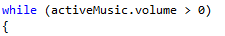
  - Decrease previous music’s volume by scaled rate, making it frame rate independent
// Decrease previous music's volume
  - Increase new music’s (inactive) volume by scale rate
  - Temporarily yield control to other program code till next frame
/ temporarily yield control till next frame
}
- END WHILE.
- You can now swap the music sources around Inactive (New Music) ↔ Active (Old Music). You use a temp variable to do this.
// Previous music's volume is now zero, can stop it
// Inactive currently contains new music to play
// Active contains previous music that was playing
// Swap inactive and active music around using temp variable
// Store previous music (active at the moment) in temp variable
- Set active music to the new music
// Set active music to the new music (inactive at the moment)
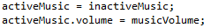
- Set inactive music to the old music
// Set inactive music to previous music (from temp variable) and stop it
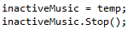
- Set isCrossFading back to false to indicate that cross fading has ended.

Play Music Method (1st One)
- Create a new private method with a return type of void called PlayMusic.
  - This method should accept an Audio Clip parameter called clip.
- BEGIN IF: Check if it is NOT currently cross-fading (is cross fading variable)
  - Start the coroutine method Cross Fade Music with the passed in clip parameter.
- END IF.

Play Music Method (2nd One)
This is an overloaded method (another option) of PlayMusic.
- Create a new private method with a return type of void called PlayMusic.
  - This method should accept a string parameter called musicFile.
- BEGIN IF: check if the music file parameter is null or empty
  - Return and exit early
- END IF.
- Now, try to lazy load the audio file from the music folder.
// Lazy load the music source
- BEGIN IF: Check that it found the music source i.e. clip IS NOT null
  - Call the other Play Music method with the clip.
- END IF.

Play Intro Music Method
- Create a new public method with a return type of void called PlayIntroMusic.
- Call the PlayMusic method with introBGMusic as the parameter.

Play Level Music Method
- Create a new public method with a return type of void called PlayIntroMusic.
- Call the PlayMusic method with levelBGMusic as the parameter.

Stop Music Method
- Create a new public method with a return type of void called StopMusic.
- Call active music’s stop method.
- Call inactive music’s stop method.

Play Background Music Method
This method plays a specific title from the play list variable if it exists.
- Create a new public method with a return type of void called PlayBackgroundMusic.
  - This method should accept a string parameter called title.
- BEGIN IF: Check if the playlist variable contains the title.
  - Call the PlayMusic method with title as the parameter.
- END IF.

Exercise 3: Updating Managers Class to Include an Audio Manager
- Open up the Managers class.
- Add the following.
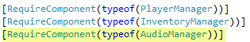
- Add a static property reference for an Audio Manager object, just after the one for Inventory Manager.

Awake Method
- Go to the Awake method.
- Initialise the Audio Manager from the script component as you did the Player and Inventory managers.
- Now add it to the list of managers to include in start-up.
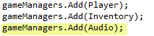

Back to Unity
- Locate your Game Manager game object.
- Attach the Inventory Manager script to it.
- Look for some free intro and background music to download off the internet. You can try:
  - Google
  - http://topfreeintro.com/download-free-intro-music-sound-effects-1/
- Create a new folder called Music in the Resources folder. Note: the folder names are important.
- Download your found music and the ding audio file available on Moodle to the music folder created in the last step.
- Add three new Game Object Audio sources to the scene and make them children of the Game Manager as shown below.
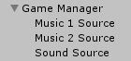
- For Music 1 and Music 2 sources set the properties as shown below:
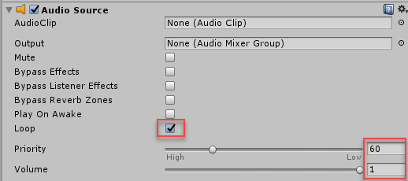
- For the Sound Source, uncheck the Loop box and you can leave the other defaults.
- Now select the Game Manager object and configure the following properties for the audio manager script.
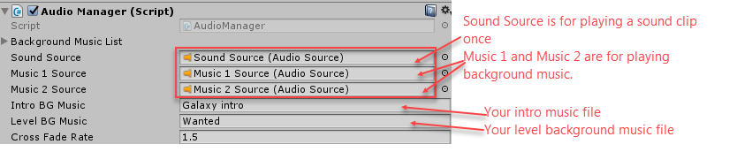
- Unfortunately, one more script to go before you can hear the music playing.

Exercise 4: Audio Settings Popup Behaviour
- Create a new script file called AudioSettingsPopup in the UI scripts folder or wherever you want.
- Import the UnityEngine.UI library into the class.
- Add the following variables to reference the volume on/off buttons.
[SerializeField]
UnityEngine.UI.Button volumeOnButton;

[SerializeField]
UnityEngine.UI.Button volumeOffButton

Close Method
- Create a new public method with a return type of void called Close.
- Initially hide the audio settings popup window. Will display when user clicks button to show.
// Deactivate/hide the audio settings window

Start Method
- Go to the Start method.
- Initially hide the audio settings popup window. Simply call the Close method created in the last step.
- Hide the volume on button as the music will be displaying by default.
// Deactive/hide the volume on button as music playing by default

Open Method
- Create a new public method with a return type of void called Open.
- Reactivate the audio settings popup window (this game object).

On Play Music Method
- Create a new public method with a return type of void called OnPlayMusic.
  - This method should accept an integer parameter called option.
- BEGIN SWITCH (option) – do not forget your breaks.
  - CASE 1
    - Call Audio Manager’s Play Intro Music method.
  - CASE 2
    - Call Audio Manager’s Play Level Music method.
  - DEFAULT
    - Call Audio Manager’s Stop Music Method.
- END SWITCH.

On Music Volume Change Method
- Create a new public method with a return type of void called OnMusicVolumeChange.
  - This method should accept a float parameter called volume.
- Set the Audio Manager’s music volume to the new value.

On Volume On/Off Click Method
- Create a new public method with a return type of void called OnVolumeOnOffClick.
  - This method should accept a Boolean parameter called mute.
- Set the Audio Manager’s mute music property to the new value.
- Note: you can implement this step with two lines of code by using the value of mute or negating the value of mute
  - Deactivate the volume off button when volume IS NOT muted (false) and vice versa
  - Deactivate the volume on button when volume IS muted (true) and vice versa.
- Save your changes.

Back to Unity
- Return to Unity.

Audio Settings Popup Game Object
- Attach the Audio Settings Popup script to the audio settings popup game object.
- Now for each of the child UI elements you have to specify which method to execute when the user interacts with them.
- Select the icon button for opening the audio settings popup.
- In the inspector window, under the Button script, locate the on click settings and click the plus symbol to add the method to call when this button is clicked.
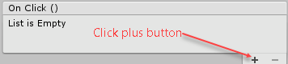
- Drag the Audio Settings Popup game object (the object the Audio Settings Popup script is attached to) into the space indicated.
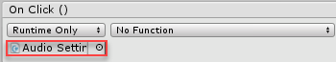
- Now you need to specify which method in this script file to execute when the button is clicked by clicking the NoFunction box.
  - You want it to execute the Open() method in the Audio Settings Popup script.
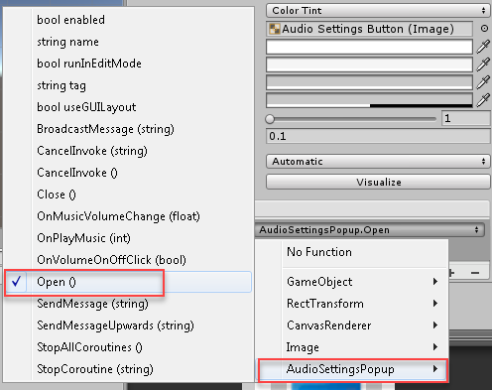
- Now do the same for the following UI objects in the Audio Settings popup window.
  - Close button: call the Close method in the script
  - Intro Music button: call OnPlayMusic. This method also requires an input parameter. Set this to one as shown.
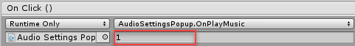
  - Level Music button: call OnPlayMusic with a value of 1.
  - No Music button: call OnPlayMusic with a value of 0.
  - Volume Off button: call OnVolumeOnOffClick with a value of true.
  - Volume On button: call OnVolumeOnOffClick with a value of false.
  - You need to do something slightly different for the slider.
- For the volume control slider, you want to change the volume based on the current (dynamically changing) volume of the slider.
Note: When dynamic options are possible, Unity will provide options for a dynamic and non-dynamic version of the function to select (see below). Select the dynamic version, so it will automatically send the current value of the slider to the method.
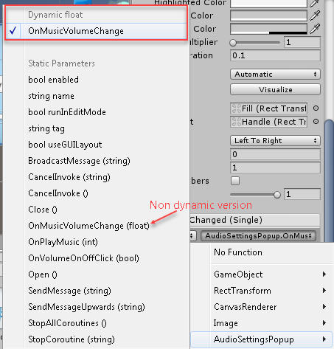

The HUD Canvas Game Object
For the score text and timer text of the HUD Canvas, the code is the same as what you have done already using the GUI. I have written the script for you in a separate file.
- Download the UI Canvas control script from Moodle and attach it to the HUD Canvas game object.
Note: if your game objects have different names to mine, then you may get the famous NULL error. Fix the code.
- Save your changes and test.

Exercise 5: Playing a Single Sound
In this exercise, you will use the Audio Manager implemented to play a single sound when the player attacks the enemy.
- Open up your Player script.
- Add the following field definition.
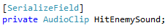

Check Hit Target
- Locate the CheckHitTarget method.
- Just before you broadcast that you hit the enemy. Add the following:
  - BEGIN IF: Check if hit enemy sound IS NOT null
    - Call the Audio Managers Play Sound method with the sound.
  - END IF.
- Save your changes and test.

Exercise 6: Changing Background Music
You may want to change the background music when something happens in the scene. For example, the player enters a dangerous zone, when the game is over, etc. You will extend the Audio Manager to support this.
- Find one or two additional music files for your project and save them to the Resources\Music folder.
- Select the Game Managers game object.
- Configure the Play List with the file names of your music files. For example:
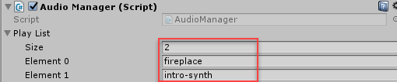

Managers Script
- Open up your Managers script.
- Locate the Update method
- Just after broadcasting a GAME OVER event, change the background music to a title from your play list.
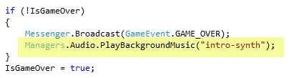
- Phew! That’s all for today.

Cheat Sheet

Audio Manager

Mute Music Property
- Full property definition for muteMusic
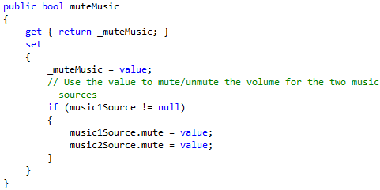

Play Intro Music Method
- Call the PlayMusic method with introBGMusic as the parameter.

Stop Music Method
- Call active music’s stop method.

Updating Managers Class
- Add a static property reference for an Audio Manager object, just after the one for Inventory Manager.

Awake Method
- Initialise the Audio Manager from the script component as you did the Player and Inventory managers.

Audio Settings Popup
- Call Audio Manager’s Play Intro Music method.

On Volume On/Off Click Method
- Note: you can implement this step with two lines of code by using the value of mute or negating the value of mute
  - Deactivate the volume off button when volume IS NOT muted and vice versa
  - Deactivate the volume on button when volume IS muted and vice versa.
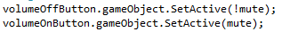

Playing a Single Sound
- Just before you broadcast that you hit the enemy. Add the following:


