T Junction Traffic Light Controller

L5 – Electronics 1
(ACD)
(EES Version)

B.C Apprentice
Student Number 2309256

Electrical and Electronics Engineering Degree Apprenticeship

Contents
- Introduction
- Background research
- Circuit Design/Breakdown
- Flowchart
- Breakdown of Code
- Identified Issues and Results
- Conclusion

Introduction
The goal of this report is to show the research, design, and simulation of a traffic light system. This will be built as a set of traffic lights on a timer at a T Junction to control the flow of traffic from three directions, as well as allowing pedestrians time to cross this imagined road. This will be done by using three sets of traffic lights, with a set of counters, and additional lights for pedestrians, placed at each road.
The counters will get up to 40, initially setting the western lights to green, with every ten seconds cycling the lights, so then the southern set of lights will turn green at the 10 second mark for example. At 30-40 seconds, all traffic lights will appear as red, with the pedestrian lights all having turned green, as the junction will now be halted with its flow of traffic. This cycle will then ideally continue on for as long as this simulation is running for, as defined by the user.
There will be a brief section on background research, looking at the variety of different traffic light versions available, as well as looking at how they function, their specific use cases, and how this version would be coded.
This simulation will then be demonstrated in Proteus, utilising existing knowledge, as well as drawing on what has been gathered from the module. The simulation will show a simple layout not representative of an actual T junction, with a breakdown of the different section of the design.
The code will be shown, identifying key lines with brief explanations to show how it operates the designed simulation, as well as identifying the major issues encountered, before concluding with thoughts on the results and what this report has shown.

Background Research
Looking into the background of traffic light systems in a real-world environment, there are multiple different types used depending on a variety of factors, largely due to where the traffic lights are located. These traffic lights can be attached to a larger network, or individual systems. An example would be in a large city where networked traffic lights are communicating with one another, in an attempt to reduce traffic congestion, via monitoring the build up of traffic and activating traffic lights at set points. This is to gain an understanding of how this task relates to the reality of a system like a traffic light, and to attempt to apply some of these findings to this report.
Timer Based
Timed traffic light systems, such as the one being simulated in this report, are largely used in built up, high population areas (Homer, 2023) due to the constant flow of traffic. These would be set up with a simple timer system to cycle through the different roads to allow a consistent flow of traffic. (What makes a Traffic Light Work?, n.d.)
As will be seen in this simulation, this can be achieved by coding a controller in a variety of ways, whether through the use of arrays, cases and loops etc.

Digital Sensor Based
Traffic lights utilising digital sensors rely upon mainly either CCD (Charge-Coupled Device) Sensors or CMOS (Complementary Metal-Oxide Semiconductor) Sensors. (Homer, 2023) These sensors would be mounted at a point that could monitor the point at the road that a vehicle would give way, informing the controller to run the case for the traffic light to allow that vehicle to pass.
Inductive Loop Based
Inductive loops are placed in the road itself, testing the inductance of the loop in the road, registering when a vehicle is awaiting at the give way. This will then activate the traffic lights, allowing the waiting vehicles to pass. This is possible due to the loop detecting a change in inductance, allowing the traffic light to trigger for an established period of time, allowing traffic to continue to flow. (Wu, 2025)

Circuit Design/Breakdown
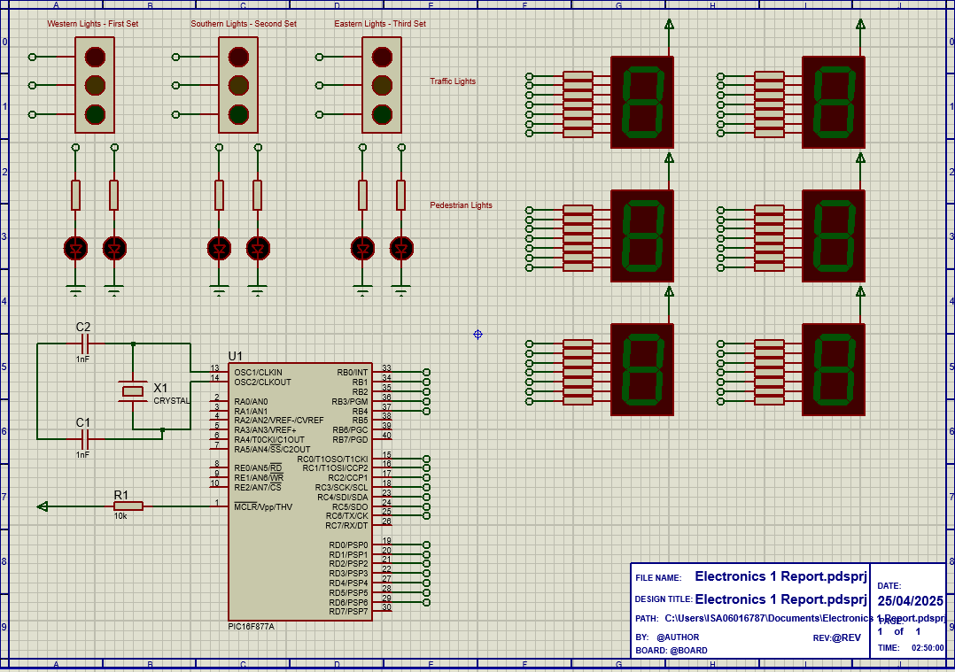
Below is the circuit design that has been demonstrated in previous lectures for this project, using a PIC16F877A, with the relevant lights and counters.
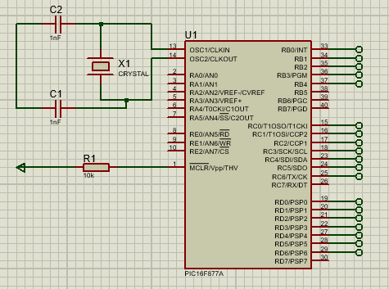
This PIC16F877A is the microcontroller used for this task, which will be running the script to time the segment displays, counting up from 0 to 40, which in turn will cycle through the traffic lights, starting with the western traffic lights for 10 seconds, then the southern traffic lights for 10 seconds, the eastern traffic lights for 10 seconds, before concluding with pedestrian lights for the final 10 seconds.

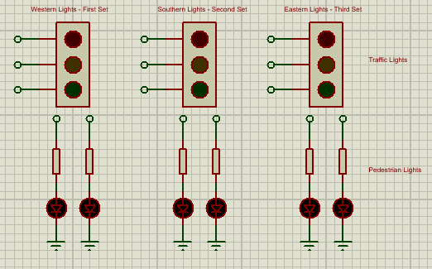
These are the set of lights that are set to cycle through the 10 second loops, going left to right from the top set of traffic lights, then activating the green LEDS in the final 10 seconds.
For the first 30 seconds, the output of the red LEDs is set to high, to keep the red light for pedestrians on whilst any of the traffic lights show green, indicating it is safe for motor vehicles to continue on.

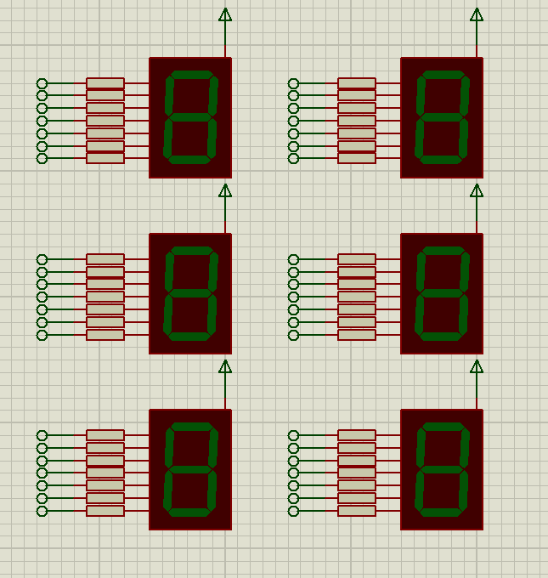
These are the LED counters that would be positioned at each set of traffic light to display whereabouts the code is in its loop. These will all be displaying the same value counting up to 40 before going back to 0, looping for the duration of the simulation. These counters show at which point the traffic lights will change.

This design has been assembled in proteus using knowledge from previous lectures, to fit the required specification, with the set positions for the traffic lights labelled.

Flowchart
Below is an example flowchart detailing how the system should operate with a basic outline of how the code should function

Identify and assign LEDs
Setup of Traffic Light Timer array
Assign ports

Set outputs of southern traffic light
Set outputs of western traffic light
Declare outputs and assign modules

Repeat with loop
Trigger pedestrian lights
Set outputs of eastern traffic light
Breakdown of Code
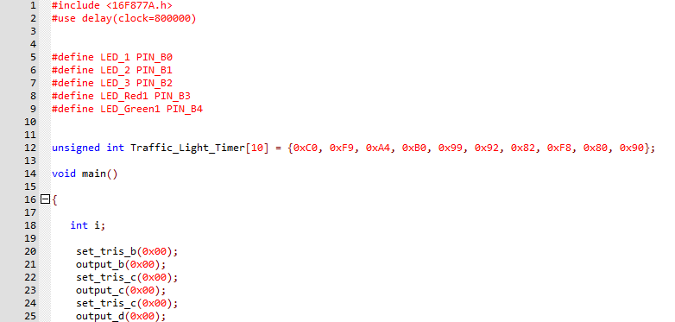
To set up the code, the bit variables of the LED are assigned with a name provided for each relevant LED, with the ports being set to the relevant ports, B0, B1 etc. integer values are then assigned for the displays, setting the count value. The array is then designated as Traffic_Light_Timer. Output ports are then declared for LEDs, with their outputs being set to 0.

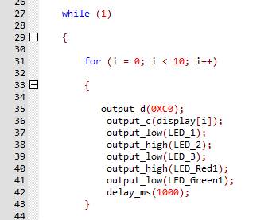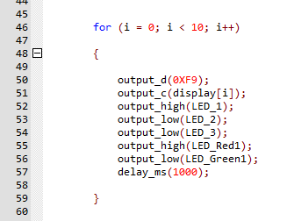
Here two different states are represented, the first setting on the right showing the first traffic light to be set to green as shown with setting the output low, counting the 1000ms until the next traffic light is triggered, as seen on the left with the output high activating the traffic light. Again, the delay is set to the 1000ms providing the 10 second count down until the next traffic light.

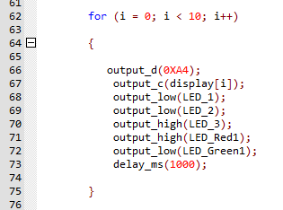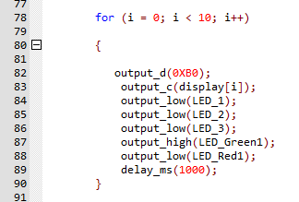
On the left the final traffic light is triggered as output is set, delaying the 1000ms, before triggering the pedestrian lights as seen on the right, with the output of the green LED being set to high.

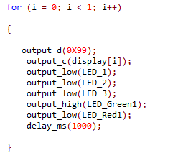
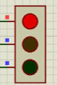
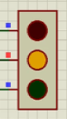
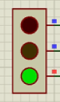
Loop is closed with the final state, repeating the system for the as long as the simulation is running.

Identified issues and results
The first issue identified was the pedestrian lights failing to switch from red to green. Having attempted to troubleshoot this issue multiple times, including with creating a new circuit, no clear issue was able to spotted in the code. This continues to persist in the current code with solution.
When inquiring about this issue with peers, I was told that this issue should flagged in this report as the issue shouldn’t be continuing to appear. The traffic lights still functioned as intended however, with the counters working.
All traffic lights cycled once before stopping until the simulation, again this being an issue that there was no answer to with the counters being the only section that was working as intended. Again, this issue was identified and brought up, being told to flag and address. The most probable cause is likely an issue with the code itself, but having gone over and rebuilt it from provided notes, no developments were made.
Another issue was an error with port RB2 with the PIC, however Proteus had identified the issue but had not given an explanation of what the actual problem was. Again, the design was rebuilt, yet nothing changed, with using a new project still yielding no results.
As for how testing can be demonstrated, due to the lack of a physical copy of the simulated system, testing cannot be achieved outside of making alterations to the code.

Conclusion
The simulation had several major flaws, with both the traffic lights and the pedestrian lights failing towards the end of the code, but with code providing feedback in the form of the lights actually activating, just failing to cycle, again possibly an issue with the code or potentially an issue with the simulation software.
With these issues, the results were less than desirable but an element of that code still worked to some extent, showing the continuous troubleshooting required to ensure the stability of coding, especially for something as important to safety and the limiting of congestion as traffic lights. As for the relevance of the proposed simulation working being employed in a actual set of traffic lights used to control the flow of traffic, from my background research, these would be most appropriate for a built up are with a constant flow of traffic, as well as large numbers of pedestrians, due to the consistent times allowing an even flow of traffic and people at all times.
As for future work, a task that has a more extensive coding requirement would be beneficial, due to the limitations of attempting to dissect what is a fairly straightforward code, limiting how much can actually be written about it, and gathered from it.
This task was rather limiting due to its strict requirements for quite a precise system but manage to integrate multiple different functions, which may have been responsible for the associated issues with the code and/or design of the simulation.

References
Homer, T. (2023, Jan 24). How Traffic Lights Detect Cars Are Waiting for the Light to Change. Retrieved from howstuffworks: https://auto.howstuffworks.com/car-driving-safety/safety-regulatory-devices/how-does-a-traffic-light-detect-that-a-car-has-pulled-up-and-is-waiting-for-the-light-to-change.htm
What makes a Traffic Light Work? (n.d.). Retrieved from BrightHub Engineering: https://www.brighthubengineering.com/structural-engineering/90116-how-traffic-light-systems-work/
Wu, J. (2025, Feb 7). Traffic Signals: A Complete Guide to How They Work. Retrieved from LEOTEK.

