Hand rendered draft - 7 x spot repeat tile. This is a useful way to layout/ compose a tile (technically repeating as a block, but could be worked as a drop, brick or other repeat system). This example has been worked as a block, repeating out side by side…but leaving the spot layout as a negative space.
Draft: the first version of a design (not finished, but has the bones to become a finished outcome)

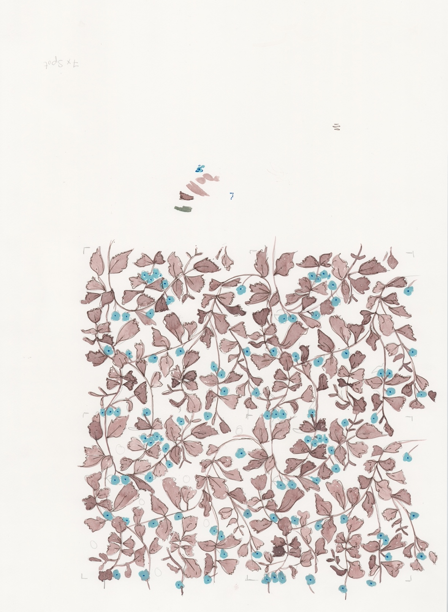
Original artwork watercolour, gouache and pen

These pattern types can work well in a spot repeat layout, but are not limited to this method of repeat. Abstract, Fauna, Floral, Foliage, Geometric, Paisley, Scattered, Spot, Stripe, Toile de Jouy.

You can draft out a 7 spot repeat within the framework of a square or rectangle, something like this…

7 x spot tile layout (arrows indicate direction/ rotation of motif but can be used without)

7 x spot tile layout repeated out

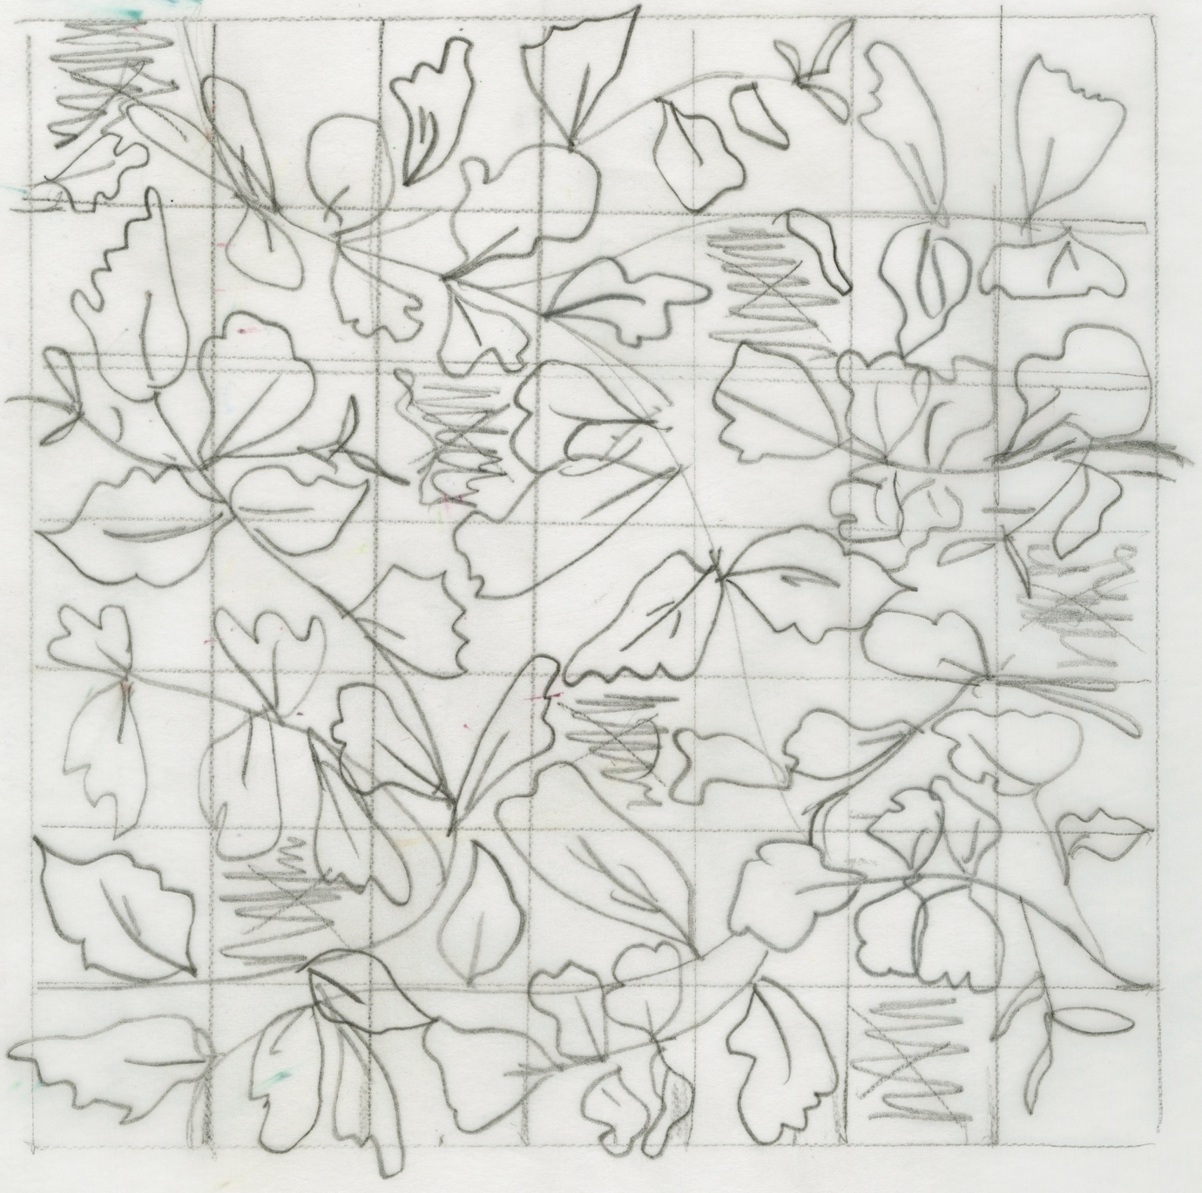

Hand rendered 7 x spot tile (draft) (notice the 7 spots are actually negative spaces left in the design)
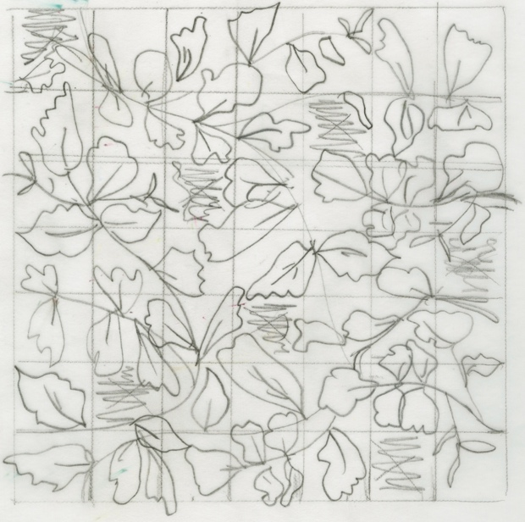

The draft pattern has been worked so that it tiles out as a block repeat network
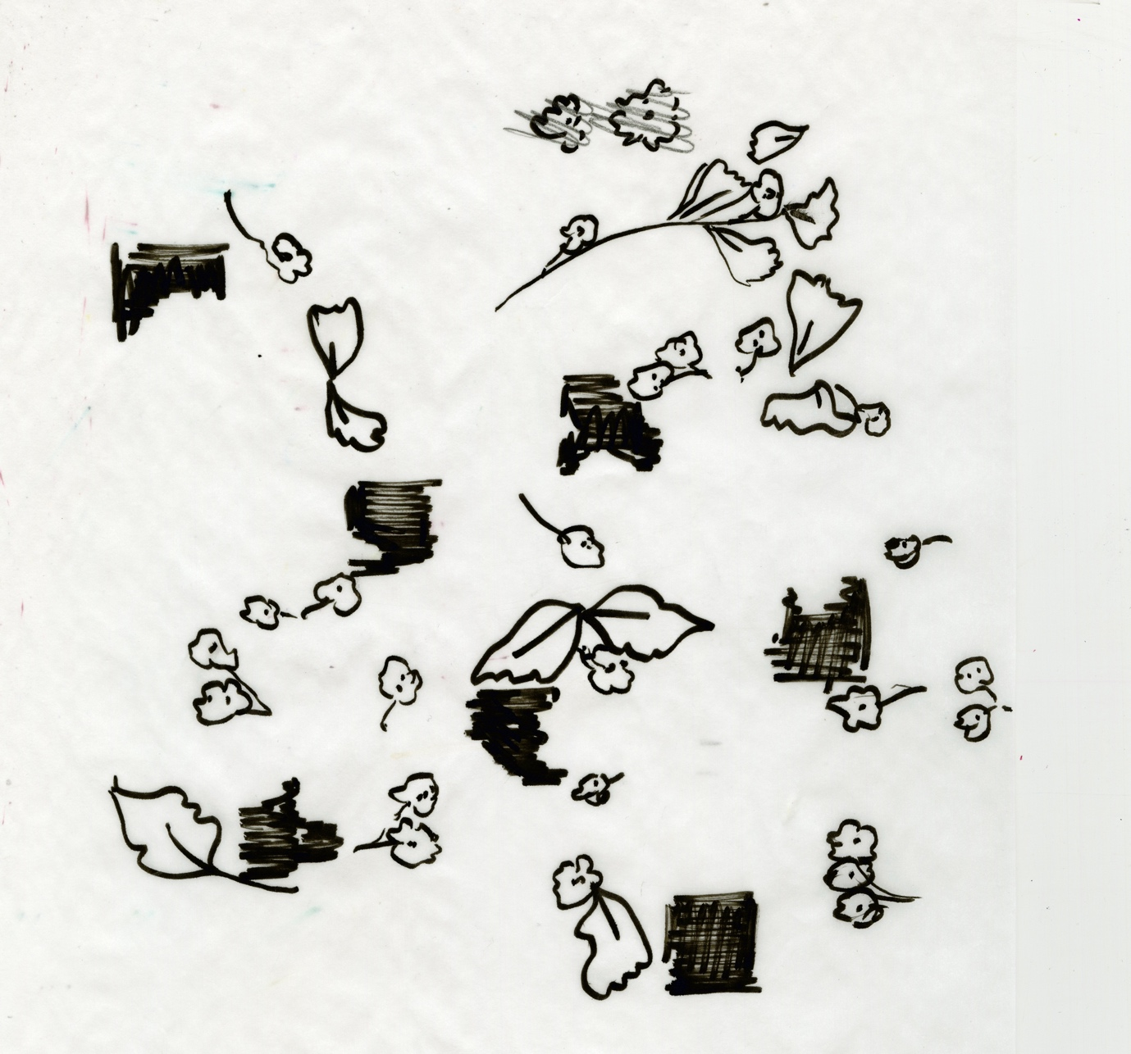

It was felt that the original drafted tile was missing something, so additional elements have been added in
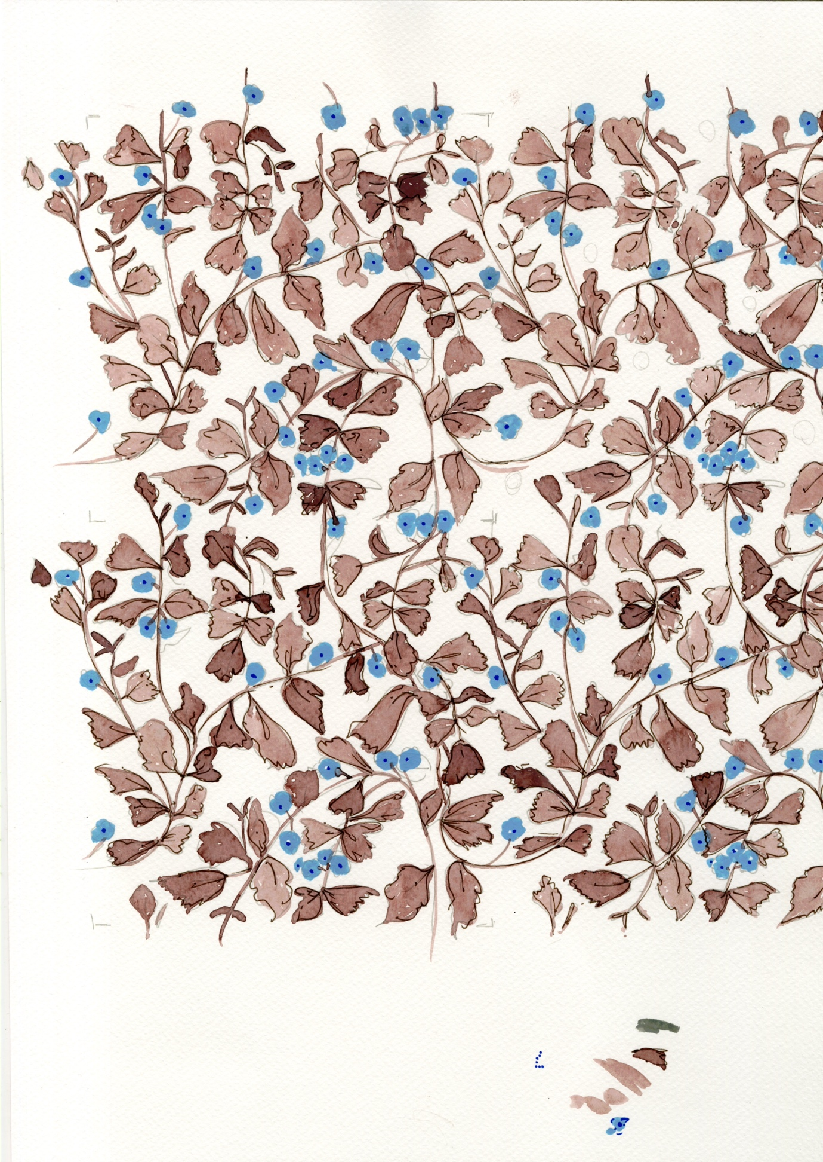

Hand rendered 7 x spot… drawn out and coloured with water colour, gouache and pen

