Network Operating System and Security

Active Directory Worksheets:
Observational tasks

Submitted in the partial fulfilment for the award degree of
BSC CLOUD COMPUTING
to
University of Wales Trinity Saint David, London

Submitted by:
1805315 Giuseppe Ventimiglia

Under the guidance of:
Terry Walcott
Academic Year 2019/2020



Contents

Worksheet 1: Building the NOS infrastructure using Active Directory. 3
Worksheet 2: Resource Management in Active Directory: Users, Computers and Groups 5
Worksheet 3: Resource Management in Active Directory – Managing Access to Files and Folders, and Controlling Domain User Environments 5
Worksheet 4: Network Administration using DHCP 7
Worksheet 5: Planning and Deploying DNS in the Network Infrastructure 8
References: 11

Worksheet 1: Building the NOS infrastructure using Active Directory.

Type 2 hypervisor virtualization has several benefits such as the ability to run multiple, different and isolated virtual machines on the same system, the ability to use the host OS together with virtual instances , the easiness to set up testing environments and the functionality of management consoles.

- A domain tree is a logical container that can contain domains and other objects like user accounts, groups, computers, printers, file shares organized in Organization units (OU)
- A domain forest is a series of domain trees joined by a trusting relationship
- A child domain shares the same namespace as the parent domain and there is a transitive relationship trust between them
- A parent domain is a collection of child domains that do not share its namespace with other domains within the domain forest.
- An active directory is a directory service that maps all the resources within the network, creating an infrastructure where all these resources can be managed and organized on different levels as shown in the graph below.
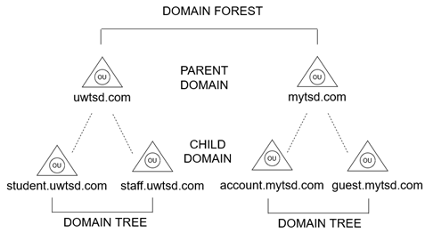
Figure 1 explanations of domain forest, tree, parent, and child (Author, 2020)

- A DC plays an important role in Active directory: It manages the security authentication of the hosts whenever they want to access resources within a domain.

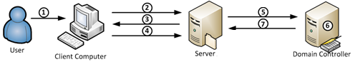
Figure 2 How a Domain controller work (Source: Microsoft, 2010)

- If the DC becomes unavailable, as administrators we can nominate a different secondary domain controller that can manage all the authentication requests. In order to re-establish availability for the primary domain controller it is necessary to troubleshoot the connectivity between the server, domain controller and DNS.

Worksheet 2: Resource Management in Active Directory: Users, Computers and Groups

The minimum password complexity for modern NOS implementation requires that the user’s account name or full name is not used in the password and the it must include at least three of the five criteria such as uppercase characters, lowercase characters, base 10 digit, any Unicode characters, Non-alphanumerical characters and uppercase characters
Moreover, complexity can be enforced when passwords are changed or created (Dansimp, 2020).

The benefitsof groups can be summarised as follows:
- Ability to put together all users that shares the same characteristics and to control all of them at the same time.
- Improved productivity, manageability, and security with two groups types (Distribution and Security) and three group scopes (Domain Local, global group, Universal group)
No disadvantages have been found.

Worksheet 3: Resource Management in Active Directory – Managing Access to Files and Folders, and Controlling Domain User Environments

According to Sitani (2003), NFTS and share permission are two types of permissions that are employed to control access to data in Windows network environments. NTFS is specifically udopted to control access to data stored in NTFS files systems. The main benefit is that NTFS share permissions affect users and network users, and permissions are applied at each windows login, without considering where the user is connecting from. Share permissions instead, manage access to network-shared folders, where permissions are applied to all files and folders in the share.

- NTFS is a method of organizing and managing data on a drive into individual pieces, called files. It stands for “New Technology File System” and it is the successor of FAT32. Comparing the two File systems it is possible to analyse the benefits that have been introduced to the newest file system.
Figure 4 Comparison NTFS and FAT32 (Sitani, 2003)

In AD domain, groups are used to provide users with access to specific resources and to delegate specific administrative permissions.

Group policy is defined as a collection of settings configured by the administrator and is widely used in active directory because of its enormous advantages (Petters, 2014).
Figure 5 GPO Advantages (Sources: Petters, 2014)
Organisational units are defined as a container of users, computers, groups, and other objects that share similar characteristics.

Figure 6 OU characteristics (Sources: Petters, 2014)

Worksheet 4: Network Administration using DHCP

According to Oracle (2012) running a DHCP Server in network infrastructure has three main advantages such as Centralized configuration (1), IP address management (2), and large network support(3).

1) Different DHCP configurations can be applied to different hosts that can be all managed from a centralized place.
DHCP
Server

3) DHCP Servers can process many multiple requests at the same time thanks to multithreading.
2) IP addresses are assigned automatically without the need to configure each new one manually.

Figure 7 DHCP Advantages (Sources: Oracle, 2012)

- The four stage process described above is called DHCP handshake and involves the following steps:



1 Discovery
DHCP Client
DHCP Server
2 Offer
3 Request

4 Acknowledge

Figure 8 DNS Handshake (Rouse, 2019)
4) The server provides the Ip address and complete the request.
1) The client sends a DHCP discover message to the server to receive an IP address.
2) The DHCP server responds offering an available IP address.
3) The client sends a request message to obtain the address from the server.

Figure 9 Explanation of the DNS handshake (Rouse, 2019)

There are two potential risks associated with the use of the DHCP service:
1 Unauthorized DHCP clients can obtain IP addresses.
2 The DHCP server can change valid DNS source records with incorrect information

Worksheet 5: Planning and Deploying DNS in the Network Infrastructure

- A recursive DNS Query is a type of query that requires to be transferred to multiple DNS servers to find a solution to the client’s request.
- An iterative query process instead, requests and uses the best answer from the DNS server can without contacting other servers.

- Root hint is a list of servers and IP addresses that support servers whenever their recursive queries have no results.
Root hints process is explained in the following steps:

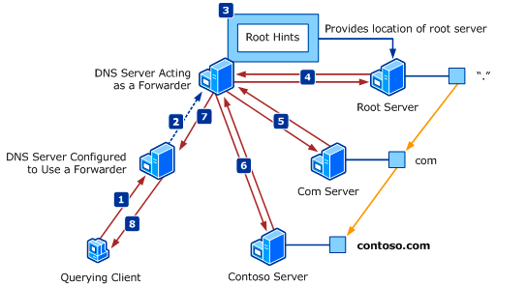
Figure 10 Root Hints (Microsoft, 2018).

Figure 11 How Root Hints work (Microsoft, 2018)

The FQDN is Server1.subcontA.nwtraders.msft

Server1.subcontA.nwtraders.msft
Empty string represents the root.
The DNS adds a dot to break the FQDN
msft (Top domain level, under root)
nwtraders. msft
(sub domain level,
under msft TDL)
subcontA.nwtraders.msft
(Sub-domain under nwtraders.msft)
Hostname

Figure 12 FQDN structure (Author, 2020)

- DNS zones are parts of the domain namespace related to a specific entity in which a single manager is responsible for the administrative tasks, the image below shows an example of DNS zones.
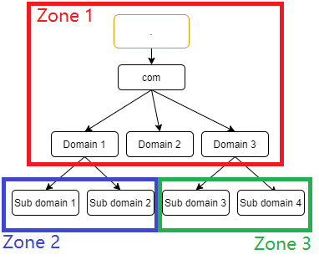  Figure 13 DNS zones (Author, 2020). | Each zone contains records for the resolution of domain names to IP addresses, that is why they are also called “forward zones”.  Zones are stored on Name servers together with zone files, text-based files that contain information about the service records.  An important factor to consider whilst configuring DNS zones is to provide fault tolerance for the primary DNS zone by creating secondary back-up DNS zones:  Indeed, there are three types of zones used for this purpose: Primary, Secondary and Stub.

References:
Dansimp (2020). Password must meet complexity requirements (Windows 10) - Windows security. [online] docs.microsoft.com. Available at: https://docs.microsoft.com/en-us/windows/security/threat-protection/security-policy-settings/password-must-meet-complexity-requirements [Accessed 2 Apr. 2020].

Margaret Rouse (2019). What is DHCP (Dynamic Host Configuration Protocol. [online] SearchNetworking. Available at: https://searchnetworking.techtarget.com/definition/DHCP [Accessed 2 Apr. 2020].
Microsoft (2018). Reviewing DNS Concepts. [online] docs.microsoft.com. Available at: https://docs.microsoft.com/en-us/windows-server/identity/ad-ds/plan/reviewing-dns-concepts [Accessed 3 Apr. 2020].
Microsoft (2010). Optimizing NTLM authentication flow in multi-domain environments. [online] docs.microsoft.com. Available at: https://docs.microsoft.com/en-gb/archive/blogs/isrpfeplat/optimizing-ntlm-authentication-flow-in-multi-domain-environments [Accessed 2 Apr. 2020].

Oracle (2012). Oracle® Solaris Administration: IP Services. [online] Available at: https://docs.oracle.com/cd/E23824_01/pdf/821-1453.pdf [Accessed 2 Apr. 2020].
Petters, J. (2014). What is Group Policy, GPO and Why it Matters for Data Security. [online] Inside Out Security. Available at: https://www.varonis.com/blog/group-policy/
Sitani, A. (2003). FAT AND NTFS DIFFERENCES. www.academia.edu. [online] Available at: https://www.academia.edu/7420470/FAT_AND_NTFS_DIFFERENCES.

