
Skills for the Workplace
Module Assignment Submission
Student Name: | Azad Khan
Student Number: | 1711422
Module No: | BMSK4003_LON
Module Title: | Digital Skills and Research Methods
Lecturer: | Balendran Kandasamy

Contents
Abstract 3
Introduction 3
Rationale 3
Methodology 4
Impact of tsunami 5
Literature Review 5
Secondary sources / (Secondary research) 6
Survey Questions 7
Findings / Analysis 8
Conclusion/Recommendation 9
Reference 11

Abstract

What causes Tsunami? A tsunami is a series of combined fast moving waves (known as a ‘train’) that are caused when water in the ocean or even a lake is quickly replaced by a sudden contusion in the configuration of an earthquake, a landslide, a volcanic eruption, or the impact of a meteorite. Tsunamis are effectively unnoticeable out in the open sea fishermen can be right over a tsunami without experiencing more than a soft ripple in the water. Nevertheless as tsunami waves channel across the ocean at speeds of up to 600mph, they create devastation on reaching land, wrecking everything in their path. As they proceed towards land, the shallow water acts as an alteration on the front of the wave, reducing it down to 200mph, while the back of the wave continues at raging speed. The back catches up with the front to form a horror stricken wall of water. This perceptible difference in activity at sea and near land gives the tsunami its name. For the term gotten from the Japanese for ‘harbour’ (‘tsu’) and ‘wave’ (‘nami’), and was think up by fishermen who returned to port to find the area surrounding the harbour destroyed.

Introduction

This report will be focused on Tsunamis and the effect it has on different countries. During the report there will be an explanation on why tsunamis happens and is earthquakes related to tsunamis, what is difference between tsunami in open sea and tsunami waves will also be discussed. How much geologists have learnt from the natural disasters.

Rationale

What are the main factors for causes of destruction from tsunamis? They can be listed as erosion, overwhelming abundance of things, impacts from tidal waves on manmade infrastructures, and catastrophic currents leading to the falling and crumbling buildings and endangering lives. The activity of buoyant in a liquid and haul intensity tipping railroad cars and move houses so that it is on its side or upside down. Noteworthy sizable amount of destruction is caused by the produced as a result of floating debris, including cars, transport vehicles and boats that become hazardous missile like rockets, start fires and damage cable lines. Flame’s from fractured coastal oil storage tanks or mangled ships in ports and considerable damage causing something unpleasant or painful directly by the tsunami in industrial establishments. The potential effect of tsunami draw down is of increasing concern, water intakes of nuclear power plants uncover when cooling waters recedes.

Methodology
In order to perceive the intended meaning of tsunami, what causes it in the Pacific Ocean at both the scale of the ocean and at the local of coastal is overwhelming; I needed to understand the occurrence of earthquakes to tsunami, the coastal wave and the tectonic plates. In a sensitivity analysis of tsunami models at three different spatial scales, a grid with 10 meter spacing can significantly alter the location of features such as river deltas and the accuracy of bathymetry data. Such vertical and horizontal uncertainty can lead to surprising lack of compatibility. In linear shallow water wave theory, waves are assumed to be non-dispersive, meaning that their phase velocity equals their group velocity, and their wavelengths are constant over time, meaning arranged in or extending along a straight or nearly straight line. This holds well for tsunamis in the deep ocean, as their wavelengths are much longer than the depth of the ocean, causing them to act like shallow water waves. Pyroclastic flows are fragments of volcanic origin; especially those associated with explosive volcanic eruptions are a common product of explosive volcanism and have the capacity to develop or to start tsunamis whenever thick, dense flows encounter bodies of water. The process of tsunami generated by the pyroclastic flow by decomposing the pyroclastic flow into two components, the dense underflow portion, which we term the pyroclastic debris flow, and the plum. which includes the surge and co ignimbrite ash cloud parts of the flow. We consider five possible wave generation mechanisms. These mechanisms consist of plume pressure, steam explosion, pressure impulse wave generation and plume shear. Theoretical analysis of tsunami generation by these mechanisms provides an estimate of tsunami features such as wavelength and characteristic wave amplitude. We find that in most situations, tsunami generation is dominated by classic rocks composed solely or primarily of volcanic materials. Component of a pyroclastic flow.

Impact of tsunami
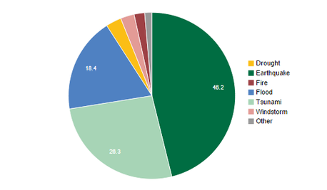

: //tectonicplatesindonesia.weebly.com/impact-of-earthquakestsunamis.html

Literature Review
On 26 December 2004 225,000 inhabitants of Indonesia in Banda Aceh, capital of Aceh province on the Indonesian island of Sumatra, had the first feeling of sensation that something might be amiss or wrong. As the nearest bid to get to and quickly to another city to avoid an epic of the massive undersea earthquake, Banda Aceh felt the vibrations and rumbling of the tremors with more powerful magnitude of a force than any other built-up area.

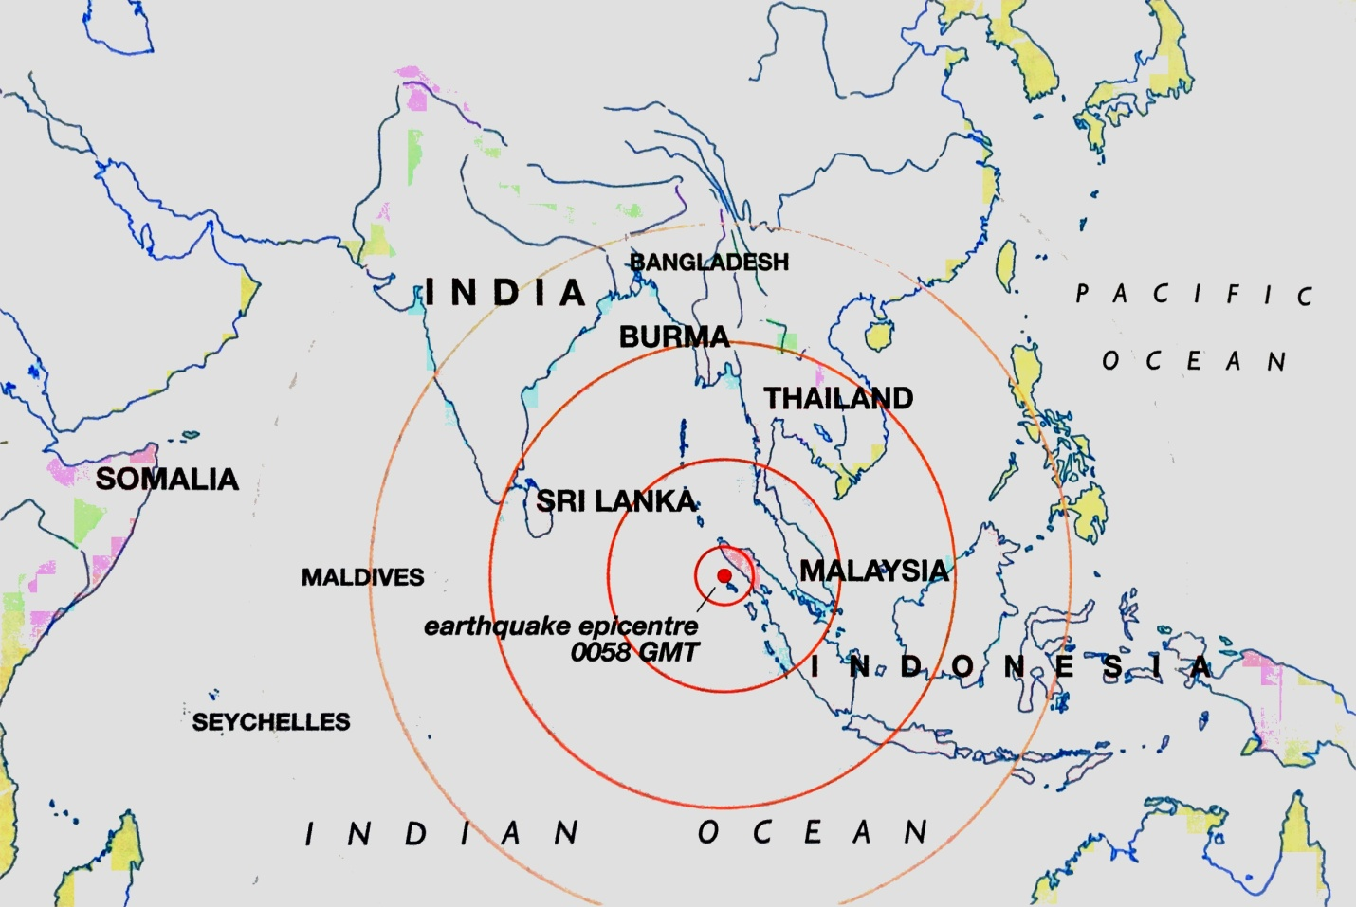

Secondary sources / (Secondary research)

The most deadly tsunami in history was the tsunami in 2004 as it was a powerful earthquake triggered deep in the ocean in a matter of few minutes. Lasting over a total period of seven hours and covering an area of more than 3,000 miles, towns and villages from Sumatra to Somalia were flattened as a giant waves destroyed everything and causing destructions in their path. At least 280,000 people were swept to their deaths; although the final death toll will never be known because of the scores of countless bodies were carried out to sea by the tsunami. Generally speaking so to say it is and may as well be higher than the reported figure. The world was in shock and united in grief in the wake of the most devastating natural disaster in modern recorded history. Many tourists were stranded in stricken regions over the holiday period the tragedy was by no means constricted to the countries thrashed by the tsunami. Nearly all the nations from Canada to China, Belgium to Brazil and Argentina to Australia, have suffered casualties with death toll running in hundreds of thousands. The Indian Ocean tsunami was a global catastrophic disaster. This has forced the nations to rethink and re-evaluate its position on threats posed by tsunamis. Geologists have pinpointed lots of danger zones in the Indian oceans and pacific where tsunami may occur in future. An Atlantic tsunami alone would and can endanger maybe three continents, America, Africa and Europe and most definitely cause widespread destruction, for property, livelihood and people. This may be the most
Extreme tsunami in history anywhere triggered in the world if it is not beaten in the next hundred or more years, but the sense of feeling or laughing it off about this phenomenon have all but vanished.

Survey Questions
What is a tsunami?
- Science fictions books
- Strange occurrences of past centuries
- Things that happened on the other side of the world
- A chain of fast moving waves
A tsunami is a chain of fast moving waves (known as a ‘train’) that are generated when water in the ocean is rapidly displaced by a sudden trauma in the form of an earthquake, a volcanic eruption etc.

When did the most deadly tsunami occur at the turn of Century?
- 2011: Japan
- 2010: Haiti
- 2004: Indian Ocean
- 2001: India
A powerful earthquake deep in the Indian Ocean triggered the deadliest tsunami in history, over a total period of seven hours and an area of more than 3,000 miles.

How many people killed in the Indian Ocean triggered in 2004 by the deadliest tsunami in history?
- Less than 280,000
- 280,000
- More than 280,000
At least 280,000 people were swept to their deaths, although the final death toll will never be known because the countless bodies were carried to sea.

How deadly is an Atlantic tsunami?
- It could wipe out marine life
- It could endanger two continents
- It could endanger three continents and destructions to both people and property
“An Atlantic tsunami alone could Europe, Africa and America, and would almost certainly cause widespread destruction, both to people and property”.

How fast is a tsunami wave?
- Speeds of up to 600mph
- Speeds of around 200mph
- Speeds of over 800mph
“Tsunami wave’s race across the ocean at speed of up to 600mph, they create havoc on reaching land”.

Where did the term tsunami come from?
- Philippines
- China
- Japan
“The term derives from the Japanese for ‘harbour’ (‘tsu’) and ‘wave’ (‘nami’)”.

What is the distance of tsunami wavelengths?
- Excess of 60 miles
- More than 80 miles
Tsunami wavelengths the distance between the wave crests can be in excess of 60 miles-100 kilometres.

Findings / Analysis

From 1920 to 2011 mostly in Asia there has been death toll of 1,817,800 lives lost due to earthquakes or tsunamis with a magnitude ranging from 6.6 around the city of Bam in Iran to highest 9.1 in the Indian ocean, although Haiti had a magnitude of 7.0 they had the most killed of up to 300,000 killed as it was one of the poorest countries in the world. The Indian Ocean was the deadliest in history ever to be recorded or even witnessed by the poor surviving souls. The magnitude of frequency was higher in the turn of 19th century of 8.0’s but as years progressed it was lower of 6.0 magnitudes but turn of the 20th century it started to fluctuate up and down of magnitudes of 7.0 to 9.1.

Japan: 19 thousand killed, tsunami triggered by an undersea quake, 9.0 recorded.

2010: Haiti: 300 thousand killed capital Port-au-Prince. Magnitude 7.0 recorded.

2008: Sichuan province, China: 87 thousand. Magnitude 8.0 recorded.

2005: Kashmir: 75 thousand. Magnitude 7.6 recorded.

2004: Indian Ocean: over 226 thousand deaths, tsunami sparked by an undersea earthquake off Indonesia hit countries around the Indian Ocean. Magnitude 9.1 recorded.

2003: Iran: over 30 thousand killed in and around the city of Bam. 6.6 recorded.

2001: India: 20 thousand killed Gujarat on India's Republic Day holiday. 7.7 recorded.

1990: Iran: 50 thousand dead, quake hits in the northwest of the country, Caspian Sea. 7.4 recorded.

1976: Tangshan, Hebei Province, China: over 242 thousand deaths. 7.8 recorded.

1970: Mount Huascaran, Peru: earthquake and resulting avalanche killed 66,800. 7.5 recorded.

1948: USSR: over 100 thousand deaths in and around Ashgabat in modern-day Turkmenistan. 7.3 recorded.

1939: Erzincan, Turkey: 35-40 thousand killed. 8.0 recorded.

1935: Quetta, India (now Pakistan): more than 50 thousand killed. 7.6 recorded.

1932: Gansu province, China: around 70 thousand 0 died. 8.0 recorded.

1927: Nanshan province, China: up to 200 thousand dead. 8.0 recorded.

1923: Yokohama, Japan: 142 thousand deaths earthquake and fire, destroying Tokyo. 8.2 recorded.

1920: Gansu, north-western China: more than 100 thousand killed. 8.5 recorded.

Number of victims reportedly killed in tsunami

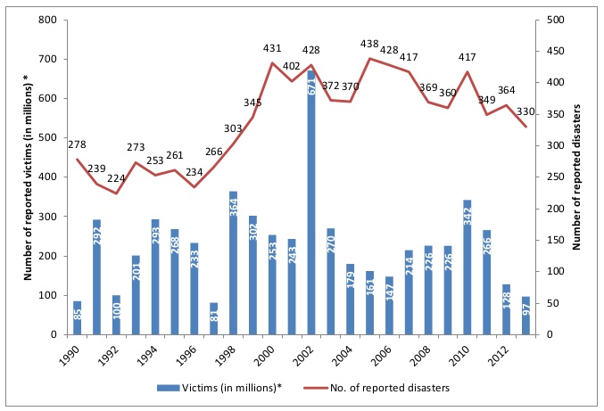

https://watchers.news/2014/09/24/the-statistics-of-natural-disasters-2013-review/

Conclusion/Recommendation

Tsunamis in coming futures

From the unimaginable horror of the 2004 Indian Ocean tsunami, I can say tsunami are caused when the tectonic plates causes a small earthquake when they rub against one another, Whilst undersea earthquakes are difficult to predict, unstable volcanoes invariably offer more tangible warning signs, bubbling and rumbling away for years before finally ready to erupt. When a volcanic eruption coincides with the threat of giant landslip into the ocean the potential for the devastating tsunami is all too clearly stated. Consequently western scientists searching for the next big thing have found it by simply focussing on the island of La Palma in the Canaries.
Situated off the west coast of Africa, the Canary Islands are an archipelago of seven big island and several small islets, all formed by volcanoes on the seabed. The chain of islands formed as the earth’s crust moved across an upwelling of molten rock from deep below the planet’s surface and from the evidence of abundant landslide deposits strewn about their bases, the canary island volcanoes have experienced at least a dozen major collapses.

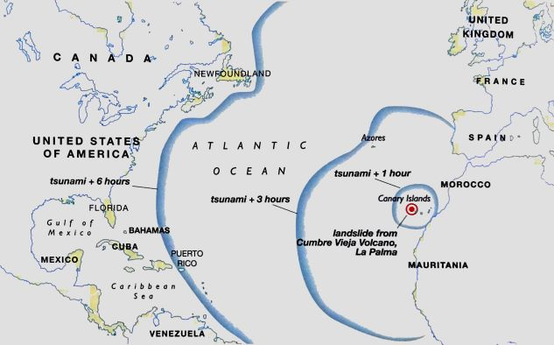
Tsunami Mitigation and Prevention

Strategic Planning at Specific Sites to Reduce Risks of Tsunami

- Avoid Inundation Areas

- Slow Water: Forests, ditches, slopes, or beams can slow down waves and filter out debris.

- Steering: water can be steered to strategically place angled walls, ditches and paved roads.

- Blocking: hardened terraces, beams and parking structures can be built to block waves.

http://courses.washington.edu/larescue/precedents/prevention.htm

Reference

Impact of tsunami
://tectonicplatesindonesia.weebly.com/impact-of-earthquakestsunamis.html

The latest killer tsunami in Indonesia was preceded over the past century by giant waves that also took a heavy toll
https://www.thehindu.com/todays-paper/tp-in-school/deadliest-earthquakes-and-tsunamis-of-the-last-100-years/article4391267.ece

A powerful earthquake (Magnitude 8.0) struck the Solomon Islands archipelago generating small tsunamis
https://www.thehindu.com/todays-paper/tp-in-school/deadliest-earthquakes-and-tsunamis-of-the-last-100-years/article4391267.ece

Number of victims reportedly killed in tsunami
https://watchers.news/2014/09/24/the-statistics-of-natural-disasters-2013-review/

Tsunami Mitigation and Prevention
http://courses.washington.edu/larescue/precedents/prevention.htm

What causes a tsunami?
https://metro.co.uk/2017/09/08/what-is-a-tsunami-how-are-they-caused-and-what-does-it-mean-6912145/

https://www.dummies.com/education/science/what-is-a-tsunami/

