
Digital Surveying

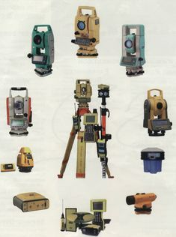

ACBA4002
1904663- Matthew Riddler
Contents Page

Introduction . . . . . . . . . . . . . . . . . . . . . . . . . . . . . . . . . . . . . 1

Part 1 – Brief History of Surveying
  - Ancient Egypt . . . . . . . . . . . . . . . . . . . . . . . . . . . . . . . . . . . . . . 3
  - Ancient Greece . . . . . . . . . . . . . . . . . . . . . . . . . . . . . . . . . . . . . 4
  - Roman Empire . . . . . . . . . . . . . . . . . . . . . . . . . . . . . . . . . . . . . 6
  - Modern Day Era . . . . . . . . . . . . . . . . . . . . . . . . . . . . . . . . . . . . 7

Part 2 – Surveying Listed Buildings . . . . . . . . . . . . . . . . . . . 9

References . . . . . . . . . . . . . . . . . . . . . . . . . . . . . . . . . . . . . . .15

Introduction
‘’A building surveyor is responsible for advising clients about the design, construction, maintenance and repair of buildings. They survey buildings and then report on their findings and make recommendations’’ – Go Construct – 2021.
This essay will give an insight into surveying within the construction industry & how it has developed from the early ages of mankind to the modern-day era. The essay will be presented in two parts, part one giving a brief insight in to the history of surveying including instruments & techniques developed during each era. Part two will describe the application of modern day surveying technologies & how they are used when surveying listed buildings.

Part 1 – Brief History of Surveying
  - Ancient Egypt
Around 1400BC, the ancient Egyptian era is recognised for having the earliest records of surveying. Surveying was used in ancient Egypt to define boundaries for land recording & taxation purposes. One of the first tools used by Egyptian surveyors was a piece of calibrated rope used to measure distance which was treated to prevent it being over stretched or becoming too dry & brittle. An example of the surveying rope used by surveyors known as ‘’rope stretchers’’ is shown in figure 1 below:
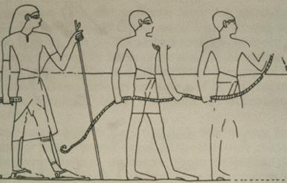
Figure 1 – Egyptian Rope Stretchers – (The Fleece - 2021)

Units of measurement during Egyptian times were derived from the human body. ‘’Cubits’’ used the human arm, ‘’foot’’ used the human foot & ‘’palms/digits’’ used the human hand & fingers. An example of this is shown in figure 2 below:
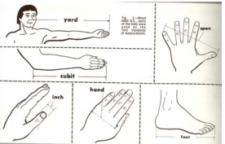
Figure 2 – Units of measurement in ancient Egypt – (Automation Mag – 2021)

  - Ancient Greece
At around 120 BC, ancient Greece or the Hellenistic era were next to move forward with developments in surveying techniques & equipment. Mathematicians & surveyors are known to have visited Egypt to study the techniques developed by the Egyptians with a view to learning their techniques & ways to improve on them. Probably the most famous of mathematicians from the era are Thales & Pythagoras which are shown in figure 3 below.

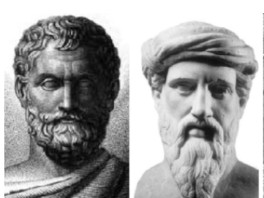
Figure 3- Pythagoras & Thales – (Genicap - 2021)
It is widely documented that they travelled to Egypt to understand their surveying techniques & in particular the application of the geometry aspect to surveying & this was where Pythagoras theorem & trigonometry became a vital aspect of surveying & is still used to this day. The most known surveying tools from this era was the ‘’Dioptra’’ as shown in figure 4 below. The Dioptra was a straight sighting tube with sighting equipment at both ends encompassed within a stand, along with measuring distance it could also be used to measure angles by attaching protractors to the equipment.

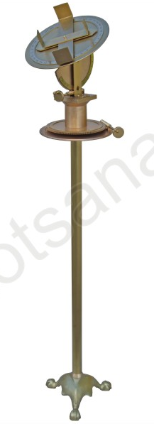
Figure 4 – The Dioptra – (Kotsanas – 2021)

  - Roman Empire
At around 27 BC, The Roman Empire is perhaps the most famous of eras for fully embedding the techniques developed for surveying throughout the ages. A surveying tool developed in the early Roman era was the ‘’Odometer’’ which was used to measure distance & was invented by Vitruvius a Roman engineer & architect. The Odometer would be pushed along the area of land being surveyed & would deposit a stone called a calculus into a container. Each wheel on the odometer was 4 feet in diameter so one full revolution of the wheel would equate to 4 feet. Each full revolution would turn a cogwheel which compromised of 400 teeth one rotation, once the 400th tooth had been rotated this would equate to one mile distance. An example of the Odometer is shown in figure 5 below:

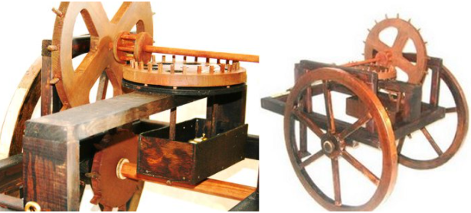
Figure 5 – The Odometer – (Ancient Pages - 2021)

Another commonly used surveying tool developed during the Roman Empire was the ‘‘Groma’’. The Groma consisted of a vertical staff located in the centre & incorporated four horizontal pieces branching out. Attached to the outer edge of each horizontal piece was a plumb line. The Groma was generally used to measure right angles & straight lines. An example of a Groma is shown in figure 6 below.

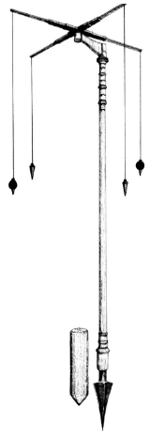
Figure 6 – The Groma – (Medium - 2021)

  - Modern Day Era
Though the early surveying methods & techniques have been superseded during more recent times, the key principles still resonate in the modern-day era & the equipment used have been developed towards the natural progression of digitisation & has accelerated significantly in recent years due to great advances in digital technology with surveying equipment & the construction industry alike. An example of a modern-day digital tool used for measuring distance is a laser measure. The laser measure has replaced the traditional measuring tape or measuring wheel. The device is simply placed towards the intended area of measure & an optical low energy laser is beamed across to the target, once set in the correct place the device measures the length of the beam & records the measurement. An example of a laser measure is shown in figure 7 below.

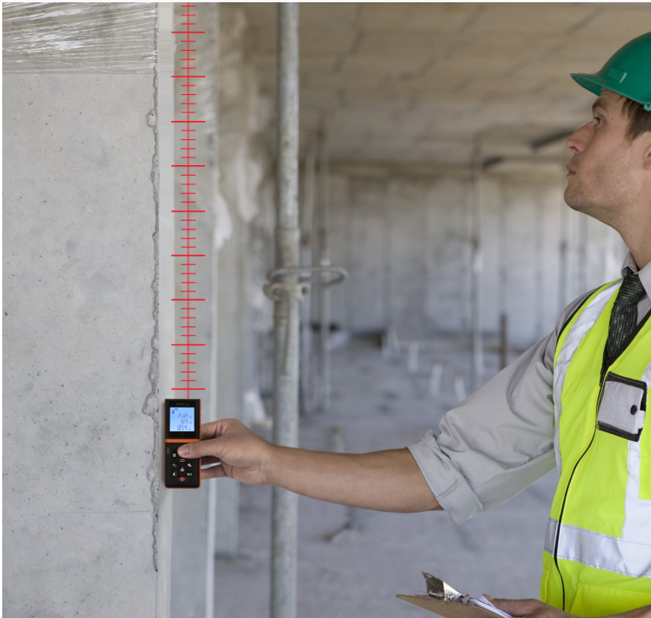
Figure 7 – Laser Measure – (Architecture Lab - 2021)

Laser measures can measure up to 600 feet & are accurate to within 3 millimetres. They are favoured from the more conventional measuring tools due their efficiency & negate inaccuracies such as tape sag or drift, especially over long distances. Laser measures also make it easier to measure high ceilings or areas which are difficult to access manually.

Part 2 - Digital Surveying Technologies for Listed Buildings
Part two will cover the digital technologies used when surveying listed buildings & their requirement to be non-intrusive due to the sensitive nature of the buildings & structures they are surveying. The key information collected from the survey will also be highlighted.

‘’A listed building is a building (or structure) that has been designated as being of special architectural or historic significance. The older and rarer a building is, the more likely it is to be designated. Buildings less than 30 years old are listed only if they are of outstanding quality and under threat. Structures can occasionally be designated as both a listed building and as a scheduled monument. A designation may comprise several separate buildings/structures (items) such as formal residential terraces. A survey should be completed for either the entire designation or an individual item/s within the designation (e.g., individual terrace houses).’’ – Wilson 2021

Thermal Camera
A thermal camera utilises infrared technology to determine the different ranges of temperature within a building, this is a key tool used for surveying listed buildings & can highlight the following information:

- Air leaks
- Moisture Leaks
- Structural damage
- Faults
- Nesting animals

An example of a thermal camera in use is shown in figure 8 below:
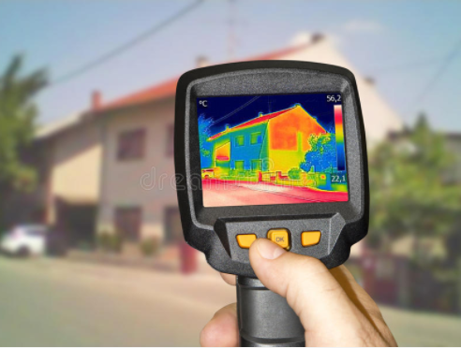
Figure 8 – Thermal Camera – (Dreamstime - 2021)
Moisture Meter
Moisture is one of the primary contributors to issues in buildings & structures, and this issue is exasperated in listed buildings due to their general age & degradation in most cases. It is crucial to accurately survey the extent of any material or structural damage due to damp or leakage. The moisture meter or protimeter is generally used for wooden material & caution must be used when surveying concrete & masonry as the results can sometimes be inaccurate. The two most common designs of moisture meter are pinned & non pinned & are shown in figure 13 below:

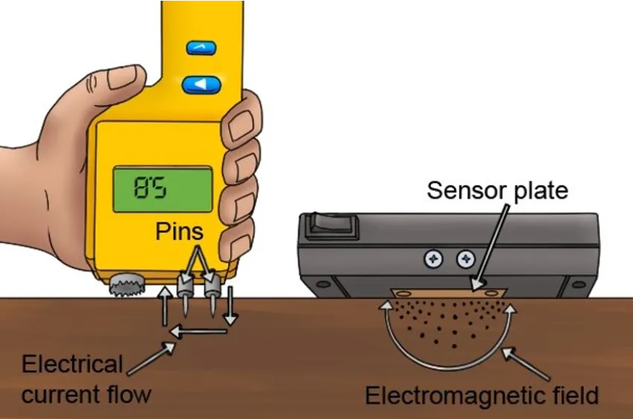
Figure 9 – Two types of protimeter (Green Building Advisor- 2021)

When carrying out a survey on a listed building, the following information should be obtained from the initial assessment as a guide:

General Building condition
An assessment of the key components of the building should be carried out to determine their condition & should be categorised as: Good, Fair, Very Bad or Not Visible. The following parts of a building are classed as key components:

- Roofs: Assess for broken or missing tiles, defective leadwork, or water leaks & rotting internally.
- Rainwater Drainage: Assess for blockages from plant growth, broken or disconnected guttering, leakage from downpipes.
- Walls: Assess for broken brickwork, loose pointing, vegetation growth.
- Structure: Assess for any structural defects or significant cracks in the walls.
- Windows & Doors: Assess for decayed framework, cracked or broken glass.
- Architecture: Assess for loss of architectural detail through decay or erosion.
- Interior Condition: Assess for water ingress or visual damage.
- Walls & Ironmongery: Assess for flaking paintwork, rotting wood or severe rust damage.

The categorisation for each condition is shown in figure 10 below:

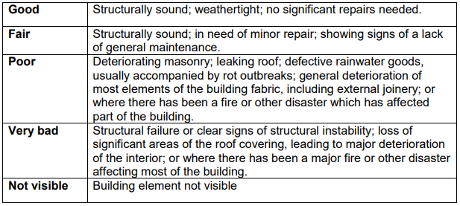
Figure 10 – Building Condition Categories – (English Heritage – 2021)

Overall Condition
With the evidence gathered from the general building condition, the overall condition should then be categorised again as Good, Fair, Very Bad or Not Visible.

Occupancy
Note whether the building is occupied, partially occupied or vacant.

Site Visit Details
The date of any visits should be noted in the following format DD/MM/YYYY

Photographs
Any relevant photos should be taken during the site visit & labelled accordingly i.e., Front Elevation, Street view etc. Photographs should be in a high resolution & also have the appropriate labels attached.

If the overall condition of the building is deemed as Good or Fair, an initial assessment will be sufficient & can be sent to a moderator for review. If the condition is deemed as poor or very bad, the building surveyor must carry out a full assessment, which compromises of the following:

Owner Type: This is the person or organisation that currently owns the building & has responsibility for it. The owner would be categorised as one of the following as shown in figure 11 below:

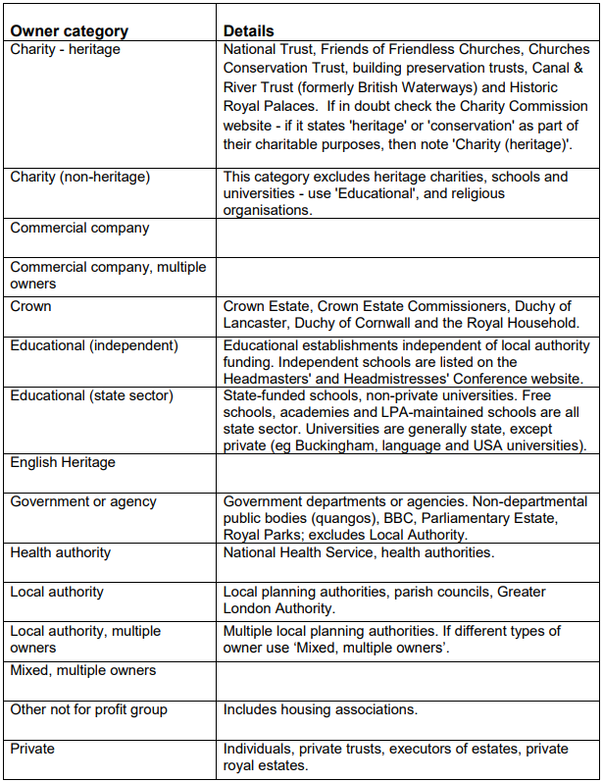
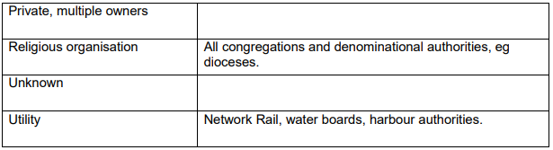
Figure 11 – Property Owner Categories (English Heritage – 2021)

Building Trend
Assess what is expected to happen to the building based on information gathered from knowledge & buildings of similar stature in the local area.

Surveyor’s Report
The report would include any relevant information on the condition of the building which has been carried out from the initial assessment.

Once both reports have been compiled, the moderator will assess them & make any suggested amendments to be completed. Once complete an overall risk assessment will be carried out for the building using the following scoring matrix based on occupancy, as shown in figure 12 below:

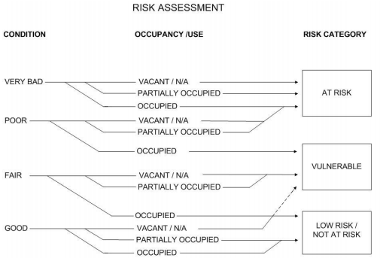
Figure 12 – Building Risk Assessment - (English Heritage – 2021)

If the risk assessment is low, the there is no further action required. If its deemed ‘at risk’ the moderator will assign it a priority category as shown in figure 13 below:

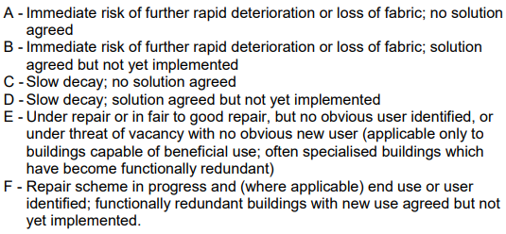

Figure 13 – Building Priority Category - (English Heritage – 2021)

References
Cover Picture – Evolution of Surveying Equipment
Available on: https://www.pinterest.com/massonassoc/the-evolution-of-survey-equipment-unusual-survey-l/
Accessed on 29/03/2021

Surveying definition
Available online: https://www.goconstruct.org/construction-careers/what-jobs-are-right-for-me/building-surveyor/
Accessed on - 29/03/2021

Figure 1 – Egyptian Rope Stretchers
Available online: http://www.thefleece.org/geometry.html
Accessed on- 29/03/2021

Figure 2 – Units of measurement in Egypt
Available online: https://www.automationmag.com/images/stories/LWTech-files/06%20Measurement%20History.pdf
Accessed on - 29/03/2021

Figure 3 – Pythagoras & Thales
Available online: https://www.genicap.com/science/a-history-of-geometry/thales-pythagoras-euclides-archimedes/
Accessed on - 29/03/2021

Figure 4 – The Dioptra
Available online: http://kotsanas.com/gb/exh.php?exhibit=1301002
Accessed on - 29/03/2021

Figure 5 – The Odometer
Available Online: https://www.ancientpages.com/2016/01/24/first-odometer-was-invented-by-vitruvius-around-15-bc/
Accessed on - 29/03/2021

Figure 6 – The Groma
Available Online: https://medium.com/the-infinite-universe/from-ancient-egypt-to-gauge-theory-the-story-of-the-groma-72869d764b40
Accessed on - 29/03/2021

Figure 7 – Laser Measure
Available Online: https://www.architecturelab.net/best-laser-measuring-tool/
Accessed on - 29/03/2021

Listed building Quote – Kate Wilson. English Heritage Methodology & Guidance For Surveying Listed Buildings.
Available Online: https://www.york.ac.uk/media/archaeology/documents/researchpages/English%20Heritage%20Methodology%20and%20Guidance%20for%20Surveying%20Listed%20Buildings.pdf
Accessed on - 29/03/2021

Figure 8 – Thermal Camera
Available Online: https://www.dreamstime.com/photos-images/thermal-camera.html
Accessed on - 29/03/2021

Figure 9 – Two Types of Protimeter
Available Online: https://www.wonkeedonkeetools.co.uk/moisture-meters/how-does-a-pinless-moisture-meter-work
Accessed on - 29/03/2021

Figure 10 – Building Condition Categories
Available Online: https://www.york.ac.uk/media/archaeology/documents/researchpages/English%20Heritage%20Methodology%20and%20Guidance%20for%20Surveying%20Listed%20Buildings.pdf
Accessed on - 29/03/2021

Figure 11 – Property Owner Categories
Available Online: https://www.york.ac.uk/media/archaeology/documents/researchpages/English%20Heritage%20Methodology%20and%20Guidance%20for%20Surveying%20Listed%20Buildings.pdf
Accessed on - 29/03/2021

Figure 12 – Building Risk Assessment
Available Online: https://www.york.ac.uk/media/archaeology/documents/researchpages/English%20Heritage%20Methodology%20and%20Guidance%20for%20Surveying%20Listed%20Buildings.pdf
Accessed on - 29/03/2021

Figure 13 – Building Priority Category
Available Online: https://www.york.ac.uk/media/archaeology/documents/researchpages/English%20Heritage%20Methodology%20and%20Guidance%20for%20Surveying%20Listed%20Buildings.pdf
Accessed on - 29/03/2021

