The Impact of the Welsh Urban–Rural Divide on Health: A Policy Analysis

Rural communities in Wales are facing substantial barriers that make it difficult for them to access healthcare services because of the urban-rural divide in the country, which plays a significant role in determining their health outcomes. As evidence indicates, geographical isolation, the shortage of skilled workers, as well as technological exclusion are all contributing factors to persisting health inequalities in our society (Woods et al., 2021; Hill et al., 2023). Based on this analysis of the impact of these disparities in rural and urban Wales, and incorporating evidence-based recommendations, this policy brief aims to bridge the health gap between urban and rural Wales, ensuring equitable access to healthcare for all citizens regardless of their location.

Introduction: The Welsh Context and Research Focus
Health care delivery in Wales is influenced by distinct geographical and demographic features. A sustained growth in employment and higher education has led to sustained growth in southern urban areas like Cardiff, Newport, and Swansea. The population of many rural counties has stagnated or declined since young adults have moved to cities for work and education (Roskams, 2022). Population shifts reduce working-age residents available and increase pressure on aging rural populations.
Several challenges face rural areas, including:
- Hospitals, emergency rooms, and doctors' surgeries are farther away.
- Service availability is reduced after hours.
- Healthcare professionals are fewer, resulting in long waits.
- Especially among older adults, higher levels of social isolation.
- Public transport restricted, limiting routine appointments.
Large parts of rural Wales are sparsely populated, as illustrated by the population density figure included in this section. Healthcare services become more expensive and complex when population density is low, leading to inequalities. This figure comes from State of Wales, 2023.
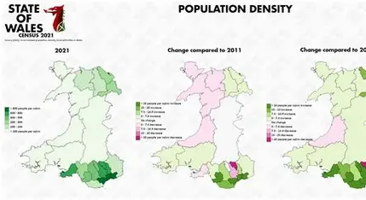
https://stateofwales.com/wp-content/uploads/2023/03/population-density.jpg
Rural-urban health disparities refer to persistent differences in access, quality, and availability of healthcare services. Rural workforce shortages, reduced transport links, and digital exclusion are contributing factors to this divide in Wales. As a result, there are measurable disparities in preventive care, access to treatment, and long-term outcomes (Johns et al., 2023). The travel time to GP practices, pharmacies, diagnostic centres, and emergency departments is often longer in rural communities. For example, Powys residents must travel over an hour to reach the nearest district general hospital, which may delay care and increase complications related to untreated conditions. Barriers affect both physical and mental health, especially for older adults and people with chronic illnesses.
Mental health outcomes in rural areas may be worsened by social isolation, contributing to anxiety and depression (Hughes, 2023). In addition to these factors, the COVID-19 pandemic and the ongoing cost-of-living crisis have exacerbated existing health disparities by causing them to be even greater (Hill et al., 2023).
The purpose of this policy brief is to provide an answer to an important question:
What evidence-based policy interventions could be most effective in reducing healthcare disparities among Welsh urban and rural residents?
Considering current evidence and policy frameworks, this brief provides recommendations for achieving health equity in Wales by analyzing the available evidence.
Comprehensive Analysis of Health Disparities

Access to Primary and Secondary Care

The geographical distribution of healthcare services in Wales creates significant barriers to rural residents being able to access these services. There are some areas of mid-Wales where the distance between GP surgeries, pharmacies, and hospitals can exceed one hour, which affects health-seeking behaviour and outcomes both directly and indirectly (Plant, 2023). Across Wales, waiting times for specialist treatments are increasing because of these challenges.
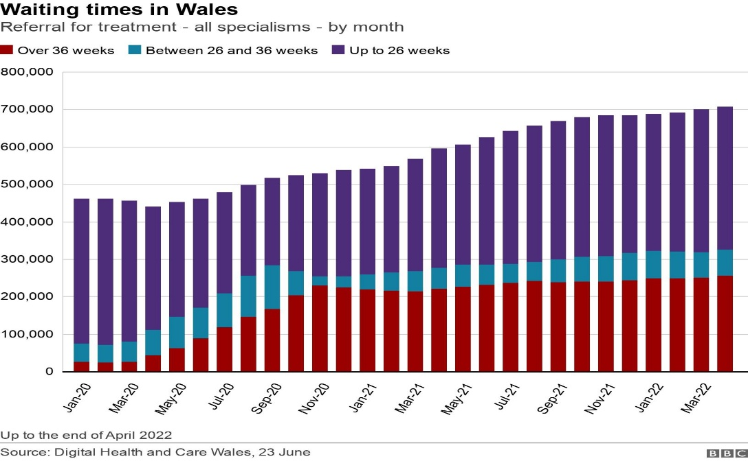
https://ichef.bbci.co.uk/news/1632/idt2/idt2/89d4f0f8-0639-4fe3-92b3-465fd6e5a4ed/image/816

In addition to these challenges, the interplay between health care and social services further exacerbates them. It is widely recognized that rural social care pressures, including limited domiciliary care provision, are important contributors to delays in hospital discharges, which in turn lead to bottlenecks occurring throughout the entire healthcare system (Hughes, 2023). Consequently, this creates a cyclical pattern in which delayed access leads to poorer health outcomes, which in turn increases the demand for acute care services, which are already stretched beyond their capacity because of this delay in access.

Workforce Shortages and Capacity Constraints
Many of the following factors contribute to the challenges in attracting and retaining healthcare professionals in rural Wales, which include professional isolation, limited career advancement opportunities as well as a lack of training and educational facilities (Royce, 2022). Insufficient attention has been paid to rural-specific challenges in "A Healthier Wales", resulting in ongoing capacity constraints and service gaps.
A workforce modelling study conducted by NHS Wales shows that if targeted interventions are not implemented, rural staffing challenges will intensify, further compromising access and quality of healthcare in the rural areas (Luis et al, 2025). Having said that, this trend is consistent with the global evidence indicating that workforce instability in rural regions strongly correlates with poorer long-term health outcomes overall (Wiese et al., 2023). Despite the Welsh context's devolved powers and geographical diversity, Alderwick and Charlesworth's (2022) research on English NHS workforce planning provides valuable comparisons.
Emergency Care Inequalities
Among the starkest examples of the urban-rural health divide can be found in the provision of emergency care. There are significant geographical challenges impacting emergency outcomes in rural counties, where Welsh Ambulance Services NHS Trust fails to meet national response time targets (WAST, 2023). Because of the mountainous terrain, narrow roads, and significant distances between the communities, situations requiring immediate intervention such as cardiac arrest, stroke, or major trauma can be delayed for days, even weeks, before they can be treated.
In a study conducted by Hunt et al. (2023), it has been shown that ambulance staff in rural areas are faced with increased workload pressures, elevated levels of fatigue, and a greater variability in emergency demand than their counterparts in urban areas. Geographic barriers and operational challenges combine to make rural residents more at risk of avoidable mortality. Despite the importance of these disparities in health, research shows that health inequalities have a significant economic impact on the NHS, with substantial costs incurred because of health inequalities (Kadel et al, 2022).

Digital Exclusion and Telehealth Barriers
The rapid expansion of digital healthcare services across NHS Wales risks exacerbating existing inequalities if not implemented with careful consideration of rural challenges. While digital healthcare offers potential efficiency gains and improved access in some contexts, its benefits are unevenly distributed (Johns et al., 2023). Rural Wales experiences significantly lower broadband speeds and reliability, reducing the feasibility of video consultations and limiting access to increasingly digital-first services.
Digital exclusion affects not only direct healthcare access but also health literacy, as online resources and self-management tools become less accessible to those with limited digital skills or connectivity. The research by Azam et al. (2025) on uncertainty modelling in under-represented languages has relevance for Welsh-speaking rural communities, where language barriers may compound digital exclusion challenges. This intersection of linguistic and digital marginalisation requires specific attention in policy development.

Environmental and Structural Determinants
In rural Wales, environmental factors have a significant impact on health outcomes. In a study, it has been shown that temperature-related mortality varies significantly across different regions of the country, with rural areas more vulnerable because their housing stock has gotten older, their energy efficiency has deteriorated, and they have limited access to energy-efficient programs (Gasparrini et al., 2022). The effects of these environmental challenges on rural residents are compounded when they are coupled with the limitations of health care services.
These inequalities are further exacerbated by structural determinants. While rural areas may be underserved by funding formulas due to rural poverty, but they are often adversely affected by centralized service planning due to their remote location (Mohammed et al., 2025). Using the research by Harrington et al. (2022) regarding the development of a distinctive Welsh health law, it is highlighted that the development of legal frameworks that specifically address these structural challenges will help to ensure that rural needs are adequately represented in health policy and funding allocations.

Mental Health and Social Wellbeing
In rural Wales, the determinants of mental health outcomes range from physical isolation and limited access to psychological services, to the decline of the community infrastructure in rural areas. Banks, libraries, and post offices are some of the local services that have been closed, reducing the opportunity for older adults and vulnerable groups to meet and communicate (Nolan-Isles et al., 2021).
Although access to green space is associated with psychological benefits (Geary et al., 2023) it cannot compensate for the lack of mental health care professionals and social infrastructure. The inaccessibility of mainstream support services in geographically isolated areas worsens anxiety, depression, and stress-related illnesses. It is important to take into account the comparative research conducted by Kendzior (2024) on healthcare access barriers in post-repeal Ireland in order to provide valuable insights into addressing service gaps in rural communities; however, the Welsh context requires particular consideration of the devolved powers and existing policy frameworks.

Policy Framework and Legislative Context
There is no doubt that Wales possesses a distinctive legislative landscape that makes it possible to address rural health inequities on a solid foundation. Even though the Well-being of Future Generations Act offers a comprehensive framework for promoting health equity, its implementation has not been consistent in the implementation of measures related to rural-specific challenges (Howe and Nutbeam, 2023). In the absence of explicit rural health planning, rural needs may be buried under the weight of system-level priorities, which are often favoured by more populated areas in rural areas.
Research conducted by Knight and Crick (2022) on inclusive education policies in Wales provides valuable lessons that can be applied to developing inclusive health policies that take geographical and linguistic diversity into account when developing health care policies. Additionally, it is valuable to note that the analysis of Aboriginal healthcare access in New South Wales carried out by Nolan-Isles et al. (2021) provides some transferable findings regarding culturally sensitive and geographically appropriate service delivery, although some adaptations would need to be made for the Welsh context.
Evidence-Based Recommendations
As a result of a comprehensive analysis of the evidence, the following recommendations are proposed to address rural health inequalities in Wales:
- Develop a National Rural Health Equity Strategy
As part of this plan, a dedicated strategy must be developed in accordance with the Well-being of Future Generations Act, setting measurable targets for the reduction of rural health disparities. The purpose of this strategy is to guide investment, workforce planning, and service redesign, to meet the specific needs of rural communities (Woods et al., 2021). It should incorporate successful elements of international rural health models but should take into consideration Welsh specificities.
- Expand Rural Emergency Care Capacity
The first step to addressing critical response time disparities is by investing in targeted interventions such as rapid response vehicles, satellite ambulance hubs, and enhanced roles for paramedics within communities (Hunt et al., 2023) to improve the situation. A strategic deployment should be planned based on current response time data and population needs.
- Improve Rural Digital Infrastructure Implementation
As part of NHS Wales’s digital initiatives, it is imperative that they are accompanied by a comprehensive broadband expansion, device support programs, and digital literacy training tailored specifically for rural and older populations (Johns et al., 2023). There should be a special focus on Welsh-language digital resources as well as accessibility for those who have limited digital skills as well.
- Introduce Comprehensive Rural Workforce Schemes
Providing targeted packages of financial incentives, subsidised housing, rural clinical rotations, and clear progression pathways is one approach to reducing recruitment and retention challenges in rural clinics (Royce, 2022; Luis et al., 2025). Specifically tailored for the Welsh rural context, they should consider professional development needs and considerations as to work-life balance to achieve a better quality of life.
- Establish Integrated Community Health Hubs
The creation of consolidated facilities where general practitioners, diagnostic specialists, mental health professionals, and social workers can be combined to reduce travel requirements and improve early intervention capabilities (Nolan-Isles et al., 2021). Adaptable to rural communities of varied sizes and needs, with a particular focus on Welsh-speaking communities.
- Enhance Rural Mental Health Support Systems
A community-based mental health initiative should be invested in including social connectors, befriending schemes, and local wellbeing programs to eliminate isolation and improve access to psychological support for people (Geary et al., 2023). The development of these projects should be integrated with the existing assets of the community and designed with the input of the local population.
Conclusion
There is no doubt that the urban-rural divide continues to have an important bearing on health outcomes in Wales, as the evidence clearly shows. Aged adults, low-income households, and isolated populations are disproportionately affected by geographic barriers, workforce shortages, digital exclusion, and infrastructure limitations.
Although Wales has strong legislation to promote health equity, most notably the Well-being of Future Generations Act, there is no dedicated rural health strategy, thus many structural inequalities remain. Implementing evidence-based recommendations that focus on emergency care, digital inclusion, workforce support, and community-based care would represent considerable progress in achieving health equity when implemented in a systematic manner.
There has never been a better time to take concerted action than now. A strategic and adequately resourced focus on rural health can transform Wales’s current paradigm of geographical health inequality into one of equitable healthcare access. In addition to fulfilling ethical obligations, this would also be economically prudent, as it would reduce the long-term costs associated with health inequalities for both the NHS and society (Kadel et al., 2022).

References

Alderwick, Hugh, and Anita Charlesworth. "A long-term workforce plan for the English NHS." bmj 377 (2022). https://doi.org/10.1136/bmj.o1047
Azam, U., Razzak, I., Vishwakarma, S. and Jameel, S., 2025, January. Uncertainty Modelling in Under-Represented Languages with Bayesian Deep Gaussian Processes. In Proceedings of the 31st International Conference on Computational Linguistics (pp. 1438-1450). https://aclanthology.org/2025.coling-main.96/
Gasparrini, A., Masselot, P., Scortichini, M., Schneider, R., Mistry, M.N., Sera, F., Macintyre, H.L., Phalkey, R. and Vicedo-Cabrera, A.M., 2022. Small-area assessment of temperature-related mortality risks in England and Wales: a case time series analysis. The Lancet Planetary Health, 6(7), pp. e557-e564. https://doi.org/10.1016/S2542-5196(22)00138-3
Geary, R.S., Thompson, D., Mizen, A., Akbari, A., Garrett, J.K., Rowney, F.M., Watkins, A., Lyons, R.A., Stratton, G., Lovell, R. and Nieuwenhuijsen, M., 2023. Ambient greenness, access to local green spaces, and subsequent mental health: a 10-year longitudinal dynamic panel study of 2· 3 million adults in Wales. The Lancet planetary health, 7(10), pp. e809-e818. https://doi.org/10.1016/S2542-5196(23)00212-7
Harrington, J., Hughes-Moore, B. and Thomas, E., 2022. Towards a Welsh health law: devolution, divergence, and values. N. Ir. Legal Q., 73, p.385.
Hill, R., Hughes, K., Cresswell, K., Ford, K. and Bellis, M., 2023. The rising cost of living and health and wellbeing in Wales: a national survey. Public Health Wales.
Howe, S. and Nutbeam, D., 2023. Interview with inaugural Future Generations Commissioner for Wales, Sophie Howe: embedding a wellbeing approach in government. Public Health Research and Practice, 33(2), p.e3322314. https://doi.org/10.17061/phrp3322314
Hughes, D., 2023. Challenges facing social care and the impact on the NHS in Wales. Nursing And Residential Care, 25(3), pp.1-5. https://doi.org/10.12968/nrec.2023.0012
Hunt, J., Gammon, J., Williams, S., Holland, P., Tham, T.L. and Humphreys, I., 2023. Contemporary portrait of the working lives of ambulance services staff in Wales. Journal of Paramedic Practice, 15(8), pp.315-321. https://doi.org/10.12968/jpar.2023.15.8.315
Johns, G., Whistance, B., Burhouse, A., Khalil, S., Whistance, M., Ahuja, S., Ogonovsky, M. and Ahuja, A., 2023. Benefits, challenges, and sustainability of digital healthcare for NHS Wales: a qualitative study. BMJ open, 13(5), p.e069371. https://doi.org/10.1136/bmjopen-2022-069371
Kadel, R., Allen, J., Darlington, O., Masters, R., Collins, B., Charles, J.M., Asaria, M., Dyakova, M., Bellis, M. and Cookson, R., 2022. Cost of health inequality to the NHS in Wales. Frontiers in public health, 10, p.959283. https://doi.org/10.3389/fpubh.2022.959283
Kendzior, A.M., (2024) Remaining Barriers to Abortion Access in Post-Repeal Ireland. Creighton Int'l & Comp. LJ, 15, p.1.
Knight, C. and Crick, T., 2022. Inclusive education in Wales: Interpreting discourses of values and practice using critical policy analysis. ECNU Review of Education, 5(2), pp.258-283. https://doi.org/10.1177/20965311211039858
Luis, M., Harper, A., Monks, T. and Mustafee, N., STRATEGIC WORKFORCE MODELLING AND ANALYSIS AT NHS WALES: TOWARDS A STRATEGIC DIGITAL TWIN OF THE WELSH HEALTHCARE WORKFORCE. https://doi.org/10.36819/SW25.035
Mohammed, S., Bailey, G.A., Farr, I.W., Jones, C., Rawlings, A., Rees, S., Scully, S., Wang, T., and Evans, H.T., 2025. Using the Welsh Index of Multiple Deprivation in research: estimating the effect of excluding domains on a routine health data study. BMC Public Health, 25(1), p.1178. https://doi.org/10.1186/s12889-025-22369-0
Nolan-Isles, D., Macniven, R., Hunter, K., Gwynn, J., Lincoln, M., Moir, R., Dimitropoulos, Y., Taylor, D., Agius, T., Finlayson, H. and Martin, R., 2021. Enablers and barriers to accessing healthcare services for Aboriginal people in New South Wales, Australia. International journal of environmental research and public health, 18(6), p.3014. https://doi.org/10.3390/ijerph18063014
Plant, M., 2023. Wales. In Rural Healthcare (pp. 30-33). CRC Press.
Roskams, M., 2022. Population and household estimates, England, and Wales: Census 2021. Office for National Statistics.
Royce, R., 2022. Is A healthier Wales: our workforce strategy for health and social care actually a strategy? British Journal of Healthcare Management, 28(10), pp.1-6. https://doi.org/10.12968/bjhc.2021.0058
Royce, R., 2022. Is A healthier Wales: Our workforce strategy for health and social care a strategy? British Journal of Healthcare Management, 28(10), pp.1-6.
Wiese, L.A.K., Gibson, A., Guest, M.A., Nelson, A.R., Weaver, R., Gupta, A., Carmichael, O., Lewis, J.P., Lindauer, A., Loi, S. and Peterson, R., 2023. Global rural health disparities in Alzheimer's disease and related dementias: state of the science. Alzheimer's & Dementia, 19(9), pp.4204-4225.
Woods, M., Heley, J., Goodwin-Hawkins, B. and Howells, H., 2021. A rural vision for Wales: The evidence report.

