Module: Quality Assurance and Service Improvements

Module code: LCHS7006

Component 2: Service Improvement Report

Name of the student:Patel Vidhi
Student ID:2523554

Table of Contents
1.0 Introduction 3
2.0 Main Body 5
2.1 Rationale for their selection 5
2.2 Critical evaluation of relevant theories 5
2.3 Way these frameworks help analyse the root causes of the identified issue and guide the development of effective, evidence-based recommendations 9
3.0 Recommendation 10
3.1 PDSA (Plan-Do-Study-Act) 10
3.2 PDCA (Plan-Do-Check-Act) 11
3.3 Lean 11
3.4 Six Sigma 12
4.0 Conclusion 14
References 15

1.0 Introduction
Quality of healthcare is an essential element of good health and social care as it is vital to ensuring that services are safe, clinically effective, responsive, equitable and have the potential to achieve positive outcomes for patients. In the field of maternity care, where poor assessment, monitoring, communication and escalation can quickly lead to irreversible and devastating effects on mothers and babies, quality is a key aspect. Quality assurance is not simply about meeting standards, it's about having good governance, competent staff, reliable clinical processes, and monitoring systems, and processes for identifying and correcting problems. Continuous Quality Improvement (CQI) further extends this responsibility by enabling organisations to constantly and systematically review performance, learn from adverse events and continually test performance improvements. These principles are illustrated by the maternity failures at Shrewsbury and Telford Hospital NHS Trust (SaTH) - the case study for this report.
The independent Ockenden Review sets out plenty of evidence that the issue within SaTH was not just a clinical issue but rather an ongoing organisational quality and patient safety issue. The review included 1,486 families, of which the majority were from 2000 to 2019, and 1,592 clinical incidents. 9 maternal deaths (75%) reviewed had significant or major concerns with the care provided (Vettriselvan et al., 2025). Additionally, there were 498 stillbirths examined, of which 26.3% were found to have significant or major concerns in care (where appropriate, this could have led to a different outcome). The findings suggest some failures that go beyond the individual clinical decision, and highlight areas of potential weakness in clinical governance, communication, escalation, investigation, leadership and organisation learning. Thus, the case offers valuable insights into how organizational weaknesses can combine and lead to a situation in which harm to patients can occur if it is not prevented.
The concern is also important as problems identified at SaTH are not only historic. The quality issue around maternity safety remains a significant problem in England. A national review of maternity services showed that none of the services inspected rated as outstanding for safety; 47% of services inspected were rated as requiring improvement and 18% of services inspected were rated as inadequate. The review also highlighted concerns across the board about the responses of maternity services to patient safety events and learning from these events. This implies that the identified organizational issues in the SaTH case (including inefficient learning, gaps in processes and poor safety culture) are still relevant to modern healthcare management.
Based on this, this report is a critical analysis of the problem of failure of maternity quality of SaTH using Fishbone Diagram, Donabedian Model and SWOT analysis. These methods are employed to identify failures that relate to immediate clinical issues versus deeper structural/organisational issues. The analysis subsequently guides to evidence based recommendations through the use of PDSA, PDCA, Lean and Six Sigma to create a practical and measurable service- improvement strategy. The aim is to illustrate how healthcare organisations can shift from reacting to harm, to independently managing quality, learning and continuous improvement of patient safety.

Fig 1: News on the issue
Source: (BBC News, 2022)

2.0 Main Body

2.1 Rationale for their selection
It is appropriate for a systems-based approach to analyse the maternity failures at Shrewsbury and Telford Hospital NHS Trust as the Ockenden Review identified that the harm suffered by patients came about as a result of a series of interconnected weaknesses, not just one clinical error. The Fishbone Diagram is of particular relevance as it allows quality improvement teams to label and look at various contributing factors that lead to an undesirable result and to help differentiate between a symptom and a root cause (Ahmed and Tamim, 2025). For this, the key factors can be classified as people, processes, leadership, governance, communication and organisational culture. Staff capability was compromised by inadequate training and supervision; and fetal monitoring, delayed escalation and inconsistent documentation were a weakness in clinical processes. At organisational level, leadership and governance at times were not effective enough and concerns and incidents from the past were not always followed through with appropriate action. The risk was compounded by the fact that there were communication challenges among the professional groups that allowed for a lack of early detection and response to deterioration (Cui et al., 2025). The Fishbone approach is useful as it avoids the blame that usually falls on a single clinician and instead identifies multiple deficiencies that may compound to create unsafe results.

2.2 Critical evaluation of relevant theories
Fishbone Diagram
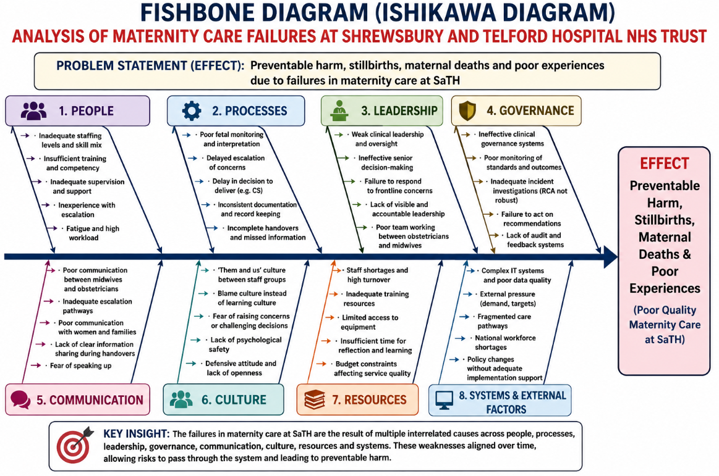
Fig 2: Fishbone Diagram
Source: (Self-Developed)
The Fishbone Diagram shows that a series of interrelated, organisational and clinical issues led to the maternity failures at Shrewsbury and Telford Hospital NHS Trust and were not a single error. The people-related factors revealed deficiencies in staffing, competence in training, supervision and escalation that decreased professionals' capacity to identify and respond to the deterioration of mothers and babies (World Health Organization, 2025). Neither the quality of clinical care, nor the reliability of such care was unimpeachably affected by process failures such as inadequate fetal monitoring, failure to escalate or failure to document and complete handovers. Leadership and governance failures further exacerbated these weaknesses, as lack of oversight, weak accountability, poor incident investigation and lack of learning further enabled unsafe practices. Midwives and obstetricians did not communicate effectively, and there were additional issues of failure to recognise and act on concerns promptly by midwives and families. The diagram also identifies a culture of fear and/or a defensive culture within the organisation and a lack of psychological safety, which reduced the ability to learn from incidents (Serchen et al., 2025). At the same time, resource pressures such as staffing, training and workload challenges affected the organisation's ability to be consistently safe in its provision of care and were exacerbated by broader system and external pressures. Importantly, these causes worked together – workload could be exacerbated by staffing pressures, which could lead to poor communication and monitoring, or poor leadership and governance could prevent these issues from being identified and addressed.
Donabedian Model
Structure
Structure: Organisational conditions and resources available to provide health services, such as staffing, leadership, training, facilities, governance systems and policies (NHS England, 2026b). The structural shortcomings identified in the case of SaTH were insufficient staffing and training, poor leadership, poor clinical governance, and inadequate organisational oversight. These vulnerabilities would provide a space in which health workers were not always backed to deliver safe and effective maternal health services (World Health Organization, 2025). Poor governance and leadership were recognised as a key driver of continued unsafe practices in the Ockenden Review.
Process
Process is about what healthcare professionals do when caring for people in relation to assessment, monitoring, communication, clinical decision making, escalation and documentation. Process failures at SaTH were related to: poor fetal monitoring, delayed escalation, delayed Caesarean intervention and the failure to document and communicate between midwive and obstetrician (Adekoya et al., 2025). The failure to implement these clinical policies and standards where they existed has shown that their effectiveness in ensuring reliability and safety of maternity care was undermined.
Outcomes
Outcomes are the outcomes of healthcare that have been provided including patient safety, morbidity, mortality, complications and patient experience. The impacts of the SaTH case were preventable maternal and neonatal harm, stillbirths, maternal death and neonatal injury. The Ockenden Review results show that poor structure and process was linked to serious adverse outcomes (Shin et al., 2025). Thus, in the Donabedian Model, weak organisational structures have logical implications as they relate to poor patient outcomes through unreliable care processes.
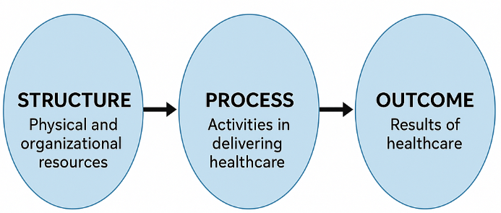
Fig 3: Donabedian Model
Source: (Zahoor, 2025)
SWOT analysis
Strengths
One of the main strengths is that SaTH is based within the NHS and thus draws on existing national clinical standards, clinical expertise, maternity advice, clinical governance frameworks and quality assurance tools. The Ockenden Review is itself an evidence base that is very large—1,592 clinical incidents have been analysed, not just a handful. Monitoring also provides national benchmarking and accountability opportunities. In addition, the NHS has set up processes for gathering evidence of patients' experience (Sylla et al., 2025). We received 16,755 responses to the 2025 CQC Maternity Survey from women in 119 NHS trusts, giving a robust national evidence base to look for issues in services. This means that SaTH has access to both national and organisational infrastructure that can help with evidence-based improvement (NHS England, 2026a).
Weaknesses
Limitations in clinical governance, leadership, incident investigation, communication, learning and weaknesses in safety culture are the most critical areas identified (NHS England, 2025b). The Ockenden Review identified that the internal investigations of maternal deaths were inadequate and often missed wider issues of systems and services. These are the areas of weakness and failure that are significant in that they did not become areas of organisational learning but instead continued to exist. The magnitude of the problem is illustrated by the discovery that 75% of the 12 maternal-death cases reviewed had significant or major concerns and 26.3% of the 498 stillbirth cases were also graded (Lathifah et al., 2025). The main area for action was not just the clinical competence of individual staff members, but the failure to be able to consistently identify risk, escalate concerns, investigate incidents and implement corrective action within the organisation.
Opportunities
The weaknesses can be addressed by the use of PDSA cycles, clinical audit, simulation training, working across multi-disciplines and digital monitoring of patient safety. There are opportunities for benchmarking and learning more from other NHS organisations through national maternity reforms. The current national evidence demonstrates that maternity safety is a system-wide priority: in a national review in 2022-24, 47% of maternity services were rated as requiring improvement for safety; 35% were rated as good and 18% as inadequate, while none of the services inspected were rated as outstanding for safety (Wang et al., 2025). This provides opportunities for SaTH to benchmark its performance against national indicators and implement evidence-based practice from higher performing services. Patient involvement is also a key opportunity as it is seen that experience of the birth remains a significant quality indicator, although there are some areas of progress in communication and involvement (NHS England, 2025a).
Threats
The most significant risks are staffing, service pressures, budget limitations, lack of acceptance of organisational change, fatigue amongst staff, and ongoing disparities in maternity outcomes. If staff lack the time and capacity to engage in training, audits and quality-improvement activities, these threats may be a burden on the process of improvement. The national context also exacerbates this worry as it is concluded that maternity services in England have undergone numerous safety investigations and that these services were generally poor rather than just having individual issues (Jeste et al., 2025). Additionally, the fact that 47% of the reviewed maternity services needed to be improved for safety suggests the presence of a broader context of pressure within the maternity system, as experienced by SaTH. Thus, implementing new policies alone is not enough, unless workforce capacity, leadership commitment and capacity for implementation are addressed.

2.3 Way these frameworks help analyse the root causes of the identified issue and guide the development of effective, evidence-based recommendations
The Fishbone Diagram, Donabedian Model and SWOT analysis offer complementary views that help to understand the maternity quality failure at Shrewsbury and Telford Hospital NHS Trust. The Fishbone Diagram helps to identify interlinked causes across people, processes, leadership, communication, governance and organisational culture, and the Donabedian Model helps to create a relationship between the structural weakness, process in healthcare and the patient outcomes (Harrison et al., 2025). SWOT analysis also looks at the strengths and weaknesses of the organisation and the opportunities and threats that exist in the external environment in relation to service improvement. These frameworks are intended to work together to ensure a systematic and evidence-based approach to identifying the main drivers of preventable harm and to developing specific recommendations that address clinical governance, capability of the workforce, communication, safety culture and continuous quality improvement.

3.0 Recommendation

3.1 PDSA (Plan-Do-Study-Act)
Plan
Delays in escalation and irregular fetal monitoring should be the top quality issue for SaTH. Baseline data should be collected on escalation compliance, response times, fetal-monitoring documentation and emergency intervention (Rahmatia et al., 2025). A standardised pathway for escalation and competency development of staff should then be developed.
Do
The new escalation pathway should initially be trialed in a single maternity unit. Practical training and simulation exercises should be given to midwives and obstetricians to include aspects of fetal monitoring, signs of deterioration, communication and escalation. Data should be gathered during the entire pilot period (Hengel et al., 2025).

Fig 4: PDSA Cycle
Source: (The W. Edwards Deming Institute, 2026)
Study
The results of the pilot should be compared to baseline performance. SaTH needs to evaluate the progress and changes in fetal-monitoring compliance, an earlier escalation and enhanced competence and consistency of staffing. Any issues with staff feedback should also be considered, as they may have an impact on improving the learning or create a problem.
Act
If there is measurable improvement by the pilot, then the standardised pathway should become part of the normal way of working in the service and be introduced and progressively rolled out across the service (Marko et al., 2025). If this is not the case, the process needs to be adapted and a new PDSA cycle needs to be performed.

3.2 PDCA (Plan-Do-Check-Act)
Plan
SaTH should aim to enhance the organisation's safety culture and the reporting mechanism for incidents and concerns that may inhibit staff from making concerns. Confidential reporting procedures, and measurable safety objectives should be put into place as well as avenues for escalation (Shende et al., 2025).
Do
The changed reporting process should start to be implemented in one maternity department at a time. The staff should be trained in incident reporting, speaking up, communicating to the multidisciplinary team and learning from adverse events (Kayumov and Boyturayeva, 2026).
Check
Management should evaluate the effectiveness of the intervention by reviewing incident-reporting rates, response times, staff feedback, and number of safety concerns escalated and completion of corrective actions. Additionally, staff-survey results should be compared with the baseline to see if there has been an improvement in psychological safety (Care Quality Commission, 2025).
Act
If the intervention is shown to be effective, a system of reporting and safeguarding needs to be established and agreed throughout the maternity service. If a weakness is found, then the management should change the process and start repeating the steps until the desired weak point is improved.

3.3 Lean
Lean methodology can help in the SaTH maternity improvement programme by identifying and removing work activities that do not add value, unnecessary delays and inefficiencies in the process that can impact patient safety. Lean could be used in this instance, from the point of recognition of fetal or maternal deterioration to clinical escalation and emergency intervention, and process mapping could be an effective tool to identify inefficiencies caused by poor communication, duplicated documentation, unclear responsibility, and/or handovers (Care Quality Commission, 2026). Standardisation of escalation processes, definition of roles and enhanced multidisciplinary communication, then, may minimise process waste and facilitate rapid clinical response. These are especially relevant considering that poor fetal monitoring, delayed intervention, and inconsistent documentation and communication failures were found to be significant factors related to poor quality through the Fishbone analysis. But Lean must not be confused with cutting staff or resources; its intent should be to eliminate non-value added process variation and delays, while maintaining clinical quality and patient safety, in a healthcare context. Hence, Lean can be used in conjunction with PDSA and PDCA to improve the efficiency, reliability and patient-centredness of maternity processes.

3.4 Six Sigma
Define
The first step is to identify the particular quality issue in a specific way and its effects on patients. The priority for SaTH might be a failure to recognise and escalate deterioration of the mother or foetus, thereby increasing the risk of preventable complications. The organization should have a clear goal for improvement, staff and departments that will be engaged in the improvement, and a desired patient-safety outcome (Beecham et al., 2026).
Measure
The organisation should be able to define a baseline with quantitative data on the current performance of maternity. The measures that should be used should relate to fetal monitoring compliance, time to escalate clinical concern, time to emergency intervention, accuracy of documentation, incident rate, and staff-training compliance (Department of Health and Social Care, 2025). The set-up of these measures enables SaTH to determine the extent of variation and to determine if future interventions have an effect that is measurable.
Analyse
The information gathered should then be analysed to find the major sources of variation and delay. The staffing pressure, poor training, communication issues, unclear clinical responsibilities, poor documentation or inconsistencies in escalation procedures should be considered for SaTH. In this stage, statistical evidence should be correlated with the organisational causes obtained from the Fishbone and Donabedian analysis (Department of Health and Social Care, 2026).
Improve
On the basis of the analysis, targeted interventions should be implemented that will increase reliability and decrease variation. These may involve having established protocols for escalation, competency-based training for fetal monitoring, simulation exercises, better communication and improved collaborative working. Improvements should be tried first in a controlled maternity context then be implemented on a wider scale.
Control
The last stage is to ensure that improvements are sustained over time. SaTH should implement regular clinical audits, safety dashboards and performance reviews to track if standards are still met. Corrective actions and additional improvements should be started if deterioration occurs in the performance (House of Commons Library, 2026).

4.0 Conclusion
The Shrewsbury and Telford Hospital NHS Trust maternity scandal analysis indicates that the quality issue stemmed from a range of organisational issues, which were interlinked and multiple in nature, rather than a single clinical error. Specifically, 75% of the 12 maternal deaths reviewed (9 of 12) had significant or major concerns in care; and 26.3% of the 498 stillbirths reviewed had significant or major concerns, in which different management could have made a difference. Such results confirm the magnitude of the quality shortfall and the need for a systematic service improvement process. (gov.uk)
The Fishbone Diagram showed that the root causes were wide-ranging and covered aspects of people, processes, leadership, governance, communication, resources and organisational culture. In addition, the Donabedian Model has shown that flaws in organisational structure affected the clinical aspects of the process and in turn led to poor patient outcomes. Through SWOT analysis, it was identified that while the national standards are available to all maternity services, its strengths are limited by weaknesses of governance, workforce capability, communication and organisational learning, as well as by its lack of quality improvement infrastructure and expertise.
The recommendations that emerge from this analysis are based on the following areas for clinical governance strengthening, staff competence, fetal monitoring and escalation, developing an open safety culture, strengthening incident investigation and more involvement of patients and families. PDSA is a suitable approach to testing interventions incrementally and PDCA facilitates organisation learning and ongoing review. Lean can minimize any avoidable delays and process inefficiencies, and Six Sigma can minimize measurable variability in key clinical process procedures. These solutions should be linked to and not used alone.

References
Adekoya, A., Okezue, M.A. and Menon, K., (2025). Medical laboratories in healthcare delivery: A systematic review of their roles and impact. Laboratories, 2(1), p.8.
Ahmed, R. and Tamim, T.R., (2025). Enhancing medication safety: the role of community and hospital pharmacists in modern healthcare systems. Radinka Journal of Health Science, 2(3), pp.328-355.
BBC News (2022) Shrewsbury and Telford maternity scandal: More than 200 baby deaths could have been prevented. Available at: https://www.bbc.com/news/uk-england-shropshire-60925959
Beecham, E., Brady, G., Bondaronek, P., O’Carroll, J., Siassakos, D., Glaser, S., Gilchrist, K., Dorey, J., Knagg, R. and Vindrola-Padros, C. (2026) ‘Beyond the report: a qualitative exploration of safety incidents in maternity services’, BMJ Open Quality, 15(1), e004020. Available at: https://bmjopenquality.bmj.com/content/15/1/e004020
Care Quality Commission (2025) Maternity survey 2025. Available at: https://www.cqc.org.uk/publications/surveys/maternity-survey
Care Quality Commission (2026) CQC rates maternity services at Croydon University Hospital as requires improvement. Available at: https://www.cqc.org.uk/press-release/cqc-rates-maternity-services-croydon-university-hospital-requires-improvement
Cui, J., Du, J., Zhang, N. and Liang, Z., (2025). National patient satisfaction survey as a predictor for quality of care and quality improvement–experience and practice. Patient preference and adherence, pp.193-206.
Department of Health and Social Care (2025) National maternity investigation launched to drive improvements. Available at: https://www.gov.uk/government/news/national-maternity-investigation-launched-to-drive-improvements
Department of Health and Social Care (2026) Taskforce set up to deliver urgent action on maternity. Available at: https://www.gov.uk/government/news/taskforce-set-up-to-deliver-urgent-action-on-maternity
Harrison, M., Tordjmann, E., Haigh, F. and Katz, I., (2025). Navigating health and social care systems: professional tensions, cross-sector effects, and methodological complexities in navigation research and practice. Health Sociology Review, pp.1-24.
Hengel, B., Guy, R.J., Casey, D., Anderson, L., Smith, K., Andrewartha, K., Applegate, T.D., Saha, A., Cunningham, P., DeToca, L. and Rawlinson, W.D., (2025). Decentralised COVID‐19 molecular point‐of‐care testing: lessons from implementing a primary care‐based network in remote Australian communities. Medical Journal of Australia, 222(4), p.172.
House of Commons Library (2026) Maternity services in England. Research Briefing CBP-10447. Available at: https://commonslibrary.parliament.uk/research-briefings/cbp-10447/
Jeste, D.V., Smith, J., Lewis-Fernández, R., Saks, E.R., Na, P.J., Pietrzak, R.H., Quinn, M. and Kessler, R.C., (2025). Addressing social determinants of health in individuals with mental disorders in clinical practice: review and recommendations. Translational Psychiatry, 15(1), p.120.
Kayumov, B.Z.O. and Boyturayeva, N.M.K., (2026). Online psychological consultation service: problems and solutions. Science and Education, 7(3), pp.527-533.
Lathifah, Z.K., Fauziah, R.S.P., Rusli, R.K., Roestamy, M., Martin, A.Y., Indra, S. and Suherman, U., (2025). Quality Assurance in Pesantren: Modernization, Adaptability, and Integration into Indonesia’s Education System. Jurnal Pendidikan Islam, 11(1), pp.101-114.
Marko, J.G.O., Neagu, C.D. and Anand, P.B., (2025). Examining inclusivity: the use of AI and diverse populations in health and social care: a systematic review. BMC Medical Informatics and Decision Making, 25(1), p.57.
NHS England (2025a) Patient Safety Incident Response Framework. Available at: https://www.england.nhs.uk/long-read/patient-safety-incident-response-framework/
NHS England (2025b) Maternity Outcomes Signal System (MOSS) standard operating procedures. Available at: https://www.england.nhs.uk/publication/maternity-outcomes-signal-system-standard-operating-procedures/
NHS England (2026a) Maternity experience survey 2025: national qualitative report. Available at: https://www.england.nhs.uk/publication/maternity-experience-survey-2025-national-qualitative-report/
NHS England (2026b) Maternity patient experience survey 2025: national qualitative report. Available at: https://www.england.nhs.uk/long-read/maternity-patient-experience-survey-2025-national-qualitative-report/
Rahmatia, S., Basri, M., Ismail, I., Adi, S., Nasrullah, N. and Ahmad, A., (2025). Service quality in hospital inpatient care: SERVQUAL model approach. Health SA Gesondheid, 30, p.3055.
Serchen, J., Johnson, D., Cline, K., Hilden, D., Algase, L.F., Silberger, J.R., Watkins Jr, C. and Health and Public Policy Committee and the Medical Practice and Quality Committee of the American College of Physicians, (2025). Improving health and health care in rural communities: a position paper from the American College of Physicians. Annals of Internal Medicine, 178(5), pp.701-704.
Shende, A.D., Tekade, S.A., Deshmukh, A.A., Tembhurkar, S.P. and Selvakumar, P., (2025). Water quality monitoring and control with AI. In Smart water technology for sustainable management in modern cities (pp. 51-80). IGI Global Scientific Publishing.
Shin, Y., Lee, M., Lee, Y., Kim, K. and Kim, T., (2025). Artificial Intelligence-Powered quality assurance: transforming Diagnostics, Surgery, and patient Care—Innovations, Limitations, and future directions. Life, 15(4), p.654.
Sylla, B., Ismaila, O. and Diallo, G., (2025). 25 years of digital health toward universal health coverage in low-and middle-income countries: rapid systematic review. Journal of medical Internet research, 27, p.e59042.
The W. Edwards Deming Institute (2026) PDSA Cycle. Available at: https://deming.org/explore/pdsa/
Vettriselvan, R., Velmurugan, P.R., Deepan, A., Jaiswani, G. and Durgarani, M., (2025). Transforming virtual education: advanced strategies for quality assurance in online and distance learning. In Navigating quality assurance and accreditation in global higher education (pp. 563-580). IGI Global Scientific Publishing.
Wang, Y., Shao, Z., Tian, Z. and Chen, J., (2025), July. Advancements and innovation trends of information technology empowering elderly care community services based on CiteSpace and VOSViewer. In Healthcare (Vol. 13, No. 13, p. 1628). MDPI.
World Health Organization, (2025). Global standards for quality health care services for adolescents. World Health Organization.
World Health Organization, (2025). WHO Global Network of National Quality Control Laboratories for Pharmaceuticals: first meeting report, Rio de Janeiro, Brazil, 1-3 October 2024. World Health Organization.
Zahoor, M. (2025) ‘Donabedian’s Model for Health care Quality Management’, LinkedIn, 28 April. Available at: https://www.linkedin.com/pulse/donabedians-model-health-care-quality-management-muhammad-zahoor-qldsf

