BMIH5001
Management & Organisational Behaviour
Report- Analyse and Critically Evaluate Both Corporate And Individual Unit Levels
Shahekur Rahman
2210706
Ernest Wavei
Word Count: 2170

Executive Summary
This report has been carried out to analyse the different type of organisational structures and cultures. In depth analysis has been carried out of the Hilton Group’s structure and culture and how it effects the way leadership and management work together. It also looks at the strategic directions an organisation adapts in order to implement changes through planning, implanting and reviewing. It also recommendations on how the Hilton Group can manage changes in the future.

Contents Table
Introduction…………………………………………………………………………………… 04
Organisational Culture……….………………………………………………………….…... 05
Organisational Structure…………... …………………………………………………….…. 06
Recent Changes Initiatives…….………………………………………………………….… 07
Strategic Direction.…………………………………………………………………….…….. 08
Conclusion……….…………………………………………………………………………… 08
Recommendation ,…………………………………………………………………………… 09
Appendixes…………………………………………………………………………………….10
References……………………………………………………………………………………..11

Introduction
Organisational culture and structure can have both positive and negative effects on an Organisation's growth. It sets the Organisation apart from those that lack a culture and structure in a positive way. It clarifies the company's limitations. It gives workers a sense of permission to get to know one another in order to succeed and accomplish goals. It can give the Organisation's social structure and stability. Any Organisation with an unusual culture and Organisational structure will have a working environment that meets the necessary standards (Law Teacher, 2024). An organisations mission statement visualises the end goal. In addition to the mission, the vision establishes the framework for Organisational action and provides strategic direction. It provides a framework for establishing key goals, priorities, and policies. It serves as the foundation for putting the necessary adjustments into practice. Furthermore, as strategic choices and actions must be in line with the vision, it serves as a prerequisite for consistency in Organisational behaviour. A vision demotivates the optimization of each unique company choice by taking into account all potential outcomes (Grant, 2002). An Organisational structure and management dependability for the organisations depends on how it is managed. Top managers will have decentralized control over how all units are organized and how much decision-making authority they have. Top managers typically perform more efficiently due to economies of size on the right to maintain the centre, even if transference is adjusted to the current tolerable situation. For instance, Organisational subdivisions are receiving money, human resources, and bookkeeping activities that were formerly kept at head office. The Hilton Group, formerly known as the Hilton Hotels Corporation, is one of the leading hotel chains in the global hospitality industry. The company states that it has over 640000 rooms spread across around 4000 hotels in over 90 countries. The company's success in the global hospitality sector can be attributed to a number of factors, including its organisational structure, culture, and political and power management strategies.

Organisation Culture and goals

The particular set of shared beliefs and customs that individuals and groups within an Organisation adhere to, governing their interactions with one another and external stakeholders, is known as organisational culture (Hill & Jones, 2001). The creation and execution of the business plan may be impacted, either favourably or unfavourably, by Organisational culture. This is dependent upon how well the environment and Organisational culture mesh. A creative culture within the company makes it easier to develop tactics that are credible and to execute marketing plans with ease (Brown, 2011). There are many different cultures but 4 main cultures have been identified as the main ones adapted by most organisations.

Organisational cultures referred to as hierarchical or hierarchy cultures place a high priority on consistency in structure, long-term stability, and a shared set of values. Unlike other types, the hierarchical model of corporate culture aims to promote many years of steady, continuous productivity. Top-level decisions are made, and new initiatives and goods are presented gradually and carefully. It is expected of team members to know what their roles are (Masterclass, 2022). The Adhocracy culture emphasises on unconventional thinking. Workers are allowed some leeway to try new things and adopt unconventional viewpoints. It is valued and encouraged to be creative. Roles are not always clear and the atmosphere is fluid. In contrast to the other Organisational cultures, it is very distinct UK Essays, 2018). Bigger, more corporate-focused businesses typically have a market culture, with tough, uncompromising CEOs that demand extreme performance from their employees. Employees are given difficult goals to strive toward. Employee performance is regularly evaluated, and sanctions and awards are meted out. Stated differently, 'getting the job done' and achieving objectives come first (Benstead, 2023). Digital Leadership (2024) said Clan cultures place a high value on cooperation, teamwork, and a strong sense of belonging inside the company. These cultures place a strong emphasis on mentorship, open communication, and shared ideals. Employees frequently view their coworkers as an extended family. Higher job satisfaction, greater employee engagement, and ultimately better corporate performance can result from this sense of belonging.

The guiding ideals of Hilton, which influence every aspect of strategy and decision-making and motivate employee behaviour, are the company's purpose, vision, and values. Hilton combined elements of clan culture and hierarchy to achieve this harmony. Hilton's senior management established codified and structured policies and procedures that were systematically implemented at all levels to guarantee adherence to standards and operational efficiency because the company had a hierarchy culture. However, their success criteria reflected a clan culture by emphasizing a positive work experience and optimizing human potential.

Organisational Structure
Employees are interested in learning about their job responsibilities, reporting lines, potential and actual decision-making authority, and how they interact with other team members and individuals inside the organization. The organizational structure creates this framework. Organizational structures come in several forms, such as decentralized, flat, matrix, and hierarchical (Organ, 2024). A hierarchical organisational system is commonly described as "tall." Organisations that have a hierarchical structure usually use a "top-down" approach with a long chain of command. There are several tiers of management in hierarchical structures. In a hierarchical structure, managers will have limited authority and will supervise a small number of employees (BBC, 2024). By reducing the number of management layers, the flat structure, sometimes referred to as a horizontal structure, challenges the conventional hierarchical paradigm. Organisations using this structure typically have decentralized decision-making and fewer levels of power. The focus is on encouraging employee empowerment and teamwork in order to create a more flexible and inclusive work environment (Two Teachers, 2023). The Matrix culture works by project or product, the workforce is divided in a matrix Organisational structure. Employees are split across several projects and products, but they are also answerable to a functional manager (Slide Model, 2019). Within a divisional Organizational structure: Businesses are divided into parts according to product, market, or location, but organizations are often grouped by departments and job duties. Companies that are split up into divisions can have separate parts in the United States and Europe, and each division is allowed to run on its own. All company operations, including engineering, sales, marketing, and other departments, would be included in each divided team. In terms of appearance, a divisional Organisational structure is horizontal, like the flat Organisational structure, or pyramid-shaped, connected to a single corporate hierarchy (Ellis, 2023). The Hilton Group is organized into divisions. A divisional structure will display on a chart the many departments and the personnel within each division as seen on Appendix 1.

Although managers and leaders both contribute to an organization, their jobs are not the same. Leaders look for new ideas and encourage creativity and original approaches. Managers focus on stability and maintain the status quo. Leaders see a forest; managers see individual trees. (Rossingol, 2023). An organizational structure that is centralized gives higher management the main power to make decisions. The power to create strategies and select the goals and objectives that will direct an organization's operations rests with a select few people. Within a centralized organization, higher management sets rules and regulations, which are then communicated to lower-level employees, who are supposed to abide by them without questioning authority. Decentralization is a distinct kind of organizational structure that distributes decision-making power across multiple teams dispersed throughout various geographical areas. In a company such as this, most planning, strategy, and implementation decisions are made by middle and lower-level management (Shrivastava, 2020). Hilton hotel’s structure is decentralized due to the size of the organisation.

Recent change initiatives, their impact and how well these were managed
Organisational change describes the transformative process that an Organisation goes through in response to changes or reforms that come from both the inside and the outside. During the transitional phase, shifting capital and resource allocations may provide a number of difficulties. Hilton Hotels Corporation values and respects cultural diversity and makes sure that all of its guests and staff, regardless of their social standing or affiliation, are treated with dignity and respect. Conrad's goal of being the best hospitality company in the world is inextricably linked to its values of inclusivity and diversity (Hilton, 2024). The Hilton Group has made two announcements in recent weeks: first, it revealed plans to acquire Graduate Hotels, a boutique lifestyle brand, from Adventurous Journeys Capital Partners (AJ Capital) for $210 million; second, it announced plans to acquire an undisclosed amount earlier this month to acquire a majority stake in Sydell Group, which owns the NoMad brand.
Hilton's purchase binge coincides with a more difficult period to maintain stakeholder impressions among investors and hotel owners (Jelski, 2024). The only group within an Organisation that actively strives to implement changes to the Organisational environment is the workforce. Hilton hotel managers and leaders in England, Scotland, and other European regions place a particular emphasis on analyzing the need for change within various segments, which has allowed them to align with the evolving demands of the hospitality business. As a result, it is now crucial for leaders to execute to the best of their abilities using the finest change management approaches. Therefore, it is crucial to oversee each employee's quality of work in order to facilitate the easy achievement of desired goals and objectives.
Kotter's eight-step change model can be used to enhance the communication system and implement the necessary adjustments in employees' behavioural patterns. The first step of the procedure involves analyzing the need to change the communication pattern due to the widening communication gap. A solution to this problem could be to use more verbal communication instead of nonverbal systems, which would save time by sending information straight to the appropriate department. The workforce needs to be inspired to promote integration in order to adapt to the evolving corporate environment. This guarantees that competing hospitality businesses will face fierce competition. Once improvements have earned the trust of the workforce, they are disseminated throughout the workplace. To improve the communication system, workforce communication is essential. The necessary support must be given in order for the entire workforce to profit as much as possible from an efficient communication system. It is possible to make new ideas and tactics permanent in this way (Hughes, 2011). This strategy therefore makes it possible for the entire staff to accept and adjust progressively in accordance with new communication plans. Hilton has been implementing changes through verbal communication. In order to execute strategic changes, communication with each employee inside their specific area is necessary.

The organisation’s strategic direction
Strategic direction serves as a kind of roadmap for interacting with the future environment, determining the amount of room available for Organisational activity and significant business decisions. It is especially important when artistic and creative endeavours require a certain set of managerial and leadership skills. It is argued that mission and vision are interrelated, indivisible structures that fall under the umbrella of strategic direction. While the mission establishes the framework for the development of strategic objectives, strategic activities, and vision, the vision provides a reason for the Organisation and serves as a basis for fostering a greater sense of commitment and engagement among its constituents (Tipuric, 2022). The core of Hilton's growth strategy has been the company's shift from a vertically integrated hotel and property management company to a hospitality-focused enterprise. Hilton separated its time-share division into Hilton Grand Vacations in 2017, and a sizable portion of its real property holdings were acquired by Park Hotels & Resorts.

Conclusion
The Hilton’s culture is built on providing exceptional customer service and appreciating cultural diversity. Conrad J. Hilton's original concept serves as the foundation for the culture. In Conrad's vision, there is no discrimination and individuals can interact freely. His dream is deeply ingrained in the company's present mission. Not to mention, Hilton Worldwide has reorganized its business practices in response to recent shifts in the industry. Hilton Worldwide has also made investments in diversity-promoting initiatives, such as inclusion training and the celebration of many cultures and customs from around the world. The Hierarchical structure and clan culture goes hand in hand in order to deliver outstanding management service, the allows them to direct their mission and vision strategically.

Recommendations
In order to examine necessary changes and choose the best model to apply them across many departments, managers and leaders must be in alignment. Kurt Lewin's change management model can be used to get maximum benefits while implementing new strategies and concepts. These benefits can be achieved by adopting an effective leadership style. The necessity of making adjustments is examined in order to maintain equilibrium with the dynamic sociocultural, political, and economic aspects of the region where a company sector is founded. To implement new policies and principles, it is necessary to study the variables bringing about a change in the hotel industry and apply the necessary models. Thus, adjustments to leadership techniques help to better match an Organisation's staff with its structure (Cameron & Green, 2015).

Appendixes
Appendix 1: Hilton Hotels Divisional Chart (Organimi, 2024)
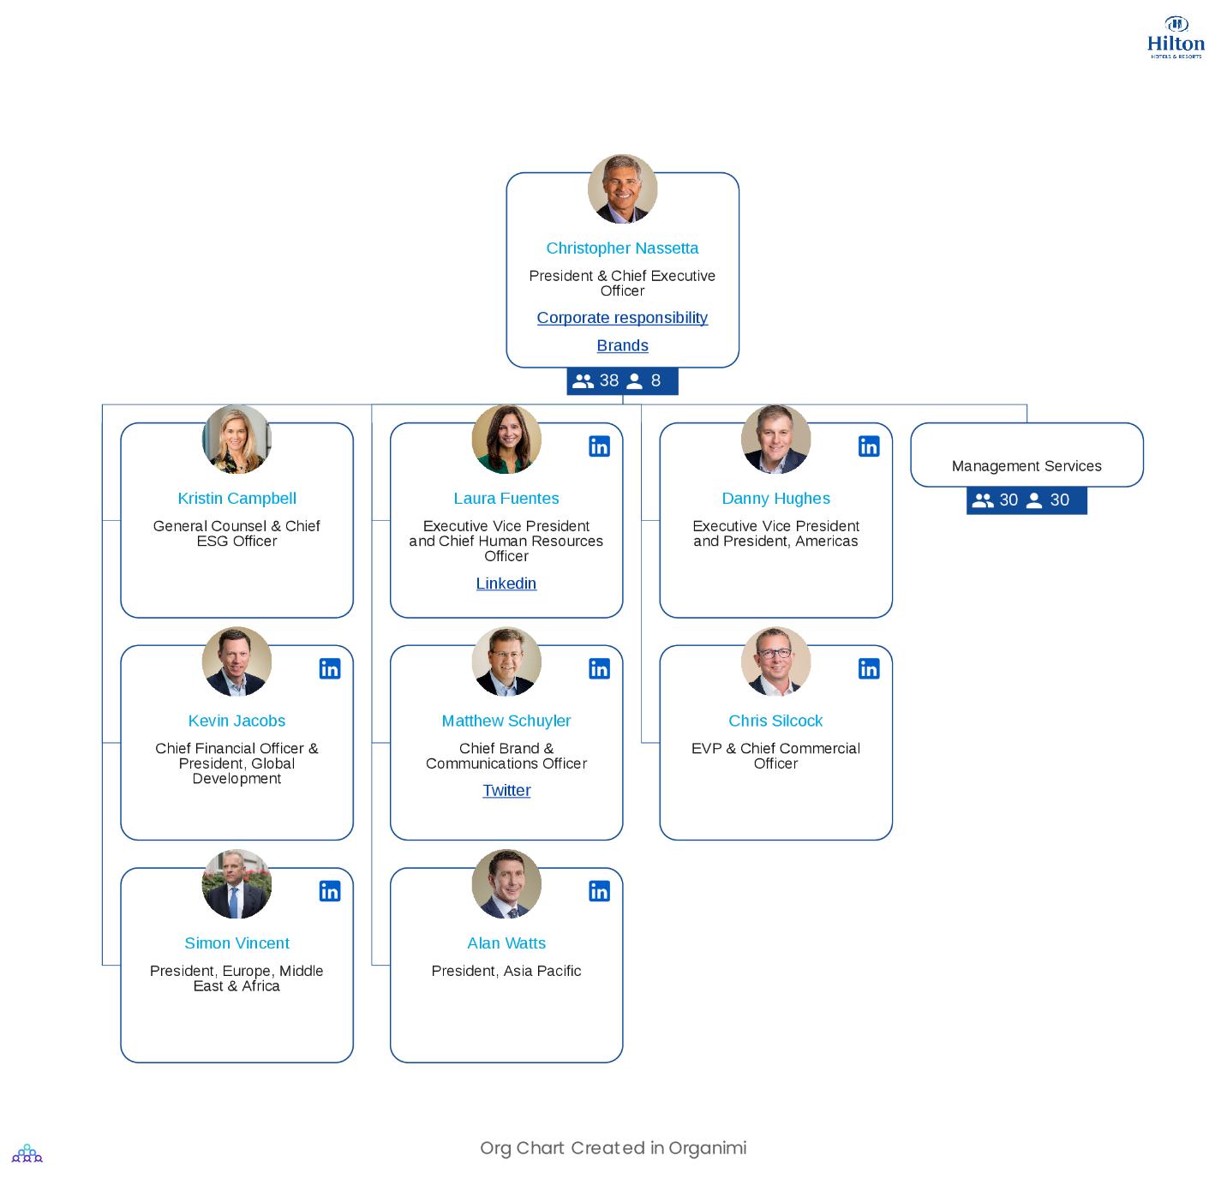

References
BBC (2024) Hierarchical And Flat Organisational Structures. Available at: Hierarchical and flat organisational structures - Organisational structures - Edexcel - GCSE Business Revision - Edexcel - BBC Bitesize [Accessed on 27 May 2024]

Benstead, S. (2023) Breathe: Market Culture. Available at: Market culture: what are the pros & cons? (breathehr.com) [Accessed on 27 May 2024]

Brown, D.R. (2011). An Experiential Approach to Organisation Development. Saddle River, NJ: Prentice Hall.

Cameron, E. & Green, M. (2015) Making Sense Of Change Management: A Complete Guide To The Models, Tools And Techniques Of Organisational Change. Kogan Page Publishers.

Digital Leadership (2024) Clan Culture For Enhancing Organisational Success. Available at: Clan Culture For Enhancing Organisational Success (digitalleadership.com) [Accessed on 27 May 2024]

Ellis, C. (2023) The Org: What Are Divisional Organisational Structures? Available at: What Are Divisional Organisational Structures? | The Org [Accessed on 23 May 2024]

Grant, R. M. (2002) Contemporary Strategy Analysis: Disrupting the Auto Industry. Text and Cases, 2nd Edn. John & Wiley. Pp 28

Hill, C.W.L. and Jones, G.R. (2001) Strategic Management Theory: An Integrated Approach. 5th Edition, Houghton Mifflin Co., Boston.

Hilton (2024) Hilton Careers: Our Culture. Available at: Learn more about Hilton Culture [Accessed on 23 May 2024]

Hughes, M. (2011) Do 70 Per Cent Of All Organisational Change Initiatives Really Fail?. Journal of Change Management. 11(4). pp.451-464.

Jelski, C. (2024) Travel Weekly: A Change Of Heart: Hilton Embraces M&A Growth Strategy. Available at: A change of heart: Hilton embraces M&A growth strategy: Travel Weekly [Accessed on 23 May 2024]

Law Teacher (2024) All Answers: Compare and Contrast Different Organisational Structure & Culture. Available at: Compare and Contrast Different Organisational Structure & Culture (lawteacher.net) [Accessed on 30 May 2024]

Masterclass (2022) Hierarchy Culture Explained: What Is Hierarchy Culture? Available at: Hierarchy Culture Explained: What Is Hierarchy Culture? - 2024 - MasterClass [Accessed on 30 May 2024]

Organ, C. (2024) Forbes: 7 Organisational Structure Types. Available at: 7 Organisational Structure Types (With Examples) – Forbes Advisor [Accessed on 27 May 2024]

Organimi (2024) Hilton’s Organisational Structure. Available at: Hilton's Organizational Structure [Interactive Chart] | Organimi [Accessed on 27 May 2024]

Rossingol, N. (2023) Runn: Leadership vs. Management: Fundamental Differences You Need to Know. Available at: Leadership vs. Management: Fundamental Differences You Need to Know | Runn [Accessed on 22 May 2024]

Shrivastava, D. (2020) ByJu’s: Top 9 Difference Between Centralization and Decentralization. Available at: Difference Between Centralization and Decentralization (byjus.com) [Accessed on 22 May 2024]

Slide Model (2019) Matrix Organisational Structure – Is it the right structure for your company? Available at: Matrix Organisational Structure - Is it the right structure for your company? - SlideModel [Accessed on 25 May 2024]

Taherimashhadi, M., & Ribas, I. (2018). A Model to align the Organisational culture to Lean. Journal of Industrial Engineering and Management, 11(2), Pp207-221

Tipurić, D. (2022). Strategic Direction. In: The Enactment of Strategic Leadership. Palgrave Macmillan, Cham. Available at: Strategic Direction | SpringerLink [Accessed on 25 May 2024]
Two Teachers (2023) Understanding Organisational Structures: Exploring Hierarchical, Flat, and Matrix Structures. Available at: Understanding Organisational Structures: Exploring Hierarchical, Flat, and Matrix Structures (twoteachers.co.uk) [Accessed on 27 May 2024]

UK Essays (2018) Relationship between Organisational Structure and Culture. Available at: Relationship between Organisational Structure and Culture (ukessays.com) [Accessed on 27 May 2024]

