

Methods and Search Strategy Academic Poster

Student name: Catalina-Gabriela Poghirc
Student ID: 2321806

The Impact of Domestic Abuse on the Mental Health and Wellbeing of Young Adults Aged 18–25 in the United Kingdom
Introduction and Research Objective  As qualitative secondary research, this study investigates the impact of domestic abuse on the mental health and wellbeing of young adults (18-25 years) in the UK. According to Anderson, this research examines what other people have said. It is basically a critical assessment of existing data. The research aimed to study the psychological impact of domestic abuse, barriers to seeking support services and consequences for health and social care practice. | 02 Search Strategy  A search strategy refers to a structured plan for identifying relevant research through the use of specific databases, keywords and search criteria (Snyder, 2019). Publications from the office for national statistics (ONS), NICE, WHO and SafeLives alongside Google scholar, pubmed and CINAHL were used. Boolean operators AND and OR reduced or expanded searches.
03 Searching for Information  The literature search consisted of four stages. 1. Determine keywords, for example, domestic violence, mental health, young adults and UK. 2. Use terms like “domestic abuse AND depression” and “coercive control AND mental wellbeing”. 3. Ensure that information is relevant, age-appropriate, geographically suited and recently published. 4. According to Booth et al. (2016), following a structured search process leads to improved transparency and ensures that relevant evidence is identified and selected consistently. 5. Citing relevant evidence and choosing sources for more detailed analysis. Priority was given to research published mostly within 2015-2025. | 04 Picture / Graph / Visual Aid / Statistics  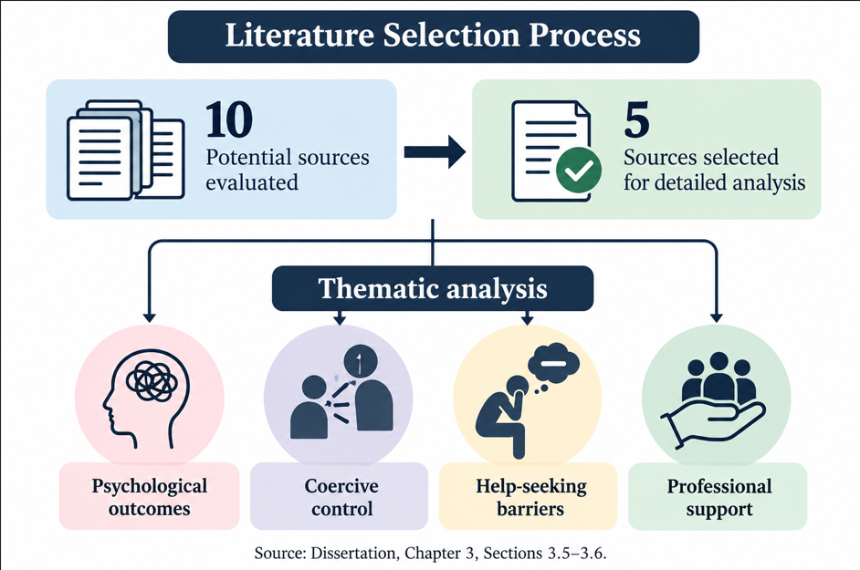
05 Research Validation and Analysis

Here you will provide a definition of validation within secondary research and explain the importance of ensuring that the information you have included within your dissertation is credible and reliable. You can also critically examine research validation and evaluate the benefits and limitations of this.
This section of your poster asks you to define secondary research analysis and explain how you have drawn out ‘themes’ from your literature which you will write about in your Chapter 4 - findings.
06 Inclusion Criteria  Research examining domestic abuse and mental health.  Young adults aged 18–25 or closely related age groups.  UK studies or relevant international evidence.  Peer-reviewed research and credible professional reports.  Mainly English-language publications from 2015–2025. | 07 Exclusion Criteria  Research unrelated to domestic abuse or psychological wellbeing.  Studies focus exclusively on children or older adults.  Evidence with limited relevance to the UK.  Unverified websites, unsupported opinions or unreliable publications.  Older research without significant theoretical relevance.
08 Ethical Considerations

Secondary research requires academic integrity, responsible evidence handling and respect for individuals represented in published studies (BERA, 2024, as cited in the dissertation).
No participants were recruited or contacted, and no personal data were collected. Ethical practice involved accurate Harvard referencing, confidentiality, respectful language, avoidance of survivor-blaming and responsible interpretation of findings.

References
1. Blakeslee, S. (2004) ‘The CRAAP test’, LOEX Quarterly, 31(3), Article 4.
2. Booth, A., Sutton, A. and Papaioannou, D. (2016) Systematic Approaches to a Successful Literature Review. 2nd edn. London: SAGE Publications.
3. Braun, V. and Clarke, V. (2006) ‘Using thematic analysis in psychology’, Qualitative Research in Psychology, 3(2), pp. 77–101. https://doi.org/10.1191/1478088706qp063oa
4. British Educational Research Association (BERA) (2018) Ethical Guidelines for Educational Research. 4th edn. London: BERA.
5. Saunders, M., Lewis, P. and Thornhill, A. (2019) Research Methods for Business Students. 8th edn. Harlow: Pearson.
6. Snyder, H. (2019) ‘Literature review as a research methodology: An overview and guidelines’, Journal of Business Research, 104, pp. 333–339. https://doi.org/10.1016/j.jbusres.2019.07.039

