How does the long-term health effects of covid 19 affect the public?

Introduction
In this assignment the long-term health effects of covid 19 will be discussed and how this effects people in their everyday life. The information that will be discussed in this assignment will be how covid 19 affects the lives of the public such as mental health issues, how many people are affected, how it can affect people’s income and finances, how many people are affected by this, and what are the key challenges for diagnosis and treatment of long covid. Overall, this assignment will inform individuals of the long-term effects of covid 19.
Individuals such as families and communities have experienced is the various restrictions that were in place across the whole of the UK, this has impacted people’s mental health. UKRI (2022) states that the levels of anxiety and depression increased during lockdown, but the levels continued to rise which was not expected. This suggests that the restrictions during lockdown took a toll on many people’s mental health causing the levels of anxiety and depression to rise. During the pandemic millions of people were at risk of falling into extreme poverty, which means that the levels of poverty and undernourishment are rising due to the impact of covid 19. The pandemic has impacted the publics finances, food systems, access to health care, and lack of social protection, without the means of earning income it means that families are unable to feed themselves meaning that these individuals are more likely to be at risk of undernourishment and because of the restrictions put in place families would be unable to access health care that they need. For most individuals this means that access to food and earning an income is a barrier for them. The restrictions of covid 19 have been affecting the food system due to closures of the borders, trade restrictions, and confinement measures which prevent farmers from accessing the markets, so they are not able to buy or produce stock and harvest their crops meaning that this prevents individuals from having access to healthy and diverse diets. Due to the access of healthy food being restricted this means that men and women are at risk of malnutrition which means that they will have poor nutrition and eventually could lead them to fall ill and die due to lack of nutrition. Most agricultural workers who are self employed face high levels of working poverty trying to feed the world meaning that their health is poor due to malnutrition and lack of safety and labour protection, when facing income losses, the workers may start to think of life negatively causing stress and using this as their coping strategy, due to them being vulnerable they face more risks because of the struggle to access measures such as a support system that is in place to help them but because of their working and living conditions they face risks in their transport which prevents them from accessing public transport and using that support system. Overall, this has affected the public health because the levels of anxiety, depression, malnutrition, and many more have increased, this shows how many people are affected by the restrictions put in place to protect the public from COVID-19.
UK Parliament (2022) states that the long-term effects of covid 19 is known as ‘long covid’ this is a condition that presents several symptoms such as no taste, no smell, and long-term breathing problems, this also affects multiple organs in the body. The symptoms of long COVID are fatigue, coughing, chest tightness, loss of breath, difficulty focusing, palpations, and myalgia. This could be related to any damages in the organs and post viral syndrome which is a chronic fatigue syndrome that causes extreme tiredness and many other symptoms.
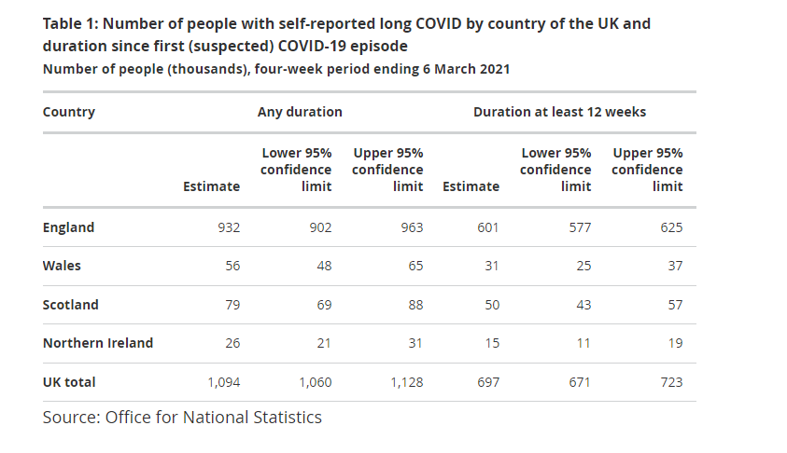
ONS (2021) shows the number of people that re self-reported with long covid in the UK. In March 2021 over the four-week period statistics show that there is an estimated of 1.1 million people in the UK were having symptoms of long covid. This shows that ‘long covid’ has affected millions of people in the UK causing it to affect their everyday lives. It is uncertain about how long these symptoms can last but there are certain risk factors in adults that can come aside these symptoms such as poor pre pandemic health and general health, asthma, and obesity. In children the risk factors for ‘long covid’ are asthma, allergies, eczema, and some other preconditions. It is known that being vaccinated with long covid reduces the risks of developing other long covid symptoms, there are still a few challenges in the medical profession when trying to come up with diagnosis and treatment, but the professionals need more time to try and understand the condition and how long it lasts. Overall, this indicates that over a million people are affected by this and that individuals who have ‘long COVID’ are at risk of developing health issues which means that the public’s health is suffering in the long term.
There is currently a UK wide clinical study that is sponsored by the university of Oxford and funded by the national institute for health research. This research helps individuals find out new antiviral treatments for COVID-19 or long COVID. There are 20,220 people who are taking part in this research trial and there are 64 sites. Daoust, J.F. (2020) states that COVID-19 is not known as just a disease with consequences, but it is known that the consequences can be worse for the elderly. This suggests that COVID-19 has more of an impact on the elderly due to underlying health conditions that they may have especially if they have the symptoms of long COVID. Age is an important factor when discussing the odds of survival in elderly who have COVID as the mortality rate for the elderly is much higher than the rate of the disease. Rismanbaf, Ali. (2020) indicates that any medications used against COVID is only based on the effectiveness of earlier strains so if there is a potential treatment it could be essential. Pandemics have a high morbidity rate in young adults and children, but the mortality rate is even higher for the elderly. There is also a high morbidity rate in elderly and by contracting the virus it means that there is a higher proportion of elderly with the virus in the population. This suggests that the elderly is more at risk when contracting the virus due to their age. The key challenges for diagnosis were finding the symptoms of the virus and how these symptoms affected individuals with COVID-19 or long COVID. Health professionals have been trying to improve prevention of infection and the control measures that help protect the public health. The three main priorities that they focus on in response to COVID-19 and long COVID is supporting the health authorities so that they can help provide care for patients, protect people who are vulnerable, and keep the essential medical care available. By the health professionals having access to equipment such as lateral flows, Vaccines, PCRs, and oxygen and drugs for supportive care they can prevent further spread of the virus. This is essential for all health professionals to acknowledge as having access to these essentials is a way to help the public fight off the virus and get back to living life normally again. Therefore, this indicates that health professionals are trying to improve individuals’ health who have contracted the virus and providing ways to improve the prevention of infection by putting control measures in place such as restrictions on what you can and cannot do and ensuring that people have access to equipment that can prevent further spread of the virus.
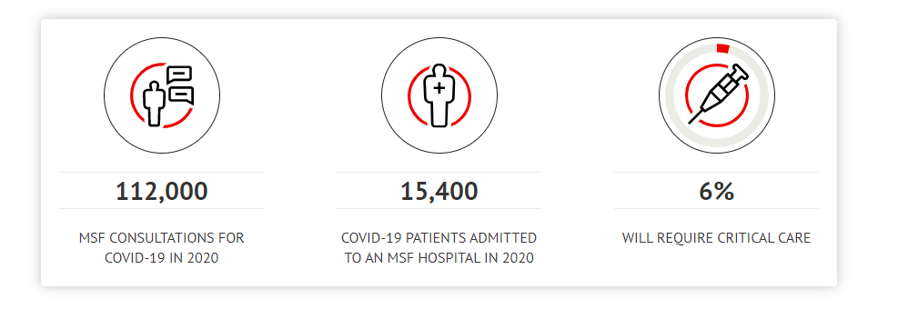
MSK UK. (2020) states that there were over 15,000 people were admitted to an MSF hospital in multiple countries over the world such as Afghanistan, Albania, Algeria, Angola, Armenia and many more. These statistics show how many individuals were admitted to hospital, how many consultations there were and the percentage of individuals who needed critical care. These are all countries that the organisation focus on is Europe, Central Asia, Middle East, and North Africa. This is a non-government medical organisation that helps countries that are in conflict zones and are affected by endemic diseases. This organisation provides help for over 70 countries so that they can save lives and ease the suffering of individuals who are in crisis. This organisation is trying to help the lives of others by providing them with the essential care so that they can prevent or slow down the spread of the virus. Overall, this suggests that the organisation helps the lives of others across the world who are affected by endemic diseases such as COVID.
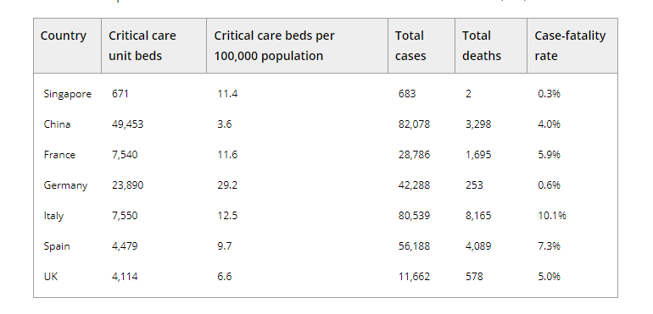
C C M Lee et al., (2020) shows the number of individuals across the globe who were using critical care unit beds, how many deaths there were, and the case fatality rate. This indicates that thousands of individuals ended up in critical care leading to a high rate of death due to these individuals being at high risk or vulnerable when contracting the virus. Containment strategies that health professionals have put in place in response to the outbreak is restrictions on overseas travel, compulsory 14 day stay at home, wearing masks, washing hands, and social distancing. Raveendran, A.V et al., (2021) states that Long COVID is persistent symptoms in individuals when recovered from covid-19. To find treatment of long COVID it would require multiple disciplines to reach any solutions. This suggests that there is still no treatment/cure for COVID-19 and long COVID. Overall, this indicates that anyone who contracts the virus can remain having symptoms even if they have recovered.
The key challenges to diagnosis were finding specific COVID-19 diagnostics methods due to the increased number of individuals who contracted the virus. The methods used was a set of probes and two sets for the detection of SARS-CoV-2, both methods must be positive to continue onto the next step of testing. These methods have many factors that are affected such as inaccurate techniques, inappropriate sample collection, and an inappropriate way of collecting samples and contamination. This form of testing can be expensive so finding a cheaper way to produce tests is the best alternative such as a chest X-ray or a CT scan that could possibly be used to detect COVID-19. There are several studies that show the significance of CT as the first diagnosis step of COVID-19. The approach to prevent the spread of this virus is an early and accurate diagnosis of the infection. The result to the methods is that the PCR also known as the (polymerase chain reaction) is a quick detection of the virus in individuals who show symptoms or the individuals who do not show symptoms. Individuals with no symptoms are known as asymptomatic and individuals who show symptoms of the virus are known as symptomatic. Overall, there is a process that must be followed when diagnosing individuals who have contracted the virus by using a combination of PCR and CT to get the full diagnosis of COVID-19.
Conclusion
In conclusion, in this assignment the long-term health effects of COVID-19 has been discussed and it shows how COVID-19 has affected people in their everyday life. The information that was talked about is how COVID-19 affects the lives of the public regarding an individual’s mental health issues such as anxiety, depression, and many more. Furthermore, this assignment has discussed the restrictions that were put in place to prevent the spread and how that affected the publics everyday life and mental health. Moreover, in this assignment it showed how it affected the elderly with underlying health conditions and how it affected the publics income and finances in the UK and across the world. Lastly, the risk factors for the elderly were discussed and what challenges there were for the health professionals to provide methods for diagnosis and treatment of COVID-19. Overall, this assignment shows how the virus has affected the publics mental health as the levels of anxiety, depression, malnutrition, and many more have increased, this shows how many people are affected by the restrictions put in place to protect the public. This assignment shows that even when individuals have recovered from the virus, they can still have symptoms which is known as ‘long COVID’ meaning that the public’s health is suffering long term. Therefore, this assignment has informed people of the public of the long-term effects of COVID-19.

References
C. C. M. Lee, S. Thampi, B. Lewin, T. J. D. Lim, B. Rippin, W. H. Wong, and R. V. Agrawal. (2020) Battling COVID-19: Critical and peri-operative healthcare resource management strategies in a tertiary academic medical centre in Singapore. Association of Anaesthetists. Available at: https://associationofanaesthetists-publications.onlinelibrary.wiley.com/doi/abs/10.1111/anae.15074 (Accessed on: 31st March 2022)
Daoust, J. F. (2020) Elderly people and responses to COVID-19 in 27 Countries. Available at: https://journals.plos.org/plosone/article/authors?id=10.1371/journal.pone.0235590 (Accessed on: 31st March 2022)
MSF, UK. (2021) Covid-19 pandemic. Available at: https://msf.org.uk/issues/covid-19-pandemic?gclid=CjwKCAjwopWSBhB6EiwAjxmqDRrEfdrh2gsUle3LEKS92EqdeX5toM_67Mx_t1RjqdRZmqr8OAmFFRoCou4QAvD_BwE (Accessed on: 31st March 2022)
Office for National Statistics (2021) Prevalence of ongoing symptoms following coronavirus (COVID-19) infection in the UK. Available at: https://www.ons.gov.uk/peoplepopulationandcommunity/healthandsocialcare/conditionsanddiseases/bulletins/prevalenceofongoingsymptomsfollowingcoronaviruscovid19infectionintheuk/1april2021 (Accessed on: 19th March 2022)
Raveendran, A. V., Jayadevan, R. and Sashidharan, S. (2021) Long COVID: An overview. Diabetes and Metabolic Syndrome: Clinical Research and Reviews. Available at: https://www.sciencedirect.com/science/article/pii/S1871402121001193 (Accessed on: 31st March 2022)
Rismanbaf, A. (2020) Potential Treatments for COVID-19; A Narrative Literature Review. PubMed Central. Available at: https://www.ncbi.nlm.nih.gov/pmc/articles/PMC7085862/ (Accessed on: 31st March 2022)
UK Parliament (2021) Long COVID: The long-term health effects of COVID-19. Available at: https://post.parliament.uk/long-covid-the-long-term-health-effects-of-covid-19/ (Accessed on: 19th March 2022)
UKRI (2022) COVID-19’s impact on our lives. Available at: https://www.ukri.org/news-and-events/tackling-the-impact-of-covid-19/researching-the-impact-of-coronavirus/covid-19s-impact-on-our-lives/ (Accessed on: 18th March 2022)

